Supplementary Material
Title: Vertical distribution of picocyanobacteria in deep lakes: the influence of inorganic turbidity.
Journal: Aquatic Sciences
Authors: Schenone, Luca^{1*}, Modenutti, Beatriz¹, Balseiro, Esteban¹.
*Corresponding author: lucaschenone@comahue-conicet.gob.ar
Affiliation: Laboratorio de Limnología, INIBIOMA-CONICET, Universidad Nacional del Comahue. Quintral 1250, San Carlos de Bariloche (8400), Río Negro, Argentina.
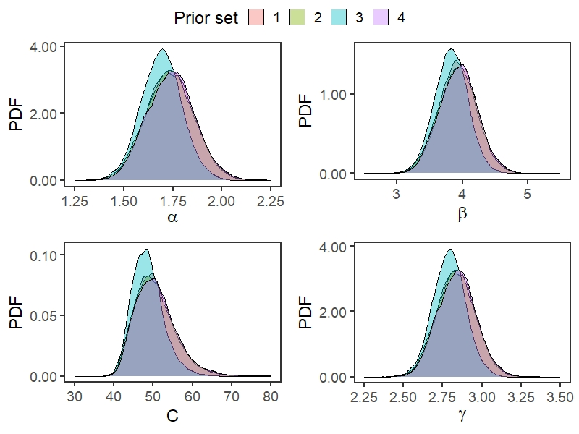
Figure S1: Posterior probability density functions (PDF) of our model parameters using four different sets of prior distributions. For each prior set, zero-truncated Normal distributions with equal mean (µ) and variance (τ) were used for all model parameters. Set 1: µ = 1 and τ = 10; Set 2: µ = 1 and τ = 100; Set 3: µ = 10 and τ = 10; Set 4: µ = 10 and τ = 100.
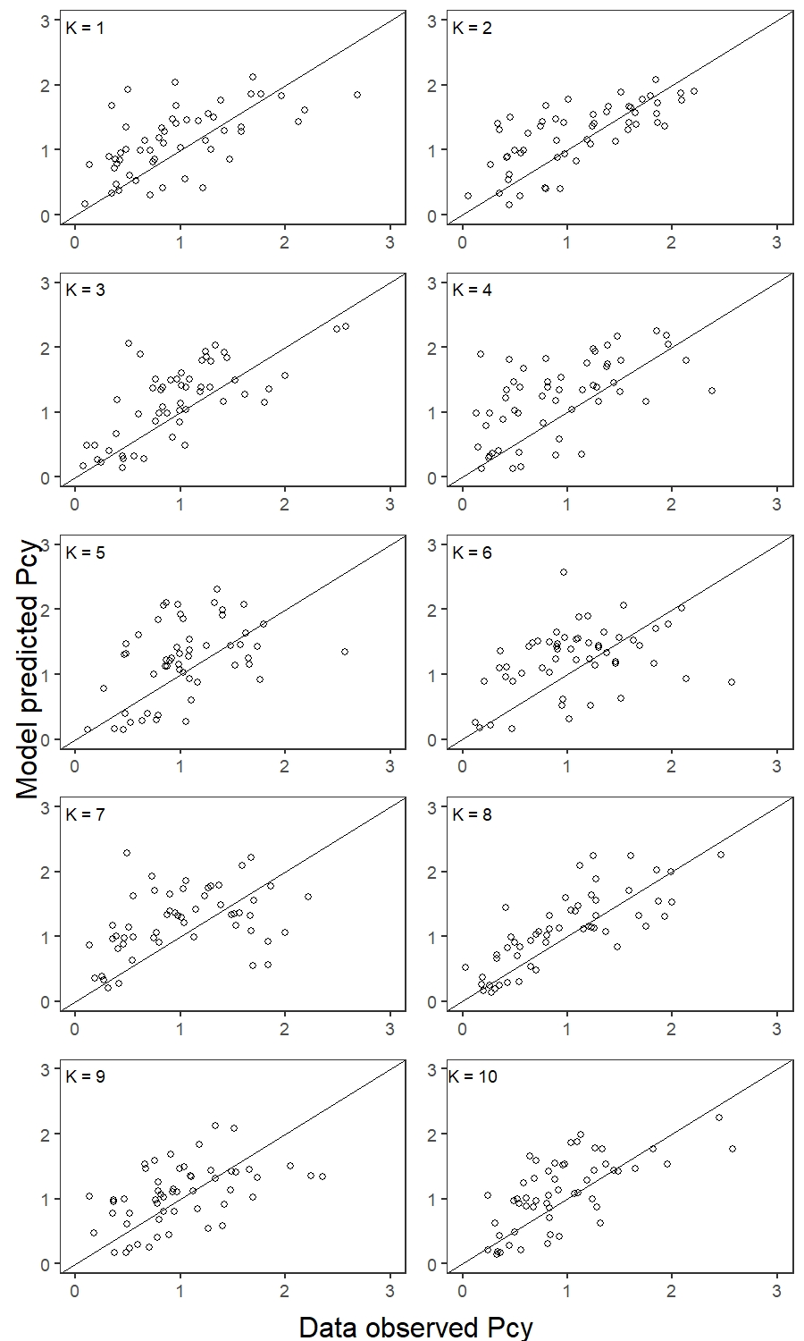
Figure S2: Predictive accuracy of our model using K-fold cross validation. Each subplot represents model fit to each of the ten-fold test data subsets.

