Supplementary Information for Global mitigation efforts should prioritize support to the emerging emitters

Can Cui¹, Dabo Guan^{1,2*}, Daoping Wang³, Vicky Chemutai⁴, Paul Brenton⁴, Shaohui Zhang^{5,6}, Qiang Zhang¹, Steven J. Davis⁷

¹ Department of Earth System Science, Tsinghua University, Beijing, China
² The Bartlett School of Sustainable Construction, University College London, London, UK
³ School of Urban and Regional Science, Shanghai University of Finance and Economics, Shanghai, China.
⁴ The World Bank, Washington, DC, USA
⁵ School of Economics and Management, Beihang University, Beijing, China
⁶ International Institute for Applied Systems Analysis, Laxenburg, Austria
⁷ Department of Earth System Science, University of California, Irvine, Irvine, CA, USA

*corresponding email: guandabo@tsinghua.edu.cn

Supplementary Methods
This section provides supplementary methods for the main text. In this work, country-level CO₂ emissions data cover a time span of 2010-2040, in which the data of 2010-2019 are mainly collected from International Energy Agency, the data of 2020-2024 are resulted from Adaptive Regional Input Output model (section 1.1), and the data of 2025-2040 are updated according to the trend of IIASA’s GAINS SSP2 scenario, the COVID impact and the historical trend, as shown in Figure S 1. Considering different levels of COVID lockdown, a no-COVID baseline and three COVID lockdown scenarios are simulated in the period of 2020-2024; after that, three sets of low-carbon scenarios, i.e. no policy, low carbon, and extreme low carbon are developed during the period 2025-2040. Then, over 2025-2040 there are 3*4=12 scenarios combining different COVID lockdown impact and low-carbon pathways. Detailed descriptions of the scenarios are in section 1.1 and 1.2.
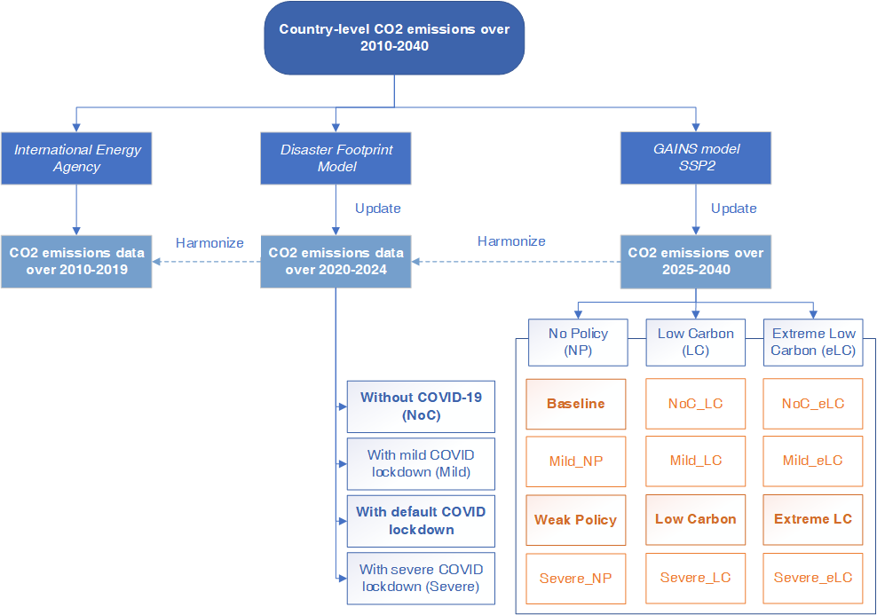
Figure S 1 Framework of the methods and data in this work. The orange rectangles represent the 12 scenarios over 2025-2040, which are combinations of four COVID lockdown scenarios and three low-carbon pathways (shown in blue-bordered rectangles). Scenarios in bold are presented in the main text. Detailed descriptions of the scenarios are in section 1.1 and 1.2.

Socioeconomic developments and emissions during COVID-19 (2020-2024)

1.1.1 Economic impact modelling based on Disaster Footprint Analysis
Both Input-Output (IO) model and Computable General Equilibrium (CGE) model are widely used in assessing the economic consequences of disaster events. IO is more popular for sudden disasters with the benefits in its simplicity and ability to reflect interdependencies of economic sectors, while CGE may be overly optimistic in terms of market flexibility in the short run¹. To overcome the rigidity of IO (i.e. the flexibility of economic transactions is ignored), Hallegatte² developed an Adaptive Regional Input-Output model (ARIO). The ARIO model can be used to analyse the disaster-induced influence on regional economy by incorporating the production capacity constraints resulting from capital loss and changes of consumption behaviour within pre- and post-disaster period, as well as possibilities of over-production^{3,4}. Equipped with different datasets of input-output linkages, the ARIO model has been used for the impact of COVID-19 in different regions on the local economy. Inoue and Todo⁵ quantifies the economic effect of a possible lockdown of Tokyo to prevent spread of COVID-19 by applying ARIO model to the actual supply chains of nearly 1.6 million firms in Japan. Pichler, et al.⁶ employed the ARIO model to assess six re-opening scenarios of the UK economy to find an appropriate economic restart strategy.
Based on the ARIO model, we built the Disaster Footprint model that can overcome the rigidity of input-output model (i.e. the flexibility of economic transactions is ignored), which is used to analyze the disaster-induced influence on regional economy by incorporating the production capacity constraints resulting from capital loss and changes of consumption behavior within pre- and post-disaster period, as well as possibilities of over-production^{3,4}. Here, we extended the model to a multiregional economic impact model, which has the ability to simulate the propagation of the shocks in multiple regions. After calibrating the model with the latest GTAP database version 10⁷, we assess the dynamic impact of COVID-19 control measures on the global economy throughout production supply chains by considering available production imbalances and consumer behavior changes⁸.
In our model, there are two types of agents, i.e., producers and households. In an economy, each sector can be regarded as a producer, in which labour and capital are the two main inputs for producing products. Meanwhile, economic sectors are also consumers that require intermediate products from other sectors.
There are various estimation methods for industrial production, such as Leontief production function from IO basic theory⁹, Cobb-Douglas (C-D) function and Constant Elasticity of Substitution (CES) function¹; in particular, the Leontief production function does not allow for substitution between inputs and is more suitable for this study, as the pandemic occurs without any predication and economic agents cannot make timely adjustments. According to the Leontief function, the output from sector $i$ in region $r$ ($x_{i,r}$) can be expressed in Equation 1.
$x_{i,r}=min\left(for all p, \frac{z_{i,r}^{p}}{a_{i,r}^{p}}; \frac{{va}_{i,r}}{b_{i,r}}\right)$ | Equation 1
where p denotes type of intermediate products;$z_{i,r}^{p}$ refers the intermediate product $p$ used in sector$i$;${va}_{i,r}$ refers the primary inputs for the sector $i$, including labour ($L$) and capital ($K$).$a_{i,r}^{p}$ and $b_{i,r}$are the input coefficients of intermediate products $p$ and primary inputs of sector $i$, which can be calculated in Equation 2. All the economic transactions and industrial interdependence are expressed as monetary values.
$a_{i,r}^{p}= \frac{{\overline{z}}_{i,r}^{p}}{{\overline{x}}_{i,r}}$, $b_{i,r}= \frac{{\overline{va}}_{i,r}}{{\overline{x}}_{i,r}}$ | Equation 2
It assumes that before the COVID-19 occurred, total output should satisfy intermediate demands and final demands from consumers. However, such economic balances are broken by the pandemic and further crush the supply chains. From the view of producer, restriction of labour input caused by control measures will decrease the production capacity and outputs.
Labour constraints after a disaster may impose severe knock-on effects on the rest of the economy⁸. This makes labour constraints a key factor to consider in disaster impact analysis. For example, in the case of a pandemic, these constraints can arise from employees’ inability to work as a result of illness or death, or from the inability to go to work and the requirement to work at home (if possible). In this model, the proportion of surviving productive capacity from the constrained labour productive capacity ($x_{i}^{L}$) after a shock is defined as:
$$x_{i}^{L}\left(t\right)=\left(1-γ_{i}^{L}\left(t\right)\right)*{\overline{x}}_{i}$$ | Equation 3
Where $γ_{i}^{L}(t)$ is the proportion of labour that is unavailable at each period $t$ during containment. $(1-γ_{i}^{L}(t))$ contains the available proportion of employment at period $t$.
$$γ_{i}^{L}(t)=\left({\overline{L}}_{i}-L_{i}(t)\right)/{\overline{L}}_{i}$$ | Equation 4
The proportion of the available productive capacity of labour is thus a function of the losses from the sectoral labour forces and its pre-disaster employment level. Following the assumption of the fixed proportion of production functions, the productive capacity of labour in each region after a disaster ($x_{i}^{L}$) will represent a linear proportion of the available labour capacity at each time step. Take COVID-19 as an example, during an outbreak of an infectious disease, authorities often adopt social distancing and other measures to reduce the risk of infection. This imposes an exogenous negative shock on the economic network.
The shortage of intermediate products will further affect the production capacity of downstream sectors and reduce their outputs due to the forward effect. If we consider the limitations of primary and intermediate inputs, the maximum production capacity of sector $i$ in period $t$ ($x_{i,r}^{max}\left(t\right)$) can be calculated as Equation 5.
$x_{i,r}^{max}\left(t\right)=min\left(x_{i}^{L}\left(t\right);for all i,r, x_{i,r}^{p}\left(t\right)\right)$ | Equation 5
$x_{i,r}^{L}\left(t\right)$, $x_{i,r}^{p}\left(t\right)$ are the maximum outputs when considering the labour constraints and intermediate input scarcity, respectively.
From the view of demand, 1) direct contact business activities become less when keeping social distancing; 2) alternative consuming activities impact on the output of producers through changing demand of consumers (i.e. backward effect). Hence, the total order demand for the sector $i$ in period $t$ (${TD}_{i,r}\left(t\right)$) equals to the sum of intermediate demand and household demand (Equation 6).
${TD}_{i,r}\left(t\right)=\sum_{j,s}{FD_{i,r}^{j,s}\left(t\right)}+\sum_{s}{{HD}_{i,r}^{s}\left(t\right)}$ | Equation 6
where $FD_{i,r}^{j,s}\left(t\right)$ refers the order demand that sector $j$ in region $s$ required from supplier $i$ in region $r$; ${HD}_{i,r}^{s}\left(t\right)$ is the order demand that household in region $s$ required from supplier $i$ in region $r$.
To make a more realistic representation to the real production process, we assume that each sector holds some inventory of intermediate goods. In each time step, sectors use intermediate products from their inventories for production, and purchase intermediate products from their supplying sectors in order to restore their inventories ³. The amount of intermediate product $p$ hold by sector $j$ in region $s$ in period $t$ is denoted as $S_{j,s}^{p}\left(t\right)$, and we assume the inventory of intermediate product $p$ required by sector $j$ in region $s$ is $S_{j,s}^{p,*}\left(t\right)$, which could fulfil its consumption for $n_{j,s}^{p}$ days.
$S_{j,s}^{p,*}\left(t\right)= n_{j,s}^{p}*{a_{j,s}^{p}*x}_{j,s}^{max}\left(t\right)$ | Equation 7
Then the order issued by sector $j$ to its supplying sector $i$ is
${FD}_{i,r}^{j,s}(t)=\left\{\begin{aligned}\left(S_{j,s}^{p,*}\left(t\right)-S_{j,s}^{p}\left(t\right)\right)*\frac{{\overline{FD}}_{i,r}^{j,s}*x_{i,r}^{max}(t)}{\sum_{j→p}{\left({\overline{FD}}_{i,r}^{j,s}*x_{i,r}^{max}(t)\right)}}, if S_{j,s}^{p,*}\left(t\right)>S_{j,s}^{p}\left(t\right); \\ 0 if S_{j,s}^{p,*}\left(t\right)≤S_{j,s}^{p}\left(t\right).\end{aligned}\right.$ | Equation 8
${HD}_{i,r}^{s}\left(t\right)$ is measured by the household demand and the supply capacity of their suppliers. In this study, the demand of final products $q$ by household in region $s$, ${HDT}_{s}^{q}\left(t\right)$, is given exogenously at each time step. Then, the order issued by household $s$ to its supplier $i$ is
${HD}_{i,r}^{s}\left(t\right)={HDT}_{s}^{q}\left(t\right)*\frac{{\overline{HD}}_{i,r}^{s}*x_{i,r}^{max}(t)}{\sum_{i→q}{\left({\overline{HD}}_{i,r}^{s}*x_{i,r}^{max}(t)\right)}}$ | Equation 9
Taking both forward effects and backward effects into consideration simultaneously, the actual output of the producer $i$ in period t ($x_{i,r}^{a}(t))$ is
$x_{i,r}^{a}\left(t\right)=min\left(x_{i,r}^{max}\left(t\right),{TD}_{i,r}(t)\right)$ | Equation 10
The actual production will be allocated to downstream economic sectors and households according to their orders. If the output is not enough to meet all orders, it will be split according to the order proportion^{2,10}.
If we assume the growth rate for each producer ($g$) remains the same within the entire process, then the actual output of the producer $i$ in time $t$ after adjusting the economic growth (${xx}_{i,r}^{a}\left(t\right))$ can be calculated in Equation 11.
${xx}_{i,r}^{a}\left(t\right)=\left(1+g_{i,r}\right)*xx_{i,r}^{a}\left(t-1\right)*\left(\frac{x_{i,r}^{a}\left(t\right)}{x_{i,r}^{a}\left(t-1\right)}\right)$ | Equation 11
We consider that COVID-19 will have impact to the efficiency level of economic productions. For example, firms may need to switch their downstream suppliers due to COVID impact, which may results inefficient production as they will need to adapt different level or types of technology provided by new suppliers ¹¹. Therefore, we set the coefficient, e, to reflect the efficiency influence of COVID-19 at sectoral level. There is lack of quantified research to define such coefficient in literature. In this work, we take this into consideration with assumptions. For the most optimistic scenario, i.e., the mildest lockdown scenario, e=1, indicating the economic efficiency is the same as the scenario without COVID; while for the severest lockdown scenario, e=0.5, assuming the economic efficiency will be half of the no-COVID scenario; for the default lockdown scenario, e=0.75.

$${xx}_{i,r}^{a}\left(t\right)=\left(1+e*g_{i,r}\right)*xx_{i,r}^{a}\left(t-1\right)*\left(\frac{x_{i,r}^{a}\left(t\right)}{x_{i,r}^{a}\left(t-1\right)}\right)$$ | Equation 12
The global multi-regional input-output (MRIO) table used in the model is compiled based on the latest GTAP database (version 10)⁷. GTAP database presents values of intermediate products transaction between 65 sectors, the output of each sector, and final consumption of commodities in 141 countries/regions. It also provides global bilateral trade links among the sectors and countries/regions. The growth rates of sectoral GDP ($g_{i,r}$) are collected from the International Institute for Applied System Analysis (IIASA)¹².

1.1.2 CO₂ emission accounts
Previous studies employed a various of economic models to forecast the emissions. For example, Kavoosi, et al¹³ forecast global CO₂ emissions until 2030 using Genetic Algorithm based on (non-)linear equations and historical energy consumption. Hosseini, et al.¹⁴ predict CO₂ emissions for Iran until 2030 with multiple linear regression and multiple polynomial regression models. Mi, et al.¹⁵ developed an Integrated Model of Economy and Climate based on the input-output model and predict emissions for China until 2035 with constraints of economic growth, energy consumption, employment, industrial structure change, etc. Mercure, et al.¹⁶ designed a simulation-based integrated assessment model that combines a macro-econometric prediction of global economy, a simulation of technology diffusion, and a carbon cycle and atmosphere circulation model of intermediate complexity.
This study investigates the emissions change brought by the sudden shock of COVID-19 for the period of 2019 – 2024 (2019 is set as pre-COVID base year). We conduct the following three procedures.
- Firstly, we extrapolate emissions for all emerging emitters in 2019 (${Emissions}_{IEA}(2019)$) by applying the trend from the latest available data from IEA for the period of 2010 – 2018.
- Secondly, we assume that the production efficiency, technology level, and economic structures are unlikely to change during COVID-19 period. This implies sectoral emission intensity kept unchanged for all emerging emitting countries during this period. Therefore, we preliminarily estimate the emissions (${Emissions}_{COVID_pre}$) of countries based on their sectoral emission intensities and economic outputs (shown in Equation 11). A similar procedure has been suggested by previous literature¹⁷.
${{Emissions}_{COVID_pre}}_{ir}(t)={intensity}_{ir}(t)×{output}_{ir}(t)$ | Equation 13
In the equation, subscript $i$ and $r$ represent sector and country/region, respectively. The superscript $t$ stands for year. ${output}_{ir}(t)$ are generated from the above described disaster footprint model. The ${intensity}_{ir}\left(t\right)$ refers to per economic output emissions, which is calculated based on the SSP2 scenario of the GAINS (Greenhouse Gas - Air Pollution Interactions and Synergies) model at IIASA¹² and World Energy Model 2019 of IEA¹⁸ for the year of 2014.
- Thirdly, we calibrate the emission deviation generated by modelled data (due to using 2014 emission intensity) with most recent data, in order to improve accuracy of emission estimation for all emerging emitters (${Emissions}_{COVID_update}$), shown in Equation 14.
$${Emissions}_{COVID_update}(t)={Emissions}_{COVID_pre}(t)×\frac{{Emissions}_{IEA}(2019)}{{Emissions}_{COVID}_pre(2019)}$$ | Equation 14

1.1.3 Scenarios of lockdown
We set the scenarios of lockdown from the dimensions of number of lockdowns, duration and strictness (see Table S 1). The duration of the mild lockdown, the default lockdown and the severe lockdown scenarios will be described in detail in 2.1.3.1. The lockdown strictness include the strictness of the first lockdown period (S1) and the strictness of the future lockdown period (S2), e.g. the strictness for mild lockdown is S1_{mild}+S2_{mild}. Detailed S1 and S2 will be described in detail in 2.1.3.2 and 2.1.3.3.
Table S 1 Definition of mild, default and severe lockdown scenarios.
Scenario  Dimension | Mild lockdown | Default lockdown | Severe lockdown
Number of lockdowns | 2 | 4 | 8
Duration | T_{mild} | T_{default} | T_{severe}
Strictness | S_{mild} | S_{default} | S_{severe}
Note: please refer all the variables to Table S 2 and Table S 4 below.
      - Lockdown duration (T)
Kissler, et al.¹⁹ projected the dynamic spread of the pandemic over the coming years and defined intermittent social distancing scenarios under restriction of critical care capacities. With reference to their results, we define three scenarios for “lockdown periods” (see Table S 2). Scenario “T_{default}” is accord with the intermittent social distancing scenario defined by Kissler, et al.¹⁹, scenario “T_{severe}” has 10% longer time for each lockdown period while scenario “T_{mild}” has 10% shorter.
Table S 2 Scenarios of lockdown duration
Duration | T_{mild} | T_{default} | T_{severe}
Lockdown 1 | 25/03/20 – 30/06/20 | 18/03/20 – 07/07/20 | 11/03/20 – 14/07/20
Lockdown 2 | 09/09/20 – 10/11/20 | 02/09/20 – 17/11/20 | 26/08/20 – 24/11/20
Lockdown 3 |  | 05/01/21 – 02/03/21 | 30/12/20 – 09/03/21
Lockdown 4 |  | 21/04/21 – 22/06/21 | 14/04/21 – 29/06/21
Lockdown 5 |  |  | 28/07/21 – 28/09/21
Lockdown 6 |  |  | 03/11/21 – 28/12/21
Lockdown 7 |  |  | 09/02/22 – 05/04/22
Lockdown 8 |  |  | 11/05/22 – 05/07/22

      - Strictness of the first lockdown period (S1)
We define three scenarios for the strictness of the first period. The basic scenario for default lockdown (“S1_{default}”) are calculated based on Google Community Mobility data²⁰. Google provides the daily changes in people’s movement trends since 15th February across six types of places: retail and recreation, groceries and pharmacies, parks, transit stations, workplaces, and residential area. We use the average of declines in movement trends from workplaces and increase from residential area to reflect the loss of labour availability and freightage capacity in different countries. We exclude the weekends and use the daily average value between 15th March and 31st July as the lockdown strictness for the first “lockdown period”. For China, we use the mobility data from Baidu and get 80% as the strictness of its first lockdown period²¹. Table S 4 shows the basic scenario of the strictness of first lockdown period (“S1_{default}”) in the 79 countries. Then we define scenario “S1_{severe}” as 10% stronger than “S1_{default}” and scenario “S1_{mild}” as 10% weaker.
The control measures may have different effects on the labour supply of different sectors. For example, there is no control measures on the lifeline sectors, such as hospitals and pharmaceutical companies. And sectors that has low exposure level to the virus, such as education, are less affected by the control measures than the commercial services which have higher level of exposure. Therefore, we time sectoral multipliers to the general strictness level to get the sector-specific strictness. The sectoral multipliers could differentiate the impact of pandemic on each sector and are designed from three dimensions, i.e., the exposure level to the virus, whether it is lifeline, and the possibility of working from home. Multipliers range from 0 to 1 (see Table S 3) ⁸. If a sector’s exposure level to the virus is low and it is a lifeline sector and is easy to work from home, the sector’s multiplier will be small, indicating that the sector is less affected by the pandemic and the lockdown measures.
Table S 3 GTAP sector classification and multiplier.
SID | Code | Name | Short Name | Multiplier | Rational
1 | pdr | Paddy rice | Rice | 0.5 | 1)Lower exposure risk of agricultural production activities.  2) Necessity
2 | wht | Wheat | Wheat | 0.5
3 | gro | Cereal grains nec | Cereals | 0.5
4 | v_f | Vegetables, fruit, nuts | Veg & fruits | 0.5
5 | osd | Oil seeds | Oilseed | 0.5
6 | c_b | Sugar cane, sugar beet | Sugar crops | 0.5
7 | pfb | Plant-based fibers | Fibre crops | 0.5
8 | ocr | Crops nec | Crops nec | 0.5
9 | ctl | Cattle, sheep and goats, horses | Livestock | 0.5
10 | oap | Animal products nec | Poultry | 0.5
11 | rmk | Raw milk | Milk | 0.5
12 | wol | Wool, silk-worm cocoons | Animal fiber | 0.5
13 | frs | Forestry | Forestry | 0.5
14 | fsh | Fishing | Fishing | 0.5
15 | coa | Coal | Coal | 1 | Ordinary setor
16 | oil | Oil | Oil | 1 | Ordinary setor
17 | gas | Gas | Gas | 1 | Ordinary setor
18 | oxt | Other Extraction | Other extraction | 1 | Ordinary setor
19 | cmt | Meat: cattle, sheep, goats, horse | Red meat | 1 | Ordinary setor
20 | omt | Meat products nec | White meat | 1 | Ordinary setor
21 | vol | Vegetable oils and fats | Oil | 1 | Ordinary setor
22 | mil | Dairy products | Dairy | 1 | Ordinary setor
23 | pcr | Processed rice | Rice products | 1 | Ordinary setor
24 | sgr | Sugar | Sugar | 1 | Ordinary setor
25 | ofd | Food products nec | Food | 1 | Ordinary setor
26 | b_t | Beverages and tobacco products | Drinks & tobacco | 1 | Ordinary setor
27 | tex | Textiles | Textiles | 1 | Ordinary setor
28 | wap | Wearing apparel | Garments | 1 | Ordinary setor
29 | lea | Leather products | Leather | 1 | Ordinary setor
30 | lum | Wood products | Timber | 1 | Ordinary setor
31 | ppp | Paper products, publishing | Paper | 1 | Ordinary setor
32 | p_c | Petroleum, coal products | Petroleum | 1 | Ordinary setor
33 | chm | Chemical products | Chemicals | 1 | Ordinary setor
34 | bph | Basic pharmaceutical products | Medicament | 1 | Ordinary setor
35 | rpp | Rubber and plastic products | Rubber & Plastic | 1 | Ordinary setor
36 | nmm | Mineral products nec | Minerals | 1 | Ordinary setor
37 | i_s | Ferrous metals | Ferrous | 1 | Ordinary setor
38 | nfm | Metals nec | Metals | 1 | Ordinary setor
39 | fmp | Metal products | Metal products | 1 | Ordinary setor
40 | ele | Computer, electronic and optical products | Electronics | 1 | Ordinary setor
41 | eeq | Electrical equipment | Electrical | 1 | Ordinary setor
42 | ome | Machinery and equipment nec | Machinnery | 1 | Ordinary setor
43 | mvh | Motor vehicles and parts | Motor parts | 1 | Ordinary setor
44 | otn | Transport equipment nec | Trans. equip | 1 | Ordinary setor
45 | omf | Manufactures nec | Other manuf. | 1 | Ordinary setor
46 | ely | Electricity | Electricity | 0.1 | Lifeline
47 | gdt | Gas manufacture, distribution | Gas | 0.1 | Lifeline
48 | wtr | Water | Water | 0.1 | Lifeline
49 | cns | Construction | Construction | 1 | Ordinary setor
50 | trd | Trade | Trade | 1 | Ordinary setor
51 | afs | Accommodation, Food and service activities | Catering | 1 | Ordinary setor
52 | otp | Transport nec | Land transport | 1 | Ordinary setor
53 | wtp | Water transport | Water transport | 1 | Ordinary setor
54 | atp | Air transport | Air transport | 1 | Ordinary setor
55 | whs | Warehousing and support activities | Warehousing | 1 | Ordinary setor
56 | cmn | Communication | Communication | 0.1 | Work on line
57 | ofi | Financial services nec | Finance | 0.1 | Work on line
58 | ins | Insurance | Insurance | 0.1 | Work on line
59 | rsa | Real estate activities | Real estate | 0.1 | Work on line
60 | obs | Business services nec | Business | 0.1 | Work on line
61 | ros | Recreational and other services | Tourism | 1
62 | osg | Public Administration and defense | Administration | 0.1 | Special setor
63 | edu | Education | Education | 0.1 | Work on line
64 | hht | Human health and social work activities | Public health | 0 | Special setor
65 | dwe | Dwellings | Dwellings | 1 | Ordinary setor
Note: GTAP database classifies agriculture, food, resource extraction, manufacturing, and service activities (65 sectors in total) to describe all economic activities in each country/region. In countries where COVID-19 broke out, the supply of labor will be affected by the epidemic control measures. Isolation measures have different effects on labor supply in different sectors. We set a specific multiplier for each sector based on three factors, i.e., the exposure level of the sector's work, whether it is the lifeline, and whether it is possible to work at home. If a sector's work exposure level is low, or it is the lifeline sector, or it is easy to work at home, its' multiplier will be small, vice versa.
      - Strictness of the future lockdown periods (S2)
Considering the learning effects and potential herd immunity, countries might achieve the same control effects of pandemic with weaker strictness in the future periods of lockdown. Therefore, we design three scenarios of the strictness of lockdown in different periods, see Table S 4.
Table S 4 Scenarios of lockdown strictness
Period | S2_{mild} | S2_{default} | S2_{severe}
Lockdown period 1 | 100% | 100% | 100%
Lockdown period 2 | 40% | 50% | 60%
Lockdown period 3 | - | 30% | 40%
Lockdown period 4 | - | 20% | 30%
Lockdown period 5 | - | - | 30%
Lockdown period 6 | - | - | 30%
Lockdown period 7 | - | - | 30%
Lockdown period 8 | - | - | 30%
Note: The numbers in the table refer to the percentage of the strictness of lockdown periods to the first lockdown period.

Socioeconomic development and CO₂ emission accounting during Post-COVID period (2025-2040)

1.2.1 CO₂ emissions accounting for post-COVID era
1.2.1.1 Country-level CO₂ emissions trend under the SSP2 scenario.
The CO₂ emissions of countries after the COVID period are based on the trend of SSP2 scenario that developed by IIASA’s GAINS model. The GAINS model provides CO₂ emissions and energy mix projections under the SSP2 scenario (middle of the road, which can be seen as the BAU scenario) up to 2050¹². However, the GAINS model covers major countries and regions, while some developing countries are aggregated into regions. Therefore, the downscaling is used to estimate the country-level emissions according to the region-level emissions. In this work, we assume that the missing countries share the same growth trend of the aggregated region’s CO₂ emissions, and their CO₂ emissions in the future are estimated as the emissions of the base year overlaying the regional annual growth rate.
1.2.1.2 Updating CO₂ emissions with historical data.
The downscaled emissions of countries such as Myanmar show inconsistent trend of emission growth with the historical trend, which means the SSP2 baseline projections given by GAINS need to be updated according to the historical trend, since the SSP2 scenario reflects the “middle of the road” pathway that follows the current development trend. Thus, we updated the SSP2 emissions by applying the historical annual growth rate over 2010-2018 to the emissions growth over 2025-2040. Then we get the updated baseline of the countries over 2025-2040. After this procedure, we obtain the preliminarily estimated emissions ${Emissions}_{postCOVID_pre}$ to be calibrated with emissions of the former stage.
1.2.1.3 Calibration with CO₂ emissions level from COVID lockdown scenarios.
Similar to the calibration of historical data and COVID-period data, we conduct the following two procedures to calibrate the CO₂ emissions of the COVID period and the post-COVID period.
- Firstly, we get the emissions estimate from the COVID period, i.e., the emissions under COVID scenarios of the year 2024 (${Emissions}_{COVID_update}(2024)$) from the procedures of section 1.1.2.
- After that, we calibrate the emission deviation generated by section 1.2.1.2 (due to using GAINS downscaled data), ${Emissions}_{postCOVID_pre}$, with the updated emissions data of the end year of COVID period, 2024, in order to improve accuracy of emission estimation for all emerging emitters (${Emissions}_{postCOVID_calibrated}$), shown in Equation 15.
$${Emissions}_{postCOVID_calibrated}(t)={Emissions}_{postCOVID_pre}(t)×\frac{{Emissions}_{COVID_update}(2024)}{{Emissions}_{postCOVID_pre}(2024)}$$ | Equation 15

1.2.2 Low-Carbon scenarios’ settings
The No-policy scenario represent the countries follow the historical trend and no extra low-carbon policy or technology will be adopted up to 2040. While the other two scenarios of Low-Carbon represent levels of deployment of a highly ambitious low-carbon technologies (LCT) scenario. Specifically, the LC assumes that the new electricity demand after 2025 is linearly covered by renewable energy sources or fossil fuel with carbon capture and storage (CCS; depending on whether the country’s power sector is currently thermal-dominated, i.e. whether thermal power accounts for over 50% power generation) and new vehicles after 2030 are linearly covered by electric vehicles. The most optimistic scenario, i.e. the extreme LC, assumes all newly increased electricity demand after 2025 is met either by renewable energy sources or fossil fuel with CCS feature and all new vehicles after 2030 are battery electric. The scenario settings are listed in Table S 5.
The LC and Extreme LC scenarios are developed based on the emissions of SSP2, No Policy scenario of the GAINS model. We simulate the application of CCS, renewable power generation and electric vehicle by considering the emission reduction rate of the low-carbon technologies. In the Low Carbon scenario, the low-carbon technologies are assumed to be applied since 2025 (linearly increasing the application, and fully applied in 2040), including carbon capture and storage (CCS), renewable energy for the production of newly-demanded electricity, and electric vehicles replacing the newly-increased oil fueled automobiles since 2030 (linearly increasing from 0 to 100% up to 2040; the additional electricity demand are provided with LCTs in electricity sector). The low-carbon technologies are modeled by applying the total emission reduction rate of the low-carbon technologies to the corresponding sector’s emissions, assuming other sectors’ emissions remain as the baseline scenario. The total emission reduction rates of the CCS, renewable energy for power generation, and electric vehicle are set as 88%²², 80%^{23,24} and 100%²⁵ according to literature, respectively.
Table S 5 Scenario settings of low-carbon pathways over the post-COVID period.
Sector |  | Electricity generation |  |  |  | Transportation
Country |  | Thermal-power dominated countries |  | Other countries |  | All countries
Low-carbon technology  (LCT) |  | New thermal-power generation adopt CCS |  | New electricity generation are from renewable energy |  | New vehicles are electric
Year |  | 2025 | 2040 | 2025 | 2040 | 2030 | 2040
LCT coverage of new energy demand | No policy | 0% | 0% | 0% | 0% | 0% | 0%
LCT coverage of new energy demand | Low carbon | 0% | 100% | 0% | 100% | 0% | 100%
LCT coverage of new energy demand | Extreme low carbon | 100% | 100% | 100% | 100% | 100% | 100%
Note: the percentages in this table are the added rate of low-carbon technologies by scenario assumptions, thus for No Policy the percentages are 0.

1.2.3 Scenario settings of post-COVID period
Table S 6 shows the scenario settings of the post-COVID period, with three different low-carbon settings combined with four different lockdown settings for COVID, 12 scenarios in total. The detailed CO₂ emissions data under the 12 scenarios are provided in section 3.3.
Table S 6 Scenario settings of post-COVID period
COVID lockdown  setting  Low carbon setting | No COVID | Mild lockdown for COVID | Default lockdown for COVID | Severe lockdown for COVID
No policy | Baseline | Mild_NP | WeakPolicy | Severe_NP
Low Carbon | NoC_LC | Mild_LC | LowCarbon | Severe_LC
Extreme Low Carbon | NoC_eLC | Mild_eLC | ExtremeLC | Severe_eLC
The Weak policy, Low Carbon and Extreme LC scenarios that presented in the main text are based on the default lockdown scenario for COVID period, and the comparison between the three scenarios can be seen as Figure S 2.
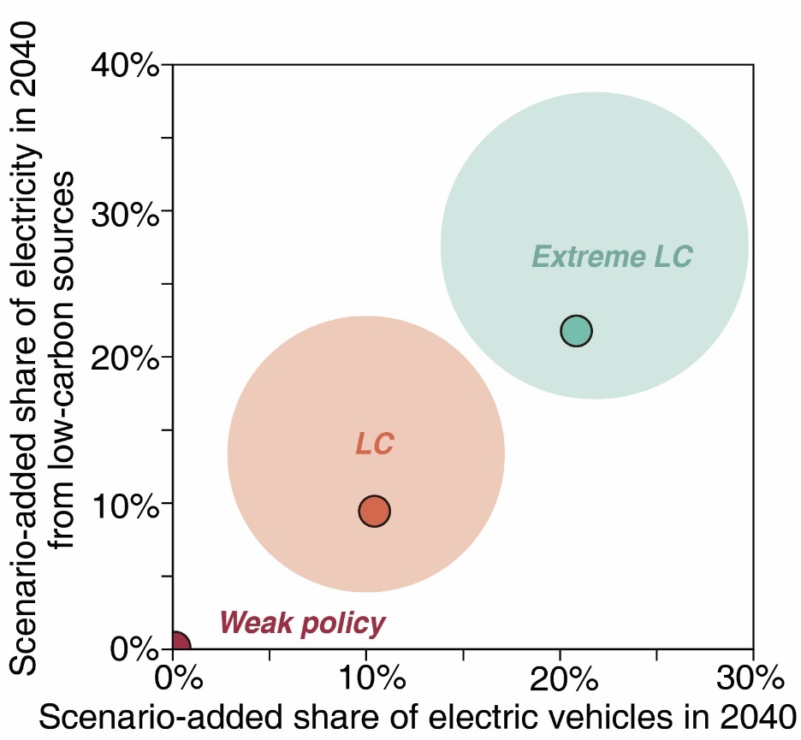
Figure S 2 Comparison between the Weak Policy, Low Carbon (LC), and Extreme LC in terms of the share of electric vehicles (x axis) and low-carbon electricity generation (y axis). The dark circles show the median across all 59 countries and the larger lighter ones show the range among all the 59.

References for Supporting methods
1. Koks, E. E. et al. Regional disaster impact analysis: comparing input–output and computable general equilibrium models. Natural Hazards and Earth System Sciences 16, (2016).
2. Hallegatte, S. An Adaptive Regional Input‐Output Model and its Application to the Assessment of the Economic Cost of Katrina. Risk Analysis (2008).
3. Hallegatte, S. Modeling the Role of Inventories and Heterogeneity in the Assessment of the Economic Costs of Natural Disasters. Risk Analysis 34, 152–167 (2014).
4. Inoue, H. & Todo, Y. Firm-level propagation of shocks through supply-chain networks. Nature Sustainability 2, 841–847 (2019).
5. Inoue, H. & Todo, Y. The propagation of economic impacts through supply chains: The case of a mega-city lockdown to prevent the spread of COVID-19. PLOS ONE 15, e0239251 (2020).
6. Pichler, A., Pangallo, M., del Rio-Chanona, R. M., Lafond, F. & Farmer, J. D. Production Networks and Epidemic Spreading: How to Restart the UK Economy? https://papers.ssrn.com/abstract=3606984 (2020) doi:10.2139/ssrn.3606984.
7. Aguiar, A., Chepeliev, M., Corong, E. L., McDougall, R. & Mensbrugghe, D. van der. The GTAP Data Base: Version 10. Journal of Global Economic Analysis 4, 1–27 (2019).
8. Guan, D. et al. Global supply-chain effects of COVID-19 control measures. Nature Human Behaviour 4, 577–587 (2020).
9. Miller, R. E. & Blair, P. D. Input–Output Analysis Foundations and Extensions. vol. 64 (Cambridge University Press, 2009).
10. Li, J., Crawford‐Brown, D., Syddall, M. & Guan, D. Modeling Imbalanced Economic Recovery Following a Natural Disaster Using Input-Output Analysis. Risk Analysis 33, 1908–1923 (2013).
11. Koks, E. E. & Thissen, M. A Multiregional Impact Assessment Model for disaster analysis. Economic Systems Research 28, 429–449 (2016).
12. International Institute for Applied Systems Analysis. Greenhouse Gas - Air Pollution Interactions and Synergies (GAINS) - IEA WEO 2019 SPS/SDS scenarios. (2020).
13. Kavoosi, H. & Kavoosi, M. Forecast Global Carbon Dioxide Emission By Use of Genetic Algorithm (GA). International Journal of Computer Science 9, 418–427 (2012).
14. Hosseini, S. M., Saifoddin, A., Shirmohammadi, R. & Aslani, A. Forecasting of CO2 emissions in Iran based on time series and regression analysis. Energy Reports 5, 619–631 (2019).
15. Mi, Z. et al. Socioeconomic impact assessment of China’s CO2emissions peak prior to 2030. Journal of Cleaner Production 142, 2227–2236 (2017).
16. Mercure, J.-F. et al. Environmental impact assessment for climate change policy with the simulation-based integrated assessment model E3ME-FTT-GENIE. Energy Strategy Reviews 20, 195–208 (2018).
17. Han, P. et al. Assessing the recent impact of COVID-19 on carbon emissions from China using domestic economic data. Science of The Total Environment 750, 141688 (2021).
18. IEA. World Energy Model. https://www.iea.org/reports/world-energy-model (2019).
19. Kissler, S. M., Tedijanto, C., Goldstein, E., Grad, Y. H. & Lipsitch, M. Projecting the transmission dynamics of SARS-CoV-2 through the postpandemic period. Science 368, 860–868 (2020).
20. Google. Google Community Mobility data. https://www.google.com/covid19/mobility/ (2020).
21. Baidu. Daily inter-city travel data. https://qianxi.baidu.com/2020/ (2020).

Supplementary Results

Overview of countries with fast-growing CO₂ emissions

2.1.1 CO₂ emissions by energy and industry
Energy-related drivers contributed largely to the emissions growth of the emerging emitters. The CO₂ emissions by fuel type and industry from 2010 to 2018 are shown in Figure S 2 (absolute emissions). Over 2010-2018, among the 34 countries that use coal, 23 countries show a rising share of coal-related CO₂ emissions, and 29 countries increased the absolute emissions from coal consumption. The carbonizing energy mix of the countries should be noticed since it would continue contributing large emissions in the future, if there is no thorough transition into renewable energy.
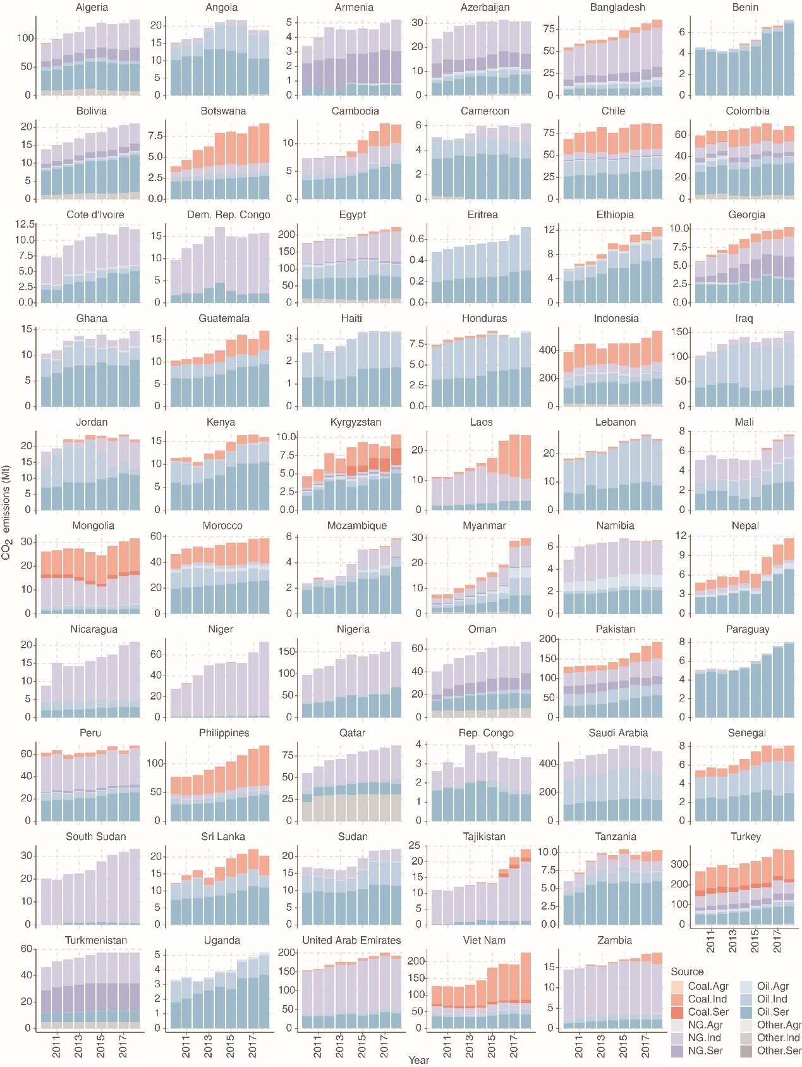
Figure S 3 CO₂ emissions by fuel type and industry from 2010 to 2018, in million tons. The emissions from coal, oil, natural gas (NG) and other energy types are shown in oranges, blues, purples and greys, respectively; the light to the dark show the emissions from agriculture (Agr), industry (Ind), and services (Ser).

2.1.2 CO₂ emissions by sector
Economic and industry-related drivers contributed largely to the emissions growth of the emerging emitters. The CO₂ emissions by sector from 2010 to 2018 are shown in Figure S 3 (in percentage). Over 2010-2018, the emerging emitters show great shares of the electricity generation sector (orange color in Figure S 3) and the transportation sector (e.g. dark blue for road transportation in Figure S 3). However, it may be worse for the climate since the ongoing construction of the infrastructure of the emerging emitters would contribute larger emissions in the future, especially power plants and the rising demand of oil-fueled vehicles.
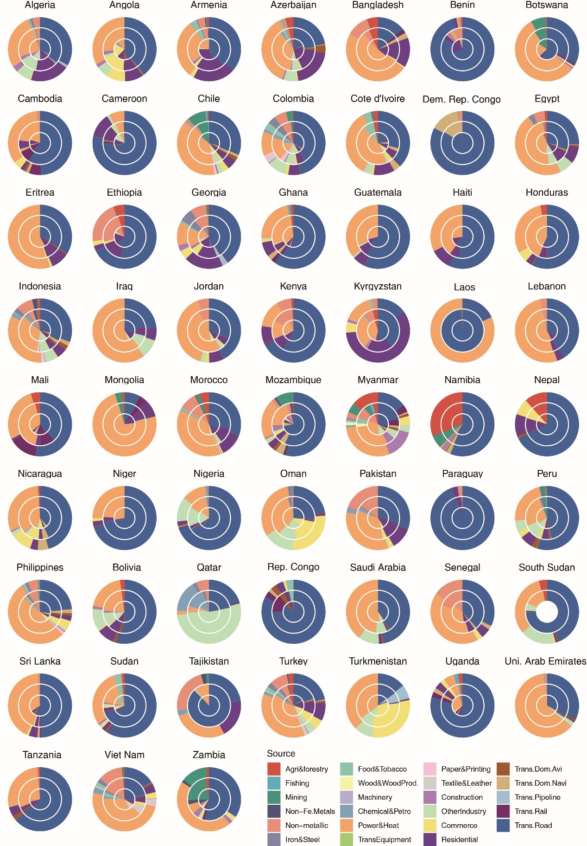
Figure S 4 Shares of CO₂ emissions by sector from 2010 to 2018, by percentage. The emissions from each sector in 2010, 2014 and 2018 are shown from the inner circle to outer ones.

Drivers of emission surges in the emerging emitters.

2.2.1 Drivers of emission surges in the 59 emerging emitters
Here we present the driving forces of emission change in the emerging emitters including the 20 countries already presented in the main text Figure 2, with the contributions of major driving forces to the emission changes, labeled in Mt.
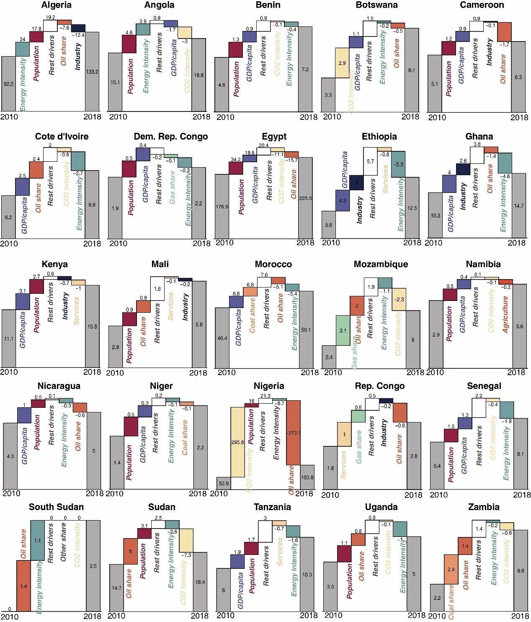
Figure S 5 Driving forces of emission changes of the emerging emitters in Africa. Numbers are the emissions or emission changes from each driver, in Mt. Note: the driving force decomposition of Eritrea is unavailable due to lack of data.

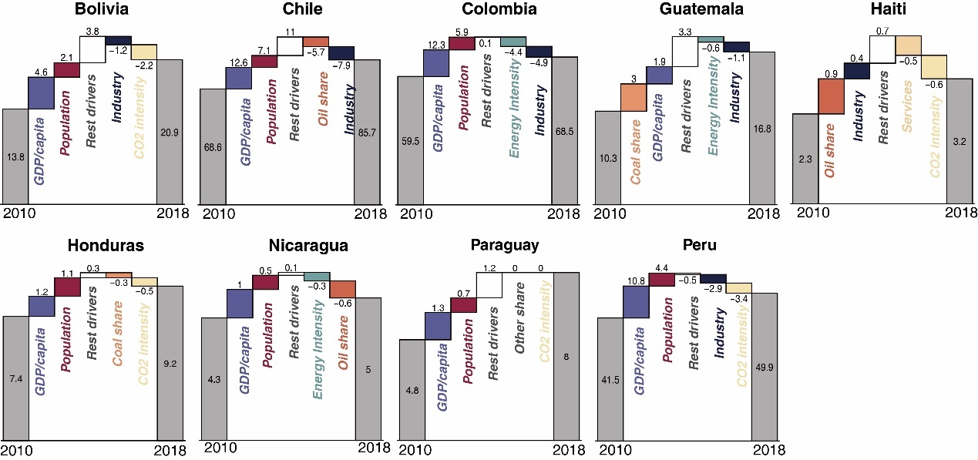
Figure S 6 Driving forces of emission changes of the emerging emitters in Latin America. Numbers are the emissions or emission changes from each driver, in Mt.

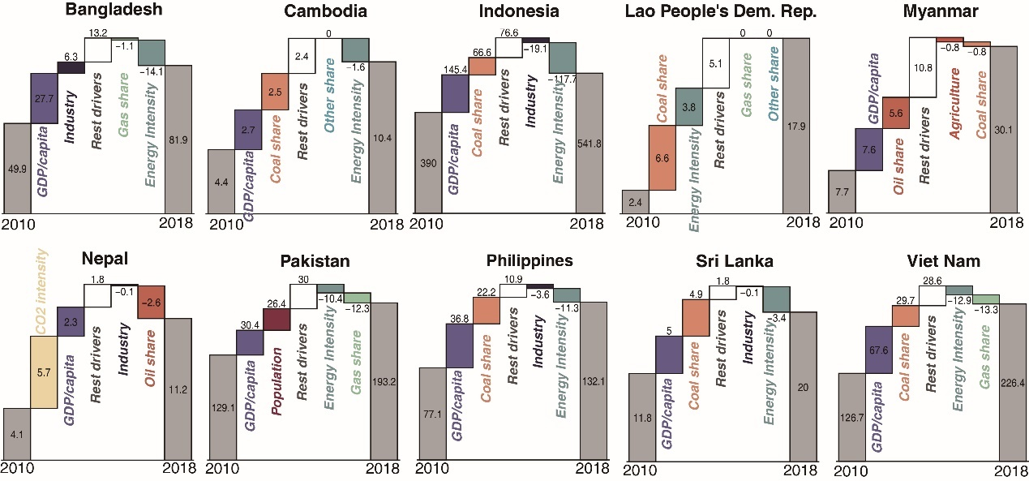
Figure S 7 Driving forces of emission changes of the emerging emitters in South and Southeast Asia. Numbers are the emissions or emission changes from each driver, in Mt.

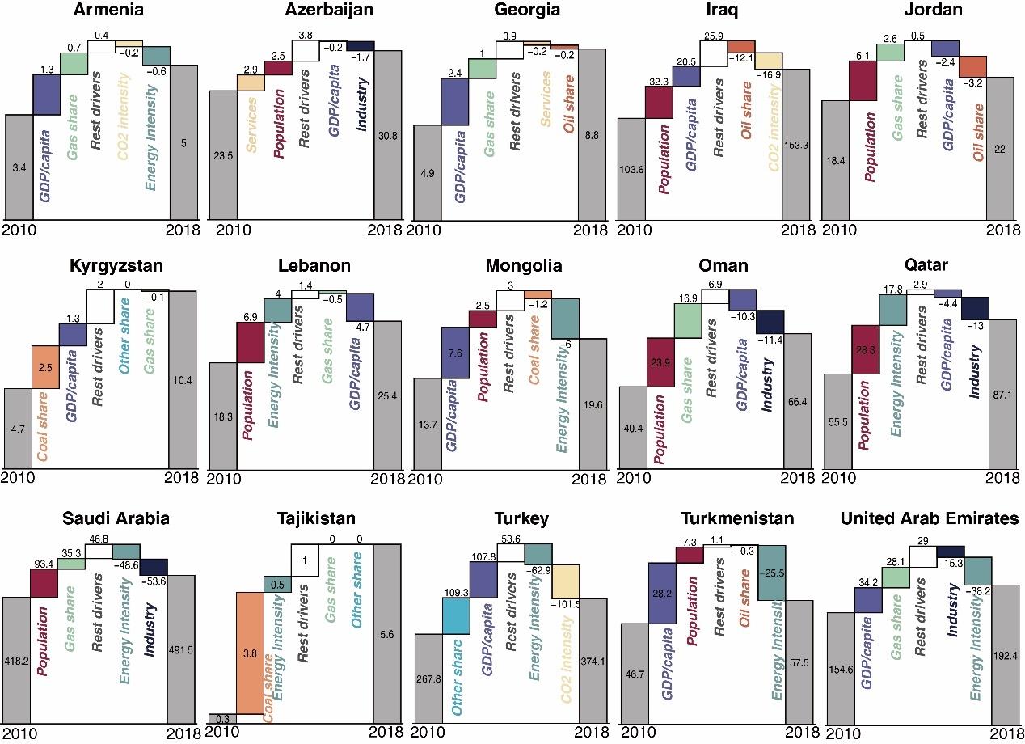
Figure S 8 Driving forces of emission changes of the emerging emitters in Other Asian regions. Numbers are the emissions or emission changes from each driver, in Mt.

2.2.2 Detailed descriptions about the six case countries: Myanmar, Ethiopia, Vietnam, Uganda, Mongolia and Peru.
Myanmar (Figure 2 k): Benefiting from political and economic reform after 2011, Myanmar finally stepped into political stability and was able to focus on domestic economic development: from 2011 to 2018, Myanmar’s GDP keeps an increasing ratio staying around 7% and reached 71.2 billion dollars in 2018. However, along with the economic development, CO₂ emission was also seen with an increment of up to 300% from 2010 to 2018 level. Therefore, the booming economic development after 2011 has also been seen with an environmental sacrifice to some extent. Comparing with 2010, Myanmar has released 22.5 Mt CO₂ more in the year of 2018, with per capita GDP, oil consumption, and energy intensity as the top three contributors. Generally, the GDP development is the largest driving force of emission increment, due to the market booming brought by reform. Next, the oil-based emission implies the energy structure of Myanmar become oil-oriented, especially in construction, power generation, manufacturing, and household sectors. Besides, the industry is also of great importance to drive up CO₂ emission, indicating that Myanmar is in its industrialization and its economic development has been found fundamentally contributed by the manufactory industry. As one of the countries with the fastest-growing CO₂ emission, Myanmar still has great growth potential in its future emission as well as pressure in climate change mitigation.
(Figure S 9a) CO₂ emissions and GDP
Benefiting from political and economic reform after 2011, Myanmar stepped into political stability and focused on domestic economic development. From 2011 to 2018, Myanmar keeps an GDP increasing ratio staying around 7%, and domestic industry is being ushered in unprecedented opportunities for development. In the year of 2016, Myanmar has been witnessed with a 90.9% and 74.2% increment on Aircraft, spacecraft, boats and Electrical equip parts, respectively. Here, Myanmar's aviation industry booms largely drive up the corresponding export to Sweden, Singapore, Vietnam, Ireland, etc. However, along with the economic development, CO₂ emission in Figure*-a was also seen with an increment up to 300% from 2010 to 2018 level. Therefore, the booming economic development after 2011 also been seen with environmental sacrifice to some extent.
(Figure S 9b) Emission drivers
Benefiting from political and economic reform after 2011, Myanmar finally stepped into political stability and was able to focus on domestic economic development: from 2011 to 2018, Myanmar’s GDP keeps an increasing ratio staying around 7% and reached 71.2 billion dollars in 2018. However, along with the economic development, CO₂ emission was also seen with an increment of up to 300% from 2010 to 2018 level. Therefore, the booming economic development after 2011 has also been seen with an environmental sacrifice to some extent. Comparing with 2010, Myanmar has released 22.5 Mt CO₂ more in the year of 2018, with per capita GDP, oil consumption, and energy intensity as the top three contributors. Generally, the GDP development is the largest driving force of emission increment, due to the market booming brought by reform. Next, the oil-based emission implies the energy structure of Myanmar become oil-oriented, especially in construction, power generation, manufacturing, and household sectors. Besides, the industry is also of great importance to drive up CO₂ emission, indicating that Myanmar is in its industrialization and its economic development has been found fundamentally contributed by the manufactory industry. As one of the countries with the fastest-growing CO₂ emission, Myanmar still has great growth potential in its future emission as well as pressure in climate change mitigation.
(Figure S 9c) Emissions by sector
Figure S 8c gives out sectoral emission ratio by the year of 2010, 2014 and 2018. Interestingly, CO₂ emission from agricultural has enlarged its ratio from 4.6% (2010) to 13.8% (2018). This part has been found as the comprehensive consequence of opening agriculture market and promoted agriculture mechanization. Since the economic opening of 2011, the main rice growing zones of the Delta and Dry Zone of Myanmar were the first to begin to mechanize, with mechanization subsequently spilling over into areas of the Dry Zone growing non-rice crops, and to upland areas (Belton, 2019). Numbers of agricultural machinery supply outlets was seen with a rapid growth took place from 2014-2018, during which 61% of all stores were established. Agriculture mechanization was not triggered by direct financial incentive, as well as the consequence of rural-urban migration, which is found up to 80% in 2015 and simultaneously brought labor shortage in rural area. However, the articulation machine promoting such as Two-wheel tractors, Four-wheel tractors and water pump also have stimulated the energy demand to agriculture machine operation especially for oil product, which bring new concern to corresponding CO₂ emission.
(Figure S 9d) Emissions by fuel type and industry
In Myanmar, the absolute coal-based emission always stays stable although slightly increment can be observed around 2018, while the structural ratio of coal-based emission decreased dramatically from 2010 to 2018. In the contrary, the natural gas and oil-based emission have increased largely. For example, oil-based emission has increased by 47.6%, from the level of 2010 to 2018. In the year of 2018, the oil-based emission was up to 61% of the total 30 Mt-CO₂. Therefore, it is not hard to define that Myanmar’s economic development is majorly powered by oil consumption, rather than the substantial natural gas produced domestically. From the sectoral perspective, Myanmar’s CO₂ emission is emitted by second industry mostly, which can be inferred than Myanmar is still lead by manufacturer industry, rather than the service industry.
(Figure S 9e) Trade pattern
In retrospect of selected period, Myanmar’s economic has largely boomed by the reform the benefit a lot from the stable political environment. For example, the opening of demotic agriculture market largely stimulates the import of seed, equipment and fertilizer that contributing to market booming, which contributes the import ratio of Agriculture, forest and fishing industry to roar up to 75% around 2012 than previous year. Myanmar’s major trade pattern has expanded from Asian countries to European counties, such as Sweden and Ireland have built a series of new connections in terms of aircraft and shipping manufactory. Although Myanmar is abundant in natural gas resource, the natural gas product is majorly used for export, rather than domestic consumption. Except traditional agricultural products like rice and beans, the clothing industry also become another important trigger of economic development as well as major export product. To the import, the mechanism and other chemical product are always found as the major products for meeting domestic demand.
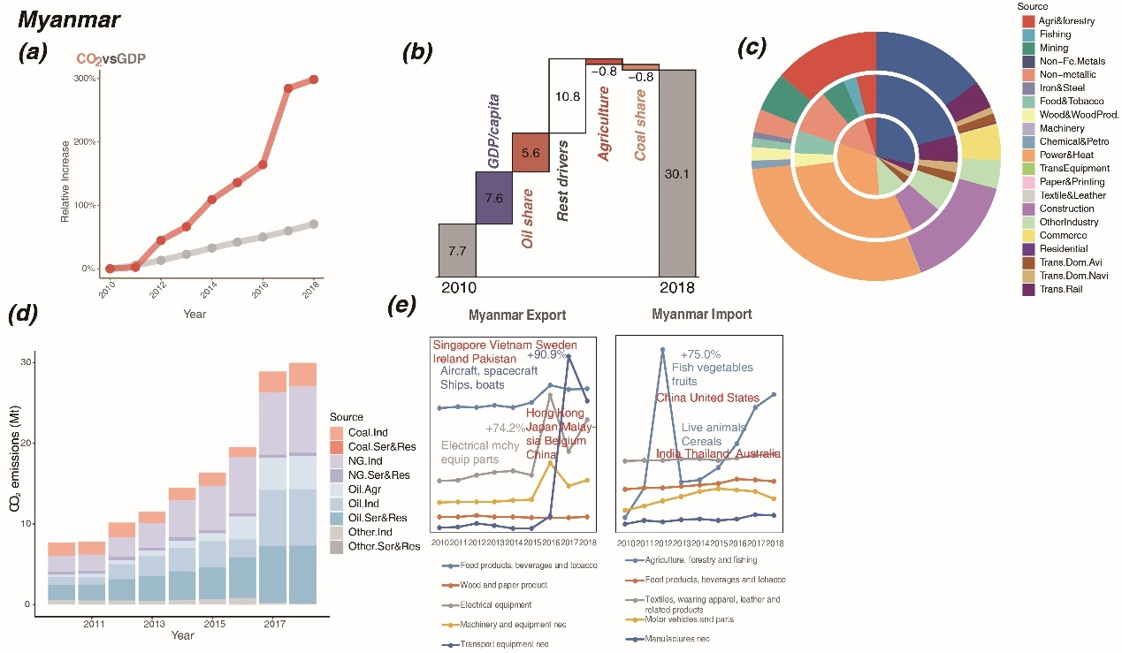
Figure S 9 Relative increase of CO₂ emissions and GDP (a), emissions change of main drivers (b, in Mt), emissions by sector (c, in 2010, 2014 and 2018 from the inner circle to outer ones), emissions by energy and industry (d), and international trade changes (e) of Myanmar.
Ethiopia (Figure 2e): Over 2010-2018, Ethiopia enjoyed an economic boom with an annual growth rate of 10% (84.4 billion dollars in 2018) while at a cost of CO₂ emissions rising by 11% each year. From 2010, Ethiopia experienced the Growth and Transformation Plan (GTP), which encouraged the large-scale foreign investment in agriculture and industry and stimulated economic growth and industrialization. Therefore, with the extraction of minerals (gold, salt, precious stones, fuels, etc.) and the infrastructure development under the GTP, the booming industry and growing GDP per capita became the largest drivers to the emission growth (summed 7.3 Mt increment). As the road and rail transport and power generation were highlighted in the GTP targets, the expanded use of oil in transport and the higher use of coal in manufacture contributed 3.7 Mt emissions. Population growth also drove the emission growth, as the population growth rate of Ethiopia reached 2.7% per year. The upsurge of population leads to the growing demands for resources, products, and services, and therefore stimulates energy consumption and CO₂ emissions. Energy intensity decline, as a result of electrification in commerce and household, led to a 5.3 Mt emission reduction over the period.
(Figure S 10a) CO₂ emissions and GDP
The growth trends of GDP and CO₂ emissions are shown in Figure S 9a. During the last two decades, Ethiopia has undergone huge structural and economic changes. The share of industry in the gross domestic product increased significantly from 9.44% in 2010 to 27.31% in 2018. With a shift from agriculture to manufacturing in recent years, especially following policies which include the Growth and Transformation Plan (GTP), Ethiopia has experienced high economic growth, averaging 9.8% a year from 2010-2018. Rapid economic growth was also underpinned by high levels of foreign direct investment, which stood at $3.6bn in 2017 compared to $109m a decade earlier. In step with economic development, Ethiopia's CO₂ emissions have been growing at a slightly faster pace compared to GDP since 2013, with an average growth rate of 10.8%, indicating the process of industrialization and higher emission intensity²⁶.
(Figure S 10b) Emission drivers
Over 2010-2018, Ethiopia enjoyed an economic boom with an annual growth rate of 10% (84.4 billion dollars in 2018) while at a cost of CO₂ emissions rising by 11% each year. From 2010, Ethiopia experienced the Growth and Transformation Plan (GTP), which encouraged the large-scale foreign investment in agriculture and industry and stimulated economic growth and industrialization. Therefore, with the extraction of minerals (gold, salt, precious stones, fuels, etc.) and the infrastructure development under the GTP, the booming industry and growing GDP per capita became the largest drivers to the emission growth (7.3 Mt increment). As the road and rail transport and power generation were highlighted in the GTP targets, the expanded use of oil in transport and the higher use of coal in manufacture contributed 3.7 Mt emissions. Population growth also drove the emission growth, as the population growth rate of Ethiopia reached 2.7% per year. The upsurge of population leads to the growing demands for resources, products, and services, and therefore stimulates energy consumption and CO₂ emissions. Energy intensity decline, as a result of electrification in commerce and household, led to a 5.3 Mt emission reduction over the period.
(Figure S 10c) Emissions by sector
Transportation accounted for the largest share of emissions, about 50 percent, while nonmetal manufacturing has fastest growth trend. According to the GTP, the government had been renewing focus on natural resource and raw material industries such as gold, oil, gas, potash, and gemstones from 2010, resulting in a huge increase in non-metallic. The export of salt, sulphur, earth & stone and plaster increased over 100 times from 984,446$ (in 2010) to 11,283,813$ (in 2018). Improved cook-stoves, universal electrification, and efficient lighting as measures put in place by Ethiopia, have gone a long way to improve household energy efficiency in recent years. Also, extreme drought since 2015 threw millions of people into famine and other crisis, which led to the sharp decrease in residential consumption and emissions. CO₂ emissions in the power and heat sector have declined as a result of the rapid development of hydropower and the improvement of energy conversion efficiency. Electricity generation by hydro grew from 4931GWh in 2010 to 13018GWh in 2018, and the share of renewables (hydro, wind and solar) in power generation has reached 100% since 2012. Emission shares of agriculture & forestry and commerce remained stable over time.
(Figure S 10d) Emissions by fuel type and industry
Ethiopia’s main energy supply is oil products and coal products, of which oil products are the main source of energy. The main part of Ethiopia's economic plan is to strengthen infrastructure construction. With the rapid development of infrastructure construction in Ethiopia, the industrialization process is constantly advancing, and the demand for cement is increasing. This caused the CO₂ emissions from non-metallic sector has the fast growth. In addition, because Ethiopia is a land locked country, most of the transportation is completed by rod transportation, which lead road transportation has the largest proportion of CO₂ emissions.
(Figure S 10e) Trade pattern
Figure S 9d shows the time series of the trade volume of the sectors with the largest change ratio of import and export in Ethiopia from 2010 to 2018. Ethiopia earns most of its foreign exchange from primary industries, such as coffee, oily seeds and manufacturing products, among which rubber and plastic products saw an apparent increase. Exports of transport services have been growing steadily since 2010. The national airline serves destinations in Ethiopia and throughout the African continent, as well as nonstop service to all over the world. We could see a sharp increase in imports of transportation equipment and industrial products, including aircraft or spacecraft from Germany and United States, railway/tramway locomotive from Belgium, as well as other industrial products such as petroleum oils, fertilizers, nuclear reactors and boilers. The import of transportation equipment increased 77.9% from 2010 to 2018 to support its transportation.
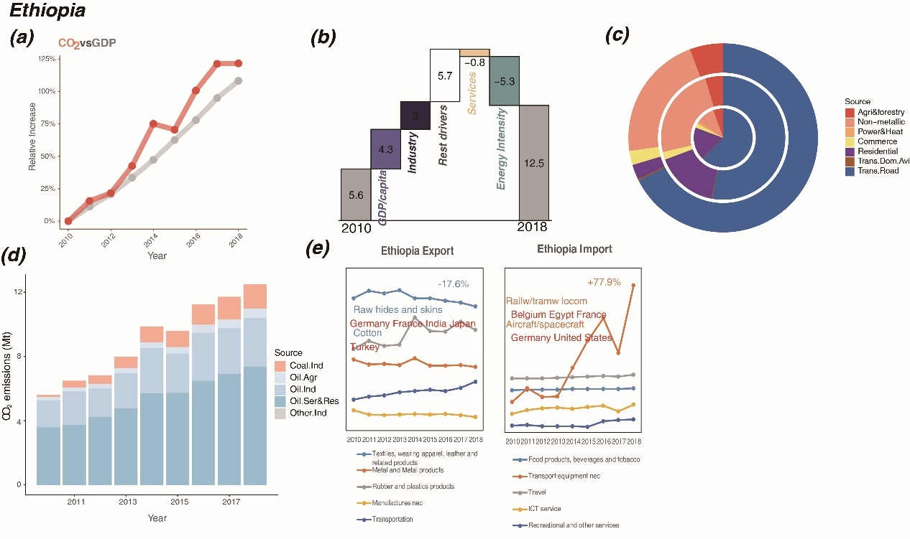
Figure S 10 Relative increase of CO₂ emissions and GDP (a), emissions change of main drivers (b, in Mt), emissions by sector (c, in 2010, 2014 and 2018 from the inner circle to outer ones), emissions by energy and industry (d), and international trade changes (e) of Ethiopia.

Vietnam (Figure 2g): Vietnam experienced rapid growth of both GDP and CO₂ emission at annual growth rates of 6% and 8%, respectively. In 2018, Vietnam’s GDP reached up to 245.2 billion dollars and CO₂ emissions reached to 226.7 Mt. During the journey of Vietnam’s emission surging, the increasing GDP per capita drove the most emission growth (67.8 Mt, 68.1% of the total increment). With fast-growing production and exports of textile, real estate, transport, and electrical equipment parts, Vietnam achieved fast and firm economic growth, in which the industry and services contributed 10 Mt emissions increment, and the related energy consumption turned to coal (in power supply) and oil (in textile and electrical parts production) that led to 36.7 Mt incremental emissions. Population growth drove the emission growth by 14 Mt as well, because of the enlarged household demand of the increased population (from 88 million to 97 million, by 1% per year). To sum up, as one of the largest factories for the world with a carbonized energy structure and large population, Vietnam has great potential to continue to surge its CO₂ emission in the near future.
(Figure S 11a) GDP and CO₂ emissions
The average annual growth rates of Vietnam's GDP and CO₂ emissions from 2010-2018 are +6.21% and +7.54% respectively. And more importantly, the growth rate of CO₂ emissions has begun to increase sharply since 2013, up to 226.5 Mt in 2018. This is mainly due to Vietnam's active trade and opening policy, such as Establishment of ASEAN Free Trade Area(2010), Free trade between Vietnam and South Korea(2015-2016), and carrying out Vietnam Europe free trade negotiations actively. These have attracted a lot of FDI and stimulate the economic growth. Specifically, from 2010 to 2018, the annual compound growth rate of Vietnam's FDI absorption agreement funds will reach 7%, among which, the manufacturing industry's annual compound growth rate of FDI absorption agreement funds is as high as 17%.
(Figure S 11b) Emission drivers
Vietnam experienced rapid growth of both GDP and CO₂ emission at annual growth rates of 6% and 8%, respectively. In 2018, Vietnam’s GDP reached up to 245.2 billion dollars and CO₂ emissions reached to 226.7 Mt. During the journey of Vietnam’s emission surging, the increasing GDP per capita drove the most emission growth (67.8 Mt, 68.1% of the total increment). With fast-growing production and exports of textile, real estate, transport, and electrical equipment parts, Vietnam achieved fast and firm economic growth, in which the industry and services contributed 10 Mt emissions increment, and the related energy consumption turned to coal (in power supply) and oil (in textile and electrical parts production) that led to 36.7 Mt incremental emissions. Population growth drove the emission growth by 14 Mt as well, because of the enlarged household demand of the increased population (from 88 million to 97 million, by 1% per year). To sum up, as one of the largest factories for the world with a carbonized energy structure and large population, Vietnam has great potential to continue to surge its CO₂ emission in the near future.
(Figure S 11c) Emissions by sector
The electricity and heat sectors generate the largest carbon dioxide emissions, and the growth rate of their carbon dioxide emissions is also rapid especially from2016 to 2018. Since 2016, Vietnam's power industry, including renewable energy, has shown signs of stagnation, while Vietnam's economy has maintained rapid growth, and the demand for electricity has also increased. During the period of 2011-2015, the average annual growth rate of Vietnam's electric power investment was 10%, among which the most is in thermal power generation. In 2018, Vietnam's coal-fired thermal power generation accounted for 32.6% of total power generation, which is the main factor of increasing coal consumption.
(Figure S 11d) Emissions by fuel type and industry
Coal is the main energy source of Vietnam and its proportion is still increasing during this research period. In the use of coal, the sectors that use coal the most in Vietnam are power plants, non-metal manufacturing and electrical supply sectors (Figure S 10b). Generally, the usages of coal have increased by 53.5% from 2010 (23.4Mt) to 2018(35.9Mt). However, during this period, there have a fluctuation. Since 2013, the use of coal in these sectors has risen. However, since 2016, there has been a gradual flattening or even a downward trend. This mainly because the supply of domestic coal has fallen (Vietnam’s domestic coal production declined 3.1% in 2016 compared to 2015), and the amount of imported coal has not met the gap. At the same time, it is worth noting that the growth output of the textile and apparel industry, so-called high load energy industry, lead the fossil fuel consumption rise. CO₂ emissions from the combustion of petroleum products are slightly increased from 2010 to 2018.Transportation consumes the largest proportion of oil. This can be ascribed to the policies of vigorously develop the domestic transportation industry. From 2010-2018, the oil used in transportation has growth from 11.2Mt in 2010 to 11.8Mt in 2018, by rate of 5.06%.
(Figure S 11e) Trade pattern
From the perspective of Vietnam's import side, Vietnam imported a large number of transportation equipment such as railways, trams and passenger cars from 2010-2018, from 24.7 million dollars in 2010 to 49.1 million dollars in 2018 (especially after 2013, mainly due to Vietnam's "North-South High-Speed Railway Program") .At the same time, in addition to continuing to increase exports from the traditional textile and apparel industry during 2010-2018, Vietnam's exports of electrical equipment components are also growing rapidly.

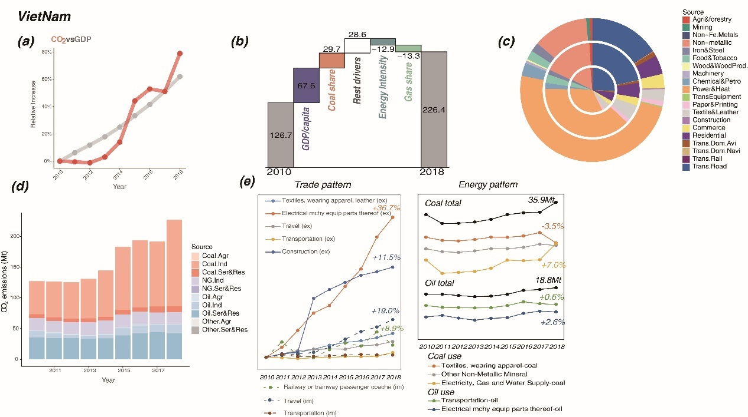
Figure S 11 Relative increase of CO₂ emissions and GDP (a), emissions change of main drivers (b, in Mt), emissions by sector (c, in 2010, 2014 and 2018 from the inner circle to outer ones), emissions by energy and industry (d), and international trade changes (e) of Vietnam.

Uganda (Figure 2 a): Uganda maintained a 5% annual average growth rate in GDP in 2010-2018 under its Five-Year Plans. In 2018, its GDP reached up to 27.5 billion dollars, increasing by around 1.85 times than that in 2010. At the same time, with the boom of domestic economic activities, the carbon emissions also gradually increase year by year with an annual average growth rate of 6%, increasing to 5 Mt by 1.45 times than 2010. Increased population and oil consumption are the main impetus driving the growth of emissions in Uganda, which contributes 37.0% (1.1Mt) and 27.6% (0.8Mt) to CO₂ emission increment, respectively. Uganda maintains a 3.6% annual average population growth rate over 2010-2018, and its net population growth totals 10.29 million. Over the period, oil consumption increased with an annual growth rate of 7.1%, which gives rise to the increase of CO₂ emissions as well. Apart from that, the economic expansion effect and the development of services also make for the growth of CO₂ emissions during the research period. The output of the services increased by 32 times over 2010-2018, mainly driven by the rising transport sector. Investments in renewable energy benefited Uganda in lower energy intensity and that led to 1 Mt less emission over the period.
(Figure S 12a) GDP and CO₂ emissions
Uganda maintained 5.1% annual average growth rate in GDP in 2010-2018. In 2018, its GDP reached up to 122694 billion shillings at 2016 constant price, increasing by around 1.46 times than that in 2010. It is primarily ascribed to overseas financial aid to Uganda and also the industrial policy of the Uganda government. As of the 21st century, the Uganda government takes active measures to execute the policies promulgated by IMF and the World Bank, which greatly attracts the financial aid from more foreign countries. In addition, Uganda begins to implement its new five-year national plan since 2010, and successfully schemes the new national development plan in 2015. By emphasizing the development of agriculture, energy, service industry and strategic infrastructure, the plan is aimed at advancing the economic growth of the country, in particular the service industry. At the same time, with the boom of domestic economic activities, the carbon emissions also gradually increase year by year with an annual average growth rate of 5.9%, increasingly to 4.8 Mt by 1.45 times than 2010.
(Figure S 12b) Emission drivers
Uganda maintained a 5% annual average growth rate in GDP in 2010-2018 under its Five-Year Plans. In 2018, its GDP reached up to 27.5 billion dollars, increasing by around 1.85 times than that in 2010. At the same time, with the boom of domestic economic activities, the carbon emissions also gradually increase year by year with an annual average growth rate of 6%, increasing to 5 Mt by 1.45 times than 2010. Increased population and oil consumption are the main impetus driving the growth of emissions in Uganda, which contributes 37.0% (1.1Mt) and 27.6% (0.8Mt) to CO₂ emission increment, respectively. Uganda maintains a 3.6% annual average population growth rate over 2010-2018, and its net population growth totals 10.29 million. Over the period, oil consumption increased with an annual growth rate of 7.1%, which gives rise to the increase of CO₂ emissions as well. Apart from that, the economic expansion effect and the development of services also make for the growth of CO₂ emissions during the research period. The output of the services increased by 32 times over 2010-2018, mainly driven by the rising transport sector. Investments in renewable energy benefited Uganda in lower energy intensity and that led to 1 Mt less emission over the period.
(Figure S 12c) Emissions by sector
According to the circular chart, it can be seen that the major emission sector in Uganda is the transportation sector especially the rood transportation. This is because road transportation carries about 95% of the country's cargo transportation and about 99% of passenger transportation²⁷. What’s more, CO₂ emissions of the road transportation and its share are increasing from 2010-2018. This is due to the Uganda Road Sector Support Initiative (URSSI) implemented in 2010, the investment of road transportation increased from 2000 million dollars in 2011 to about 9500 million dollars in 2017 with 21.5% average growth rate²⁸. In addition, the proportion of CO₂ emissions from the power and heating industry has shown an overall trend of increasing first and then decreasing during the period 2010 to 2018.This mainly because the Uganda electricity system partly relied on the hydrogen power, which is easily affected by climate change. During drought period (2011-2012), due to the drop in the water level of Lake Victoria, the hydroelectric power plant can only use about half of the installed capacity, resulting in inadequate domestic electricity supply. Uganda increase thermal power generation about 150MW in order to fill the power demand gap, which also increased the CO₂ emissions in electricity heat sector. However, after the successful construction of the Bujagali 250MW hydropower plant in 2012²⁹ and the water level of Lake Victoria is in a stable state. The Ugandan government gradually reduced the amount of electricity generated by thermal power plants and then hydropower accounts for about 75.6% of the total installed capacity of 983MW in 2018²⁹. And therefore, only when hydroelectric power generation is insufficient to meet the electricity demand during periods of drought, the operation of thermal power generation will be increased in order to maintain power grid steady. As a result, the CO₂ emissions generated by the power sector in Uganda show to increase first and then decrease.
(Figure S 12d) Emissions by fuel type and industry
As can be seen from the Emissions by fuel type and industry, oil is the only energy consumption category in Uganda. Between 2010 and 2018, CO₂ emissions from oil consumption increased in fluctuations. In 2011-2012, there was a very significant decline of CO₂ emissions. This is because a severe drought in Uganda in 2011. The drop in water levels led to a shortage of hydroelectric power, which is unable to meet the supply of industrial electricity. In other words, industrial production was affected to a certain extent, which inevitably led to a decline of CO₂ emissions from the second industry. Another aspect, it had a major impact on agricultural sector production, resulting in a significant decline in the harvest of agricultural products that year. As the climate stabilized after 2012, industrial production gradually returned to steady growth. More importantly, the CO₂ emissions emitted by service and residential sector accounts for more than half of the total and increase steadily in Uganda during the research period. This is mainly due to population and service output increase. Uganda maintains 3.6% annual average population growth rate in 2010-2018, and its net population growth totals 10.29 million³⁰. The upsurge of population leads to the growing demands for resources, products and services, and therefore stimulates energy consumption and CO₂ emissions. On another side, that is benefited by Uganda’s stable political environment and its development policies for the service industry in 2010-2018, during which the output value of the service industry increased from 32225 billion to 52946 billion shillings at 2016 constant price, and corresponding proportion in GDP also reached 43.15% in 2018. And therefore, the demand for fuel brought by population and the government's strong industrial policies have led to a steady increase in CO₂ emissions from the service and residential sector during this period.
(Figure S 12e) Trade pattern
In terms of foreign trade, Uganda’s main exports goods are gold and related products (39.6%), followed by coffee and other economic crops (11.7%), and the main exporting countries are the United Arab Emirates and Kenya³¹. Since 2016, gold exports have rocketed in the Uganda exceeding the coffee became the largest export goods, and gold worth 1.68 billion dollars was shipped out of Uganda in 2018– over 60 times what the country was exporting a decade. This is because that the Uganda cancel the gold export tax in 2014 and African Gold Refinery (AGR) was built and operated in 2015³², a first gold production and refiner in east Africa, which is also the main reason for Uganda’s gold production surge. Additionally, Uganda is located in the most fertile land in Africa and close to Lake Victoria, which provides favorable growth conditions for economic crops such as coffee and cotton. Uganda has a large agricultural population, up to 74%, which provides sufficient cheap labor for Uganda’s agricultural production. These have made Uganda's agricultural products of high quality and low price, attracting overseas customers. Furthermore, during this period the manufacturing for aviation and components export has the fastest growth especially after 2016. This is principally because Uganda and Russia jointly established Pro Heli International Service Limited in 2016, a helicopter and maintenance parts manufacturing company, mainly for Russian armed helicopter parts. In terms of import goods³³, 2018 UN customs data showed that Uganda mainly imported petroleum products from the UAE and Saudi Arabia, accounting 17.4% of the total, and imported packaged medicines from India (3.93%)⁵. As for importing countries, Uganda’s largest importing country is China, with a total import value of over US$1.15 billion, including broadcasting equipment (18%) and mobile phones (4.98%). To sum up, Uganda’s main export and import goods are gold and oil respectively. The largest exporter is the UAE, and importer is China.

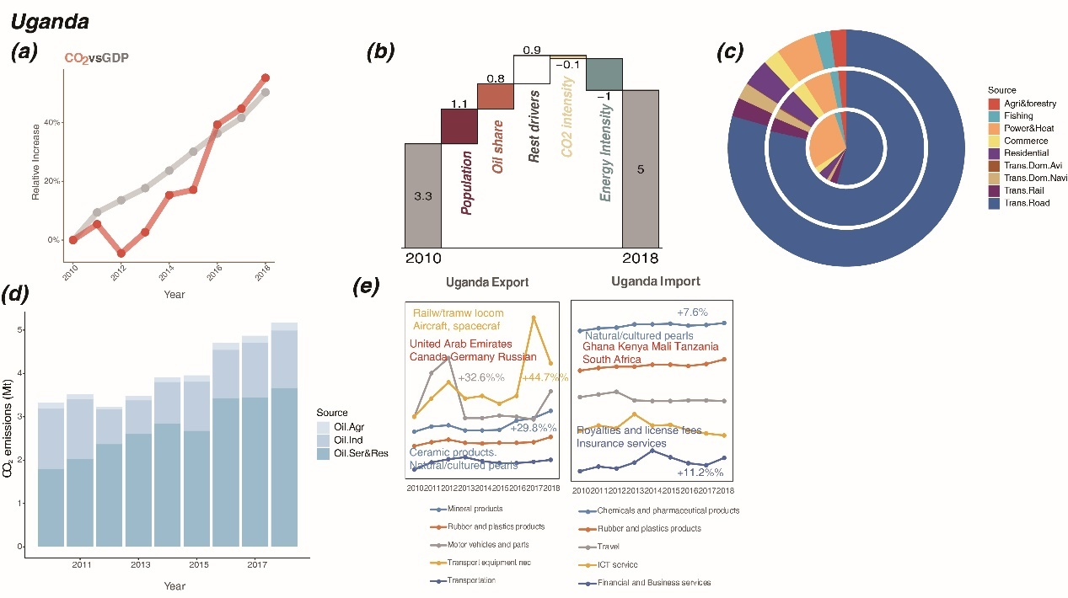
Figure S 12 Relative increase of CO₂ emissions and GDP (a), emissions change of main drivers (b, in Mt), emissions by sector (c, in 2010, 2014 and 2018 from the inner circle to outer ones), emissions by energy and industry (d), and international trade changes (e) of Uganda.

Mongolia (Figure 2 c): Over 2010-2018, under a stable domestic political situation after the 2009 presidential election, Mongolia experienced rapid economic growth with an average annual growth rate of 8%, and its GDP reached 13.1 billion dollars mainly driven by exports (metals and fuels to China). Meanwhile, CO₂ emissions of Mongolia underwent a rising trend with a cliff-like decline (due to unstable domestic policies, investment, and low price of bulk products in the international market), which showed an average annual growth rate of 5%. GDP per capita, population, and industry are the main drivers of Mongolia’s emission growth. As the pillar industry of the national economy, the mining industry is the essential engine for economic growth: in 2014, mining output value accounted for about 30% of Mongolia’s GDP; the development of such a pillar industry is also crucial for the CO₂ emission growth. As of 2018, Mongolia’s coal production reached a record high of over 50 million tons, and coal export also reached a record high of 36.3 million tons. That also contributed to the incremental emission of 4.3 Mt driven by industry growth. Mongolia’s population is a major cause of carbon emissions for household consumption due to the poor natural conditions, the cold climate, and the traditional means of heating. It is worth noting that the contribution of energy intensity to carbon emissions has decreased significantly(-11Mt) due to the energy efficiency improvement project of Ulan Bator cogeneration units.
(Figure S 13a) GDP and CO₂ emissions
According to the results of study period, the CO₂ emissions of Mongolia shown in Figure S 12a from 2010 to 2018 are basically consistent with the GDP growth level, showing a high-speed upward trend in general, and the GDP growth rate is significantly higher than carbon dioxide emissions. To be more specific, GDP in 2010 was 7.19 bills of US dollars, and in 2018 it was 13.11 bills of US dollars³⁴, with an average annual growth rate of 7.96%. The rapid growth of Mongolia is due to the fact that after the 2009 presidential election, the domestic political situation is basically stable, and the authorities have insisted on taking the road of stable development to provide a political foundation for economic prosperity. In addition, with the gradual weakening of the impact of the global financial crisis, the global mining industry out of the trough, and the rising price of mineral products in the international market, Mongolia’s economy has recovered rapidly. Moreover, with the implementation of the strategy of “invigorating the country through mining”, the national economy has developed rapidly under the guidance of mining development, meanwhile, carbon emissions increased. However, due to the single industrial structure of Mongolia, once affected by the economic cycle and changes in the international market, the economic situation is relatively unstable. During 2013-2015, affected by internal factors such as unstable domestic policies and investment environment, as well as external factors such as the continuous low price of bulk products in the international market, the economic situation deteriorate rapidly, as a result, the growth rate of the national economy slowed down significantly. At the same time, the carbon dioxide emissions showed a cliff-like decline, but it began to recover slowly in 2016.
(Figure S 13b) Emission drivers
Over 2010-2018, under a stable domestic political situation after the 2009 presidential election, Mongolia experienced rapid economic growth with an average annual growth rate of 8%, and its GDP reached 13.1 billion dollars mainly driven by exports (metals and fuels to China). Meanwhile, CO₂ emissions of Mongolia underwent a rising trend with a cliff-like decline (due to unstable domestic policies, investment, and low price of bulk products in the international market), which showed an average annual growth rate of 5%. GDP per capita, population, and industry are the main drivers of Mongolia’s emission growth. As the pillar industry of the national economy, the mining industry is the essential engine for economic growth: in 2014, mining output value accounted for about 30% of Mongolia’s GDP; the development of such a pillar industry is also crucial for the CO₂ emission growth. As of 2018, Mongolia’s coal production reached a record high of over 50 million tons, and coal export also reached a record high of 36.3 million tons. That also contributed to the incremental emission of 4.3 Mt driven by industry growth. Mongolia’s population is a major cause of carbon emissions for household consumption due to the poor natural conditions, the cold climate, and the traditional means of heating. It is worth noting that the contribution of energy intensity to carbon emissions has decreased significantly(-11Mt) due to the energy efficiency improvement project of Ulan Bator cogeneration units.
(Figure S 13c) Emissions by sector
According to the Emission by sector, the main sectors emitted CO₂ are the power and heat industry, households and transportation. Their emission proportions have not changed significantly for many years (2010, 2014, 2018) accounting for about 72%, 8%, and 7% respectively and emissions from these sectors increased steadily. The main reason is that economic structure and energy structure used by sectors in Mongolia have no changes during this period. Additionally, the CO₂ emissions from the power and heat industry is still growing the most. Because the Mongolian government has committed to accelerating the construction speed of national power infrastructure, by putting forward a series of plans of reconstruction or expansion of existing power and construction of new power, in order to solve the low efficiency of power sector facilities and shortage of power supply, which restricts economic development. More specifically from 2012 to 2018, Mongolia's installed power generation capacity increased by 30%, among which thermal power installed capacity increased by 40% and the number of power users increased by 4%. In 2018, the installed electric power capacity of Mongolia was 1.1 million kilowatts, of which 93% was thermal power generation, and 5.8% relied on imports. The growth of CO₂ emissions generated by the transportation sector is the second only to the electricity and heating sector, with the largest increase from railway sector. In 2010, the Mongolian parliament passed the national railway transportation construction plan, which proposed to build 5683.5 km new railway infrastructure in stages³⁵. After completion, the railway transportation capacity in Mongolia will be greatly improved, and the railway direct transportation from, Naryn Sukhait and Tavan Tolgoi coal mine, Oyu tolgoi copper and gold mine, and other large mining areas in southern Gobi province of Mongolia to Mongolia border port will be realized.
(Figure S 13d) Emissions by fuel type and industry
Figure S 12c shows that the CO₂ emissions of Mongolia mainly comes from coal industry and natural gas industry. This is due to the fact that the reserves of coal and oil shale in the country are in the forefront of the world, and coal combustion is the main way to provide electricity and heat energy for local residents. At the same time, in 2013, the Mongolian government proposed to build "five channels" connecting China, Mongolia and Russia, such as railways, highways, oil, electricity and natural gas, and expand trans Mongolian railways and natural gas pipelines to form a comprehensive emission. However, due to the coal industry is the pillar industry of Mongolia, coupled with the lack of domestic funds, the construction of energy transportation system and renewable energy development in Mongolia is slow
(Figure S 13e) Trade pattern
In terms of foreign trade, Mongolia's exports are mainly livestock products and mineral products³⁶, and mineral products accounted for more than 70 percent of the total exports of Mongolia. This is because Mongolia's economy is mainly dependent on animal husbandry and mining. Additionally, Mongolia's industry is backward and most of its industrial products need to be imported, in order to meet the needs of social development and daily consumption of residents. And therefore, imports include a wide range of consumer and industrial products, such as transport, construction machinery, electrical and electronic products, refined oil, grain, daily necessities, etc. More specially, from 2013 to 2018, the import and export of financial and commercial services grew rapidly. This is due to the increasingly improved domestic investment environment and the in-depth advancement of the "Belt and Road" initiative, which promoted the deepening of regional financial and monetary cooperation. At the same time, imports of vehicles (such as cars and trains, etc.) have also risen significantly. The reason is that the population growth of Ulaanbaatar and other major cities has led to a substantial increase in their car imports, while the large increase in freight vehicles is mainly due to the recovery of mining development. Mongolia has carried out bilateral trade with many countries or regions around the world, and its main exporters are China, Russia, Ukraine, the United States, Canada and other countries. China is the largest trading partner of Mongolia, with a trade volume of nearly 8 billion of US dollars in 2018.
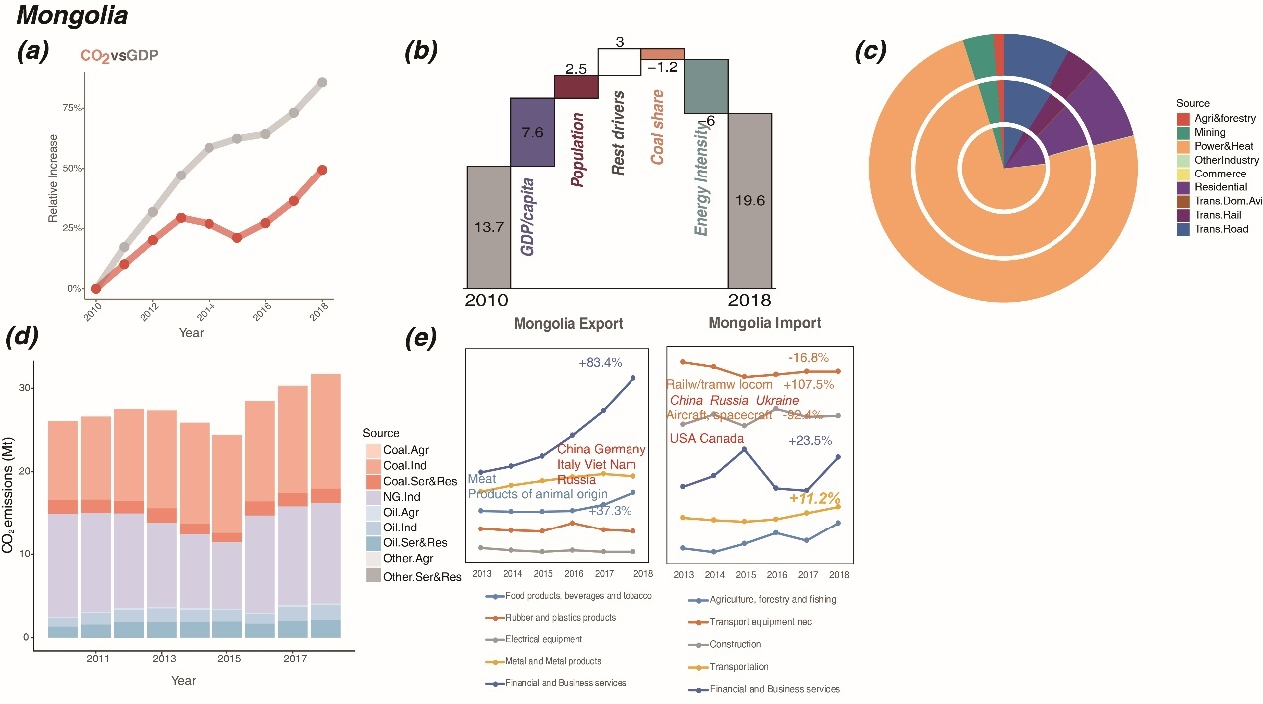
Figure S 13 Relative increase of CO₂ emissions and GDP (a), emissions change of main drivers (b, in Mt), emissions by sector (c, in 2010, 2014 and 2018 from the inner circle to outer ones), emissions by energy and industry (d), and international trade changes (e) of Mongolia.

Peru (Figure 2 b): From 2010 to 2018, Peru's GDP grew at a speed of 4.3% per year, nearly twice as the carbon emissions growth (2.4%). GDP per capita and population growth are the two main factors driving Peru's CO₂ emission growth. The GDP increased to 222 billion dollars in 2018, resulting from the national infrastructure construction such as transportation highlighted by the Peruvian government: in the past ten years, the Peruvian government has implemented a series of supportive policies including investment, funding, and infrastructure construction to stimulate economic growth which directly improve national economic growth. Meanwhile, with the fast increase of population growth rate from 2010 to 2018 (0.7% in 2010, to 1.5% in 2018), the population growth is undoubtedly the second biggest contributor to Peru's domestic carbon emissions. The absolute increase in the Peruvian population, in part, is due to the young population structure, while another considerable reason is immigration growth. More and more migrants from other countries come to Peru, especially from Venezuela. By 2018, more than three million immigrants have been officially accepted by the Peruvian government. Foreign immigrants will become the future of energy consumption and carbon emissions contributor in Peru. Besides, the expanded transport, household, and commerce sectors contributed to the incremental emission from services, and also pulled the oil consumption, thus the services and the oil use drove a 3.5 Mt CO₂ emission increment.
(Figure S 14a) GDP and CO₂ emissions
From 2010 to 2018, Peru's GDP grew more than 40%, nearly twice as the carbon emissions growth (20%). There was a significant fall in CO₂ emissions in 2017, followed by a slight rise in 2018, but overall growth was much slower than GDP, so Peru was in the sustainable growth category over the past decade.
(Figure S 14b) Emission drivers
From 2010 to 2018, Peru's GDP grew at a speed of 4.3% per year, nearly twice as the carbon emissions growth (2.4%). GDP per capita and population growth are the two main factors driving Peru's CO₂ emission growth. The GDP increased to 222 billion dollars in 2018, resulting from the national infrastructure construction such as transportation highlighted by the Peruvian government: in the past ten years, the Peruvian government has implemented a series of supportive policies including investment, funding, and infrastructure construction to stimulate economic growth which directly improve national economic growth. Meanwhile, with the fast increase of population growth rate from 2010 to 2018 (0.7% in 2010, to 1.5% in 2018), the population growth is undoubtedly the second biggest contributor to Peru's domestic carbon emissions. The absolute increase in the Peruvian population, in part, is due to the young population structure, while another considerable reason is immigration growth. More and more migrants from other countries come to Peru, especially from Venezuela. By 2018, more than three million immigrants have been officially accepted by the Peruvian government. Foreign immigrants will become the future of energy consumption and carbon emissions contributor in Peru. Besides, the expanded transport, household, and commerce sectors contributed to the incremental emission from services, and also pulled the oil consumption, thus the services and the oil use drove a 3.5 Mt CO₂ emission increment.
(Figure S 14c) Emissions by sector
The road transport sector is Peru's main emitter, and its emissions are growing fast, especially from 2014 to 2018.It is due to the low turnover rate of the fleet, poor driving habits, insufficient traffic regulations and lack of vehicle maintenance. Additionally, a very bad fuel price policy that does not promote the use of clean fuels. Specially, Peru uses stabilization fund to ease price of fossil fuel volatility. Additionally, CO₂ emissions from shipping and air transport have also increased. Peruvian government is constantly promoting the renovation and expansion of the coastal railway. On shipping transportation, government also works on a port expansion to meet the needs of commercial shipping. For example, the expansion of Port of Callao and the new construction of Port of Paita. Overall CO₂ emissions in the transportation sector increased sharply from 2010 to 2018.
Meanwhile, with the fast increase of population growth rate from 2010 to 2018 (0.7% in 2010, to 1.5% in 2018), makes residential energy consumption the second increase to CO₂ emissions. The absolute increase in the Peruvian population, in part, is due to the young population structure, a large proportion of population are of childbearing age. Another reason is immigration. More and more migrants come to Peru, especially from Venezuela. By 2018, more than three million immigrants have been officially accepted by the Peruvian government. Among them, there are 800,000 international migrants from Venezuela and this number is still growing. Foreign immigrants become the energy consumption and carbon emissions contributor of Peru from 2014 to 2018.
(Figure S 14d) Emissions by fuel type and industry
On the whole, Peru's energy structure has remained stable during this research period. The main energy sources of Peru are natural gas and oil. Peru's oil production is not enough to meet domestic demand. Due to its limited refining capacity, Peru exports crude oil and imports refined oil. Natural gas is mainly used for power generation, automobile fuel and household fuel. In recent years, Peru has been increasing its efforts to explore and develop oil and gas resources, and has signed sixty-eight oil and gas exploration and development contracts in Peru's coastal, mountainous and rainforest areas. The main oil field is Tarala oil field along the northern Pacific coast, and the largest gas field is Camisea gas field in the southeast. In November 2014, PetroChina completed the delivery of major oil and gas assets of Petrobras in Peru, becoming the largest oil company in Peru, accounting for more than half of oil production.
(Figure S 14e) Trade pattern
In terms of foreign trade, Peru had a significant increase in the import of transportation equipment such as railway equipment from China, Spain, Italy, Mexico, and Brazil. The wide application of these vehicles has led to the fast growth of Peru’s transport emission. Great importance the Peruvian government lays on national transportation infrastructure construction. For export, ships and boats are the main export vehicle commodities, especially during 2010-2014. Additionally, the export of motor vehicles has the largest growing, increased by 22.1% from 2010 to 2018.
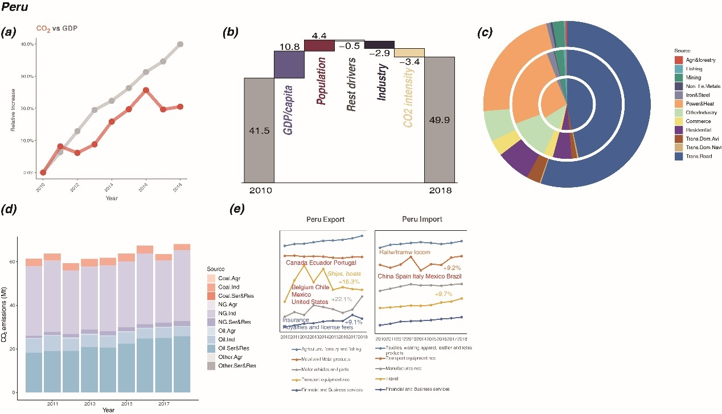
Figure S 14 Relative increase of CO₂ emissions and GDP (a), emissions change of main drivers (b, in Mt), emissions by sector (c, in 2010, 2014 and 2018 from the inner circle to outer ones), emissions by energy and industry (d), and international trade changes (e) of Myanmar.

CO₂ emissions under scenarios over 2020-2040
2.3.1 CO₂ emissions over COVID period under different lockdown scenarios
The COVID-19 impact to emission is covered during 2020-2024, under scenarios including 1) the baseline scenario, 2) the mildest COVID lockdown scenario, 3) the default COVID lockdown scenario, and 4) the severe COVID lockdown assumption, which were defined in section 1.1. After 2024 with each scenario of COVID impact, supposing the COVID is defeated and countries return to normal development, we designed three scenarios including the Weak Policy scenario, Low Carbon scenario, and Extreme Low Carbon scenario (for details, see section 1.2). Here we described how the different COVID lockdown scenarios affect the emerging emitters’ CO₂ emissions, taking Myanmar, Ethiopia, Vietnam, Uganda and Peru as examples. Detailed emissions estimations of the COVID period and post-COVID period are in the supplementary data (section 3).
COVID impact causes a visible decline to the sum of the countries’ emissions. Compared to the baseline scenario without COVID, the emissions under the default COVID lockdown scenario also dropped by nearly 22% at the first lockdown and took a longer time to recover to nearly 96% of the baseline level. While the emissions under the scenario of the mildest COVID lockdown dropped by nearly 22% at the first lockdown and then took two years to recover to the baseline level, and the emissions under the severe COVID lockdown scenario undergoes eight times of drop and rise from 2020 to 2024, and reaches the valley of 66% of the baseline level in 2023; after the eighth severe lockdown, the emissions surges to nearly 92% of the baseline level in 2024.
Myanmar is projected to experience a slow growth from 2020 to 2024 without COVID impact, and the emissions under the default lockdown scenario drop by about 25% as well and recover to 96% of the baseline level; while the emissions under the mildest lockdown scenario drop by about 25% at the first lockdown, and revive to the baseline level in 2022; and the emissions under the severe lockdown scenario declines by nearly 36% after four-year-long drops and rises, and recovers to nearly 93% of the baseline level.
Ethiopia is projected to experience a moderate growth from 2020 to 2024 without COVID impact, and the emissions under the default lockdown scenario drop by about 25% as well and recovers to 96% of the baseline level in 2024. While the emissions under the mildest lockdown scenario drop by about 25% at the first lockdown, and back to the baseline level in 2022; and the emissions under the severe lockdown scenario declines by nearly 36% after four-year-long drops and rises, and recovers to nearly 92% of the baseline level.
Vietnam is projected to maintain a rapid growth from 2020 to 2024 without COVID impact, and the emissions under the default lockdown scenario drops by about 10% as well and recover to 95% of the baseline level. While the emissions under the mildest lockdown scenario drop by about 9% at the first lockdown, and revive to the baseline level in 2022; and the emissions under the severe lockdown scenario declines by nearly 36% after three-year-long drops and rises, and recovers to nearly 87% of the baseline level.
Uganda is projected to experience a slow growth from 2020 to 2024 without COVID impact, and the emissions under the default lockdown scenario drop by about 25% as well and recover to 96% of the baseline level. While the emissions under the mildest lockdown scenario drop by about 25% at the first lockdown, and revive to the baseline level in 2022; and the emissions under the severe lockdown scenario declines by nearly 35% after three-year-long drops and rises, and recovers to nearly 92% of the baseline level.
Peru is projected to experience a steady increase from 2020 to 2024 without COVID impact, while the emissions under the default lockdown scenario drop by about 40% as well and recover to 98% of the baseline level; while the emissions under the mildest lockdown scenario drop by about 40% at the first lockdown, and revive to the baseline level in 2022; and the emissions under the severe lockdown scenario declines by nearly 47% after three-year-long drops and rises, and recovers to nearly 95% of the baseline level.
The post-COVID emissions of the case countries and the sum of the 59 countries can be considerably influenced by the COVID lockdown impact; they are delayed by the COVID by 3-8 years under the default and the severe lockdown scenarios. However, the trend is not defeated, and the emissions soon surge back to the normal trajectory. Detailed emissions rebounding growth are in the supplementary data (section 3.3).
2.3.2 CO₂ emissions over 2020-2040 and the 1.5 degree target
According to our projection, if the emerging emitters follow the default lockdown scenario for COVID period (2020-2024) and the Weak Policy scenario for post-COVID period (2025-2040), the magnitude of emissions from these emerging emitters will strain the limits of the remaining budget of emissions that would avoid 1.5℃ warming³⁷, leaving very limited carbon space for other countries, as shown in Figure S 15. Fast carbonization of the 59 emerging emitters would require significant space by 2040 and leaves small room for other countries if the 1.5℃ (Fig. 4d) target is to be met.
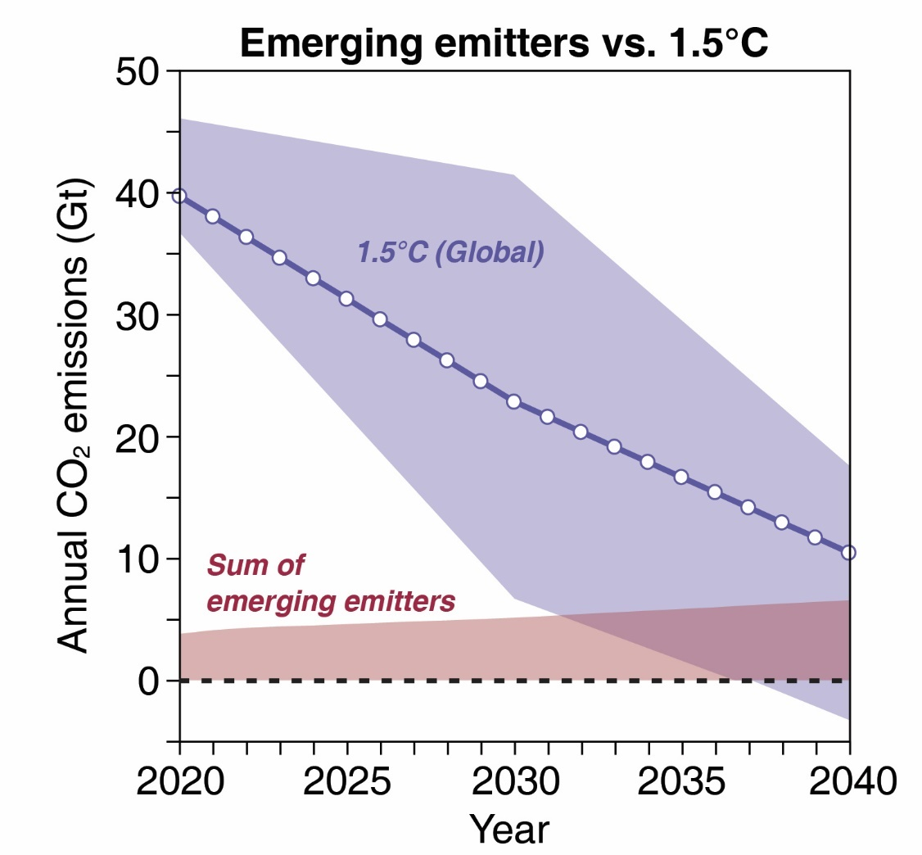
Figure S 15 CO₂ emissions of emerging emitters over 2020-2040, under the default lockdown scenario for COVID period and Weak Policy scenario for post-COVID period.

The comparison between updated WPS data and SSPs data
We selected SSP2 pathway from the GAINS model that inherited CO₂ emissions results of IIASA MESSAGE model, which usually represents the development along historical patterns. However, GAINS only provides emissions data of major economies but does not cover every country, thus, we further have separated those emerging emitters from the aggregated regions and updated their emission trends in terms of historical data. Although the emerging emitters surge the emissions recently, it is the first time that the future emissions trends of the emerging emitters are updated. Figure S 14 shows the CO₂ emissions of history, under the scenario of no-COVID baseline, weak policy, and the downscaled scenarios of SSP1 and SSP5 from AIM/CGE model and SSP2 scenario from GAINS model. Generally, the emissions estimated by GAINS model are lower than that by AIM/CGE model, and the emissions estimated in this work, i.e. under scenarios of baseline and weak policy, are more consistent with the historical trend. Country-specific comparisons between scenarios are provided as follows.

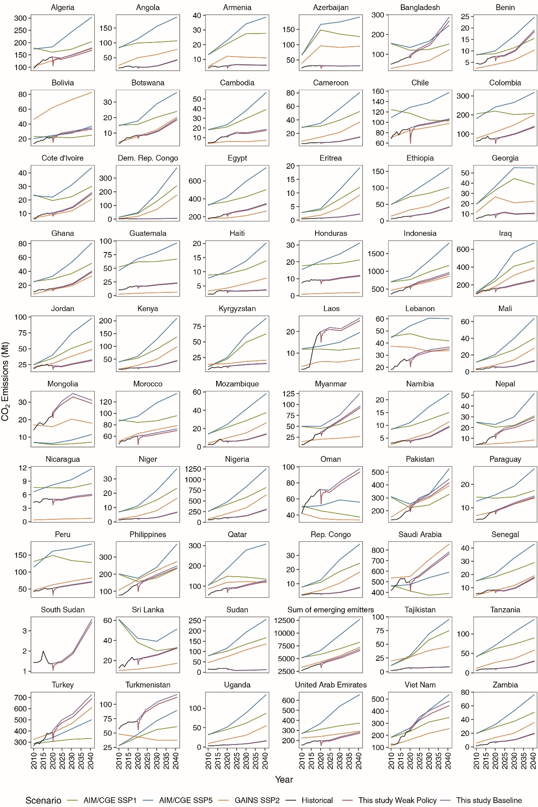
Figure S 16 CO₂ emissions comparison among scenario sets: sum of emerging emitters. The green line and the blue line show the estimation under SSP1 and SSP5, respectively, both from AIM/CGE model. The orange line shows the estimation under SSP2 from GAINS model. The black line shows the history emissions sourced from International Energy Agency (IEA), and the purple line and the red line show emissions of the no-COVID baseline and the default-COVID-WPS scenarios, respectively.

Algeria: The emissions estimated by GAINS model are lower than that by AIM/CGE model, and the emissions adjusted in this work (no-COVID baseline) are close to that from GAINS SSP2.
Angola：The emissions estimated by GAINS model are lower than that by AIM/CGE model，but higher than the emissions adjusted in this work (no-COVID baseline and the default-COVID-WPS scenarios).
Armenia：The emissions estimated by GAINS model are lower than that by AIM/CGE model，but higher than the emissions adjusted in this work (no-COVID baseline and the default-COVID-WPS scenarios). In addition, the emission trend after 2020 estimated by the GAINS model and this work is relatively flat.
Azerbaijan：The emissions estimated by AIM/CGE SSP1 show a downward trend after 2020, but are still higher than the emissions estimated by the GAINS model; the carbon emissions estimated by this work (no-COVID baseline and the default-COVID-WPS scenarios) lower than the emissions estimated by the GAINS model.
Bangladesh: The emissions estimated by the GAINS model are lower than other scenarios and will increase rapidly after 2030; the emissions estimated by this work (no-COVID baseline and the default-COVID-WPS scenarios) will increase rapidly after 2020, and exceed SSP1 and SSP5 scenarios calculated by the AIM/CGE model.
Benin: The emissions estimated by GAINS model are lower than other scenarios, and increase rapidly after 2030; the emission estimated by this work (no-COVID baseline and the default-COVID-WPS scenarios) shows an increasing trend after 2020, and accelerates after 2030, which gradually exceeds that from AIM/CGE SSP1, but is lower than that from AIM/CGE SSP5.
Bolivia: The emissions estimated by GAINS SSP2 are much higher than other scenarios, and the emissions adjusted in this work (no-COVID baseline and the default-COVID-WPS scenarios) are slightly higher than that from AIM/CGE SSP1.
Botswana：The emissions estimated by GAINS model are lower than that by AIM/CGE model，and a bit higher than the emissions adjusted in this work (no-COVID baseline and the default-COVID-WPS scenario).
Cambodia: The emissions adjusted in this work (no-COVID baseline and the default-COVID-WPS scenarios) are lower than that by AIM/CGE model, and the emissions estimated by GAINS SSP2 are lower than other scenarios.
Cameroon: The emissions estimated by GAINS model are lower than that by AIM/CGE model and will increase rapidly after 2030, and the emissions estimated by this work (no-COVID baseline and the default-COVID-WPS scenarios) are lower than that from AIM/CGE and GAINS model.
Chile: The carbon emissions estimated by AIM/CGE SSP5 have been on an upward trend, while that by AIM/CGE SSP1 have shown a downward trend, and are ultimately lower than the emissions estimated by this work (no-COVID baseline and the default-COVID-WPS scenarios), and the emissions estimated by GAINS SSP2 are a bit lower than that from this work.
Colombia: The emissions estimated by GAINS SSP2 are lower than that by AIM/CGE model, and higher than the emissions estimated by this work (no COVID baseline and the default COVID-WPS scenario).
Cote d'Ivoire: The emissions estimated by this work (no COVID baseline and the default COVID-WPS scenario) are lower than that by AIM/CGE model, and the emissions estimated by GAINS SSP2 are a bit lower than that from this work.
Dem. Rep. Congo: The emissions estimated by AIM/CGE and GAINS model are on an increasing trend, and the emissions estimated by GAINS are lower than the estimation under SSP1 and SSP5 both from AIM/CGE model; the emissions estimated by this work have basically maintained to 0Mt.
Egypt: The emissions estimated by this work (no COVID baseline and the default COVID-WPS scenario) are lower than that by AIM/CGE model, and the emissions estimated by GAINS SSP2 are lower than that from this work.
Eritrea: The emissions estimated by GAINS SSP2 are lower than that by AIM/CGE model, and higher than the emissions estimated by this work (no COVID baseline and the default COVID-WPS scenario).
Ethiopia: The emissions estimated by GAINS SSP2 are lower than that by AIM/CGE model, and higher than the emissions estimated by this work (no COVID baseline and the default COVID-WPS scenario), and the estimation from AIM/CGE SSP5 maintains a stable growth rate.
Georgia：The emissions estimated by GAINS SSP2 are lower than that by AIM/CGE model, and higher than the emissions estimated by this work. The carbon emissions estimated by AIM/CGE SSP1 show a downward trend after 2030, while that by GAINS SSP2 first decline and then show an upward trend after 2030.
Ghana: The emissions estimated by this work (no COVID baseline and the default COVID-WPS scenario) are lower than that by AIM/CGE model, and the emissions estimated by GAINS SSP2 are a bit lower than that from this work.
Guatemala: The emissions estimated by this work (no COVID baseline and the default COVID-WPS scenario) are lower than that by AIM/CGE model, and the emissions estimated by GAINS SSP2 are lower than that from this work. The future annual carbon emissions estimated by GAINS and this work will change little.
Haiti: The emissions estimated by GAINS SSP2 are lower than that by AIM/CGE model, and higher than the emissions estimated by this work (no COVID baseline and the default COVID-WPS scenario).
Honduras: The emissions estimated by this work (no COVID baseline and the default COVID-WPS scenario) are lower than that by AIM/CGE model, and higher than the emissions estimated by GAINS SSP2. The future annual carbon emissions estimated by GAINS and this work will change little.
Indonesia: The emissions estimated by this work and GAINS SSP2 are both lower than that by AIM/CGE model, among them, the emissions estimated by the default-COVID-WPS scenario are lower than the no-COVID baseline from this work, and higher than that by GAINS SSP2.
Iraq: The emissions estimated by GAINS SSP2 are lower than that by AIM/CGE model, and higher than the emissions estimated by this work (no COVID baseline and the default COVID-WPS scenario).
Jordan：The emissions estimated by GAINS SSP2 are lower than that by AIM/CGE model, and higher than the emissions estimated by this work (no COVID baseline and the default COVID-WPS scenario).
Kenya：Similar to Iraq and Jordan, the emissions estimated by GAINS SSP2 are lower than that by AIM/CGE model, and higher than the emissions estimated by this work (no COVID baseline and the default COVID-WPS scenario).
Kyrgyzstan: The emissions estimated by GAINS SSP2 are lower than that by AIM/CGE model, and higher than the emissions estimated by this work (no COVID baseline and the default COVID-WPS scenario). And the emission trends estimated by GAINS SSP2 and this work are roughly the same.
Lao People's Dem. Rep.: The history emissions sourced from IEA have grown rapidly, making the carbon emissions estimated by this work (no COVID baseline and the default COVID-WPS scenario) higher than that by AIM/CGE and GAINS model. Among them, the estimation from GAINS is the lowest.
Lebanon: AIM/CGE SSP5 and SSP1 have the highest estimated emissions, and the estimation of SSP1 is decreasing year by year after 2020. The emissions estimated by this work (no COVID baseline and the default COVID-WPS scenario) will continue to rise in the future and exceed the emissions estimated by the GAINS model.
Mali: The emissions estimated by GAINS SSP2 are lower than that by AIM/CGE model, and higher than the emissions estimated by this work (no COVID baseline and the default COVID-WPS scenario).
Mongolia：The emissions estimated in this work (no COVID baseline and the default COVID-WPS scenario) are about twice the emissions estimated by GAINS SSP2 and about three times that by AIM/CGE model.
Morocco: The emissions estimated by GAINS SSP2 are lower than that by AIM/CGE model, and slightly higher than the emissions estimated by this work; the emissions estimated by the default-COVID-WPS scenario are a bit lower than the no-COVID baseline from this work.
Mozambique: The emissions estimated by GAINS SSP2 are lower than that by AIM/CGE model, and higher than the emissions estimated by this work (no COVID baseline and the default COVID-WPS scenario).
Myanmar: The emissions estimated by this work are lower than that by AIM/CGE model, and the emissions estimated by GAINS SSP2 are lower than that from this work (no COVID baseline and the default COVID-WPS scenario).
Namibia: The emissions estimated by GAINS SSP2 are lower than that by AIM/CGE model, and slightly higher than the emissions estimated by this work (no COVID baseline and the default COVID-WPS scenario).
Nepal: The estimation of AIM/CGE SSP5 is the highest, while GAINS SSP2 estimates the lowest emissions. The emissions estimated by AIM/CGE SSP1 are a bit higher than the emissions adjusted in this work (no-COVID baseline), and that by the no-COVID baseline are a bit higher than the default-COVID-WPS scenario from this work.
Nicaragua: The emissions estimated by this work (no COVID baseline and the default COVID-WPS scenario) are lower than that by AIM/CGE model, and the emissions close to 0 Mt estimated by GAINS SSP2 are lower than that from this work.
Niger: The emissions estimated by GAINS SSP2 are lower than that by AIM/CGE model, and higher than the emissions estimated by this work (no COVID baseline and the default COVID-WPS scenario).
Nigeria: Similar to Niger, the emissions estimated by GAINS SSP2 are lower than that by AIM/CGE model, and higher than the emissions estimated by this work. And there is a large gap in emissions among the several scenarios.
Oman: The history emissions sourced from IEA have grown rapidly, making the emissions estimated by this work (no COVID baseline and the default COVID-WPS scenario) higher than that by AIM/CGE and GAINS model. Among them, the estimation from GAINS is the lowest, and the gap with emissions estimated by AIM/CGE SSP1 is narrowing.
Pakistan：Except for the historical scenarios indicated by the green line, the estimated emissions trends of the other five scenarios are relatively similar, and the emissions from high to low are AIM/CGE SSP5, this work (no-COVID baseline), this work (default-COVID-WPS), GAINS SSP2 and AIM/CGE SSP1.
Paraguay: The emissions estimated by GAINS model are lower than that by AIM/CGE model, and the emissions adjusted in this work (no-COVID baseline) are a bit higher than that from GAINS SSP2.
Peru: The estimated emissions of AIM/CGE model are much higher than that by GAINS model, and the estimated emissions of GAINS are higher than this work (no COVID baseline and the default COVID-WPS scenario); the emission gap between AIM/CGE SSP1 and SSP5 is widening.
Philippines: The emissions from high to low are AIM/CGE SSP5, GAINS SSP2, this work (no-COVID baseline), this work (default-COVID-WPS), and AIM/CGE SSP1. After 2030, the growth rate of emissions estimated by AIM/CGE SSP5 will accelerate.
Qatar: The emissions estimated by AIM/CGE SSP5 are much higher than other scenarios. The emissions estimated by this work (no COVID baseline and the default COVID-WPS scenario) increase year by year and exceed that by GAINS model in the future, but are still lower than the emissions estimated by AIM/CGE SSP1.
Rep. Congo: The emissions estimated by GAINS SSP2 are lower than that by AIM/CGE, and higher than the emissions estimated by this work (no COVID baseline and the default COVID-WPS scenario). The emissions estimated by AIM/CGE SSP5 are higher than that by AIM/CGE SSP1, and the gap is increasing year by year.
Saudi Arabia: The emissions estimated by this work (no COVID baseline and the default COVID-WPS scenario) are lower than that by GAINS SSP2, and higher than the emissions estimated by AIM/CGE model. AIM/CGE SSP1 estimates the lowest emissions and will be less than 400Mt after 2025.
Senegal: The emissions estimated by GAINS SSP2 are lower than that by AIM/CGE, and a bit higher than the emissions estimated by this work (no COVID baseline and the default COVID-WPS scenario).
South Sudan: The emissions estimated by the AIM/CGE and GAINS models are negligible, and the emissions estimated by the default-COVID-WPS scenario are close to the no-COVID baseline from this work.
Sri Lanka: The emissions estimated by this work (no COVID baseline and the default COVID-WPS scenario) are lower than that by AIM/CGE model, and the emissions estimated by GAINS SSP2 are lower than that from this work. The emissions estimated by the AIM/CGE model will start to rise in 2030, and AIM/CGE SSP1 will be equal to the that by this work in 2040.
Sudan: The emissions estimated by GAINS SSP2 are lower than that by AIM/CGE model, and much higher than the emissions estimated by this work (no COVID baseline and the default COVID-WPS scenario).
Sum of emerging emitters: The emissions estimated by GAINS SSP2 are lower than that by AIM/CGE model, and a bit higher than the emissions estimated by this work (no COVID baseline).
Tajikistan: The emissions estimated by GAINS SSP2 are lower than that by AIM/CGE model, and higher than the emissions estimated by this work (no COVID baseline and the default COVID-WPS scenario). The emission trend after 2020 estimated by this work is relatively flat.
Tanzania: The emissions estimated by GAINS SSP2 are lower than that by AIM/CGE model, and higher than the emissions estimated by this work (no COVID baseline and the default COVID-WPS scenario).
Turkey: After 2020, the emissions from high to low are this work (no-COVID baseline), this work (default-COVID-WPS), GAINS SSP2, AIM/CGE SSP5, and AIM/CGE SSP1.
Turkmenistan: The estimation of the GAINS model shows a downward trend and stabilizes after 2030. And the emissions from high to low are this work (no-COVID baseline), this work (default-COVID-WPS), AIM/CGE SSP5, AIM/CGE SSP1 and GAINS SSP2.
Uganda: The emissions estimated by GAINS SSP2 are lower than that by AIM/CGE model, and higher than the emissions estimated by this work (no COVID baseline and the default COVID-WPS scenario). The emissions estimated by the AIM/CGE SSP1 model are approximately twice than that by the GAINS model.
United Arab Emirates: The emissions estimated by GAINS SSP2 are lower than that by AIM/CGE model, and higher than the emissions estimated by this work (no COVID baseline and the default COVID-WPS scenario). The emissions estimated by AIM/CGE SSP5 will grow the fastest in the future, and the emissions estimated by the default-COVID-WPS scenario are close to the no-COVID baseline from this work.
Vietnam: The emissions estimated by AIM / CGE SSP5 will grow the fastest in the future, surpassing the emissions estimated by this work (default-COVID-WPS) after 2025, and exceeding this work (no-COVID baseline) after 2030. The emissions estimated by AIM / CGE SSP1 are lower than that by this work, and higher than the emissions estimated by GAINS SSP2.
Zambia: The emissions estimated by GAINS SSP2 are lower than that by AIM/CGE model, and higher than the emissions estimated by this work (no COVID baseline and the default COVID-WPS scenario).

References for Supporting Results
22. Rubin, E. et al. IPCC Special Report on Carbon dioxide Capture and Storage: Technical Summary. 34.
23. Varun, Bhat, I. K. & Prakash, R. LCA of renewable energy for electricity generation systems—A review. Renewable and Sustainable Energy Reviews 13, 1067–1073 (2009).
24. Abdallah, L. & El-Shennawy, T. Reducing Carbon Dioxide Emissions from Electricity Sector Using Smart Electric Grid Applications. Journal of Engineering 2013, 1–8 (2013).
25. Mouli, G. R. C. et al. Economic and CO2 Emission Benefits of a Solar Powered Electric Vehicle Charging Station for Workplaces in the Netherlands. in 2016 IEEE Transportation Electrification Conference and Expo (ITEC) 1–7 (IEEE, 2016). doi:10.1109/ITEC.2016.7520273.
26. Mondal, M. A. H., Bryan, E., Ringler, C., Mekonnen, D. & Rosegrant, M. Ethiopian energy status and demand scenarios: Prospects to improve energy efficiency and mitigate GHG emissions. Energy 149, 161–172 (2018).
27. Uganda National Ro ads Authority,. Road Transportation. (2019).
28. Nabasa, D. The contribution of road transport to the economic development of Uganda. (Makerere University, 2018).
29. Electricity Regulation Authority. Install Capacity. https://www.era.go.ug/index.php/stats/generation-statistics/installed-capacity (2019).
30. Uganda Bureau of Statistics. Population Projections 2018. (2019).
31. BACI database. BACI HS6 REV.1992(1995-2018). (2018).
32. Busia. How can Uganda export so much more gold than it mines? Economics. Economics (2019).
33. Dun&bradstreet. Aerospace Products & Parts Manufacturing Companies In Uganda. (2020).
34. National Statistical Office of Mongolia. Statistical Yearbook.
35. Ryu, H., Dorjragchaa, S., Kim, Y. & Kim, K. Electricity-generation mix considering energy security and carbon emission mitigation: Case of Korea and Mongolia. Energy 64, 1071–1079 (2014).
36. Davaakhuu, O., Sharma, K. & Oczkowski, E. Has foreign investment played a role in Mongolia’s export success? Post-Communist Economies 27, 256–267 (2015).
37. Allen, M. et al. Global warming of 1.5°C. An IPCC Special Report on the impacts of global warming of 1.5°C above pre-industrial levels and related global greenhouse gas emission pathways, in the context of strengthening the global response to the threat of climate change, sustainable development, and efforts to eradicate poverty. (2018).
38. United Nations. World Economic Situation and Prospects 2020. World Economic Situation and Prospects 163–170 (2020).

Supplementary Data

The 59 countries with fast-growing CO₂ emissions
The 59 countries with fast-growing CO₂ emissions are listed in Table S 7 (also in the EXCEL file: SupplementaryData1.xlsx). The developing stages of the countries vary from least developed countries (LDC), developing economies (DE), and economies in transition (EIT).
Table S 7 The 59 countries with fast-growing CO₂ emissions and their developing stage³⁸.
Country | Country
Lao People's Dem. Rep. | Kenya
Myanmar | Uganda
Zambia | Qatar
Mozambique | Pakistan
Tajikistan | Turkey
Nepal | Indonesia
Botswana | Mongolia
Cambodia | Algeria
Ethiopia | Jordan
Sri Lanka | Iraq
Georgia | Ghana
Cote d'Ivoire | Eritrea
Tanzania | Azerbaijan
Philippines | Namibia
Dem. Rep. Congo | Armenia
Mali | Colombia
Haiti | Sudan
Bolivia | United Arab Emirates
Paraguay | Saudi Arabia
Nigeria | Chile
Rep. Congo | Honduras
Niger | Morocco
Bangladesh | Cameroon
Kyrgyzstan | Angola
Oman | Turkmenistan
Guatemala | Nicaragua
Vietnam | Peru
Senegal | South Sudan
Benin | Egypt
Lebanon

CO₂ emissions of different COVID scenarios over 2020-2024

As described in section 1.1.3, the lockdown scenarios for COVID are defined from dimensions of number of lockdowns, duration, and strictness. In our models, the baseline scenario, i.e. the situation without COVID lockdown is also provided. The four lockdown scenarios over 2020-2024 are shown in Table S 6. The detailed CO₂ emissions data under the four scenarios are provided in the EXCEL file: SupplementaryData2.xlsx.
Table S 8 Scenario settings of the COVID lockdown
Dimension | Baseline | Mild lockdown | Default lockdown | Severe lockdown
Number of lockdowns | 0 | 2 | 4 | 8
Duration | - | T_{mild} | T_{default} | T_{severe}
Strictness | - | S_{mild} | S_{default} | S_{severe}

CO₂ emissions of post-COVID low-carbon scenarios over 2025-2040
After the COVID period of 2020-2024, three scenario sets with different adoption of low-carbon technologies are provided as clarified in section 1.2. Table S 1 shows the scenario settings of the post-COVID period, with three different low-carbon settings combined with four different lockdown settings for COVID, 12 scenarios in total. The detailed CO₂ emissions data under the 12 scenarios are provided in the EXCEL file: SupplementaryData3.xlsx.
Table S 9 Scenario settings of post-COVID period
COVID lockdown  setting  Low carbon setting | No COVID | Mild lockdown for COVID | Default lockdown for COVID | Severe lockdown for COVID
No policy | Baseline | Mild_NP | WeakPolicy | Severe_NP
Low Carbon | NoC_LC | Mild_LC | LowCarbon | Severe_LC
Extreme Low Carbon | NoC_eLC | Mild_eLC | ExtremeLC | Severe_eLC

