Table 1: PCR and qPCR primers and thermal conditions
Target | Name | Primer (5’-3’) | Primer final concentration (nM) | PCR/qPCR
ITS | ITS1F | CTTGGTCATTTAGAGGAAGTAA | 200 | 95 ºC 10 min  95 ºC 5 min  95 ºC 1 min  61 ºC 30 s  72 ºC 1 min  35 cycles  72 ºC 10 min  4 ºC - ∞
ITS | ITS4 | TCCTCCGCTTATTGATATGC | 200
LSU | LRoR | ACCCGCTGAACTTAAGC | 200 | 95 ºC 10 min  95 ºC 5 min  95 ºC 1 min  52 ºC 30 s  72 ºC 1 min  35 cycles  72 ºC 10 min  4 ºC - ∞
LSU | LR5 | TCCTGAGGGAAACTTCG | 200
16S rRNA | EUB9-27F | GAG TTT GAT CCT GGC TCA G | 200 | 95 ºC 10 min  95 ºC 5 min  95 ºC 30 s  64 ºC (-0.7/cycle) – 30 s  72 ºC 1 min  10 cycles  95 ºC 1 min  57 ºC 30 s  72 ºC 1 min  25 cycles  72 ºC 10 min  4 ºC ∞
16S rRNA | 907r | CCG TCA ATT CCT TTG AGT TT | 200
16S rRNA | F341 | CCTACGGGNGGCWGCAG | 200 | 98 ºC 30 s  98 ºC 10 min  55 ºC 30 s  72 ºC 30 s  20 cycles  72 ºC 10 min  4 ºC - ∞
16S rRNA | R806 | GGACTACHVGGGTATCTAATCC | 200
16S rRNA | E8-F | AGAGTTTGATCCTGGCTCAG | 300 | 95ºC 3min  44 cycles of 95ºC 15s  55ºC 1min
16S rRNA | E533-R | TTACCGCGGCTGCTGGCAC | 300 | 95ºC 3min  44 cycles of 95ºC 15s  55ºC 1min

B
B
B
F
Figure 1: Confrontation assay, fungus (F) and bacteria (B)

Table 2: Sequence of 16S rRNA-directed oligonucleotide probes used
Probe | Sequence of probe | Reference
Eub338 HCR | GCT GCC TCC CGT AGG AGT | [30]
Euk516 | ACC AGA CTT GCC CTC C | [31]

a) | b) | c)
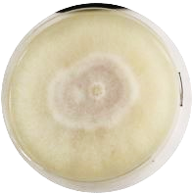 | 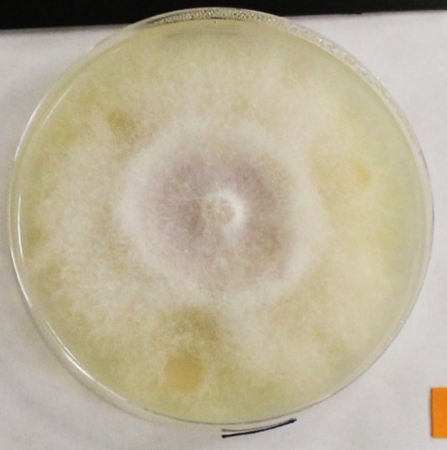 | 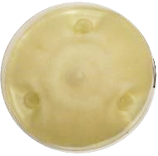
d) | e) | f)
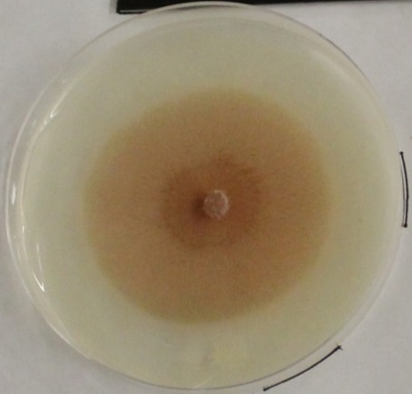 | 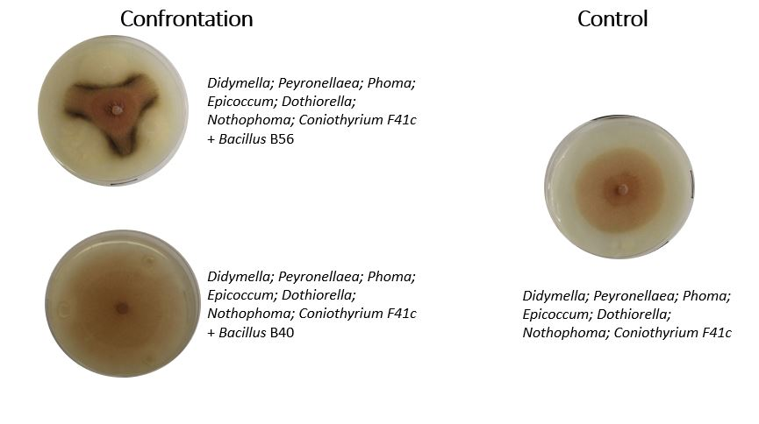 | 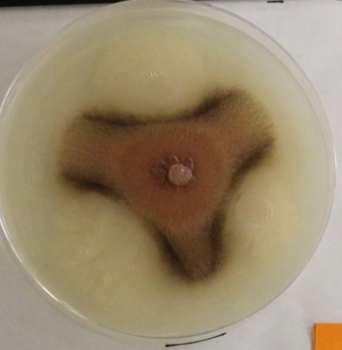
Figure 2: Pictures of the confrontation assay after 5 days from the co-inoculation of fungi and bacteria (OD₆₀₀ ~1): a) Fusarium (F54) Control; b) Fusarium co-inoculated with Microvirga (B22); c) Fusarium co-inoculated with Paenibacillus (B54); d) Phoma (F41c) Control; e) Phoma (F41c) co-inoculated with Bacillus (B40); f) Phoma (F41c) co-inoculated with Bacillus (B56). The negative interactions c) and f) were discerned from the neutral interactions b), e) based on the observation of the growth of the fungal hyphae in proximity to the bacterial inoculum.

Figure 3: Venn diagram of the fungal genus in the different sublocation based on the relative plant coverage: Tree-like (T1=Orange tree, T2= Persimmon tree, T3= Cycas) vs Bush-like (B1= Yaupon, B2= Wax myrtle, B3= Boxwood).

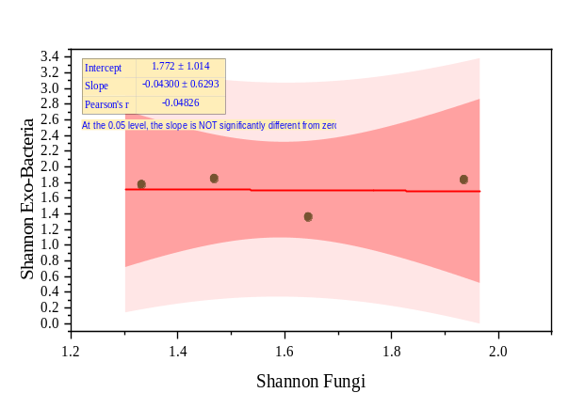
  Shannon index | Fungi | Exo-Bacteria
  Oatmeal | 1.47 | 1.85
  Cornmeal | 1.64 | 1.36
  Sorghum grain | 1.94 | 1.83
  Potato-carrot | 1.33 | 1.77
Figure 4: Linear correlation between diversity index (Shannon) fungi and exo-bacteria collections based on the plant-based media (Oatmeal, Cornmeal, Sorghum grain and Potato-carrot)

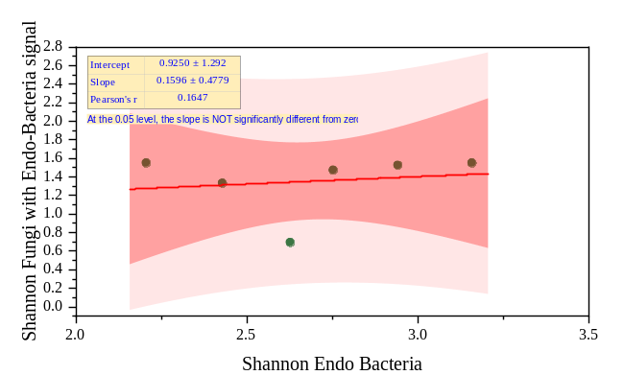
  Shannon index | Fungi | Endo-Bacteria
  B1= Yaupon | 1.54983 | 2.20634
  B2= Wax myrtle | 0.69315 | 2.62749
  B3= Boxwood | 1.33218 | 2.42902
  T1=Orange tree | 1.52471 | 2.94213
  T2= Persimmon tree | 1.54983 | 3.15904
  T3= Cycas | 1.47294 | 2.75349
Figure 5: Linear correlation between diversity index (Shannon) fungi and endo-bacteria collections based on the locations.

Figure 6: Taxa distribution of the fungal isolates in the different media (Oatmeal agar, Cornmeal agar, Sorghum grain agar and Potato-carrot agar), the locations have been divided in two subcategories based on the relative plant coverage: Tree-like (T1=Orange tree, T2= Persimmon tree, T3= Cycas) and Bush-like (B1= Yaupon, B2= Wax myrtle, B3= Boxwood).

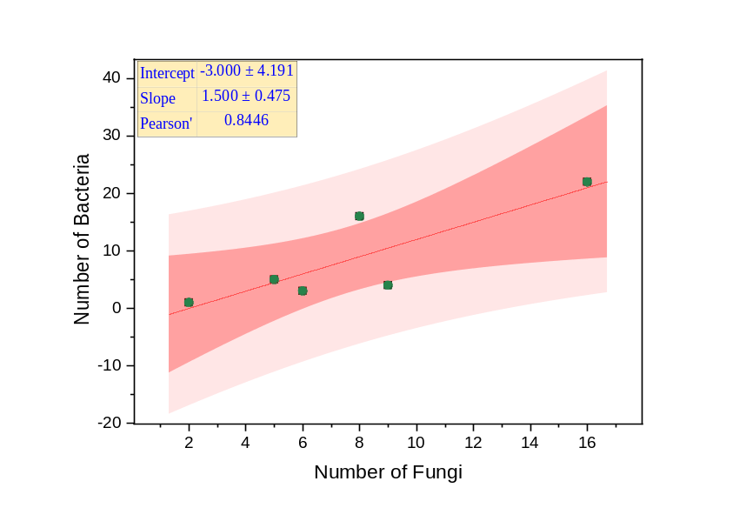
   | Number of isolated fungi | Number of isolated bacteria
  B1= Yaupon | 9 | 4
  B2= Wax myrtle | 8 | 16
  B3= Boxwood | 5 | 5
  T1=Orange tree | 2 | 1
  T2= Persimmon tree | 16 | 22
  T3= Cycas | 6 | 3
Figure 7: Linear correlation of number of isolated fungi and exo-bacteria based on plant coverage: Tree-like (T1=Orange tree, T2= Persimmon tree, T3= Cycas) and Bush-like (B1= Yaupon, B2= Wax myrtle, B3= Boxwood). The total number was calculated clustering all the isolate obtained with the different plant-based media (Oatmeal agar, Cornmeal agar, Sorghum grain agar and Potato-carrot agar).

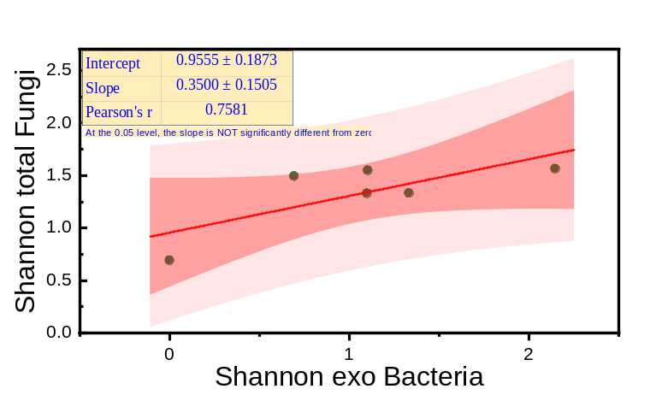
   | Shannon exo Bacteria | Shannon total Fungi
  B1= Yaupon | 0.69 | 1.49
  B2= Wax myrtle | 0 | 0.69
  B3= Boxwood | 1.33 | 1.33
  T1=Orange tree | 2.15 | 1.57
  T2= Persimmon tree | 1.10 | 1.33
  T3= Cycas | 1.10 | 1.55
Figure 8: Linear correlation of diversity index (Shannon Index) of fungi and exo-bacteria based on plant coverage: Tree-like (T1=Orange tree, T2= Persimmon tree, T3= Cycas) and Bush-like (B1= Yaupon, B2= Wax myrtle, B3= Boxwood). The diversity was calculated clustering all the isolate obtained with the different plant-based media (Oatmeal agar, Cornmeal agar, Sorghum grain agar and Potato-carrot agar).

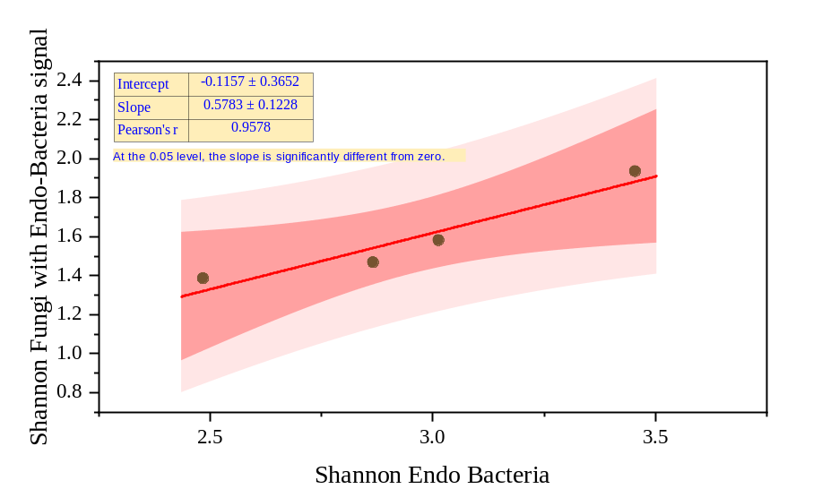
   | Shannon Endo Bacteria | Shannon Fungi 18s+16s
  Oatmeal | 2.8661 | 1.46814
  Cornmeal | 3.01312 | 1.58217
  Sorghum grain | 3.4545 | 1.9356
  Potato-carrot | 2.48449 | 1.38629
Figure 9: Linear correlation of diversity index (Shannon Index) of fungi with endo-bacteria signal (16s) and endo-bacteria based on plant-based media (Oatmeal agar, Cornmeal agar, Sorghum grain agar and Potato-carrot agar). The diversity was calculated clustering all the isolate obtained with the different locations (T1=Orange tree, T2= Persimmon tree, T3= Cycas, B1= Yaupon, B2= Wax myrtle, B3= Boxwood).
Figure 10: UpSet plot of the intersection of different taxa of endo bacteria obtained from the different plant-based media. The analysis was performed clustering all the isolate obtained with the different locations (T1=Orange tree, T2= Persimmon tree, T3= Cycas, B1= Yaupon, B2= Wax myrtle, B3= Boxwood) and plant-based media (Oatmeal agar, Cornmeal agar, Sorghum grain agar and Potato-carrot agar).
A | B | C | D | E | F | G
Achromobacter | Pelomonas | Acidovorax | Actinomyces | Nocardioides | Mesorhizobium | Paracoccus
Bacillus |  | Aquabacterium | Lautropia | Paenibacillus |  | Sphingomonas
Bradyrhizobium |  | Comamonas | Neisseria | Other |  | Ralstonia
Brevundimonas |  | Methylobacterium |  |  |  | Brevibacillus
Candidatus Finniella |  | Phyllobacterium |  |  |  | Staphylococcus
Citrobacter |  | Pisciglobus |  |  |  | Kocuria
Cutibacterium |  | Plasmopara |  |  |  | Modestobacter
Herbaspirillum |  |  |  |  |  | Variovorax
Microbacterium
Novosphingobium
Pseudomonas
Stenotrophomonas
Streptococcus

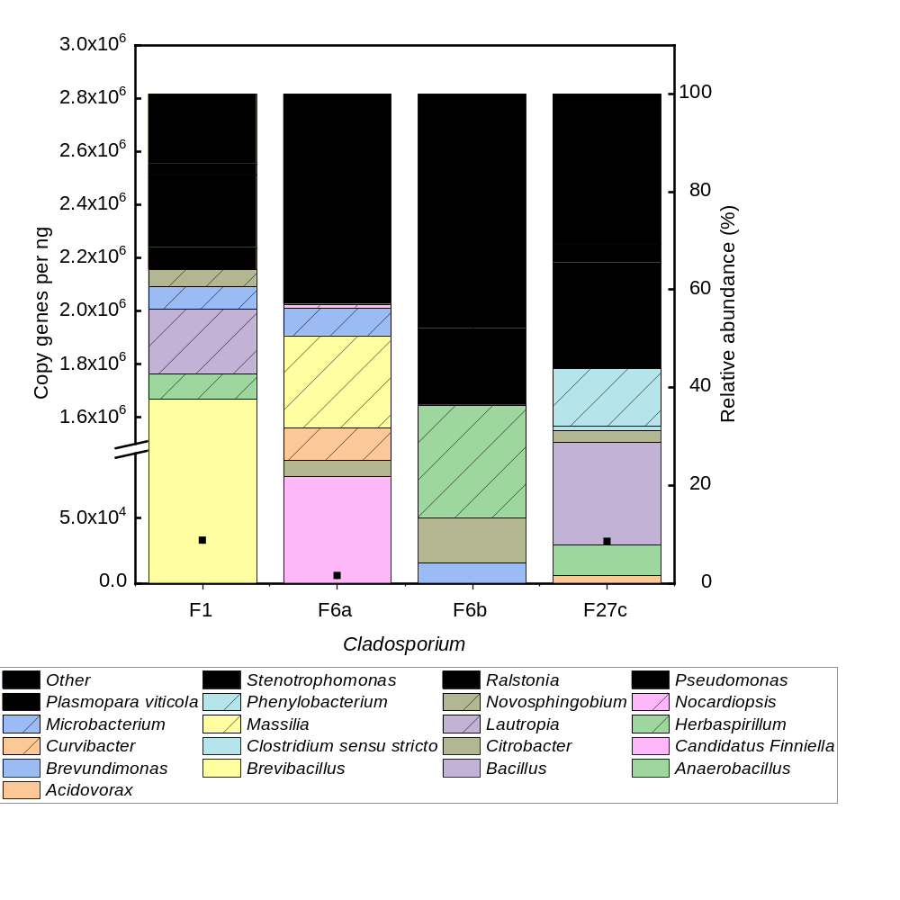
Figure 11: Relative distribution and abundance of endo-bacteria obtained from the MiSeq analysis of the 16s rRNA of the fungi belonging to the genus Cladosporium. The abundance has been related with the copy gene per ng obtained from the qPCR of the 16s rRNA and the result is represented with black squares
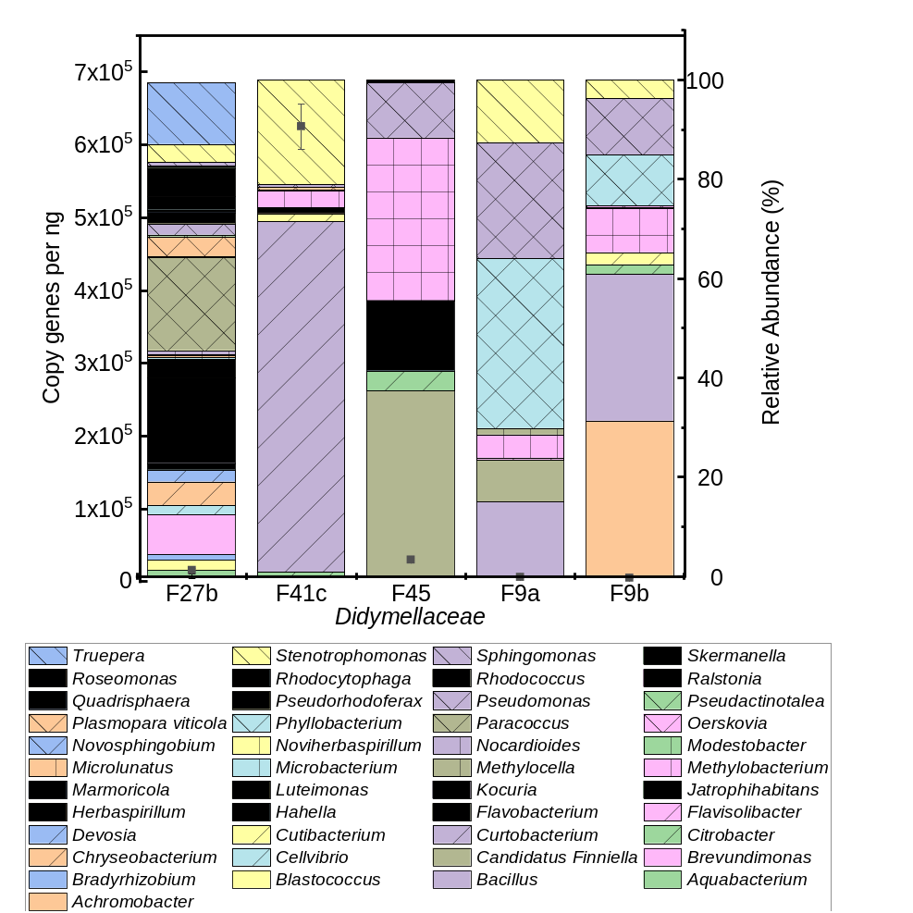
Figure 12: Relative distribution and abundance of endo-bacteria obtained from the MiSeq analysis of the 16s rRNA of the fungi belonging to the family of Didymellaceae. The abundance has been related with the copy gene per ng obtained from the qPCR of the 16s rRNA and the result is represented with black squares
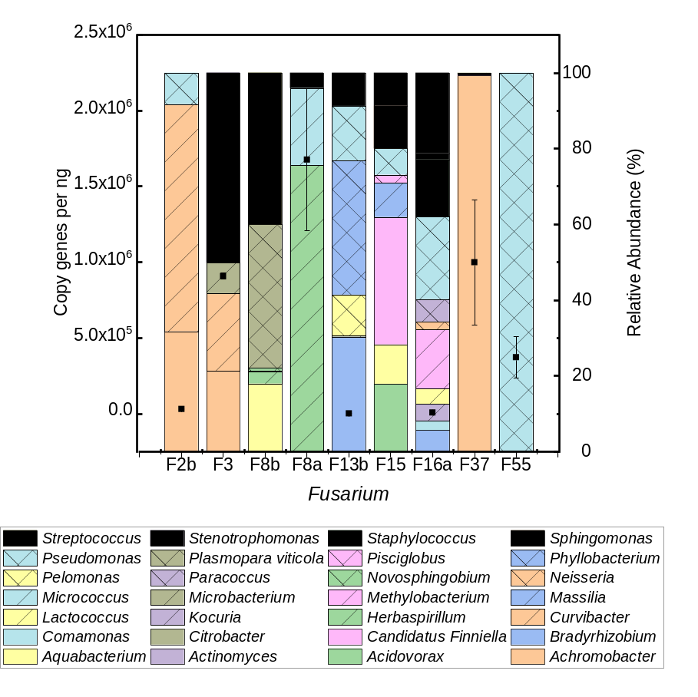
Figure 13: Relative distribution and abundance of endo-bacteria obtained from the MiSeq analysis of the 16s rRNA of the fungi belonging to the genus Fusarium. The abundance has been related with the copy gene per ng obtained from the qPCR of the 16s rRNA and the result is represented with black squares
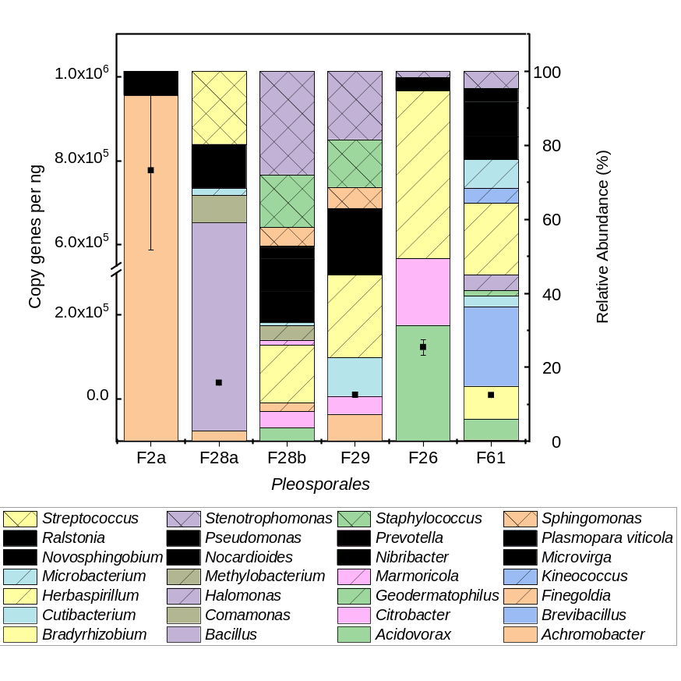
Figure 14: Relative distribution and abundance of endo-bacteria obtained from the MiSeq analysis of the 16s rRNA of the fungi genus of genus Pleosporales. The abundance has been related with the copy gene per ng obtained from the qPCR of the 16s rRNA and the result is represented with black squares
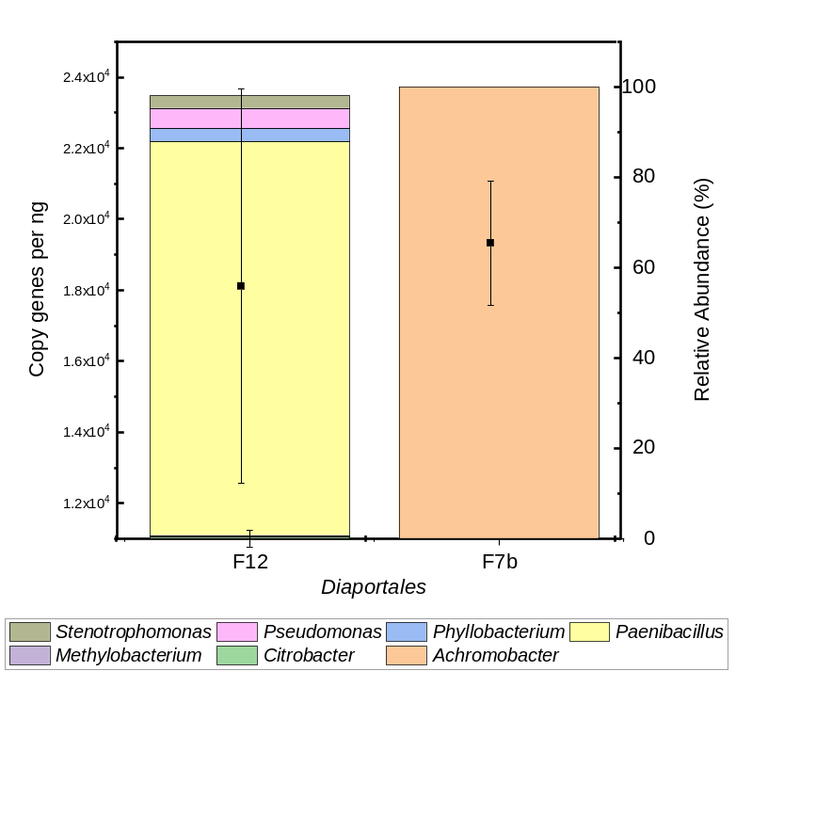
Figure 15: Relative distribution and abundance of endo-bacteria obtained from the MiSeq analysis of the 16s rRNA of the fungi belonging to the genus Diaportales. The abundance has been related with the copy gene per ng obtained from the qPCR of the 16s rRNA and the result is represented with black squares.
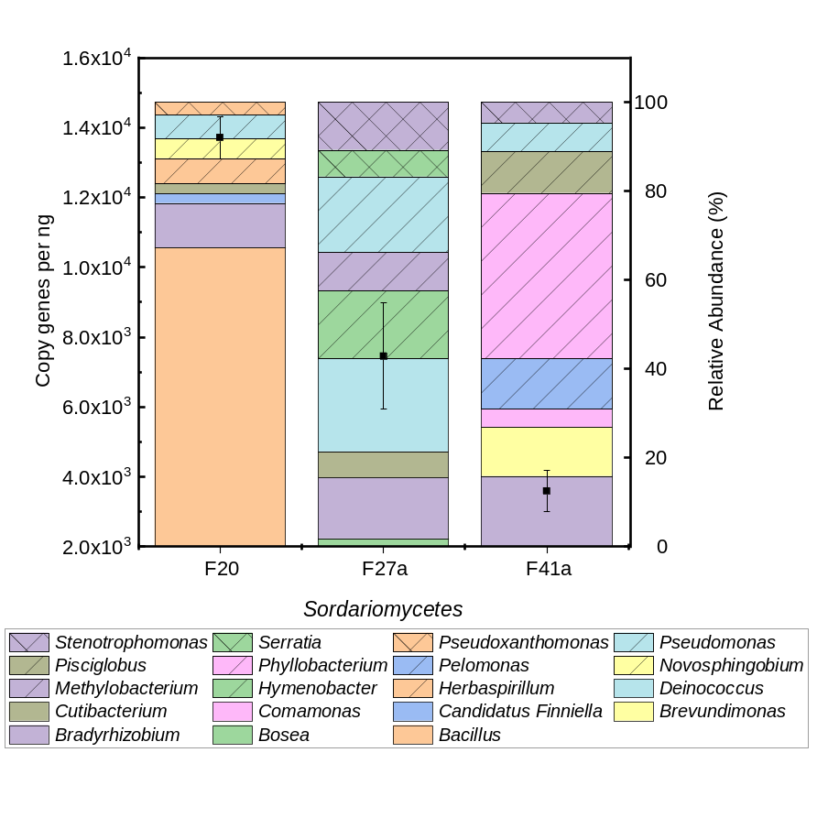
Figure 16: Relative distribution and abundance of endo-bacteria obtained from the MiSeq analysis of the 16s rRNA of the fungi belonging to the class of Sordariomycetes. The abundance has been related with the copy gene per ng obtained from the qPCR of the 16s rRNA and the result is represented with black squares.

Additional files:
Additional_file_1.xlsx: Isolation metadata and taxonomic assignments for fungal and bacterial isolates
Additional_file_2.xlsx: Taxonomic assignments of the endo-bacterial signal associated with the fungal isolates
Additional_file_3.xlsx: Subdivision of media-location matrix for confrontation assay of the bacterial and fungal used for this study.
Additional_file_4.xlsx: Quantification of the number of fungal and bacterial interaction recorded for fungal isolates and co-isolated bacterial strain.

