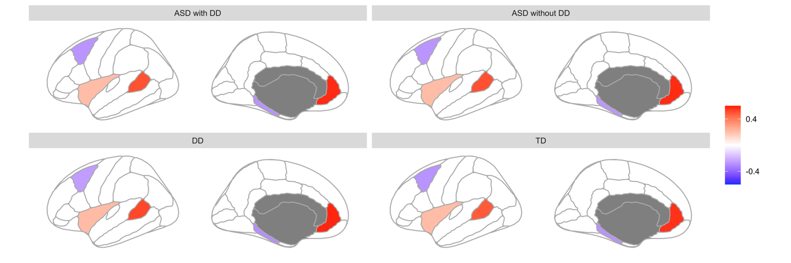
Figure S1. The mean values of GMV asymmetry in 3 diagnosis groups and TD children. The superior temporal sulcus, rostral anterior cingulate and insula showed leftwards laterality, while the caudal middle frontal cortex, parahippocampal, frontal pole and temporal pole showed rightwards laterality.

