Sequential use of Microalgae and Constructed Wetlands and its potential to remove organic load, toxicity and pharmaceuticals from urban wastewaters
Fábio Rodrigo de Oliveira ¹, Carlos Alexandre Lutterbeck^{1,2*} Rosana de Cassia de Souza Schneider^{1,3}, Adriane Lawisch Rodriguez¹, Carine Baggiotto¹, Maurício Kersting¹, Alexandre Rieger^{1,2}, Tuanne Carvalho Nunes², Guilherme Lemões Iepsen², João Vitor Frantz², Eduardo Alcayaga Lobo^{1,2}, Bruna Allebrandt² Renato Zanella⁴, Julia Antunes de Oliveira⁴, Ênio Leandro Machado^{1,3}
1 – Postgraduate Program in Environmental Technology – PPGTA, University of Santa Cruz do Sul, RS, Brazil
2 – Department of Life Sciences, University of Santa Cruz do Sul, UNISC, Brazil
3 – Department of Sciences, Humanities and Education, University of Santa Cruz do Sul, UNISC, Brazil
4 – Pesticide Residue Analysis Laboratory (LARP), Federal University of Santa Maria (UFSM), Santa Maria, RS, Brazil

* Corresponding author at: carlosalexandre@unisc.br

Supplementary Material
Text S1

1.1 Seed preparation
To begin the germination process, five petri dishes containing filter paper were used for each analysis, namely: (CN), (CP) and samples (EB), (PA), (MA) and (WC). Totaling five plates for each control and type of treatment, as the test was carried out in quintuplicates. After identification, all plates received twenty Allium cepa seeds (Fig. 1).
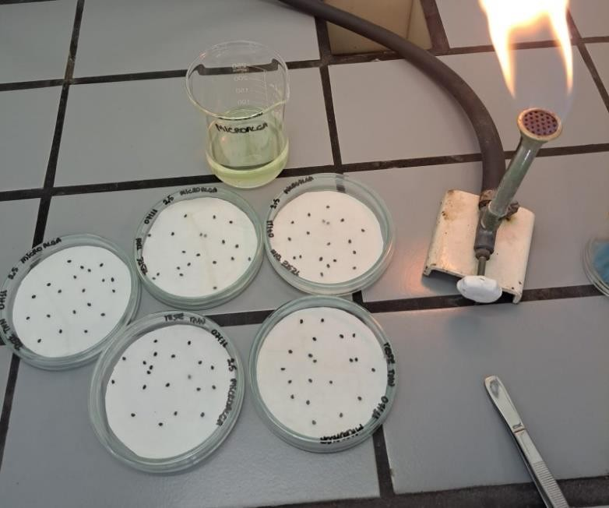
Figure 1 – Preparation of the plates
In the plates identified as (NC), 2.5 ml of H₂O_{d} was added to the seeds, while the (PC) plates had 2.5 ml of a solution of copper sulfate (CuSO₄) at a concentration of 1µg/ mL. In the same way, 2.5 ml of each sample (EB), (PA), (MA) and (WC) were added to their respective identified plates containing the seeds (Fig. 1). This entire process was carried out in a laminar flow hood, to avoid possible contamination with microorganisms present in the environment.
Subsequently, the plates were placed in the incubation chamber, with no light and a temperature of 25ºC for an interval of 84 hours.

1.2 Germination and root length
After the incubation period, the phytotoxicity assessment was carried out, based on the germination index (GI), in which it was analyzed how many seeds achieved germination success during this period, in relation to the total number of seeds sown.
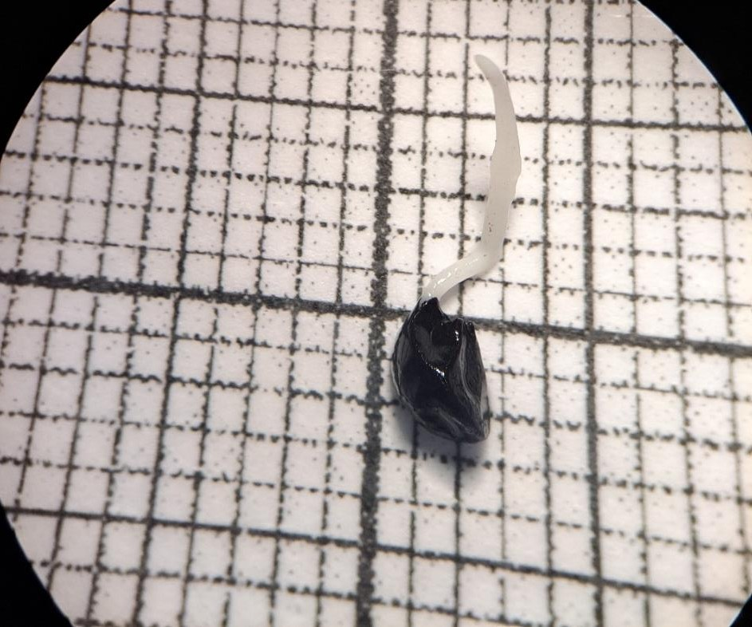
Figure 2 – Allium cepa radicle measurements

Cytotoxicity was also evaluated by measuring the rootlets in centimeters, using graph paper to obtain the length of the rootlets (Fig. 4), and subsequently analyzing the mitotic index.
1.3 Seed fixation process
Following the radicle measurement process, the germinated seeds of each control and treatment were placed in their respective conical bottom tubes, which were already identified (Fig.3). In these containers, the seeds were immersed in Carnoy's solution for 24 hours. This solution has the function of fixing the biological material and is used in a 3:1 ratio and is equivalent to three parts of methanol to one part of P.A. glacial acetic acid.

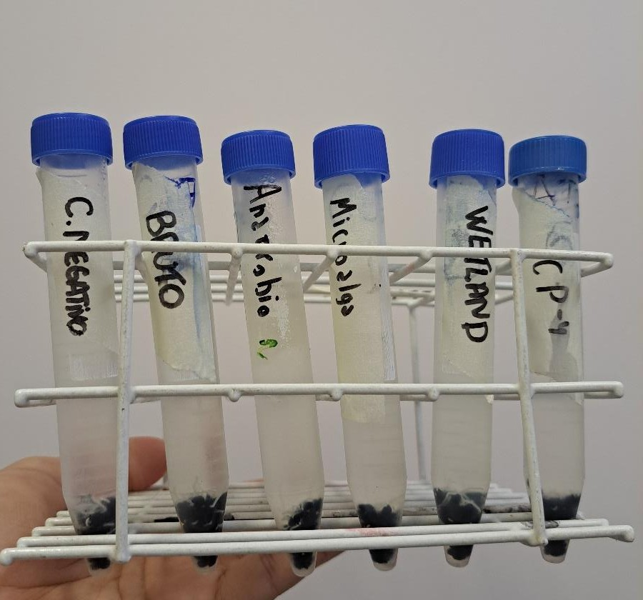
.

Figure 3 – Controls and samples during the seed fixation process

After the expected period of 24 hours, the solution was removed and the seeds were washed three times with H₂O_{d}, after rinsing, 70% alcohol was added to each container, thus fixing the seeds, which were suitable for storage at a controlled temperature of 4ºC.

1.4 Preparation of slides
The seeds for making slides were transferred to microcubes, where they were washed three times with H₂O_{d}. After washing, it was transferred to another microcube containing 1M hydrochloric acid, and this container was placed in an oven at 40ºC for 30 minutes.
This was necessary for acid hydrolysis to occur, which was important for the fume hood to be simple to handle and thus facilitate cutting and, consequently, visualization of individual cells. After this interval, the seeds were transferred to another microcube where they were washed again with H₂O_{d} three times and then the slides were made.
Under observation under a magnifying glass and with the aid of a scalpel and histological needles, a germinated seed was placed on top of a slide and a cut was made to separate the cap from the rest of the seed (Fig. 4).
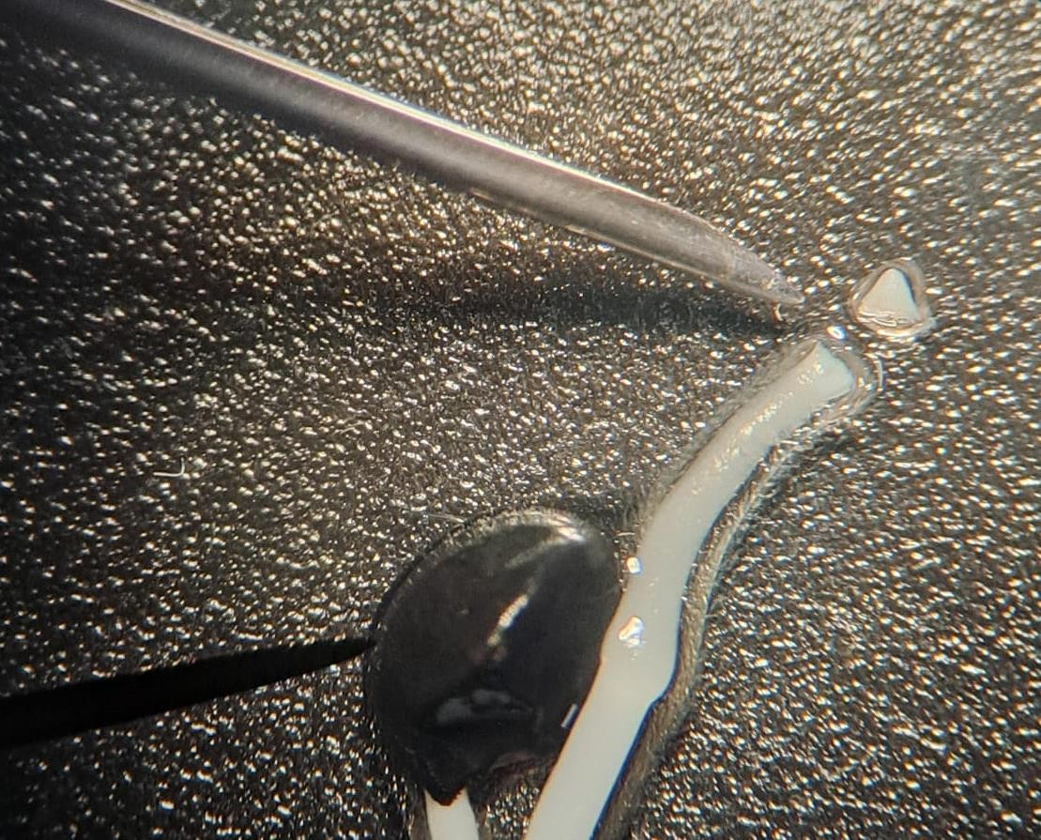
Figure 4 – Separation of the root cap from the radicle using histological needles
The root cap is a structure located at the end of the root and protects this region because cell multiplication occurs there, being the youngest part of the root (Parvan et al., 2020). After the separation of this organ, several longitudinal cuts were made in the apical meristem to help detach the cells. Therefore, the staining technique followed by crushing proposed by Guerra & Souza (2002) was performed, which consists of applying 2% orcein for 5 minutes and adding a coverslip under the analyzed material (Fig. 5).
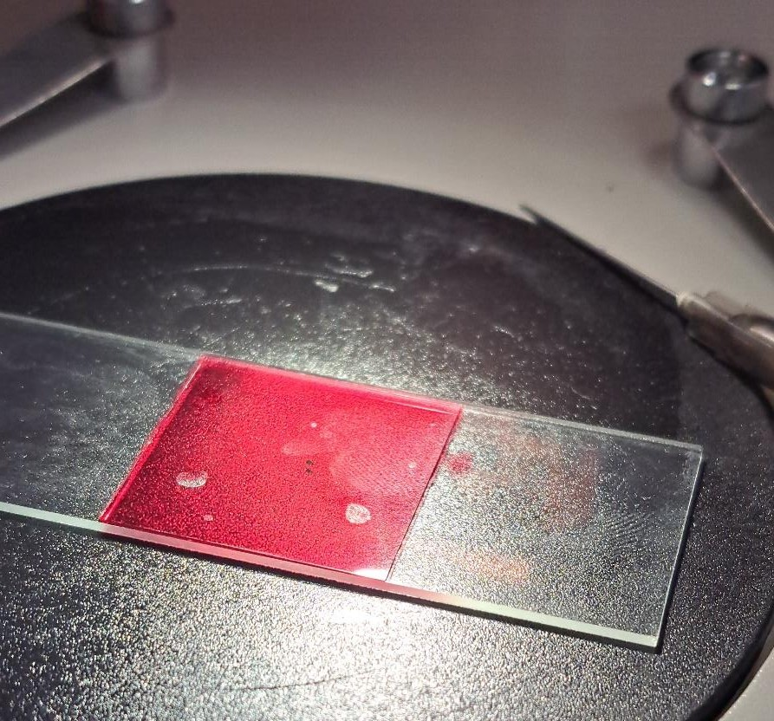
Figure 7 – Cell staining process using 2% acetic orcein
Subsequently, under the microscope at a lower viewing magnification, the coverslip was tapped with the histological needle; this technique was also important to loosen the cells from each other and improve observation.
1.5 Cell analysis
The slides were made from 10 rootlets per control and treatment, on each slide 250 cells were analyzed per field, resulting in a count of 2500 cells per sample. The cells were observed under 400x and 1000x magnification under an optical microscope. Throughout this analysis, cells were classified according to their mitotic stage, being interphase, prophase, metaphase, anaphase and telophase. The mitotic index (MI) was calculated based on the identification of the following phases of the cell cycle: interphase (I), prophase (P), metaphase (M), anaphase (A) and telophase (T). The MI formula is expressed as a percentage (%) and considers the ratio of cells in division to the total number of cells in the meristematic region (Frescura et al., 2012).
IM (%) = [(P+M+A+T) / (I+P+M+A+T)] x 100
There was also classification into nuclear abnormalities, aneugenic and clastogenic chromosomal aberrations. As for nuclear aberrations, the

Cells were characterized for the presence of micronucleus, nuclear budding and lobulated nucleus.
The frequency of chromosomal aberrations was expressed as a percentage of the total number of dividing cells. In relation to aneugenic chromosomal aberrations, there was classification according to the presence of: wandering chromosome, spindle abnormalities, duplications or polyploidies, abnormal metaphase, C-metaphase, Stickiness (metaphases with adhesions), chromosome lost in anaphase and chromosome delayed in telophase.
As for clastogenic aberrations, there was classification based on metaphase with chromosomal breakage, chromosomal bridges with lost chromosomes, bridges in anaphase and bridges in telophase. These classifications occurred according to Leme and Marin-Morales (2009).

REREFENCES

FRESCURA, V. D. S; CASA IV, H. D. R; TEDESCO, S. B. Antiproliferative effect of the tree and medicinal species Luehea divaricata on the Allium Cepa cell cycle. International Journal of Citology, Cytosystematics and Cytogenetics. V. 65, ed.1, 2012.
GUERRA, M.; SOUZA, M.J. Como observar cromossomos: um guia de técnicas em citogenética vegetal, animal e humana. Ribeirão Preto: FUNPEC, 2002. 191p.

LEME, D. M.; MARIN-MORALES, M. A. Allium cepa test in environmental monitoring A review on its application. Mutation Research 682. p. 71 – 81, 2009.
PARVAN, L. G; LEITE, T. G; FREITAS, T. B; PEDROSA, P. A. A; CALIXTO, J. S; AGOSTINHO, L. A. Bioensaio comAllium cepa revela genotoxicidade herbicida com flumiozaxina. Revista Pan Amaz Saude 2020;11:e202000544 – e-ISSN: 2176-6223.

