Supplementary Information

Cattle grazing and herbaceous competition shape woody seedling survival across environmental gradients in Neotropical savannas. Agroforestry Systems. Mochi, Lucía S.*; Aguiar, Martín R.; Aranda, Melina J.; Biganzoli, Fernando; Mazía, Noemí.
* Correspondence: Lucía S. Mochi, Departamento de Métodos Cuantitativos y Sistemas de Información, Facultad de Agronomía, Universidad de Buenos Aires, Argentina and Consejo Nacional de Investigaciones Científicas y Técnicas (CONICET), Argentina.
Email address: lmochi@agro.uba.ar

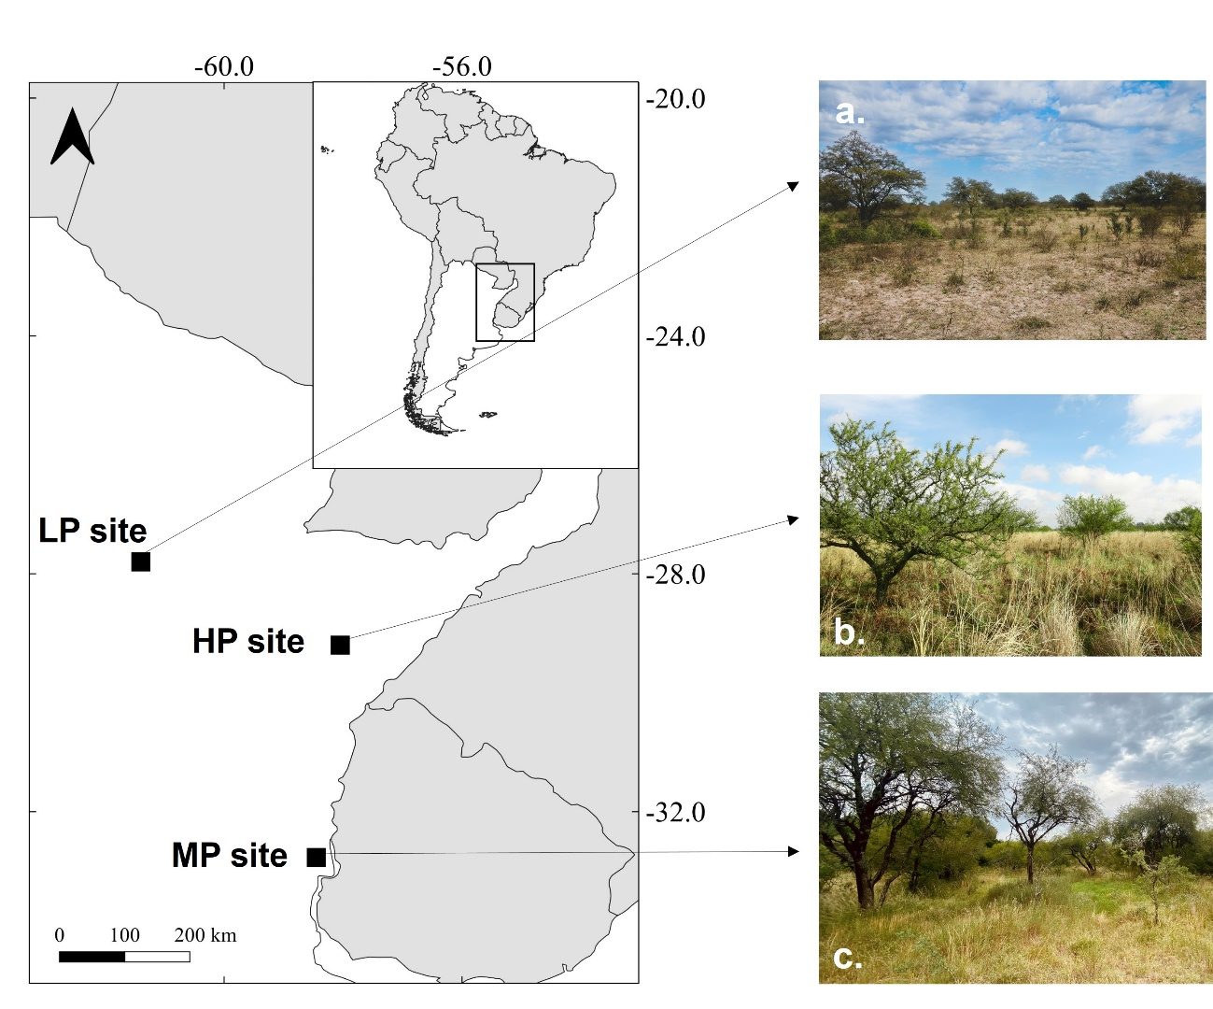

Figure S1. Savanna study site locations (LP: low-productivity site, MP: medium-productivity site, and HP: high-productivity site) in Argentina (left). Savanna ecosystem pictures in the low productivity site (a), high productivity site (b) and medium productivity site (c).

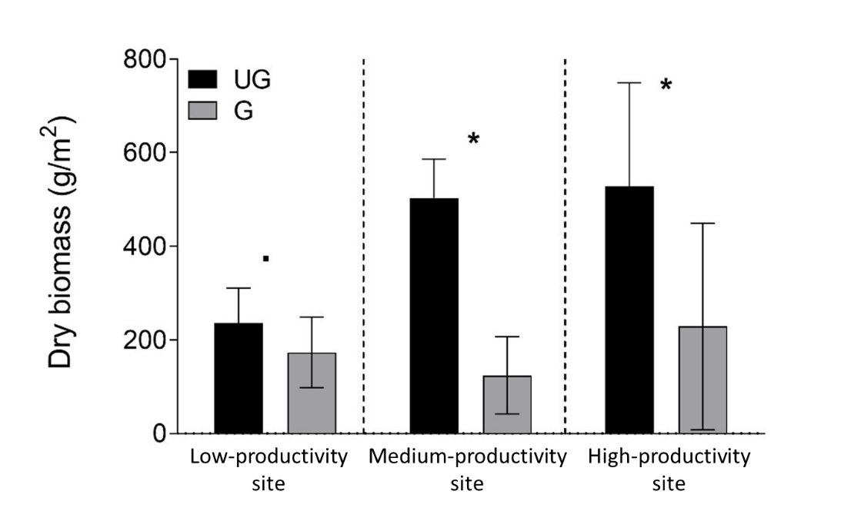

Fig. S2. Mean dry biomass on ungrazed (UG) and grazed (G) plots at each savanna site. Asterisks indicate significant differences for a significance level of 0.05. Dot indicates marginal difference (0.05 < p < 0.1). Error bars represent 95% confidence interval.

Table S1. Seedling survival and growth experiment characteristics among sites.
Site | Low productivity | Medium-productivity | High productivity
Seedling cultivation | Winter and springtime of 2017 | Springtime 2016 and summer of 2017 | Winter and springtime of 2017
Number of blocks | 3 | 4 | 4
Subplots per treatment per block | 32 | 50 | 50
Total number of seedlings | 246 | 400 | 400
Definitive cohorts obtained after replacing died seedlings due to transplantation shock | October 2017 | April 2017 | October 2017
Experiment visits and measurements dates | Three times: February 2018, November 2018, and March 2019. | Five times: August 2017, October 2017, January 2018, May 2018, and November 2018. | Three times: March 2018, October 2018, and March 2019.

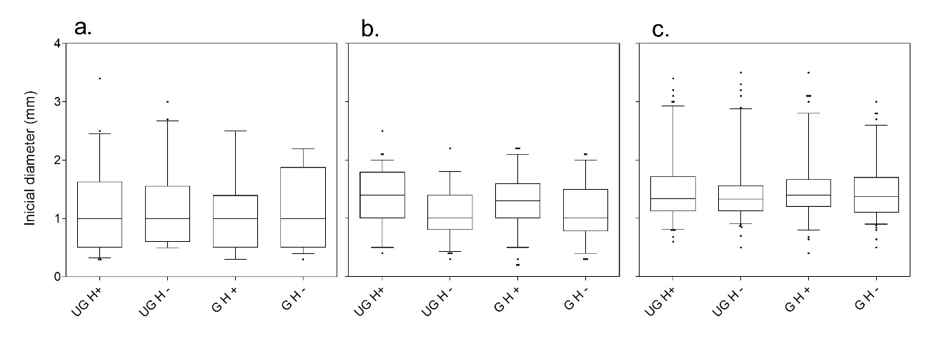

Figure S3. Initial diameter (mm) distribution of V. aroma in Chaco (A) and V. caven in Entre Ríos and Corrientes (B and C) seedling for all treatments at the beginning of the experiments. Error bars indicate 0.05 and 0.95 percentiles of the distribution.

