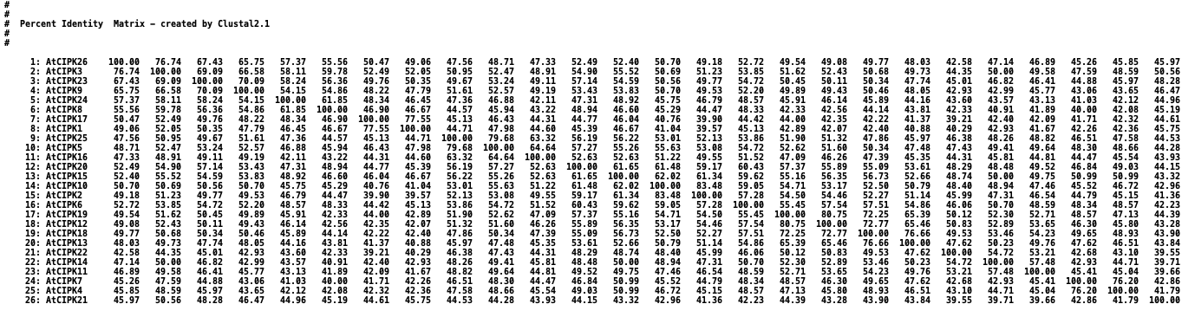
Suppl Figure 1: Thepairwise sequence identitites of Arabidopsis thaliana CIPKs. In X-axis the proteins are arranged in same sequence.

Supp. Table 1. Template structures used in this study
PDB ID (chain used) | Description of the PDB | Comment | Reference
2EHB (chain A) | The C-terminal domain of AtCIPK24 (SOS2) bound to AtCBL4 (SOS3) | Used for the building of the NAF sequence binding conformation of CBL4 | (Sánchez-Barrena et al., 2007)
2EHB (chain B) |  | Used for the building of the PPI domain of CIPK; used for the modeling of the NAF sequence | (Sánchez-Barrena et al., 2007)
4D28 (any of the A, B, C, D chains) | The kinase domain of AtCIPK24 (SOS2) | Used for the building of the kinase domain of CIPK | (Chaves-Sanjuan et al., 2014)
6C9D (chain A) | MARK1 kinase autoinhibited by the tightly associated with its regulatory domain (KA1) | Used to model the relative positions of the CIPK-KD and the CIPK-PPI domains | (Emptage, Lemmon, Ferguson, & Marmorstein, 2018)
Uniport (CIPK24) Q9LDI3 | AlphaFold Model | Used to model CIPK with different PPI conformation
4RER (chain A) | Phosphorylated human holo-AMPK (α1β2γ1) complex bound to AMP and cyclodextrin | Used to model activated CIPK; the CBL-bound conformation of CIPK. | (Li et al., 2015)
7MYJ (chain C) | Full length human AMPK (α1β2γ1) in complex with a small molecule activator MSG011 | Used to model activated CIPK; the CBL-bound conformation of CIPK | (Ovens et al., 2022)
Uniport (GIRK2) Q5HZ38 | AlphaFold Model | Used to GIRK2 reference model
4G3F | Murine NFκB inducing kinase bound to 2-aminothiazoly)phenol (cmp2) | Used to model and compare the GIRK2 important residues | (de Leon-Boenig et al., 2012)

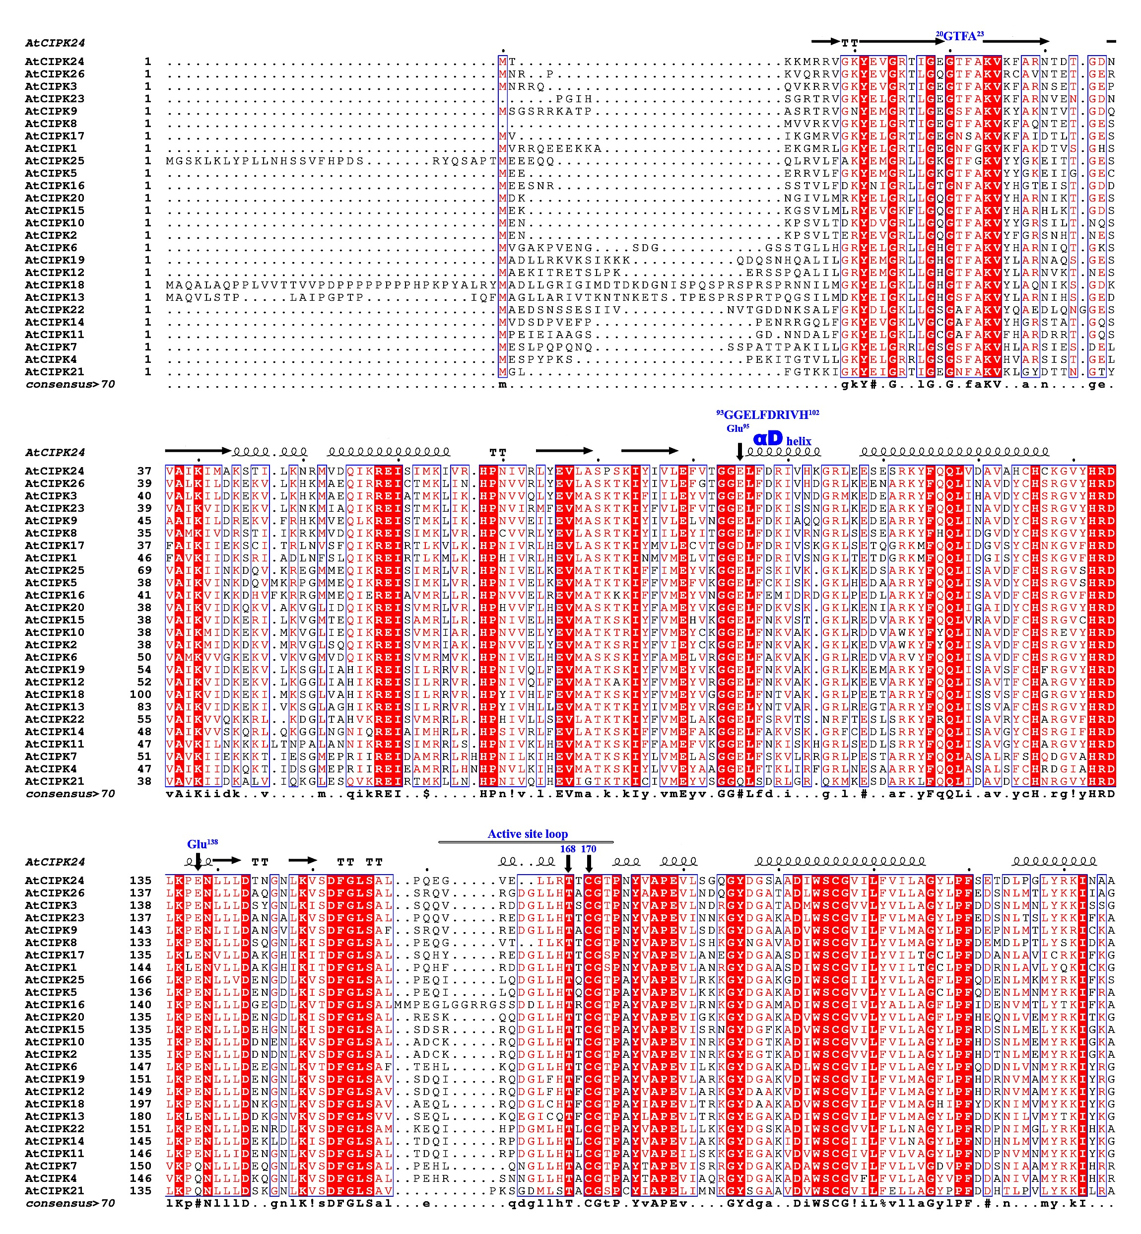

Sequence alingment continued ...
Suppl Figure 2: Multiple sequence alingment of Arabidopsis thaliana CIPK sequences showing the important amino acids and motifs identified in CIPK24 from this work. At the top the secondary structures of AtCIPK24 is shown. The important amino acid clusters GTFA motif, αD helix and the active site loop are shown. Amino acid residus found importatn in this study are highlighted by the down arrow. The consensus amino acids are shown at the beneth the sequence alignment. Sequence alingment is done using MAFFT (Katoh & Standley, 2013) and the diagram is prepapred using EsPript (Gouet, Robert, & Courcelle, 2003).

Suppl Figure 3: Comparisons of the relative orinetations of the bound CBL4 and the PPI doamin of the CIPK24. (A) Relative orientaiton of the PPI domain and the CBL4 in presence of KD. (B) Relative orientation fot eh PPI doamin and the CBL4 in abscene of KD. The major PPI shift is due to the presence of KD.
Suppl Table 2. Interactions identified in the structures
 | Residues in KD | Residues in PPI | Comments
1. | Glu⁹⁵, Asp⁹⁸ – Arg⁹⁹, His¹⁰² | Arg³³⁷ and Gln³³⁸ | Pairs of interactions Glu⁹⁵ – Arg³³⁷ (~ 2.0 Å) and Asp⁹⁸-Arg³³⁷ (~2.7 Å), and His¹⁰²-Gln³³⁸ (~2.5 Å)
2. | Gly¹⁰⁴ | His⁴¹⁴ | ~ 2.0 Å
3. | Glu¹³⁸ | Lys⁴⁰⁵ | ~ 2.3 Å
4. | Cys¹⁷⁰ | Gly⁴⁰⁹ | Distance Cys¹⁷⁰- Gly⁴⁰⁹ used to determine the shift of the active site loop
5. | Leu²⁰⁸ | Leu⁴¹¹ | May be engaged in Leu208 – Leu411 hydrophobic interactions (~4.2 Å)
CBL4-CIPK24 complex in binary complex
 | CIPK24 residues | CBL4 residues
1. | Phe³¹³ | Leu¹³³, Met¹⁵⁶, Ala¹⁶⁰ | Phe³¹³ mediated hydrophobic interactions are also found in crystal structure
2. | Phe³²⁸ | Leu¹⁹³ and Tyr¹⁹⁵ | May be engaged in hydrophobic interactions
3. | Glu³¹⁴ | Ser¹⁸⁶ | ~1.8 Å
4. | Ser³¹⁹ | Glu¹⁴³ | Ser³¹⁹ interaction is also found crystal structure
5. | Arg³³¹ | Asp¹⁹⁸ | PPI domain mediated CBL4 interaction
6. | Lys³⁷¹ | Glu¹⁴⁵ | PPI domain mediated CBL4 interaction
7. | Glu³⁹³ | Arg⁷¹ | PPI domain mediated CBL4 interaction
8. | Arg⁴⁰⁴ | Glu¹⁴⁵ | PPI domain mediated CBL4 interaction
CIPK24-GIRK2 complex in ternary complex *
1. | Glu¹⁹ | Lys¹⁹⁸, Ser¹¹⁵ | CIPK24 interaction with GIRK2 P-loop
2. | Glu⁹⁵ | Lys¹²⁰ | Possibly GIRK2 P-loop stabilizing interaction
3. | Asp⁹⁸ | Arg¹⁰⁹ | CIPK24 αD mediated interaction with GIRK2
5. | Glu¹³⁸ | Lys¹²⁰ | Possibly GIRK2 P-loop stabilizing interaction
7. | Thr¹⁶⁹ | Gly¹¹⁶ | CIPK24 active site loop and GIRK2 P-loop interaction
* in the ternary complex the critical amino acids involved in the GIRK2 and the CIPK24 are mentioned.
Suppl Figure 4: Multiple sequence alingment of AtGIRK2 (Uniport: Q5HZ38) with its homologues: 4G3F_NFkB : murine NFkB, 2QNJ_MARK3_UAD: MARK3 ubiquitin associated domain, 4CFH_AMPK: AMP kinase, 3HX4_TgCDPk1: Toxoplasma gondii Cyclin Dependent Kinase 1, 3LIJ_CpCDPK3: Cryptosporidium paruvum Iowa II Cyclin Dependent Kinase 3, 3Q5I_PbCDPK1: Plasmodium berghei Cyclin Dependent Kinase 1, 4C0T_CaPDK1: Candida albicans Protein Dependent Kinase 1, 5LVO_Human_PDK1: Human Protein Depdent Kinase 1. The important regions discussed in the literature are shown such as the P-loop, Catalytic loop and the metal-binding region. Sequence alingment is done using MAFFT (Katoh & Standley, 2013) and the diagram is prepapred using EsPript (Gouet, Robert, & Courcelle, 2003).
References
Chaves-Sanjuan, A., Sanchez-Barrena, M. J., Gonzalez-Rubio, J. M., Moreno, M., Ragel, P., Jimenez, M., . . . Albert, A. (2014). Structural basis of the regulatory mechanism of the plant CIPK family of protein kinases controlling ion homeostasis and abiotic stress. Proceedings of the National Academy of Sciences, 111(42), E4532-E4541
de Leon-Boenig, G., Bowman, K. K., Feng, J. A., Crawford, T., Everett, C., Franke, Y., . . . Starovasnik, M. A. (2012). The crystal structure of the catalytic domain of the NF-κB inducing kinase reveals a narrow but flexible active site. Structure, 20(10), 1704-1714
Emptage, R. P., Lemmon, M. A., Ferguson, K. M., & Marmorstein, R. (2018). Structural basis for MARK1 kinase autoinhibition by its KA1 domain. Structure, 26(8), 1137-1143. e1133
Gouet, P., Robert, X., & Courcelle, E. (2003). ESPript/ENDscript: extracting and rendering sequence and 3D information from atomic structures of proteins. Nucleic acids research, 31(13), 3320-3323
Katoh, K., & Standley, D. M. (2013). MAFFT multiple sequence alignment software version 7: improvements in performance and usability. Molecular biology and evolution, 30(4), 772-780
Li, X., Wang, L., Zhou, X. E., Ke, J., De Waal, P. W., Gu, X., . . . Xu, H. E. (2015). Structural basis of AMPK regulation by adenine nucleotides and glycogen. Cell research, 25(1), 50-66
Ovens, A. J., Gee, Y. S., Ling, N. X., Yu, D., Hardee, J. P., Chung, J. D., . . . Scott, J. W. (2022). Structure-function analysis of the AMPK activator SC4 and identification of a potent pan AMPK activator. Biochemical Journal, 479(11), 1181-1204
Sánchez-Barrena, M. J., Fujii, H., Angulo, I., Martínez-Ripoll, M., Zhu, J.-K., & Albert, A. (2007). The structure of the C-terminal domain of the protein kinase AtSOS2 bound to the calcium sensor AtSOS3. Molecular cell, 26(3), 427-435

