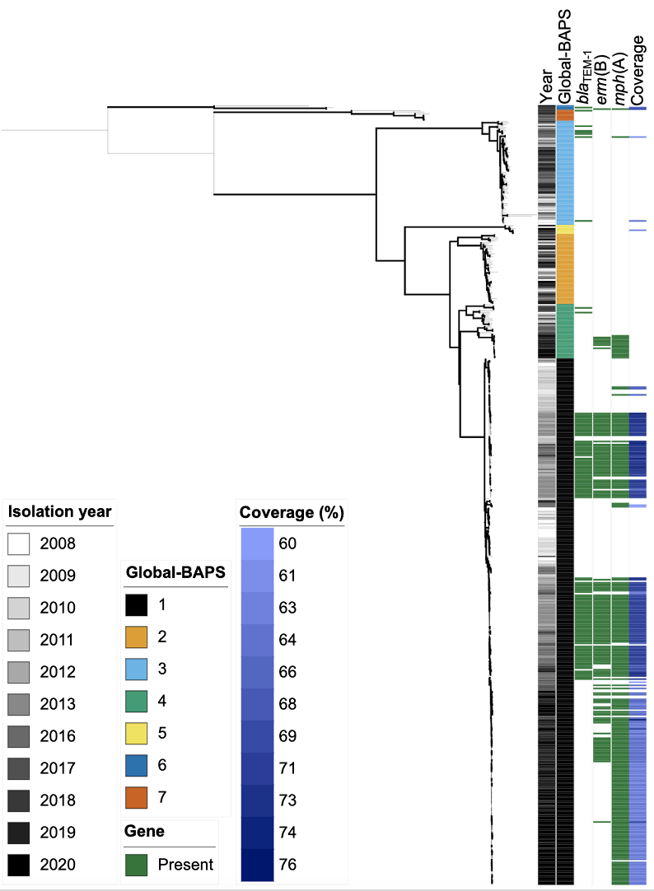
Supplementary Information
a
b

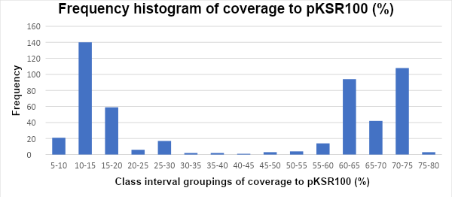
b

Supplementary Figure 1a. 1X coverage mapping of Illumina sequence reads of S. flexneri 3a isolates (n = 502) to a pKSR100 reference plasmid from S. flexneri 2a. Only coverage of ≥60% is displayed. Metadata tracks show year, BAPS subgroup, presence and absence of AMR genes associated with the pKSR100 plasmid, and the percentage mapping coverage at 1X depth of the S. flexneri 3a isolates to the pKSR100 reference plasmid from S. flexneri 2a. Emboldened branches represent a bootstrap value of ≥ 70 out of 100. Branches represent substitutions across a 22985 bp alignment. Supplementary Figure 1b. Histogram displaying the frequencies of varying groups of % coverage to pKSR100, including all isolates in the tree. Class interval groups of ≥ 60 were selected to be displayed on the phylogenetic tree.
Supplementary Table 1. Antimicrobial susceptibility testing and genotypic AMR profiles of a subset of 20 representative isolates of the varying AMR profiles in Global-BAPS-1. Performed and reported according to European Committee on Antimicrobial Susceptibility Testing (EUCAST) guidance. All isolates were from males, aged 16-60, who had not travelled internationally in the last month. The antibiotics: Ciprofloxacin (CIP), Ceftriaxone (CRO), Azithromycin (AZM), Fosfomycin (FOS), Mecillinam (MEC), Ertapenem (ERT), Sulfamethoxazole-Trimethoprim (SXT) were used.
Metadata |  |  | Genes |  |  |  |  |  |  |  |  |  |  |  |  |  |  | Minimum Inhibitory Concentration (mg/L)
Accession | Year |  | bla_{OXA-1} | catA1 | aadA1 | tet(B) | bla_{TEM-1} | erm(B) | mph(A) | dfrA17 | sul1 | aadA5 | dfrA14 | sul2 |  |  | CIP |  | CRO | AZM | FOS | MEC | ERT | SXT
ERR230553 | 2010 |  | P | P | P | P | A | A | A | A | A | A | A | A |  |  | 0.008 |  | 0.016 | 3 | 0.38 | 0.064 | 0.008 | 0.094
ERR230509 | 2008 |  | P | P | P | P | A | A | A | A | A | A | A | A |  |  | 0.008 |  | 0.016 | 3 | 0.5 | 0.125 | 0.008 | 0.094
ERR230486 | 2008 |  | P | P | P | P | A | A | A | A | A | A | A | A |  |  | 0.012 |  | 0.023 | 3 | 0.25 | 0.094 | 0.006 | 0.094
SRR7286393 | 2016 |  | P | P | P | P | A | A | P | A | A | A | P | P |  |  | 0.008 |  | 0.016 | >256 | 0.5 | 0.064 | 0.006 | >32
SRR4788220 | 2016 |  | P | P | P | P | A | A | P | A | A | A | P | P |  |  | 0.012 |  | 0.016 | 64 | 0.5 | 0.064 | 0.006 | >32
ERR654275 | 2013 |  | P | P | P | P | P | P | P | A | A | A | P | P |  |  | 0.012 |  | 0.016 | 2 | 0.38 | 0.38 | 0.006 | 0.094
ERR654270 | 2013 |  | P | P | P | P | P | P | P | A | A | A | A | A |  |  | 0.016 |  | 0.032 | >256 | 0.75 | 0.75 | 0.008 | 0.125
ERR654256 | 2013 |  | A | A | P | P | P | P | P | P | P | P | A | P |  |  | 0.008 |  | 0.016 | >256 | 0.38 | 0.75 | 0.004 | >32
ERR449050 | 2013 |  | A | A | P | P | P | P | P | P | P | P | A | A |  |  | 0.008 |  | 0.012 | >256 | 0.5 | 0.75 | 0.003 | >32
SRR9257780 | 2019 |  | P | P | P | P | A | P | P | A | A | A | A | A |  |  | 0.012 |  | 0.032 | >256 | 0.75 | 0.064 | 0.008 | 0.094
SRR4897819 | 2016 |  | P | P | P | P | P | P | P | A | A | A | A | A |  |  | 0.008 |  | 0.016 | >256 | 0.5 | 0.75 | 0.008 | 0.094
SRR4897018 | 2016 |  | P | P | P | P | P | P | P | A | A | A | A | A |  |  | 0.012 |  | 0.023 | >256 | 0.75 | 0.75 | 0.006 | 0.094
SRR12743036 | 2020 |  | P | P | P | P | A | A | P | A | A | A | A | A |  |  | 0.012 |  | 0.023 | 32 | 0.5 | 0.064 | 0.008 | 0.094
SRR12683901 | 2020 |  | P | P | P | P | A | A | P | A | A | A | A | A |  |  | 0.008 |  | 0.023 | 24 | 1 | 0.125 | 0.008 | >32
SRR12598696 | 2020 |  | P | P | P | P | A | A | P | A | A | A | A | A |  |  | 0.008 |  | 0.016 | 48 | 0.38 | 0.064 | 0.008 | 0.094
SRR12470239 | 2020 |  | P | P | P | P | A | A | P | A | A | A | A | A |  |  | 0.012 |  | 0.016 | >256 | 0.5 | 0.094 | 0.006 | 0.094
SRR11832244 | 2020 |  | P | P | P | P | A | A | P | A | A | A | A | A |  |  | 0.012 |  | 0.023 | 32 | 0.38 | 0.094 | 0.008 | 0.094
SRR10858726 | 2019 |  | P | P | P | P | A | A | P | A | A | A | A | A |  |  | 0.008 |  | 0.023 | 32 | 0.5 | 0.064 | 0.008 | 0.094
SRR10419840 | 2019 |  | P | P | P | P | A | P | P | A | A | A | A | A |  |  | 0.012 |  | 0.032 | >256 | 0.75 | 0.064 | 0.008 | 0.094
ERR449074 | 2013 |  | P | P | P | P | P | P | P | A | A | A | A | A |  |  | 0.008 |  | 0.016 | >256 | 0.38 | 0.75 | 0.006 | 0.094
 |  |  |  |  |  |  |  |  | Absent |  |  |  |  |  |  |  |  |  |  | Sensitive
 |  |  |  |  |  |  |  |  | Present |  |  |  |  |  |  |  |  |  |  | Resistant

