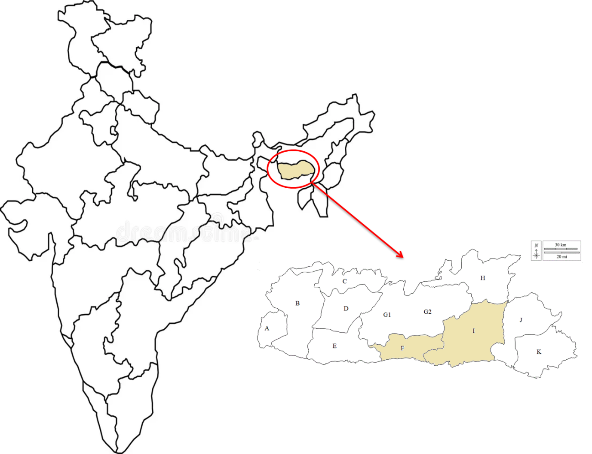
Fig S1: General geographical location of the study sites: A: South West Garo Hills District; B: West Garo Hills District; C: North Garo Hills District; D: East Garo Hills District; E: South Garo Hills District; F: South West Khasi Hills District; G1: West Khasi Hills District; G2: Eastern West Khasi Hills District (recently recognised, no well determine boundary); H: Ri Bhoi District; I: East Khasi Hills District; J: West Jaintia Hills District; K: East Jaintia Hills District.
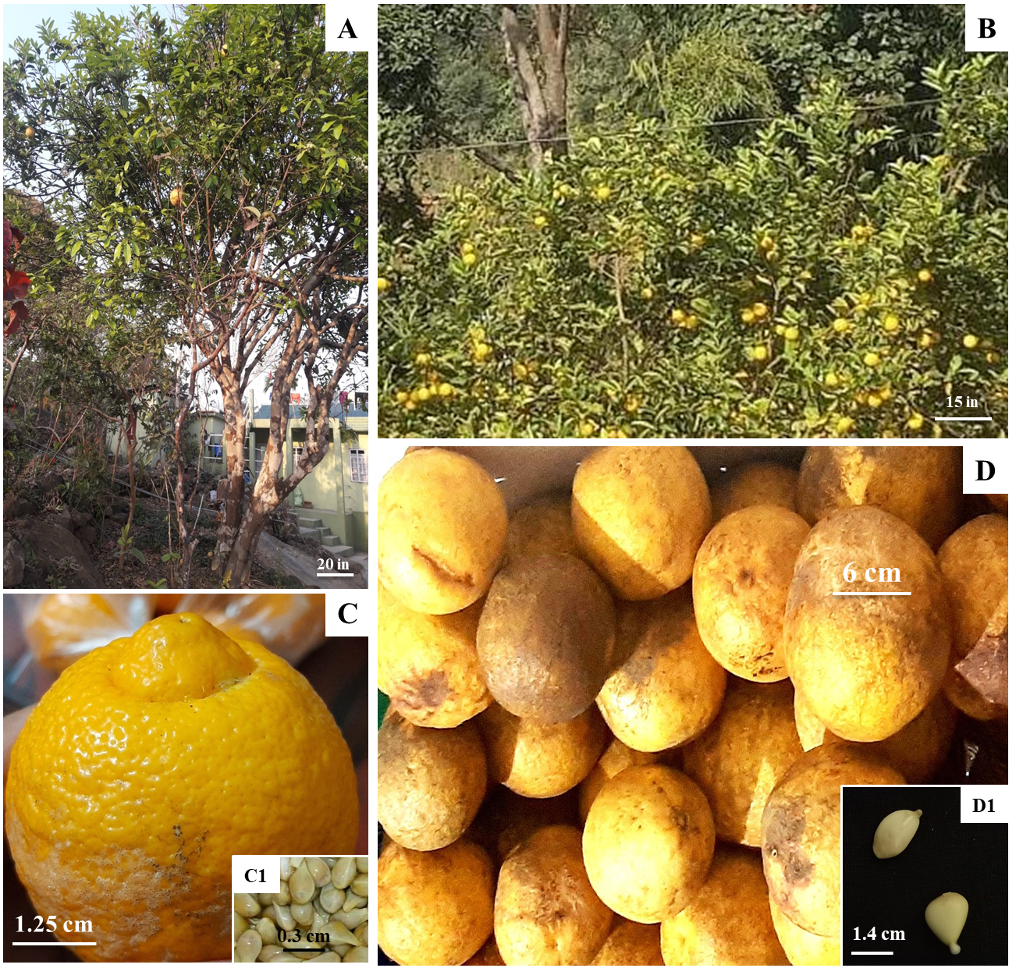
Fig S2: A: Citrus maxima Merr. tree bearing fruits in the wild; B: Citrus jambhiri Lush trees bearing fruits in the wild; C: Mature fruit of Citrus jambhiri Lush; C1: Seeds of Citrus jambhiri Lush D: Mature fruits of Citrus maxima Merr.; D1: Seeds of Citrus maxima Merr.

Table SI: Details of the localities and geographical locations of the study sites.
Sl No. | Citrus spp. | Locality | District | Geographical location
Sl No. | Citrus spp. | Locality |  | Latitudes | Longitudes
1. | Citrus jambhiri Lush. | Jakrem | South West Khasi Hills | 25.34623
  91.44221
2 | Citrus maxima Merr. | Nongtrai | East Khasi Hills | 25.207269 | 91.606790

Table S2: Estimation of chlorophyll A, Chlorophyll B, Total Chlorophyll and Carotenoids contents from the leaves of clonally propagated and in vitro grown plantlets of Citrus maxima Merr. and C. jambhiri Lush raised from a single cryopreserved (+LN) and non- cryopreserved (-LN) seeds coming from one mature fruit
Citrus spp. | Treatments | Non-Cryopreserved (-LN) |  |  |  |  | Cryopreserved (+LN)
Citrus spp. | Treatments | Conc.  (µM) | Chlorophyll A (µg/ml) | Chlorophyll B  (µg/ml) | Total Chlorophyll (µg/ml) | Carotenoids (µg/ml) | Chlorophyll A (µg/ml) | Chlorophyll B  (µg/ml) | Total Chlorophyll (µg/ml) | Carotenoids (µg/ml)
Citrus jambhiri | Phloroglucinol | Control | 2.38±0.07^{G} | 3.58±0.07^{G} | 5.95±0.15^{G} | 5.43±0.15^{G} | 1.22±0.07^{F} | 1.75±0.07^{G} | 2.98±0.15^{F} | 2.41±0.15^{F}
 |  | 0.1 | 4.48±0.042^{F} | 5.30±0.042^{F} | 9.77±0.09^{F} | 9.25±0.09^{F} | 1.95±0.04^{F} | 2.98±0.04^{F} | 4.93±0.09^{F} | 3.81±0.09^{F}
 |  | 0.2 | 5.79±0.040^{B} | 6.61±0.04^{B} | 12.40±0.08^{B} | 11.872±0.08^{B} | 3.27±0.04^{B} | 4.29±0.04^{B} | 7.56±0.08^{B} | 6.44±0.08^{B}
 |  | 0.3 | 7.46±0.15^{C} | 8.28±0.15^{C} | 15.74±0.32^{C} | 15.21±0.32^{C} | 4.94±0.16^{C} | 5.96±0.16^{C} | 10.90±0.32^{C} | 9.78±0.32^{C}
 |  | 0.4 | 6.05±0.01^{C} | 6.87±0.02^{C} | 12.92±0.03^{C} | 12.39±0.03^{C} | 3.52±0.02^{C} | 4.55±0.02^{C} | 8.08±0.03^{C} | 6.96±0.03^{C}
 |  | 0.5 | 5.29±0.02^{C} | 6.11±0.03^{C} | 11.39±0.05^{C} | 10.87±0.06^{C} | 2.76±0.03^{C} | 3.79±0.03^{C} | 6.55±0.06^{C} | 5.43±0.06^{C}
 | Tocopherol | 1 | 3.66±0.04E | 4.48±0.04E | 8.15±0.08E | 7.62±0.09E | 1.14±0.04E | 2.16±0.04E | 3.31±0.09E | 2.19±0.09E
 |  | 2 | 6.89±0.15^{C} | 7.71±0.16^{C} | 14.60±0.32^{C} | 14.07±0.32^{C} | 4.37±0.16^{C} | 5.39±0.16^{C} | 9.76±0.32^{C} | 8.64±0.32^{C}
 |  | 3 | 6.02±0.01^{A} | 6.84±0.02^{A} | 12.85±0.02^{A} | 12.32±0.02^{A} | 3.49±0.01^{A} | 4.52±0.02^{A} | 8.01±0.02^{A} | 6.89±0.02^{A}
 |  | 4 | 5.96±0.02^{C} | 6.73±0.02^{C} | 12.69±0.03^{C} | 12.16±0.03^{C} | 3.43±0.02^{C} | 4.41±0.02^{C} | 7.84±0.03^{C} | 6.73±0.03^{C}
 |  | 5 | 5.84±0.02^{D} | 6.58±0.02^{D} | 12.42±0.01^{D} | 11.89±0.01^{D} | 3.31±0.02^{D} | 4.26±0.02^{D} | 7.58±0.01^{D} | 6.46±0.01^{D}
Citrus maxima | Phloroglucinol | Control | 4.46±0.03^{H} | 5.04±0.03^{H} | 9.50±0.06^{H} | 8.68±0.06^{H} | 2.94±0.03^{G} | 3.18±0.03^{G} | 6.12±0.05^{G} | 4.56±0.06^{G}
 |  | 1 | 5.34±0.01^{G} | 5.92±0.01^{G} | 11.26±0.02^{G} | 10.44±0.02^{G} | 3.31±0.01^{G} | 3.66±0.01^{G} | 6.98±0.02^{G} | 5.42±0.02^{G}
 |  | 2 | 6.46±0.10^{F} | 7.04±0.10^{F} | 13.50±0.20^{F} | 12.68±0.02^{F} | 4.43±0.09^{F} | 4.78±0.08^{F} | 9.22±0.06^{F} | 7.66±0.09^{F}
 |  | 3 | 7.69±0.09^{B} | 8.27±0.09^{B} | 15.96±0.17^{B} | 15.13±0.17^{B} | 5.66±0.09^{B} | 6.01±0.09^{B} | 11.67±0.17^{B} | 10.11±0.17^{B}
 |  | 4 | 8.55±0.02^{C} | 9.13±0.02^{B,C} | 17.68±0.04^{C} | 16.86±0.04^{C} | 6.52±0.02^{C} | 6.87±0.02^{B,C} | 13.40±0.04^{C} | 11.84±0.04^{C}
 |  | 5 | 6.20±0.01^{C} | 6.78±0.01^{C} | 12.99±0.03^{C} | 12.16±0.03^{C} | 4.18±0.01^{C} | 4.52±0.01^{C} | 8.71±0.03^{C} | 7.14±0.03^{C}
 | Tocopherol | 5 | 4.95±0.01^{F} | 5.53±0.01^{F} | 10.49±0.03^{F} | 9.66±0.03^{F} | 2.93±0.01^{F} | 3.27±0.01^{F} | 6.21±0.03^{F} | 4.64±0.03^{F}
 |  | 10 | 5.55±0.02^{D} | 6.13±0.02^{D} | 11.68±0.04^{D} | 10.86±0.04^{D} | 3.52±0.02^{D} | 3.87±0.01^{D} | 7.40±0.04^{D} | 5.84±0.04^{D}
 |  | 15 | 7.73±0.02^{B} | 8.31±0.02^{B} | 16.04±0.04^{B} | 15.21±0.04^{B} | 5.70±0.02^{B} | 6.05±0.02^{B} | 11.75±0.04^{B} | 10.19±0.04^{B}
 |  | 20 | 7.25±0.01^{A} | 8.12±0.02^{A} | 15.37±0.03^{A} | 14.54±0.03^{A} | 5.22±0.01^{A} | 5.86±0.01^{A} | 11.09±0.03^{A} | 9.52±0.03^{A}
 |  | 25 | 7.12±0.01E | 7.96±0.03E | 15.08±0.02E | 14.26±0.02E | 5.09±0.01E | 5.70±0.03E | 10.80±0.02E | 9.24±0.02E
(Means that do not share the same letters are significantly different as shown by Tukey’s test of significance at p≤0.05; Tukey’s tests was performed separately between antioxidant treatments in both the species)

