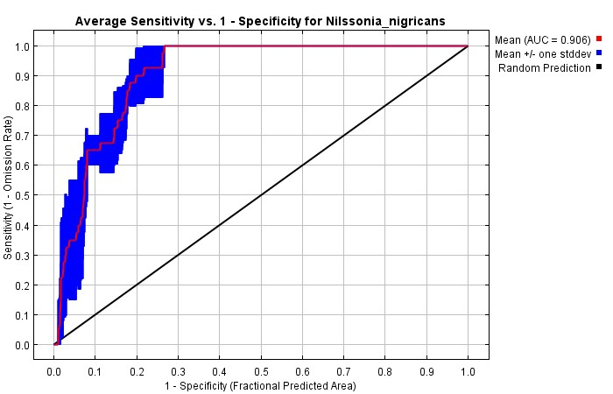
Supplementary Figure 1. Average specificity curve of Nilssonia nigricans (AUC=0.906).

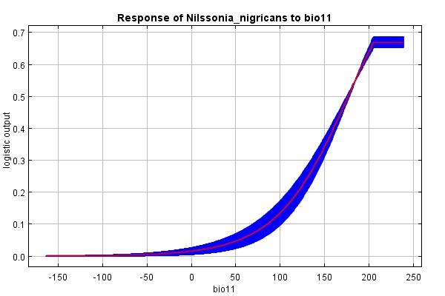 | 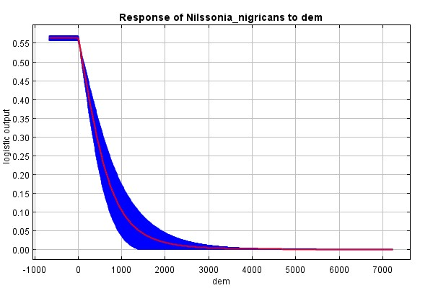
bio11 (⁰C) | DEM (m)
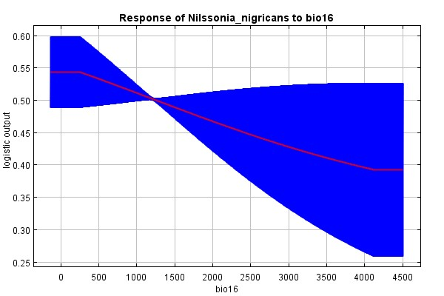 | 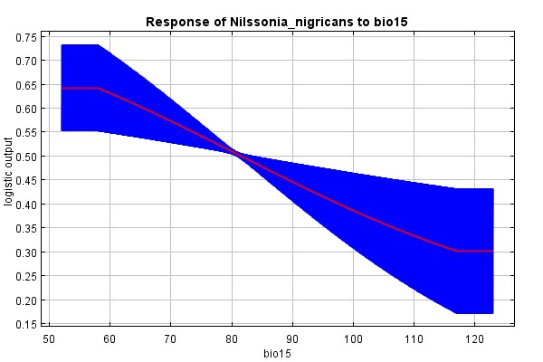
bio16 (mm) | bio15
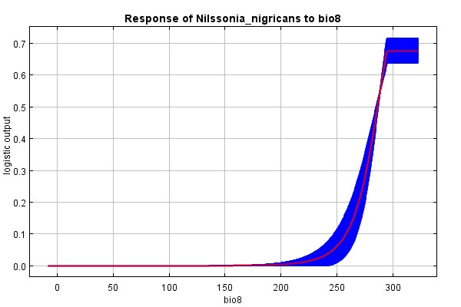 | 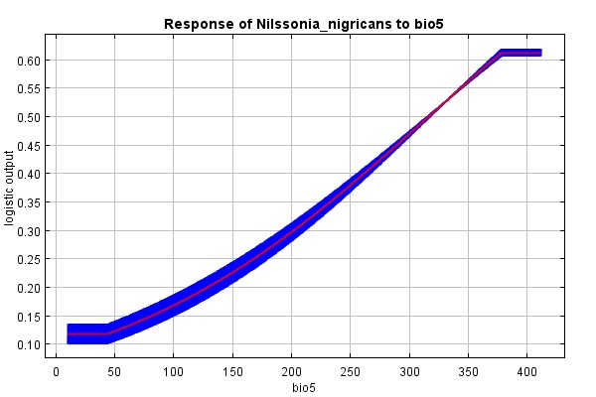
bio8 (⁰C) | bio5(⁰C)
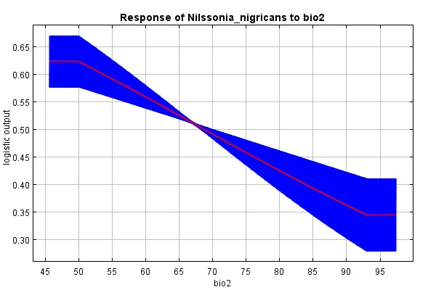
bio2 (⁰C)
Supplementary Figure 2. Probability of Response curves (Logistic Output)

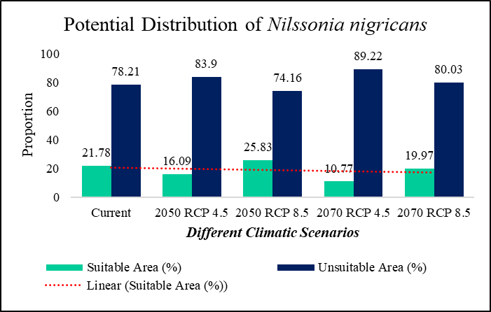
Supplementary Figure 3. The proportion of suitable area for the potential distribution of N. nigricans in different climatic scenarios

Supplementary Table. 1. Occurrence Locations of Nilssonia nigricans obtained from published literature and GBIF (Note: Only 35 locations have been obtained after the spatial rarification of 1km²)
Sl.no. | Place | Latitude (°N) | Longitude (°E) | Source
 | Agartala, Tripura | 23.5090 | 91.4989 | Das and Vishnu 2021
 | Arunachal Pradesh | 27.750028 | 95.80002 | Kundu et al. 2018
 | Kamakhya Temple Pond, Guwahati, Assam | 26.165503 | 91.704968 | Purkayastha et al. 2013
 | Nagshankar temple, Tezpur, Assam | 26.724952 | 92.994551 | Barhadiya et al. 2020
 | Athkheliya Namgarh Golaghat, Assam | 26.472967 | 94.098528 | Barhadiya et al. 2020
 | Baneshwar Shiva Cooch Behar, West Bengal | 26.39825 | 89.498167 | Barhadiya et al. 2020
 | Barokheliya Namghar Golaghat, Assam | 26.263444 | 93.923889 | Barhadiya et al. 2020
 | Chinatoli bor Namghar Golaghat, Assam | 26.570703 | 93.918056 | Barhadiya et al. 2020
 | Deopani Karbi Anglong, Assam | 26.219241 | 93.827991 | Barhadiya et al. 2020
 | Dhareshwari devalaya Siliguri, Assam | 26.176611 | 91.476806 | Barhadiya et al. 2020
 | Gorokhiya Gohain Than Sarbog, Assam | 26.487765 | 90.881089 | Barhadiya et al. 2020
 | Haigrib Madhab Hajo, Assam | 26.244417 | 91.526444 | Barhadiya et al. 2020
 | Hatigarh dewalay Jorhat, Assam | 26.777074 | 94.265372 | Barhadiya et al. 2020
 | Kedar Hajo, Assam | 26.241798 | 91.544421 | Barhadiya et al. 2020
 | Madhab Jamuguri, Assam | 26.736326 | 92.934995 | Barhadiya et al. 2020
 | Mandir devalaya Golaghat, Assam | 26.502169 | 93.979425 | Barhadiya et al. 2020
 | Monkey Lakhimpur, Assam | 27.002049 | 93.984007 | Barhadiya et al. 2020
 | Nagshankar Mandir Biswanath, Assam | 26.725104 | 92.994651 | Barhadiya et al. 2020
 | Rudra Sagar Siba Sagar, Assam | 26.949972 | 94.583859 | Barhadiya et al. 2020
 | Siva Sagar Siba Sagar, Assam | 26.991667 | 94.633523 | Barhadiya et al. 2020
 | Ugrotara Guwahati, Assam | 26.188732 | 91.751328 | Barhadiya et al. 2020
 | Manas National Park, Assam | 26.72011 | 91.075162 | Dutta et al. 2022
 | Assam | 26.4 | 89.5 | GBIF
 | Assam | 26.2 | 91.7 | GBIF
 | Assam | 26.2 | 91.7 | GBIF
 | West Bengal | 26.4 | 89.5 | GBIF
 | West Bengal | 26.4 | 89.5 | GBIF
 | West Bengal | 26.7 | 93.6 | GBIF
 | Assam | 26.7 | 93 | GBIF
 | Assam | 26.7 | 93 | GBIF
 | Assam | 26.7 | 93 | GBIF
 | Assam | 26.7 | 93 | GBIF
 | Assam | 26.7 | 93 | GBIF
 | Assam | 26.7 | 93 | GBIF
 | Assam | 26.7 | 93 | GBIF
 | Assam | 26.8 | 92.9 | GBIF
 | Assam | 26.7 | 93.1 | GBIF
 | Assam | 26.7 | 93.1 | GBIF
 | Assam | 25.7 | 93 | GBIF
 | Assam | 25.7 | 93 | GBIF
 | Assam | 25.7 | 93 | GBIF
 | Assam | 25.7 | 93 | GBIF
 | Assam | 24.2 | 92.2 | GBIF
 | Assam | 24.2 | 92.2 | GBIF
 | Assam | 24.5 | 92.5 | GBIF
 | Assam | 24.4 | 92.2 | GBIF
 | Assam | 24.5 | 92.5 | GBIF
 | Assam | 24.4 | 92.2 | GBIF
 | Assam | 24.5 | 92.2 | GBIF
 | Assam | 24.5 | 92.2 | GBIF
 | Assam | 24.5 | 92.2 | GBIF
 | Assam | 24.5 | 92.2 | GBIF
 | Assam | 27.3 | 95.2 | GBIF
 | Assam | 27.3 | 95.2 | GBIF
 | Assam | 27.3 | 95.2 | GBIF
 | Assam | 27.3 | 95.2 | GBIF
 | Assam | 23.3 | 91.3 | GBIF
 | Assam | 23.3 | 91.3 | GBIF
 | Assam | 25.7 | 93 | GBIF
 | Assam | 25.7 | 93 | GBIF
 | Assam | 25.7 | 93 | GBIF
 | Assam | 25.7 | 93 | GBIF
 | Assam | 26.4 | 89.5 | GBIF

Supplementary Table 2. Correlation matrix of Bioclimatic and Topographical variables in the study area

