Development and validation of pathological nomograms for colorectal cancer patients’ prognosis prediction

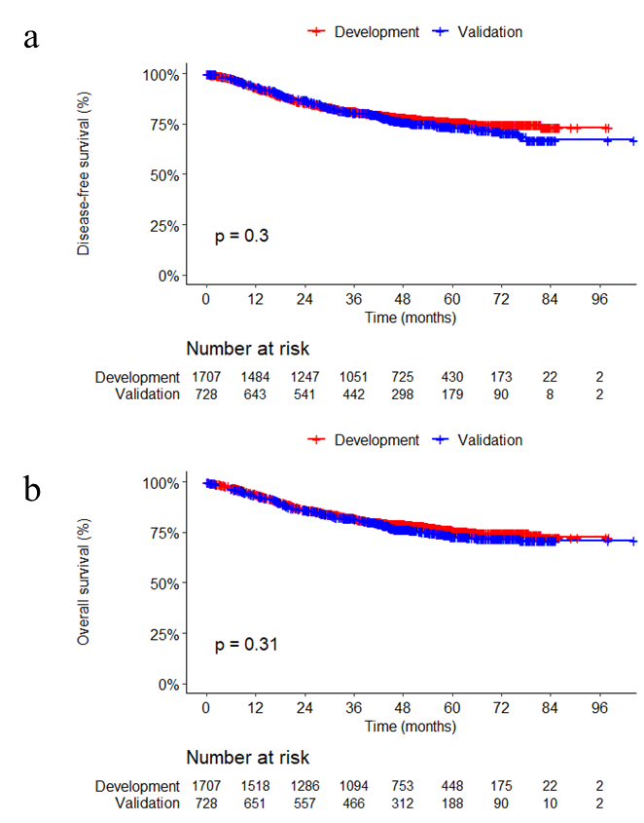
Fig S1. Kaplan-Meier results of patients in development set and validation set for long-term prognosis, indicating no significant difference in survival between two subsets.

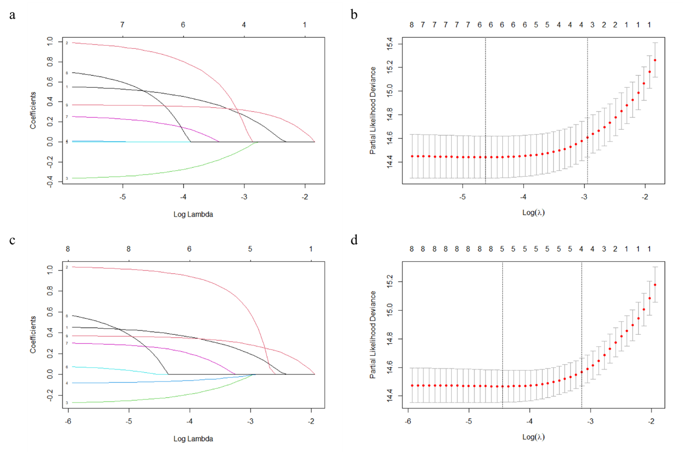
Fig S2. Selecting predictive factors by using LASSO regression model. LASSO coefficient curves of 9 predictors for OS (a) and DFS (c). Identification of the best punishment coefficient lambda in LASSO regression model for OS (b) and DFS (d).

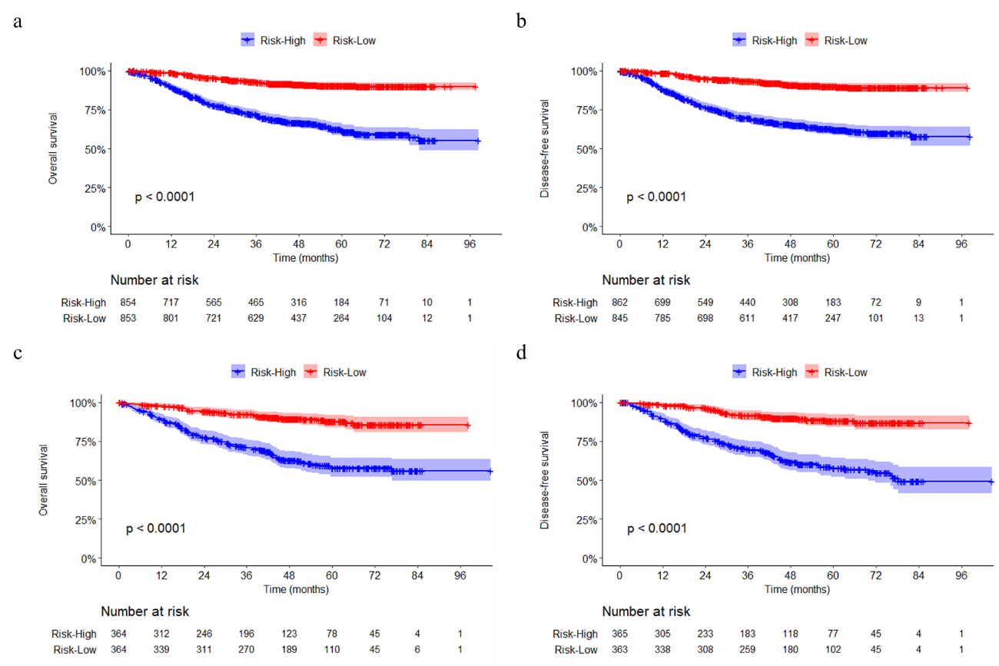

Fig S3. Kaplan-Meier results. Overall survival in development (a) and validation (c) set, disease-free survival in development (b) and validation (d) set.

