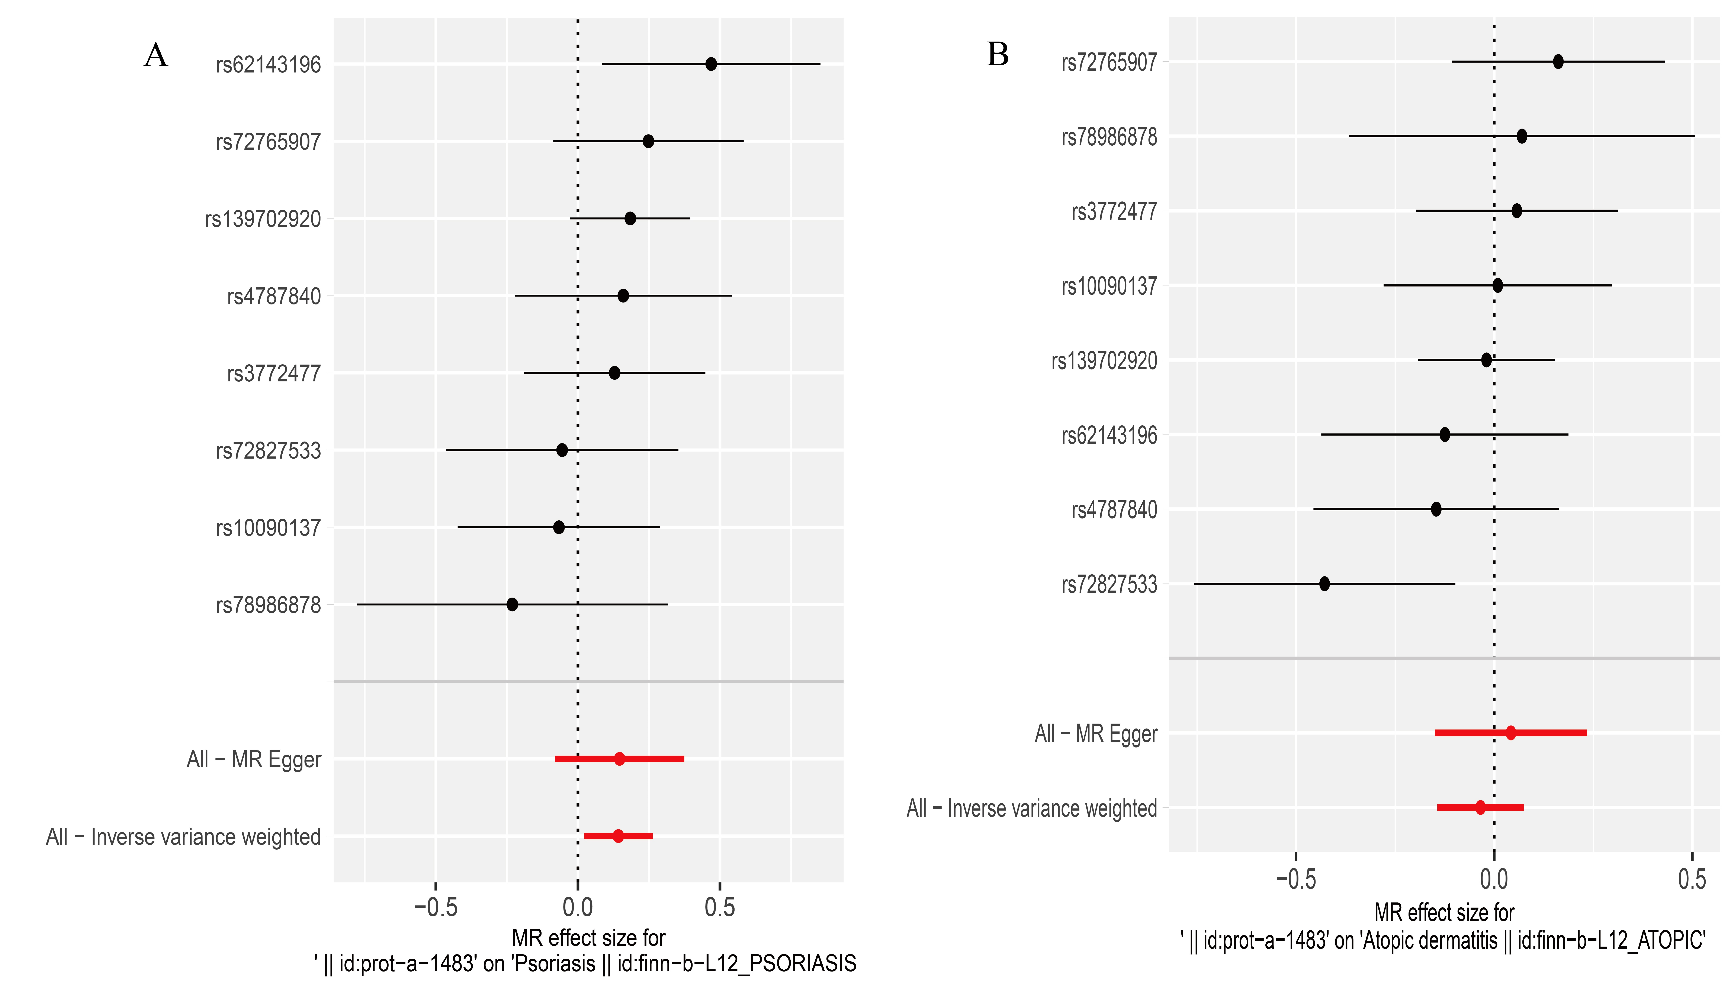
Supplementary Figure 1 Forest plots: (A) IL-17C and Psoriasis; (B) IL-17C and Atopic dermatitis

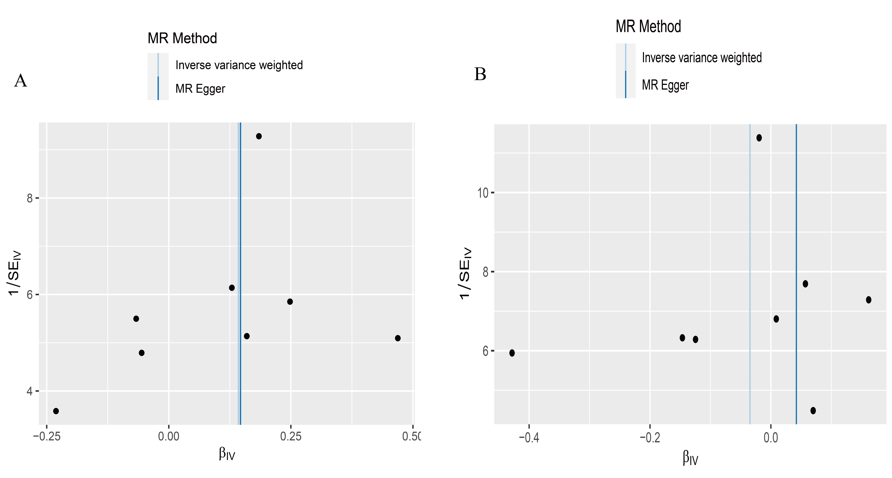
Supplementary Figure 2 Funnel plots: (A) IL-17C and Psoriasis; (B) IL-17C and Atopic dermatitis

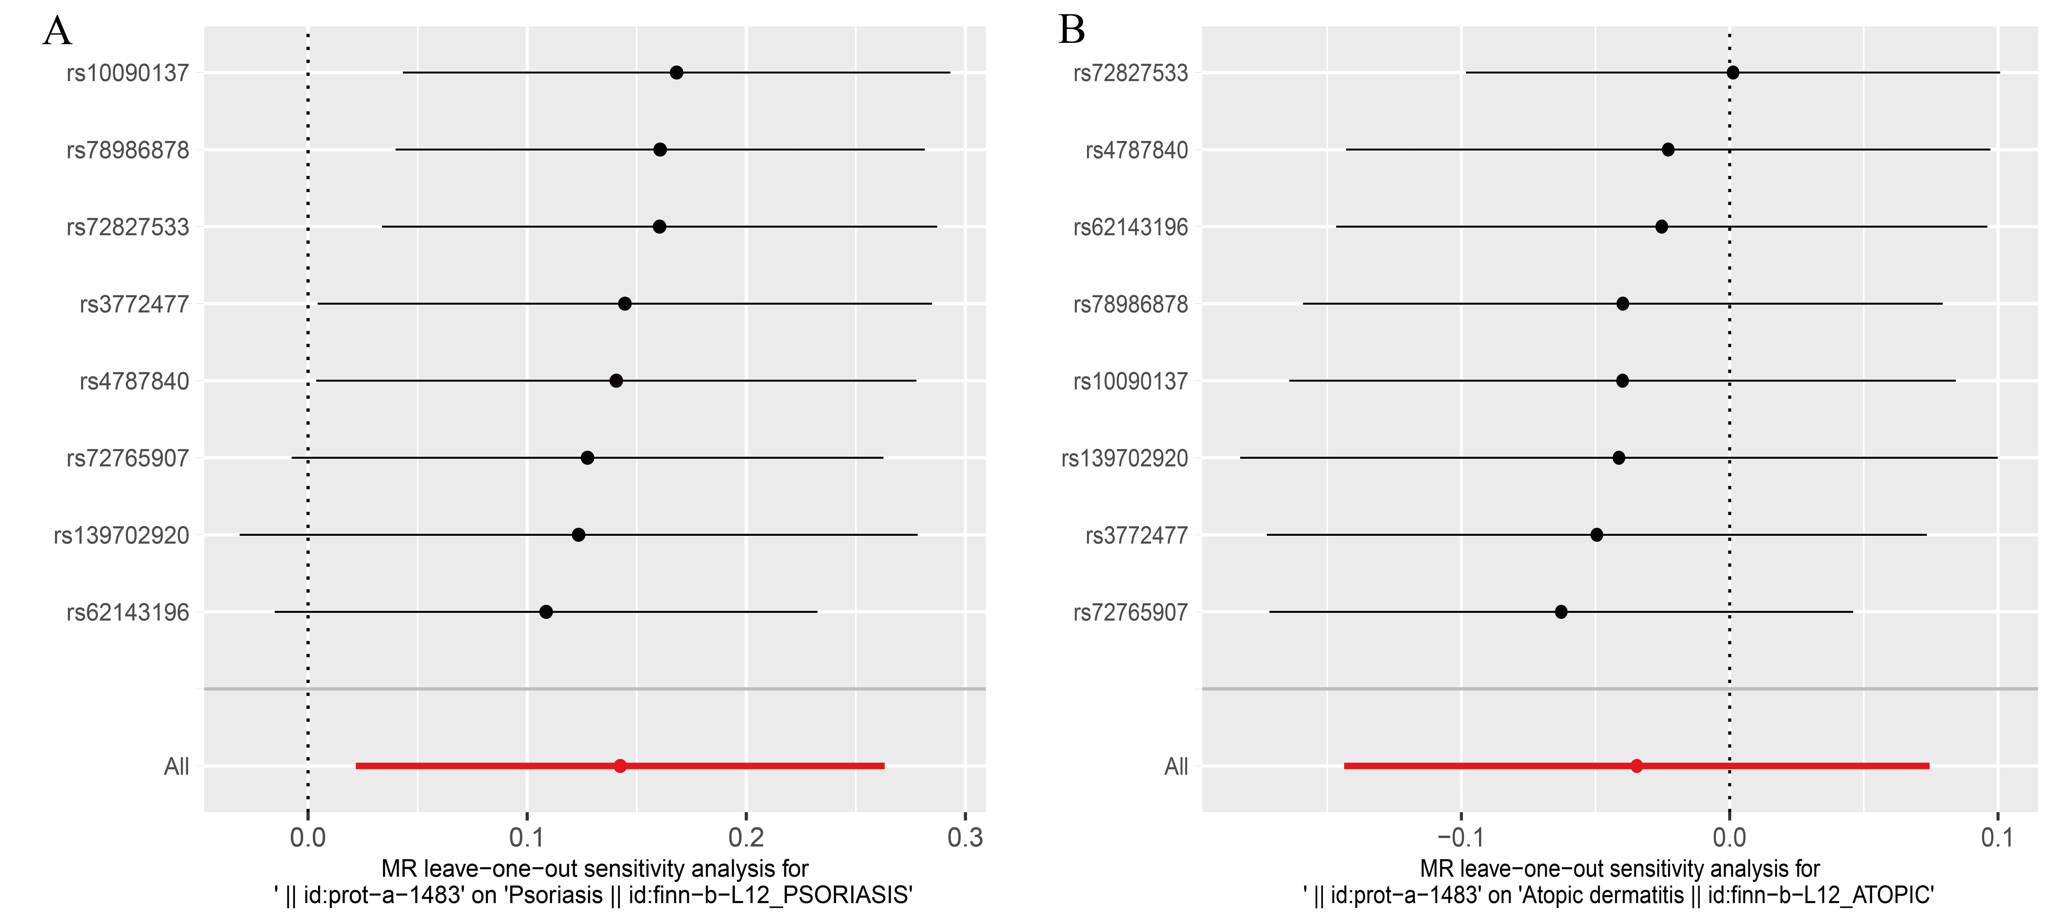
Supplementary Figure 3 Leave-one-out sensitivity analysis: (A) IL-17C and Psoriasis; (B) IL-17C and Atopic dermatitis

