Supplementary information
Table s1. Frequency of patients in each cluster/SRS grouping

Condition | total | Cluster 1 | Cluster 2 | Cluster 3
Control | 30 | 26 (86.7%) | 1 (3.3%) | 3 (10%)
Admission | 25 | 0 | 19 (76%) | 6 (24%)
Day 3 | 23 | 0 | 16 (69.6%) | 7 (30.4%)
Day 5 | 24 | 0 | 14 (58.3%) | 10 (41.7%)
Discharge | 13 | 0 | 3 (23.1%) | 10 (76.9%)
Total | 115 | 26 | 53 | 36

Table s2. Number of patients in each dataset
 | Control | Admission | Day 3 | Day 5 | Discharge
RNA-seq | 30 | 25 | 23 | 24 | 13
Cytokines | 27 | 27 | 26 | 25 | 15
cyTOF | 28 | 24 | 16 | 18 | 12

Table s3. Antibodies for cyTOF immunophenotyping panel
Marker | Metal tag | Company | Catologue No. | Volume (μl)
CD45 (Qdot605) | 111Cd | Invitrogen | Q10051 | 1
CD45 | 159Tb | Biolegend | 304045 (custom) | 0.5
CD45 | 88Y | Fluidigm | 308003B | 1
CD45 | 115In | Biolegend | 304045 (custom) | 1
CD45 | 209Bi | Biolegend | 304045 (custom) | 1
CD196 (CCR6) | 141Pr | Fluidigm | 3141003A | 2
CD19 | 142Nd | Fluidigm | 3142001B | 1
CD127 (IL-7Ra) | 143Nd | Fluidigm | 3143012B | 1
CD38 | 144Nd | Fluidigm | 3144014B | 1
CD279 (PD-1) | 145Nd | BioLegend | 329941 (custom) | 1
IgD | 146Nd | Fluidigm | 3146005B | 1
CD11c | 147Sm | Fluidigm | 3147008B | 1
CD16 | 148Nd | Fluidigm | 3148004B | 1
CD194/CCR4 | 149Sm | Fluidigm | 3149029A | 1
CD119 (IFGR1) | 150Nd | BioLegend | 308604 (custom) | 1
CD123 (IL-3R) | 151Eu | Fluidigm | 3151001B | 1
TCRgd | 152Sm | Fluidigm | 3152008B | 1
CD185 (CXCR5) | 153Eu | Fluidigm | 3153020B | 1
CD3 | 154Sm | Fluidigm | 3154003B | 1
CD45RA | 155Gd | Fluidigm | 3155011B | 1
CD274 (PD-L1) | 156Gd | Fluidigm | 3156026B | 1
CD27 | 158Gd | Fluidigm | 3158010B | 1
CD28 | 160Gd | Fluidigm | 3160003B | 1
CD152 (CTLA4) | 161Dy | Fluidigm | 3161004B | 1
CD66b | 162Dy | Fluidigm | 3162023B | 1
CD183 (CXCR3) | 163Dy | Fluidigm | 3163004B | 1
CD161 | 164Dy | Fluidigm | 3164009B | 1
CD45RO | 165Ho | Fluidigm | 3165011B | 1
CD24 | 166Er | Fluidigm | 3166007B | 1
CD197 (CCR7) | 167Er | Fluidigm | 3167009A | 1
CD8a | 168Er | Fluidigm | 3168002B | 1
CD25 (IL-2R) | 169Tm | Fluidigm | 3169003B | 1
CD116 (GM-CSFR) | 170Er | BioLegend | 305902 (custom) | 1
CD20 | 171Yb | Fluidigm | 3171012B | 1
IgM | 172Yb | Fluidigm | 3172004B | 1
HLA-DR | 173Yb | Fluidigm | 3173005B | 1
CD4 | 174Yb | Fluidigm | 3174004B | 1
CD14 | 175Lu | Fluidigm | 3175015B | 2
CD56 (NCAM) | 176Yb | Fluidigm | 3176008B | 1

Table s3: cyTOF markers for FlowSOM analyses
Innate | CD4+ T cells | CD8+ T cells | B cells
CD11c | CCR6 | CCR6 | CCR6
CD16 | CD38 | CD38 | CD38
CD119 | CXCR5 | CXCR5 | IgD
CD123 | CD45RA | CD45RA | CXCR5
CD66b | CD45RO | CD45RO | CD45RA
CD161 | CD27 | CD27 | CD27
CCR7 | CXCR3 | CXCR3 | CXCR3
CD116 | CCR7 | CCR7 | CD24
HLA-DR | CD25 | CD25 | CCR7
CD14 | CD127 | CD127 | CD20
CD56 | HLA-DR | HLA-DR | IgM
 | CCR4 | CCR4 | CD25
 | CD28 | CD28 | CD19
 | CD56 | CD56 | CD11c
Figure s1. UpSet plot of the number of patients at each timepoint by dataset
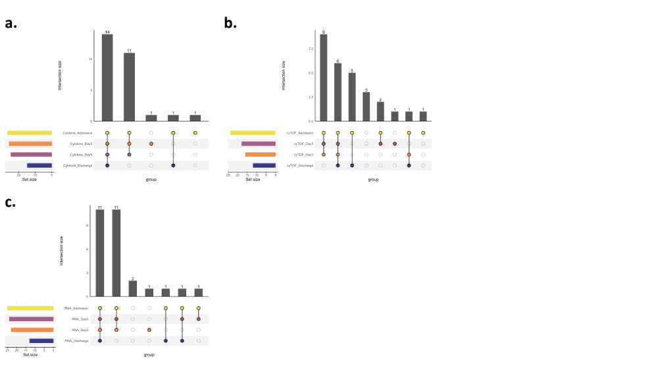

Figure s2. Expression levels of dysregulated plasma cytokines over clinical time

Figure s3. Proportions of immune cell subsets as identified by cyTOF
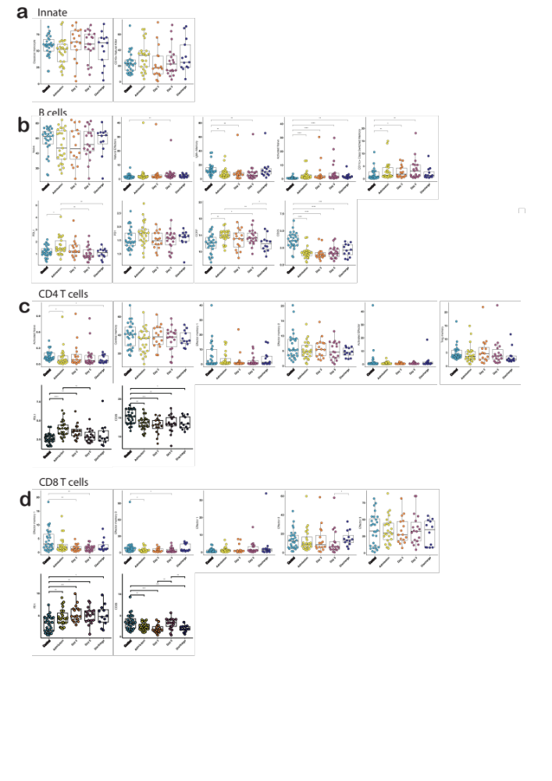

Figure s4. Enriched pathways
