Supplementary Figure

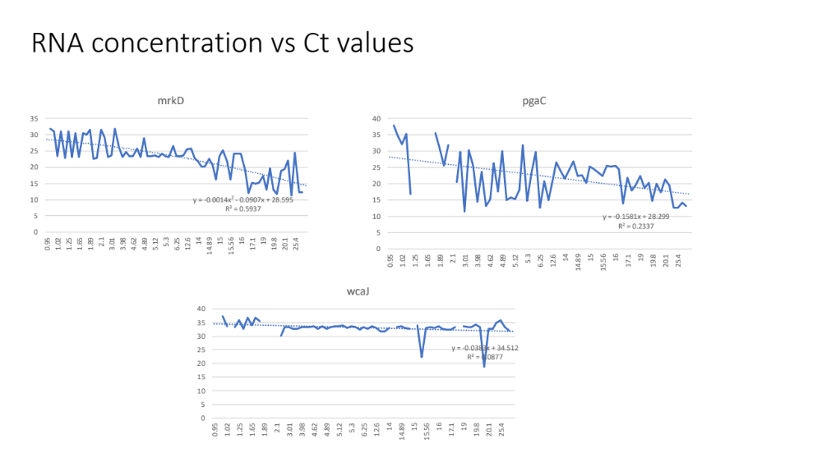
Figure S1: RNA concentration vs observed RT-PCR Ct values for mrkD, pgaC and wcaJ genes from K. pneumoniae. Picture depicts decreased Ct values with increasing RNA concentration exhibiting the sensitivity of the RT-PCR with as low as 1 ng/µl RNA concentrations.

