Additional File 11 – Figure showing the risks of contamination in DAIRE (1)
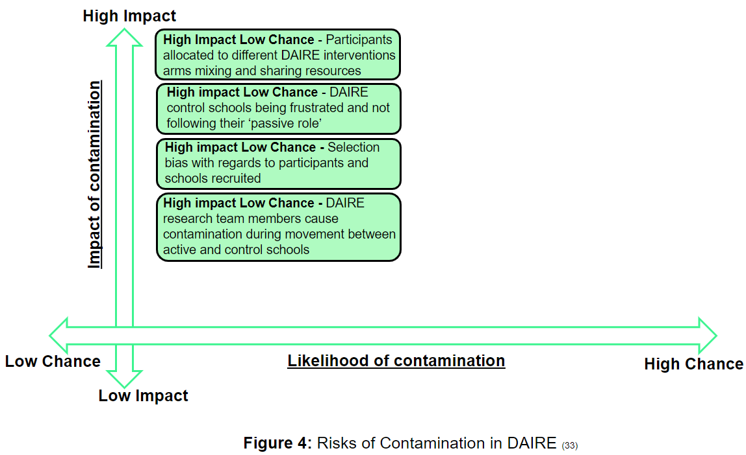
Reference:
(1) Stamp E, Schofield H, Roberts VL, Burton W, Collinson M, Stevens J, et al. Contamination within trials of community-based public health interventions: lessons from the HENRY feasibility study. Pilot and Feasibility Studies. 2021;7(1):88.

