Supplementary materials
Sub-group analyses with IQ-matched adults
Because in the whole sample, there was a significant difference between RD adults and typical adults on Raven, we performed sub-group analyses on both behavioral tests and fNIRS data with Raven well matched in adults with RD and typical control adults. This resulted in a sub-group of 14 adults with RD, and 12 age-matched control adults, and children groups remained the same. Age and raven scores were matched for typical adult readers and adults with RD (controls = 19.67±1.56 years, RDs = 19.57±1.09 years, t(24) = 0.18, p = 0.86 for age; controls = 123.33±3.82, RDs = 116.43±12.26, t(15.87) = 1.99, p = 0.063 for raven).
Results for behavioral tests
A Group (AC, RD) by Age (children, adults) ANOVA was conducted for each behavioral test in the sub-group analyses. Significant main effects of Age and Group were observed for all three screening tests (Table S1), with adults better than children and typical readers better than individuals with RD. The Age by Group interaction was significant for character naming (F(1,66) = 33.37, p_{FDR} < 0.001, η_{p}² = 0.35), and sentence reading fluency (F(1,66) = 12.18, p_{FDR} = 0.035, η_{p}² = 0.16) but not for one-minute regular character naming (F(1,66) = 2.03, p_{FDR} = 0.30, η_{p}² = 0.03) or one-minute irregular character naming (F(1,66) = 3.91, p_{FDR} = 0.15, η_{p}² = 0.06). Simple effect revealed a consistent pattern as in the whole sample analysis, with children with RD showing a greater deficit than adults with RD on the Chinese character naming test ( F(1,62) = 146.74, p < 0.001 for children; F(1,62) = 5.57, p = 0.021 for adults), and adults with RD showing a greater deficit than children with RD on the sentence reading fluency test (F(1,62) = 86.83, p < 0.001 for adults; F(1,62) = 35.77, p < 0.001 for children).
The main effects of Age and Group was also significant for all meta-linguistic and cognitive tests (Table S1). The Age by Group interaction was significant for homographic morpheme test (F(1,64) = 17.17, p_{FDR} < 0.001, η_{p}² = 0.22), and homophonic morpheme test (F(1,64) = 14.04, p_{FDR} = 0.002, η_{p}² = 0.19). The interaction between Age and Group was not significant for working memory forward-digit span (F(1,57) = 2.93, uncorrected p = 0.093) or rapid automatized naming of digits (F(1,66) = 1.92, uncorrected p = 0.171). Simple effect analysis revealed a deficit in morphological awareness in children with RD (F(1,60) = 34.16, p < 0.001 for homographic morpheme, F(1,60) = 47.82, p < 0.001 for homophonic morpheme), but not in adults with RD (F(1,60) = 0.29, p = 0.59 for homographic morpheme, F(1,60) = 0.75, p = 0.39 for homophonic morpheme).
Table S1. Main effects of Age and Group for behavioral tests.
 | F_{age} | η_{p}² | F_{group} | η_{p}²
Chinese Character Naming | 158.57*** | .72 | 89.28*** | .59
Sentence Reading Fluency | 39.86*** | .39 | 121.15*** | .66
One-minute Character Naming (regular) | 67.53*** | .52 | 68.92*** | .53
One-minute Character Naming (irregular) | 73.59*** | .54 | 64.86*** | .51
Initial Sound Deletion | 11.39** | .18 | 22.06*** | .26
Pseudowords Rhyming | 13.26** | .19 | 23.57*** | .27
Homophonic Morpheme | 45.92*** | .43 | 25.82*** | .30
Homographic Morpheme | 75.48*** | .56 | 11.01** | .15
Character Correction | 40.34*** | .40 | 14.85*** | .20
Delayed Copy | 42.03*** | .41 | 11.51** | .16
Forward Digit Span | 34.15*** | .39 | 5.93* | .10
Backward Digit Span | 67.85*** | .52 | 32.85*** | .35
RAN (digits) | 50.22*** | .45 | 21.40*** | .26
RAN (pictures) | 25.95*** | .29 | 12.41** | .17
Note: * FDR p<0.05, ** FDR p<0.01, *** FDR p<0.001.
fNIRS results for speech perception task
We conducted a repeated measure ANOVA of group (AC, RD) by age (children, adults) by similarity to Chinese (high similarity, low similarity) by syllable consistency (identical, different). Results showed no significant main effect of age, group, similarity or syllable consistency. The three-way (age×group×similarity) interactions found in CH31 (right IFG, F(1,69) = 10.86, p = 0.002, η_{p}² = 0.14) and CH37 (right DLPFC, F(1,69) = 10.36, p = 0.002, η_{p}² = 0.13) were significant. Simple effect analyses showed that adults with RD had a greater hemodynamic response than typical adults in perception of Spanish syllables with high similarity to Chinese in CH31(F(1,69) = 4.73, p = 0.033), while no significant differences were found between typical children and children with RD. For CH37, children with RD showed lower hemodynamic response in perception of Spanish syllables with high similarity to Chinese (F(1,69) = 4.56, p = 0.036) and greater hemodynamic response in perception of Spanish syllables with low similarity to Chinese than control children (F(1,69) = 5.40, p = 0.023), while no significant differences were found between typical adults and adults with RD. Another way to explain the interaction is a greater developmental increase in typical controls for the perception of Spanish syllables with low similarity to Chinese (F(1,69) = 5.03, p = 0.028 for CH31, F(1,69) = 5.28, p = 0.025 for CH37) and a greater developmental increase in RDs for Spanish syllables with high similarity to Chinese (F(1,69) = 5.09, p = 0.027 for CH31, F(1,69) = 5.49, p = 0.022 for CH37).
fNIRS results for speech production task
A repeated measure ANOVA was conducted with language as a within-subject factor and group and age as between-subject factors. No significant main effect of Age or Group was observed, and neither was the interaction effect between age and group. The main effect of language was observed in CH10 (left postcentral, F(1,63) = 9.66, p_{FDR} = 0.045, η_{p}² = 0.13), CH32(right IFG, F(1,63) = 17.81, p_{FDR} = 0.004, η_{p}² = 0.22), and CH43 (right postcentral, F(1,63) = 12.26, p_{FDR} = 0.020, η_{p}² = 0.16), with the activation for Chinese greater than that for Spanish. The language by group interaction for CH22 was significant (F(1,63) = 7.75, p = 0.007,η_{p}² = 0.11). Simple effect analyses showed that individuals with RD exhibited greater hemodynamic response for Spanish than Chinese (F(1,63) = 4.84, p = 0.031), whereas no significant language differences was found in typical controls (F(1,63) = 3.05, p = 0.086). Another way to explain the interaction is that individuals with RD had greater hemodynamic response than controls for Spanish production (F(1,63) = 7.92, p = 0.007), while no significant group difference was observed for Chinese production (F(1,63) = 0.10, p = 0.92).
The sub-group analyses showed basically the same results as the whole group analyses for both behavioral and fNIRS data.

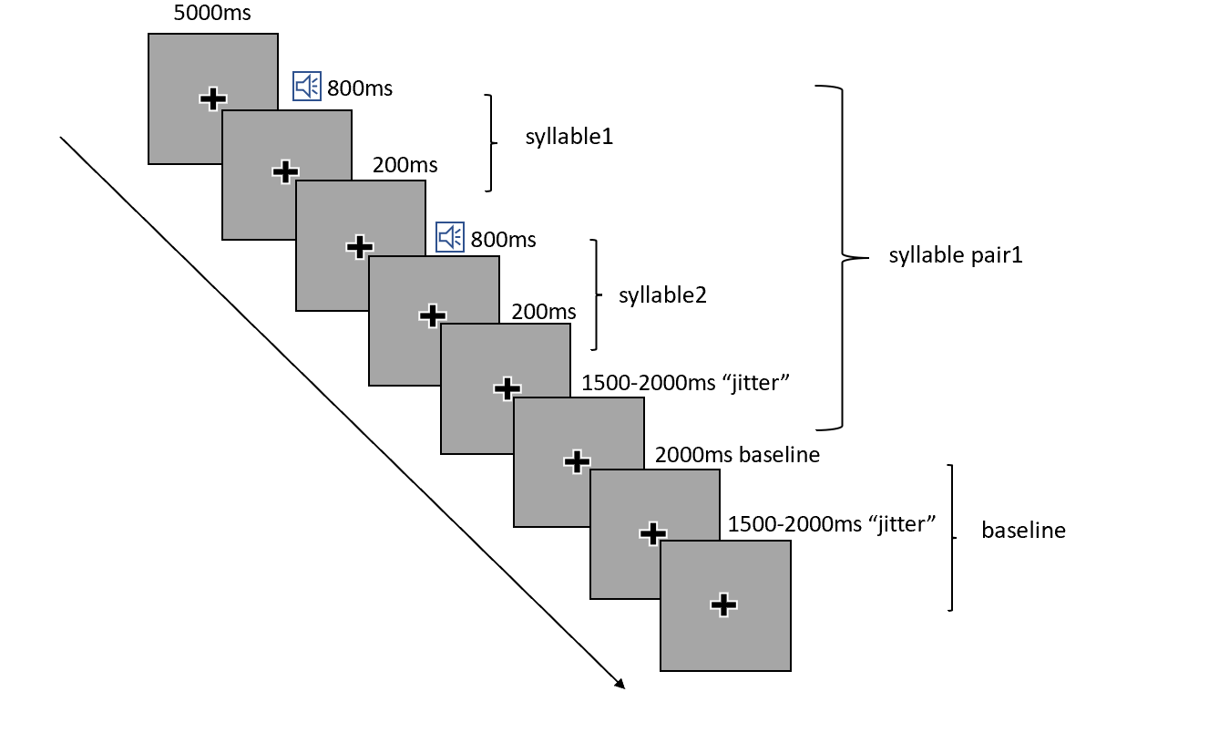
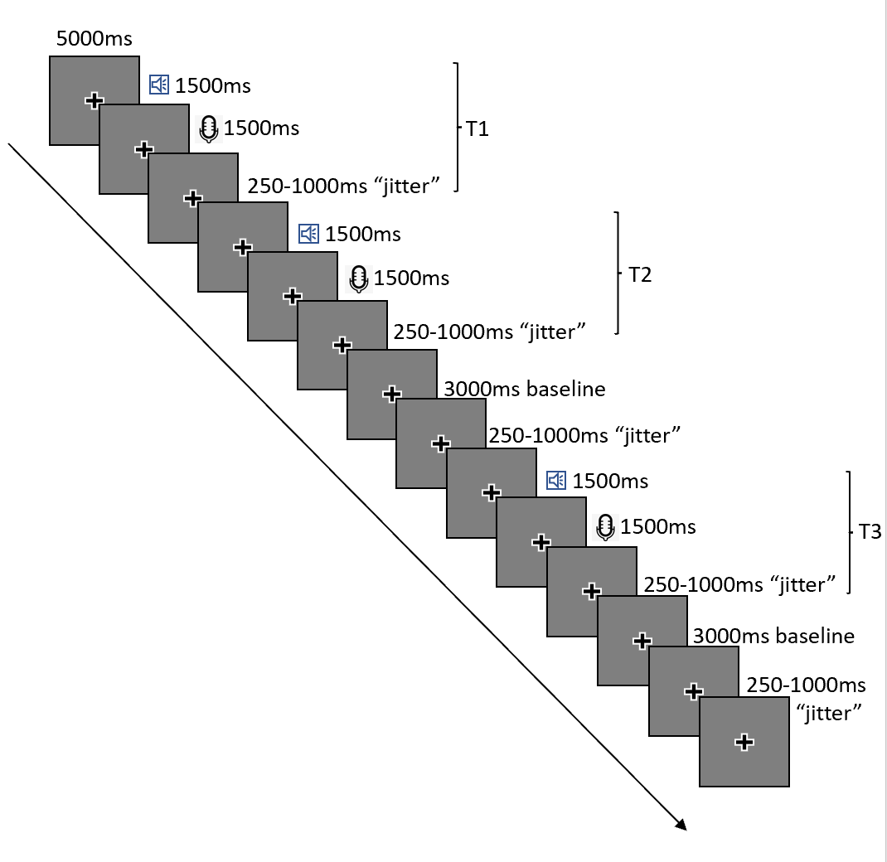
Figure S1. Experimental procedures for the speech perception (upper) and speech production task (bottom).

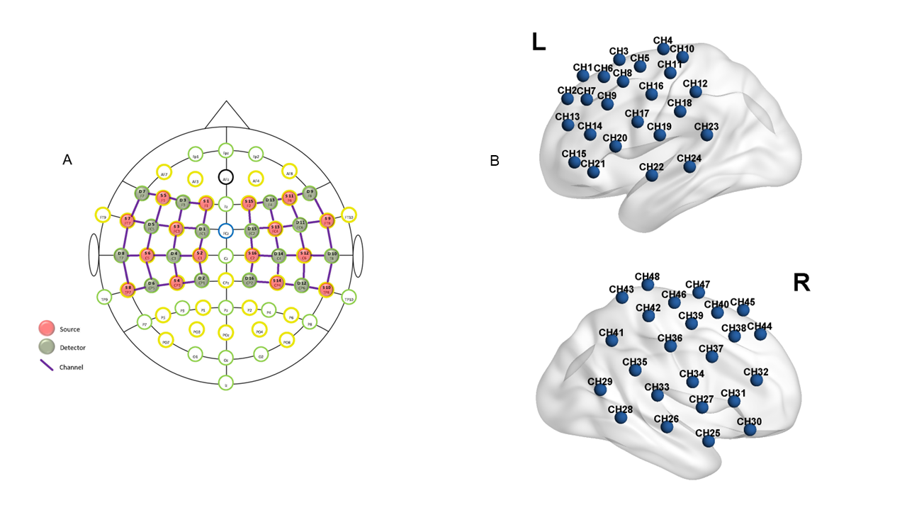
Figure S2. (A) fNIRS probes and channels configuration. (B) Location of fNIRS channels over a brain model.

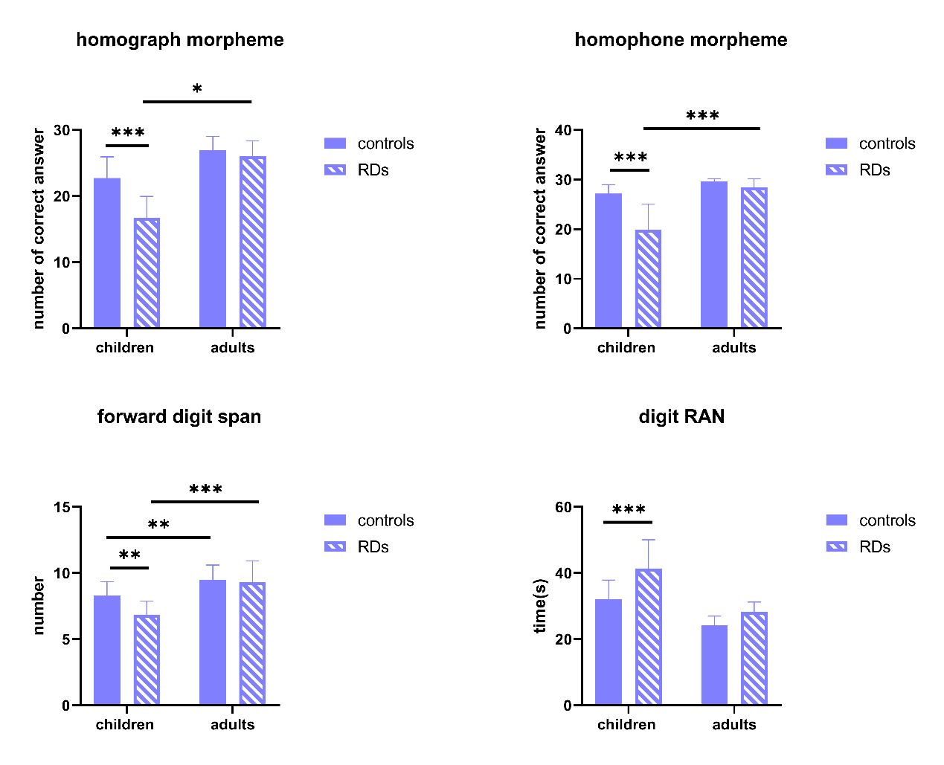
Figure S3. Behavioral performance of each group on four assessments showed a significant age by group interaction. The deficits were greater in children with RD than in adults with RD in all four tests.
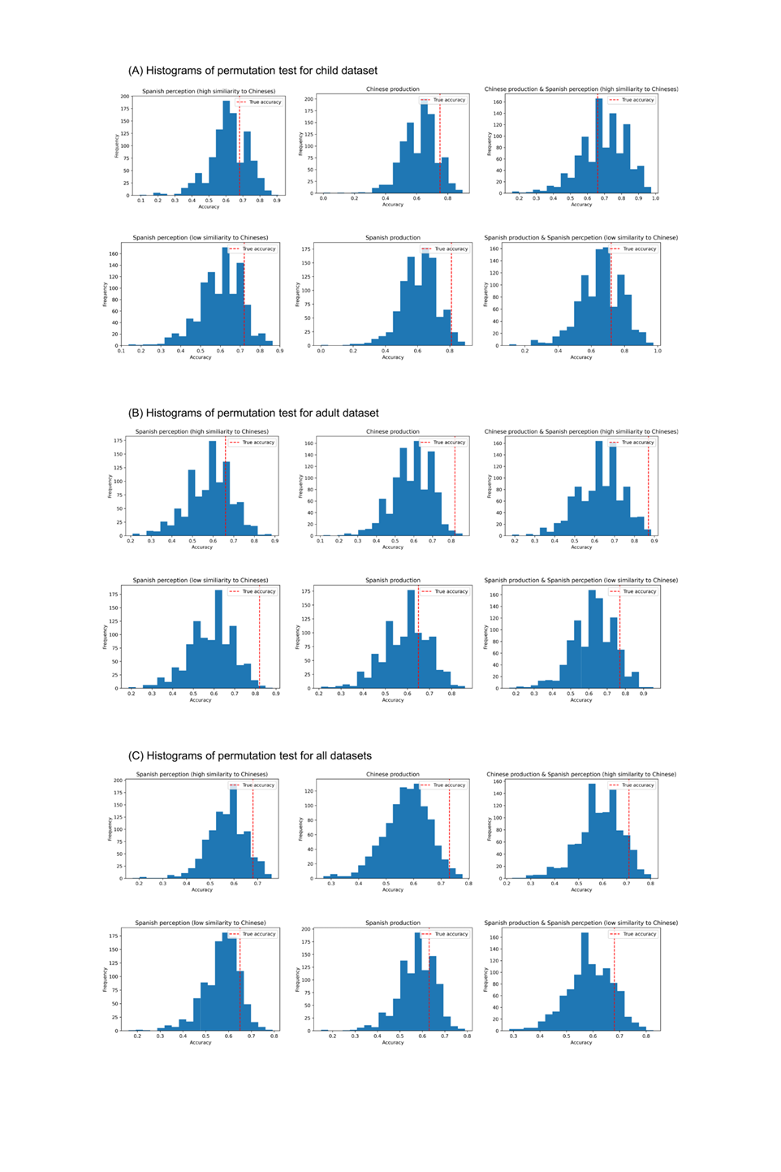
Figure S4. Histograms of permutation test for the child dataset (A), adult dataset (B), and the combination of two datasets (C).

