Supporting information

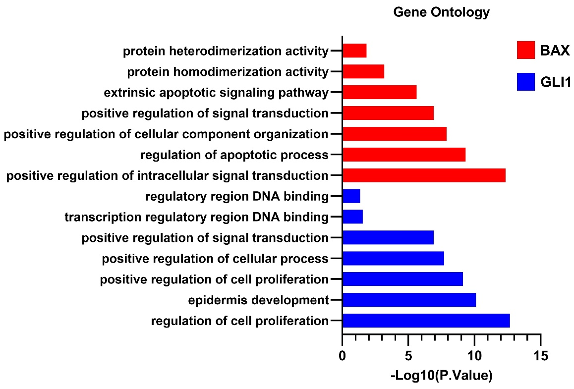
Fig. S1. Biological process and molecular function analysis for GLI1 and BAX. The most important gene ontologies were discovered in PANTHER and listed according to p.value.

Table S1. Selected Samples for Each cell line in GSE70466.

PrEC | LNCAP
GSM1778905 | GSM1778901
GSM1778906 | GSM1778903
GSM1778907 | GSM1778904

Table S2. Genes that were detected in PANTHER to be involved in cell cycle, apoptosis, or hedgehog signaling pathway.
Genes | Path accession | Path name | Genes | Path accession | Path name | Genes | Path accession | Path name
 | P00025 | hedgehog | AL049829 | GO:0006915 | apoptosis | TIMELESS | GO:0007049 | cell_cycle
  CSNK1E
STK36 | P00025 | hedgehog | PHLDA1 | GO:0006915 | apoptosis | RTTN | GO:0007049 | cell_cycle
SUFU | P00025 | hedgehog | BCL10 | GO:0006915 | apoptosis | BACH1 | GO:0007049 | cell_cycle
PTCH1 | P00025 | hedgehog | FANK1 | GO:0006915 | apoptosis | MZT1 | GO:0007049 | cell_cycle
PRKAR2B | P00025 | hedgehog | PINK1 | GO:0006915 | apoptosis | CLTC | GO:0007049 | cell_cycle
GLI1 | P00025 | hedgehog | TMEM109 | GO:0006915 | apoptosis | NSL1 | GO:0007049 | cell_cycle
BTRC | P00025 | hedgehog | HIPK2 | GO:0006915 | apoptosis | PSME2 | GO:0007049 | cell_cycle
MAP10 | GO:0007049 | cell_cycle | FAS | GO:0006915 | apoptosis | CCNJ | GO:0007049 | cell_cycle
CAMSAP3 | GO:0007049 | cell_cycle | APOE | GO:0006915 | apoptosis | JUNB | GO:0007049 | cell_cycle
TBRG1 | GO:0007049 | cell_cycle | DNASE2B | GO:0006915 | apoptosis | CCDC67 | GO:0007049 | cell_cycle
CSNK2A2 | GO:0007049 | cell_cycle | BIRC3 | GO:0006915 | apoptosis | TUBA1A | GO:0007049 | cell_cycle
GADD45G | GO:0007049 | cell_cycle | DFFB | GO:0006915 | apoptosis | IRAK3 | GO:0007049 | cell_cycle
TUBB2B | GO:0007049 | cell_cycle | TNFRSF10C | GO:0006915 | apoptosis | TEX15 | GO:0007049 | cell_cycle
PARD6A | GO:0007049 | cell_cycle | FAM162A | GO:0006915 | apoptosis | CCNJL | GO:0007049 | cell_cycle
TEX14 | GO:0007049 | cell_cycle | DEDD2 | GO:0006915 | apoptosis | ANXA1 | GO:0007049 | cell_cycle
45170 | GO:0007049 | cell_cycle | AXL | GO:0006915 | apoptosis | RMI1 | GO:0007049 | cell_cycle
ROCK1 | GO:0007049 | cell_cycle | NCK2 | GO:0006915 | apoptosis | CCNB3 | GO:0007049 | cell_cycle
TUBB3 | GO:0007049 | cell_cycle | FBXO11 | GO:0006915 | apoptosis | ANXA11 | GO:0007049 | cell_cycle
BIRC3 | GO:0007049 | cell_cycle | PLEKHO2 | GO:0006915 | apoptosis | ZNF711 | GO:0007049 | cell_cycle
CDKN2B | GO:0007049 | cell_cycle | RELT | GO:0006915 | apoptosis | 45178 | GO:0007049 | cell_cycle
CDK3 | GO:0007049 | cell_cycle | CASP10 | GO:0006915 | apoptosis | CHORDC1 | GO:0007049 | cell_cycle
PLK3 | GO:0007049 | cell_cycle | JMY | GO:0006915 | apoptosis | 45175 | GO:0007049 | cell_cycle
ARHGEF10 | GO:0007049 | cell_cycle | DAPK2 | GO:0006915 | apoptosis | RTKN2 | GO:0007049 | cell_cycle
GMNC | GO:0007049 | cell_cycle | PSEN2 | GO:0006915 | apoptosis | TUBB6 | GO:0007049 | cell_cycle
SNX33 | GO:0007049 | cell_cycle | NLRP1 | GO:0006915 | apoptosis | PLK2 | GO:0007049 | cell_cycle
RAD51C | GO:0007049 | cell_cycle | CAPN3 | GO:0006915 | apoptosis | MAJIN | GO:0007049 | cell_cycle
MYB | GO:0007049 | cell_cycle | BAG3 | GO:0006915 | apoptosis | BORA | GO:0007049 | cell_cycle
CDK6 | GO:0007049 | cell_cycle | PRUNE2 | GO:0006915 | apoptosis | MAST1 | GO:0007049 | cell_cycle
45179 | GO:0007049 | cell_cycle | EYA1 | GO:0006915 | apoptosis | CLASP1 | GO:0007049 | cell_cycle
CETN3 | GO:0007049 | cell_cycle | TNF | GO:0006915 | apoptosis | EME1 | GO:0007049 | cell_cycle
TUBB4A | GO:0007049 | cell_cycle | CYFIP2 | GO:0006915 | apoptosis | HSPA1B | GO:0007049 | cell_cycle
ERCC1 | GO:0007049 | cell_cycle | HAX1 | GO:0006915 | apoptosis | SNX9 | GO:0007049 | cell_cycle
HBEGF | GO:0007049 | cell_cycle | TNFRSF10A | GO:0006915 | apoptosis | TUBB2A | GO:0007049 | cell_cycle
MCMDC2 | GO:0007049 | cell_cycle | CASP4 | GO:0006915 | apoptosis | PRDM7 | GO:0007049 | cell_cycle
CCNA1 | GO:0007049 | cell_cycle | AIFM3 | GO:0006915 | apoptosis | PPP2CB | GO:0007049 | cell_cycle
GPR132 | GO:0007049 | cell_cycle | TMEM117 | GO:0006915 | apoptosis | STK33 | GO:0007049 | cell_cycle
KANK2 | GO:0007049 | cell_cycle | MCL1 | GO:0006915 | apoptosis | CCSAP | GO:0007049 | cell_cycle
E2F1 | GO:0007049 | cell_cycle | CD74 | GO:0006915 | apoptosis | KIFC2 | GO:0007049 | cell_cycle
CDK18 | GO:0007049 | cell_cycle | HSPD1 | GO:0006915 | apoptosis | JUND | GO:0007049 | cell_cycle
CDC25C | GO:0007049 | cell_cycle | DUSP6 | GO:0006915 | apoptosis | CDC14A | GO:0007049 | cell_cycle
DONSON | GO:0007049 | cell_cycle | CASP6 | GO:0006915 | apoptosis | CCND2 | GO:0007049 | cell_cycle
RTKN | GO:0007049 | cell_cycle | DDIT4L | GO:0006915 | apoptosis | FAM9C | GO:0007049 | cell_cycle
45172 | GO:0007049 | cell_cycle | BEX2 | GO:0006915 | apoptosis | RB1 | GO:0007049 | cell_cycle
TGFA | GO:0007049 | cell_cycle | EYA2 | GO:0006915 | apoptosis | TUBA3E | GO:0007049 | cell_cycle
TUBA3D | GO:0007049 | cell_cycle | BCL2A1 | GO:0006915 | apoptosis | DOT1L | GO:0007049 | cell_cycle
DYRK3 | GO:0007049 | cell_cycle | XKR9 | GO:0006915 | apoptosis | LLGL2 | GO:0007049 | cell_cycle
SPHK1 | GO:0006915 | apoptosis | LGALS3 | GO:0006915 | apoptosis | PHLDA3 | GO:0006915 | apoptosis
BAX | GO:0006915 | apoptosis | STK17A | GO:0006915 | apoptosis | ANXA1 | GO:0006915 | apoptosis
HTRA1 | GO:0006915 | apoptosis | BCL2L1 | GO:0006915 | apoptosis | FAM134B | GO:0006915 | apoptosis
GDNF | GO:0006915 | apoptosis | SH3RF2 | GO:0006915 | apoptosis | CD40 | GO:0006915 | apoptosis
BID | GO:0006915 | apoptosis | LATS2 | GO:0006915 | apoptosis | NAIP | GO:0006915 | apoptosis
USE1 | GO:0006915 | apoptosis | DAPK1 | GO:0006915 | apoptosis | EGFR | GO:0006915 | apoptosis
CIDEB | GO:0006915 | apoptosis | TMBIM1 | GO:0006915 | apoptosis | BAK1 | GO:0006915 | apoptosis
TNFRSF21 | GO:0006915 | apoptosis | BMP4 | GO:0006915 | apoptosis | DDIT4 | GO:0006915 | apoptosis
PSME1 | GO:0007049 | cell_cycle | PARD6G | GO:0007049 | cell_cycle | BDNF | GO:0006915 | apoptosis
CCNE2 | GO:0007049 | cell_cycle | CDK14 | GO:0007049 | cell_cycle | TRADD | GO:0006915 | apoptosis
C5ORF45 | GO:0007049 | cell_cycle | NDE1 | GO:0007049 | cell_cycle | PPM1F | GO:0006915 | apoptosis
AL135787 | GO:0007049 | cell_cycle | SYCP3 | GO:0007049 | cell_cycle | NUSAP1 | GO:0007049 | cell_cycle
CCNH | GO:0007049 | cell_cycle | KIAA1614 | GO:0007049 | cell_cycle | IRAK2 | GO:0007049 | cell_cycle
CDK1 | GO:0007049 | cell_cycle | SASS6 | GO:0007049 | cell_cycle | CDKN1B | GO:0007049 | cell_cycle
FBXL17 | GO:0007049 | cell_cycle | 45183 | GO:0007049 | cell_cycle | CDK17 | GO:0007049 | cell_cycle
45174 | GO:0007049 | cell_cycle | EBF3 | GO:0007049 | cell_cycle | AFAP1L2 | GO:0007049 | cell_cycle
NUPR1 | GO:0007049 | cell_cycle | AVEN | GO:0007049 | cell_cycle | NUPR2 | GO:0007049 | cell_cycle
HEXIM2 | GO:0007049 | cell_cycle | RP1 | GO:0007049 | cell_cycle | LIN9 | GO:0007049 | cell_cycle
ROCK2 | GO:0007049 | cell_cycle | SPIRE2 | GO:0007049 | cell_cycle | EPGN | GO:0007049 | cell_cycle
HSPA1A | GO:0007049 | cell_cycle | CEP295 | GO:0007049 | cell_cycle | RAB11FIP4 | GO:0007049 | cell_cycle
EREG | GO:0007049 | cell_cycle | LATS2 | GO:0007049 | cell_cycle | 45173 | GO:0007049 | cell_cycle
AREG | GO:0007049 | cell_cycle | GADD45A | GO:0007049 | cell_cycle | REC8 | GO:0007049 | cell_cycle
ABL2 | GO:0006915 | apoptosis | WAPL | GO:0007049 | cell_cycle | BCL2L11 | GO:0007049 | cell_cycle
FAIM | GO:0006915 | apoptosis | GOLGA8R | GO:0007049 | cell_cycle | TUBD1 | GO:0007049 | cell_cycle
BMF | GO:0006915 | apoptosis | BTC | GO:0007049 | cell_cycle | NABP1 | GO:0007049 | cell_cycle
MLLT11 | GO:0006915 | apoptosis | CDKN2C | GO:0007049 | cell_cycle | CAPG | GO:0007049 | cell_cycle
GADD45B | GO:0007049 | cell_cycle | SRC | GO:0006915 | apoptosis | TNFRSF10B | GO:0006915 | apoptosis
HYPK | GO:0006915 | apoptosis | NTF4 | GO:0006915 | apoptosis | GSK3A | GO:0006915 | apoptosis
WT1 | GO:0006915 | apoptosis | MIEN1 | GO:0006915 | apoptosis | XKR5 | GO:0006915 | apoptosis
IFI27L2 | GO:0006915 | apoptosis

Table S3. Genes that were detected in PANTHER to be involved in cell cycle, apoptosis, or hedgehog signaling pathway.
Source | Target | Weight | Target degree | Path accession | Path name | GEPIA
BAX | GSK3A | 0.949104204 | 110 | GO:0006915 | apoptosis | 0.37
BAX | BID | 0.984684065 | 206 | GO:0006915 | apoptosis | 0.32
BAX | APOE | 0.72164764 | 183 | GO:0006915 | apoptosis | 0.28
BAX | BAK1 | 0.909729068 | 195 | GO:0006915 | apoptosis | 0.26
BAX | BCL2L1 | 0.80409853 | 188 | GO:0006915 | apoptosis | 0.25
BAX | CASP6 | 0.969864451 | 191 | GO:0006915 | apoptosis | 0.24
BAX | TNFRSF10A | 0.892461716 | 163 | GO:0006915 | apoptosis | 0.15
BAX | DEDD2 | 0.881077612 | 182 | GO:0006915 | apoptosis | 0.14
BAX | EYA2 | 0.97932077 | 201 | GO:0006915 | apoptosis | 0.13
BAX | TNFRSF21 | 0.847965768 | 133 | GO:0006915 | apoptosis | 0.12
BAX | CD74 | 0.923495674 | 192 | GO:0006915 | apoptosis | 0.1
BAX | BCL2A1 | 0.931258848 | 172 | GO:0006915 | apoptosis | 0.1
BAX | JMY | -0.828935581 | 97 | GO:0006915 | apoptosis | -0.11
BAX | DFFB | -0.70998373 | 190 | GO:0006915 | apoptosis | -0.21
BAX | PRUNE2 | -0.800762646 | 183 | GO:0006915 | apoptosis | -0.22
BAX | CIDEB | -0.895485914 | 173 | GO:0006915 | apoptosis | -0.28
GLI1 | IRAK3 | 0.907878581 | 175 | GO:0007049 | cell_cycle | 0.6
GLI1 | CDK18 | 0.782884757 | 183 | GO:0007049 | cell_cycle | 0.58
GLI1 | KIAA1614 | 0.987407358 | 123 | GO:0007049 | cell_cycle | 0.53
GLI1 | PLK3 | 0.878737537 | 190 | GO:0007049 | cell_cycle | 0.48
GLI1 | RTTN | 0.865938675 | 186 | GO:0007049 | cell_cycle | 0.48
GLI1 | ARHGEF10 | 0.91059354 | 162 | GO:0007049 | cell_cycle | 0.46
GLI1 | SNX33 | 0.930634739 | 172 | GO:0007049 | cell_cycle | 0.37
GLI1 | RTKN | 0.829916338 | 184 | GO:0007049 | cell_cycle | 0.32
GLI1 | ROCK1 | 0.894358091 | 179 | GO:0007049 | cell_cycle | 0.28
GLI1 | CLASP1 | 0.773047514 | 172 | GO:0007049 | cell_cycle | 0.25
GLI1 | EBF3 | -0.741978232 | 172 | GO:0007049 | cell_cycle | 0.25
GLI1 | IRAK2 | 0.987636985 | 110 | GO:0007049 | cell_cycle | 0.25
GLI1 | PARD6G | 0.842664537 | 189 | GO:0007049 | cell_cycle | 0.21
GLI1 | GADD45A | 0.966240892 | 164 | GO:0007049 | cell_cycle | 0.2
GLI1 | ROCK2 | 0.823019654 | 162 | GO:0007049 | cell_cycle | 0.17
GLI1 | CAPG | 0.902216206 | 190 | GO:0007049 | cell_cycle | 0.15
GLI1 | PPP2CB | 0.751575378 | 182 | GO:0007049 | cell_cycle | 0.15
GLI1 | EREG | 0.979287474 | 187 | GO:0007049 | cell_cycle | 0.14
GLI1 | ANXA1 | 0.721831907 | 188 | GO:0007049 | cell_cycle | 0.13
GLI1 | NDE1 | 0.971543492 | 150 | GO:0007049 | cell_cycle | 0.13
GLI1 | CDKN2B | 0.802285716 | 194 | GO:0007049 | cell_cycle | 0.12
GLI1 | CSNK2A2 | 0.810811181 | 186 | GO:0007049 | cell_cycle | 0.12
GLI1 | DYRK3 | 0.822774098 | 197 | GO:0007049 | cell_cycle | 0.11
GLI1 | JUNB | 0.949192575 | 177 | GO:0007049 | cell_cycle | 0.012
GLI1 | CDK1 | -0.700005664 | 202 | GO:0007049 | cell_cycle | -0.13
GLI1 | GMNC | -0.709975019 | 201 | GO:0007049 | cell_cycle | -0.15
GLI1 | CCNB3 | -0.70723541 | 187 | GO:0007049 | cell_cycle | -0.16

