Appendix
Selection of key factors
Data pre-analysis is conducted to select suitable factors influencing navigability. Firstly, the movement and variations in sea ice distribution are primarily influenced by cyclonic pathways, sea surface temperature, and seawater density (Chen et al, 2023), which means sea ice is subject to external forcing (ice albedo) and internal feedback regulation (wind speed and sea surface temperature), so that as sea ice extent and volume decreases, the sea ice albedo decreases while sea temperature rises, leading to further ice melting (Liu et al, 2015). Secondly, due to the significant correlation between sea ice age and thickness, this study does not consider the factor of sea ice age but is based on SIT. Thirdly, compared to SIC, SIT has a greater impact on ship speed (Shi-Yi et al., 2022; Shen, 2021). Hence, combined with the summary of the factors affecting the natural conditions of the polar navigation environmental risk assessment in 1.2.2, the influencing factors of air temperature, wind speed and sea ice concentration were excluded, sea ice thickness data that could represent the above factors were selected instead. Furthermore, as for other factors, visibility is not predictable for long time series (Kim et al, 2022), and water depth not only lacks significant spatial and temporal variability but the majority of the Arctic has a seabed depth above the threshold of 15 meters and is therefore not considered in this study. Based on the considerations above, this study solely utilizes data on sea ice thickness and drift speed to calculate the navigability.
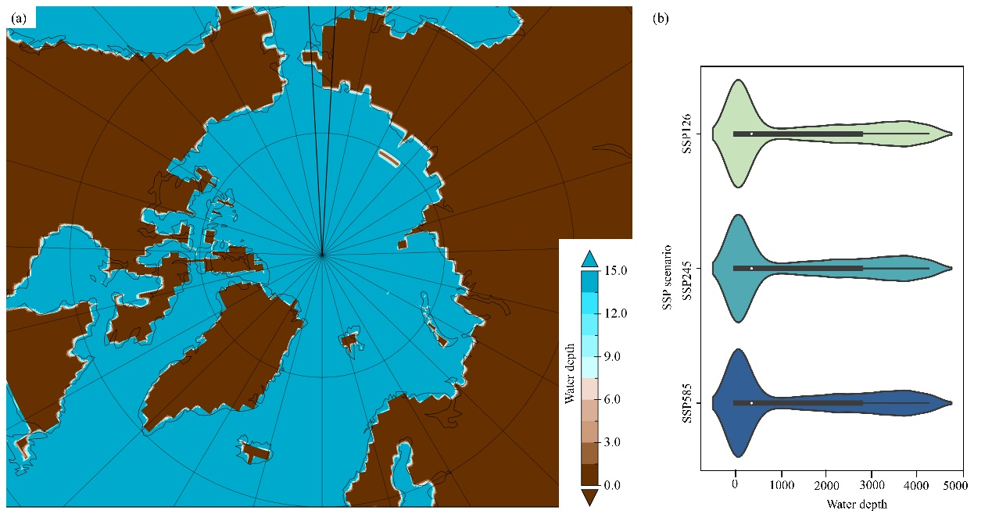
Fig. S1 The spatial and temporal pattern of the sea floor depth below: (a) Spatial distribution (m); (b) Value distribution under different scenarios.

Uncertainty of projected climate models
Proper models are carefully selected in order to reduce uncertainty. PIOMAS has advantages in climate assessment (Laxon et al., 2013), which is reanalyzed data but similar to observation, though underestimate thick ice but overestimate thin ice (Wang et al, 2016), with spatial consistency, temporal duration, and comprehensiveness (Wang et al, 2021)
Climate projections data are from different shared socioeconomic pathways (SSPs), such as SSP1-2.6 (low emission scenario), SSP2-4.5 (medium emission scenario), SSP3-7.0 (medium-high emission scenario), and SSP5-8.5 (high greenhouse gas emission scenario) developed by IPCC.
It is noticeable that CMIIP6 models average underestimate the observed Arctic SIA decrease (Kim et al., 2023). The simulated SIT result of MIROC6 is with high correlation and relatively less RMSEs (Wang et al. 2021; Chen et al., 2023). The GFDL-ESM4 is capable of reproducing the spatial patterns of Arctic SIC well and have the small biases between simulation and observation (Long et al., 2021). The CESM2-WACCM SIE have the smaller biases between simulation and observation (Wang et al., 2021; Long et al, 2021). With regard to sea ice drift speed, though the HadGEM3-GC3-MM model demonstrates the best overall performance concerning NSIDC's values when compared to the other models, CESM2-FV2 model is with daily resolution and relatively high accuracy (Wang et al., 2023).
Table S1 Data source and preprocessing
Data type | Sources | Realization | Resolution
PIOMAS SIT | http://psc.apl.uw.edu/research/projects/arctic-sea-ice-volume-anomaly/data/model_grid |  | 25Km,  daily  (1979-2020)
NSIDC SIE | http://nsidc.org/data/g02135 |  | monthly  (1979-2022)
CMIP6 CESM2-WACCM  sea ice extent | https://esgf-node.llnl.gov/search/cmip6/ | r1i1p1f1 | 1°,  Daily and monthly  (1979-2014;  2015-2100)
CMIP6 MIROC6  sea ice thickness | https://esgf-node.llnl.gov/search/cmip6/ | r1i1p1f2 | 1°,  Daily and monthly  (1979-2014;  2015-2100)
CMIP6 CESM2-FV2  sea ice drift speed | https://esgf-node.llnl.gov/search/cmip6/ | r1i1p1f3 | 1°,  Daily and monthly  (1979-2014;  2015-2100)
CMIP6 CESM2-WACCM  water depth | https://esgf-node.llnl.gov/search/cmip6/ | r1i1p1f1 | 1°,  Daily and monthly  (1979-2014;  2015-2100)
CMIP6 GFDL-ESM4  Sea ice concentration | https://pcmdi.llnl.gov/CMIP6/ | r1i1p1f1 | 1°,  Daily and monthly  (1979-2014;  2015-2100)

- Chen L, Wu R, Shu Q, et al. The Arctic Sea Ice Thickness Change in CMIP6’s Historical Simulations[J]. Advances in Atmospheric Sciences, 2023: 1-13.
- Laxon S W, Giles K A, Ridout A L, et al. CryoSat‐2 estimates of Arctic sea ice thickness and volume[J]. Geophysical Research Letters, 2013, 40(4): 732-737.
- Liu Y, Fan H, Jiang X, et al. Evaluation on northern sea route navigation Environment[C]//2015 International Conference on Mechatronics, Electronic, Industrial and Control Engineering (MEIC-15). Atlantis Press, 2015: 515-521.
- Long M, Zhang L, Hu S, et al. Multi-aspect assessment of CMIP6 models for Arctic sea ice simulation[J]. Journal of Climate, 2021, 34(4): 1515-1529.
- Wang B, Zhou X, Ding Q, et al. Increasing confidence in projecting the Arctic ice-free year with emergent constraints[J]. Environmental Research Letters, 2021, 16(9): 094016.
- Wang X, Key J, Kwok R, et al. Comparison of Arctic sea ice thickness from satellites, aircraft, and PIOMAS data[J]. Remote Sensing, 2016, 8(9): 713.
- Wang X, Lu R, Wang S Y, et al. Assessing CMIP6 simulations of Arctic sea ice drift: Role of near-surface wind and surface ocean current in model performance[J]. Advances in Climate Change Research, 2023, 14(5): 691-706.
- Wang Y, Liu K, Zhang R, et al. Feasibility of the Northeast Passage: The role of vessel speed, route planning, and icebreaking assistance determined by sea-ice conditions for the container shipping market during 2020–2030[J]. Transportation Research Part E: Logistics and Transportation Review, 2021, 149: 102235.

