Supplementary Materials for
“Intertwined charge-density-wave order in vanadium-based kagome superconductors”

Kuanglv Sun^{1‡}, Linpeng Nie^{1‡}, Hongyu Li¹, Jiyin Zhao¹, Huachen Rao¹, Fanghang Yu¹, Mengzhu Shi¹, Ziji Xiang¹, Jianjun Ying^{2,3}, Zhenyu Wang^{2,3}, Tao Wu^{1,2,3,4,5*} and Xianhui Chen^{1,2,3,4,5*}
1. Hefei National Research Center for Physical Sciences at the Microscale, University of Science and Technology of China, Hefei, Anhui 230026, China
2. CAS Key Laboratory of Strongly coupled Quantum Matter Physics, Department of Physics, University of Science and Technology of China, Hefei, Anhui 230026, China
3. CAS Center for Excellence in Superconducting Electronics (CENSE), Shanghai 200050, China
4. Collaborative Innovation Center of Advanced Microstructures, Nanjing University, Nanjing 210093, China
5. Hefei National Laboratory, University of Science and Technology of China, Hefei 230088, China
‡These authors contributed equally to this work
*Correspondence to: wutao@ustc.edu.cn, chenxh@ustc.edu.cn

This PDF file includes:
S1. Asymmetric (E_{2g}) and symmetric (A_{1g}) elastoresistance responses
S2. Geometry-dependent elastoresistance coefficient${d(∆R/R)}_{yy}/dε_{xx}$
S3. Nonideal current path in the two-bar method
S4. Discussion of strain inhomogeneity
S5. Nonideal current path in the modified Montgomery method
S6. Finite value at high temperature and Scaling procedure

S1. Asymmetric (E_{2g}) and symmetric (A_{1g}) elastoresistance responses
The strain applied on a hexagonal lattice sample can be decomposed into three parts in the form of irreducible representations: A_{1g}, E_{1g} and E_{2g}. According to the strain classification, we can obtain corresponding elastoresistance responses. Specifically, the A_{1g} strain represents isotropic deformation, such as volume expansion or contraction, and it can be divided into an in-plane term (ε_{xx} +ε_{yy})/2 and an out-of-plane term ε_{zz}. The E_{1g} strain (ε_{xz}, ε_{yz}) indicates an out-of-plane deformation caused by out-of-plane shear distortions. The E_{2g} strain ((ε_{xx} -ε_{yy})/2, ε_{xy}) is the degenerate B_{1g} and B_{2g} strain described in the D_{4h} point group, indicating that arbitrary in-plane strain is equivalent. Briefly, arbitrary in-plane strains can be composed of A_{1g} and E_{2g} strains. The formula of elastoresistance responses for E_{2g} and A_{1g} symmetry are given as [1]:
$$m_{E_{2g}}=\frac{1}{\left(1+v_{xy}\right)}\left(\frac{{d\left(ΔR/R\right)}_{xx}}{dε_{xx}}-\frac{{d\left(ΔR/R\right)}_{yy}}{dε_{xx}}\right)=m_{11}-m_{12},$$
$$m_{A_{1g}}=\frac{1}{\left(1-v_{xy}\right)}\left(\frac{{d\left(ΔR/R\right)}_{xx}}{dε_{xx}}+\frac{{d\left(ΔR/R\right)}_{yy}}{dε_{xx}}\right)=m_{11}+m_{12}-\frac{2v_{xz}}{1-v_{xy}}m_{13},$$
where v_{xy} = - ε_{yy}/ε_{xx} represents the Poisson's ratio of the PZT stack and v_{xz} = - ε_{zz}/ε_{xx} represents the out-of-plane Poisson's ratio of a specific sample. By the combination of the elastoresistance coefficient in the x and y directions, we can obtain the elastoresistance responses for E_{2g} and A_{1g} symmetry. We notice that the relative magnitudes of $m_{A_{1g}}$ and $m_{E_{2g}}$, which is inconsistent among different reports [2–4], seems to be dependent on the geometry of sample in practice. Next, we will show evidence that the sign of the elastoresistance coefficient ${{d\left(ΔR/R\right)}_{yy}}/{dε_{xx}}$ is actually width dependent, which strongly affects the magnitude of both $m_{A_{1g}}$ and $m_{E_{2g}}$. A nonideal current path is proposed to account for the width-dependent effect, which could also affect the results from the modified Montgomery method. A scaling of the raw data to the finite value at high temperature has been used to extract the intrinsic value for both $m_{A_{1g}}$ and $m_{E_{2g}}$.

S2. Geometry-dependent elastoresistance coefficient ${d(∆R/R)}_{yy}/dε_{xx}$
In our elastoresistance measurement, we found that the relative magnitudes of $m_{A_{1g}}$ and $m_{E_{2g}}$ seems to be dependent on the geometry of sample phenomenally. In practice, we have repeated our elastoresistance measurement on different pristine CsV₃Sb₅ samples with different aspect ratio (Fig. S2a). Among these results, we noticed that the elastoresistance coefficient ${{d\left(ΔR/R\right)}_{xx}}/{dε_{xx}}$ is always a positive value, but the sign of the elastoresistance coefficient ${{d\left(ΔR/R\right)}_{yy}}/{dε_{xx}}$ is changed from positive to negative with increasing the aspect ratio as shown in Fig. S2. The sign problem of ${{d\left(ΔR/R\right)}_{yy}}/{dε_{xx}}$ is also shown in recent three preprints, in which the sign of ${{d\left(ΔR/R\right)}_{yy}}/{dε_{xx}}$ is also inconsistent in these independent elastoresistance measurement [2-4]. The different value of ${{d\left(ΔR/R\right)}_{yy}}/{dε_{xx}}$ can make a significant difference on the relative magnitudes of $m_{A_{1g}}$ and $m_{E_{2g}}$.
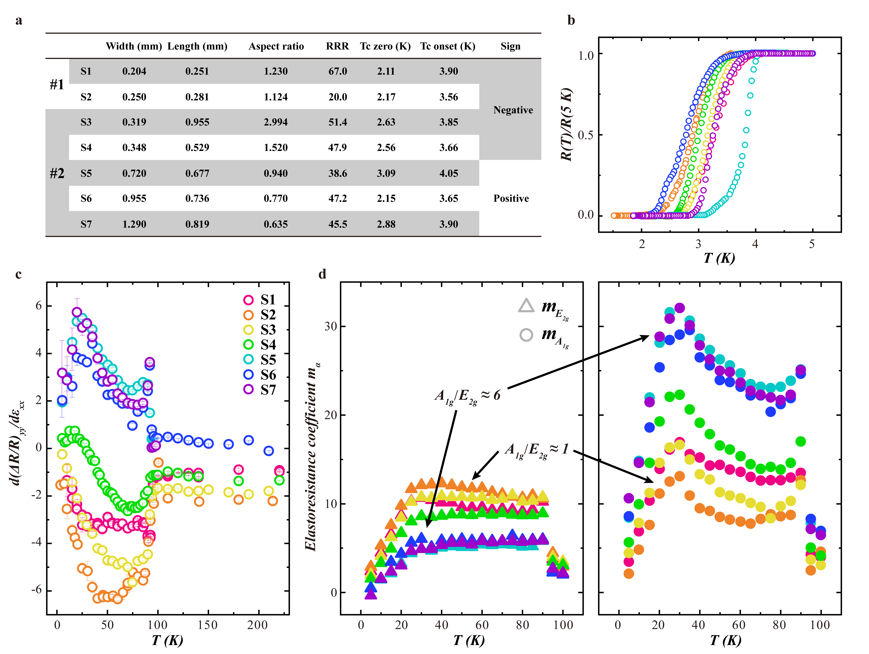
Figure S2. Two-bar method for CsV₃Sb₅ single crystals of different widths. a, Detail information for all the samples is listed as a table, with sample width, length between two voltage measurement electrodes, residual resistivity ratio (RRR), Tc-zero, Tc-onset and the sign of the elastoresistance coefficient in the y direction, where #1 and #2 represent different sample batches. b, Renormalized resistance R(T)/R(5K) for different samples sticked on PZT stack. c, Elastoresistance coefficient in the y direction ${d(∆R/R)}_{yy}/dε_{xx}$ for different samples. The error bars attached on each point are the standard deviation from the linear fitting. A clear sign change is observed in the samples with different aspect ratio. For S1, S2 and S3, the sign of elastoresistance coefficient is negative, while for S5, S6 and S7, the sign of elastoresistance coefficient is positive. An interesting case is S4, where the sign of elastoresistance coefficient changes from negative to positive with temperature decreasing. d, E_{2g} and A_{1g} elastoresistance coefficients for different samples, which is calculated with the same ${d(∆R/R)}_{xx}/dε_{xx}$ presented in the main text. When the sign of ${d(∆R/R)}_{yy}/dε_{xx}$ is negative (S1, S2 and S3), the values of E_{2g} and A_{1g} elastoresistance coefficients are comparable. When the sign is positive (S5, S6 and S7), the value of A_{1g} elastoresistance coefficient is approximately 6 times larger than the value of E_{2g} elastoresistance coefficient. The sixfold difference in magnitude for A_{1g} and E_{2g} elastoresistance coefficients was also found in the Montgomery method (see details in S5 section below). In the next section, we would further discuss the possible explanation on the geometry-dependent ${d(∆R/R)}_{yy}/dε_{xx}$.
S3. Nonideal current path in the two-bar method
To explain the geometry-dependent ${d(∆R/R)}_{yy}/dε_{xx}$, we propose that the nonideal current path could be responsible for the change of sign in different sample with different aspect ratios. As shown in Figure S3, we consider that the rectangle sample used to measure ${d(∆R/R)}_{yy}/dε_{xx}$ is perfectly aligned along the y direction. Then, the electrodes for transport measurement are assumed to be misaligned with an angle θ. In practice, this misalignment could occur due to imperfect electrode contact or geometry, which is almost inevitable in practical operations. This misalignment will lead to a nonideal current path which picks up a partial elastoresistance response from the x direction in the measurement of ${d(∆R/R)}_{yy}/dε_{xx}$. It could be used to explain the observed change of sign in different measurements. Next, we try to make a quantitative analysis on the possible sign change in this situation. The resistance tensor can be expressed as $\left(R_{xx},R_{yy},R_{zz},R_{yz},R_{zy},R_{zx},R_{xz},R_{xy},R_{yx}\right)$. Applying the tensor transformation matrix [5] with a tilting angle θ, we obtain:
${\left(ΔR/R\right)}_{yy'}={\left(ΔR/R\right)}_{xx}\sin^{2}θ+{\left(ΔR/R\right)}_{yy}\cos^{2}θ-\frac{1}{2}\left({\left(ΔR/R\right)}_{xy}+{\left(ΔR/R\right)}_{yx}\right)sin\left(2θ\right)$.
Taking the derivative of $ε_{xx}$ on both sides, the elastoresistance coefficient in yy´ direction can be expressed as the combination of elastoresistance coefficient in the xx, yy and xy directions. In our measurement setup, the diagonal term xy could be inconsequential under strain [5], which will be ignored in the following analysis. By now, the elastoresistance coefficient in the yy´ direction can be expressed as:
${{d\left(ΔR/R\right)}_{yy'}}/{dε_{xx}}={{d\left(ΔR/R\right)}_{xx}}/{dε_{xx}}\sin^{2}θ+{{d\left(ΔR/R\right)}_{yy}}/{dε_{xx}}\cos^{2}θ$.
Recalling the results in Fig. 1c, we roughly estimate the intrinsic value of ${{d\left(ΔR/R\right)}_{xx}}/{dε_{xx}}$ to be 12 and ${{d\left(ΔR/R\right)}_{yy}}/{dε_{xx}}$ to be -3. By substituting these two values, we could consider the critical case where ${{d\left(ΔR/R\right)}_{yy'}}/{dε_{xx}}$ is equal to zero. Then, we obtain:
$$0=12\sin^{2}θ-3\left(1-\sin^{2}θ\right).$$
We obtain that the critical angle θ for sign change is approximately 26°. Using this critical angle, we could estimate the critical aspect ratio for sign change, in which the sample width is equal to half of the length between the two voltage electrodes (Fig. S3c). If the sample width is smaller, the current is more likely to flow along the ideal direction (θ ~ 0) and ${{d\left(ΔR/R\right)}_{yy'}}/{dε_{xx}}$ is negative. If the sample width becomes bigger than the critical value, the angle θ could be easily increased owing to the nonideal current path and ${{d\left(ΔR/R\right)}_{yy'}}/{dε_{xx}}$ will become positive.
Similarly, this sign change problem could also occur in the measurement of ${{d\left(ΔR/R\right)}_{xx}}/{dε_{xx}}$, which would suppress the original positive elastoresistance coefficient in the x direction. To avoid this nonideal current path, it is better to use a bar-shaped sample etched by a focused ion beam, similar to Hall measurements. In our experiments, we cut the single crystal into bar-shaped samples and consider the positive responses in the x direction and negative responses in the y direction as intrinsic results.

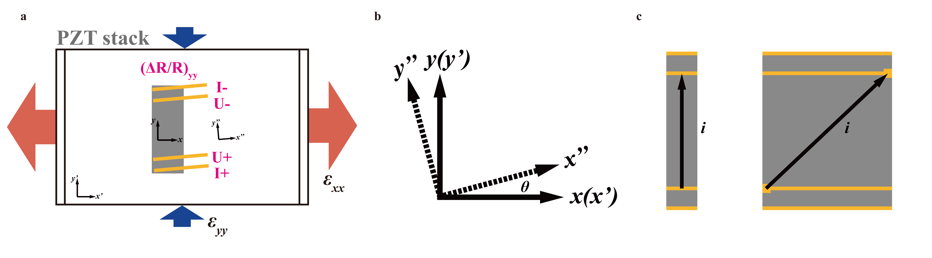
Figure S3. The effect of nonideal current path in elastoresistance measurements. a, Schematic diagram of the two-bar configuration for the y direction, whose elastoresistance response is dependent on its width. Red arrows represent the strain in the x direction $ε_{xx}$, while blue arrows represent strain in the y direction $ε_{yy}$. The gray block represents the sample along the y direction, attached by four yellow probes that measure resistance. The frames of crystal, strain and transport measurements are denoted as x, x’ and x’’, respectively. In this setup, we assume that the sample is perfectly aligned along the y direction, but the transport frame could be misaligned with an angle θ, as shown in b. This transport misalignment could be caused by imperfect electrode contact or geometry, as shown in c. These nonideal current paths could pick up partial elastoresistance responses in the x direction when trying to detect the y direction response, which could lead to the sign change problem described in S2.

S4. Discussion of strain inhomogeneity
Another possible explanation for the sign change problem is the inhomogeneity of strain experienced on samples. The bar-shaped sample glued along the x(y) direction could experience dominantly uniaxial strain $ε_{xx}(ε_{yy})$ rather than nominal strain $ε_{xx}-ε_{yy}$ [3]. Adopting the elastoresistance tensor formulation, this condition can be evaluated qualitatively. In principle, the elastoresistance coefficients in the y direction can be expressed as:
$${\left(\frac{∆R}{R}\right)}_{yy}=m_{12}ε_{xx}^{PZT}+m_{11}ε_{yy}^{PZT}+m_{13}ε_{zz}=\left(m_{12}-v_{xy}^{PZT}m_{11}-v_{out}^{sample}m_{13}\right)ε_{xx}^{PZT}$$
where $v_{xy}^{PZT}\sim 0.45$ represents the Poisson's ratio of the PZT stack and $v_{out}^{sample}$ represents the out-of-plane sample Poisson's ratio. In the ideal case, the strain experienced by the sample perfectly follows the strain applied by the PZT stacks, i.e., $ε_{xx}^{sample}=ε_{xx}^{PZT}$ and $ε_{yy}^{sample}=ε_{yy}^{PZT}$.
Now, we consider the nonideal condition, where $ε_{yy}$ is dominantly experienced according to PZT stacks, but $ε_{xx}$ is not. The worst case is that the sample does not feel the strain applied by the PZT stacks in the x direction but follows the strain in the y direction according to the in-plane sample Poisson's ratio $v_{in}^{sample}$. In this condition, the sample experienced strain in the y direction $ε_{yy}^{sample}$ still equal to the PZT applied strain in the y direction $ε_{yy}^{PZT}$, i.e., $ε_{yy}^{sample}=ε_{yy}^{PZT}$. However, the sample experienced strain in the x direction $ε_{xx}^{sample}$ depends on $ε_{yy}^{sample}$ (which equals $ε_{yy}^{PZT}$) and the in-plane sample Poisson's ratio $v_{in}^{sample}$, given as
$$ε_{xx}^{sample}=-\frac{ε_{yy}^{PZT}}{v_{in}^{sample}}.$$
By now, the elastoresistance coefficients in the y direction can be expressed as:
$${\left(\frac{∆R}{R}\right)}_{yy}=\left(\frac{v_{xy}^{PZT}}{v_{in}^{sample}}m_{12}-v_{xy}^{PZT}m_{11}-v_{out}^{sample}m_{13}\right)ε_{xx}^{PZT}.$$
Compared with the ideal equation, we found that the only difference is an additional coefficient for $m_{12}$, i.e., $v_{p}/v_{in}^{sample}$. According to Ref [2], in-plane sample Poisson's ratio is 0.44, which is similar to Poisson's ratio of the PZT stack. Hence, this additional coefficient nearly equals 1, which will not largely modify the elastoresistance coefficients in the y direction. In a short summary, based on above analysis, the strain inhomogeneity could not explain the sign change problem in ${d(∆R/R)}_{yy}/dε_{xx}$.

S5. Nonideal current path in the modified Montgomery method
Furthermore, the modified Montgomery method could also suffer this nonideal current path. We cut a squared sample with length Lx = 1.25 mm, width Ly = 1.33 mm, and thickness Lz = 0.015 mm. Following the formula derivations in Ref [6], we obtain the A_{1g} and E_{2g} elastoresistance coefficients shown in Figure S5.
Both the E_{2g} and A_{1g} symmetries present similar temperature behavior: a jump at T_{CDW} and a decrease at approximately 35 K. Selecting the temperature region from 60 K to 80 K, the value of A_{1g} elastoresistance coefficient is 51.08 on average, and the value of E_{2g} elastoresistance coefficient is 8.79 on average. This sixfold difference in magnitude of A_{1g} and E_{2g} elastoresistance coefficients is similar as that in two-bar measurement with a comparable sample geometry. We think that this is also related to the nonideal electrodes contact or geometry, which could rotate the transport frame, as shown in Fig. S5. The formulation derivation of the modified Montgomery method asks for the assumption of perfect electrodes at four corners of squared samples. However, the electrodes are not an ideal point at the corner but a partial circle because of the droplet of silver paste. In this condition, the current possibly follows a nonideal path, which can be regarded as the rotation of the transport frame, namely, the scenario of a mixture of x and y elastoresistance responses discussed above. Hence, the elastoresistance coefficient ${{d\left(ΔR/R\right)}_{yy}}/{dε_{xx}}$ is positive, corresponding to the results of a wider sample.
In addition to the nonideal current path, the squared samples also lower the sample resistance, which makes it difficult to measure the relative resistance change at lower temperatures. We can roughly give an estimation. For example, the resistance of squared CsV₃Sb₅ is approximately 0.01 Ohm at 300 K. Considering that RRR is approximately 50, the strain is approximately 10⁻⁴, and the elastoresistance coefficient is approximately 10, we obtain that the absolute change in resistance at low temperature is 10⁻⁷ Ohm. If we apply a current of 1 mA, we obtain a voltage change of approximately 0.1 nV. This voltage change is beyond the resolution of the delta mode of Keithley 6221/2182. Hence, the resistance measurements of squared metals challenge the equipment limit. Overall, considering the possible nonideal current path and smaller resistance in the squared sample, we propose that it is better to use the two-bar method with careful scaling estimation.

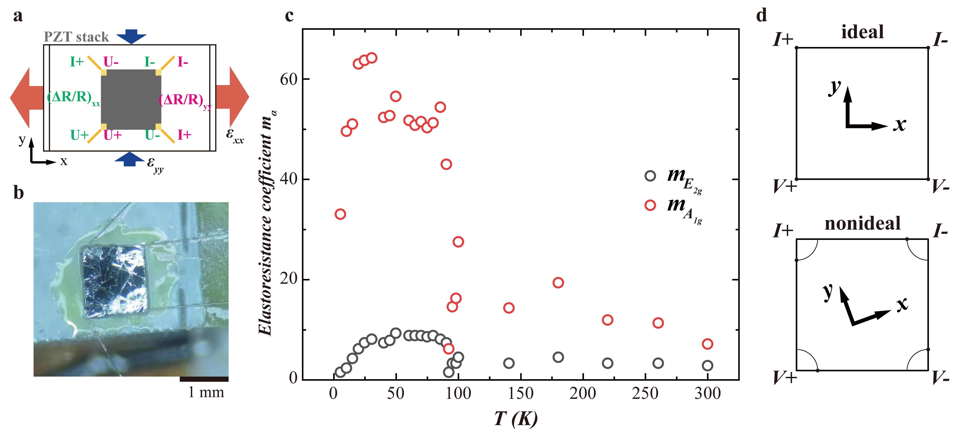
Figure S5. Modified Montgomery method for CsV₃Sb₅. a, Schematic diagram of the modified Montgomery method. b, Picture of the piezoelectric stack with a square CsV₃Sb₅ single crystal glued on its surface. Sample length Lx = 1.25 mm, width Ly = 1.33 mm, and thickness Lz = 0.015 mm. c, E_{2g} and A_{1g} symmetry elastoresistance responses calculated by the Montgomery method. Both E_{2g} and A_{1g} symmetry present similar temperature behavior: a jump at T_{CDW} and a decrease at approximately 35 K. Selecting the temperature region from 60 to 80, the A_{1g} elastoresistance responses are 51.08 on average, and the E_{2g} elastoresistance responses are 8.79 on average, which gives A_{1g} responses that are larger than the E_{2g} responses by approximately 5.8 times. This sixfold relation between A_{1g} and E_{2g} corresponded to the two-bar method when the width of sample y increased. d, Diagram of the ideal and nonideal current paths in the modified Montgomery method.

S6. Finite value at high temperature and Scaling procedure
Theoretically, we can obtain the finite value of the elastoresistance response at high temperature when using the two-bar method. This response comes from geometry change. The resistance for the sample along the x direction can be expressed as
$$R_{xx}=ρ_{xx}\frac{L_{x}}{L_{y}L_{z}}.$$
Taking the natural logarithm for both sides of the equation and then differentiating, we obtain
$${\left(\frac{dR}{R}\right)}_{xx}={\left(\frac{dρ}{ρ}\right)}_{xx}+{\left(\frac{dL}{L}\right)}_{x}-{\left(\frac{dL}{L}\right)}_{y}-{\left(\frac{dL}{L}\right)}_{z}.$$
Dividing the strain $ε_{xx}$ on both sides since these changes are due to the strain, we obtain
$$\frac{{\left(\frac{dR}{R}\right)}_{xx}}{ε_{xx}}=\frac{{\left(\frac{dρ}{ρ}\right)}_{xx}}{ε_{xx}}+\frac{{\left(\frac{dL}{L}\right)}_{x}}{ε_{xx}}-\frac{{\left(\frac{dL}{L}\right)}_{y}}{ε_{xx}}-\frac{{\left(\frac{dL}{L}\right)}_{z}}{ε_{xx}}=\frac{{\left(\frac{dρ}{ρ}\right)}_{xx}}{ε_{xx}}+1+v_{xy}+v_{xz},$$
where $ε_{xx}={(dL/L)}_{x}$, $ε_{yy}=-v_{xy}ε_{xx}$ and $ε_{zz}=-v_{xz}ε_{xx}$. Similarly, the same procedure can be performed for the sample in the y direction, which gives
$$\frac{{\left(\frac{dR}{R}\right)}_{yy}}{ε_{xx}}=\frac{{\left(\frac{dρ}{ρ}\right)}_{yy}}{ε_{xx}}+\frac{{\left(\frac{dL}{L}\right)}_{y}}{ε_{xx}}-\frac{{\left(\frac{dL}{L}\right)}_{x}}{ε_{xx}}-\frac{{\left(\frac{dL}{L}\right)}_{z}}{ε_{xx}}=\frac{{\left(\frac{dρ}{ρ}\right)}_{yy}}{ε_{xx}}-v_{xy}-1+v_{xz}.$$
By now, we can obtain E_{2g} and A_{1g} responses,
$$χ_{E_{2g}}=\frac{1}{\left(1+v_{xy}\right)}\frac{{\left(\frac{dR}{R}\right)}_{xx}-{\left(\frac{dR}{R}\right)}_{yy}}{ε_{xx}}=\frac{1}{\left(1+v_{xy}\right)}\left[\frac{{\left(\frac{dρ}{ρ}\right)}_{xx}-{\left(\frac{dρ}{ρ}\right)}_{yy}}{ε_{xx}}+2+2v_{xy}\right],$$
$$χ_{A_{1g}}=\frac{1}{\left(1-v_{xy}\right)}\frac{{\left(\frac{dR}{R}\right)}_{xx}+{\left(\frac{dR}{R}\right)}_{yy}}{ε_{xx}}=\frac{1}{\left(1-v_{xy}\right)}\left[\frac{{\left(\frac{dρ}{ρ}\right)}_{xx}+{\left(\frac{dρ}{ρ}\right)}_{yy}}{ε_{xx}}+2v_{xz}\right],$$
where $v_{xy}\sim 0.45$ is the Poisson's ratio for the PZT stack and $v_{xz}\sim 0.3$ is the sample out-of-plane Poisson's ratio. Hence, we find that the geometric effect contributes to a constant 2 for the E_{2g} channel at high temperature and approximately 1.09 for the A_{1g} channel. At high temperature, without approaching any phase transition or instability, we anticipate that $χ_{E_{2g}}$ and $χ_{A_{1g}}$ attributed to electronic resistivity are nearly zero. Hence, we suggest scaling the raw data at high temperature to this calculated finite value. By doing so, geometric effects are considered ideally, and the remaining temperature dependences at lower temperatures are attributed to pure elastoresistivity, which comes from the change in electronic states (see Fig. S5). To avoid possible uncertainty, we take the average when calculating the high temperature value of the raw data.

Fig S6. Elastoresistance responses for hole-doped CsV₃Sb₅. a-f, Temperature dependence of elastoresistance responses in the A_{1g} (hollow circle) and E_{2g} (hollow triangle) symmetry channels for CsV₃Sb_{5-y}Sn_{y} (y = 0, 0.04 and 0.06) and CsV_{3-x}Ti_{x}Sb₅ (x = 0.03, 0.05 and 0.09), respectively. The A_{1g} and E_{2g} responses are scaled to finite values at high temperature, following the scaling procedure discussed above. All the samples present a clear peak or dip feature around the T_{CDW} (marked as a light gray region). The black dashed line indicates the finite value at high temperature. Below the CDW transition (light gray region), a kink-like behavior can be clearly distinguished, depicted as the dark gray region. The error bars attached on each point in a-f are the standard deviation from the linear fitting. All the horizontal axes and vertical axes in a-f follow the same scale.

Reference
1. Wiecki, P. et al. Emerging symmetric strain response and weakening nematic fluctuations in strongly hole-doped iron-based superconductors. Nat Commun 12, 4824 (2021).
2. Frachet, M. et al. Colossal c-axis response and lack of rotational symmetry breaking within the kagome plane of the CsV₃Sb₅ superconductor. Preprint at: arXiv:2310.06102 (2023).
3. Liu, Z. et al. Absence of nematic instability in the kagome metal CsV₃Sb₅. Preprint at: arXiv:2309.14574 (2023).
4. Asaba, T. et al. Evidence for an odd-parity nematic phase above the charge density wave transition in kagome metal CsV₃Sb₅. Preprint at: arXiv:2309.16985 (2023).
5. Shapiro, M. C., Hristov, A. T., Palmstrom, J. C., Chu, J.-H. & Fisher, I. R. Measurement of the B_{1g} and B_{2g} components of the elastoresistivity tensor for tetragonal materials via transverse resistivity configurations. Rev. Sci. Instrum. 87, 063902 (2016).
6. Kuo, H.-H., Chu, J.-H., Palmstrom, J. C., Kivelson, S. A. & Fisher, I. R. Ubiquitous signatures of nematic quantum criticality in optimally doped Fe-based superconductors. Science 352, 958–962 (2016).

