A novel method for monitoring of Δ⁹-tetrahydrocannabinolic acid and cannabidiolic acid thermal decarboxylation reactions in cannabis plant
Baochang Gao*^{,1,2,3}, Yuan Tian^{2,3}, Yu Shi^{2,3}, Zhiguo Zhang^{2,3}, Jingru Zhang^{2,3}, Guoliang Mao*^{,1}
¹ College of Chemistry and Chemical Engineering, Northeast Petroleum University, Daqing 163319, P. R. China
² Daqing Branch of Heilongjiang Academy of Sciences, Daqing 163319, P. R. China
³ Engineering Research Center for Hemp and Product in Cold Region of Ministry of Education, Qiqihar University, Qiqihar 161006, China
* Corresponding authors
E-mail address: chemgbc@163.com, maoguoliang@nepu.edu.cn
Abstract: The decarboxylation reaction for acidic cannabinoids is an important step in the use of cannabis. The effect of heating rates and cannabinoid composition on the decarboxylation process was studied. The TG/DTG curves of Δ9-tetrahydrocannabinolic acid (THCA) and cannabidiolic acid (CBDA), for a first time, compared the decarboxylation dynamics at different heating rates. Moreover, HPLC analysis on the plant sample after TG run presented evidence of cannabinoids conversion. The results showed that THCA had a higher decarboxylation reaction temperature than CBDA. In all cases, a significant loss of acid and neutral cannabinoids was observed at elevated heating rates in the absence of oxygen. THCA-dominant cannabis plant show lower activation energy (Ea) on THCA decarboxylation reaction. These findings were used to improve the decarboxylation condition and increase THC or CBD concentration.
Keywords: Δ⁹-tetrahydrocannabinolic acid·Cannabidiolic acid·Decarboxylation·TG/DTG·HPLC

Electronic Supporting Information
- General procedure for the analysis of CBD, CBDA, THC, and THCA
- Table S1. Linearity and limits of detection (LOD) and quantification (LOQ) data calculated for standard CBD, CBDA, THC, and THCA
3. Table S2. Retention times of CBD, CBDA, THC, and THCA
4. Figure S1. Chromatograms obtained by HPLC analysis of cannabis plant
5. General analytical method for determining the conversion of and decarboxylation
6. Figure S2. MS analysis spectra of CBD
7. Figure S3. MS analysis of CBDA
8. Figure S4. MS analysis of THC
9. Figure S5. MS analysis of THCA
1. General procedure for the analysis of CBD and CBDA
A precise 0.1 g weight of the sample was placed into 10 mL polypropylene centrifuge tubes. The tube was filled with 5 mL methanol (HPLC reagent grade). The combination underwent 30 s of vortexing and 30 min of sonication at 40 °C. Samples were centrifuged for 5 min at 4000 rpm after they have all reached room temperature. The supernatant was removed to allow for more investigation. To make sure that all of the target cannabinoids present in the extract fell within the calibration curve, each sample was further diluted with methanol as necessary. Under the given conditions for the standards, plant material residues and extracts, baseline separation for all cannabinoids was successfully accomplished. Precision (RSD) was under the acceptable range (<15%) for CBDA, CBD, THC, and THCA in all samples analysis. Data were analyzed five times, with mean values being used. A signal-to-noise ratio greater than 3:1 was obtained for LOD. A signal-to-noise ratio greater than 10:1 was obtained for LOQ.
2. Table S1. Linearity and limits of detection (LOD) and quantification (LOQ) data calculated for standard CBD, CBDA, THC, and THCA. Data were determined by analyzing serial dilutions of a standard solution to reach a signal-to-noise ratio of 3:1 and 10:1, respectively
Cannabinoids | Linearity range (μg/mL) | R² | LOD (μg/mL) | LOQ (μg/mL)
CBD | 0.5-100 | 0.9997 | 0.04 | 0.12
CBDA | 0.5-100 | 0.9998 | 0.08 | 0.24
THC | 0.5-100 | 0.9999 | 0.06 | 0.18
THCA | 0.5-100 | 0.9998 | 0.1 | 0.3
3. Table S2. Retention times of CBD and CBDA
Cannabinoids | t_{R}(min)
CBDA | 8.03
CBD | 9.28
THC | 15.06
THCA | 18.98
4. Figure S1. Chromatograms obtained by HPLC analysis of cannabis plant: a) THCA-dominant cannabis plant; b) CBDA-dominant cannabis plant
5. General analytical method for determining the conversion of and decarboxylation
Comparisons with the contents of the products and substrates were used to calculate the decarboxylation conversions. The conversion using the equations below.
$$THCA conversion (\%)=\frac{THCA content (\%) after reaction−Initial THCA content (\%)}{Initial THCA content (\%)}$$
$$CBDA conversion (\%)=\frac{CBDA content (\%) after reaction−Initial CBDA content (\%)}{Initial CBDA content (\%)}$$
6. Figure S2. MS analysis spectra of CBD
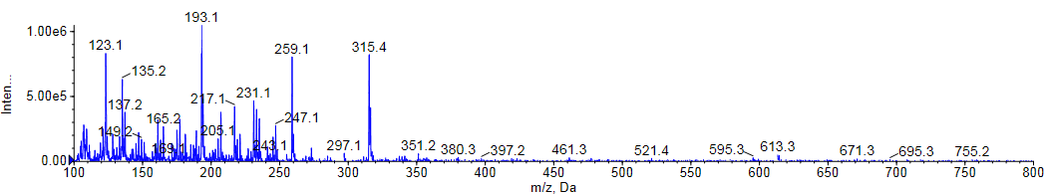
7. Figure S3. MS analysis of CBDA
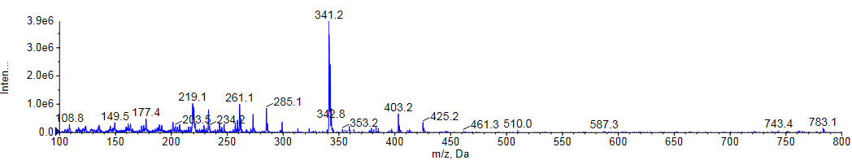
8. Figure S4. MS analysis of THC
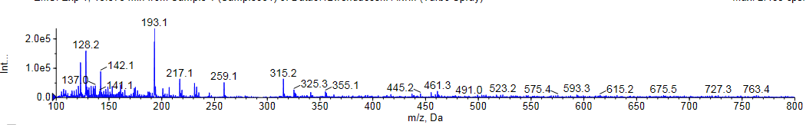
9. Figure S5. MS analysis of THCA
