Table 1 Properties of rice straw biochar (RB) and soil
Material | pH | N (%) | C (%) | H (%) | S (%) | O (%) | Density (g·cm⁻³) | BET (m²·g⁻¹)
RB | 6.78 | 1.16 | 51.42 | 2.41 | 0.33 | 44.68 | 0.35 | 144.79

Table 2 Structures and physiochemical properties of three pesticides
Items | Chlorantraniliprole (CAP) | Haloxyfop-etotyl (HPM) | Indoxacarb (IXB)
Structure | 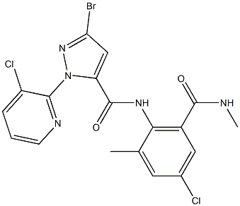 | 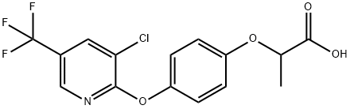 | 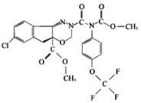
CAS Registry No. | 500008-45-7 | 69806-34-4 | 144171-61-9
Molecular formula | C₁₈H₁₄BrCl₂N₅O₂ | C₁₅H₁₁ClF₃NO₄ | C₂₂H₁₇ClF₃N₃O₇
Molecular weight (g mol⁻¹) | 483.152 | 361.7 | 527.1
Melting point (°C) | 208–210 | 107.5 | 139-141
Vapor pressure (25°C, Pa) | 2.1×10⁻⁸ | 1.33×10⁻³ | 2.13×10⁻⁴
Solubility (mg L⁻¹) | 1.023 | 43.3 | <0.5
Log K_{ow} | 2.76 | 3.12 | 4.65

Table 3 Dosages of the three pesticides used in different trials (g a.i.ha⁻¹)
Pesticides | Low dosage (recommended dosage) | High dosage (1.5 times the recommended dosage)
Chlorantraniliprole, CAP | 41.25 | 61.87
Haloxyfop-r-methyl, HPM | 80.00 | 120.00
Indoxacarb, IXB | 22.00 | 33.00

Table 4. Detection parameters of the three pesticides
Pesticides | Retention time | m/z | LOD ( μg·kg⁻¹)
CAP | 1.552 | 484.00>452.90 | 5.00
HPM | 1.004 | 528.10>150.10 | 0.66
IXB | 1.506 | 484.00>452.90 | 1.89
Note: CAP means chlorantraniliprole; HPM means haloxyfop-etotyl; IXB means indoxacarb, and LOD means Limit of Detection.

Table 5. Matrix effect of three pesticides under different trials
Pesticides | Matrix | Matrix effect (%)
CAP | Pakchoi | 83.16 ± 2.58
CAP | Soil | 91.36 ± 3.26
CAP | Soil–biochar | 88.09 ± 4.35
CAP | Broccoli | 84.50 ± 4.08
HPM | Pakchoi | 89.39 ± 3.26
HPM | Soil | 85.09 ± 4.38
HPM | Soil–biochar | 85.06 ± 3.68
HPM | Broccoli | 85.13 ± 2.68
IXB | Pakchoi | 85.95 ± 3.86
IXB | Soil | 102.19 ± 5.23
IXB | Soil–biochar | 106.69 ± 3.65
IXB | Broccoli | 86.06 ± 6.23

Note: CAP means chlorantraniliprole; HPM means haloxyfop-etotyl; and IXB means indoxacarb.

Table 6. Effect of rice straw biochar (RB) on pesticide degradation dynamics under different trials
 |  |  | CAP | HPM | IXB
Broccoli | Broccoli | High dose | + | + | +
Broccoli | Broccoli | Low dose | + | + | -
Broccoli | Soil | High dose | + | + | -
Broccoli | Soil | Low dose | + | + | +
Pakchoi. | Pakchoi | High dose | + | - | -
Pakchoi. | Pakchoi | Low dose | - | - | 0
Pakchoi. | Soil | High dose | - | + | -
Pakchoi. | Soil | Low dose | - | + | -
Note: “+” means that the degradation dynamics were accelerated, “-” means that the degradation dynamics were slowed, and “0” means that the degradation dynamics were not changed.

