Support information
Plant nutrient allocation is fundamentally important for plants to function as balanced systems in terms of resource uptake and use, and is related to plant growth rate, reproduction, defense, and other life‐history strategies. Stoichiometric homeostasis refers to the degree to which an organism maintains relatively constant elemental concentrations or ratios within its tissues when confronted with variation in the relative availabilities of elements in its environment. These index explore that the general rules constraining nutrient allocation in different plant functional groups. Indeed, the observed index indicate a degree of conservatism in nutrient allocation with the scaling exponent constrained within a specific range in response to different plant functional groups and environmental change. Therefore, we calculated these parameters in different parts of moss plant to reveal the characteristics of nutrient allometric distribution and stoichiometry homeostasis to environmental changes.
The scaling relationship of multiple nutrients among the plant organs is described by the following equations:
Y=βX^{α}
or log(Y)=log(β)+α log(X) ,
where X and Y are the elemental concentrations of moss different parts,β represents the y‐intercept and α represents the slope of the scaling function, indicating the allometric exponent.
Homoeostatic regulation coefficient (H), calculated using the following equation:
where y represents elemental concentrations in different parts of moss, x represents the concentrations of the corresponding elements in soil (g/kg), and c is a constant. The value of (1/H) ranged between 1 and 0.
In recent years, structural equation modeling approach (SEM) has been applied more and more. It is used to analyze and study the complex interactions between different processes in the ecosystem. In this study, SEM was used to calculate the path correlation coefficient of each variable to identify the moss crust. Based on the relationship between different climate factors, soil nutrients and moss stoichiometry, the key factors driving different parts of moss stoichiomery were determined. There are three steps in the analysis: 1) A priori model is proposed, which is the assumption of causality of the problems involved, that is, the initial model or a priori model. In this model, causality or correlation between variables is assumed based on the existing knowledge level. Different initial SEM models were built separately for N, P and K. According to the integrated model, three conceptual variables are initially set: climate factors, latitude, longitude, soil nutrients and moss stoichiometry. The arrow represents the possible impact. 2) A priori model is put forward, which is the assumption of causality for the problems involved, that is, the initial model or a priori model. In this model, causality or correlation between variables is assumed based on the existing knowledge level. 2) Model evaluation: use observation or test data to fit the initial model as a whole. SEM can not only evaluate the whole model, but also observe the statistical information of each path in the model. In this study, chi square test was used to evaluate the fitting effect of the initial model. When P > 0.05, it was generally considered that the "initial model" was acceptable. If it is found that the collected data can not fit the initial model well, the model should be modified, and some paths should be added or reduced according to the correction index; 3) Inference and prediction based on the modified model: the modified model fits the observed data. The key factors affecting the stoichiometric characteristics of moss were demonstrated.

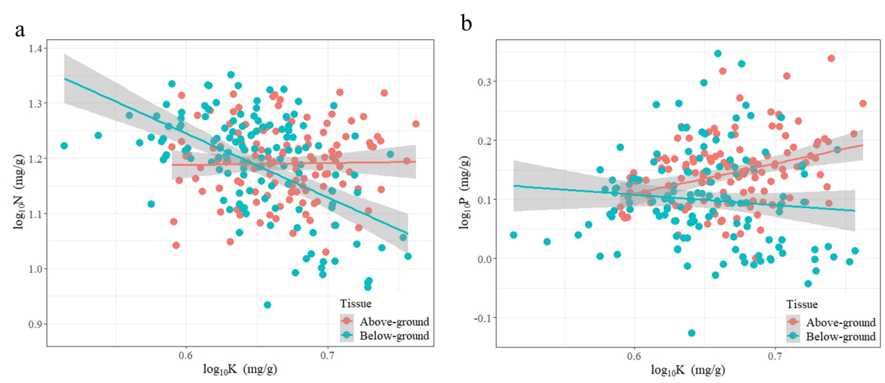
Fig S1 The scaling exponents in above- and below-ground of moss element. a, the N vs. K scaling exponents; b, the P vs. K scaling exponents.
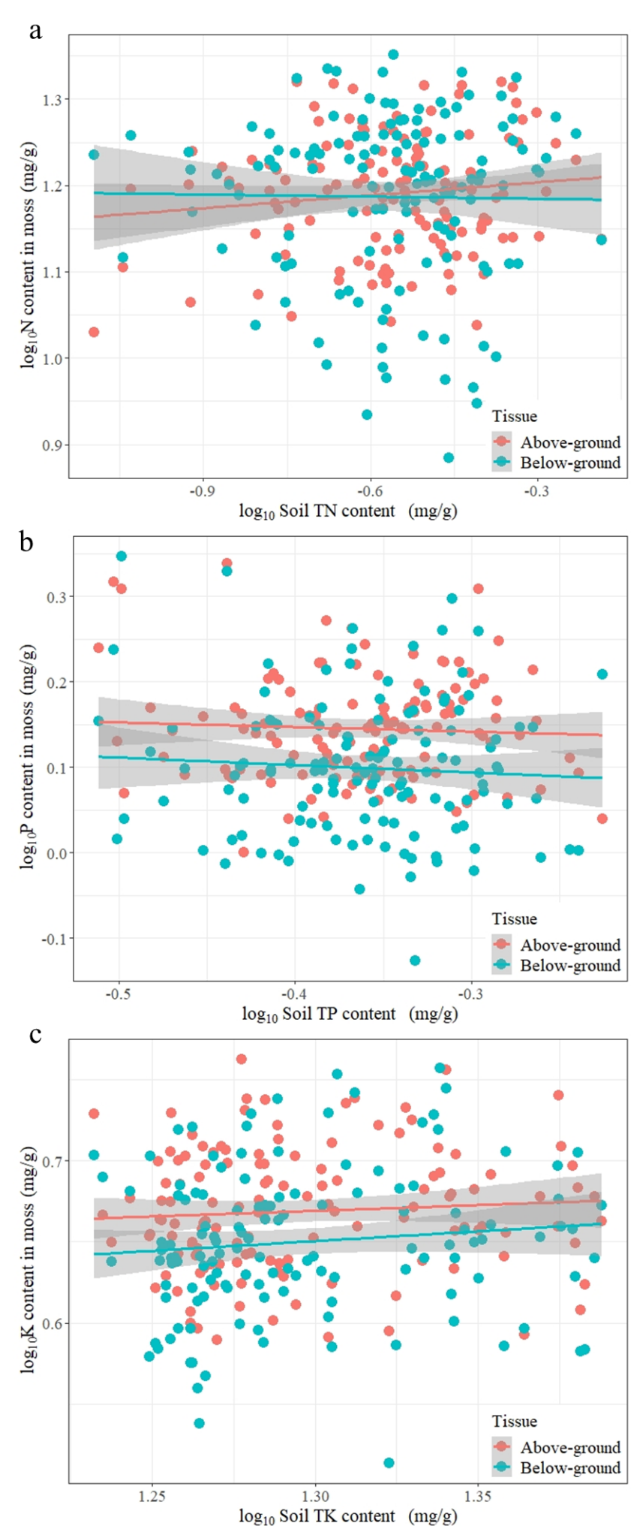
Fig S2 Scaling relationships between soil and moss nitrogen (or phosphorus, potassium) concentrations. (a) nitrogen element; (b) phosphorus element. (c) potassium element.
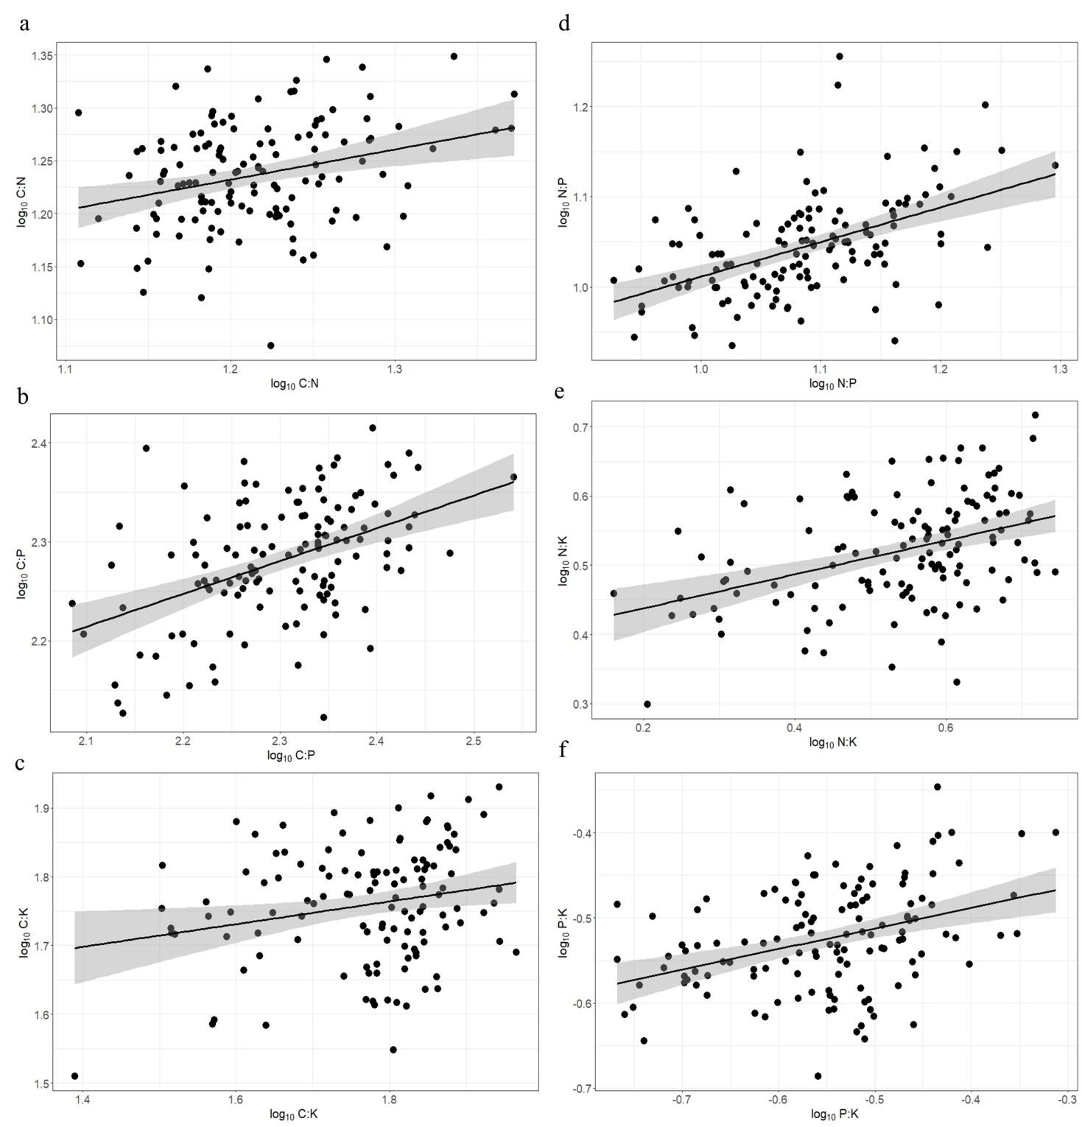
Fig S3 Scaling relationships between above-ground and below-ground of moss element rate. Axis X is element rate in below-ground; Axis Y is element rate in above-ground parts. (a) the C:N scaling exponent; (b) the C:P scaling exponent; (c) the C:K scaling exponent; (d) the N:P scaling exponent; (e) the N:K scaling exponent; (f) the P:K scaling exponent.
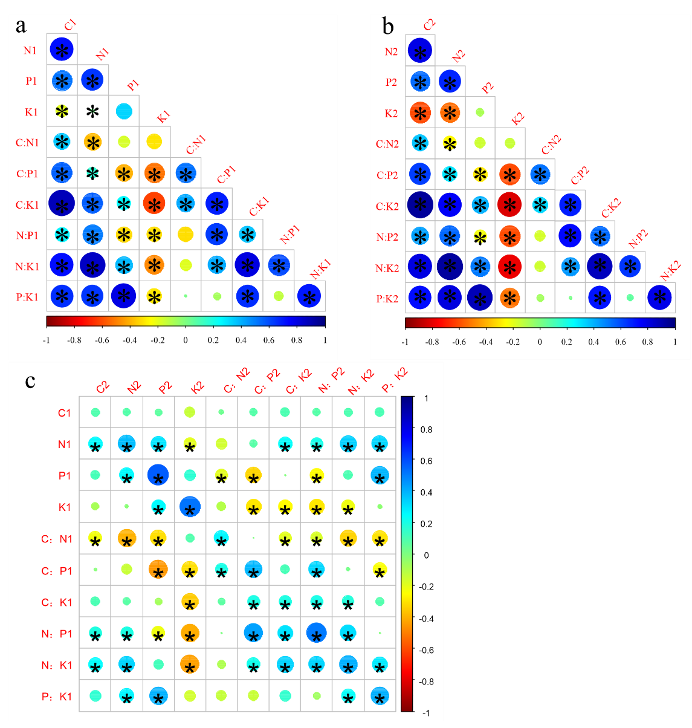

Fig S4 Correlation analysis of moss stoichiometry and stoichiometric ratios in different parts of moss. a, moss stoichiometry and stoichiometric ratios in aboveground parts of moss; b, moss stoichiometry and stoichiometric ratios in belowground of parts moss; c, moss stoichiometry and stoichiometric ratios between aboveground and belowground parts of moss. The number 1 after the letters indicates aboveground parts of the mosses, while number 2 indicates belowground parts of the mosses. The size and color of the circle indicate the strength and significance of the relationship (Pearson's correlation coefficient), respectively. The colors also indicate the strength of the relationship (Pearson’s correlation coefficient). * in the circle indicates the Pearson's correlation ( P<0.05 ).

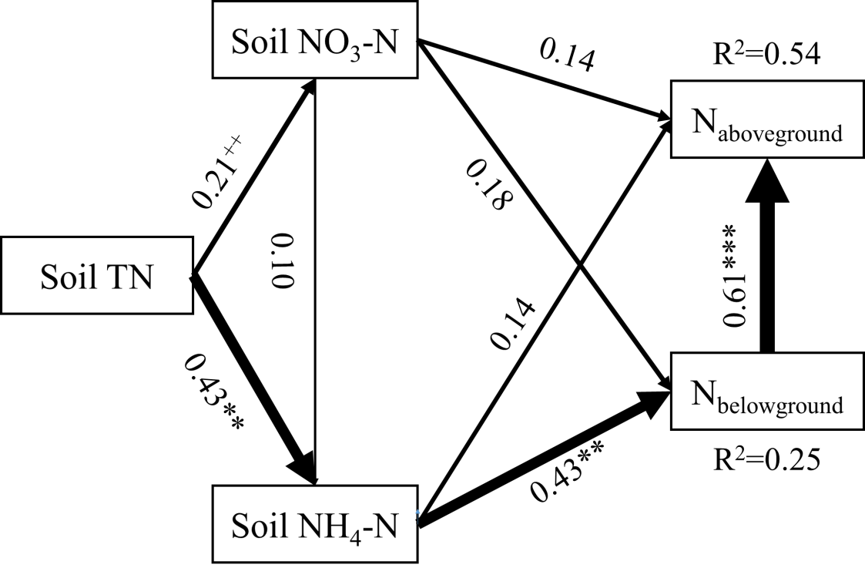

Fig. S5 Final fitted structural equation models depicting relative effects of soil N and moss N content in above-ground and below-ground parts. Boxes represent measured variables. N_{above-ground}: nitrogen content in above-ground parts of moss; N_{below-ground}: nitrogen content in below-ground parts of moss. Standardized path coefficients are displayed, with the width of each arrow equivalent to the strength of the path. Solid lines represent the positive paths. Dashed lines indicate negative paths. The total amount of variance (R²) explained for each endogenous variable (that is, those with arrows pointing to them) is given on the top right of the variable. Corresponding probability values are included when P<0.20 (++ P< 0.20, + P< 0.10, * P< 0.05, ** P< 0.01, *** P< 0.001). The fit of the model was satisfactory (GFI=0.998, AGFI=0.983, RMSEA=0.000, Chi-square=0.196, P=0.907).

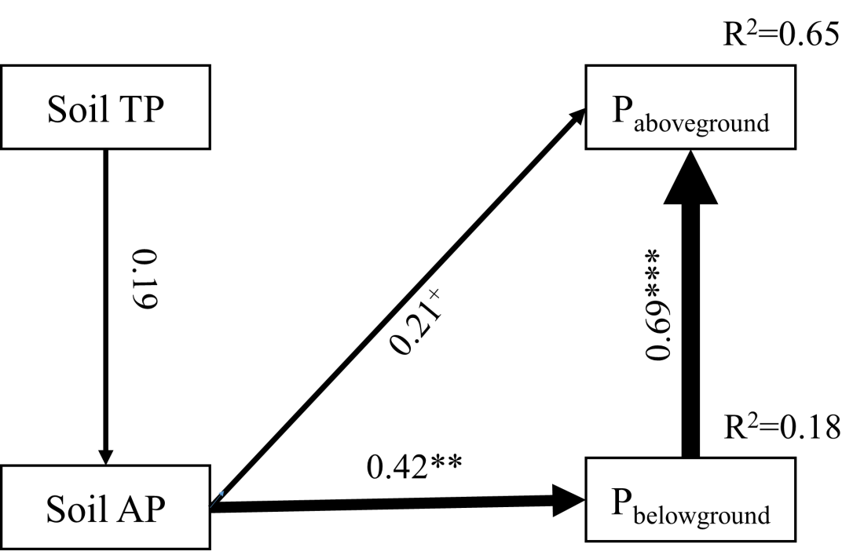
Fig. S6 Final fitted structural equation models depicting relative effects of soil P and moss P content in above-ground and below-ground parts. Boxes represent measured variables. P_{above-ground}: phosphorus content in above-ground parts of moss; P_{below-ground}: phosphorus content in below-ground parts of moss; Siol TP: soil total phosphorus content; Soil AP: soil available phosphorus content. Standardized path coefficients are displayed, with the width of each arrow equivalent to the strength of the path. Solid lines represent the positive paths. Dashed lines indicate negative paths. The total amount of variance (R²) explained for each endogenous variable (that is, those with arrows pointing to them) is given on the top right of the variable. Corresponding probability values are included when P<0.20 (++ P< 0.20, + P< 0.10, * P< 0.05, ** P< 0.01, *** P< 0.001). The fit of the model was satisfactory (GFI=0.993, AGFI=0.963, RMSEA=0.000, Chi-square=0.527, P=0.768).

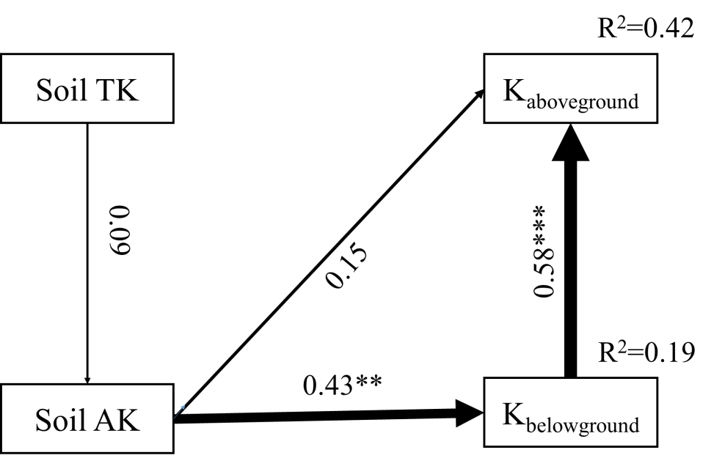
Fig. S7 Final fitted structural equation models depicting relative effects of soil K and moss K content in above-ground and below-ground parts. Boxes represent measured variables. K_{above-ground}: potassium content in above-ground parts of moss; K_{below-ground}: potassium content in below-ground parts of moss; Siol TK: soil total potassium content; Soil AK: soil available potassium content. Standardized path coefficients are displayed, with the width of each arrow equivalent to the strength of the path. Solid lines represent the positive paths. Dashed lines indicate negative paths. The total amount of variance (R²) explained for each endogenous variable (that is, those with arrows pointing to them) is given on the top right of the variable. Corresponding probability values are included when P<0.20 (++ P< 0.20, + P< 0.10, * P< 0.05, ** P< 0.01, *** P< 0.001). The fit of the model was satisfactory (GFI=0.984, AGFI=0.979, RMSEA=0.000, Chi-square=1.165, P=0.559).

