Table 1. Structures of known SARS-COV2 M^{pro} protease inhibitors and their IC₅₀ values.
Structures | 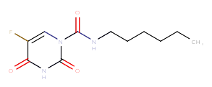  Carmofur | 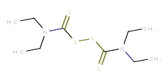  Disulfuram | 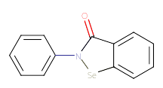  Ebselen | 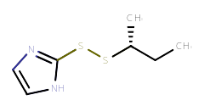  Px-12
IC₅₀ (μM) | 1.82 | 9.35 | 0.67 | 21.39
Structures | 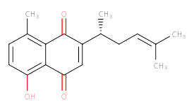  Shikonin | 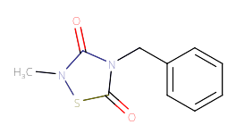  Tdzd-8 | 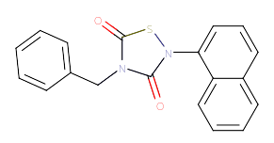  Tideglusib
IC₅₀ (μM) | 15.75 | 2.15 | 1.55

