Extended Data
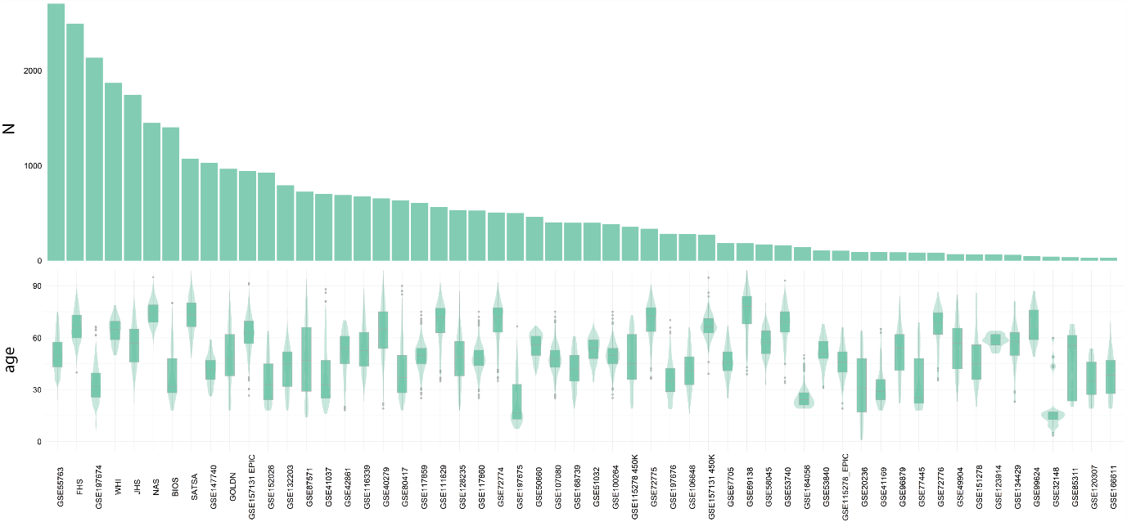
Extended Data Fig. 1 Sample size and age distribution in the 56 blood datasets analysed in this study. Bottom panel: boxplots & violin plots displaying the distribution of samples across the age range. Top panel: number of samples in each dataset (N), ordered from largest (left) to smallest (right).
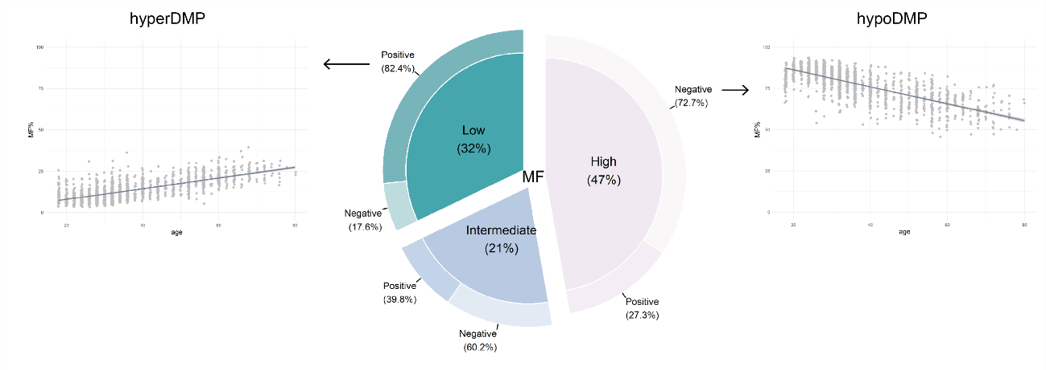
Extended Data Fig. 2 Doughnut chart of the proportions of highly, intermediately, and lowly methylated with age. The inner pie of the donut represents the proportions of CpGs that are highly methylated (<75%), intermediately methylated (25 – 75%) and lowly methylated (<25%) at baseline in a single blood dataset (BIOS), with the direction of change in methylation with age in the outer circle. A positive direction implies that a DMP increases in methylation with age, and a negative direction implies a DMP loses methylation with age. MF = Methylation Fraction
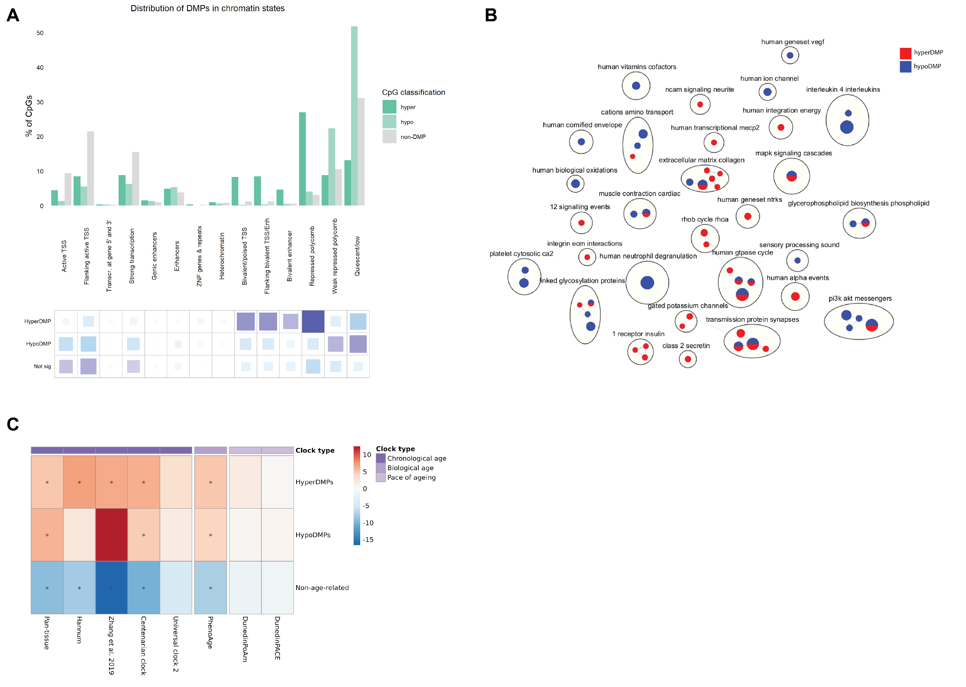
Extended Data Fig. 3 Enrichment of hypomethylated and hypermethylated differentially methylated positions (DMPs) and non-DMPs in chromatin states (A), biological pathways (B) and epigenetic clocks (C). A) Distribution of hypoDMPs, hyperDMPs and non-DMPs in chromatin states from peripheral blood mononuclear cells; the grids under the graph represent the residuals from the ꭓ² test, with the size of the blocks in the grid being proportional to the cell’s contribution. Purple indicates over-representation or enrichment in the chromatin state, and blue represents under-representation or depletion in the chromatin state. B) Enrichment map showing Reactome pathways enriched in hypomethylated or hypermethylated DMPs. Nodes in the network represent pathways and similar pathways with many common genes are connected. Groups of similar pathways are indicated. Nodes are coloured according to significance in different DMPs types: blue (hypomethylated) and red (hypermethylated). C) Relative over- (red) or under- (blue) representation of clock CpGs in hyperDMPs, hypoDMPs and non-age-related CpGs.


Extended Data Fig. 4 Comparison of DMP and VMP meta-analyses with and without correction for cell types. A) A correlation plot of the effect sizes of the CpGs meta-analysed in the cell type adjusted versus the meta-analysis not adjusted for cell types of differential methylation and age in blood. The effect sizes (ES) from the meta-analysis not adjusted for cell types on the x-axis and the ES for the meta-analysis adjusted for cell types on the y-axis. B) A correlation plot of the Zscores of the CpGs in the variable methylation and age meta-analyses in both the cell type adjusted and the unadjusted meta-analysis in blood. The Zscore from the meta-analysis not unadjusted for cell types on the x-axis and the Zscore for the meta-analysis adjusted for cell types on the y-axis.

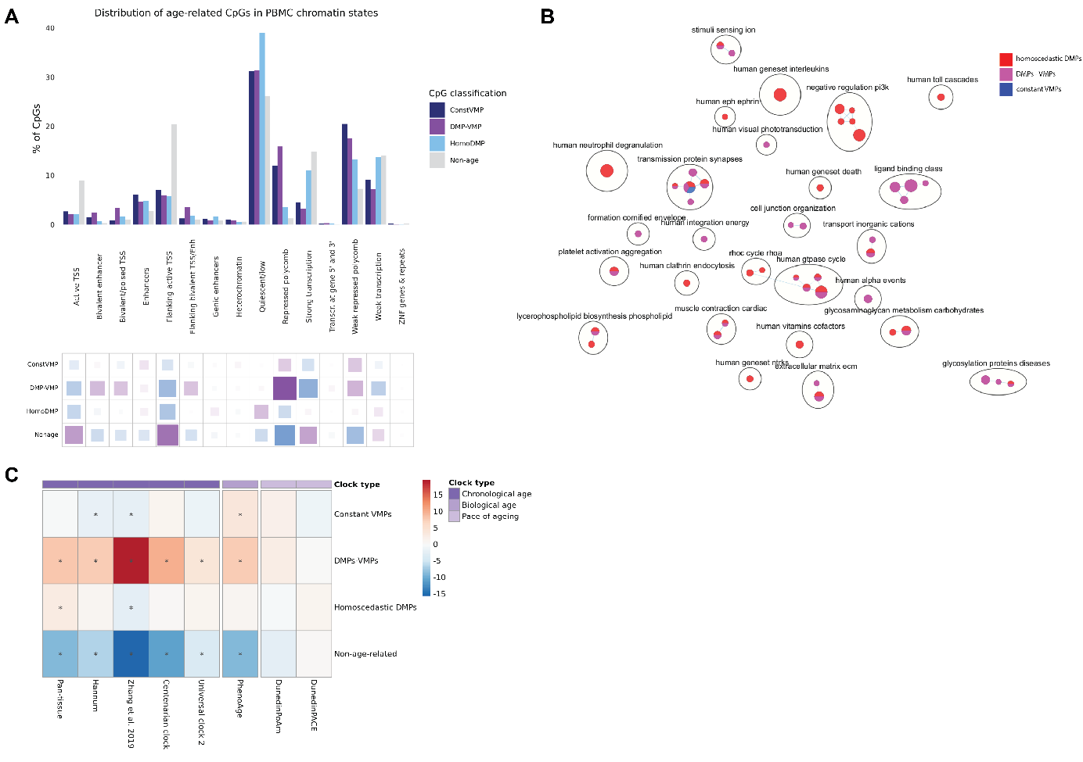
Extended Data Fig. 5 Enrichment of three classes of age-associated CpGs in chromatin states (A), biological pathways (B) and epigenetic clocks (C). A) Distribution of homoscedastic DMPs, DMPs-VMPs, constant VMPs and non-age-related CpGs in chromatin states from PBMCs. The grids under the graph represent the residuals from the ꭓ² test, with the size of the blocks in the grid being proportional to the cell’s contribution. Purple indicates over-representation or enrichment in the chromatin state, and blue represents under-representation or depletion in the chromatin state. B) Enrichment map showing Reactome pathways enriched in homoscedastic DMPs, DMPs-VMPs, or constant VMPs. Nodes in the network represent pathways and similar pathways with many common genes are connected. Groups of similar pathways are indicated. Nodes are coloured according to significance in different age-related CpG types: red (homoscedastic DMPs), purple (DMPs-VMPs) and blue (constant VMPs). C) Relative over- (red) or under- (blue) representation of clock CpGs in homoscedastic DMPs, DMPs-VMPs, constant VMPs and non-age-related CpGs.

Extended Data Fig. 6 Forest plot of the genome-wide meta-analysis of entropy and age in blood. On the x axis is the change in entropy per decade of age, with the effect size and standard errors from each independent EWAS plotted on the y-axis. The dataset, sample size (N) and mean age ± SD (standard deviation) are on the left side of the plot and the 95% CI intervals are displayed on the right panel. The meta-analysis effect size is represented by the blue polygon.

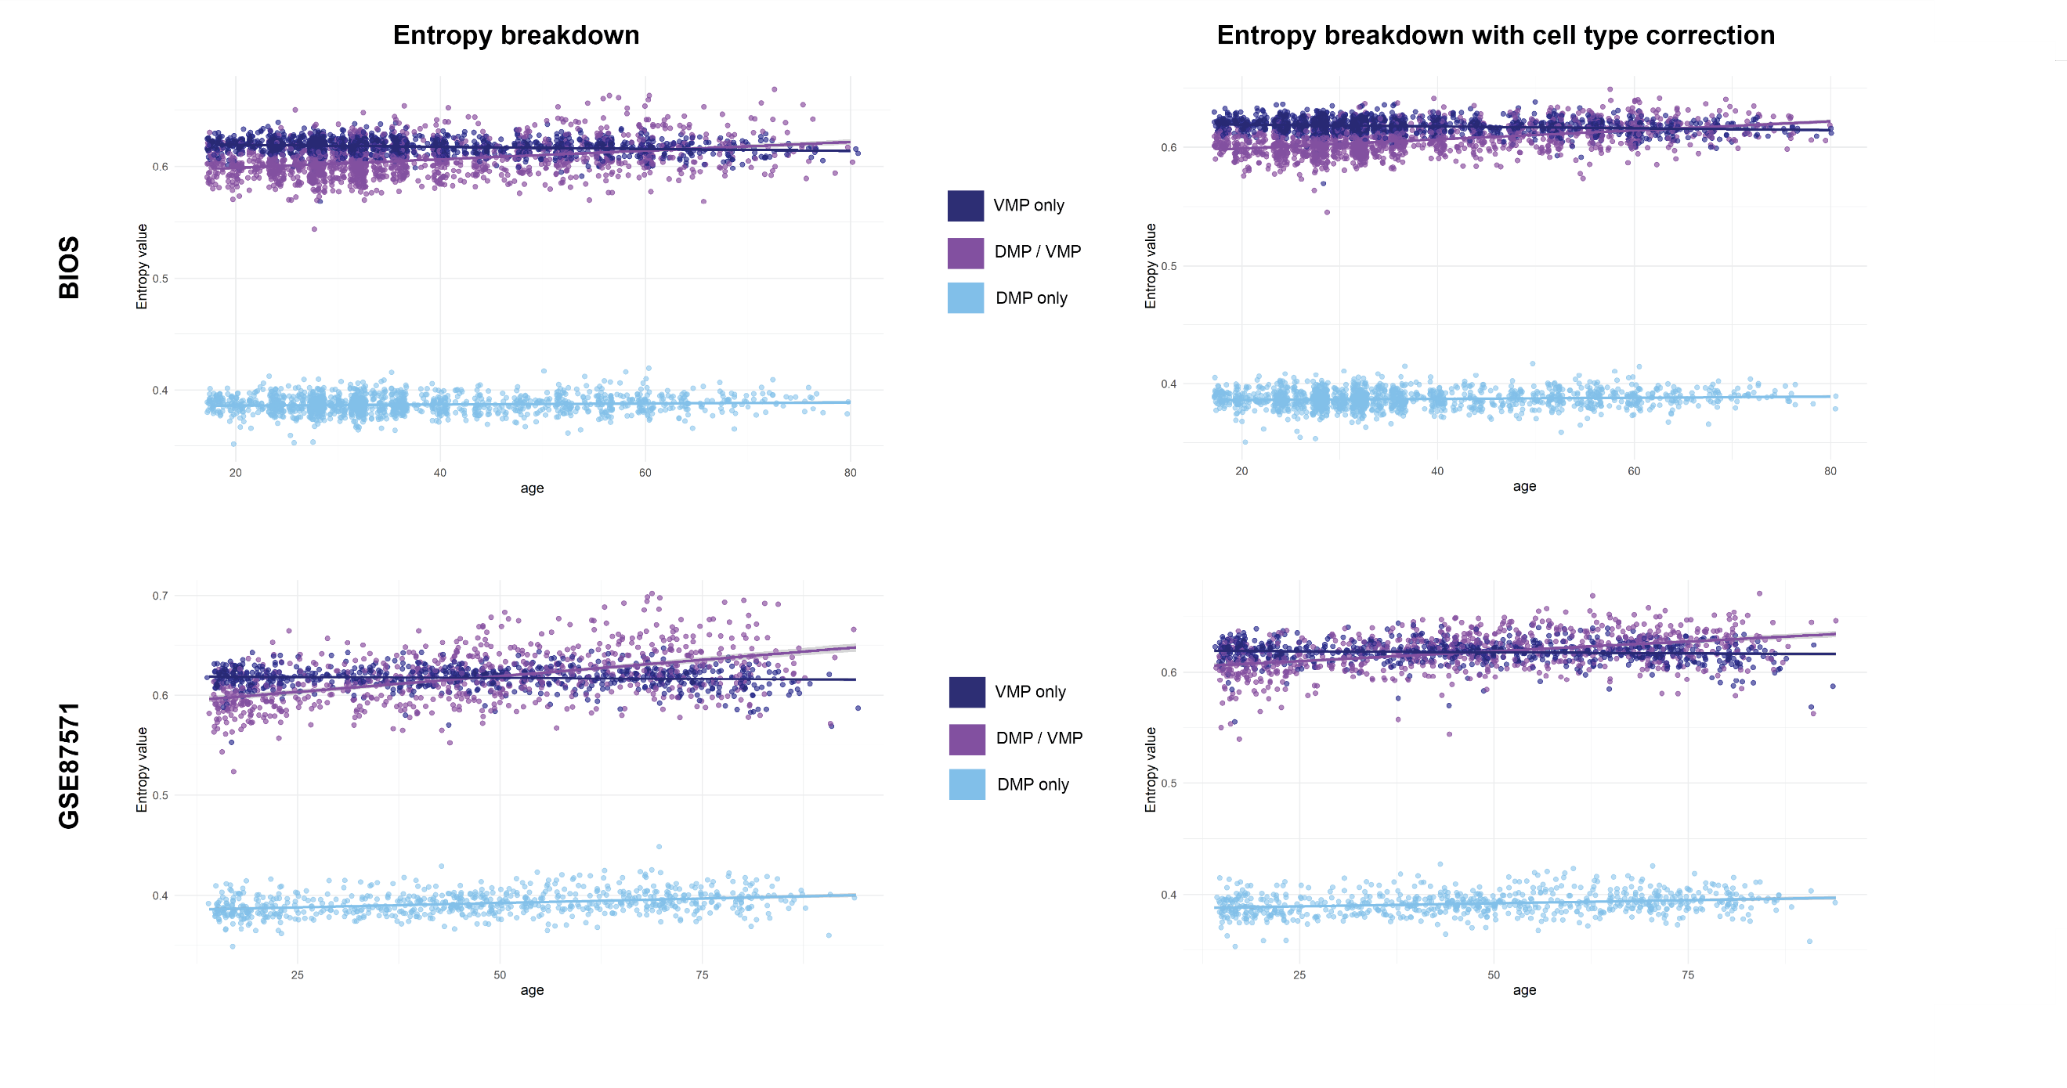
Extended Data Fig. 7 A comparison of the changes in entropy with age in homoscedastic DMPs, DMPs-VMPs and constant VMPs. Entropy was calculated for each type of age-related CpG on the y-axis and plotted against age (x-axis) for two datasets: BIOS and GSE87571. Analyses were performed A) unadjusted for cell types and B) adjusting for cell types.
A
B

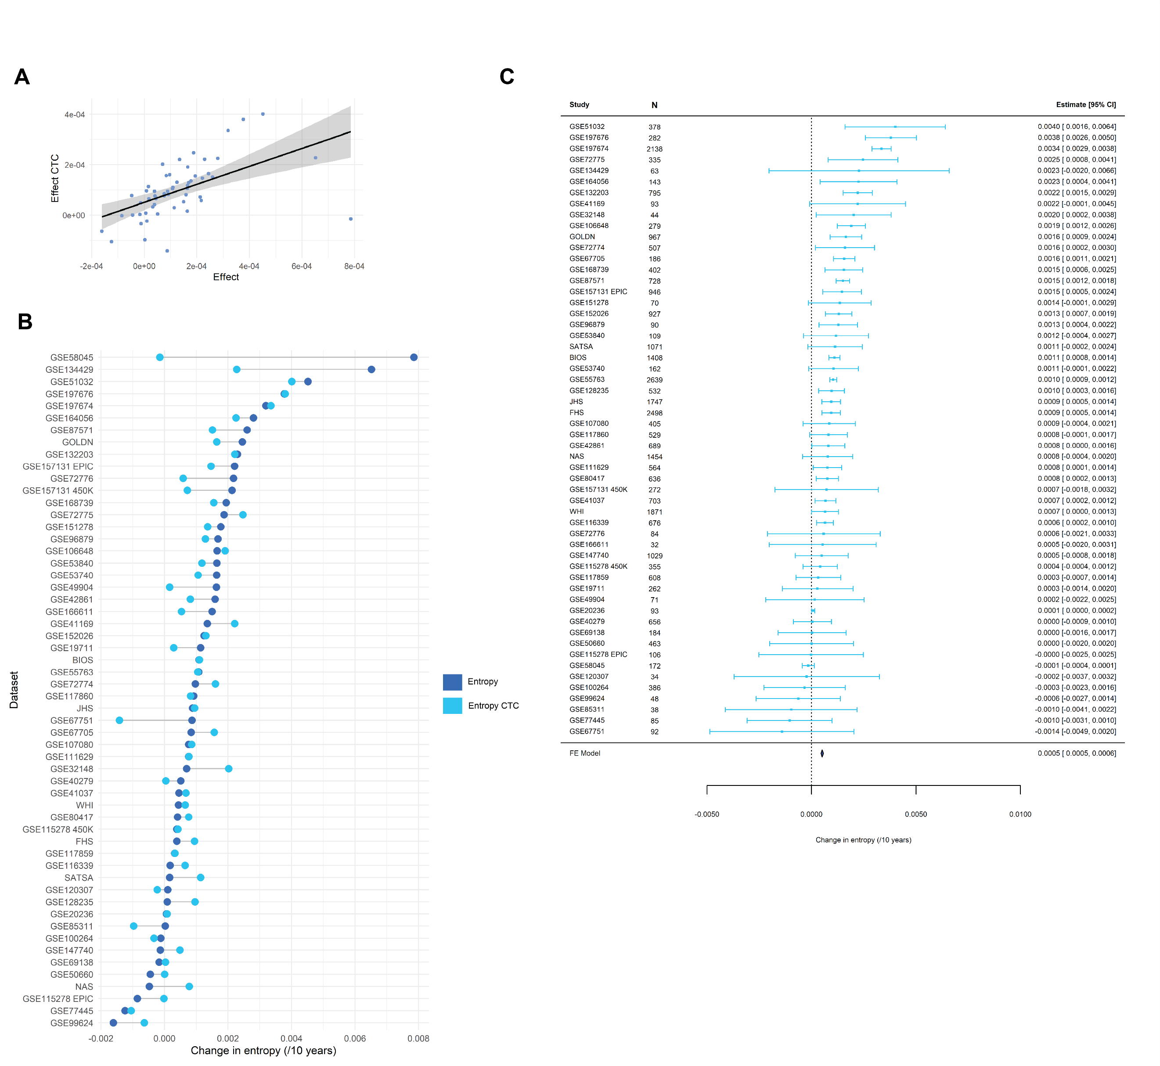
Extended Data Fig. 8 Entropy changes in blood after correction for cell types. A) The effect sizes from the independent EWAS of entropy and age for the analyses unadjusted for the 5 largest blood cell types (x-axis) and the effect size for the cell type corrected (CTC) analyses. Each point on the graph represents a single blood dataset. The Pearson’s correlation is 0.53. B) A lollipop chart to display the change in direction of entropy before (royal blue) and after cell type correction (skyblue) for each dataset (y-axis). C)A forest plot of the genome-wide meta-analysis of entropy and age in the cell type corrected datasets. The change in entropy per decade of age is located on the x-is, with the effect size and standard error measurements from the independent EWAS on the y-axis. The 95% confidence intervals are on the right pane. The meta-analysis effect size is represented by the navy polygon at the bottom of the plot.

Extended Data Fig. 9 Entropy comparison in six sorted blood cell types in a single dataset. Individual entropy values (y-axis) for six sorted cell types (naïve B cells, naïve CD4+ T cells, naïve CD8+ T cells, granulocytes, monocytes, natural killer cells) and peripheral blood mononuclear cells (PMBCs) (x-axis) from the GSE184269 dataset that contains both mixed and sorted blood cells from the same individuals. Each individual is colour-coded according to the legend (donor id) on the right side of the chart.

Supplementary
Supplementary Table 1. Description of blood datasets.
Dataset name | Database | Initial sample size | Sample size after pre-processing | Age (mean ± SD) | Age range (min - max) | Array | % Male | Phenotype | Access / info required | Check for sex | Pre-processed ourselves | Covariates
GOLDN | dbGaP | 967 | 967 | 49 ± 16 | 18 - 88 | 450K | 47.4 | Normal | Yes. Access through dbGaP. | Yes | Yes | age + sex
WHI | dbGaP | 1890 | 1871 | 64 ± 7.0 | 50 - 79 | 450K | 0.0 | Postmenopausal women | Yes. Access through dbGaP. | N/A. All samples are female. | Yes | age
GSE55763 | GEO | 2707 | 2639 | 51 ± 10 | 23 - 75 | 450K | 67.7 | Normal |  | Yes. 4 samples with incorrect sex removed. | No. R keeps crashing when trying to pre-process. | age + sex
GSE128235 | GEO | 537 | 532 | 48 ± 13 | 18-87 | 450K | 42.7 | Depression / healthy control |  | Yes. | Yes. 1 sample corrupted IDAT file. 4 samples without a diagnosis removed. | age + sex + diagnosis
GSE99624 | GEO | 48 | 48 | 67 ± 9.9 | 49 - 87 | 450K | 18.7 | Osteoporosis / healthy controls |  | Yes | Yes | age + sex
GSE115278_450 | GEO | 366 | 355 | 47 ± 15 | 19 - 73 | 450K | 35.8 | Normal |  | Yes. 11 samples removed with incorrect sex. | Yes | age + sex + study
GSE115278_EPIC | GEO | 108 | 106 | 46 ± 9.6 | 19 - 66 | EPIC | 36.8 | Normal |  | Yes. 2 samples removed with incorrect sexes | Yes | age + sex + study
GSE87571 | GEO | 732 | 728 | 47 ± 21 | 14 - 94 | 450K | 46.7 | Normal |  | Yes. 3 samples removed with incorrect sex. | Yes. 1 sample missing age information. | age + sex
GSE53740 | GEO | 384 | 162 | 68 ± 10 | 34 - 93 | 450K | 48.4 | Progressive supranuclear palsy / frontotemporal dementia / healthy controls |  | Yes. Remove batch 2 all samples have been scrambled. Remove 63 samples from batch 1 with mismatch sex or undefined sex. | Yes | age + sex + race
GSE58045 | GEO | 172 | 172 | 57 ± 8.2 | 32 - 80 | 27K | 0.0 | Normal twins |  | N/A. All samples female. | No | age + (1|family number)
NAS | dbGaP | 1454 | 1454 | 75 ± 7.0 | 55 - 100 | 450K | 100.0 | Normal / chronic disease | Yes. Access through dbGaP. | N/A. All samples are male. | Partly. Raw files not available but ran normalisation and batch correction. | age + year + (1|ID)
BIOS | EGA | 4386 | 1408 | 38 ± 14 | 18 - 80 | 450K | 34.2 | Unknown | Yes. Application sent to authors. | Not all sex info supplied. 3 samples with sex did not match predicted sex. | Yes. Samples without ages remove, samples with corrupt IDATs removed. | age + sex
GSE77445 | GEO | 85 | 85 | 34 ± 16 | 18 - 69 | 450K | 50.5 | Normal |  | No. Only signal intensities for a reduced set of CpGs are provided. | No | age + sex
JHS | Independent | 1747 | 1747 | 56 ± 12 | 22 - 93 | EPIC | 37.0 | Cardiometabolic conditions in African population | Yes. Independent application. | Yes. | No | age + sex + education + BMI + smoker + alcohol
FHS | dbGaP | 2562 | 2498 | 66 ± 8.9 | 40 - 92 | 450K | 45.8 | Normal / cardiovascular disease | Yes. Access through dbGaP. | Yes. 19 samples removed | Yes. 40 Samples had corrupt IDATS removed. 1 sample failed QC. | age + sex
GSE49904 | GEO | 71 | 71 | 55 ± 15 | 23 - 83 | 27K | 31.0 | Iron deficiency anaemia / Anaemia / Healthy |  | N/A | No | age + sex + ethnicity + diagnosis + smoking history
GSE80417 | GEO | 675 | 636 | 40 ± 15 | 18 - 90 | 450K | 59.3 | Schizophrenia / normal |  | Yes. | No. 39 samples with no age / incorrect age. | age + sex
SATSA | ArrayExpress | 1072 | 1071 | 73 ± 9.7 | 48 - 98 | 450K | 39.7 | Normal |  | Yes. 1 sample removed | Yes | age + sex + (1|twin pair)
GSE42861 | GEO | 689 | 689 | 52 ± 12 | 18 - 70 | 450K | 28.6 | Rheumatoid arthritis / healthy controls |  | Yes | Yes | age + sex + disease status
GSE51032 | GEO | 845 | 378 | 53 ± 7.2 | 34-72 | 450K | 20.4 | Only normal samples |  | Yes. 10 samples incorrect sex removed. | No. IDATS corrupted. Removed 424 samples with a cancer diagnosis. 9 samples failed QC | age + sex
GSE67705 | GEO | 284 | 186 | 46 ± 8.8 | 25 - 67 | 450K | 100.0 | HIV positive / HIV negative |  | N/A. All samples male. | No. 98 Samples failed QC and were removed. | age + HIV status
GSE32148 | GEO | 48 | 44 | 20 ± 15 | 10-76 | 450K | 47.9 | Normal / Crohn's / Ulcerative Colitis |  | Yes. 4 samples removed with incorrect sex. | No | age + sex + disease status
GSE106648 | GEO | 279 | 279 | 41 ± 11 | 16 - 66 | 450K | 27.6 | Multiple sclerosis / healthy control |  | Yes | Party. No detection pvalue information. | age + sex + smoking status
GSE69138 | GEO | 589 | 184 | 75 ± 13 | 39 - 99 | 450K | 51.1 | Ischaemic stroke subtypes |  | Yes. 1 sample removed with incorrect sex | Yes | age + sex + stroke subtype
GSE50660 | GEO | 464 | 463 | 55 ± 6.6 | 38 - 67 | 450K | 70.5 | Smoker / non-smoker |  | Yes. 1 sample removed. | No. Sample IDs in raw files don't match the phenotype table. | age + sex + smoking status
GSE40279 | GEO | 656 | 656 | 64 ± 15 | 19 - 101 | 450K | 48.5 | Healthy | Emailed authors for raw IDATS or detection pvals. | No | No. Could not pre-process. Raw sample IDs did not match the phenotype table. | age + sex + ethnicity
GSE41037 | GEO | 717 | 703 | 37 ± 16 | 16 - 88 | 27K | 61.9 | Schizophrenia / healthy control |  | Yes. 5 samples don't match | Yes. 12 samples failed QC | age + sex
GSE41169 | GEO | 95 | 93 | 32 ± 10 | 18 - 65 | 450K | 29.5 | Schizophrenia / healthy control | Emailed authors for raw data | Yes. 2 samples removed with incorrect sexes | No | age + sex
GSE53840 | GEO | 120 | 109 | 52 ± 8.0 | 31 - 68 | 450K | 100.0 | HIV viral load |  | Yes | Yes. 9 samples no age info. | age + HIV viral load
GSE67751 | GEO | 92 | 92 | 50 ± 8.9 | 24 - 68 | 450K | 45.7 | HIV / control | Emailed authors for batch info | Yes | No | age + sex + HIV status
GSE72775 | GEO | 335 | 335 | 70 ± 10 | 36.5-90.5 | 450K | 58.8 | Caucasian/Hispanic | Emailed authors for batch info | Yes | Partly. No batch info. | age + sex + ethnicity
GSE111629 | GEO | 572 | 564 | 69 ± 11 | 35 - 92 | 450K | 56.2 | Parkinson's disease / control |  | Yes | Yes. 8 samples failed QC. | age + sex
GSE72774 | GEO | 508 | 507 | 70 ± 11 | 35.1 - 92 | 450K | 55.4 | Parkinson's disease | Emailed authors for batch info | Yes. 1 sample removed with incorrect sex prediction. | Partly. No batch info. | age + sex + number of years in school + smoking status
GSE72776 | GEO | 84 | 84 | 66 ± 12 | 34 - 50 | 450K | 59.5 | Parkinson's disease | Emailed authors for batch info | Yes | Partly. No batch info. | age + sex
GSE166611 | GEO | 32 | 32 | 39 ± 12 | 19 - 69 | 450K | 0.0 | Normal weight / Obese |  | Yes | Yes | age + BMI
GSE164056 | GEO | 143 | 143 | 26 ± 6.4 | 19 - 50 | EPIC | 34.3 | Social Anxiety Disorder |  | Yes | Yes | age + sex

GSE85311 | GEO | 38 | 38 | 47 ± 18 | 20 - 68 | 450K | 71.0 | Young / old sedentary /old exercise trained |  | Yes | Partly. No batch info. | age + sex + training status
GSE151278 | GEO | 70 | 70 | 47 ± 15 | 20-86 | 450K | 61.4 | Psoriasis |  | Yes | Yes | age + sex + drug response
GSE96879 | GEO | 90 | 90 | 52 ± 14 | 22 - 84 | 450K | 0.0 | Lupus / Healthy controls |  | N/A | Yes | age + ethnicity + disease status
GSE134429 | GEO | 64 | 63 | 56 ± 13 | 23 - 81 | EPIC | 11.1 | Rheumatoid arthritis / healthy controls | Emailed authors for batch info | Yes. 1 sample with incorrect sex | Partly. No batch info. | age + sex + batch + patient cohort + donor
GSE120307 | GEO | 34 | 34 | 36 ± 11 | 19-54 | 450K | 53.0 | Healthy / psychiatric disorder (twin pairs) |  | Yes | No | age + sex + (1|twin pair)
GSE20236 | GEO | 93 | 93 | 32 ± 19 | 49 - 74 | 27K | 0.0 | Normal | Emailed authors for batch info | N/A | No. Sample IDs in the raw files are missing. | age
GSE19711 | GEO | 540 | 262 | 65 ± 6.7 | 52 - 78 | 27K | 0.0 | Normal samples only |  | N/A | Yes. Removed 266 cancer samples. 2 samples failed QC | age + ca125
GSE157131_EPIC | GEO | 946 | 946 | 63 ± 9.7 | 26.4 - 91.6 | EPIC | 100.0 | Hypertension / control | Emailed authors for batch info | All samples are male in description of study, and the sex prediction confirmed this. In the raw phenotype table, some of the samples are 'female'. Phenotypes were changed to be all male. | Partly. No batch info | age
GSE157131_450K | GEO | 272 | 272 | 67 ± 6.5 | 39 - 94 | 450K | 100.0 | Hypertension / control | Emailed authors for batch info | All samples are male in description of study, and the sex prediction confirmed this. In the raw phenotype table, some of the samples are 'female'. Phenotypes were changed to be all male. | Partly. No batch info | age
GSE117859 | GEO | 608 | 608 | 49 ± 7.6 | 25 - 75 | 450K | 100.0 | Smoking + HIV |  | N/A | Yes | age + smoking
GSE117860 | GEO | 529 | 529 | 48 ± 7.8 | 25 - 75 | 450K | 100.0 | Smoking + HIV |  | N/A | Yes. More than half the CpGs were removed during pre-processing due to NA probes. After checking the probes this is a 450K dataset and not 850K as stipulated on GEO. | age + smoking
GSE147740 | GEO | 1129 | 1029 | 42 ± 7.8 | 26 - 59 | EPIC | 60.3 | Normal |  | Yes. 3 Samples with incorrect sex were removed. | Yes. Removed samples without actual ages (samples with ages as a range) | age + sex
GSE152026 | GEO | 934 | 927 | 35 ± 13 | 18 - 64 | EPIC | 54.9 | Psychosis / control |  | Yes. 1 Sample with incorrect sex removed | Yes | age + sex + disease status
GSE132203 | GEO | 795 | 795 | 42 ± 12 | 18 - 76 | EPIC | 28.2 | Psychiatric disorders |  | Yes | Yes | age + sex + ethnicity + child abuse
GSE100264 | GEO | 386 | 386 | 50 ± 7.3 | 25 - 75 | 450K | 100.0 | Drug use + Hepatitis C + HIV+ / control |  | Yes | Yes | age + hepatitis C infection
GSE107080 | GEO | 405 | 405 | 48 ± 8.0 | 25 - 75 | EPIC | 100.0 | Drug use + Hepatitis C + HIV+ / control |  | Yes | Yes | age + hepatitis C infection + race + smoking + artadherence
GSE116339 | GEO | 679 | 676 | 54 ± 13 | 23 - 88.5 | EPIC | 41.3 | Polybrominated biphenyl exposure |  | Yes. 3 samples with incorrect sex removed | Yes | age + sex + PBB exposure
GSE168739 | GEO | 407 | 402 | 42 ± 10 | 19 - 61 | EPIC | 44.9 | COVID-19 |  | Yes. 5 samples with incorrect sex removed | Yes | age + sex
GSE197674 | GEO | 2138 | 2138 | 33 ± 10 | 6 - 66.4 | EPIC | 47.1 | Survivors of childhood cancer |  | Yes. All samples clustered with the correct sex | Partly. Used their pre-processed matrix but filtered additional champ probes and pidsley cross-reactive probes. Performed combat for slide and array. | age + sex + abdominal pelvic rt + brain rt + chest rt + alkylating agent + anthracyclines + corticosteroids + epipodophyllotoxins + platinum + vincristine
GSE197676 | GEO | 282 | 282 | 36 ± 10 | 18.6 - 70.2 | EPIC | 45.6 | Healthy / non-diseased |  | Yes | Yes | age + sex
 |  | 36954 | 32136
GOLDN, Genetics of Lipid-Lowering Drugs and Diet Network Study; WHI, Women’s Health Initiative; NAS, Normative Ageing Study; BIOS, Biobank-based integrative omics study; JHS, Jackson Heart Study; FHS, Framingham Heart Study; SATSA, Swedish Adoption/Twin Study of Ageing; GEO, Gene Expression Omnibus; dbGaP, Database of Genotypes and Phenotypes; N, Sample number; SD, Standard deviation; HIV, human immunodeficiency virus; COVID-19, coronavirus disease of 2019; QC, quality control

Supplementary Table 2. Shannon entropy results in blood.
Dataset | Tissue | N | Age (mean ± SD) | Array | % Male | Entropy p-value | Effect | Stderr | Entropy p-value CTC | Effect CTC | Stderr CTC | ALL p-value | ALL effect | ALL stderr | NON p-value | NON effect | NON stderr
BIOS | Blood | 1408 | 37.5 ± 13.9 | 450K | 34.2 | 5.62461E-12 | 0.000108893 | 1.56711E-05 | 1.66797E-15 | 0.000109871 | 1.36385E-05 | 2.48E-28 | 0.000230373 | 2.04E-05 | 1.64E-05 | -5.70E-05 | 1.64E-05
FHS | Blood | 2498 | 66.3 ± 8.9 | 450K | 45.8 | 0.1877697 | 3.86966E-05 | 2.93697E-05 | 2.78042E-05 | 9.45327E-05 | 2.25156E-05 | 0.036621 | 8.69E-05 | 4.16E-05 | 0.2459571 | -2.85E-05 | 2.46E-05
GOLDN | Blood | 967 | 48.9 ± 16.4 | 450K | 47.4 | 5.824E-08 | 0.000245031 | 4.48189E-05 | 0.00002118 | 0.000164522 | 3.85012E-05 | 6.11E-15 | 0.000404495 | 5.10E-05 | 0.5808556 | 2.84E-05 | 5.14E-05
GSE100264 | Blood | 386 | 49.5 ± 7.3 | 450K | 100 | 0.9039949 | -1.177589e-05 | 9.756643e-05 | 0.7386943 | -3.318863e-05 | 9.941942e-05 | 0.218594 | 0.000175854 | 0.000143 | 0.08593418 | -0.000211998 | 0.000123135
GSE106648 | Blood | 279 | 41.2 ± 11.2 | 450K | 27.6 | 0.000546446 | 0.000165539 | 4.73E-05 | 5.87E-08 | 0.000190881 | 3.42E-05 | 0.00012 | 0.000283737 | 7.27E-05 | 0.8445477 | 6.92E-06 | 3.52E-05
GSE107080 | Blood | 405 | 47.9 ± 8.0 | EPIC | 100 | 8.585942e-05 | 7.605117e-05 | 8.585942e-05 | 0.1803641 | 8.5567e-05 | 6.376264e-05 | 0.209893 | 0.000158405 | 0.000126 | 0.6157777 | -3.81E-05 | 7.58E-05
GSE111629 | Blood | 564 | 69.3 ± 11.3 | 450K | 56.2 | 0.09432215 | 7.60E-05 | 4.54E-05 | 0.02716773 | 7.68E-05 | 3.47E-05 | 0.023896 | 0.00014016 | 6.19E-05 | 0.8094899 | -1.17E-05 | 4.87E-05
GSE115278 450K | Blood | 355 | 46.9 ± 15.4 | 450K | 35.8 | 0.5078759 | 3.8748E-05 | 0.000058459 | 0.4362365 | 4.20312E-05 | 4.20312E-05 | 0.264123 | 7.82E-05 | 6.99E-05 | 0.8314082 | -1.49E-05 | 6.99E-05
GSE115278 EPIC | Blood | 106 | 46.1 ± 9.6 | EPIC | 36.8 | 0.5765098 | -8.57169E-05 | 0.000152996 | 0.9879491 | -1.93584E-06 | 0.000127859 | 0.906673 | -2.30E-05 | 0.000196 | 0.3511263 | -0.000163515 | 0.000174581
GSE116339 | Blood | 676 | 53.9 ± 12.9 | EPIC | 41.3 | 0.5539667 | 1.750642e-05 | 2.956551e-05 | 2.050586e-05 | 6.457464e-05 | 2.050586e-05 | 0.731308 | 1.56E-05 | 4.55E-05 | 0.4511984 | 1.99E-05 | 2.64E-05
GSE117859 | Blood | 608 | 49.4 ± 7.6 | 450K | 100 | 0.6654736 | 3.19082E-05 | 7.37624E-05 | 0.5534623 | 3.25011E-05 | 5.48163E-05 | 0.665474 | 3.19E-05 | 7.38E-05 | 0.02726577 | -0.000142777 | 6.45E-05
GSE117860 | Blood | 529 | 48.1 ± 7.8 | 450K | 100 | 0.1489717 | 9.180556e-05 | 6.352066e-05 | 0.07426908 | 8.187646e-05 | 4.57793e-05 | 0.095856 | 0.000163884 | 9.82E-05 | 0.8964397 | -6.76E-06 | 5.19E-05
GSE120307 | Blood | 34 | 35.5 ± 11.0 | 450K | 53 | 0.9649455 | 9.95E-06 | 0.000224609 | 0.897244 | -2.31E-05 | 0.000177596 | 0.892103 | 3.69E-05 | 0.00027 | 0.9041536 | -2.65E-05 | 0.000218004
GSE128235 | Blood | 532 | 47.7 ± 13.4 | 450K | 42.7 | 0.7846098 | 8.58E-06 | 3.14E-05 | 0.00234564 | 9.61E-05 | 3.14E-05 | 6.86E-05 | 0.000175678 | 4.38E-05 | 0.2050711 | -5.50E-05 | 4.33E-05
GSE132203 | Blood | 795 | 42.3 ± 12.3 | EPIC | 28.2 | 8.25274E-08 | 0.000229697 | 4.24405E-05 | 7.7381E-10 | 0.000221362 | 3.55529E-05 | 3.12E-10 | 0.000355602 | 5.58E-05 | 0.162107 | 6.88E-05 | 4.92E-05
GSE147740 | Blood | 1029 | 41.6 ± 7.8 | EPIC | 60.3 | 0.8578721 | -1.34189E-05 | 7.49119E-05 | 0.4528796 | 4.86315E-05 | 6.47635E-05 | 0.485971 | 5.40E-05 | 7.74E-05 | 0.3093811 | -9.26E-05 | 9.11E-05
GSE151278 | Blood | 70 | 47.1 ± 14.6 | 450K | 61.4 | 0.05822633 | 0.0001772981 | 9.203258e-05 | 0.08005927 | 0.0001357616 | 7.640418e-05 | 0.021347 | 0.000247961 | 0.000105 | 0.4872273 | 8.21E-05 | 0.00011757
GSE152026 | Blood | 927 | 35.2 ± 12.8 | EPIC | 54.9 | 0.0006154573 | 0.0001244897 | 3.622545e-05 | 5.892645e-05 | 0.0001302386 | 3.227122e-05 | 2.08E-11 | 0.000294393 | 4.34E-05 | 0.06430396 | -9.20E-05 | 4.96E-05
GSE157131 450K | Blood | 272 | 66.7 ± 6.5 | 450K | 100 | 0.1403107 | 0.0002125616 | 0.0001437215 | 0.5701558 | 7.182903e-05 | 0.0001263443 | 0.029841 | 0.000407517 | 0.000187 | 0.7411363 | -5.07E-05 | 0.000153269
GSE157131 EPIC | Blood | 946 | 62.6 ± 9.7 | EPIC | 100 | 0.0003969457 | 0.0002206612 | 6.206786e-05 | 0.002077936 | 0.000146279 | 4.74E-05 | 6.55E-07 | 0.000421581 | 8.42E-05 | 0.7718038 | -1.75E-05 | 6.02E-05
GSE164056 | Blood | 143 | 25.8 ± 6.4 | EPIC | 34.3 | 0.00011632 | 0.000280024 | 0.00011632 | 0.01755237 | 0.000225162 | 9.36921E-05 | 0.001561 | 0.000495444 | 0.000154 | 0.891697 | 1.60E-05 | 0.000117325
GSE166611 | Blood | 32 | 38.5 ± 12.4 | 450K | 0 | 0.3533241 | 0.0001497593 | 0.0001588485 | 0.6865235 | 5.329313e-05 | 0.000130776 | 0.104708 | 0.000371036 | 0.000222 | 0.1738786 | -0.000147505 | 0.000105896
GSE168739 | Blood | 402 | 42.0 ± 10.3 | EPIC | 44.9 | 0.005971567 | 0.000194046 | 7.02016E-05 | 0.000830029 | 0.00015494 | 4.60011E-05 | 0.00116 | 0.000368954 | 0.000113 | 0.7208878 | -2.16E-05 | 6.03E-05
GSE19711 | Blood | 262 | 64.9 ± 6.7 | 27K | 0 | 0.3314212 | 0.000113503 | 0.000116644 | 0.7376015 | 2.90499E-05 | 8.66153E-05 | 0.180264 | 0.000204286 | 0.000152 | 0.8299482 | 2.31E-05 | 0.000107638
GSE197674 | Blood | 2138 | 32.9 ± 10.0 | EPIC | 47.1 | 4.40E-28 | 0.000319244 | 2.86E-05 | 1.72E-44 | 0.000335183 | 2.34E-05 | 3.18E-43 | 0.000513533 | 3.64E-05 | 0.000502173 | 8.19E-05 | 2.35E-05
GSE197676 | Blood | 282 | 35.8 ± 10.2 | EPIC | 45.6 | 7.01873E-05 | 0.000376987 | 7.01873E-05 | 4.1106E-09 | 0.000379745 | 6.25442E-05 | 8.73E-05 | 0.000635775 | 8.73E-05 | 0.4128983 | 5.81E-05 | 7.08E-05
GSE20236 | Blood | 93 | 32.0 ± 18.78 | 27K | 0 | 0.2295936 | 5.89216E-06 | 4.87146E-06 | 0.03455883 | 8.24421E-06 | 3.8422E-06 | 0.094658 | 8.24E-05 | 4.88E-05 | 0.1785174 | -6.90E-05 | 5.09E-05
GSE32148 | Blood | 44 | 19.7 ± 14.6 | 450K | 47.9 | 0.558993 | 6.96E-05 | 0.000118187 | 0.03244751 | 0.000201963 | 9.13E-05 | 0.663959 | 6.74E-05 | 0.000154 | 0.5142416 | 7.29E-05 | 0.00011083
GSE40279 | Blood | 656 | 64.0 ± 14.7 | 450K | 48.5 | 0.3204021 | 5.10554E-05 | 5.13436E-05 | 0.9272555 | 4.24542E-06 | 4.64825E-05 | 0.092281 | 9.91E-05 | 5.88E-05 | 0.5737251 | -3.08E-05 | 5.47E-05
GSE41037 | Blood | 703 | 37 ± 16 | 27K | 61.9 | 0.1592406 | 4.56E-05 | 3.23E-05 | 0.008152934 | 6.73E-05 | 2.53E-05 | 0.000591 | 0.000120773 | 3.50E-05 | 0.5985051 | -1.81E-05 | 3.43E-05
GSE41169 | Blood | 93 | 31.6 ± 10.4 | 450K | 29.5 | 0.2869219 | 0.000134718 | 0.000125766 | 0.06228045 | 0.000220851 | 0.000117007 | 0.103579 | 0.000233607 | 0.000142 | 0.9900006 | 1.85E-06 | 0.000147594
GSE42861 | Blood | 689 | 51.9 ± 11.8 | 450K | 28.6 | 0.001366545 | 0.000159234 | 4.95317E-05 | 0.04421635 | 8.12344E-05 | 4.03001E-05 | 2.06E-06 | 0.000307344 | 6.42E-05 | 0.3254957 | -4.59E-05 | 4.66E-05
GSE49904 | Blood | 71 | 55 ± 14.5 | 27K | 31 | 0.2402566 | 0.000163367 | 0.000137914 | 0.8946044 | 1.60E-05 | 0.000120196 | 0.05103 | 0.000279712 | 0.000141 | 0.6982522 | 6.45E-05 | 0.000165601
GSE50660 | Blood | 463 | 55.4 ± 6.6 | 450K | 70.5 | 0.6890406 | -4.47802E-05 | 0.000111836 | 0.9971298 | 3.68951E-07 | 0.000102507 | 0.947926 | 7.25E-06 | 0.000111 | 0.3793442 | -0.000114795 | 0.000130456
GSE51032 | Blood | 378 | 53.2 ± 7.2 | 450K | 20.4 | 0.001526438 | 0.000451577 | 0.000141488 | 0.001150322 | 0.000400854 | 0.000122414 | 0.000101 | 0.000600497 | 0.000153 | 0.1682637 | 0.000215158 | 0.000155877
GSE53740 | Blood | 162 | 68.1 ± 10.3 | 450K | 47.9 | 0.1677049 | 0.000164121 | 0.000118422 | 0.08266189 | 0.000105605 | 6.05E-05 | 0.156757 | 0.000247893 | 0.000174 | 0.5929959 | 4.94E-05 | 9.22E-05
GSE53840 | Blood | 109 | 52 ± 8 | 450K | 100 | 0.2500448 | 0.000164896 | 0.00014258 | 0.1407098 | 0.000117615 | 7.92472E-05 | 0.429937 | 0.000180077 | 0.000227 | 0.19465 | 0.000145058 | 0.000111145
GSE55763 | Blood | 2639 | 51 ± 10.1 | 450K | 67.7 | 3.15012E-24 | 0.000107633 | 1.04972E-05 | 3.25478E-35 | 0.000104553 | 8.32351E-06 | 4.77E-36 | 0.000238909 | 1.88E-05 | 2.13E-07 | -7.01E-05 | 1.35E-05
GSE58045 | Blood | 172 | 57.2 ± 8.2 | 27K | 0 | 0.001603156 | 0.00078535 | 0.000244892 | 0.9427179 | -1.47415E-05 | -1.47415E-05 | 7.35E-05 | 0.001002084 | 0.000247 | 0.05238299 | 0.000568455 | 0.00029097
GSE67705 | Blood | 186 | 46.1 ± 8.8 | 450K | 100 | 0.00380295 | 8.38585E-05 | 2.86073E-05 | 0.001462808 | 0.000156706 | 2.61127E-05 | 0.000166 | 0.000143254 | 3.73E-05 | 0.9221143 | 4.15E-06 | 4.24E-05
GSE67751 | Blood | 92 | 49.5 ± 8.9 | 450K | 45.7 | 0.6995618 | 8.66E-05 | 0.00022372 | 0.4221127 | -0.000141879 | 0.000175932 | 0.209037 | 0.000333099 | 0.000263 | 0.246199 | -0.000244177 | 0.000209193
GSE69138 | Blood | 184 | 74.8 ± 12.6 | 450K | 51.1 | 0.8784567 | -1.70775E-05 | 0.000111515 | 0.9707839 | 3.05626E-06 | 8.33324E-05 | 0.684125 | -6.07E-05 | 0.000149 | 0.7793944 | 3.06E-05 | 0.000109034
GSE72774 | Blood | 507 | 69.6 ± 11.2 | 450K | 55.4 | 0.2455719 | 9.69E-05 | 8.34E-05 | 0.02605122 | 0.0001603 | 7.18E-05 | 0.085205 | 0.00015757 | 9.14E-05 | 0.8923563 | 1.39E-05 | 0.000102413
GSE72775 | Blood | 335 | 70.2 ± 10.3 | 450K | 58.8 | 0.09070863 | 0.000187568 | 0.000110556 | 0.00390439 | 0.000246771 | 8.49139E-05 | 0.009118 | 0.000323684 | 0.000123 | 0.9918559 | 1.40E-06 | 0.000137433
GSE72776 | Blood | 84 | 66.4 ± 11.7 | 450K | 59.5 | 0.2467337 | 0.000216987 | 0.000185992 | 0.6720531 | 5.85E-05 | 0.00013777 | 0.010186 | 0.000572139 | 0.000218 | 0.2100965 | -0.000261696 | 0.000207169
GSE134429 | Blood | 63 | 56.0 ± 12.7 | EPIC | 11.1 | 0.01163675 | 0.000651829 | 0.00025701 | 0.3016693 | 0.00022742 | 0.000219863 | 3.67E-07 | 0.001083024 | 0.000209 | 0.7060233 | 0.000135957 | 0.000360143
GSE77445 | Blood | 85 | 33.8 ± 15.9 | 450K | 50.5 | 0.2884682 | -0.000124334 | 0.000116111 | 0.3170136 | -0.000104965 | 0.00010404 | 0.351017 | -9.59E-05 | 1.02E-04 | 0.2711624 | -0.00015937 | 1.44E-04
GSE80417 | Blood | 636 | 40.4 ± 15.0 | 450K | 59.3 | 0.1578088 | 4.11E-05 | 2.91E-05 | 0.005250155 | 7.60E-05 | 2.71E-05 | 0.001604 | 9.04E-05 | 2.85E-05 | 0.4897902 | -2.51E-05 | 3.64E-05
GSE85311 | Blood | 38 | 47.4 ± 17.9 | 450K | 71 | 0.9905637 | 2.223144e-06 | 0.0001866718 | 0.549951 | -9.716753e-05 | 0.000161003 | 0.06426 | 0.000306489 | 0.000161 | 0.1166512 | -0.000407661 | 0.000253578
GSE87571 | Blood | 728 | 47.4 ± 21.0 | 450K | 46.7 | 3.21171E-33 | 0.000260116 | 2.05873E-05 | 6.84639E-19 | 0.000150763 | 1.65182E-05 | 5.43E-42 | 0.000457339 | 3.16E-05 | 0.4415698 | -1.27E-05 | 1.65E-05
GSE96879 | Blood | 90 | 51.6 ± 14.4 | 450K | 0 | 0.01628075 | 0.0001682668 | 6.869033e-05 | 0.007405148 | 0.0001286493 | 4.692491e-05 | 0.038121 | 0.000228333 | 0.000108 | 0.1831673 | 8.75E-05 | 6.52E-05
GSE99624 | Blood | 48 | 67.2 ± 9.9 | 450K | 18.7 | 0.2631376 | -0.000161301 | 0.000142382 | 0.5391254 | -6.37106E-05 | 0.000102965 | 0.723378 | -7.80E-05 | 0.000219 | 0.00013508 | -0.000116006 | 0.00013508
JHS | Blood | 1747 | 55.7 ± 12.3 | EPIC | 37 | 0.00319957 | 8.835696e-05 | 2.993141e-05 | 4.047926e-05 | 9.463708e-05 | 2.299669e-05 | 4.56E-05 | 1.53E-04 | 3.73E-05 | 2.13E-07 | -7.01E-05 | 1.35E-05
NAS | Blood | 1454 | 74.5 ± 7 | 450K | 100 | 0.4407512 | -4.77873E-05 | 6.19699E-05 | 0.2034583 | 7.78616E-05 | 6.11959E-05 | 0.049396 | 0.00015854 | 8.06E-05 | 0.5675632 | -3.34E-05 | 5.84E-05
SATSA | Blood | 1071 | 73.1 ± 9.7 | 450K | 39.7 | 0.8347775 | 1.59187E-05 | 7.62863E-05 | 0.08817062 | 0.000113456 | 6.64096E-05 | 0.138618 | -0.000112596 | 7.60E-05 | 0.003085382 | 0.000243825 | 8.22E-05
WHI | Blood | 1871 | 64.2 ± 7.0 | 450K | 0 | 0.3131826 | 4.41529E-05 | 4.3766E-05 | 0.04760497 | 6.50322E-05 | 3.28084E-05 | 0.27251 | 6.98E-05 | 6.36E-05 | 0.8377477 | 7.85E-06 | 3.83E-05
GOLDN, Genetics of Lipid-Lowering Drugs and Diet Network Study; WHI, Women’s Health Initiative; NAS, Normative Ageing Study; BIOS, Biobank-based integrative omics study; JHS, Jackson Heart Study; FHS, Framingham Heart Study; SATSA, Swedish Adoption/Twin Study of Ageing; N, Sample number; SD, Standard deviation; Stderr, Standard error; CTC, cell-type corrected; ALL, All age-associated CpGs; NON, non-age-associated CpGs

Supplementary Table 3. Entropy results for three categories of age-associated CpGs.
A | DMPs only |  |  | DMPs only CTC
 | p-value | effect | stderr | p-value | effect | stderr
BIOS | 0.00263494 | 0.000046 | 1.53E-05 | 0.001221366 | 0.000046509 | 1.44E-05
GSE87571 | 2.13E-18 | 0.000176 | 1.96E-05 | 2.85E-10 | 0.000111197 | 1.74E-05
B | DMP/ VMP |  |  | DMP / VMP CTC
 | p-value | effect | stderr | p-value | effect | stderr
BIOS | 1.29E-41 | 0.000383 | 2.75E-05 | 5.30E-78 | 0.0003835 | 1.92E-05
GSE87571 | 1.88E-47 | 0.000649 | 4.16E-05 | 2.81E-32 | 0.000352149 | 2.83E-05
C | VMPs only |  |  | VMPs only CTC
 | p-value | effect | stderr | p-value | effect | stderr
BIOS | 1.18E-12 | -0.0000900 | 1.25E-05 | 3.84E-11 | 0.00030754 | 3.08E-04
GSE87571 | 0.02844887 | -0.0000415 | 1.89E-05 | 0.03538065 | -0.00003671 | 1.74E-05
BIOS, Biobank-based integrative omics study; DMPs, differentially methylated positions; VMPs, variably methylated positions; stderr, standard error; CTC, cell type correction.

Dataset | Cell type | N | Age ± sd | p-value | effect | stderr | ALL p-value | ALL effect | ALL stderr | NON p-value | NON effect | NON stderr
GSE56046 | Monocytes | 1201 | 60 ± 9.5 | 0.2551 | 0.000017 | 0.000015 | 0.572209 | 0.572198 | 0.000020 | 0.000917 | 0.000048 | 0.000014
GSE56581 | CD4+ T cells | 211 | 59 ± 8.7 | 0.2107 | 0.000065 | 0.000052 | 0.083408 | 0.000137 | 0.000079 | 0.254963 | 0.000031 | 0.000027
GSE137594 | B cells | 119 | 56 ± 14 | 0.7809 | -0.00003 | 0.000104 | 0.702303 | -0.00005 | 0.000135 | 0.997297 | 0.000000 | 0.000100
GSE137593 | CD4+ T cells | 101 | 56 ± 14 | 0.3264 | -0.00012 | 0.000123 | 0.901693 | -0.00002 | 0.000146 | 0.111324 | 0.000255 | 0.000159
GSE59065 | CD4+ T cells | 100 | 52 ± 24 | 1.22E-07 | 0.000321 | 0.000056 | 2.49E-11 | 0.000518 | 0.000069 | 0.506980 | 0.000045 | 0.000067
GSE59065 | CD8+ T cells | 100 | 53 ± 24 | 2.01E-11 | 0.000556 | 0.000073 | 6.37E-13 | 0.000811 | 0.000098 | 0.003355 | 0.000199 | 0.000066
Supplementary Table 4. Entropy results in datasets containing isolated cell types.
N, Sample number; SD, Standard deviation; Stderr, Standard error; CTC, cell-type corrected; ALL, All age-associated CpGs; NON, non-age-associated CpGs

