(Additional File 4)

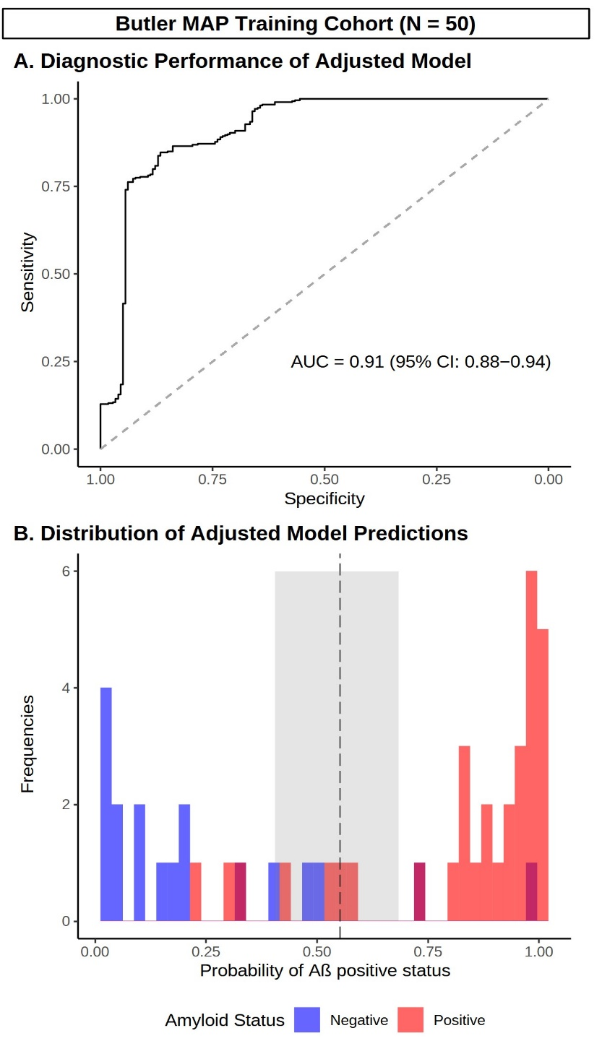
Supplementary Figure 1. Development of adjusted cutoffs using Butler MAP training data. (A) ROC curve demonstrating diagnostic performance of a logistic regression model containing P-tau217 and all covariates of interest (age, APOE genotype, clinical diagnosis, cognition [MoCA], timing of plasma draw and type of reference standard [Aβ-PET/CSF]) in the training cohort. (B) Histogram depicting the distribution of the regression fitted values in Aβ positive (red) and negative (blue) participants, as well as Youden’s optimal cutoff (black dashed line) and the intermediate region (shaded gray). See Supplementary Table 2 for individual predictors. N = 50.

