(Additional File 9)
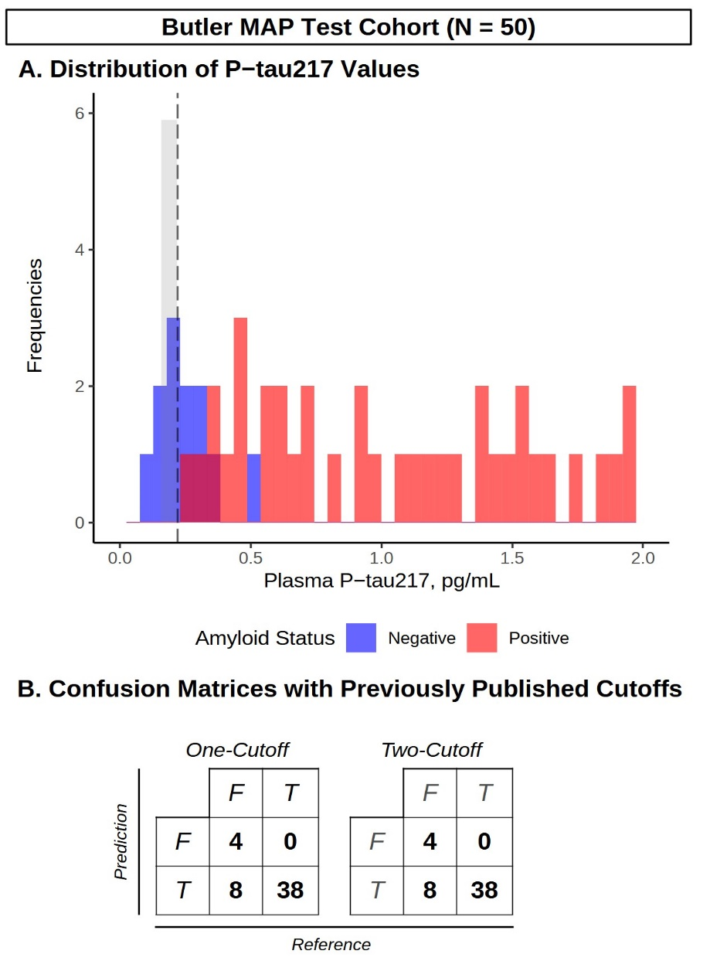
Supplementary Figure 3. Diagnostic performance of previously published cutoffs for DMT eligibility screening. (A) Histogram depicting the distribution of P-tau217 values in the Test Cohort, with Aβ positive (red) and amyloid negative (blue) participants, as well as Youden’s optimal cutoff (black dashed line) and the intermediate region (shaded gray). (B) Confusion matrices for the one- and two- cutoff strategies in the Test Cohort using previously published cutoffs (one-cutoff: 0.22 pg/mL, two-cutoff: 0.159 pg/mL, 0.219 pg/mL) as described from Mattsson-Carlgren et al. (2024) compared the reference standard (Aβ-PET/CSF). N = 50.
Reference:
Mattsson-Carlgren N, Collij LE, Stomrud E, Pichet Binette A, Ossenkoppele R, Smith R, et al. Plasma Biomarker Strategy for Selecting Patients With Alzheimer Disease for Antiamyloid Immunotherapies. JAMA Neurol. 2024 Jan 1;81(1):69–78.

