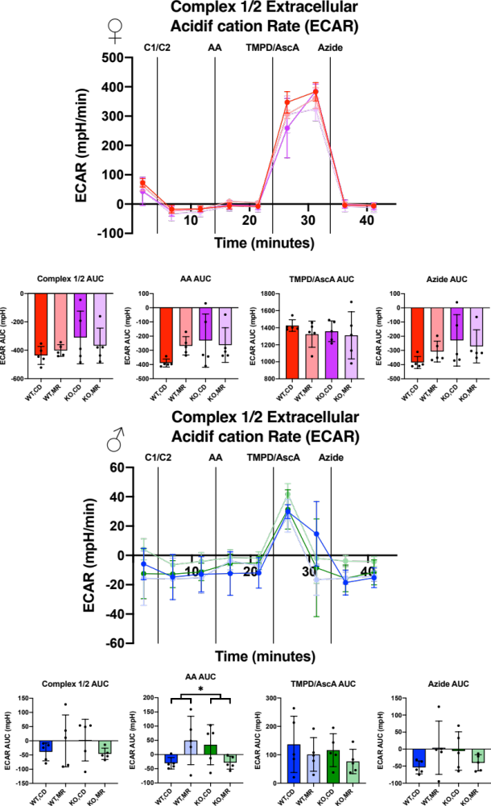
Supplemental Figure 1: Liver Isolated Mitochondria Seahorse Extracellular Acidification Rate (ECAR), Complex 1/Complex 2
Liver isolated mitochondria from frozen tissue were measured for Extracellular Acidification Rate (ECAR) via 96-well Seahorse. 10μg of isolated mitochondria were used in MAS buffer in the presence of 10μg/ml Cytochrome C. Injections were as follows: Complex 1/Complex 2 ECAR using NADH as substrate (C1/C2), Complex 3 inhibition with Antimycin A (AA), Complex 4 OCR with N,N,N’,N’-tetramethyl-p-phenylenediamine and Ascorbic Acid (TMPD/AscA), Complex 4 Inhibition with Sodium Azide (Azide). Area Under the Curve (AUC) was calculated via the trapezoid method for each segment. Analysis was completed within each sex via 2-Way ANOVA for main effects with post-hoc analysis performed with Sidac multiple comparisons correction to assess the diet effect within each genotype. Graphs represent mean ± SD. Group sizes were 5. (* p < 0.05; ** p < 0.01)

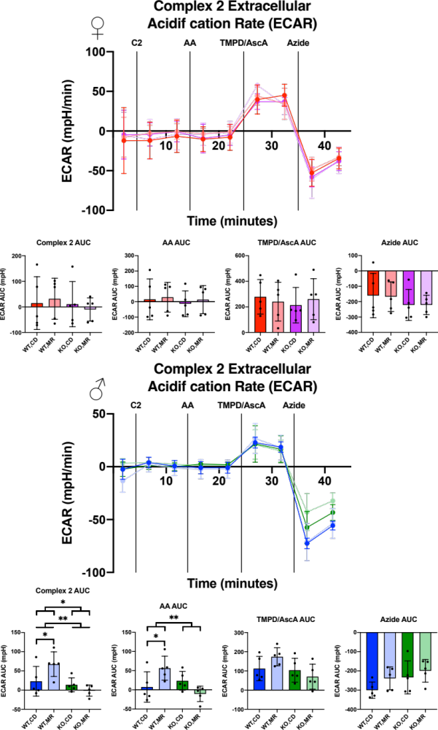
Supplemental Figure 2: Liver Isolated Mitochondria Seahorse Extracellular Acidification Rate (ECAR), Complex 2
Liver isolated mitochondria from frozen tissue were measured for Extracellular Acidification Rate (ECAR) via 96-well Seahorse. 10μg of isolated mitochondria were used in MAS buffer in the presence of 10μg/ml Cytochrome C. Injections were as follows: Complex 2 ECAR using Succinate and Rotenone as substrate and Complex 1 inhibitor (C2), Complex 3 inhibition with Antimycin A (AA), Complex 4 OCR with N,N,N’,N’-tetramethyl-p-phenylenediamine and Ascorbic Acid (TMPD/AscA), Complex 4 Inhibition with Sodium Azide (Azide). Area Under the Curve (AUC) was calculated via the trapezoid method for each segment. Analysis was completed within each sex via 2-Way ANOVA for main effects with post-hoc analysis performed with Sidac multiple comparisons correction to assess the diet effect within each genotype. Graphs represent mean ± SD. Group sizes were 5. (* p < 0.05; ** p < 0.01)

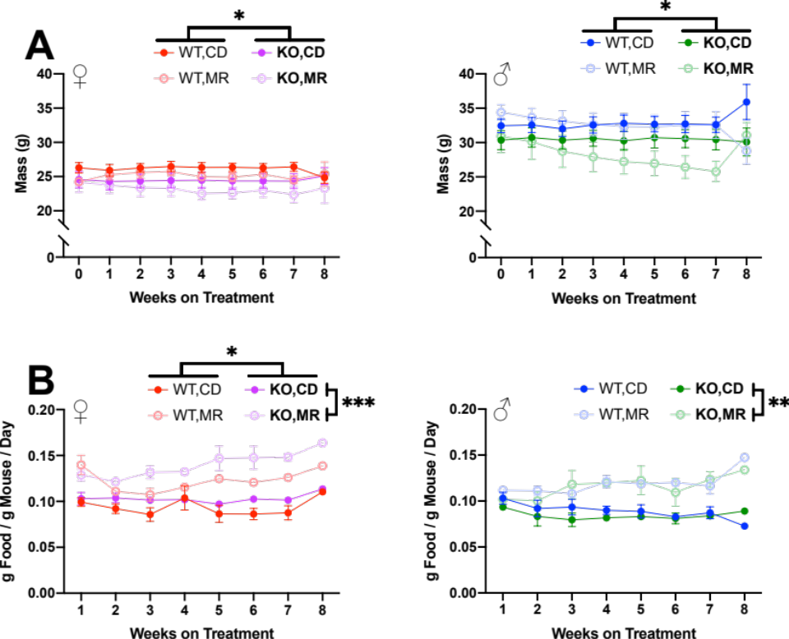
Supplemental Figure 3: Mitochondrial Cohort Body Weight and Normalized Food Consumption
Body weight (A) and normalized food consumption (B) were measured weekly. Sexes analyzed separately with Repeated Measures, 3-Way ANOVA. Main effects for diet and MsrA KO genotype indicated by significance bars by legends (right side and above, respectively). Post-hoc diet specific effect within a genotype was analyzed with Repeated Measures, 2-Way ANOVA Multiple Comparisons with False Discovery Rate correction, Q = 0.05. Graphs represent mean ± SEM, group sizes were 7-10 mice. (*p < 0.05; **p < 0.01; ***p < 0.001)

