Supplementary Information

What is more important for structuring Dragonfly assemblages in Subtropical grasslands lentic water bodies in the Pampa biome: space or vegetation?

Journal of Insect Conservation

Luísa Vareira², Jean Carlo Gonçalves Ortega², Leandro Juen², Sebastian Felipe Sendoya¹, Cristiano Agra Iserhard¹

¹ Programa de Pós-graduação em Biodiversidade Animal, Instituto de Biologia, Universidade Federal de Pelotas, Pelotas, Rio Grande do Sul, Brazil.
² Programa de Pós-graduação em Ecologia, Instituto de Ciências Biológicas, Universidade Federal do Pará, Belém, Pará, Brazil.
Corresponding author: Luísa Vareira (luisavareira@gmail.com)

Table S1 List of the lentic water bodies in order from the larger to the smaller ones.
Site | Lat | Long | Area (m²) | Classification
CAP3 | -31.797 | -52.503 | 19232.834 | large
CAP1 | -31.804 | -52.508 | 13152.491 | large
HBI3 | -31.813 | -52.426 | 7209.714 | large
HBI1 | -31.807 | -52.42 | 5782.988 | large
CAP4 | -31.797 | -52.501 | 4633.523 | large
CAP2 | -31.802 | -52.503 | 3437.933 | large
EMB2 | -31.816 | -52.45 | 1552.187 | large
EMB4 | -31.808 | -52.476 | 996.425 | small
EMB1 | -31.783 | -52.415 | 863.243 | small
HBI4 | -31.816 | -52.429 | 814.826 | small
HBI2 | -31.81 | -52.423 | 725.096 | small
EMB3 | -31.807 | -52.472 | 132.903 | small

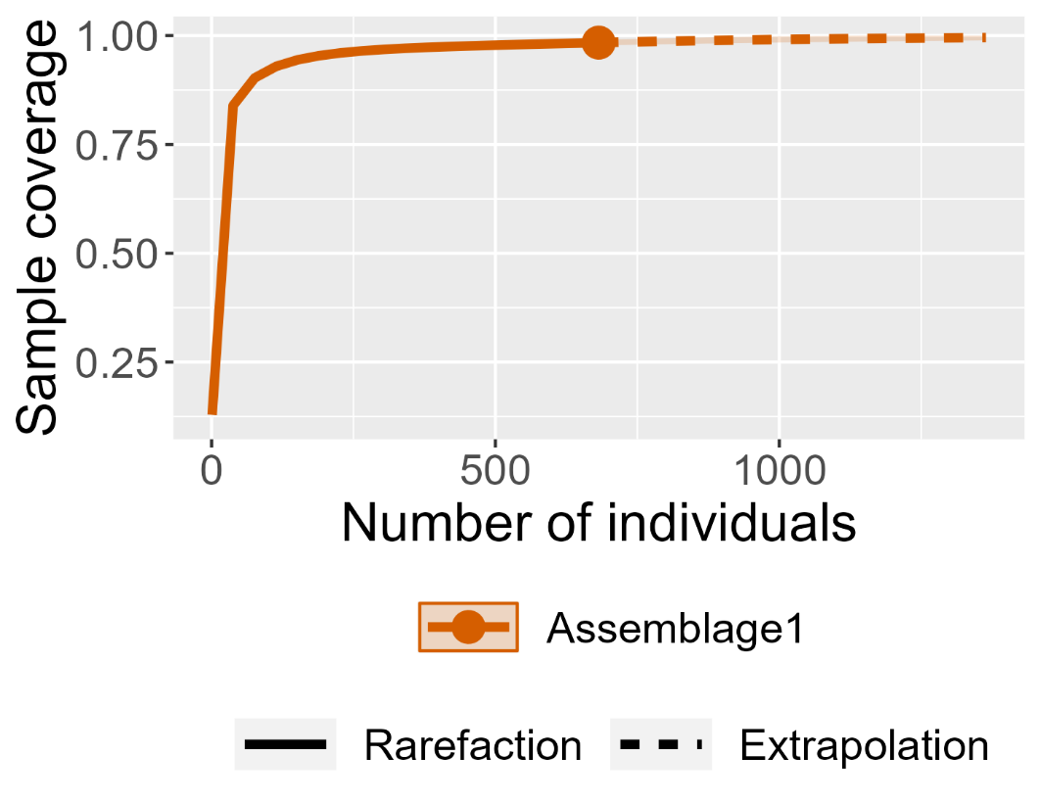
Figure S1 Sample completeness of the dragonfly species inhabiting grassland water bodies.

Table S2 List of suborders, families, and species registered in different grassland lakes. All dragonfly species are classified as least concern (LC) category of extinction risk following ICMBio and IUCN red lists.
Suborder / Family / Species | N | Site
Anisoptera
Libellulidae | 499
Brachymesia furcata Hagen, 1861 | 2 | CAP3, CAP4
Diastatops obscura Fabricius, 1775 | 6 | CAP3, CAP4, EMB4
Erythemis credula Hagen, 1861 | 3 | CAP4, EMB4
Erythemis peruviana Rambur, 1842 | 8 | CAP3, CAP4, EMB2, EMB3, EMB4
Erythrodiplax atroterminata Ris, 1911 | 1 | EMB3
Erythrodiplax basalis Kirby, 1897 | 46 | CAP2, CAP4, EMB3, EMB4, HBI2, HBI4
Erythrodiplax connata Burmeister, 1839 | 1 | CAP2
Erythrodiplax fusca Rambur, 1842 | 13 | CAP2, CAP4, EMB3
Erythrodiplax media Borror, 1942 | 82 | CAP1, CAP2, CAP3, CAP4, EMB1, EMB2, EMB3, EMB4, HBI1, HBI2, HBI3, HBI4
Erythrodiplax nigricans Rambur, 1842 | 170 | CAP1, CAP2, CAP3, CAP4, EMB1, EMB2, EMB3, EMB4, HBI1, HBI2, HBI3, HBI4
Erythrodiplax pallida Needham, 1904 | 2 | EMB3
Erythrodiplax paraguayensis Förster, 1905 | 54 | CAP1, CAP3, EMB4, HBI1, HBI2, HBI3, HBI4
Erythrodiplax sp. | 2 | CAP2, EMB4
Idiataphe longipes Hagen, 1861 | 7 | CAP3, EMB4
Miathyria marcella (Selys in Sagra,1857) | 10 | CAP3, EMB3, HBI3
Micrathyria catenata Calvert, 1909 | 21 | CAP1, CAP2, CAP3, CAP4, EMB4
Micrathyria eximia Kirby, 1897 | 1 | HBI3
Micrathyria hypodidyma Calvert, 1906 | 12 | CAP1, CAP 4, EMB3, HBI4
Micrathyria sp. | 2 | CAP3, EMB4
Micrathyria spuria Selys, 1900 | 8 | CAP2, CAP3, EMB4
Nephepeltia flavifrons Karsch, 1889 | 30 | CAP2, CAP3, CAP4, EMB2, EMB3, EMB4
Pantala flavescens Fabricius, 1798 | 2 | HBI3
Perithemis tenera Say, 1839 | 14 | CAP1, CAP2, CAP3, CAP4, EMB2, EMB3, EMB4, HBI1, HBI3, HBI4
Tauriphila argo Hagen, 1869 | 1 | CAP3
Tramea binotata Rambur, 1842 | 1 | CAP3
Zygoptera
Coenagrionidae | 167
Acanthagrion gracile Rambur,  1842 | 2 | CAP4, EMB3
Argentagrion ambiguum Ris, 1904 | 1 | CAP1
Argia sp. | 1 | CAP3
Ischnura capreolus Hagen, 1861 | 26 | CAP1, CAP3, EMB3, EMB4, HBI2
Ischnura fluviatilis Selys, 1876 | 130 | CAP1, CAP2, CAP3, CAP4, EMB1, EMB2, EMB3, EMB4, HBI1, HBI2, HBI3, HBI4
Oxyagrion rubidum Rambur, 1842 | 1 | CAP3
Telebasis corallina Selys, 1876 | 6 | CAP1, CAP3, CAP4
Lestidae | 15
Lestes bipupillatus Calvert, 1909 | 1 | EMB2
Lestes forficula Rambur, 1842 | 1 | EMB2
Lestes paulistus Calvert, 1909 | 6 | EMB1, EMB2, HBI1, HBI2, HBI3, HBI4
Lestes spatula Fraser, 1946 | 5 | EMB2, EMB3
Lestes undulatus Say, 1840 | 2 | HBI2, HBI3
Total: | 681

