Supplement material for:
Hidden in plain sight: Revisiting the synthesis, characterisation, degradation and the intricate relationship between Scheele’s green and Emerald green
Leonardo Pantoja Munoz, corresponding author
Department of Natural Sciences, Faculty of Science and Technology, Middlesex University, The Burroughs, NW4 4BT, London, UK.
E-mail: l.pantojamunoz@mdx.ac.uk
Sample pictures
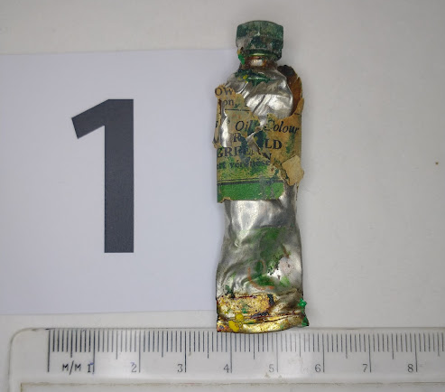
S1 Rowney & Co Emerald green oil paint tube, date unknown
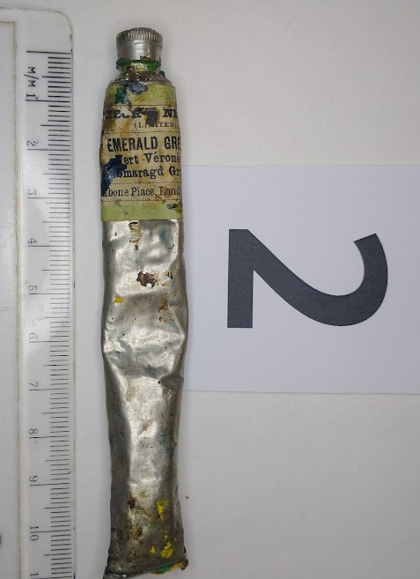
S2 Winsor & Newton Limited, Emerald green oil paint tube, post 1882
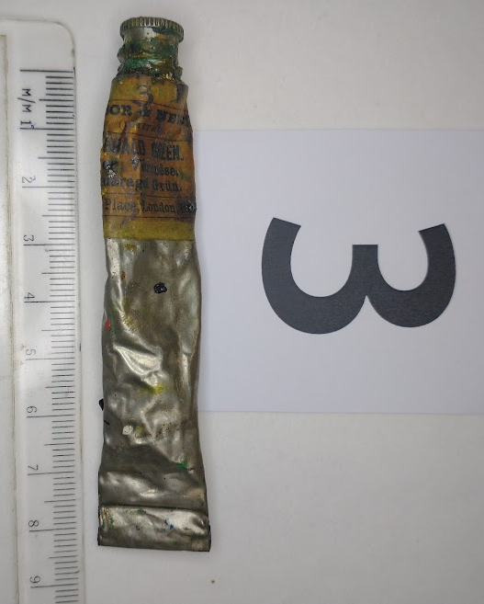
S3 Winsor & Newton Limited, Emerald green oil paint tube, post 1882

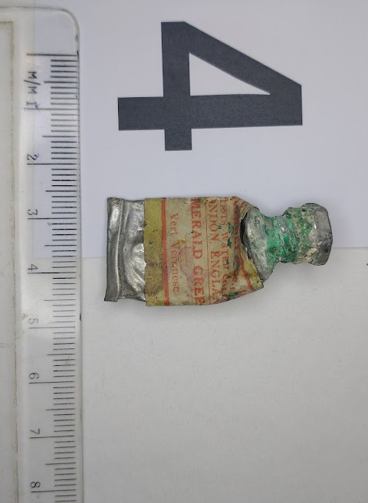
S4 George Rowney & Co Emerald green watercolour paint tube, date unknown 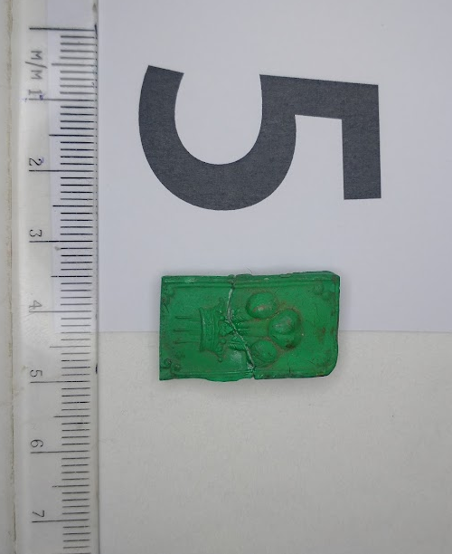
S5 Newman’s Emerald green watercolour cake, date unknown
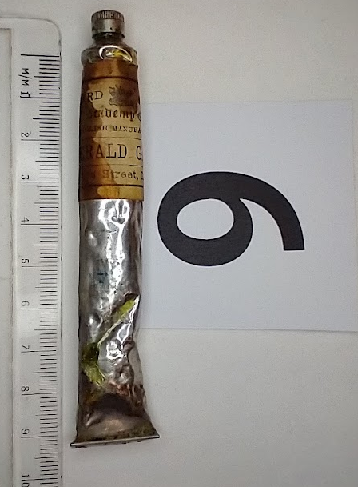
S6 Barnard’s & son, Emerald green oil paint tube, date unknown
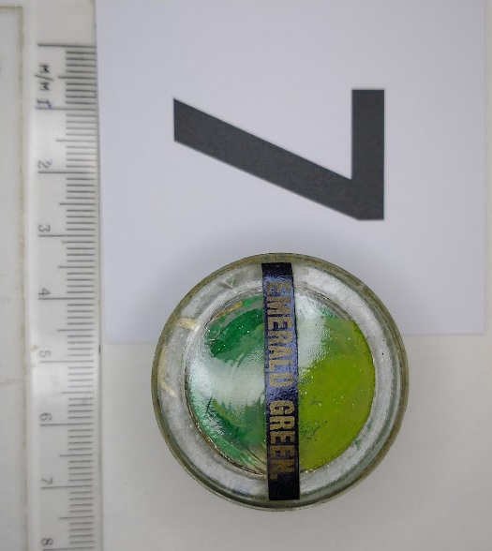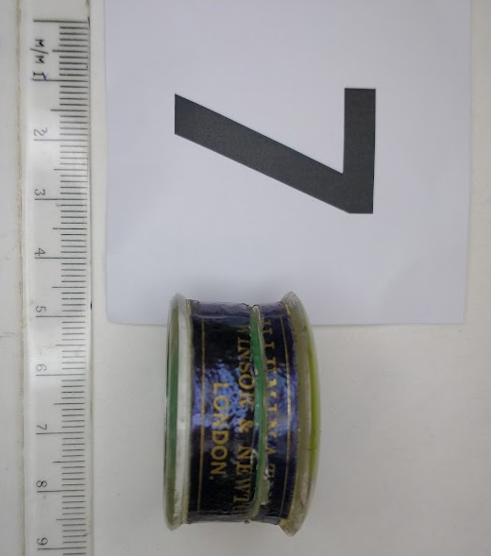
S7 Winsor & newton, Emerald green Illuminating colours, date unknown
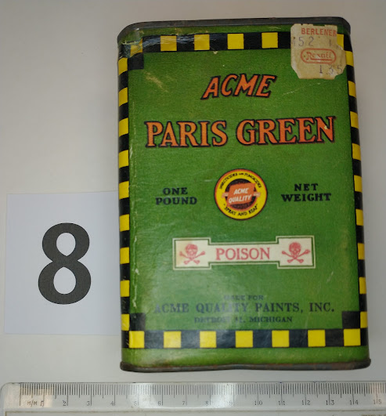
S8 Acme quality paints Inc. Paris green poison, date unknown
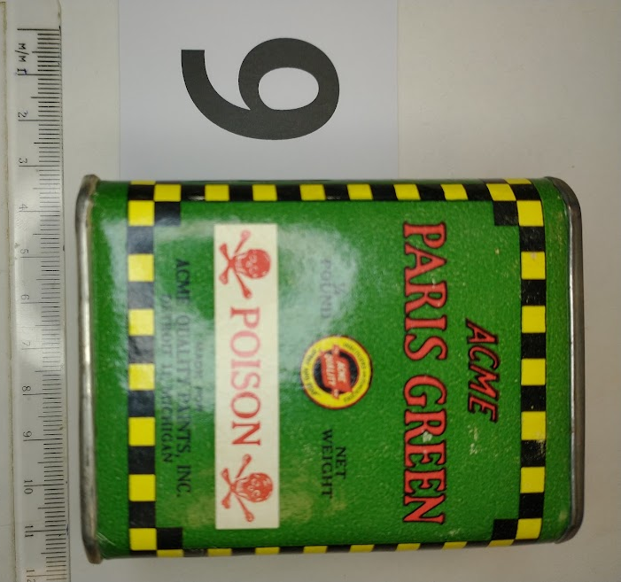
S9 Acme quality paints Inc. Paris green poison, date unknown
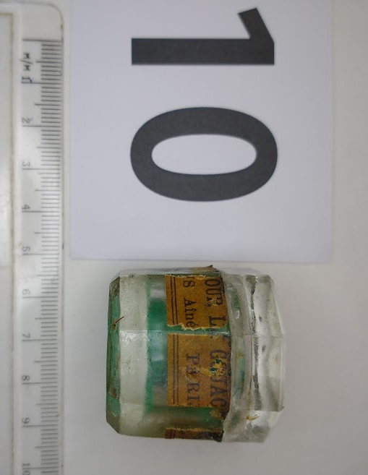
S10 Bourgeois Aine, Emerald green Gouache colours, date unknown
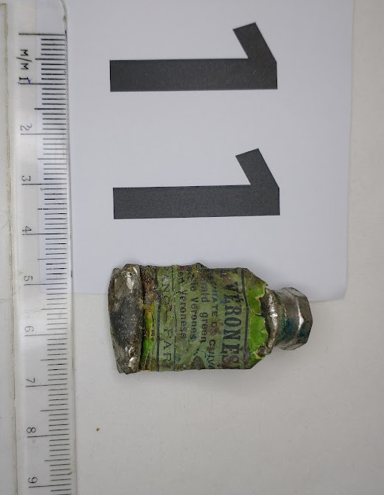
S11 Lefranc et Cie, Vert Veronese, oil paint tube, date unknown
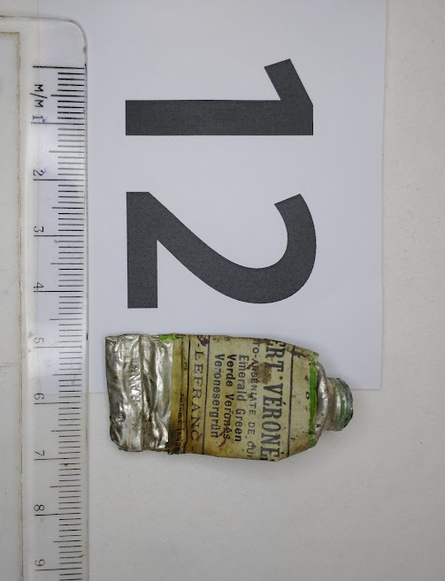
S12 Lefranc et Cie, Vert Veronese, oil paint tube, date unknown
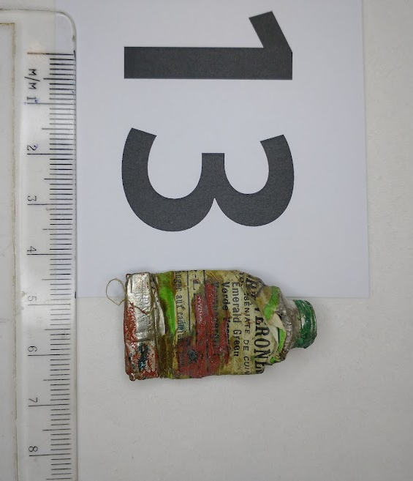
S13 Lefranc et Cie, Vert Veronese, oil paint tube, date unknown
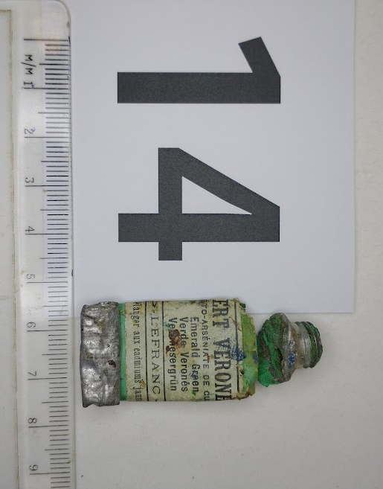
S14 Lefranc et Cie, Vert Veronese, oil paint tube, date unknown
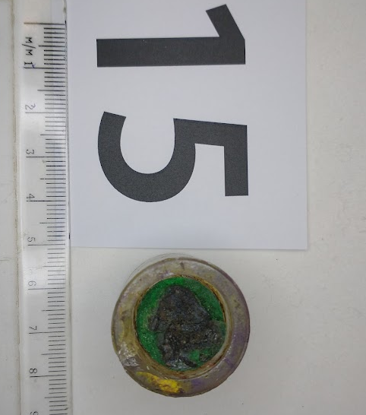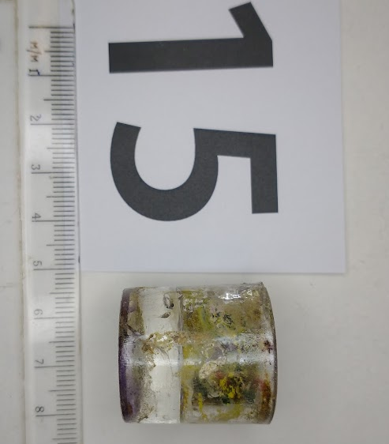
S15 Bourgeois Aine, Unknown pigment, Gouache colours, date unknown
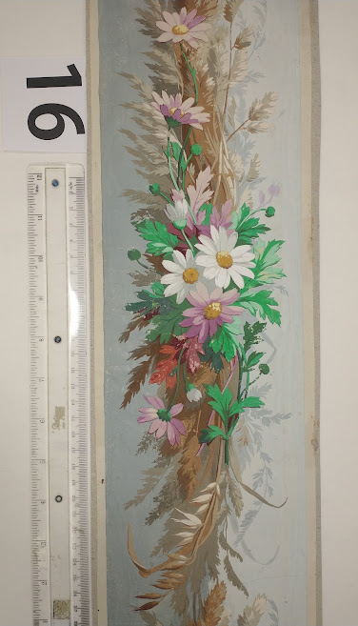
S16 French 1858 papier peint (wallpaper) catalogue sample
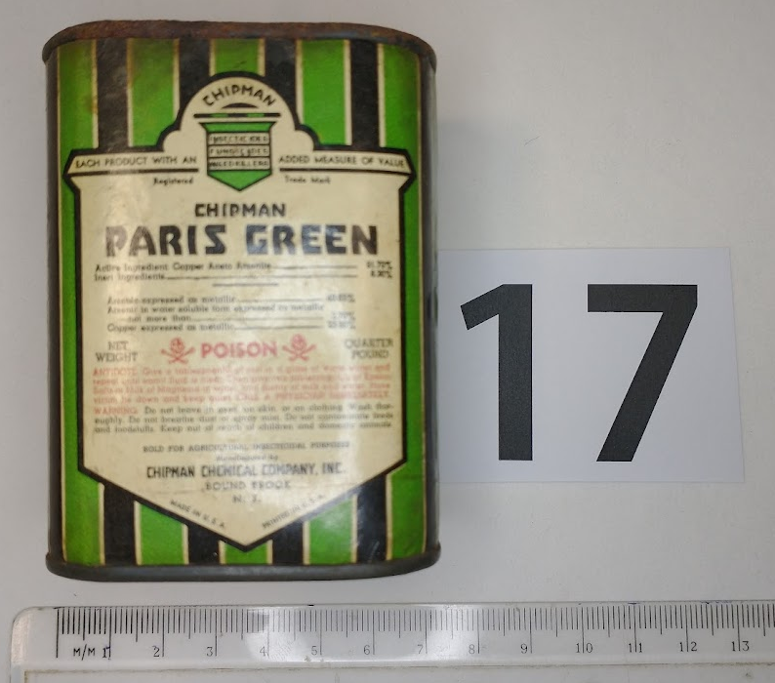
S17 Chipman Chemical company Inc, Paris green poison, date unknown
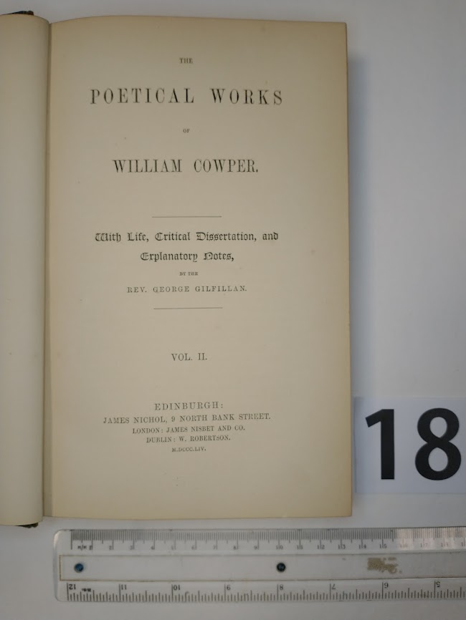
S18 The poetical works of William Cowper, 1864, green spine
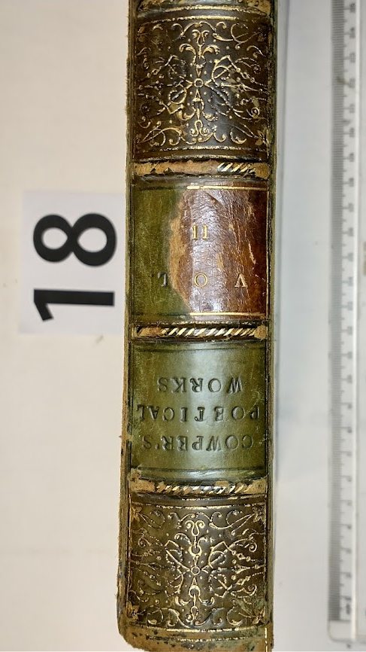
S18 The poetical works of William Cowper, 1864, green spine
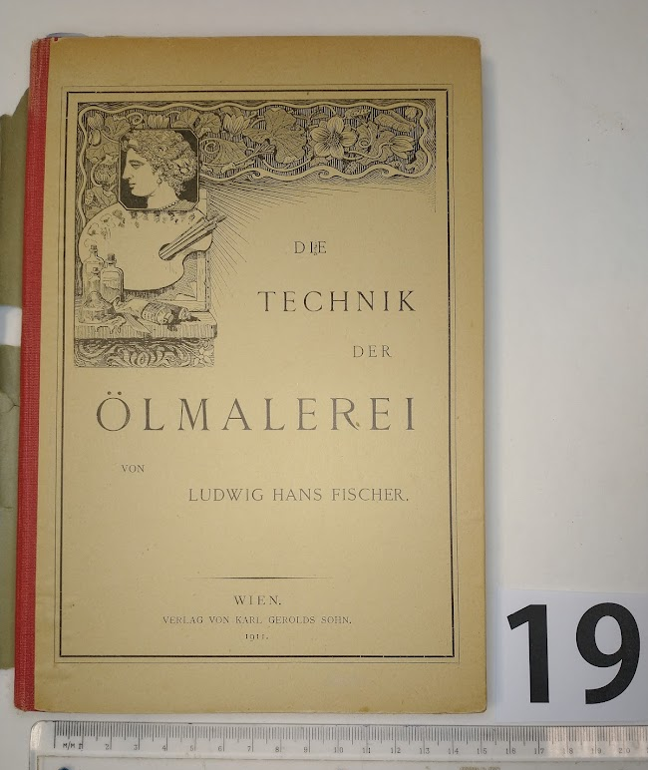
S19 Die Technik der Olmalerei, 1911, W&N Emerald green sample paint
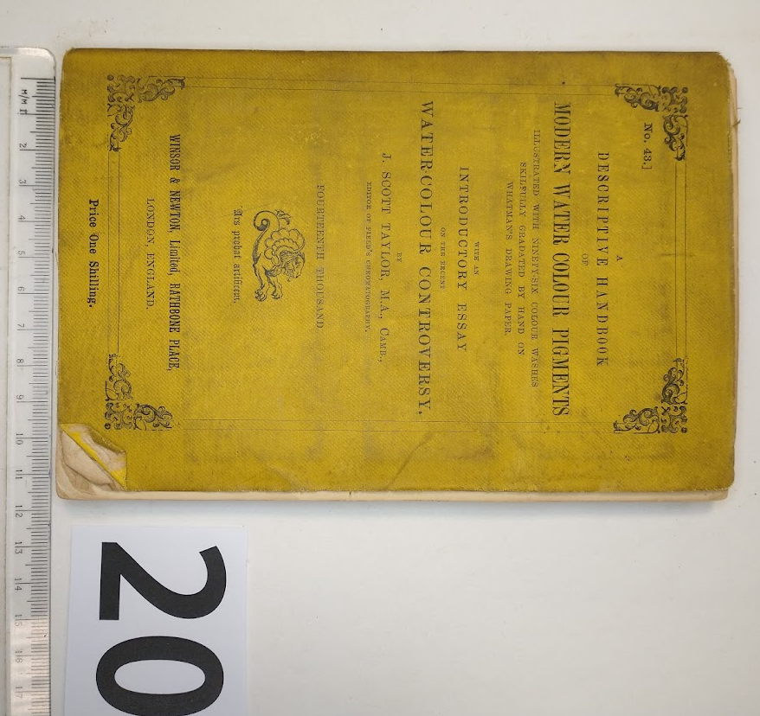

S20, A Descriptive Handbook of Modern Water-Colour Pigments, W&N, 1887
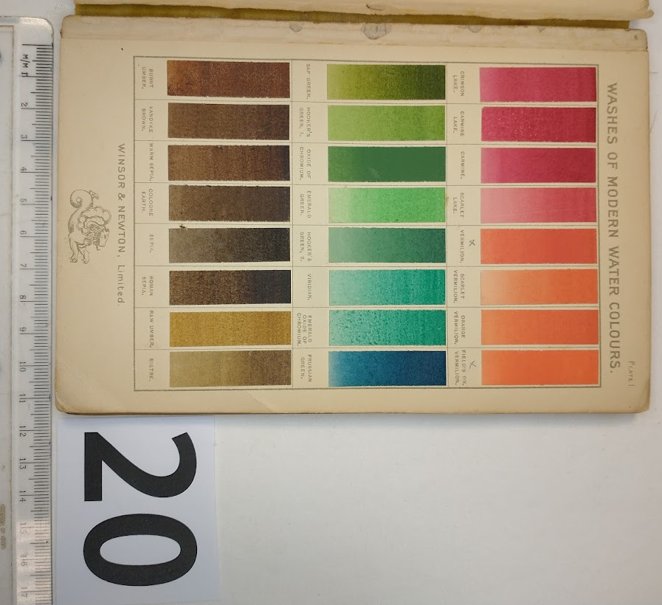
S20, A Descriptive Handbook of Modern Water-Colour Pigments, W&N, 1887
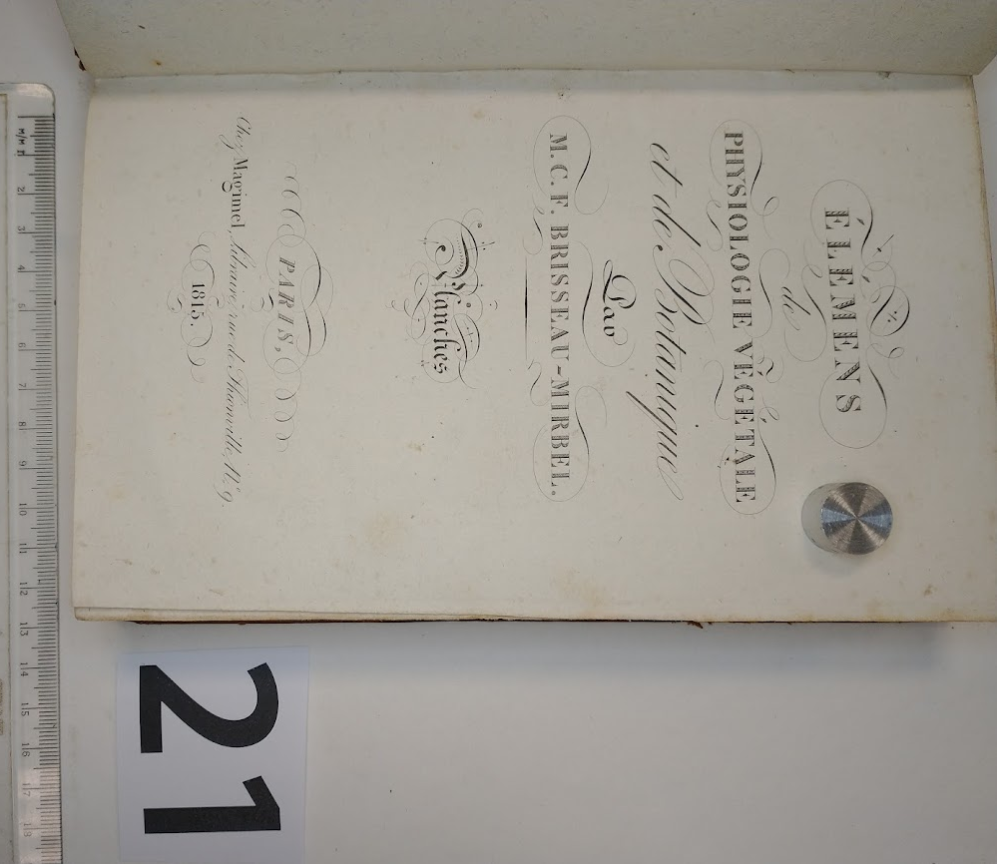
S21 Éléments de physiologie végétale et de botanique, 1815, 1er tableaux, plate 11
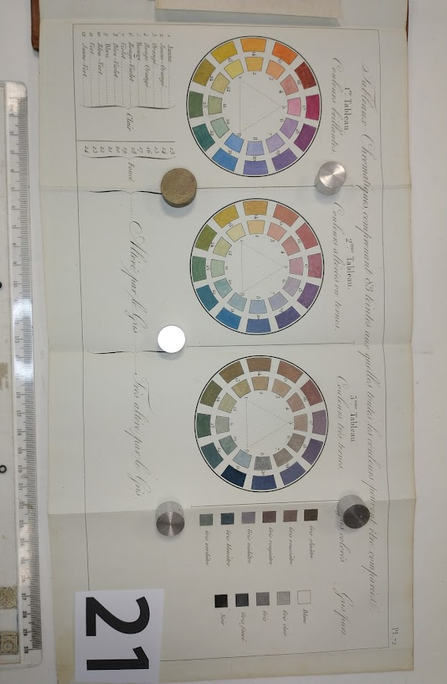
S21 Éléments de physiologie végétale et de botanique, 1815, 1er tableaux, plate 11

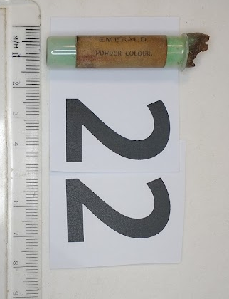
S22 Velvotint Emerald powder colour, J. Barnard & Son
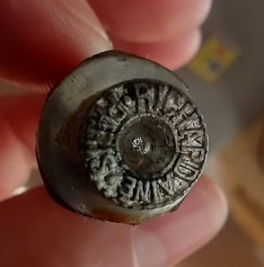
23
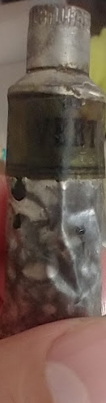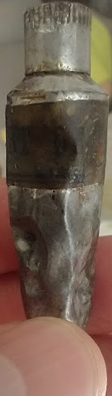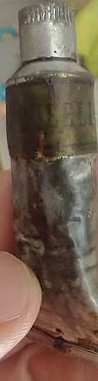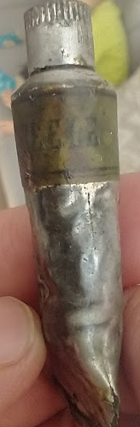
S23 Vert de Scheele, oil paint, Richard Aine Paris

Raman spectroscopic identifications
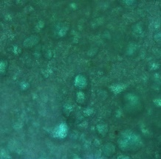
S1 Sample 1, Emerald green
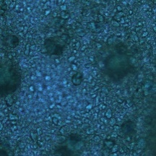
S2 Sample 2, Emerald green

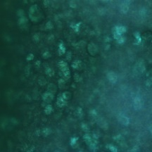
Sample 3 S3, particle 1, Emerald green
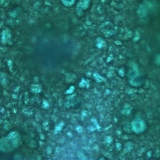
Sample 3 S3, particle 2, Scheele’s green
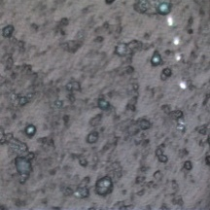
Sample 4 S4, Emerald green
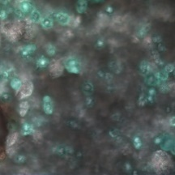
Sample 5 S5 , Emerald green
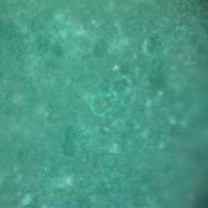
Sample 6 S6, Emerald green
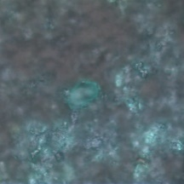
Sample 7 , S7, Emerald green

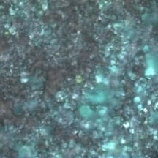
Sample 7 S7 , Cobalt yellow
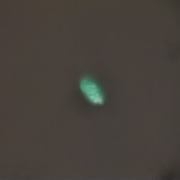
Sample 8, S8, Scheele’s green
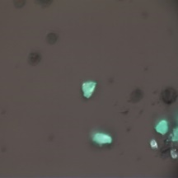
Sample 8 , S8, Emerald green
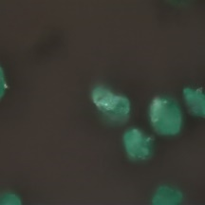
Sample 8 S8, Scheele’s green
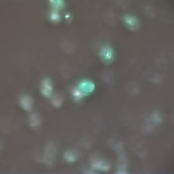
Sample 9 S9, Emerald green
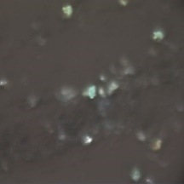
Sample 10 S10, Emerald green
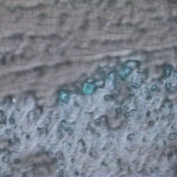
Sample 11 S1, Emerald green
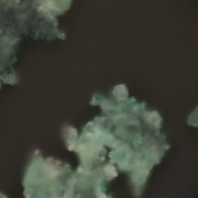
Sample 12, S11, Emerald green

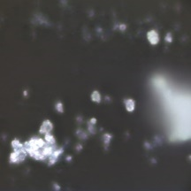
Sample 12 S12, particle 5, Unknown Cerussite?
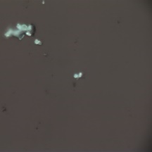
Sample 13 S13, Emerald green
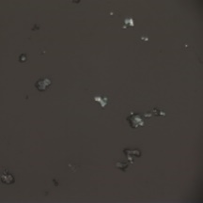
Sample 14, S14, particle 1, Emerald green
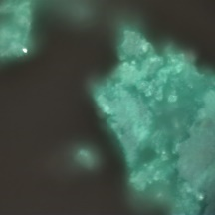
Sample 14, S14, particle 2, Scheele’s green
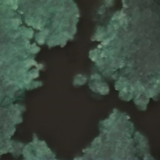
Sample 14, S14, Scheele’s green
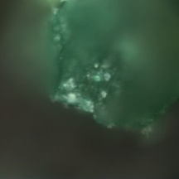
Sample 15, S15, particle 1, Emerald green
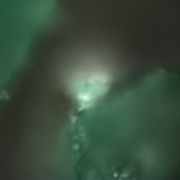
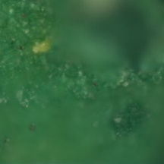
Sample 15 S15, particle 3, Scheele’s green
Sample 16, S16, particle 1, Emerald green

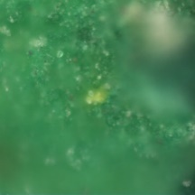
Sample 16, S16, particle 2, unknown
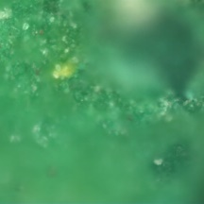
Sample 16 S16 , particle 3, Scheele’s green
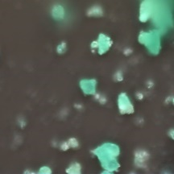
Sample 17 S17, Emerald green
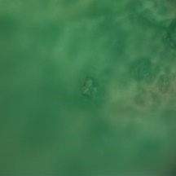
Sample 20 S20, Emerald green
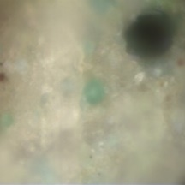
Sample 21 S2, Scheele’s green
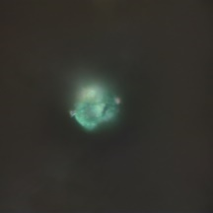
Sample 22 S22 , Emerald green

Summary
Sample No | Description | Identification
S1 | Rowney & Co Emerald green oil paint tube, date unknown | Emerald green
S2 | Winsor & Newton Limited, Emerald green oil paint tube, post 1882 | Emerald green
S3 | Winsor & Newton Limited, Emerald green oil paint tube, post 1882 | Emerald green
 | Winsor & Newton Limited, Emerald green oil paint tube, post 1882 | Scheele’s green
S4 | George Rowney & Co Emerald green watercolour paint tube, date unknown | Emerald green
S5 | Newman’s Emerald green watercolour cake, date unknown | Emerald green
S6 | Barnard’s & son, Emerald green oil paint tube, date unknown | Emerald green
S7 | Winsor & newton , Emerald green Illuminating colours, date unknown | Emerald green
 | Winsor & newton , Emerald green Illuminating colours, date unknown | Cobalt yellow
S8 | Acme quality paints Inc. Emerald green poison, date unknown | Emerald green
 | Acme quality paints Inc. Emerald green poison, date unknown | Scheele’s green
S9 | Acme quality paints Inc. Emerald green poison, date unknown | Emerald green
S10 | Bourgeois Aine , Emerald green Gouache colours, date unknown | Emerald green
S11 | Lefranc et Cie, Vert Veronese, oil paint tube, date unknown | Emerald green
S12 | Lefranc et Cie, Vert Veronese, oil paint tube, date unknown | Emerald green
 | Lefranc et Cie, Vert Veronese, oil paint tube, date unknown | Cerussite?
S13 | Lefranc et Cie, Vert Veronese, oil paint tube, date unknown | Emerald green
S14 | Lefranc et Cie, Vert Veronese, oil paint tube, date unknown | Emerald green
 | Lefranc et Cie, Vert Veronese, oil paint tube, date unknown | Scheele’s green
S15 | Bourgeois aine , Unknown pigment, Gouache colours, date unknown | Emerald green
 | Bourgeois aine , Unknown pigment, Gouache colours, date | Scheele’s green
S16 | French 1858 papier peint (wallpaper) catalogue sample | Emerald green
 | French 1858 papier peint (wallpaper) catalogue sample | Scheele’s green
 | French 1858 papier peint (wallpaper) catalogue sample | Unknown
S17 | Chipman Chemical company Inc, Paris green poison, date unknown | Emerald green
S18 | The poetical works of William Cowper, 1864, green spine | Copper, arsenic
S19 | Die Technik der Olmalerei, 1911, W&N sample paint | No Arsenic
S20 | A Descriptive Handbook of Modern Water-Colour Pigments: Illustrated With Ninety-six Colour Washes, W&N, 1887 | Emerald green
S21 | Éléments de physiologie végétale et de botanique, 1815 | Scheele’s green
S22 | Velvotint Emerald powder colour, J. Barnard & Son | Emerald green
S23 | Scheele’s green, oil paint, Richard Aine Paris | Calcite
 | Scheele’s green, oil paint, Richard Aine Paris | Unknown
S24 | Scheele’s Synthesis 1
S25 | Scheele’s Synthesis 1
S26 | Emerald green synthesis 1 | Emerald green
S27 | Trippkeite Synthesis | Trippkeite
S28 | Spanish forger | Unknown
S29 | Emerald green Hoxton | Emerald green

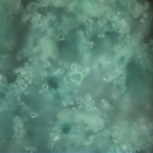
Sample 23, S23, particle 1, Calcite
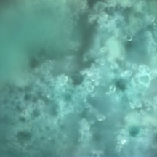
Sample 23, S23, particle 4, unknown
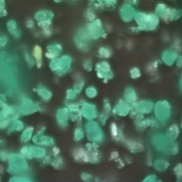
Sample A, Emerald green synthesis, Emerald green
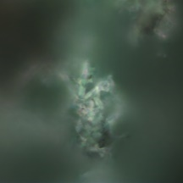
Sample B, Trippkeite synthesis in 1M acetic acid, Scheele’s green
Sample B, Trippkeite synthesis in 1M acetic acid, FTIR spectra
Sample C, Trippkeite Synthesis in water, Scheele’s green

Sample C, Trippkeite Synthesis in water, FTIR spectra
Sample D1, Scheele’s Synthesis, Unknown
Sample D2, Scheele’s Synthesis, Unknown
Sample D3, Scheele’s Synthesis, unknown
Sample E, Scheele’s Synthesis, Unknow
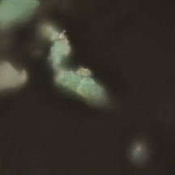
Sample G, Scheele’s Synthesis, Scheele’s green
Sample H, , Scheele’s Synthesis, unknown

Summary of the elemental analysis
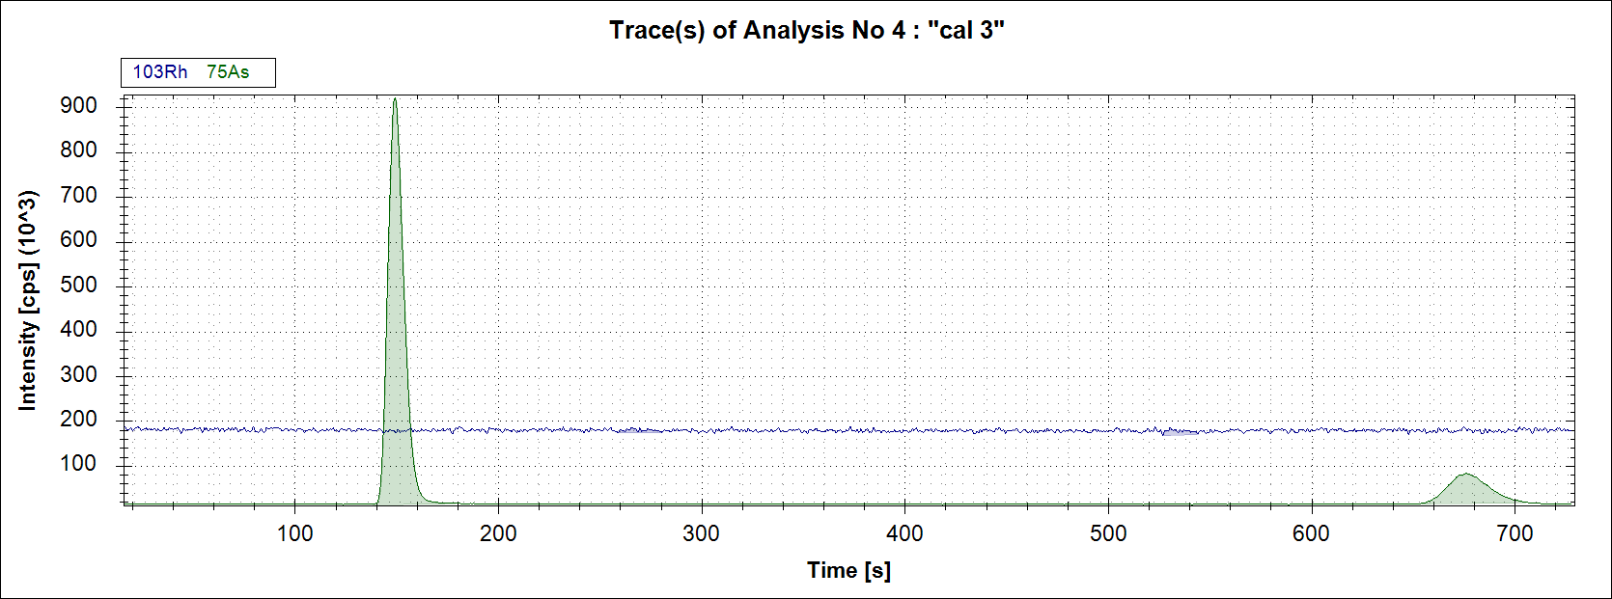
As(V)
As(III)
Example of chromatogram, showing arsenic species and Rh internal standard signal

Speciation of arsenic (III) and (V) calibration curves
ICP-OES analysis
Copper calibration curve

