Scattered trees in smallholder farms improve soil properties and litter decomposition in humid- agroecosystems in Ethiopia

Gizatu Nesi Anbessa¹, Yonas Ugo Utaile¹*

¹Department of Forestry, College of Agriculture, Arba Minch University, Arba Minch, Ethiopia

*Correspondence
Yonas Ugo Utaile, Department of Forestry, College of Agriculture, Arba Minch University, Arba Minch, Ethiopia
Email: yonasu2009@gmail.com
ORCID: 0000-0002-3287-3426

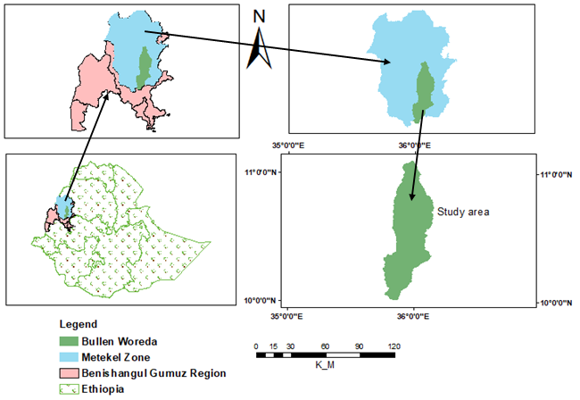

Online Resource 1 Map of study area, Bullen Woreda, Metekel Zone, Benshangul Gumuz Region, northwestern Ethiopia

Online Resource 2 Tukey’s-test post-hoc results for the effect of distance and species identity on all soil variables following linear mixed model analysis. Test statistics (F/Z) and P-value for the overall distance effect and all three pairwise comparisons between distances, species identity, and mass loss. N = 45 per species. P< 0.05.
 | Distance | D1-D2 | D1-D3 | D2-D3 | Species ID | Cordia-Croton
 | F & P | Z & P | Z & P | Z & P | F & P | Z & P
pH-H2O | 448.0*** | -10.8*** | -29.6*** | -18.7*** | 1.6 | 1.3
TN (%) | 162.8*** | -6.4*** | -17.8*** | -11.3*** | 17.1** | 4.1***
AP (mg/Kg) | 102.7*** | -7.4*** | -14.3*** | -6.8*** | 5.1* | 2.3*
OC (%) | 193.0*** | -5.8*** | -19.2*** | -13.3*** | 17.3*** | 4.2***
CEC (meq/100g) | 216.7*** | -10.0*** | -20.8*** | -10.7*** | 0.2 | -0.4

Online Resource 3 Tukey’s-test post-hoc results for the effect of distance, species identity, and time on litter decomposition following linear mixed model analysis. Test statistics (F/Z) and P-value for the overall distance and species identity effect and pairwise comparisons between distances and species identity. N = 45 per species. P< 0.05.
 | Distance | D1-D2 | D1-D3 | D2-D3 | Species ID | Cordia-Croton | Time | T1-T2 | T1-T3 | T2-T3
 | F & P | Z & P | Z & P | Z & P | F & P | Z & P | F & P | Z & P | Z & P | Z & P
Mass loss (%) | 1325.6*** | -15.0*** | -50.2*** | -35.1*** | 415.9*** | 20.4*** | 2564.4*** | 27.4*** | 71.0*** | 43.6***

