Supplementary Material
Figure S1: Example Attrition Scenarios for SDS negation terms
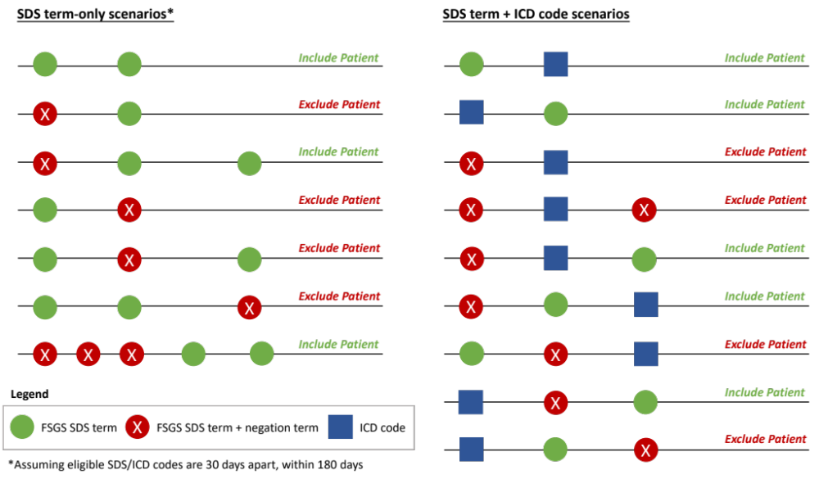

Table S1: HRU by Baseline CKD Stage

Category | Baseline CKD Stage
Category | Stage 1 (n=68) | Stage 2 (n=104) | Stage 3 (n=294) | Stage 4 (n=185) | Stage 5/KF (n=249) | P-value
Patients with ≥1 visit, n (%) | 68 (100.0) | 100 (96.2) | 293 (99.7) | 184 (99.5) | 247 (99.2) | 0.05ª
Inpatient visits
Patients with ≥1 visit, n (%)  Visits PPPM | 15 (22.1) | 23 (22.1) | 99 (33.7) | 90 (48.6) | 137 (55.0) | <0.001ª
Mean (SD) | 0.10 (0.13) | 0.11 (0.13) | 0.10 (0.08) | 0.16 (0.22) | 0.17 (0.25) | 0.01^{b}
Median (Q1 - Q3) | 0.00 (0.00 - 0.10) | 0.10 (0.00 - 0.20) | 0.10 (0.00 - 0.10) | 0.10 (0.00 - 0.10) | 0.10 (0.00 - 0.20) | <0.01^{c}
Min (Max) | 0.01 (0.52) | 0.02 (0.55) | 0.01 (0.40) | 0.01 (1.10) | 0.02 (1.97) | -
LOS PPPM
Mean (SD) | 0.80 (1.66) | 0.54 (0.70) | 0.62 (0.80) | 1.27 (2.62) | 1.04 (1.66) | 0.06^{b}
Median (Q1 - Q3) | 0.10 (0.00 - 0.70) | 0.20 (0.10 - 0.80) | 0.40 (0.10 - 0.80) | 0.40 (0.10 - 0.90) | 0.50 (0.20 - 1.10) | 0.01^{c}
Min (Max) | 0.01 (6.28) | 0.02 (2.65) | 0.01 (5.65) | 0.02 (19.54) | 0.02 (10.92) | -
ED visits
Patients with ≥1 visit, n (%)  Visits PPPM | 28 (41.2) | 47 (45.2) | 155 (52.7) | 106 (57.3) | 164 (65.9) | <0.001ª
Mean (SD) | 0.08 (0.08) | 0.15 (0.23) | 0.15 (0.18) | 0.19 (0.25) | 0.33 (0.83) | <0.01^{b}
Median (Q1 - Q3) | 0.10 (0.00 - 0.10) | 0.10 (0.00 - 0.10) | 0.10 (0.00 - 0.20) | 0.10 (0.10 - 0.20) | 0.20 (0.10 - 0.30) | <0.001^{c}
Min (Max) | 0.01 (0.39) | 0.01 (1.19) | 0.01 (1.34) | 0.01 (2.16) | 0.01 (8.02) | -
Outpatient visits
Patients with ≥1 visit, n (%)  Visits PPPM | 67 (98.5) | 99 (95.2) | 290 (98.6) | 184 (99.5) | 246 (98.8) | 0.11ª
Mean (SD) | 2.31 (1.83) | 2.41 (3.15) | 3.85 (4.53) | 5.54 (5.49) | 11.09 (9.78) | <0.001^{b}
Median (Q1 - Q3) | 1.60 (1.00 - 3.40) | 1.70 (0.90 - 2.80) | 2.40 (1.30 - 4.30) | 3.10 (1.60 - 8.30) | 8.20 (4.10 - 16.10) | <0.001^{c}
Min (Max) | 0.24 (8.16) | 0.11 (27.13) | 0.04 (27.45) | 0.03 (26.87) | 0.10 (57.49) | -
Pharmacy claims
Patients with ≥1 visit, n (%)  Claims PPPM | 63 (92.6) | 88 (84.6) | 282 (95.9) | 175 (94.6) | 238 (95.6) | <0.01ª
Mean (SD) | 3.93 (3.52) | 3.67 (2.88) | 4.36 (3.53) | 4.43 (3.44) | 4.89 (4.19) | 0.01^{b}
Median (Q1 - Q3) | 3.10 (1.50 - 4.70) | 2.90 (1.50 - 4.90) | 3.50 (1.90 - 5.70) | 3.50 (2.00 - 5.90) | 3.90 (2.10 - 6.40) | 0.01^{c}
Min (Max) | 0.12 (15.68) | 0.03 (11.81) | 0.05 (20.04) | 0.08 (21.38) | 0.03 (29.64) | -

Abbreviations: CKD: chronic kidney disease; KF: kidney failure; PPPM: per patient per month; Q1: first quartile; Q3: third quartile; SD: standard deviation.
ª Fisher’s exact test
^{b} Linear regression
^{c} Jonckheere–Terpstra test
Table S2: HRU by Baseline UPCR (g/g)
Category | Baseline UPCR (g/g)
Category | ≤ 1.5 g/g (n=105) | >1.5 g/g (n=166) | P-value | <3.5 g/g (n=174) | ≥3.5 g/g (n=97) | P-value
Patients with ≥1 visit, n (%) | 103 (98.1) | 164 (98.8) | 0.64ª | 171 (98.3) | 96 (99.0) | 1.00ª
Inpatient visits
Patients with ≥1 visit, n (%)  Visits PPPM | 16 (15.2) | 82 (49.4) | <0.001ª | 43 (24.7) | 55 (56.7) | <0.001ª
Mean (SD) | 0.10 (0.13) | 0.16 (0.21) | 0.25^{b} | 0.11 (0.13) | 0.18 (0.23) | 0.09^{b}
Median (Q1 - Q3) | 0.10 (0.00 - 0.10) | 0.10 (0.00 - 0.20) | 0.07^{c} | 0.10 (0.00 - 0.10) | 0.10 (0.00 - 0.20) | 0.09^{c}
Min (Max) | 0.01 (0.49) | 0.01 (1.10) |  | 0.01 (0.52) | 0.01 (1.10)
LOS PPPM
Mean (SD) | 0.56 (0.85) | 1.30 (2.59) | 0.26^{b} | 0.80 (1.29) | 1.47 (2.99) | 0.17^{b}
Median (Q1 - Q3) | 0.20 (0.10 - 0.40) | 0.40 (0.10 – 1.10) | 0.09^{c} | 0.30 (0.10 – 0.80) | 0.50 (0.10 - 1.40) | 0.27^{c}
Min (Max) | 0.01 (3.02) | 0.01 (19.54) |  | 0.01 (6.28) | 0.01 (19.54)
ED visits
Patients with ≥1 visit, n (%)  Visits PPPM | 53 (50.5) | 90 (54.2) | 0.62ª | 85 (48.9) | 58 (59.8) | 0.10ª
Mean (SD) | 0.10 (0.11) | 0.21 (0.29) | 0.01^{b} | 0.13 (0.18) | 0.23 (0.31) | 0.02^{b}
Median (Q1 - Q3) | 0.10 (0.00 - 0.10) | 0.10 (0.00 - 0.20) | 0.01^{c} | 0.10 (0.00 - 0.10) | 0.10 (0.10 - 0.30) | <0.01^{c}
Min (Max) | 0.01 (0.58) | 0.01 (2.16) |  | 0.01 (1.19) | 0.02 (2.16)
Outpatient visits
Patients with ≥1 visit, n (%)  Visits PPPM | 101 (96.2) | 163 (98.2) | 0.44ª | 169 (97.1) | 95 (97.9) | 1.00ª
Mean (SD) | 2.33 (2.51) | 4.80 (4.97) | <0.001^{b} | 2.88 (3.33) | 5.60 (5.35) | <0.001^{b}
Median (Q1 - Q3) | 1.50 (0.90 – 2.80) | 2.90 (1.50 – 6.20) | <0.001^{c} | 1.80 (1.00 – 3.10) | 3.50 (1.60 – 8.20) | <0.001^{c}
Min (Max) | 0.09 (14.67) | 0.03 (25.10) |  | 0.03 (18.41) | 0.11 (25.10)
Pharmacy claims
Patients with ≥1 visit, n (%)  Claims PPPM | 93 (88.6) | 160 (96.4) | 0.02ª | 158 (90.8) | 95 (97.9) | 0.02ª
Mean (SD) | 3.74 (2.60) | 4.18 (3.31) | 0.27^{b} | 3.88 (2.85) | 4.24 (3.40) | 0.38^{b}
Median (Q1 - Q3) | 3.00 (2.00 – 4.90) | 3.40 (1.80 – 5.30) | 0.52^{c} | 3.10 (1.90 - 5.10) | 3.50 (1.80 - 5.30) | 0.65^{c}
Min (Max) | 0.09 (11.72) | 0.05 (17.70) |  | 0.09 (17.70) | 0.05 (15.78)

Abbreviations: PPPM: per patient per month; Q1: first quartile; Q3: third quartile; SD: standard deviation; UPCR: urinary protein-creatinine ratio
ª Fisher’s exact test
^{b} Linear regression
^{c} Jonckheere–Terpstra test

Table S3: Costs by Baseline CKD Stage
Category | Baseline CKD Stage
Category | Stage 1 (n=68) | Stage 2 (n=104) | Stage 3 (n=294) | Stage 4 (n=185) | Stage 5/KF (n=249) | P-value
Total costs PPPM
Mean (SD) | $2256 ($3951) | $2664 ($4231) | $4250 ($7788) | $6671 ($9087) | $13 608 ($16 112) | <0.001ª
Median (Q1 - Q3) | $748 ($321 - $2233) | $935 ($436 - $2349) | $1380 ($560 - $4498) | $3015 ($1089 - $8415) | $8841 ($4113 - $15 930) | <0.001^{b}
Min (Max) | $58 ($18 623) | $19 ($18 932) | $0 ($86 329) | $61 ($54 125) | $28 ($97 292) | -
Inpatient visits costs PPPM
Mean (SD) | $2521 ($4584) | $2405 ($3086) | $2603 ($3173) | $4459 ($7198) | $4882 ($8445) | 0.01ª
Median (Q1 - Q3) | $517 ($276 - $1999) | $1344 ($368 - $3163) | $1559 ($537 - $3667) | $1316 ($565 - $4403) | $2343 ($1059 - $4909) | <0.001^{b}
Min (Max) | $122 ($15 299) | $86 ($11 108) | $99 ($21 458) | $20 ($40 781) | $7 ($60 036) | -
ED visits costs PPPM
Mean (SD) | $73 ($112) | $174 ($551) | $126 ($187) | $114 ($159) | $328 ($935) | <0.01ª
Median (Q1 - Q3) | $22 ($13 - $53) | $43 ($11 - $145) | $50 ($21 - $151) | $55 ($16 - $161) | $98 ($36 - $220) | <0.001^{b}
Min (Max) | $6 ($434) | $0 ($3739) | $0 ($1161) | $0 ($1085) | $0 ($7862) | -
Outpatient visits costs PPPM
Mean (SD) | $1227 ($2390) | $1305 ($2428) | $2,168 ($3,909) | $3,544 ($4,940) | $9317 ($11 774) | <0.001ª
Median (Q1 - Q3) | $410 ($200 - $1383) | $502 ($202 - $1299) | $716 ($280 - $2143) | $1541 ($562 - $4 736) | $5550 ($2311 - $10 782) | <0.001^{b}
Min (Max) | $0 ($17 213) | $8 ($16 723) | $0 ($28 569) | $6 ($29 473) | $0 ($93 763) | -
Pharmacy claims costs PPPM
Mean (SD) | $498 ($908) | $837 ($2683) | $1204 ($5249) | $925 ($2705) | $1456 ($4515) | 0.12ª
Median (Q1 - Q3) | $158 ($44 - $568) | $225 ($57 - $446) | $268 ($73 - $788) | $279 ($97 - $869) | $597 ($148 - $1513) | <0.001^{b}
Min (Max) | $3 ($5 377) | $0 ($18 824) | $0 ($80 319) | $1 ($32 830) | $0 ($56 455) | -

Abbreviations: CKD: chronic kidney disease; KF: kidney failure; PPPM: per patient per month; Q1: first quartile; Q3: third quartile; SD: standard deviation.
ª Linear regression
^{b} Jonckheere–Terpstra test

Table S4: Costs by Baseline UPCR (g/g)
Category | Baseline UPCR (g/g)
Category | ≤ 1.5 g/g (n=105) | >1.5 g/g (n=166) | P-value | <3.5 g/g (n=174) | ≥3.5 g/g (n=97) | P-value
Total costs PPPM
Mean (SD) | $2169 ($4,553) | $6472 ($9244) | <0.001ª | $3142 ($6108) | $7786 ($10 023) | <0.001ª
Median (Q1 - Q3) | $784 ($365 - $1997) | $2119 ($725 - $8852) | <0.001^{b} | $1051 ($414 - $2486) | $3012 ($1060 - $12 639) | <0.001^{b}
Min (Max) | $19 ($29 763) | $24 ($54 125) |  | $19 ($43 164) | $24 ($54 125)
Inpatient visit costs PPPM
Mean (SD) | $2653 ($4085) | $4544 ($7193) | 0.31ª | $3034 ($4697) | $5175 ($7995) | 0.12ª
Median (Q1 - Q3) | $1143 ($572 - $1539) | $1777 ($565 - $4531) | 0.31^{b} | $1190 ($579 - $2803) | $2267 ($525 - $6429) | 0.20^{b}
Min (Max) | $276 ($14 406) | $99 ($40 781) |  | $205 ($21 578) | $99 ($40 781)
ED visit costs PPPM
Mean (SD) | $88 ($141) | $181 ($422) | 0.13ª | $128 ($416) | $173 ($213) | 0.45ª
Median (Q1 - Q3) | $32 ($12 - $94) | $65 ($24 - $183) | 0.02^{b} | $34 ($13 - $112) | $83 ($36 - $240) | <0.01^{b}
Min (Max) | $0 ($0.654) | $0 ($3739) |  | $0 ($3739) | $0 ($1085)
Outpatient visit costs PPPM
Mean (SD) | $1357 ($3044) | $3127 ($4796) | <0.01ª | $1629 ($3667) | $3910 ($4917) | <0.001ª
Median (Q1 - Q3) | $537 ($162 - $1187) | $1,180 ($369 - $3773) | <0.001^{b} | $554 ($223 - $1436) | $1827 ($626 - $6559) | <0.001^{b}
Min (Max) | $18 ($22 208) | $6 ($29 473) |  | $6 ($29 473) | $19 ($24 030)
Pharmacy claim costs PPPM
Mean (SD) | $421 ($792) | $1,018 ($2650) | 0.04ª | $763 ($2296) | $857 ($1976) | 0.74ª
Median (Q1 - Q3) | $185 ($64 - $368) | $251 ($67 - $803) | 0.09^{b} | $192 ($64 - $547) | $267 ($67 - $804) | 0.32^{b}
Min (Max) | $2 ($6407) | $0 ($18 995) |  | $0 ($18 995) | $0 ($15 785)

Abbreviations: ED: emergency department; PPPM: per patient per month; Q1: first quartile; Q3: third quartile; SD: standard deviation; UPCR: urinary protein-creatinine ratio
ª Linear regression
^{b} Jonckheere–Terpstra test

