Supplemental Materials

Supplementary Table 1 Behavioral Inventories and Items

Supplementary Text 1 Secondary Community Detection Methods

Supplementary Figure 1 Comparison of Secondary Community Detection Methods

Supplementary Text 2 Additional Control Analyses

Supplementary Table 2 Comparison of Clustering Variations

Supplementary Table 3 Cluster 1 – Original Leave-One-Behavior-Out Rankings

Supplementary Table 4 Cluster 2 – Original Leave-One-Behavior-Out Rankings

Supplementary Table 5 Cluster 1 – Cleaned Leave-One-Behavior-Out Rankings

Supplementary Figure 2 Final Leave-One-Behavior-Out Clusters

Supplementary Figure 3 Whole-Brain Volume Space Primary Cluster Maps

Supplementary Table 6 Spatial Correlations of Cluster Map Variations

Supplementary Table 7 Clinical Validation Dataset Characteristics

Supplementary Table 8 Individual Dataset Clinical Predictions

Supplementary Table 1
Behavioral Inventories and Items
Index | Inventory | Item
1 | Beck Depression Inventory-II¹  (BDI-II) | Sad
2 | Beck Depression Inventory-II¹  (BDI-II) | Hopeless
3 | Beck Depression Inventory-II¹  (BDI-II) | Failure
4 | Beck Depression Inventory-II¹  (BDI-II) | Dissatisfaction
5 | Beck Depression Inventory-II¹  (BDI-II) | Guilt
6 | Beck Depression Inventory-II¹  (BDI-II) | Punishment
7 | Beck Depression Inventory-II¹  (BDI-II) | Self-Dislike
8 | Beck Depression Inventory-II¹  (BDI-II) | Self-Accusation
9 | Beck Depression Inventory-II¹  (BDI-II) | Suicidal Ideation
10 | Beck Depression Inventory-II¹  (BDI-II) | Crying
11 | Beck Depression Inventory-II¹  (BDI-II) | Irritability
12 | Beck Depression Inventory-II¹  (BDI-II) | Social Withdrawal
13 | Beck Depression Inventory-II¹  (BDI-II) | Decision Making
14 | Beck Depression Inventory-II¹  (BDI-II) | Negative Body Image
15 | Beck Depression Inventory-II¹  (BDI-II) | Work Difficulty
16 | Beck Depression Inventory-II¹  (BDI-II) | Sleep Issues
17 | Beck Depression Inventory-II¹  (BDI-II) | Fatigue
18 | Beck Depression Inventory-II¹  (BDI-II) | Appetite Change
19 | Beck Depression Inventory-II¹  (BDI-II) | Weight Change
20 | Beck Depression Inventory-II¹  (BDI-II) | Somatic Preoccupation
21 | Beck Depression Inventory-II¹  (BDI-II) | Loss of Libido
22 | Minnesota Multiphasic Personality Inventory²  (MMPI) | Validity Lie Scale
23 | Minnesota Multiphasic Personality Inventory²  (MMPI) | Validity Severe
24 | Minnesota Multiphasic Personality Inventory²  (MMPI) | Validity Defensiveness
25 | Minnesota Multiphasic Personality Inventory²  (MMPI) | Hypochondriasis
26 | Minnesota Multiphasic Personality Inventory²  (MMPI) | Depression
27 | Minnesota Multiphasic Personality Inventory²  (MMPI) | Hysteria
28 | Minnesota Multiphasic Personality Inventory²  (MMPI) | Psychopathic Deviate
29 | Minnesota Multiphasic Personality Inventory²  (MMPI) | Masculinity
30 | Minnesota Multiphasic Personality Inventory²  (MMPI) | Paranoia
31 | Minnesota Multiphasic Personality Inventory²  (MMPI) | Psychasthenia
32 | Minnesota Multiphasic Personality Inventory²  (MMPI) | Schizophrenia
33 | Minnesota Multiphasic Personality Inventory²  (MMPI) | Hypomania
34 | Minnesota Multiphasic Personality Inventory²  (MMPI) | Social Introversion
35 | Minnesota Multiphasic Personality Inventory²  (MMPI) | Ego Strength
36 | Minnesota Multiphasic Personality Inventory²  (MMPI) | Locus of Control
37 | Minnesota Multiphasic Personality Inventory²  (MMPI) | Alcoholism
38 | Clinician-Administered PTSD Scale for DSM-IV³  (CAPS) | Re-experiencing Trauma
39 | Clinician-Administered PTSD Scale for DSM-IV³  (CAPS) | Avoidance of Triggers
40 | Clinician-Administered PTSD Scale for DSM-IV³  (CAPS) | Hyperarousal
41 | Clinician-Administered PTSD Scale for DSM-IV³  (CAPS) | PTSD Duration
42 | Clinician-Administered PTSD Scale for DSM-IV³  (CAPS) | Distress from PTSD
43 | Clinician-Administered PTSD Scale for DSM-IV³  (CAPS) | PTSD Severity
44 | Clinician-Administered PTSD Scale for DSM-IV³  (CAPS) | PTSD Associated Symptoms
45 | adaptation of the Marilyn Albert remote memory battery⁴ | Amnesia Remote Memory
46 |  | Inattention
47 |  | Somatic Concern
48 |  | Disorientation
49 |  | Anxiety
Index | Inventory | Item
50 | Neurobehavioral Rating Scale⁵  (NBR) | Expressive Deficit
51 | Neurobehavioral Rating Scale⁵  (NBR) | Emotional Withdrawal
52 | Neurobehavioral Rating Scale⁵  (NBR) | Concept Disorganization
53 | Neurobehavioral Rating Scale⁵  (NBR) | Disinhibition
54 | Neurobehavioral Rating Scale⁵  (NBR) | Guilt
55 | Neurobehavioral Rating Scale⁵  (NBR) | Memory Deficit
56 | Neurobehavioral Rating Scale⁵  (NBR) | Agitation
57 | Neurobehavioral Rating Scale⁵  (NBR) | Inaccurate Self Appraisal
58 | Neurobehavioral Rating Scale⁵  (NBR) | Depressive Mood
59 | Neurobehavioral Rating Scale⁵  (NBR) | Hostility
60 | Neurobehavioral Rating Scale⁵  (NBR) | Decreased Initiative
61 | Neurobehavioral Rating Scale⁵  (NBR) | Suspiciousness
62 | Neurobehavioral Rating Scale⁵  (NBR) | Fatiguability
63 | Neurobehavioral Rating Scale⁵  (NBR) | Hallucinatory Behavior
64 | Neurobehavioral Rating Scale⁵  (NBR) | Motor Retardation
65 | Neurobehavioral Rating Scale⁵  (NBR) | Unusual Thought Content
66 | Neurobehavioral Rating Scale⁵  (NBR) | Blunted Affect
67 | Neurobehavioral Rating Scale⁵  (NBR) | Excitement
68 | Neurobehavioral Rating Scale⁵  (NBR) | Poor Planning
69 | Neurobehavioral Rating Scale⁵  (NBR) | Lability of Mood
70 | Neurobehavioral Rating Scale⁵  (NBR) | Tension
71 | Neurobehavioral Rating Scale⁵  (NBR) | Comprehension Deficits
72 | Neurobehavioral Rating Scale⁵  (NBR) | Speech Articulation Defect
73 | Bear-Fedio Inventory⁶  (Bear) | Humorlessness
74 | Bear-Fedio Inventory⁶  (Bear) | Dependence
75 | Bear-Fedio Inventory⁶  (Bear) | Circumstantiality
76 | Bear-Fedio Inventory⁶  (Bear) | Personal Destiny
77 | Bear-Fedio Inventory⁶  (Bear) | Obsessionalism
78 | Bear-Fedio Inventory⁶  (Bear) | Viscosity
79 | Bear-Fedio Inventory⁶  (Bear) | Emotionality
80 | Bear-Fedio Inventory⁶  (Bear) | Guilt
81 | Bear-Fedio Inventory⁶  (Bear) | Philosophical Interest
82 | Bear-Fedio Inventory⁶  (Bear) | Anger
83 | Bear-Fedio Inventory⁶  (Bear) | Religiosity
84 | Bear-Fedio Inventory⁶  (Bear) | Hypermoralism
85 | Bear-Fedio Inventory⁶  (Bear) | Paranoia
86 | Bear-Fedio Inventory⁶  (Bear) | Sadness
87 | Bear-Fedio Inventory⁶  (Bear) | Hypergraphia
88 | Bear-Fedio Inventory⁶  (Bear) | Elation
89 | Bear-Fedio Inventory⁶  (Bear) | Aggression
90 | Bear-Fedio Inventory⁶  (Bear) | Altered Sexuality
91 | Bear-Fedio Inventory⁶  (Bear) | Lie Scale
92 | Bear-Fedio Inventory⁶  (Bear) | Joking
93 | Bear-Fedio Inventory⁶  (Bear) | Attitude Towards Problems
94 | Bear-Fedio Inventory⁶  (Bear) | Attitude Towards People
95 | Bear-Fedio Inventory⁶  (Bear) | Foresight
96 | Bear-Fedio Inventory⁶  (Bear) | Personal Code of Conduct
97 | Bear-Fedio Inventory⁶  (Bear) | Interests
98 | Bear-Fedio Inventory⁶  (Bear) | General Behavior
99 |  | Friendly
100 |  | Tense
101 |  | Angry
Index | Inventory | Item
102 | Profile of Mood States⁷  (POMS) | Worn Out
103 | Profile of Mood States⁷  (POMS) | Unhappy
104 | Profile of Mood States⁷  (POMS) | Clear-headed
105 | Profile of Mood States⁷  (POMS) | Lively
106 | Profile of Mood States⁷  (POMS) | Confused
107 | Profile of Mood States⁷  (POMS) | Sorry
108 | Profile of Mood States⁷  (POMS) | Shaky
109 | Profile of Mood States⁷  (POMS) | Listless
110 | Profile of Mood States⁷  (POMS) | Peeved
111 | Profile of Mood States⁷  (POMS) | Considerate
112 | Profile of Mood States⁷  (POMS) | Sad
113 | Profile of Mood States⁷  (POMS) | Active
114 | Profile of Mood States⁷  (POMS) | On edge
115 | Profile of Mood States⁷  (POMS) | Grouchy
116 | Profile of Mood States⁷  (POMS) | Blue
117 | Profile of Mood States⁷  (POMS) | Energetic
118 | Profile of Mood States⁷  (POMS) | Panicky
119 | Profile of Mood States⁷  (POMS) | Hopeless
120 | Profile of Mood States⁷  (POMS) | Relaxed
121 | Profile of Mood States⁷  (POMS) | Unworthy
122 | Profile of Mood States⁷  (POMS) | Spiteful
123 | Profile of Mood States⁷  (POMS) | Sympathetic
124 | Profile of Mood States⁷  (POMS) | Uneasy
125 | Profile of Mood States⁷  (POMS) | Restless
126 | Profile of Mood States⁷  (POMS) | Concentration Difficulties
127 | Profile of Mood States⁷  (POMS) | Fatigued
128 | Profile of Mood States⁷  (POMS) | Helpful
129 | Profile of Mood States⁷  (POMS) | Annoyed
130 | Profile of Mood States⁷  (POMS) | Discouraged
131 | Profile of Mood States⁷  (POMS) | Resentful
132 | Profile of Mood States⁷  (POMS) | Nervous
133 | Profile of Mood States⁷  (POMS) | Lonely
134 | Profile of Mood States⁷  (POMS) | Miserable
135 | Profile of Mood States⁷  (POMS) | Muddled
136 | Profile of Mood States⁷  (POMS) | Cheerful
137 | Profile of Mood States⁷  (POMS) | Bitter
138 | Profile of Mood States⁷  (POMS) | Exhausted
139 | Profile of Mood States⁷  (POMS) | Anxious
140 | Profile of Mood States⁷  (POMS) | Ready to fight
141 | Profile of Mood States⁷  (POMS) | Good-natured
142 | Profile of Mood States⁷  (POMS) | Gloomy
143 | Profile of Mood States⁷  (POMS) | Desperate
144 | Profile of Mood States⁷  (POMS) | Sluggish
145 | Profile of Mood States⁷  (POMS) | Rebellious
146 | Profile of Mood States⁷  (POMS) | Helpless
147 | Profile of Mood States⁷  (POMS) | Weary
148 | Profile of Mood States⁷  (POMS) | Bewildered
149 | Profile of Mood States⁷  (POMS) | Alert
150 | Profile of Mood States⁷  (POMS) | Deceived
151 | Profile of Mood States⁷  (POMS) | Furious
152 | Profile of Mood States⁷  (POMS) | Efficient
153 | Profile of Mood States⁷  (POMS) | Trusting
Index | Inventory | Item
154 |  | Full of pep
155 |  | Bad-tempered
156 |  | Worthless
157 |  | Forgetful
158 |  | Carefree
159 |  | Terrified
160 |  | Guilty
161 |  | Vigorous
162 |  | Uncertain
163 |  | Bushed
164 | Structured Clinical Interview for the DSM-IV⁸  (SCID) | Major Depressive Disorder
165 | Structured Clinical Interview for the DSM-IV⁸  (SCID) | Dysthymic Disorder
166 | Structured Clinical Interview for the DSM-IV⁸  (SCID) | Depression Not Otherwise Specified
167 | Structured Clinical Interview for the DSM-IV⁸  (SCID) | Substance Induced Mood Disorder
168 | Structured Clinical Interview for the DSM-IV⁸  (SCID) | Schizophrenia
169 | Structured Clinical Interview for the DSM-IV⁸  (SCID) | Alcohol Abuse
170 | Structured Clinical Interview for the DSM-IV⁸  (SCID) | Sedative Hypnotic Abuse
171 | Structured Clinical Interview for the DSM-IV⁸  (SCID) | Cannabis Abuse
172 | Structured Clinical Interview for the DSM-IV⁸  (SCID) | Stimulant Abuse
173 | Structured Clinical Interview for the DSM-IV⁸  (SCID) | Opioid Abuse
174 | Structured Clinical Interview for the DSM-IV⁸  (SCID) | Cocaine Abuse
175 | Structured Clinical Interview for the DSM-IV⁸  (SCID) | Hallucinogen Abuse
176 | Structured Clinical Interview for the DSM-IV⁸  (SCID) | Poly Abuse
177 | Structured Clinical Interview for the DSM-IV⁸  (SCID) | Panic Disorder
178 | Structured Clinical Interview for the DSM-IV⁸  (SCID) | Agoraphobia
179 | Structured Clinical Interview for the DSM-IV⁸  (SCID) | Social Phobia
180 | Structured Clinical Interview for the DSM-IV⁸  (SCID) | Specific Phobia
181 | Structured Clinical Interview for the DSM-IV⁸  (SCID) | OCD
182 | Structured Clinical Interview for the DSM-IV⁸  (SCID) | PTSD
183 | Structured Clinical Interview for the DSM-IV⁸  (SCID) | Generalized Anxiety
184 | Structured Clinical Interview for the DSM-IV⁸  (SCID) | Bulimia Nervosa
185 | Structured Clinical Interview for the DSM-IV⁸  (SCID) | Adjustment Disorder

Supplementary Text 1
Secondary Community Detection Methods
We used three other community detection methods to confirm our findings: silhouette plots, force directed layouts, and network modularity. For each of these methods we examined the top three clustering solutions (2-4 clusters). We first plotted and assessed silhouette plots. We then converted our correlation maps into a network where each node represented a map and every pair of nodes were linked with a weight equal to their spatial correlation. We used Gephi to apply a force directed layout to visually see the resulting clusters. We also measured the network modularity of our network and compared the results with the primary clustering model using Gephi. Each method was compared with our primary analysis. In each of the secondary clustering methods, 2 clusters continued to be the best solution. However, 3 clusters appeared to be better than 4 clusters.

Supplementary Figure 1
Comparison of Secondary Community Detection Methods
We ran various clustering methods across the optimal number of clusters (2 clusters), as well as against 3 clusters, and 4 clusters. Clustering methods consisted of the primary silhouette clustering imposed on a force directed layout, modularity imposed on a force directed layout, and silhouette plots. Comparing the number of clusters across methods, both 2 and 3 appear to be a reasonable choice for the number of clusters, but four does not. Based on these results and the primary clustering solution we chose two clusters.

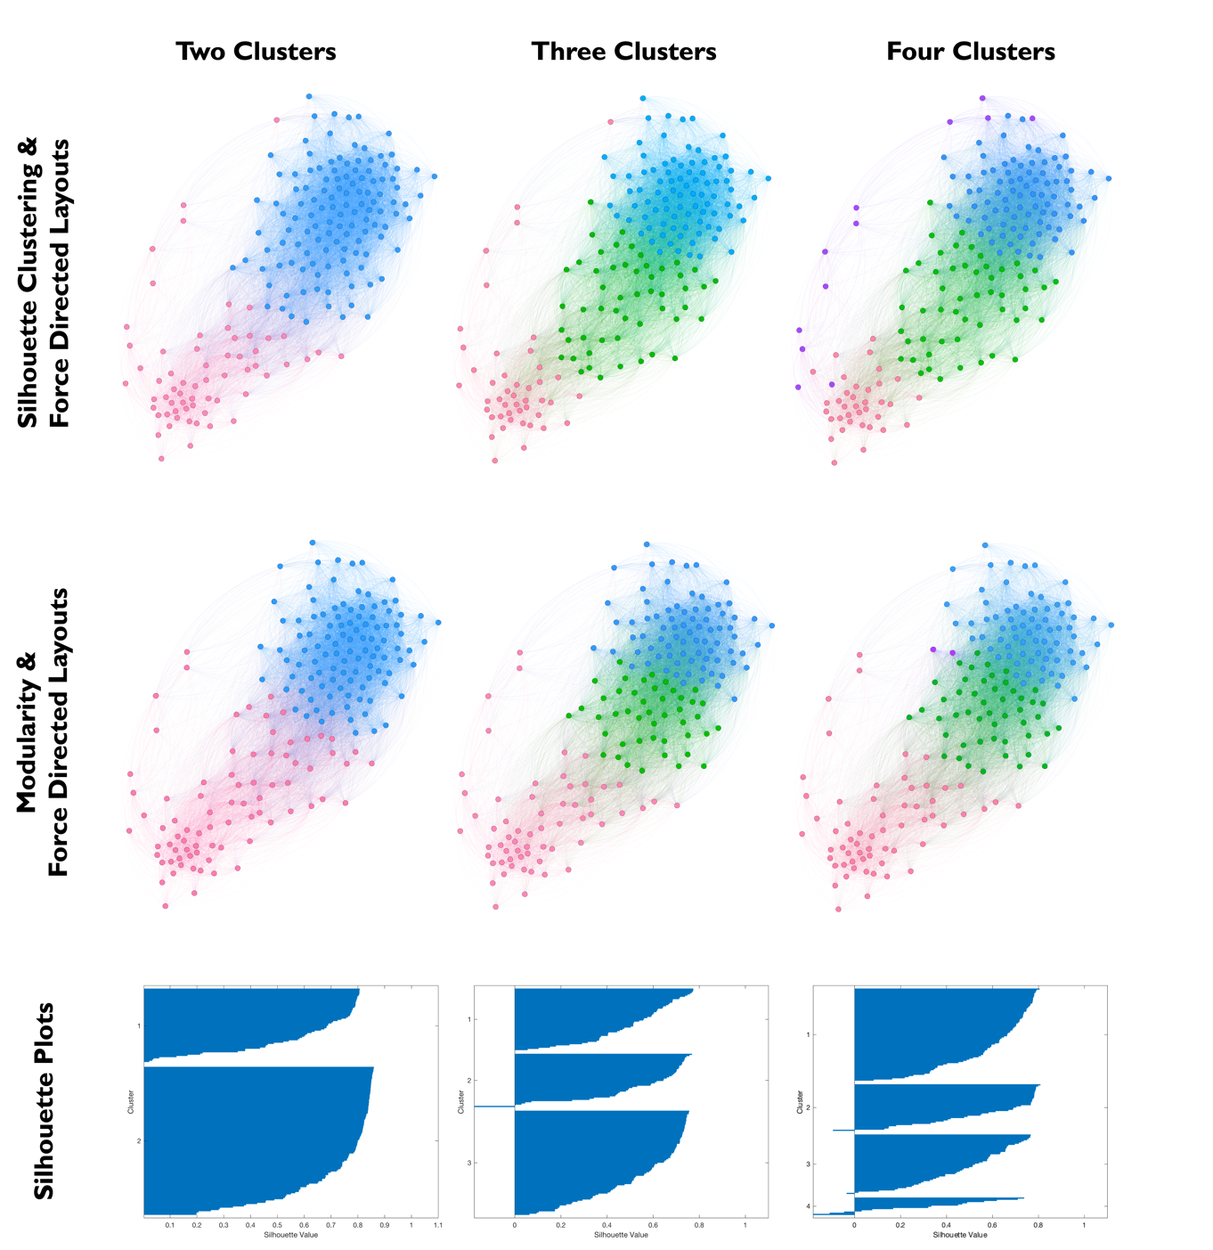

Supplementary Text 2
Additional Control Analyses
To confirm that our results were not driven by a particular choice in data transforms or thresholds, we repeated our analyses with various different methodological variations. The options for transformations on the behavioral data included no transformation, z-score normalization, and ranking. The options for cleaning participant data were to keep the data as-is or to remove all participants who had not completed all items. The options for cleaning behavioral data were to remove no items, to remove items with 1 or less responses and to remove items with less than 4 responses. The options for thresholding the cross-correlation matrix clustering were no threshold and r=0.25 threshold. We also tried thresholding the lesion connectivity maps using a grey matter mask.

The overall results did not differ for any of these options. The optimal number of clusters remained two, with the next best candidates being three and four clusters. Therefore, our results were not due to these methodological variations (Table S2). In the interest of including as much data as possible, in the primary analysis we only removed behavioral items with 1 or less responses, did not remove participants who had not completed all behavioral items, and did not threshold the circuit maps. Due to the need to combine behavioral values across metrics, we applied a rank transform to the behavioral data to put all metrics on the same scale.

Supplementary Table 2
Comparison of Clustering Variations
Number of Clusters | Two | Three | Four | Five | Six | Seven | Eight | Nine | Ten
Primary  S.C.  P-Value | *  .68  .04 | .55  .03 | .55  .002 | .44  .05 | .46  .005 | .40  .07 | .39  .03 | .38  .03 | .35  .12
Raw  S.C.  P-Value | *  .69  .04 | .50  .15 | .52  .02 | .45  .04 | .38  .32 | .38  .16 | .35  .39 | .31  .78 | .36  .11
Z-Score  S.C.  P-Value | *  .69  .04 | .50  .16 | .52  .02 | .45  .05 | .39  .24 | .39  .11 | .36  .25 | .38  .06 | .34  .28
0.25 Threshold  S.C.  P-Value | *  .66  .04 | .53  .04 | .53  .004 | .42  .08 | .38  .12 | .39  .04 | .35  .11 | .34  .11 | .32  .22
NaNs **Removed  S.C.  P-Value | *  .68  .04 | .55  .02 | .54  .002 | .44  .05 | .45  .007 | .40  .05 | .34  .35 | .36  .00 | .36  .06
No Behaviors Removed  S.C.  P-Value | *  .68  .05 | .54  .03 | .54  .004 | .44  .07 | .44  .01 | .39  .08 | .33  .62 | .33  .54 | .38  .016
<4 Behaviors Removed  S.C.  P-Value | *  .69  .05 | .55  .03 | .56  .002 | .44  .06 | .46  .005 | .41  .03 | .38  .06 | .35  .16 | .35  .15
Grey Matter Threshold  S.C.  P-Value | *  .68  .06 | .55  .03 | .53  .01 | .48  .01 | .45  .01 | .41  .04 | .40  .04 | .36  .15 | .38  .03
Note: * indicates optimal number of clusters, S.C. stands for silhouette criterion.

Supplementary Table 3
Cluster 1 – Original Leave-One-Behavior-Out Rankings
ID | Item | Pearson R
166 | Depression Not Otherwise Specified | 0.9419509
158 | Carefree | 0.9230975
161 | Vigorous | 0.9182874
99 | Friendly | 0.9142042
173 | Opiate Abuse | 0.912401
153 | Trusting | 0.8939663
170 | Sedative Hypnotic Anxiolytic Abuse | 0.8764613
41 | PTSD Duration | 0.8727777
128 | Helpful | 0.8599417
4 | Dissatisfaction | 0.8531052
117 | Energetic | 0.8508328
113 | Active | 0.8480908
141 | Good-natured | 0.8467744
174 | Cocaine Abuse | 0.8209655
149 | Alert | 0.8003867
120 | Relaxed | 0.7969984
105 | Lively | 0.7950307
154 | Full of pep | 0.7891976
136 | Cheerful | 0.7787319
104 | Clear-headed | 0.7450743
7 | Self-Dislike | 0.7428719
44 | PTSD Associated Symptoms | 0.7335905
172 | Stimulant Abuse | 0.7280656
185 | Adjustment Disorder | 0.7260062
10 | Crying | 0.7232683
32 | Schizophrenia | 0.7060351
42 | Distress from PTSD | 0.7032273
74 | Dependence | 0.6946137
152 | Efficient | 0.6854499
175 | Hallucinogen/PCP Abuse | 0.6786894
14 | Negative Body Image | 0.6773359
182 | PTSD | 0.6557713
110 | Peeved | 0.6491047
21 | Loss of Libido | 0.6322005
17 | Fatigue | 0.6287722
38 | Re-experiencing Trauma | 0.5927142
ID | Item | Pearson R
1 | Sad | 0.5708794
178 | Agoraphobia | 0.5337208
180 | Specific Phobia | 0.5208255
176 | Polysubstance Abuse | 0.5197208
9 | Suicidal Ideation | 0.5075654
88 | Elation | 0.5051601
39 | Avoidance of Triggers | 0.4783905
179 | Social Phobia | 0.4484542
184 | Bulimia Nervosa | 0.4416547
18 | Appetite Change | 0.4358994
22 | Validity Lie Scale | 0.4226039
111 | Considerate | 0.4007106
29 | Masculinity | 0.3698906
181 | OCD | 0.3142934
123 | Sympathetic | 0.2742306
69 | Lability of Mood | 0.2246201
96 | Personal Code of Conduct | 0.1770062
24 | Validity Defensiveness | 0.1561997
171 | Cannabis Abuse | 0.1288528
35 | Ego Strength | 0.1253012
64 | Motor Retardation | 0.122584
169 | Alcohol Abuse | 0.1007663
72 | Speech Articulation Defect | -0.0047066
28 | Psychopathic Deviate | -0.1304815
165 | Dysthymic Disorder | -0.2325721
167 | Substance Induced Mood Disorder | -0.6393045

Supplementary Table 4
Cluster 2 – Original Leave-One-Behavior-Out Rankings
ID | Item | Pearson R
80 | Guilt | 0.9307277
82 | Anger | 0.9304738
85 | Paranoia | 0.9303286
146 | Helpless | 0.9282977
86 | Sadness | 0.9194334
48 | Disorientation | 0.9190047
36 | Locus of Control | 0.9107512
119 | Hopeless | 0.9085251
155 | Bad-tempered | 0.9072507
129 | Annoyed | 0.9034036
77 | Obsessionalism | 0.9029911
56 | Agitation | 0.8990787
148 | Bewildered | 0.8969227
130 | Discouraged | 0.8934407
47 | Somatic Concern | 0.8929545
52 | Concept Disorganization | 0.8913137
138 | Exhausted | 0.8884442
49 | Anxiety | 0.8806814
12 | Social Withdrawal | 0.8743154
151 | Furious | 0.8664901
61 | Suspiciousness | 0.8618382
51 | Emotional Withdrawal | 0.8618233
46 | Inattention | 0.8616067
19 | Weight Change | 0.8566083
75 | Circumstantiality | 0.8565913
73 | Humorlessness | 0.855846
142 | Gloomy | 0.8522119
124 | Uneasy | 0.8502212
5 | Guilt | 0.8499873
26 | Depression | 0.8475458
53 | Disinhibition | 0.8424437
68 | Poor Planning | 0.8414868
143 | Desperate | 0.8389093
55 | Memory Deficit | 0.8384086
6 | Punishment | 0.8376212
34 | Social Introversion | 0.8345066
ID | Item | Pearson R
60 | Decreased Initiative | 0.8343252
112 | Sad | 0.8313836
133 | Lonely | 0.8285396
15 | Work Difficulty | 0.8275694
139 | Anxious | 0.8268977
71 | Comprehension Deficits | 0.8263836
150 | Deceived | 0.8231574
43 | PTSD Severity | 0.8072608
31 | Psychasthenia | 0.8066038
122 | Spiteful | 0.7971765
132 | Nervous | 0.7847875
121 | Unworthy | 0.7826949
16 | Sleep Issues | 0.7798275
100 | Tense | 0.777001
116 | Blue | 0.7761318
54 | Guilt | 0.7696775
84 | Hypermoralism | 0.7660067
81 | Philosophical Interest | 0.7604921
95 | Foresight | 0.7553051
87 | Hypergraphia | 0.7546858
30 | Paranoia | 0.7540025
140 | Ready to fight | 0.7501525
135 | Muddled | 0.7458996
147 | Weary | 0.7398557
115 | Grouchy | 0.7349946
20 | Somatic Preoccupation | 0.7348135
59 | Hostility | 0.7307246
125 | Restless | 0.7298542
90 | Altered Sexuality | 0.7285181
131 | Resentful | 0.7277994
70 | Tension | 0.7239007
58 | Depressive Mood | 0.7189418
62 | Fatiguability | 0.7179408
118 | Panicky | 0.7152511
157 | Forgetful | 0.7148497
78 | Viscosity | 0.7109199
65 | Unusual Thought Content | 0.710306
40 | Hyperarousal | 0.7093076
ID | Item | Pearson R
168 | Psychotic Symptoms | 0.7067559
23 | Validity Severe | 0.6962044
163 | Bushed | 0.6746122
103 | Unhappy | 0.6745447
156 | Worthless | 0.6686845
50 | Expressive Deficit | 0.66202
159 | Terrified | 0.6480664
89 | Aggression | 0.6438889
144 | Sluggish | 0.641135
76 | Personal Destiny | 0.6377018
108 | Shaky | 0.6327153
83 | Religiosity | 0.6320533
13 | Decision Making | 0.6238307
67 | Excitement | 0.6079223
79 | Emotionality | 0.6064879
106 | Confused | 0.6035381
57 | Inaccurate Self Appraisal | 0.5849295
127 | Fatigued | 0.5758307
114 | On edge | 0.5758058
92 | Joking | 0.5668719
162 | Uncertain | 0.5617657
25 | Hypochondriasis | 0.53602
164 | Major Depression | 0.5328528
137 | Bitter | 0.5282716
107 | Sorry | 0.5223422
98 | General Behavior | 0.5151684
134 | Miserable | 0.5147168
8 | Self-Accusation | 0.5046978
33 | Hypomania | 0.4887751
102 | Worn Out | 0.477005
145 | Rebellious | 0.4758351
3 | Failure | 0.4739938
63 | Hallucinatory Behavior | 0.4661711
160 | Guilty | 0.4486596
11 | Irritability | 0.4432525
126 | Concentration Difficulties | 0.42903
93 | Attitude Towards Problems | 0.428689
94 | Attitude Towards People | 0.4237607
ID | Item | Pearson R
109 | Listless | 0.4234292
101 | Angry | 0.420744
91 | Lie Scale | 0.39812
37 | Alcoholism | 0.3835564
2 | Hopeless | 0.3536878
177 | Panic Disorder | 0.3424616
66 | Blunted Affect | 0.3192579
45 | Amnesia Remote Memory | 0.3093928
97 | Interests | 0.2759744
27 | Hysteria | 0.2097785
183 | Generalized Anxiety | 0.00601733

Supplementary Table 5
Cluster 1 – Cleaned Leave-One-Behavior-Out Rankings
ID | Item | Pearson R
163 | Depression Not Otherwise Specified | 0.93686128
156 | Carefree | 0.92763489
169 | Opiate Abuse | 0.92062944
159 | Vigorous | 0.92039102
97 | Friendly | 0.89909327
151 | Trusting | 0.88318658
40 | PTSD Duration | 0.86855811
126 | Helpful | 0.86090463
4 | Dissatisfaction | 0.85401422
166 | Sedative Hypnotic Anxiolytic Abuse | 0.85085136
139 | Good-natured | 0.84824473
111 | Active | 0.84689844
115 | Energetic | 0.83983648
147 | Alert | 0.82608002
170 | Cocaine Abuse | 0.80371237
118 | Relaxed | 0.80044615
103 | Lively | 0.79479188
152 | Full of pep | 0.77702916
134 | Cheerful | 0.76362342
43 | PTSD Associated Symptoms | 0.75982851
10 | Crying | 0.75739825
7 | Self-Dislike | 0.74800861
102 | Clear-headed | 0.74469638
31 | Schizophrenia | 0.73076952
181 | Adjustment Disorder | 0.72945637
41 | Distress from PTSD | 0.7273863
72 | Dependence | 0.7247988
150 | Efficient | 0.71130598
168 | Stimulant Abuse | 0.69014853
14 | Negative Body Image | 0.6867494
108 | Peeved | 0.68452173
178 | PTSD | 0.67938775
171 | Hallucinogen/PCP Abuse | 0.66053957
21 | Loss of Libido | 0.64810431
17 | Fatigue | 0.64032143
37 | Re-experiencing Trauma | 0.61177742
ID | Items | Pearson R
1 | Sad | 0.60132861
86 | Elation | 0.54928291
174 | Agoraphobia | 0.53752184
38 | Avoidance of Triggers | 0.51271129
176 | Specific Phobia | 0.50914496
9 | Suicidal Ideation | 0.50313741
175 | Social Phobia | 0.48533139
172 | Polysubstance Abuse | 0.4848229
18 | Appetite Change | 0.47541517
180 | Bulimia Nervosa | 0.44359127
22 | Validity Lie Scale | 0.40109444
109 | Considerate | 0.38315398
28 | Masculinity | 0.3796536
177 | OCD | 0.34207052
121 | Sympathetic | 0.2716119
68 | Lability of Mood | 0.23521574
94 | Personal Code of Conduct | 0.18606211
24 | Validity Defensiveness | 0.11200624
167 | Cannabis Abuse | 0.11088349
63 | Motor Retardation | 0.10040719
34 | Ego Strength | 0.08662389
165 | Alcohol Abuse | 0.05115766

Supplementary Figure 2
Final Leave-One-Behavior-Out Clusters
We ran leave-one-behavior-out analyses for all behaviors in a) Cluster 1 and b) Cluster 2. Force-directed graph visualization depicts each individual cluster. For each cluster, the more representative behaviors are primarily central to the cluster (larger circles indicate greater importance/representativity) whereas less representative behaviors remain towards the outskirts. Final individual behaviors and their rankings are listed in Supplementary Table #5 for Cluster 1 and Supplementary Table #4 for Cluster 2.

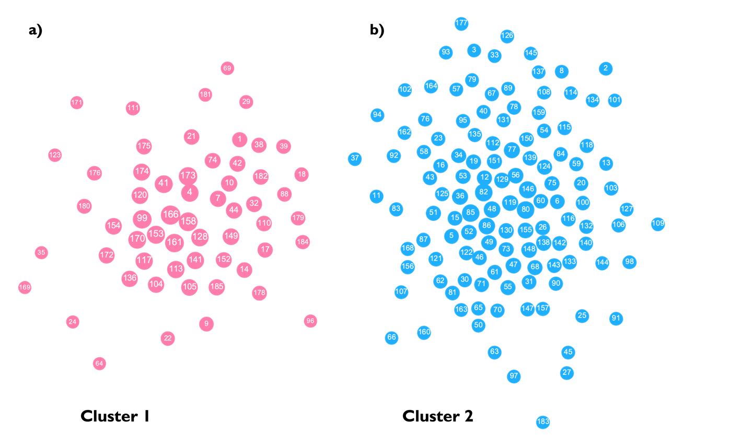

Supplementary Figure 3
Whole-Brain Volume Space Primary Cluster Maps
We derived a mean whole-brain map as seen in Fig. 3. Here we show multiple volume-space slices of our Cluster 1 and Cluster 2 maps respectively. The significant peaks in Cluster 1 were in the ventral tegmental area, substantia nigra, posterior cingulate cortex, and in the tapetum of the corpus callosum.^{9–11} Cluster 2 had a significant peak in the pituitary gland.

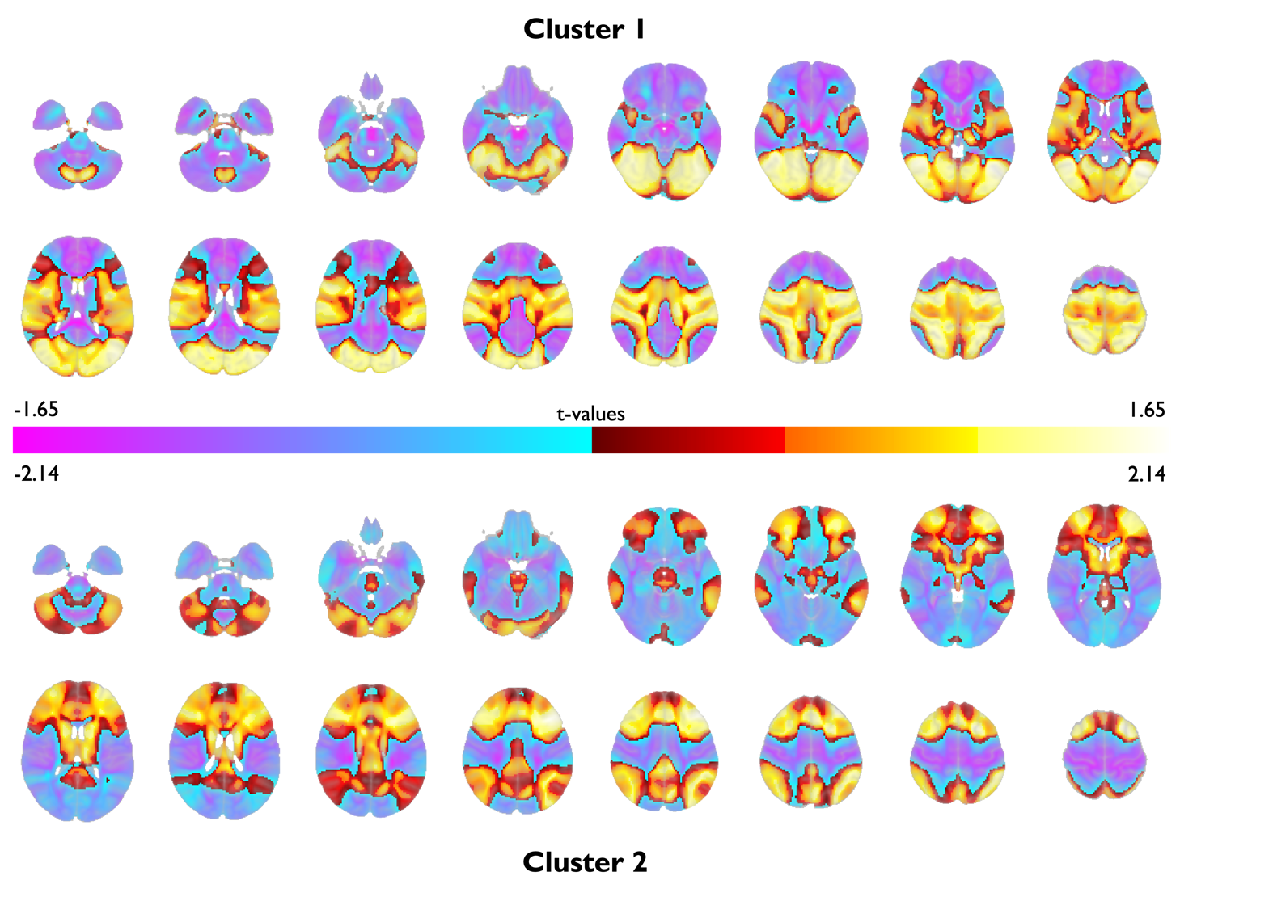

Supplementary Table 6
Spatial Correlations of Cluster Map Variations
 | Nans  Removed | No Behaviors Removed | <4 Behaviors Removed | Gray Matter
Cluster 1  Final Map | .9981 | .9979 | .9969 | .9986
Cluster 2 Final Map | 1 | .9999 | .9999 | .9999

Supplementary Table 7
Clinical Validation Dataset Characteristics
Dataset | Treatment  Type | n | Treatment  Site | Depression Measure | Connectivity  Type | Population | Sex | Mean age (SD)
Dataset 1 | TMS | 30 | “5.5 cm rule” | BDI | Group | MDD | 67% F  33% M | 53 (10)
Dataset 2 | TMS | 24 | Beam F3 | BDI | Group | MDD | 50% F  50% M | 44 (13)
Dataset 3 | TMS | 16 | Task fMRI | MADRS | Group | MDD | 69% F  31% M | 47 (11)
Dataset 4 | TMS | 81 | “5 cm rule” | HAMD | Group | MDD | 57% F  43% M | 47 (11)
Dataset 5 | DBS | 27 | sgACC | HAMD | Group | MDD | 44% F  56% M | 50 (13)
Dataset 6 | DBS | 9 | sgACC | HAMD | Group | MDD | 67% F  33% M | 45 (10)
Dataset 7 | DBS | 8 | VC/VS | MADRS | Group | MDD | 38% F  62% M | 40 (17)
Dataset 8 | DBS | 32 | STN | BDI | Group | Parkinson disease | 31% F  69% M | 61 (10)
Dataset 9 | DBS | 25 | ANT | BDI | Group | Epilepsy | 24% F  76% M | 39 (12)
Dataset 10 | TMS | 302 | Fox | HRSD-17 | Individual | MDD | 59% F  41% M | 43 (12)

Supplementary Table 8
Individual Dataset Clinical Predictions
Dataset | Cluster 1  Predictions  (Pearson’s R) | Cluster 1  p-values | Cluster 2  Predictions  (Pearson’s R) | Cluster 2  p-values
Dataset 1 | .38 | .02 | .13 | .06
Dataset 2 | .42 | .05 | .44 | .005
Dataset 3 | .16 | .29 | .12 | .08
Dataset 4 | .03 | .4 | .06 | .07
Dataset 5 | .007 | .48 | -.05 | .14
Dataset 6 | .86 | .006 | .87 | .001
Dataset 7 | .05 | .46 | .10 | .11
Dataset 8 | .36 | .03 | -.04 | .15
Dataset 9 | .37 | .04 | .19 | .05
Dataset 10 | .13 | .01 | .11 | .008
Subtotal Datasets 1-9 | .24 | .0005 | .15 | .02
Total  All Datasets | .18 | .00008 | .13 | .002

References
1. Beck, A. T., Steer, R. A. & Brown, G. K. Manual for the beck depression inventory-II. San Antonio TX Psychol. Corp. 1, 10.1037 (1996).
2. Hathaway, S. R. & Mckinley, J. C. A Multiphasic Personality Schedule (Minnesota) : I. Construction of the Schedule. J. Psychol. 10, 249–254 (1940).
3. Blake, D. D. et al. The development of a Clinician-Administered PTSD Scale. J. Trauma. Stress 8, 75–90 (1995).
4. Ferguson, M. A. et al. A human memory circuit derived from brain lesions causing amnesia. Nat. Commun. 10, 3497 (2019).
5. Levin, H. S. et al. The neurobehavioural rating scale: assessment of the behavioural sequelae of head injury by the clinician. J. Neurol. Neurosurg. Psychiatry 50, 183–193 (1987).
6. Bear, D. M. & Fedio, P. Quantitative Analysis of Interictal Behavior in Temporal Lobe Epilepsy. Arch. Neurol. 34, 454–467 (1977).
7. McNair, D. M., Droppleman, L. F. & Lorr, M. Profile of Mood States (POMS). (Educational and Industrial Testing Service, 1971).
8. First, M. B. & Gibbon, M. The Structured Clinical Interview for DSM-IV Axis I Disorders (SCID-I) and the Structured Clinical Interview for DSM-IV Axis II Disorders (SCID-II). in Comprehensive handbook of psychological assessment, Vol. 2: Personality assessment 134–143 (John Wiley & Sons, Inc., 2004).
9. Maller, J. J. et al. Revealing the Hippocampal Connectome through Super-Resolution 1150-Direction Diffusion MRI. Sci. Rep. 9, 2418 (2019).
10. Pauli, W. M., Nili, A. N. & Tyszka, J. M. A high-resolution probabilistic in vivo atlas of human subcortical brain nuclei. Sci. Data 5, 180063 (2018).
11. Schaefer, A. et al. Local-Global Parcellation of the Human Cerebral Cortex from Intrinsic Functional Connectivity MRI. Cereb. Cortex 28, 3095–3114 (2018).

