Additional file 1
Table e1. Risk of Alzheimer’s disease associated with metformin use based on the duration of diabetes mellitus

 | <5 years |  |  |  |  | 5-9 years |  |  |  |  |  | ≥10 years
 | Case | Controls |  | AOR (95%Cl) |  | Case |  | Controls |  | AOR (95%Cl) |  | Case | Controls |  | AOR (95%Cl)
 | n (%) | n (%) |  |  |  | n (%) |  | n (%) |  |  |  | n (%) | n (%)
Metformin use
Never user | 32 (16.5) |  | 164 (17.5) |  | 1 |  | 78 (8.6) |  | 558 (12.5) |  | 1 | 24 (4.2) |  | 255 (9.0) |  | 1
Ever user | 162 (83.5) |  | 775 (82.5) |  | 0.88 (0.54-1.43) |  | 828 (91.4) |  | 3897 (87.5) |  | 1.48 (1.14-1.91) | 551 (95.8) |  | 2582 (91.0) |  | 2.18 (1.41-3.39)
Metformin (cDDD)
Never user | 32 (16.5) |  | 164 (17.5) |  | 1 |  | 78 (8.6) |  | 558 (12.5) |  | 1 | 24 (4.2) |  | 255 (9.0) |  | 1
Ever user
Q1 | 42 (21.7) |  | 196 (20.9) |  | 0.82 (0.46-1.46) |  | 224 (24.7) |  | 958 (21.5) |  | 1.66 (1.24-2.21) | 147 (25.6) |  | 637 (22.5) |  | 2.40 (1.51-3.82)
Q2 | 41 (21.1) |  | 190 (20.2) |  | 1.01 (0.57-1.80) |  | 200 (22.1) |  | 981 (22.0) |  | 1.43 (1.06-1.92) | 138 (24.0) |  | 645 (22.7) |  | 2.11 (1.32-3.37)
Q3 | 45 (23.2) |  | 189 (20.1) |  | 1.04 (0.51-1.85) |  | 216 (23.8) |  | 966 (21.7) |  | 1.49 (1.11-2.00) | 139 (24.2) |  | 644 (22.7) |  | 2.17 (1.36-3.49)
Q4 | 34 (17.5) |  | 200 (21.3) |  | 0.67 (0.36-1.24) |  | 188 (20.8) |  | 992 (22.3) |  | 1.27 (0.94-1.72) | 127 (22.1) |  | 656 (23.1) |  | 1.98 (1.23-3.19)
Metformin (cDDD per day)
Never user | 32 (16.5) |  | 164 (17.5) |  | 1 |  | 78 (8.6) |  | 558 (12.5) |  | 1 | 24 (4.2) |  | 255 (9.0) |  | 1
Ever user
Q1 | 48 (24.7) |  | 288 (30.7) |  | 0.79 (0.46-1.39) |  | 239 (26.4) |  | 1404 (31.5) |  | 1.30 (0.98-1.73) | 158 (27.5) |  | 790 (27.9) |  | 2.15 (1.35-3.41)
Q2 | 26 (13.4) |  | 107 (11.4) |  | 0.99 (0.52-1.87) |  | 140 (15.5) |  | 580 (13.0) |  | 1.59 (1.16-2.18) | 105 (18.3) |  | 512 (18.1) |  | 2.05 (1.27-3.32)
Q3 | 45 (23.2) |  | 188 (20.0) |  | 0.93 (0.51-1.67) |  | 209 (23.1) |  | 972 (21.8) |  | 1.44 (1.07-1.93) | 143 (24.9) |  | 642 (22.6) |  | 2.24 (1.40-3.58)
Q4 | 43 (22.2) |  | 192 (20.5) |  | 0.89 (0.50-1.59) |  | 240 (26.5) |  | 941 (21.1) |  | 1.70 (1.27-2.28) | 145 (25.2) |  | 638 (22.5) |  | 2.30 (1.43-3.68)

cDDDs cumulative defined daily doses; AOR, adjusted odds ratio; CI, confidence interval
* Analysis was adjusted for the following covariates: hypertension, ischemic heart disease, dyslipidemia, Charlson comorbidity index, Diabetes complications severity index, depression, statin use, aspirin use, antiplatelet use, anticoagulant use, antihypertensive drug use, antiarrhythmic drug use, use of antidiabetic medications, fasting blood glucose levels, systolic blood pressure, diastolic blood pressure, total cholesterol levels, creatinine levels, body mass index, smoking status, alcohol consumption, and physical activity.
‘
Table e2. Comparison of the risk of Alzheimer’s disease associated with metformin use between patients with and without depression

 | Without depression |  |  |  | With depression
 | Cases  (n = 1,213 ) | Controls  (n = 5,085 ) | AOR (95% Cl) |  | Cases  (n = 278 ) | Controls  (n = 415 ) | AOR (95% Cl)
 | n (%) | n (%) |  |  | n (%) | n (%)
Metformin use
Never user | 100 (8.2) | 645 (12.7) | 1 |  | 18 (6.5) | 39 (9.4) | 1
Users | 1113 (91.8) | 4440 (87.3) | 1.57 (1.24-1.98) |  | 260 (93.5) | 376 (90.6) | 2.05 (1.02-4.12)
Metformin (cDDD)
Never user | 100 (8.2) | 645 (12.7) |  | Never user | 18 (6.5) | 39 (9.4)
Ever user |  |  |  | Ever user
Q1 (<180cDDDs) | 294 (24.2) | 1099 (21.6) | 1.68 (1.31-2.17) | Q1 (<176.3 cDDDs) | 71 (25.5) | 88 (21.2) | 2.70 (1.24-5.89)
Q2 (180-495 cDDDs) | 265 (21.9) | 1119(22.0) | 1.54 (1.19-2.00) | Q2 (176.3-502.7 cDDDs) | 61 (21.9) | 98 (23.6) | 1.92 (0.87-4.24)
Q3 (495-1037.5 cDDDs) | 277 (22.8) | 1111 (21.9) | 1.50 (1.16-1.95) | Q3 (502.7-974.8 cDDDs) | 74 (26.6) | 85 (20.5) | 2.55 (1.17-5.55)
Q4 (≥1037.5 cDDDs) | 277 (22.8) | 1111 (21.9) | 1.50 (1.15-1.95) | Q4 (≥974.8 cDDDs) | 54 (19.4) | 105 (25.3) | 1.38 (0.80-3.01)
Metformin (cDDD per day)
Never user | 100 (8.2) | 645 (12.7) |  |  | 18 (6.5) | 39 (9.4)
Ever user
Q1 (< 0.25 cDDDs/day) | 311 (25.6) | 1500 (29.5) | 1.41 (1.10-1.82) | Q1 (< 0.25 cDDDs/day) | 83 (29.9) | 150 (36.1) | 2.02 (0.95-4.28)
Q2 (0.25-0.32 cDDDs/day) | 199 (16.4) | 767 (15.1) | 1.56 (1.19-2.06) | Q2 (0.25-0.30 cDDDs/day) | 36 (13.0) | 49 (11.8) | 2.05 (0.87-4.84)
Q3 (0.32-0.47cDDDs/day) | 296 (24.4) | 1091 (21.5) | 1.65 (1.27-2.13) | Q3 (0.30-.44 cDDDs/day) | 77 (27.7) | 82 (19.8) | 2.88 (1.31-6.32)
Q4 (≥0.47 cDDDs/day) | 307 (25.3) | 1082 (21.3) | 1.71 (1.32-2.22) | Q4 (≥0.44cDDDs/day) | 64 (23.0) | 95 (22.9) | 1.71 (0.80-3.65)

cDDDs cumulative defined daily doses; AOR, adjusted odds ratio; CI, confidence interval
* Analysis was adjusted for the following covariates: hypertension, ischemic heart disease, dyslipidemia, Charlson comorbidity index, Diabetes complications severity index, depression, statin use, aspirin use, antiplatelet use, anticoagulant use, antihypertensive drug use, antiarrhythmic drug use, use of antidiabetic medications, fasting blood glucose levels, systolic blood pressure, diastolic blood pressure, total cholesterol levels, creatinine levels, body mass index, smoking status, alcohol consumption, and physical activity.

Table e3. Characteristics of the study population stratified according to metformin use

Variables | Never user  (n = 1131) | Ever user  (n = 8920) | SMD
Variables | n (%) | n (%) | SMD
Age |  |  | 0.110
< 75 years | 671 (59.4) | 5773 (59.4)
≥ 75 years | 459 (40.6) | 3147 (35.3)
Women | 617 (54.6) | 5047 (56.6) | 0.040
Diabetes duration |  |  | 0.275
<5 years | 200 (17.7) | 963 (10.8)
5-10 years | 649 (57.4) | 4781 (53.6)
≥10 years | 281 (24.9) | 3176 (35.6)
BMI |  |  | 0.104
< 18.5 kg/m² | 9 (0.8) | 113 (1.3)
18.5-22.9 kg/m² | 277 (24.5) | 1921 (21.5)
23-25 kg/m² | 256 (22.7) | 2322 (26.0)
≥ 25 kg/m² | 588 (52.0) | 4564 (51.2)
Fasting blood glucose (mg/dL) † | 127.21 ± 40.99 | 134.81 ± 50.95 | 0.165
BP (mmHg) †
Systolic | 136.42 ± 18.06 | 134.07 ± 17.37 | 0.132
Diastolic | 81.11 ±10.98 | 80.76 ± 10.73 | 0.032
Total cholesterol (mg/dL) † | 204.06 ± 41.61 | 204.48 ± 41.66 | 0.010
Creatinine (mg/dL) † | 1.04 ± 0.91 | 0.99 ± 0.85 | 0.052
Hypertension | 988 (87.4) | 7,704 (86.4) | 0.032
Ischemic heart disease | 324 (28.7) | 2,685 (30.1) | 0.031
Dyslipidemia | 615 (54.4) | 5,878 (65.9) | 0.236
CCI |  |  | 0.126
0 | 448 (39.6) | 3017 (33.8)
1 | 251 (22.2) | 2047 (22.9)
2 | 431 (38.1) | 3856 (43.2)
aDCSI |  |  | 0.008
0 | 993 (87.9) | 7817 ( 87.6)
1 | 96 (8.5) | 779 (8.7)
2 | 41 (3.6) | 324 (3.6)
Depression | 176 (15.6) | 1681 (18.8) | 0.087
Medication
Statin | 628 (55.6) | 6100 (68.4) | 0.266
Aspirin | 685 (60.6) | 5867 (65.8) | 0.107
Antiplatelet | 213 (18.8) | 1797 (20.1) | 0.033
Anticoagulant | 45 (4.0) | 297 (3.3) | 0.035
Antihypertensive agents | 929 (82.2) | 7124 (79.9) | 0.060
Antiarrhythmic agents | 117 (10.4) | 1101 (12.3) | 0.063
Smoking |  |  | 0.031
None | 859 (76.0) | 6694 (75.0)
Past | 117 (10.4) | 913 (10.2)
Current | 154 (13.6) | 1313 (14.7)
Alcohol use |  |  | 0.032
Low | 917 (81.2) | 7159 (80.3)
Moderate | 148 (13.1) | 1265 (14.2)
Heavy | 65 (5.8) | 496 (5.6)
Physical activity |  |  | 0.028
Yes (≥1 time per week) | 784 (69.4) | 6075 (68.1)

CCI, Charlson Comorbidity Index; aDCSI, adapted Diabetes Complication Severity Index; DPP-IV, dipeptidyl peptidase IV; SGLT-2, Sodium glucose cotransporter 2; SMD, Standardized mean difference.
†Mean and standard deviation (SD) of the continuous independent variables in this study.
Figure e1. Odds ratios for Alzheimer’s disease in different subgroups in overall population

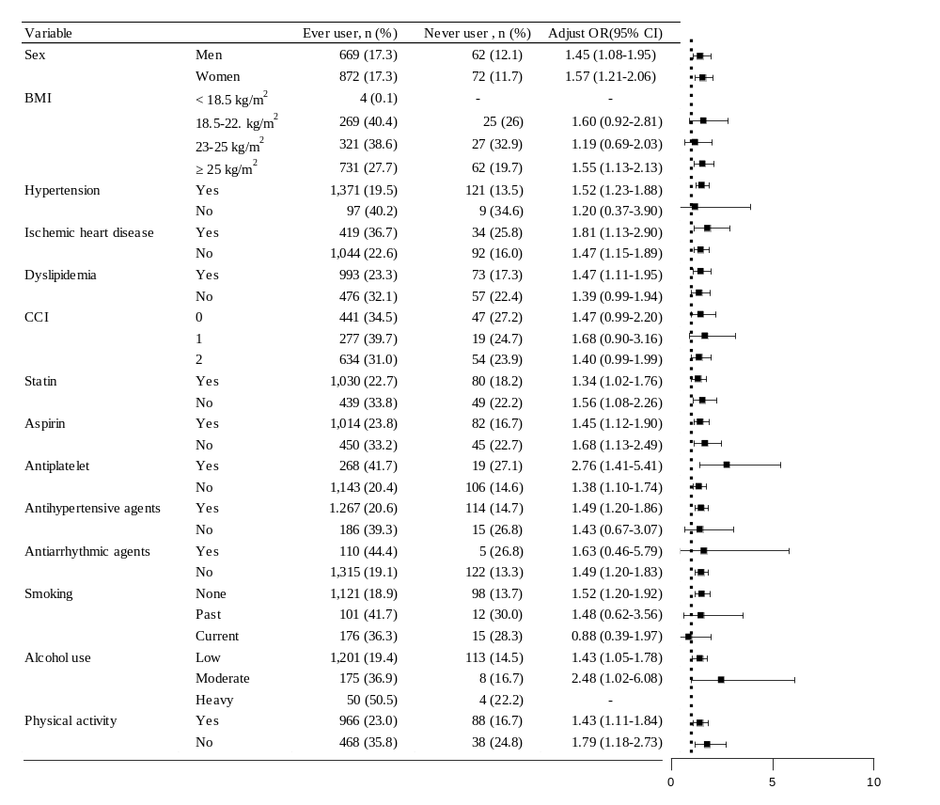
Adjusted odds ratios with 95% confidence intervals for multivariable models evaluating associations between metformin use and incident Alzheimer’s disease according to subgroup. Boxes indicate the odds ratio, limit lines indicate the 95% confidence interval, and the horizontal indicates odds ratio. Metformin never user as reference.

