Content Table
1. General Information 2
1.1 Materials, Reagents, and Protein Targets 2
2. Substrate Synthesis 2
2.1 The automated synthesis of INT-7 4
2.2 The semi-automated synthesis of sub-libraries 9
2.3. The automated parallel resynthesis of 51 compounds 108
3. General Procedure for ASMS experiment 127
3.1 Affinity Selection Mass Spectrometry (ASMS) instrumentation and Methods 127
3.2 General Affinity Competition Experiment Procedure 128
3.3 Calculation methods of efficiency and normalization 129
3.4 The original scatter plot based on the origin efficiency value 132
4. Spectra 133
5. Invitrogen IC₅₀ Titration Curves 166

1. General Information

1.1 Materials, Reagents, and Protein Targets
All reagents used in this manuscript were purchased from commercial suppliers, including Bidepharm, Energy-chemical. Pharmablock, Leyan. Reagents and intermediates that were not commercially available were prepared as described below. Products were purified (when necessary) using Phenomenex Gemini 150 mm*25 mm*25 mm*10μ (mobile phase: CH3CN & H2O with 0.5% NH4HCO3).
The target mass of reaction products was monitored by Agilent 1260II+6125B or 2030plus+2020. 1H Nuclear Magnetic Resonance (1H-NMR) spectra were recorded in d6-DMSO Bruker BioSpin GmbH 400MHz. NMR data are represented as follows: chemical shift, multiplicity (s = singlet, br s = broad singlet, d = doublet, dd = doublet of doublet, t = triplet, q = quartet, m = multiplet, etc.), coupling constant, and integration. Coupling constants (J) are given in Hertz (Hz). HRMS was performed on a Waters Vion IMS QTof.
PTPN2 Protein (Human, Recombinant) was purchased from Sino Biological (10570-HNCB).

2. Substrate Synthesis
As depicted in Scheme S1, each target compound was synthesized in a ten-step route, commencing from starting material 1. The synthetic tasks included the scale-up of crucial intermediate 7, the preparation of mixture sub-libraries, and the parallel resynthesis of selected PTPN2-binders. All tasks were carried out within the automation system, which combines human ingenuity with machine precision to facilitate highly automated and efficient experimental procedures.
Firstly, the pivotal intermediate 7 was synthesized on a gram-scale using the 40mL-automated workstations through a six-step route. The ample supply of this intermediate facilitated the subsequent preparation of mixture sub-libraries in different series, as well as the subsquent parallel resynthesis of selected PTPN2 binders for bioassay.
During the period of synthesizing mixture sub-libraries, intermediates 10 from different series were obtained after Buchwald cross-coupling, deprotection of t-Butyloxy carbonyl group, and deprotection of benzyl group reactions. In these reactions, the last hydrogenation reduction reaction requires manual operation, because of the use of flammable Pd/C and the mismatch between the hydrogenation device and the automated workstation at the present. Finally, the amide-coupling yield of each target compound under the common reaction condition, was obtained automatedly using the workstations. In each series, 9 to 28 reactions (average ~19) with different target molecular weights and acceptable yields (>25% yield on LCMS, as man-made setting in this project) were combined. Following removal of DMF through reverse-phase prepared chromatography and lyophilization, the resulting residue was the mixture sub-library for further screened by ASMS.
The parallel resynthesis of PTPN2-binders, which were selected after ASMS screening, was successfully achieved thanks to the automated synthesis attempts and known yields in the earlier stage.
Before all the automated synthesis started, all necessary materials, including reactants, reagents, solvents, pipette tips and other consumables would be assigned a unique QR code. The codes were manually scanned to input the information into the system after the materials were transferred to the in-rack. The AGV would then transfer them to the reaction setup-station.
Scheme S1. General procedure of mixture libraries synthesis

2.1 The automated synthesis of INT-7
Scheme S2. Scale-up automated synthesis of INT-7：
Step 1: Preparation of 1-(benzyloxy)-4-bromo-3-fluoro-2-nitrobenzene
In the reaction setup-station, compound 3 (1.20 g, 5.08 mmol), potassium carbonate (1.41 g, 10.17 mmol), DMF (15 mL) and benzyl bromide (0.73 mL, 6.1 mmol) were added to the 40 mL reaction tube automatically. After capped the reaction tube with screw cap capper, the tube was transferred to the reaction executive-station and stirred at room temperature for 12 h in the temperature-controlled electromagnetic stirrer.
After stirring, a qualified sample was prepared through the automatic sample preparation system and sent to UPLC for monitoring. It showed the total consumption of the start material compound 3 and the product formed. The tube was transferred to reaction work-up station and the mixture was blown to dryness with nitrogen at 40ºC and the residue was dissolved in PE (10 mL). The resulting solution was transferred to the SPE column (silica) and then eluted for 6 rounds automatically. (1: PE = 25 mL; 2: PE/DCM = 35 ml/10 mL; 3: PE/DCM = 30 mL/15 mL; 4: PE/DCM = 30 mL/15 mL; 5: DCM = 40 mL; 6: DCM/MeOH = 23 mL/22 mL). The eluent was collected separately in the 6 tubes placed in a tube rack below. After confirmed by the TLC board, the second and third tubes were picked and combined for rotary evaporation concentration manually to give compound 4 (1.55 g, 4.75 mmol, 93.47%) as yellow solid.
MS m/z（ESI）= 326.0, 328.0 [M+H]⁺.

Step 2: Preparation of 6-(benzyloxy)-3-bromo-2-fluoroaniline
In the reaction setup-station, compound 4 (0.50 g, 1.53 mmol), ammonium chloride (0.33 g, 6.13 mmol), Fe powder (0.34 g,6.13 mmol), ethanol (12 mL) and H₂O (4 mL) were added to the 40 mL reaction tube automatically. After capped the reaction tube with screw cap capper, the tube was transferred to the reaction executive-station and stirred at 100ºC for 2 h in the temperature-controlled electromagnetic stirrer.
After stirring, a qualified sample was prepared through the automatic sample preparation system and sent to UPLC for monitoring. It showed the total consumption of the start material compound 4 and the product formed. The tube was transferred to reaction work-up station and the mixture was transferred to the SPE column (diatomite) and then eluted for 3 rounds automatically. (1: MeOH = 12 mL; 2: MeOH = 30 ml; 3: MeOH = 30 mL). The eluent was collected separately in the 3 tubes placed in a tube rack below. The eluent was combined for rotary evaporation concentration manually to give compound 5 (1.2 g, 4.05 mmol, 81%) as brown solid.
MS m/z（ESI）= 296.0, 298.1 [M+H]⁺.

Step 3: Preparation of methyl (6-(benzyloxy)-3-bromo-2-fluorophenyl)glycinate

In the reaction setup-station, compound 5 (0.75 g, 2.53 mmol), potassium carbonate (1.05 g, 7.59 mmol), DMF (15 mL) and methyl bromoacetate (1.16 g, 7.59 mmol) were added to the 40 mL reaction tube automatically. After capped the reaction tube with screw cap capper, the tube was transferred to the reaction executive-station and stirred at 65ºC for 12 h in the temperature-controlled electromagnetic stirrer.
After stirring, a qualified sample was prepared through the automatic sample preparation system and sent to UPLC for monitoring. It showed that most of the start material compound 5 had converted to the product. The tube was transferred to reaction work-up station and the mixture was blown to dryness with nitrogen at 40ºC. The residue was dissolved in PE (15 mL) and the solution was transferred to the SPE column (silica) and then eluted for 6 rounds automatically. (1: PE = 15 mL; 2: PE/DCM = 40 ml/2 mL; 3: PE/DCM = 40 mL/4 mL; 4: PE/DCM = 35 mL/10 mL; 5: PE/DCM = 22 mL/20 mL; 6: DCM = 45 mL). The eluent was collected separately in the 6 tubes placed in a tube rack below. After confirmed by the TLC board, the third, fourth and fifth tubes were picked and combined for rotary evaporation concentration manually to give compound 6 (470 mg, 1.27 mmol, 49.95%) as colorless oil.
MS m/z（ESI）= 368.1, 370.1 [M+H]⁺.

Step 4: Preparation of methyl N-(6-(benzyloxy)-3-bromo-2-fluorophenyl)-N-(N-(tert-butoxycarbonyl) sulfamoyl) glycinate
In the reaction setup-station, tert-butanol (0.46 mL, 4.89 mmol) was added to a solution of chlorosulfonyl isocyanate (0.75 g, 2.53 mmol) in DCM (21 mL) at 2ºC with stirring on. The mixture was stirred at 2ºC for 1 h and a solution of compound 6 (900 mg, 2.44 mmol) in DCM (2 mL), TEA (742.02 mg, 7.33 mmol) were added automatically. The mixture was blown with nitrogen for 1 min and the reaction tube was capped with screw cap capper. The tube was then transferred to the reaction executive-station and stirred at room temperature for 5 h in the temperature-controlled electromagnetic stirrer.
After stirring, a qualified sample was prepared through the automatic sample preparation system and sent to UPLC for monitoring. It showed the total consumption of the start material compound 6 and the product formed. The tube was transferred to reaction work-up station and the mixture was blown to dryness with nitrogen at 40ºC and the residue was dissolved in PE (10 mL). The resulting solution was transferred to the SPE column (silica) and then eluted for 6 rounds automatically. (1: PE/DCM = 20 mL/10 mL; 2: PE/DCM = 33 ml/12 mL; 3: PE/DCM = 33 mL/12 mL; 4: DCM = 45 mL/10 mL; 5: DCM = 45 mL; 6: DCM = 45 mL). The eluent was collected separately in the 6 tubes placed in a tube rack below. After confirmed by the TLC board, the third, fourth and fifth tubes were picked and combined for rotary evaporation concentration manually to give compound 7 (1.05 g, 1.9 mmol, 78.48%) as white solid.
MS m/z（ESI）= 569.2, 571.2 [M+Na]⁺.

Step 5: Preparation of methyl N-(6-(benzyloxy)-3-bromo-2-fluorophenyl)-N-sulfamoylglycinate
In the reaction setup-station, compound 7 (2 g, 3.66 mmol), DCM (20 mL) and TFA (2 mL) were added automatically. After capped the reaction tube with screw cap capper, the tube was transferred to the reaction executive-station and stirred at room temperature for 0.5 h in the temperature-controlled electromagnetic stirrer.
After stirring, a qualified sample was prepared through the automatic sample preparation system and sent to UPLC for monitoring. It showed the total consumption of the start material compound 7 and the product formed. The tube was transferred to out-rack for rotary evaporation concentration manually to give compound 8 (1.4 g, 3.13 mmol, 85.47%) as brown solid.
MS m/z（ESI）= 447.1, 449.1 [M+H]⁺.

Step 6: Preparation of 5-(6-(benzyloxy)-3-bromo-2-fluorophenyl)-1,2,5-thiadiazolidin-3-one 1,1-dioxide
In the reaction setup-station, t-BuOk (1.12 mL, 1M in THF) was added to a solution of compound 8 (500 mg, 1.12 mmol) in THF (6 mL) automatically. The mixture was blown with nitrogen for 1 min and the reaction tube was capped with screw cap capper. The tube was then transferred to the reaction executive-station and stirred at room temperature for 2 h in the temperature-controlled electromagnetic stirrer.
After stirring, a qualified sample was prepared through the automatic sample preparation system and sent to UPLC for monitoring. It showed the total consumption of the start material compound 8 and the product formed. The tube was transferred to reaction work-up station and the mixture was blown to dryness with nitrogen at 40ºC and the residue was dissolved in DCM (10 mL). The resulting solution was transferred to the SPE column (silica) and then eluted for 6 rounds automatically. (1: DCM = 27 mL; 2: DCM/MeOH = 44 ml/1 mL; 3: DCM/MeOH = 40 ml/5 mL; 4: DCM/MeOH = 36 mL/9 mL; 5: DCM/MeOH = 36 mL/9 mL; 6: DCM/MeOH = 30 mL/15 mL). The eluent was collected separately in the 6 tubes placed in a tube rack below. After confirmed by the TLC board, the second, third, fourth and fifth tubes were picked and combined for rotary evaporation concentration manually to give compound Int1 (270 mg, 0.65 mmol, 55.26%) as yellow solid.
MS m/z（ESI）= 415.0, 417.0 [M+H]⁺.

2.2 The semi-automated synthesis of sub-libraries
Step 7: General Procedure for the Synthesis of INT-8 in Various Series
In the reaction setup-station, Int 7 (1 eq.), BrettPhos Pd G3 (0.08 eq.), BrettPhos (0.2 eq.), Cs₂CO₃ (3 eq.) and t-BuOH (7 mL/mmol INT-7) were added automatically. It was blown with nitrogen for 2 min and heated to 105ºC with stirring on. The solution of linker-Boc (1.5 eq.) in t-BuOH (3 mL/mmol INT-7) was then added. After capped the reaction tube with screw cap capper, the tube was transferred to the reaction executive-station and stirred at 105ºC for 16 h in the temperature-controlled electromagnetic stirrer.
After stirring, a qualified sample was prepared through the automatic sample preparation system and sent to UPLC for monitoring. It showed the total consumption of the start material Int 1 and the product formed. The tube was transferred to reaction work-up station and the mixture was blown to dryness with nitrogen at 40ºC and the residue was dissolved in DCM (50 mL/mmol INT-7). The resulting solution was transferred to the SPE column (silica) and then eluted for 6 rounds automatically. (1: DCM = 27 mL; 2: DCM/MeOH = 44 ml/1 mL; 3: DCM/MeOH = 43 ml/2 mL; 4: DCM/MeOH = 43 mL/2 mL; 5: DCM/MeOH = 42 mL/3 mL; 6: DCM/MeOH = 40 mL/5 mL). The eluent was collected separately in the 6 tubes placed in a tube rack below. After confirmed by the TLC board, the fourth and fifth tubes were picked and combined for rotary evaporation concentration manually to give compound INT-8.

INT-8A: yellow solid (54.60%). MS m/z（ESI）= 505.2 [M-H]⁺.

INT-8B: yellow solid (87.00%), MS m/z（ESI）= 519.2 [M-H]⁻.

INT-8C: yellow solid (89.40%), MS m/z（ESI）= 545.0 [M-H]⁻.

INT-8D: yellow solid (60.60%), MS m/z（ESI）= 545.2 [M-H]⁻.

INT-8E: yellow solid (82.17%), MS m/z（ESI）= 545.2 [M-H]⁻.

INT-8F: yellow solid (62.02%), MS m/z（ESI）= 545.2 [M-H]⁻.

Step 8: General Procedure for the Synthesis of INT-9 in Various Series
To a solution of INT-8 (1 eq.) in MeOH (10 mL/mmol INT-8) was added 10% Pd/C (10% W/W), the reaction was stirred at 25℃ for 18 hrs. After that, LCMS showed starting material was consumed and desired product was formed. The mixture was filtered and concentrated to dryness under reduced pressure to give INT-9.

INT-9A: yellow solid (89.3%), MS m/z（ESI）= 417.1 [M+H]⁺.

INT-9B: green solid (89.8%), MS m/z（ESI）= 429.1[M-H]⁻.

INT-9C: yellow solid (83.8%), MS m/z（ESI）= 455.1 [M-H]⁻.

INT-9D: yellow solid (82.84%), MS m/z（ESI）= 455.1 [M-H]⁻.

INT-9E: yellow solid (65.79%), MS m/z（ESI）= 401.0[M+H-56]⁺.

INT-9F: green solid (82.3%), MS m/z（ESI）= 457.0 [M+H]⁺.

Step 9: General Procedure for the Synthesis of INT-10 in Various Series
In the reaction setup-station, INT-9 (1 eq.), DCM (6 mL/mmol INT-7) and TFA (0.6 mL/mmol INT-9) were added automatically. After capped the reaction tube with screw cap capper, the tube was transferred to the reaction executive-station and stirred at room temperature for 0.5 h in the temperature-controlled electromagnetic stirrer.
After stirring, a qualified sample was prepared through the automatic sample preparation system and sent to UPLC for monitoring. It showed the total consumption of the start material compound 7 and the product formed. The tube was transferred to out-rack for rotary evaporation concentration manually to give crude product. The crude produce was purified by prep-HPLC (Phenomenex Gemini 150 mm * 25 mm * 10 μm column (eluent: 12% to 100% (v/v) CH3CN and H2O with 0.05% NH4HCO3) to afford INT-10.
INT-10A: brown solid (30.4%), MS m/z（ESI）=317.0 [M+H]⁺.

INT-10B: brown solid (58.7%), MS m/z（ESI）= 331.0 [M+H]⁺.

INT-10C: brown solid (61.30%), MS m/z（ESI）= 355.1 [M-H]⁻.

INT-10D: brown solid (65.21%), MS m/z（ESI）= 357.1 [M+H]⁺.

INT-10E: brown solid (65.97%), MS m/z（ESI）= 357.1 [M+H]⁺.

INT-10F: brown solid (30.3%), MS m/z（ESI）=357.0 [M+H]⁺.

Step 10: General Procedure for the Synthesis of target compounds in Various Series
In the reaction setup-station, carboxylic acid (1.1 eq), HATU (1.1 eq), DIPEA (3.0 eq) and DMF (2 mL/mmol INT-10) were added automatically. It was stirred at room temperature for 30 min and a solution of INT-10 (1.0 eq) in DMF (1 mL/mmol INT-10) was added. After capped the reaction tube with screw cap capper, the tube was transferred to the reaction executive-station and stirred at room temperature for 30 min in the temperature-controlled electromagnetic stirrer.
After stirring, a qualified sample was prepared through the automatic sample preparation system and sent to UPLC for monitoring. It showed the total consumption of the start material INT-10 and the product formed. The selected reaction solutions (See Table S1) were pooled together, removed DMF by prep-HPLC. The mixture libraries were obtained after lyophilization.
The structures of 116 Carboxylic Acids:
The 116 in-house acids shown below, were used as the building blocks to generate the amide with amine group of linkers. The number of each building block corresponded to the code of target compound (see below).
Table S1. The mixture sub-libraries grouping of compounds.
 | A Series
No. | Structures | Compound content
 | XTN-A1-L1 (Brown solid)
XTN-A1-022 |  | ~0.47%
XTN-A1-057 |  | ~0.76%
XTN-A1-063 |  | ~0.47%
XTN-A1-084 |  | ~0.28%
 | XTN-A1-L2 (Brown solid)
XTN-A1-049 |  | ~5.45%
XTN-A1-050 |  | ~5.45%
XTN-A1-065 |  | ~3.64%
XTN-A1-067 |  | ~1.82%
 | XTN-A1-L3 (Brown solid)
XTN-A1-079 |  | ~2.73%
XTN-A1-081 |  | ~1.82%
XTN-A1-083 |  | ~1.82%
XTN-A1-086 |  | ~1.82%
XTN-A1-113 |  | ~1.82%
 | XTN-A1-L4 (Brown solid)
XTN-A1-061 |  | ~1.9%
XTN-A1-062 |  | ~1.3%
XTN-A1-078 |  | ~1.3%
XTN-A1-080 |  | ~1.3%
XTN-A1-082 |  | ~2.3%
XTN-A1-085 |  | ~1.9%
 | XTN-A1-L5 (Brown solid)
XTN-A1-089 |  | ~3.16%
XTN-A1-091 |  | ~1.05%
XTN-A1-092 |  | ~3.16%
XTN-A1-093 |  | ~1.05%
XTN-A1-107 |  | ~1.58%
 | XTN-A1-L6 (Brown solid)
XTN-A1-088 |  | ~2.31%
XTN-A1-090 |  | ~1.54%
XTN-A1-094 |  | ~2.31%
XTN-A1-109 |  | ~0.77%
XTN-A1-076 |  | ~3.08%
Total cpds.: 29 cpds ASMS:18 cpds.
Total sub-Lib: 6 ASMS remix-Lib: 3
 | B Series
No. | Structures | Compound content
 | XTN-B2-L1 (Brown solid)
XTN-B2-015 |  | ~2.7%
XTN-B2-019 |  | ~2.7%
XTN-B2-021 |  | ~1.3%
XTN-B2-024 |  | ~2.7
XTN-B2-068 |  | ~2.7%
 | XTN-B2-L2 (Brown solid)
XTN-B2-012 |  | ~0.4%
XTN-B2-013 |  | ~0.5%
XTN-B2-017 |  | ~0.4%
XTN-B2-018 |  | ~0.3%
XTN-B2-040 |  | ~0.2%
 | XTN-B2-L3 (Brown solid)
XTN-B2-003 |  | ~0.5%
XTN-B2-043 |  | ~0.8%
XTN-B2-045 |  | ~0.2%
XTN-B2-059 |  | ~0.4%
XTN-B2-074 |  | ~0.6%
XTN-B2-098 |  | ~0.4%
 | XTN-B2-L4 (Brown solid)
XTN-B2-011 |  | ~0.3%
XTN-B2-062 |  | ~0.2%
XTN-B2-070 |  | ~0.3%
XTN-B2-102 |  | ~0.3%
XTN-B2-104 |  | ~0.4%
 | XTN-B2-L5 (Brown solid)
XTN-B2-002 |  | ~1.1%
XTN-B2-034 |  | ~1.2%
XTN-B2-033 |  | ~1.0%
XTN-B2-020 |  | ~0.7%
XTN-B2-041 |  | ~0.8%
 | XTN-B2-L6 (Brown solid)
XTN-B2-001 |  | ~0.8%
XTN-B2-004 |  | ~1.3%
XTN-B2-052 |  | ~1.4%
XTN-B2-054 |  | ~1.5%
XTN-B2-101 |  | ~1.2%
 | XTN-B2-L7 (Brown solid)
XTN-B2-023 |  | ~1.8%
XTN-B2-028 |  | ~1.6%
XTN-B2-036 |  | ~0.6%
XTN-B2-073 |  | ~0.7%
XTN-B2-103 |  | ~1.8%
 | XTN-B2-L8 (Brown solid)
XTN-B2-014 |  | ~1.6%
XTN-B2-027 |  | ~0.8%
XTN-B2-044 |  | ~0.6%
XTN-B2-106 |  | ~1.7%
XTN-B2-112 |  | ~1.5%
 | XTN-B2-L9 (Brown solid)
XTN-B2-006 |  | ~0.6%
XTN-B2-025 |  | ~0.6%
XTN-B2-026 |  | ~0.6%
XTN-B2-037 |  | ~0.6%
XTN-B2-051 |  | ~0.3%
 | XTN-B2-L10 (Brown solid)
XTN-B2-030 |  | ~2.1%
XTN-B2-038 |  | ~1.4%
XTN-B2-047 |  | ~1.5%
XTN-B2-072 |  | ~1.4%
XTN-B2-078 |  | ~2.0%
XTN-B2-076 |  | ~1.8%
XTN-B2-066 |  | ~1.3%
 | XTN-B2-L11 (Brown solid)
XTN-B2-042 |  | ~0.1%
XTN-B2-046 |  | ~0.1%
XTN-B2-053 |  | ~0.1%
XTN-B2-071 |  | ~0.1%
XTN-B2-082 |  | ~0.2%
XTN-B2-097 |  | ~0.1%
 | XTN-B2-L12 (Brown solid)
XTN-B2-031 |  | ~0.2%
XTN-B2-061 |  | ~0.2%
XTN-B2-062 |  | ~0.1%
XTN-B2-080 |  | ~0.2%
XTN-B2-085 |  | ~0.2%
XTN-B2-088 |  | ~0.2%
 | XTN-B2-L13 (Brown solid)
XTN-B2-022 |  | ~0.3%
XTN-B2-032 |  | ~0.2%
XTN-B2-056 |  | ~0.1%
XTN-B2-060 |  | ~0.1%
XTN-B2-063 |  | ~0.1%
XTN-B2-084 |  | ~0.1%
XTN-B2-110 |  | ~0.2%
 | XTN-B2-L14 (Brown solid)
XTN-B2-010 |  | ~0.2%
XTN-B2-039 |  | ~0.2%
XTN-B2-050 |  | ~0.1%
XTN-B2-075 |  | ~0.3%
XTN-B2-083 |  | ~0.1%
XTN-B2-086 |  | ~0.1%
XTN-B2-113 |  | ~0.1%
 | XTN-B2-L15 (Brown solid)
XTN-B2-007 |  | ~2.5%
XTN-B2-016 |  | ~3.4%
XTN-B2-057 |  | ~0.5%
XTN-B2-065 |  | ~0.5%
XTN-B2-077 |  | ~0.8%
XTN-B2-081 |  | ~0.5%
XTN-B2-105 |  | ~2.6%
 | XTN-B2-L16 (Brown solid)
XTN-B2-009 |  | ~0.5%
XTN-B2-048 |  | ~0.6%
XTN-B2-088 |  | ~0.7%
XTN-B2-091 |  | ~0.7%
XTN-B2-092 |  | ~0.5%
XTN-B2-093 |  | ~0.6%
XTN-B2-094 |  | ~0.7%
XTN-B2-115 |  | ~0.8%
 | XTN-B2-L17 (Brown solid)
XTN-B2-055 |  | ~1.0%
XTN-B2-089 |  | ~2.0%
XTN-B2-096 |  | ~2.0%
XTN-B2-099 |  | ~1.4%
XTN-B2-100 |  | ~0.4%
XTN-B2-107 |  | ~1.8%
XTN-B2-114 |  | ~2.9%
 | XTN-B2-L18 (Brown solid)
XTN-B2-090 |  | ~1.0%
XTN-B2-095 |  | ~0.6%
XTN-B2-108 |  | ~1.1%
XTN-B2-109 |  | ~0.7%
XTN-B2-111 |  | ~1.2%
XTN-B2-116 |  | ~0.9%
XTN-B2-058 |  | ~0.7%
 | XTN-B2-L19 (Brown solid)
XTN-B2-005 |  | ~2.0%
XTN-B2-008 |  | ~2.2%
XTN-B2-064 |  | ~1.3%
XTN-B2-087 |  | ~1.7%
Total cpds.: 112 cpds ASMS:95 cpds.
Total sub-Lib: 19 ASMS sub-Lib: 5
 | C Series
No. | Structures | Compound content
 | XTN-C3-L1 (Brown solid)
XTN-C3-017 |  | ~2.7%
XTN-C3-030 |  | ~2.4%
XTN-C3-038 |  | ~2.4%
XTN-C3-046 |  | ~1.6%
XTN-C3-066 |  | ~2.1%
 | XTN-C3-L2 (Brown solid)
XTN-C3-033 |  | ~3.33%
XTN-C3-042 |  | ~2.22%
XTN-C3-047 |  | ~2.22%
XTN-C3-071 |  | ~2.22%
 | XTN-C3-L3 (Brown solid)
XTN-C3-031 |  | ~3.33%
XTN-C3-053 |  | ~1.11%
XTN-C3-072 |  | ~3.33%
XTN-C3-097 |  | ~1.11%
XTN-C3-102 |  | ~2.22%
 | XTN-C3-L4 (Brown solid)
XTN-C3-019 |  | ~1.8%
XTN-C3-024 |  | ~1.6%
XTN-C3-062 |  | ~1.7%
XTN-C3-070 |  | ~1.4%
XTN-C3-088 |  | ~1.6%
XTN-C3-092 |  | ~1.7%
XTN-C3-109 |  | ~1.4%
 | XTN-C3-L5 (Brown solid)
XTN-C3-048 |  | ~1.3%
XTN-C3-055 |  | ~1.0%
XTN-C3-089 |  | ~1.3%
XTN-C3-091 |  | ~1.5%
XTN-C3-093 |  | ~1.1%
XTN-C3-094 |  | ~1.5%
XTN-C3-096 |  | ~1.1%
 | XTN-C3-L6 (Brown solid)
XTN-C3-009 |  | ~1.4%
XTN-C3-090 |  | ~1.6%
XTN-C3-095 |  | ~1.2%
XTN-C3-104 |  | ~1.6%
XTN-C3-108 |  | ~1.8%
XTN-C3-111 |  | ~1.4%
XTN-C3-116 |  | ~1.2%
 | XTN-C3-L7 (Brown solid)
XTN-C3-001 |  | ~1.48%
XTN-C3-003 |  | ~1.60%
XTN-C3-004 |  | ~1.36%
XTN-C3-012 |  | ~1.48%
XTN-C3-013 |  | ~1.48%
XTN-C3-014 |  | ~1.23%
XTN-C3-016 |  | ~1.36%
 | XTN-C3-L8 (Brown solid)
XTN-C3-006 |  | ~3.33%
XTN-C3-015 |  | ~3.61%
XTN-C3-017 |  | ~3.33%
XTN-C3-026 |  | ~3.33%
XTN-C3-021 |  | ~2.78%
XTN-C3-022 |  | ~3.33%
XTN-C3-023 |  | ~3.06%
 | XTN-C3-L9 (Brown solid)
XTN-C3-018 |  | ~2.4%
XTN-C3-075 |  | ~2.0%
XTN-C3-099 |  | ~1.7%
XTN-C3-100 |  | ~0.3%
XTN-C3-107 |  | ~1.5%
XTN-C3-114 |  | ~2.1%
XTN-C3-105 |  | ~2.0%
 | XTN-C3-L10 (Brown solid)
XTN-C3-002 |  | ~3.39%
XTN-C3-007 |  | ~3.05%
XTN-C3-010 |  | ~3.05%
XTN-C3-027 |  | ~4.07%
XTN-C3-028 |  | ~4.07%
XTN-C3-036 |  | ~2.37%
 | XTN-C3-L11 (Brown solid)
XTN-C3-020 |  | ~2.77%
XTN-C3-025 |  | ~3.69%
XTN-C3-032 |  | ~3.69%
XTN-C3-034 |  | ~3.69%
XTN-C3-037 |  | ~2.46%
XTN-C3-039 |  | ~3.69%
 | XTN-C3-L12 (Brown solid)
XTN-C3-005 |  | ~2.9%
XTN-C3-008 |  | ~3.0%
XTN-C3-011 |  | ~1.5%
XTN-C3-040 |  | ~1.7%
XTN-C3-041 |  | ~1.7%
XTN-C3-043 |  | ~2.1%
XTN-C3-044 |  | ~0.5%
 | XTN-C3-L13 (Brown solid)
XTN-C3-045 |  | ~2.0%
XTN-C3-050 |  | ~2.7%
XTN-C3-051 |  | ~0.6%
XTN-C3-052 |  | ~2.6%
XTN-C3-054 |  | ~2.6%
XTN-C3-057 |  | ~1.0%
XTN-C3-059 |  | ~2.5%
 | XTN-C3-L14 (Brown solid)
XTN-C3-060 |  | ~2.0%
XTN-C3-061 |  | ~1.2%
XTN-C3-063 |  | ~1.3%
XTN-C3-064 |  | ~1.6%
XTN-C3-065 |  | ~1.4%
XTN-C3-067 |  | ~1.1%
XTN-C3-068 |  | ~1.7%
 | XTN-C3-L15 (Brown solid)
XTN-C3-073 |  | ~0.6%
XTN-C3-074 |  | ~1.0%
XTN-C3-077 |  | ~0.8%
XTN-C3-079 |  | ~1.1%
XTN-C3-081 |  | ~0.9%
XTN-C3-082 |  | ~0.8%
XTN-C3-083 |  | ~1.3%
 | XTN-C3-L16 (Brown solid)
XTN-C3-084 |  | ~0.6%
XTN-C3-085 |  | ~1.0%
XTN-C3-086 |  | ~0.9%
XTN-C3-087 |  | ~0.9%
XTN-C3-098 |  | ~0.9%
XTN-C3-101 |  | ~0.9%
XTN-C3-103 |  | ~0.9%
 | XTN-C3-L17 (Brown solid)
XTN-C3-106 |  | ~1.3%
XTN-C3-110 |  | ~1.2%
XTN-C3-112 |  | ~1.4%
XTN-C3-113 |  | ~0.9%
XTN-C3-115 |  | ~1.4%
XTN-C3-076 |  | ~1.1%
XTN-C3-058 |  | ~1.4%
Total cpds.: 110 cpds ASMS:109 cpds
Total sub-Lib: 17 ASMS sub-Lib: 5
 | D Series
No. | Structures | Compound content
 | XTN-D4-L1 (Brown solid)
XTN-D4-001 |  | ~2.12%
XTN-D4-002 |  | ~1.92%
XTN-D4-003 |  | ~2.31%
XTN-D4-007 |  | ~2.12%
XTN-D4-008 |  | ~2.31%
XTN-D4-010 |  | ~1.92%
XTN-D4-059 |  | ~2.31%
 | XTN-D4-L2 (Brown solid)
XTN-D4-011 |  | ~2.37%
XTN-D4-012 |  | ~2.37%
XTN-D4-013 |  | ~2.37%
XTN-D4-014 |  | ~2.17%
XTN-D4-016 |  | ~1.58%
XTN-D4-017 |  | ~2.17%
XTN-D4-018 |  | ~1.97%
 | XTN-D4-L3 (Brown solid)
XTN-D4-019 |  | ~1.91%
XTN-D4-020 |  | ~1.53%
XTN-D4-021 |  | ~1.81%
XTN-D4-022 |  | ~1.53%
XTN-D4-023 |  | ~1.25%
XTN-D4-024 |  | ~1.41%
XTN-D4-026 |  | ~0.92%
 | XTN-D4-L4 (Brown solid)
XTN-D4-027 |  | ~1.11%
XTN-D4-028 |  | ~1.53%
XTN-D4-031 |  | ~1.11%
XTN-D4-034 |  | ~1.53%
XTN-D4-039 |  | ~1.39%
XTN-D4-041 |  | ~1.67%
XTN-D4-051 |  | ~1.37%
 | XTN-D4-L5 (Brown solid)
XTN-D4-005 |  | ~1.56%
XTN-D4-006 |  | ~1.30%
XTN-D4-015 |  | ~1.43%
XTN-D4-025 |  | ~1.43%
XTN-D4-030 |  | ~1.56%
XTN-D4-032 |  | ~1.30%
XTN-D4-038 |  | ~1.43%
 | XTN-D4-L6 (Brown solid)
XTN-D4-033 |  | ~1.32%
XTN-D4-037 |  | ~1.45%
XTN-D4-052 |  | ~1.58%
XTN-D4-053 |  | ~1.58%
XTN-D4-055 |  | ~1.32%
XTN-D4-064 |  | ~1.18%
XTN-D4-070 |  | ~1.58%
 | XTN-D4-L7 (Brown solid)
XTN-D4-004 |  | ~1.33%
XTN-D4-040 |  | ~1.56%
XTN-D4-042 |  | ~1.33%
XTN-D4-043 |  | ~1.78%
XTN-D4-044 |  | ~1.33%
XTN-D4-050 |  | ~1.33%
XTN-D4-054 |  | ~1.33%
 | XTN-D4-L8 (Brown solid)
XTN-D4-045 |  | ~2.14%
XTN-D4-046 |  | ~1.84%
XTN-D4-057 |  | ~1.84%
XTN-D4-062 |  | ~2.45%
XTN-D4-074 |  | ~1.84%
XTN-D4-079 |  | ~2.45%
XTN-D4-081 |  | ~2.45%
 | XTN-D4-L9 (Brown solid)
XTN-D4-047 |  | ~1.08%
XTN-D4-063 |  | ~1.08%
XTN-D4-065 |  | ~1.33%
XTN-D4-068 |  | ~1.20%
XTN-D4-077 |  | ~1.20%
XTN-D4-083 |  | ~1.45%
XTN-D4-084 |  | ~1.45%
XTN-D4-114 |  | ~1.20%
 | XTN-D4-L10 (Brown solid)
XTN-D4-056 |  | ~0.72%
XTN-D4-061 |  | ~0.72%
XTN-D4-085 |  | ~0.54%
XTN-D4-087 |  | ~0.66%
XTN-D4-090 |  | ~0.66%
XTN-D4-097 |  | ~0.60%
XTN-D4-098 |  | ~0.72%
XTN-D4-102 |  | ~0.72%
XTN-D4-103 |  | ~0.72%
XTN-D4-104 |  | ~0.60%
XTN-D4-107 |  | ~0.60%
XTN-D4-108 |  | ~0.66%
XTN-D4-110 |  | ~0.66%
XTN-D4-105 |  | ~0.72%
XTN-D4-066 |  | ~0.72%
 | XTN-D4-L11 (Brown solid)
XTN-D4-060 |  | ~0.43%
XTN-D4-075 |  | ~0.58%
XTN-D4-082 |  | ~0.65%
XTN-D4-086 |  | ~0.58%
XTN-D4-089 |  | ~0.43%
XTN-D4-092 |  | ~0.43%
XTN-D4-094 |  | ~0.58%
XTN-D4-095 |  | ~0.87%
XTN-D4-096 |  | ~0.72%
XTN-D4-101 |  | ~0.72%
XTN-D4-106 |  | ~0.87%
XTN-D4-109 |  | ~0.65%
XTN-D4-115 |  | ~0.87%
XTN-D4-116 |  | ~0.87%
XTN-D4-076 |  | ~0.72%
Total cpds.: 99 cpds ASMS:94 cpds.
Total sub-Lib: 11 ASMS sub-Lib: 3
 | E Series
No. | Structures | Compound content
 | XTN-E5-L1 (Brown solid)
XTN-E5-007 |  | ~2.5%
XTN-E5-008 |  | ~6.25%
XTN-E5-064 |  | ~5%
XTN-E5-087 |  | ~3.75%
XTN-E5-060 |  | ~3.1%
XTN-E5-084 |  | ~2.3%
XTN-E5-096 |  | ~4.6%
 | XTN-E5-L2 (Brown solid)
XTN-E5-010 |  | ~0.57%
XTN-E5-022 |  | ~0.71%
XTN-E5-039 |  | ~0.43%
XTN-E5-093 |  | ~0.71%
XTN-E5-094 |  | ~0.57%
 | XTN-E5-L3 (Brown solid)
XTN-E5-016 |  | ~1.1%
XTN-E5-057 |  | ~1.4%
XTN-E5-063 |  | ~1.4%
XTN-E5-089 |  | ~2.1%
XTN-E5-113 |  | ~1.1%
 | XTN-E5-L4 (Brown solid)
XTN-E5-048 |  | ~5.6%
XTN-E5-049 |  | ~4.5%
XTN-E5-050 |  | ~11.3%
XTN-E5-056 |  | ~7.9%
XTN-E5-065 |  | ~6.7%
 | XTN-E5-L5 (Brown solid)
XTN-E5-067 |  | ~2.7%
XTN-E5-075 |  | ~1.6%
XTN-E5-088 |  | ~1.9%
XTN-E5-090 |  | ~2.2%
XTN-E5-091 |  | ~1.6%
 | XTN-E5-L6 (Brown solid)
XTN-E5-092 |  | ~5.0%
XTN-E5-109 |  | ~3.7%
XTN-E5-110 |  | ~3.1%
XTN-E5-114 |  | ~3.1%
XTN-E5-099 |  | ~5.0%
 | XTN-E5-L7 (Brown solid)
XTN-E5-007 |  | ~1.7%
XTN-E5-077 |  | ~2.2%
XTN-E5-079 |  | ~1.7%
XTN-E5-081 |  | ~1.7%
XTN-E5-083 |  | ~2.6%
 | XTN-E5-L8 (Brown solid)
XTN-E5-061 |  | ~1.7%
XTN-E5-069 |  | ~1.7%
XTN-E5-080 |  | ~2.3%
XTN-E5-085 |  | ~1.4%
XTN-E5-086 |  | ~2.9%
 | XTN-E5-L9 (Brown solid)
XTN-E5-078 |  | ~1.4%
XTN-E5-082 |  | ~3.8%
XTN-E5-115 |  | ~0.8%
XTN-E5-116 |  | ~1.6%
XTN-E5-076 |  | ~1.4%
XTN-E5-058 |  | ~1.1%
 | XTN-E5-L10 (Brown solid)
XTN-E5-009 |  | ~2.0%
XTN-E5-055 |  | ~1.3%
XTN-E5-062 |  | ~2.7%
XTN-E5-095 |  | ~2.0%
XTN-E5-107 |  | ~2.0%
 | XTN-E5-L11 (Brown solid)
XTN-E5-052 |  | ~4.9%
XTN-E5-070 |  | ~4.3%
XTN-E5-074 |  | ~7.3%
XTN-E5-103 |  | ~7.3%
XTN-E5-112 |  | ~6.1%
 | XTN-E5-L12 (Brown solid)
XTN-E5-011 |  | ~4.0%
XTN-E5-042 |  | ~2.0%
XTN-E5-101 |  | ~3.0%
XTN-E5-102 |  | ~2.5%
XTN-E5-104 |  | ~3.5%
 | XTN-E5-L13 (Brown solid)
XTN-E5-001 |  | ~3.5%
XTN-E5-002 |  | ~1.2%
XTN-E5-004 |  | ~1.8%
XTN-E5-020 |  | ~1.8%
XTN-E5-072 |  | ~1.8%
 | XTN-E5-L14 (Brown solid)
XTN-E5-013 |  | ~3.5%
XTN-E5-017 |  | ~3.0%
XTN-E5-023 |  | ~3.9%
XTN-E5-036 |  | ~3.0%
XTN-E5-059 |  | ~2.6%
XTN-E5-105 |  | ~3.9%
 | XTN-E5-L15 (Brown solid)
XTN-E5-003 |  | ~2.4%
XTN-E5-014 |  | ~4.2%
XTN-E5-025 |  | ~1.8%
XTN-E5-028 |  | ~1.8%
XTN-E5-031 |  | ~3.0%
XTN-E5-062 |  | ~1.8%
 | XTN-E5-L16 (Brown solid)
XTN-E5-006 |  | ~1.3%
XTN-E5-038 |  | ~2.0%
XTN-E5-054 |  | ~2.2%
XTN-E5-097 |  | ~1.3%
XTN-E5-106 |  | ~0.9%
XTN-E5-108 |  | ~2.2%
 | XTN-E5-L17 (Brown solid)
XTN-E5-024 |  | ~1.43%
XTN-E5-026 |  | ~1.43%
XTN-E5-030 |  | ~2.14%
XTN-E5-033 |  | ~1.43%
XTN-E5-041 |  | ~1.43%
XTN-E5-073 |  | ~2.14%
 | XTN-E5-L18 (Brown solid)
XTN-E5-015 |  | ~2.73%
XTN-E5-019 |  | ~0.91%
XTN-E5-032 |  | ~0.91%
XTN-E5-034 |  | ~1.82%
XTN-E5-037 |  | ~1.82%
XTN-E5-068 |  | ~1.82%
 | XTN-E5-L19 (Brown solid)
XTN-E5-012 |  | ~2.22%
XTN-E5-047 |  | ~2.22%
XTN-E5-051 |  | ~1.11%
XTN-E5-098 |  | ~2.22%
XTN-E5-111 |  | ~1.11%
XTN-E5-066 |  | ~1.11%
XTN-E5-018 |  | ~2.4%
XTN-E5-021 |  | ~2.0%
XTN-E5-027 |  | ~1.5%
Total cpds.: 107 cpds ASMS:89 cpds.
Total sub-Lib: 19 ASMS sub-Lib: 7
 | F Seroes
No. | Structures | Compound content
 | XTN-F6-L1 (Brown solid)
XTN-F6-061 |  | ~3.66%
XTN-F6-062 |  | ~2.20%
XTN-F6-080 |  | ~1.83%
XTN-F6-082 |  | ~4.02%
XTN-F6-089 |  | ~3.29%
 | XTN-F6-L2 (Brown solid)
XTN-F6-085 |  | ~1.43%
XTN-F6-088 |  | ~1.07%
XTN-F6-090 |  | ~1.96%
XTN-F6-091 |  | ~2.14%
XTN-F6-092 |  | ~1.79%
XTN-F6-093 |  | ~1.61%
 | XTN-F6-L3 (Brown solid)
XTN-F6-094 |  | ~3.67%
XTN-F6-095 |  | ~2.14%
XTN-F6-096 |  | ~2.45%
XTN-F6-099 |  | ~3.67%
XTN-F6-107 |  | ~3.06%
 | XTN-F6-L4 (Brown solid)
XTN-F6-022 |  | ~3.33%
XTN-F6-048 |  | ~3.89%
XTN-F6-109 |  | ~2.22%
XTN-F6-110 |  | ~3.33%
XTN-F6-113 |  | ~2.22%
 | XTN-F6-L5 (Brown solid)
XTN-F6-007 |  | ~3.00%
XTN-F6-009 |  | ~3.43%
XTN-F6-010 |  | ~3.86%
XTN-F6-039 |  | ~2.57%
XTN-F6-055 |  | ~2.14%
 | XTN-F6-L6 (Brown solid)
XTN-F6-004 |  | ~3.33%
XTN-F6-054 |  | ~2.50%
XTN-F6-108 |  | ~3.33%
XTN-F6-116 |  | ~2.92%
XTN-F6-058 |  | ~2.92%
 | XTN-F6-L7 (Brown solid)
XTN-F6-052 |  | ~5.19%
XTN-F6-069 |  | ~6.92%
XTN-F6-114 |  | ~5.77%
XTN-F6-115 |  | ~6.35%
XTN-F6-076 |  | ~5.77%
 | XTN-F6-L8 (Brown solid)
XTN-F6-002 |  | ~1.67%
XTN-F6-011 |  | ~1.82%
XTN-F6-075 |  | ~1.52%
XTN-F6-077 |  | ~1.67%
XTN-F6-102 |  | ~1.52%
XTN-F6-105 |  | ~1.82%
 | XTN-F6-L9 (Brown solid)
XTN-F6-033 |  | ~4.38%
XTN-F6-034 |  | ~5.63%
XTN-F6-070 |  | ~5.63%
XTN-F6-101 |  | ~5.00%
XTN-F6-104 |  | ~4.38%
 | XTN-F6-L10 (Brown solid)
XTN-F6-003 |  | ~2.84%
XTN-F6-006 |  | ~3.10%
XTN-F6-012 |  | ~2.84%
XTN-F6-014 |  | ~3.10%
XTN-F6-030 |  | ~3.10%
 | XTN-F6-L11 (Brown solid)
XTN-F6-013 |  | ~1.92%
XTN-F6-026 |  | ~1.92%
XTN-F6-027 |  | ~2.12%
XTN-F6-031 |  | ~1.92%
XTN-F6-051 |  | ~2.12%
 | XTN-F6-L12 (Brown solid)
XTN-F6-020 |  | ~1.43%
XTN-F6-021 |  | ~1.79%
XTN-F6-036 |  | ~1.43%
XTN-F6-047 |  | ~1.43%
XTN-F6-059 |  | ~2.14%
XTN-F6-066 |  | ~1.79%
 | XTN-F6-L13 (Brown solid)
XTN-F6-023 |  | ~3.00%
XTN-F6-028 |  | ~3.00%
XTN-F6-038 |  | ~3.33%
XTN-F6-103 |  | ~3.00%
XTN-F6-112 |  | ~2.67%
 | XTN-F6-L14 (Brown solid)
XTN-F6-017 |  | ~2.33%
XTN-F6-018 |  | ~2.00%
XTN-F6-025 |  | ~3.00%
XTN-F6-074 |  | ~2.33%
XTN-F6-097 |  | ~2.33%
XTN-F6-106 |  | ~3.00%
 | XTN-F6-L15 (Brown solid)
XTN-F6-001 |  | ~1.67%
XTN-F6-008 |  | ~1.36%
XTN-F6-015 |  | ~1.36%
XTN-F6-016 |  | ~1.21%
XTN-F6-056 |  | ~1.67%
XTN-F6-079 |  | ~1.52%
XTN-F6-083 |  | ~1.21%
 | XTN-F6-L16 (Brown solid)
XTN-F6-005 |  | ~2.94%
XTN-F6-019 |  | ~2.35%
XTN-F6-032 |  | ~2.35%
XTN-F6-053 |  | ~3.53%
XTN-F6-057 |  | ~3.24%
XTN-F6-064 |  | ~2.65%
XTN-F6-086 |  | ~2.94%
 | XTN-F6-L17 (Brown solid)
XTN-F6-024 |  | ~1.80%
XTN-F6-042 |  | ~2.10%
XTN-F6-060 |  | ~2.10%
XTN-F6-063 |  | ~2.10%
XTN-F6-068 |  | ~2.40%
XTN-F6-081 |  | ~2.10%
XTN-F6-084 |  | ~2.40%
 | XTN-F6-L18 (Brown solid)
XTN-F6-050 |  | ~1.42%
XTN-F6-065 |  | ~1.42%
XTN-F6-067 |  | ~3.11%
XTN-F6-073 |  | ~1.42%
XTN-F6-087 |  | ~3.40%
XTN-F6-098 |  | ~3.40%
XTN-F6-111 |  | ~0.08%
Total cpds.: 102 cpds ASMS:96 cpds.
Total sub-Lib: 18 ASMS sub-Lib: 5

Each mixture sub-library contained 4 to 15 compounds, which were in the same series but with different molecular weight. The advantages of having small amounts of compounds in a sub-library include protection against compound degradation and ease of redetermination by LCMS or ASMS. During the quality control (QC) phase, the content of each compound in the sub-library, which exhibited a LCMS yield of >25% in the reaction mixture, was reassessed using LCMS approximately. These content values served as a reference for the subsequent mixing of sub-libraries and the preparation of solutions in ASMS experiments (See Supporting Information).
The number of compounds in each series, detected through synthesis QC and subsequent ASMS QC, was illustrated in Fig. S1. Some compounds, initially discovered in the sub-library after synthesis, were not detected in the ASMS QC using high resolution mass spectrum (HRMS). These compounds were identified as failed synthesis products (Figure 5) due to their instability or false-positive signal in LCMS.
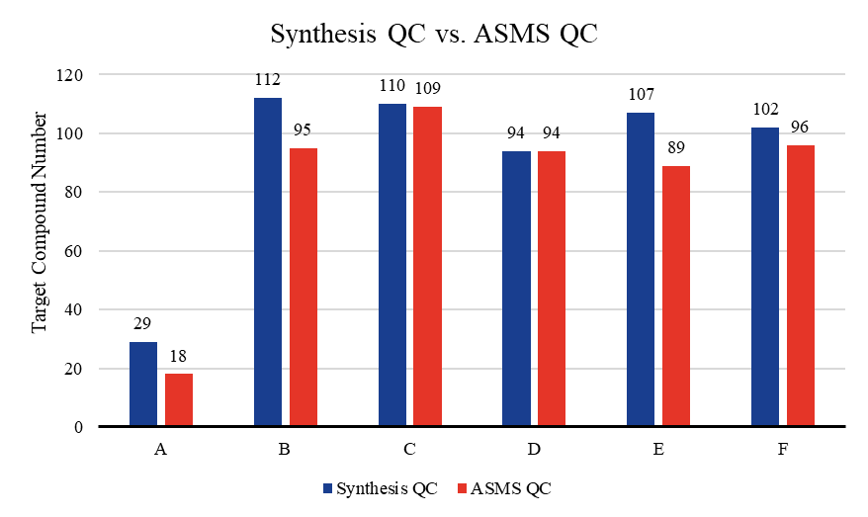
Fig. S2. The results of synthesis QC and ASMS QC.

2.3. The automated parallel resynthesis of 51 compounds
General procedure for synthesis of compounds in C series
In the reaction setup-station, carboxylic acid (0.13 mmol, 1.1 eq), HATU (51.22 mg, 0.13 mmol, 1.1 eq), DIPEA (43.52 mg, 0.34 mmol, 3.0 eq) and DMF (6 mL/mmol INT-10) were added automatically. It was stirred at room temperature for 30 min and a solution of INT-C3-11 (40 mg, 0.11 mmol, 1.0 eq) in DMF (4 mL/mmol INT-10) was added. After capped the reaction tube with screw cap capper, the tube was transferred to the reaction executive-station and stirred at room temperature for 30 min in the temperature-controlled electromagnetic stirrer.
After stirring, a qualified sample was prepared through the automatic sample preparation system and sent to UPLC for monitoring. It showed the total consumption of the start material INT-10 and the product formed. The reaction solution was purified by preparative HPLC (Phenomenex Gemini 150 mm * 25 mm * 10 μm column (eluent: 20% to 40% (v/v) CH3CN and H2O with 0.5% NH4HCO3) to give target product.
58.86% yield as a brown solid. MS m/z (ESI) = 518.9 [M+H]+.
1H NMR (400 MHz, DMSO) δ 8.65 (s, 1H), 7.26 – 7.21 (m, 2H), 7.12 – 7.08 (m, 2H), 6.59 – 6.50 (m, 1H), 6.45 – 6.33(m, 1H), 4.02 – 3.95 (m, 2H), 3.90 – 3.67 (m, 6H), 3.63 – 3.47 (m, 2H), 2.37 – 2.28 (m, 1H), 2.22 – 2.14 (m, 1H), 2.11 –2.01 (m, 2H), 1.42 – 1.32 (m, 1H), 1.23 – 1.12 (m, 1H).

30.57% yield, as a brown solid. MS m/z (ESI) = 505.2 [M+H]+.
1H NMR (400 MHz, DMSO) δ 8.60 (s, 1H), 6.58 – 6.52 (m, 1H), 6.43 – 6.33 (m, 2H), 4.13 – 4.05 (m, 3H), 3.99 – 3.94(m, 2H), 3.89 (t, J = 6.8 Hz, 1H), 3.78 – 3.73 (m, 2H), 3.72 – 3.69 (m, 2H), 3.66 – 3.61 (m, 1H), 3.51 (t, J = 7.0 Hz, 1H),2.75 (t, J = 6.2 Hz, 2H), 2.16 (t, J = 6.8 Hz, 1H), 2.06 (t, J = 7.0 Hz, 1H), 2.02 – 1.92 (m, 2H), 1.83 – 1.71 (m, 2H).

30.09% yield, as a brown solid. MS m/z (ESI) = 531.2 [M+H]+.
1H NMR (400 MHz, DMSO) δ 7.13 – 7.07 (m, 2H), 6.91 – 6.85 (m, 2H), 6.55 – 6.50 (m, 1H), 6.38 – 6.27 (m, 1H), 3.96 –3.90 (m, 2H), 3.75 – 3.58 (m, 6H), 3.53 – 3.48 (m, 2H), 3.39 – 3.36 (m, 2H), 3.20 (t, J = 6.4 Hz, 1H), 2.03 – 1.89 (m, 2H),1.26 – 1.18 (m, 2H), 1.09 – 0.98 (m, 2H).

53.51% yield, as a brown solid. MS m/z (ESI) = 536.1 [M+H]+.
¹H NMR (400 MHz, DMSO) δ 11.73 (d, J = 13.4 Hz, 1H), 8.67 (s, 1H), 7.70 – 7.55 (m, 1H), 7.40 – 7.30 (m, 1H), 7.05 – 6.97 (m, 1H), 6.61 – 6.50 (m, 1H), 6.48 – 6.34 (m, 1H), 4.05 (s, 1H), 4.00 (d, J = 4.3 Hz, 2H), 3.90 (t, J = 6.6 Hz, 1H), 3.86 – 3.70 (m, 5H), 3.62 (t, J = 7.0 Hz, 1H), 2.27 (t, J = 6.6 Hz, 1H), 2.15 (t, J = 6.9 Hz, 1H).

36.38% yield, as a brown solid. MS m/z (ESI) = 501.1 [M+H]+.
¹H NMR (400 MHz, DMSO) δ 13.14 (s, 1H), 8.56 (s, 1H), 7.76 (t, J = 7.8 Hz, 1H), 7.53 (d, J = 8.0 Hz, 1H), 7.33 – 7.22 (m, 2H), 6.66 – 6.48 (m, 1H), 6.47 – 6.33 (m, 1H), 4.42 (s, 1H), 4.24 (t, J = 6.8 Hz, 1H), 3.99 – 3.92 (m, 2H), 3.86 – 3.73 (m, 5H), 3.65 (t, J = 6.8 Hz, 1H), 2.26 (t, J = 7.0 Hz, 1H), 2.14 (t, J = 7.0 Hz, 1H).

91.29% yield, as a brown solid. MS m/z (ESI) = 530.1 [M+H]+.
¹H NMR (400 MHz, DMSO) δ 11.39 (d, J = 10.8 Hz, 1H), 8.70 (s, 1H), 7.33 (d, J = 8.8 Hz, 1H), 7.21 – 6.93 (m, 4H), 6.94 – 6.81 (m, 2H), 6.61 – 6.50 (m, 1H), 6.47 – 6.32 (m, 1H), 4.05 (s, 1H), 4.01 – 3.94 (m, 2H), 3.95 – 3.87 (m, 1H), 3.87 – 3.67 (m, 8H), 3.62 (t, J = 7.2 Hz, 1H), 2.27 (t, J = 6.4 Hz, 1H), 2.15 (t, J = 6.6 Hz, 1H).

26.88% yield, as a brown solid. MS m/z (ESI) = 501.1 [M+H]+.
¹H NMR (400 MHz, DMSO) δ 12.99 (s, 1H), 9.48 (s, 1H), 8.58 (s, 1H), 8.49 – 8.33 (m, 2H), 7.91 (d, J = 6.5 Hz, 1H), 6.63 – 6.48 (m, 1H), 6.47 – 6.32 (m, 1H), 4.07 – 3.99 (m, 1H), 3.95 (s, 2H), 3.91 – 3.71 (m, 6H), 3.66 – 3.57 (m, 1H), 2.29 – 2.12 (m, 2H).

36.64% yield, as a brown solid. MS m/z (ESI) = 517.1 [M+H]+.
¹H NMR (400 MHz, DMSO) δ 8.62 (s, 1H), 8.18 – 8.11 (m, 1H), 8.08 – 8.01 (m, 1H), 7.99 – 7.92 (m, 1H), 7.51 – 7.35 (m, 2H), 6.61 – 6.47 (m, 1H), 6.47 – 6.29 (m, 1H), 4.05 – 3.91 (m, 2H), 3.87 – 3.81 (m, 1H), 3.80 – 3.65 (m, 5H), 3.65 – 3.59 (m, 1H), 3.58 – 3.52 (m, 1H), 2.24 – 2.06 (m, 2H).

29.58% yield, as a brown solid. MS m/z (ESI) = 500.1 [M+H]+.
¹H NMR (400 MHz, DMSO) δ 11.62 (s, 1H), 8.65 (s, 1H), 8.07 (d, J = 8.0 Hz, 1H), 7.86 (d, J = 2.8 Hz, 1H), 7.41 (d, J = 8.0 Hz, 1H), 7.18 – 7.12 (m, 1H), 7.11 – 7.08 (m, 1H), 6.55 (d, J = 8.8 Hz, 1H), 6.44 – 6.35 (m, 1H), 3.99 (s, 2H), 3.93 – 3.55 (m, 8H), 2.24 – 2.08 (m, 2H).

22.04% yield, as a brown solid. MS m/z (ESI) = 525.1 [M+H]+.
¹H NMR (400 MHz, DMSO) δ 12.17 (s, 1H), 8.81 – 8.53 (m, 1H), 8.23 (d, J = 8.4 Hz, 1H), 8.17 (d, J = 2.4 Hz, 1H), 7.93 (s, 1H), 7.44 (d, J = 9.8 Hz, 1H), 6.55 (d, J = 8.8 Hz, 1H), 6.48 – 6.31 (m, 1H), 3.99 (s, 2H), 3.96 – 3.56 (m, 8H), 2.25 – 2.08 (m, 2H).

30.36% yield, as a brown solid. MS m/z (ESI) = 514.1 [M+H]+.
¹H NMR (400 MHz, DMSO) δ 11.48 (s, 1H), 8.55 (s, 1H), 7.87 (s, 1H), 7.79 (d, J = 2.8 Hz, 1H), 7.29 (d, J = 8.4 Hz, 1H), 6.99 – 6.95 (m, 1H), 6.54 (d, J = 9.2 Hz, 1H), 6.45 – 6.35 (m, 1H), 3.95 (s, 2H), 3.91 – 3.45 (m, 8H), 2.38 (s, 3H), 2.26 – 2.05 (m, 2H).

15.92% yield, as a brown solid. MS m/z (ESI) = 530.1 [M+H]+.
¹H NMR (400 MHz, DMSO) δ 11.41 (s, 1H), 8.56 (s, 1H), 7.94 (d, J = 9.0 Hz, 1H), 7.72 (s, 1H), 6.89 (d, J = 2.4 Hz, 1H), 6.79 – 6.69 (m, 1H), 6.55 (d, J = 9.2 Hz, 1H), 6.46 – 6.30 (m, 1H), 3.95 (s, 2H), 3.91 – 3.51 (m, 11H), 2.25 – 2.05 (m, 2H).

24.13% yield, as a brown solid. MS m/z (ESI) = 530.1 [M+H]+.
¹H NMR (400 MHz, DMSO) δ 11.50 (d, J = 1.8 Hz, 1H), 8.55 (s, 1H), 7.81 (d, J = 2.8 Hz, 1H), 7.61 (d, J = 2.4 Hz, 1H), 7.30 (d, J = 8.8 Hz, 1H), 6.87 – 6.69 (m, 1H), 6.55 (d, J = 9.0 Hz, 1H), 6.46 – 6.30 (m, 1H), 4.00 – 3.92 (m, 2H), 3.81 – 3.73 (m, 7H), 3.66 – 3.53 (m, 2H), 3.19 – 2.98 (m, 2H), 2.26 – 2.04 (m, 2H).

47.74% yield, as a brown solid. MS m/z (ESI) = 517.1 [M+H]+.
¹H NMR (400 MHz, DMSO) δ 8.62 (s, 1H), 8.07 – 7.90 (m, 3H), 7.52 – 7.39 (m, 2H), 6.62 – 6.51 (m, 1H), 6.46 – 6.35 (m, 1H), 4.09 (s, 1H), 4.04 – 3.88 (m, 3H), 3.86 – 3.70 (m, 5H), 3.61 (t, J = 7.0 Hz, 1H), 2.27 (t, J = 7.0 Hz, 1H), 2.17 (t, J = 6.8 Hz, 1H).

39.70% yield, as a brown solid. MS m/z (ESI) = 482.1 [M+H]+.
¹H NMR (400 MHz, DMSO) δ 8.58 (s, 1H), 8.07 (s, 1H), 6.63 – 6.47 (m, 1H), 6.47 – 6.28 (m, 1H), 4.01 – 3.91 (m, 3H), 3.86 – 3.70 (m, 5H), 3.69 – 3.64 (m, 1H), 3.57 – 3.51 (m, 1H), 2.66 (s, 3H), 2.27 – 2.09 (m, 2H).

39.14% yield, as a brown solid. MS m/z (ESI) = 453.1 [M+H]+.
1H NMR (400 MHz, DMSO) δ 8.61 (s, 1H), 6.62 – 6.50 (m, 1H), 6.45 – 6.30 (m, 1H), 3.97 (s, 2H), 3.76 – 3.66 (m, 5H), 3.53 (t, J = 6.8 Hz, 1H), 3.46 (s, 1H),3.32 – 3.29 (m, 1H), 2.88 – 2.73 (m, 1H), 2.15 (t, J = 6.8 Hz, 1H), 2.04 (t, J = 7.0 Hz, 1H), 1.82 – 1.72 (m, 2H), 1.67 – 1.46 (m, 6H).

57.19% yield, as a brown solid. MS m/z (ESI) = 465.1 [M+H]+.
¹H NMR (400 MHz, DMSO) δ 12.86 (s, 1H), 8.56 (s, 1H), 6.59 – 6.50 (m, 1H), 6.47 – 6.25 (m, 2H), 4.12 – 3.84 (m, 4H), 3.77 – 3.69 (m, 4H), 3.56 – 3.47 (m, 2H), 2.24 (s, 3H), 2.19 – 2.02 (m, 2H).

66.36% yield, as a brown solid. MS m/z (ESI) = 465.1 [M+H]+.
¹H NMR (400 MHz, DMSO) δ 8.57 (s, 1H), 8.17 (d, J = 8.0 Hz, 1H), 7.77 (s, 1H), 6.55 (d, J = 9.0 Hz, 1H), 6.44 – 6.32 (m, 1H), 3.95 (s, 2H), 3.85 (s, 4H), 3.79 – 3.67 (m, 5H), 3.62 (s, 1H), 3.49 (t, J = 7.2 Hz, 1H), 2.21 (t, J = 6.8 Hz, 1H), 2.09 (t, J = 7.0 Hz, 1H).

62.71% yield, as a brown solid. MS m/z (ESI) = 501.1 [M+H]+.
¹H NMR (400 MHz, DMSO) δ 8.82 – 8.75 (m, 1H), 8.67 (s, 1H), 8.45 (s, 1H), 8.20 (d, J = 8.8 Hz, 1H), 7.52 – 7.40 (m, 1H), 7.10 – 7.08 (m, 1H), 7.07 – 7.05 (m, 1H), 6.56 (d, J = 8.4 Hz, 1H), 6.47 – 6.34 (m, 1H), 3.99 (s, 2H), 3.90 – 3.54 (m, 8H), 2.29 – 2.07 (m, 2H).

5.64% yield, as a brown solid. MS m/z (ESI) = 506.1 [M+H]+.
¹H NMR (400 MHz, DMSO) δ 11.64 (s, 1H), 8.60 (s, 1H), 7.46 – 7.33 (m, 1H), 6.97 – 6.94 (m, 2H), 6.62 – 6.50 (m, 1H), 6.46 – 6.29 (m, 1H), 4.08 – 3.91 (m, 3H), 3.89 – 3.69 (m, 6H), 3.64 – 3.54 (m, 1H), 2.30 – 2.07 (m, 2H).

56.67% yield, as a brown solid. MS m/z (ESI) = 501.1 [M+H]+.
¹H NMR (400 MHz, DMSO) δ 7.27 – 7.05 (m, 4H), 6.59 – 6.53 (m, 1H), 6.46 – 6.37 (m, 2H), 4.29 – 4.13 (m, 1H), 3.96 (s, 2H), 3.89 (s, 1H), 3.85 – 3.68 (m, 5H), 3.55 (s, 1H), 3.42 (t, J = 7.0 Hz, 1H), 3.04 – 2.91 (m, 1H), 2.91 – 2.78 (m, 1H), 2.31 – 2.08 (m, 4H).

53.68% yield, as a brown solid. MS m/z (ESI) = 466.1 [M+H]+.
¹H NMR (400 MHz, DMSO) δ 8.57 (s, 1H), 8.45 (s, 1H), 6.64 – 6.47 (m, 1H), 6.46 – 6.27 (m, 1H), 4.03 (s, 1H), 3.95 (d, J = 2.8 Hz, 2H), 3.86 (t, J = 6.8 Hz, 1H), 3.79 – 3.68 (m, 4H), 3.63 (s, 1H), 3.51 (t, J = 7.0 Hz, 1H), 2.45 (s, 3H), 2.18 (t, J = 6.8 Hz, 1H), 2.07 (t, J = 7.2 Hz, 1H).

27.55% yield, as a brown solid. MS m/z (ESI) = 527.1 [M+H]+.
¹H NMR (400 MHz, DMSO) δ 8.87 (d, J = 7.6 Hz, 1H), 8.61 (s, 1H), 8.08 (s, 1H), 7.92 (d, J = 8.4 Hz, 2H), 7.59 – 7.47 (m, 2H), 7.42 – 7.29 (m, 1H), 6.62 – 6.49 (m, 1H), 6.46 – 6.32 (m, 1H), 4.04 – 3.92 (m, 3H), 3.89 – 3.73 (m, 5H), 3.67 (s, 1H), 3.55 (t, J = 6.8 Hz, 1H), 2.24 (t, J = 6.8 Hz, 1H), 2.14 (t, J = 7.2 Hz, 1H).

58.15% yield, as a brown solid. MS m/z (ESI) = 439.1 [M+H]+.
¹H NMR (400 MHz, DMSO) δ 8.57 (s, 1H), 6.55 (d, J = 7.6 Hz, 1H), 6.38 (t, 1H), 4.03 – 3.88 (m, 2H), 3.75 – 3.68 (m, 4H), 3.60 – 3.48 (m, 2H), 3.18 – 2.89 (m, 2H), 2.31 – 1.90 (m, 2H), 1.23 (s, 3H), 0.88 – 0.70 (m, 2H), 0.63 – 0.37 (m, 2H).

57.84% yield, as a brown solid. MS m/z (ESI) = 514.1 [M+H]+.
¹H NMR (400 MHz, DMSO) δ 8.57 (s, 1H), 8.11 (d, J = 7.8 Hz, 1H), 7.93 (s, 1H), 7.47 (d, J = 8.2 Hz, 1H), 7.25 – 7.21 (m, 1H), 7.16 – 7.10 (m, 1H), 6.55 (d, J = 8.0 Hz, 1H), 6.48 – 6.29 (m, 1H), 3.96 (s, 2H), 3.94 – 3.52 (m, 11H), 2.26 – 2.07 (m, 2H).

59.44% yield, as a brown solid. MS m/z (ESI) = 515.2 [M+H]+.
¹H NMR (400 MHz, DMSO) δ 8.85 – 8.43 (m, 1H), 7.34 – 7.26 (m, 3H), 7.25 – 7.22 (m, 1H), 7.20 – 7.14 (m, 1H), 6.59 – 6.51 (m, 1H), 6.45 – 6.33 (m, 1H), 3.99 (s, 2H), 3.78 – 3.68 (m, 4H), 3.61 (s, 1H), 3.56 – 3.45 (m, 3H), 3.26 – 3.19 (m, 1H), 2.69 – 2.51 (m, 2H), 2.40 – 1.94 (m, 5H).

General procedure for synthesis of compounds in D series
The synthetic procedure was the same as that of the C series.

43.7% yield, as a brown solid. MS m/z (ESI) = 500.1 [M+H]+.
¹H NMR (400 MHz, DMSO) δ 11.59 (s, 1H), 8.59 (s, 1H), 7.60 (d, J = 7.8 Hz, 1H), 7.48 – 7.39 (m, 1H), 7.21 – 7.15 (m, 1H), 7.06 – 7.00 (m, 1H), 6.87 – 6.80 (m, 1H), 6.67 – 6.59 (m, 1H), 6.59 – 6.53 (m, 1H), 4.64 – 4.38 (m, 2H), 4.16 – 4.01 (m, 2H), 3.98 (s, 2H), 3.69 – 3.55 (m, 1H), 3.52 – 3.39 (m, 3H), 2.28 – 2.12 (m, 2H).

91.08% yield, as a brown solid. MS m/z (ESI) = 514.2 [M+H]+.
¹H NMR (400 MHz, DMSO) δ 11.36 (s, 1H), 8.63 (s, 1H), 7.42 (d, J = 7.6 Hz, 1H), 7.00 – 6.97 (m, 1H), 6.96 – 6.91 (m, 1H), 6.85 (d, J = 1.8 Hz, 1H), 6.68 – 6.60 (m, 1H), 6.60 – 6.50 (m, 1H), 4.62 – 4.36 (m, 2H), 4.19 – 4.04 (m, 2H), 3.99 (s, 2H), 3.47 – 3.42 (m, 2H), 3.29 – 3.25 (m, 2H), 2.51 (s, 3H), 2.27 – 2.12 (m, 2H).

45.39% yield, as a brown solid. MS m/z (ESI) = 536.1 [M+H]+.
¹H NMR (400 MHz, DMSO) δ 12.22 (s, 1H), 8.58 (s, 1H), 7.29 – 7.22 (m, 1H), 7.09 – 7.06 (m, 1H), 6.96 – 6.92 (m, 1H), 6.68 – 6.59 (m, 1H), 6.59 – 6.52 (m, 1H), 4.57 – 4.43 (m, 2H), 4.14 – 4.03 (m, 2H), 3.97 (s, 2H), 3.47 – 3.40 (m, 2H), 3.28 – 3.23 (m, 2H), 2.26 – 2.12 (m, 2H).

78.76% yield, as a brown solid. MS m/z (ESI) = 514.2 [M+H]+.
¹H NMR (400 MHz, DMSO) δ 11.45 (s, 1H), 8.65 (s, 1H), 7.37 (s, 1H), 7.32 (d, J = 8.4 Hz, 1H), 7.02 (d, J = 8.4 Hz, 1H), 6.74 (s, 1H), 6.67 – 6.61 (m, 1H), 6.56 (d, J = 8.8 Hz, 1H), 4.61 – 4.39 (m, 2H), 4.16 – 4.02 (m, 2H), 4.00 (s, 2H), 3.46 – 3.42 (m, 2H), 3.30 – 3.25 (m, 2H), 2.36 (s, 3H), 2.27 – 2.12 (m, 2H).

40.51% yield, as a brown solid. MS m/z (ESI) = 530.1 [M+H]+.
¹H NMR (400 MHz, DMSO) δ 11.44 (s, 1H), 8.68 (s, 1H), 7.32 (d, J = 8.8 Hz, 1H), 7.05 (d, J = 2.4 Hz, 1H), 6.88 – 6.81 (m, 1H), 6.74 (s, 1H), 6.68 – 6.60 (m, 1H), 6.56 (d, J = 9.0 Hz, 1H), 4.61 – 4.39 (m, 2H), 4.16 – 4.03 (m, 2H), 4.01 (s, 2H), 3.75 (s, 3H), 3.45 – 3.42 (m, 2H), 3.29 – 3.24 (m, 2H), 2.30 – 2.10 (m, 2H).

25.92% yield, as a brown solid. MS m/z (ESI) = 514.1 [M+H]+.
¹H NMR (400 MHz, DMSO) δ 11.65 – 11.41 (m, 1H), 8.60 (s, 1H), 8.00 (d, J = 8.2 Hz, 1H), 7.69 (d, J = 2.8 Hz, 1H), 7.19 (s, 1H), 6.95 – 6.90 (m, 1H), 6.63 (t, J = 9.2 Hz, 1H), 6.58 – 6.52 (m, 1H), 4.51 – 3.81 (m, 6H), 3.46 – 3.39 (m, 2H), 3.29 – 3.23 (m, 2H), 2.39 (s, 3H), 2.22 – 2.11 (m, 2H).

55.53% yield, as a brown solid. MS m/z (ESI) = 559.1 [M+H]+.
¹H NMR (400 MHz, DMSO) δ 9.20 – 9.09 (m, 1H), 8.75 – 8.67 (m, 1H), 8.64 (s, 1H), 8.39 – 8.25 (m, 1H), 7.61 – 7.49 (m, 1H), 6.62 (t, J = 9.2 Hz, 1H), 6.55 (d, J = 9.0 Hz, 1H), 4.44 – 4.20 (m, 2H), 4.15 – 3.88 (m, 4H), 3.43 – 3.40 (m, 2H), 3.27 – 3.21 (m, 2H), 2.64 (s, 3H), 2.23 – 2.12 (m, 2H).

64.68% yield, as a brown solid. MS m/z (ESI) = 514.2 [M+H]+.
¹H NMR (400 MHz, DMSO) δ 8.66 (s, 1H), 8.16 (d, J = 7.8 Hz, 1H), 7.86 (s, 1H), 7.47 (d, J = 8.2 Hz, 1H), 7.25 – 7.22 (m, 1H), 7.18 – 7.12 (m, 1H), 6.64 (t, J = 9.2 Hz, 1H), 6.59 – 6.52 (m, 1H), 4.55 – 3.93 (m, 6H), 3.82 (s, 3H), 3.50 – 3.40 (m, 4H), 2.27 – 2.08 (m, 2H).

General procedure for synthesis of compounds in E series
The synthetic procedure was the same as that of the C series.

11.16% yield, as a black solid. MS m/z (ESI) = 537.2 [M+H]⁺.
¹H NMR (400 MHz, DMSO-d₆) δ 8.56 (s, 1H), 7.70 (d, J = 7.6 Hz, 1H), 6.55 – 6.45 (m, 1H), 6.38 – 6.29 (m, 1H), 4.17 – 4.09 (m, 1H), 3.95 (s, 1H), 3.78 (s, 2H), 3.69 (s, 2H), 3.61 (s, 4H), 2.42 (s, 2H), 2.15 (s, 2H), 1.79 (d, J = 21.8 Hz, 7H), 1.58 (d, J = 6.5 Hz, 4H).

40.47% yield, as a black solid. MS m/z (ESI) = 519.0 [M+H]⁺.
¹H NMR (400 MHz, DMSO-d₆) δ 7.39 – 7.30 (m, 3H), 7.16 (t, J = 7.2 Hz, 2H), 7.00 (d, J = 7.6 Hz, 1H), 6.51 (d, J = 8.6 Hz, 1H), 6.31 (t, J = 9.3 Hz, 1H), 4.18 – 4.07 (m, 1H), 3.93 (s, 2H), 3.75 (s, 2H), 3.62 (s, 2H), 2.38 – 2.28 (m, 2H), 2.16 – 2.06 (m, 2H), 1.36 – 1.25 (m, 2H), 0.95 – 0.87 (m, 2H).

5.62% yield, as a black solid. MS m/z (ESI) = 529.2 [M+H]⁺.
¹H NMR (400 MHz, DMSO-d₆) δ 7.61 – 7.52 (m, 2H), 7.31 – 7.30 (m, 4H), 7.22 – 7.20 (m, 1H), 6.56 – 6.48 (m, 1H), 6.31 (t, J = 10.4 Hz, 1H), 4.08 – 4.01 (m, 1H), 3.93 (s, 2H), 3.74 (s, 2H), 3.63 (s, 2H), 2.08 – 2.03 (m, 2H), 1.80 – 1.71 (m, 4H), 1.62 – 1.53 (m, 6H).

8.80% yield, as a black solid. MS m/z (ESI) = 516.20 [M+H]⁺.
¹H NMR (400 MHz, DMSO-d₆) δ 8.83 – 8.72 (m, 2H), 8.65 – 8.63 (m, 1H), 8.54 – 8.51 (m, 1H), 7.37 (d, J = 3.6 Hz, 1H), 6.54 (dd, J = 8.8, 0.9 Hz, 1H), 6.37 (t, J = 9.4 Hz, 1H), 4.43 – 4.37 (m, 1H), 4.15 (s, 3H), 3.96 (s, 2H), 3.85 (s, 2H), 3.73 (s, 2H), 2.63 – 2.54 (m, 2H), 2.44 – 2.40 (m, 2H).

43.36% yield, as a black solid. MS m/z (ESI) = 479 [M+H]⁺.
¹H NMR (400 MHz, DMSO-d₆) δ 8.58 (s, 1H), 7.88 (d, J = 7.4 Hz, 1H), 6.55 – 6.50 (m, 1H), 6.34 (t, J = 9.2 Hz, 1H), 4.11 – 4.02 (m, 1H), 3.96 (s, 2H), 3.78 (s, 2H), 3.68 (s, 2H), 2.78 – 2.72 (m, 1H), 2.46 – 2.39 (m, 2H), 2.07 – 1.98 (m, 10H), 1.83 – 1.81 (m, 2H), 1.76 – 1.72 (m, 2H).

General procedure for synthesis of compounds in F series
The synthetic procedure was the same as that of the C series.

32.11% yield, as a white solid. MS m/z (ESI) = 455.2 [M+H]⁺.
¹H NMR (400 MHz, DMSO-d6) δ 8.70 (s, 1H), 6.70 – 6.61 (m, 1H), 6.55 (dd, J = 9.0, 1.6 Hz, 1H), 5.79 (s, 1H), 3.98 (s, 2H), 3.74 (dd, J = 11.6, 7.5 Hz, 1H), 3.64 (dd, J = 12.3, 8.2 Hz, 1H), 3.49 (dd, J = 11.6, 4.5 Hz, 1H), 3.31 – 3.17 (m, 5H), 3.07 – 2.99 (m, 2H), 2.99 – 2.87 (m, 2H), 2.87 – 2.79 (m, 1H), 2.06 – 1.90 (m, 2H), 1.78 – 1.63 (m, 1H), 1.52 – 1.36 (m, 1H).

88.29% yield, as a white solid. MS m/z (ESI) = 531.3 [M+H]⁺.
¹H NMR (400 MHz, DMSO-d6) δ 8.80 – 8.61 (m, 1H), 7.12 – 7.06 (m, 3H), 6.87 – 6.79 (m, 2H), 6.73 – 6.60 (m, 1H), 6.60 – 6.49 (m, 1H), 4.04 – 3.97 (m, 2H), 3.72 – 3.69 (m, 3H), 3.66 – 3.59 (m, 1H), 3.48 – 3.42 (m, 2H), 3.31 – 3.23 (m, 3H), 3.15 – 3.03 (m, 2H), 3.03 – 2.94 (m, 1H), 2.94 – 2.85 (m, 1H), 2.29 – 2.19 (m, 1H), 2.04 – 1.94 (m, 1H), 1.40 – 1.29 (m, 1H), 1.19 – 1.09 (m, 1H).

97.30% yield, as a white solid. MS m/z (ESI) = 529.3 [M+H]⁺.
¹H NMR (400 MHz, DMSO-d6) δ 8.73 (s, 1H), 7.31 – 7.24 (m, 2H), 7.23 – 7.16 (m, 4H), 6.57 – 6.47 (m, 2H), 3.99 (s, 2H), 3.62 – 3.53 (m, 1H), 3.23 – 3.15 (m, 1H), 3.09 – 2.56 (m, 7H), 2.45 – 2.21 (m, 3H), 1.99 – 1.81 (m, 2H), 1.69 – 1.57 (m, 4H).

77.02% yield, as a white solid. MS m/z (ESI) = 500.2 [M+H]⁺.
¹H NMR (400 MHz, DMSO-d6) δ 11.53 (s, 1H), 8.76 (s, 1H), 7.64 – 7.59 (m, 1H), 7.43 (dd, J = 8.3, 1.0 Hz, 1H), 7.20 – 7.15 (m, 1H), 7.06 – 6.99 (m, 1H), 6.98 – 6.95 (m, 2H), 6.71 – 6.64 (m, 1H), 6.56 (dd, J = 8.9, 1.6 Hz, 1H), 4.25 – 4.08 (m, 1H), 4.01 (s, 2H), 3.97 – 3.85 (m, 1H), 3.85 – 3.72 (m, 1H), 3.62 – 3.54 (m, 1H), 3.34 – 3.30 (m, 2H), 3.21 – 3.15 (m, 2H), 3.11 – 2.94 (m, 2H).

23.49% yield, as a white solid. MS m/z (ESI) = 501.2 [M+H]⁺.
¹H NMR (400 MHz, DMSO-d6) δ 12.46 (s, 1H), 8.66 (s, 1H), 8.49 (s, 1H), 8.34 – 8.21 (m, 1H), 8.21 – 8.05 (m, 1H), 7.44 – 7.34 (m, 1H), 6.95 (s, 1H), 6.69 – 6.61 (m, 1H), 6.55 (d, J = 8.9 Hz, 1H), 4.13 – 4.01 (m, 1H), 3.96 (s, 2H), 3.91 – 3.84 (m, 1H), 3.68 – 3.53 (m, 2H), 3.26 – 3.20 (m, 2H), 3.16 – 3.10 (m, 2H), 3.04 – 2.96 (m, 2H).

41.11% yield, as a white solid. MS m/z (ESI) = 517.2 [M+H]⁺.
¹H NMR (400 MHz, DMSO-d6) δ 8.67 (s, 1H), 8.13 – 7.86 (m, 4H), 7.48 – 7.40 (m, 2H), 6.72 – 6.64 (m, 1H), 6.57 (dd, J = 8.9, 1.6 Hz, 1H), 4.25 – 4.10 (m, 1H), 3.98 (s, 2H), 3.96 – 3.87 (m, 1H), 3.85 – 3.73 (m, 1H), 3.61 – 3.50 (m, 1H), 3.32 – 3.28 (m, 2H), 3.23 – 3.16 (m, 2H), 3.13 – 2.96 (m, 2H).

93.20% yield, as a white solid. MS m/z (ESI) = 502.2 [M+H]⁺.
¹H NMR (400 MHz, DMSO-d6) δ 9.19 (dd, J = 7.0, 1.7 Hz, 1H), 8.71 (dt, J = 5.5, 2.7 Hz, 2H), 8.44 (s, 1H), 7.16 (dd, J = 7.0, 4.1 Hz, 1H), 6.95 (s, 1H), 6.67 (t, J = 9.2 Hz, 1H), 6.56 (dd, J = 8.9, 1.6 Hz, 1H), 3.98 (s, 2H), 3.95 – 3.86 (m, 2H), 3.57 – 3.47 (m, 2H), 3.22 – 2.89 (m, 6H).

37.41% yield, as a white solid. MS m/z (ESI) = 501.2 [M+H]⁺.
¹H NMR (400 MHz, DMSO-d6) δ 8.78 (dt, J = 7.0, 1.1 Hz, 1H), 8.64 (s, 1H), 8.43 (s, 1H), 8.20 – 8.12 (m, 1H), 7.49 – 7.39 (m, 1H), 7.08 – 7.02 (m, 2H), 6.70 – 6.61 (m, 1H), 6.55 (dd, J = 9.0, 1.6 Hz, 1H), 4.09 – 3.97 (m, 1H), 3.97 (s, 2H), 3.72 – 3.54 (m, 2H), 3.31 – 3.25 (m, 3H), 3.21 – 3.12 (m, 2H), 3.05 – 2.93 (m, 2H).

37.75% yield, as a white solid. MS m/z (ESI) = 559.2 [M+H]⁺.
¹H NMR (400 MHz, DMSO-d6) δ 9.12 (dd, J = 2.4, 0.9 Hz, 1H), 8.86 (s, 1H), 8.68 (dd, J = 4.8, 1.6 Hz, 1H), 8.34 – 8.26 (m, 1H), 7.59 – 7.50 (m, 1H), 6.95 (s, 1H), 6.69 (t, J = 9.2 Hz, 1H), 6.57 (dd, J = 9.0, 1.6 Hz, 1H), 4.04 (s, 2H), 3.87 – 3.76 (m, 2H), 3.56 – 3.49 (m, 2H), 3.24 (d, J = 12.6 Hz, 2H), 3.11 (d, J = 10.6 Hz, 2H), 2.98 (d, J = 11.6 Hz, 2H), 2.46 (s, 3H).

50.62% yield, as a brown solid. MS m/z (ESI) = 514.3 [M+H]⁺.
¹H NMR (400 MHz, DMSO-d6) δ 9.25 (s, 1H), 8.05 (d, J = 7.9 Hz, 1H), 7.90 (s, 1H), 7.47 (d, J = 8.2 Hz, 1H), 7.28 – 7.08 (m, 3H), 6.72 (t, J = 9.3 Hz, 1H), 6.59 (dd, J = 8.9, 1.6 Hz, 1H), 4.23 (s, 2H), 3.98 – 3.93 (m, 2H), 3.83 (s, 3H), 3.61 – 3.56 (m, 2H), 3.35 – 3.30 (m, 2H), 3.19 – 3.13 (m, 2H), 3.04 – 2.97 (m, 2H).

98.22% yield, as a white solid. MS m/z (ESI) = 521.2 [M+H]⁺.
¹H NMR (400 MHz, DMSO-d6) δ 8.70 (s, 1H), 7.27 (s, 1H), 6.95 (s, 1H), 6.66 (t, J = 9.2 Hz, 1H), 6.55 (dd, J = 8.9, 1.6 Hz, 1H), 3.99 (s, 2H), 3.97 – 3.73 (m, 2H), 3.67 – 3.51 (m, 2H), 3.27 (d, J = 7.5 Hz, 2H), 3.13 (d, J = 9.8 Hz, 2H), 3.05 – 2.88 (m, 2H), 2.71 (t, J = 5.9 Hz, 2H), 2.56 (t, J = 6.0 Hz, 2H), 1.81 – 1.67 (m, 4H).

3. General Procedure for ASMS experiment

3.1 Affinity Selection Mass Spectrometry (ASMS) instrumentation and Methods
Instrument: Waters Vion IMS QTof
Detection range: 50-800 Da，ESI: negative ion mode
Ion source temperature: 100°C; Desolvent temperature: 280°C
Electric spray voltage: 2.5kV; Desolvent carrier gas: 800L/h

Column: Agilent SB-Aq 2.1*150mm 2.7μm
Column temperature: 40 °C；Injection Volume: 2μL；Flow rate: 0.4mL/min；12min Method
Time (min) | Mobile Phase A: 0.1 % formic acid in Optima LC/MS-grade water | Mobile Phase B: 0.1% formic acid in Optima LC/MS-grade MeCN
0.0 | 95% | 5%
1.0 | 95% | 5%
5.0 | 60% | 40%
7.5 | 5% | 95%
9.5 | 5% | 95%
9.6 | 95% | 5%
12 | 95% | 5%

Microcentrifuge tubes: Millipore Amicon Ultra-2mL (3kDa, UFC500324)

3.2 General Affinity Competition Experiment Procedure
1. Solution preparation
The content value of the specific compound that was close to the average content value in this sub-library was employed for the calculation and preparation of a 20 mM DMSO stock solution of this sub-library for ASMS screening. The 90 sub-libraries were reorganized into 29 newly remixed groups as small-scale samples (2 to 4 synthetic sub-libraries, totaling 10 to 37 compounds, See Supplemental Extended File 3).

2. Incubation System:
Total volume 100μL, incubate at room temperature for 30 minutes
 | Protein 4μM | Mix+Reference 2μM | 5%DMSO-Buffer
Control+Reference (mix) |  | 50μL | 50μL
Protein+mix+Reference | 50μL | 50μL

3. Ultrafiltration (10kD): 4°C
1) Add 200μL ultrapure water to the ultrafiltration tube, centrifuge at 13,000g for 20min, remove the supernatant;
2) Add the sample to the ultrafiltration tube, centrifuge at 13,000g for 10min;
3) Add 100μL ultrapure water to the ultrafiltration tube, centrifuge at 13,000g for 10min;
4) Add another 100μL ultrapure water to the ultrafiltration tube, centrifuge at 13,000g for 10min (ultrafiltration three times in total).

4. Protein denaturation and concentration:
1) Draw out the liquid from the upper part of the ultrafiltration tube to a clean EP tube;
2) Add 150mM ammonium acetate to wash the membrane twice, each time adding 40μL, and combine it into the EP tube. The total volume at this time is about 50+40*2=130μL;
3) Add 400μL pre-cooled 90% MeOH and vortex for 30s;
4) Centrifuge at 13,000g, 4℃ for 10min;
5) Pipette 400μL supernatant and dry it under vacuum at 55°C;
6) Re-dissolve it with 50μL 50% MeOH in bottle and wait for LCMS detection.

3.3 Calculation methods of efficiency and normalization
In ASMS experiments of “preMTA” phase, the “efficiency” value was calculated as the ratio of the amount of each compound present in the complex to its total amount. The “efficiency” value of each compound, obtained from small-scale (10-37 compounds) and large-scale (~100 compounds in the same series) samples respectively, was impacted by affinity competition.
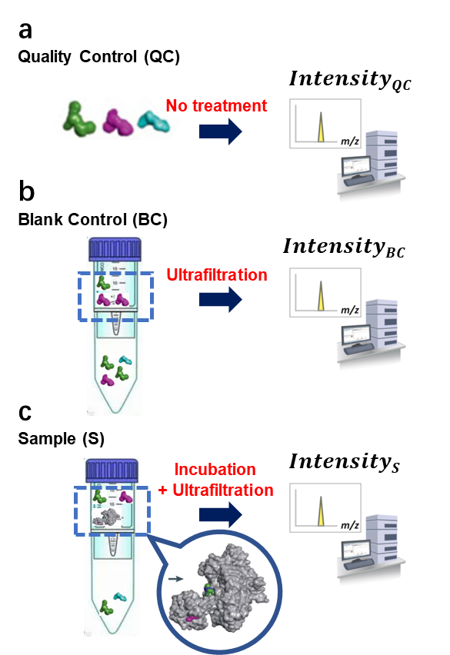
Fig. S2. The intensity values captured by High-Resolution Mass Spectrometry (HRMS) in the ASMS procedure. a. For quality control purposes, the “intensity_{QC}” value of each compound within the remixed groups of synthetic sub-libraries, was utilized firstly. b. As a blank control, the post-ultrafiltration “intensity_{BC}” value of each compound in the remixed groups were recorded to account for nonspecific binding to the microcentrifuge tube. c. After incubation and ultrafiltration, the compounds that were complexed with the PTPN2 protein were released and subsequently detected, yielding “intensity_{s”} values.

The calculation formula for “efficiency” value:
$$Efficiency=\frac{{Intensity}_{S}-{Intensity}_{BC}}{{Intensity}_{QC}}$$

To display the “efficiency” value of compounds in scatter plots (Figure 5a and Figure 6), values of both small- and large- scale ASMS are normalized as following equation respectively:
$${nE}_{i}=\left\{\begin{aligned}\frac{E_{i}-0.01}{max\left(E-0.01\right)}, E_{i}-0.01≥0 \\ \frac{E_{i}-0.01}{min\left(E-0.01\right)}, &E_{i}-0.01<0\end{aligned}\right.$$

Efficiency = 0.01 was set as cutoff to distinguish binders and non-binders in this project.

3.4 The original scatter plot based on the origin efficiency value
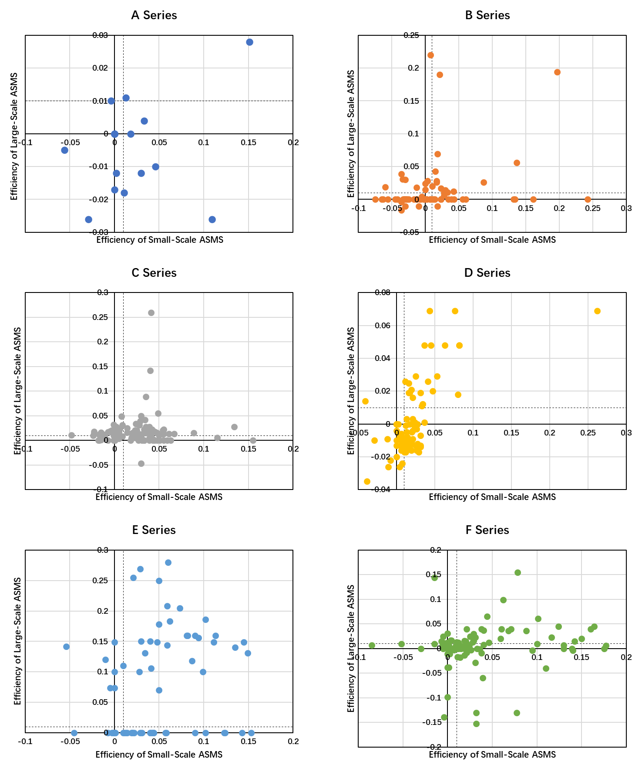
Fig. S3. The scatter plot of each individual series extracted from Figure 4a.

4. Spectra
5-(2-fluoro-3-(6-(2-(4-fluorophenyl)cyclopropane-1-carbonyl)-2,6-diazaspiro[3.4]octan-2-yl)-6-hydroxyphenyl)-1,2,5-thiadiazolidin-3-one 1,1-dioxide（XTN-C3-008）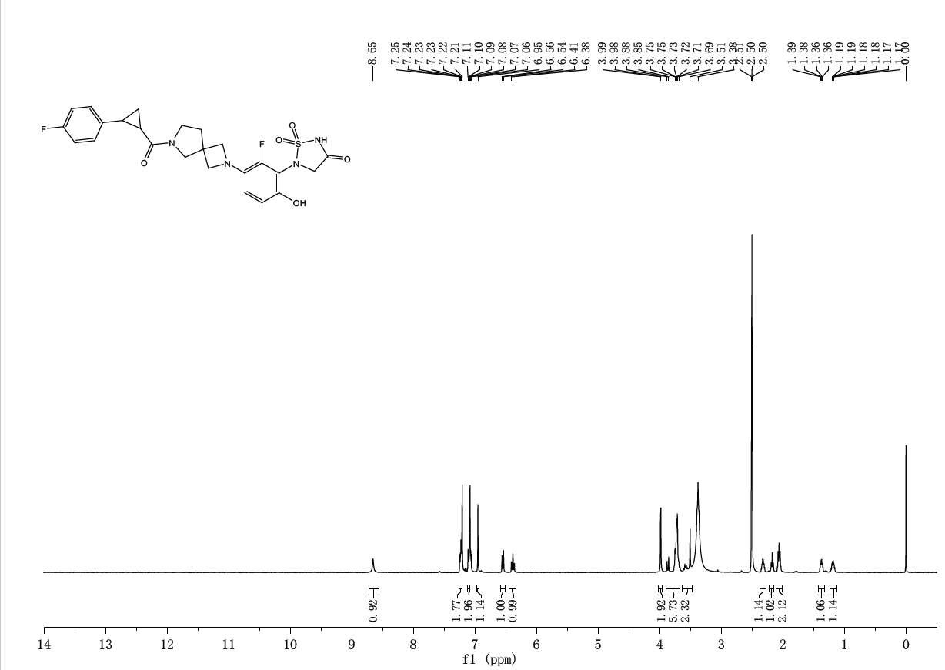5-(2-fluoro-6-hydroxy-3-(6-(4,5,6,7-tetrahydropyrazolo[1,5-a]pyridine-3-carbonyl)-2,6-diazaspiro[3.4]octan-2-yl)phenyl)-1,2,5-thiadiazolidin-3-one 1,1-dioxide（XTN-C3-010）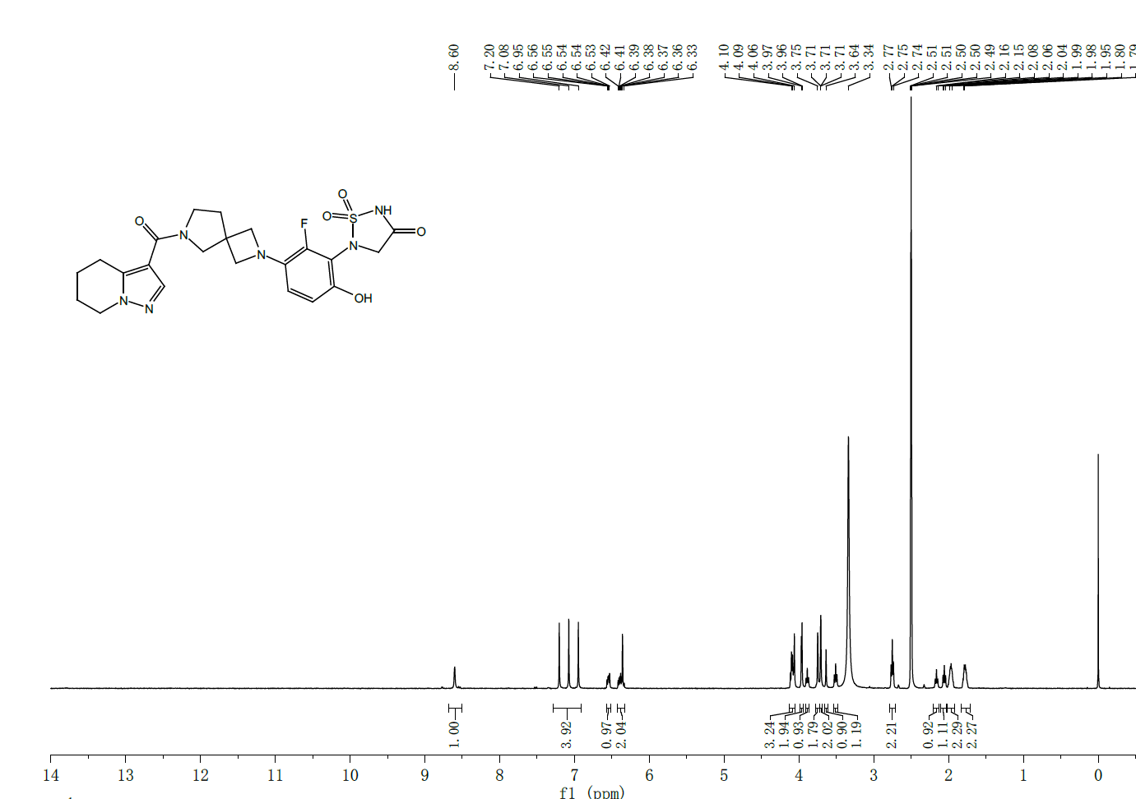5-(2-fluoro-6-hydroxy-3-(6-(1-(4-methoxyphenyl)cyclopropane-1-carbonyl)-2,6-diazaspiro[3.4]octan-2-yl)phenyl)-1,2,5-thiadiazolidin-3-one 1,1-dioxide（XTN-C3-017）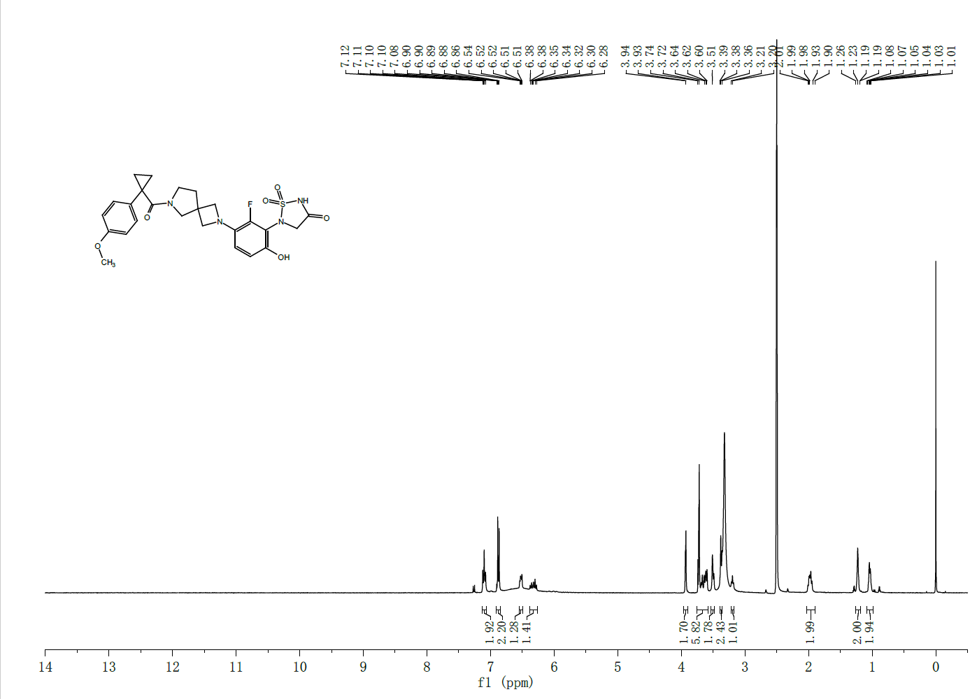
5-(3-(6-(5,6-difluoro-1H-indole-2-carbonyl)-2,6-diazaspiro[3.4]octan-2-yl)-2-fluoro-6-hydroxyphenyl)-1,2,5-thiadiazolidin-3-one 1,1-dioxide（XTN-C3-021） 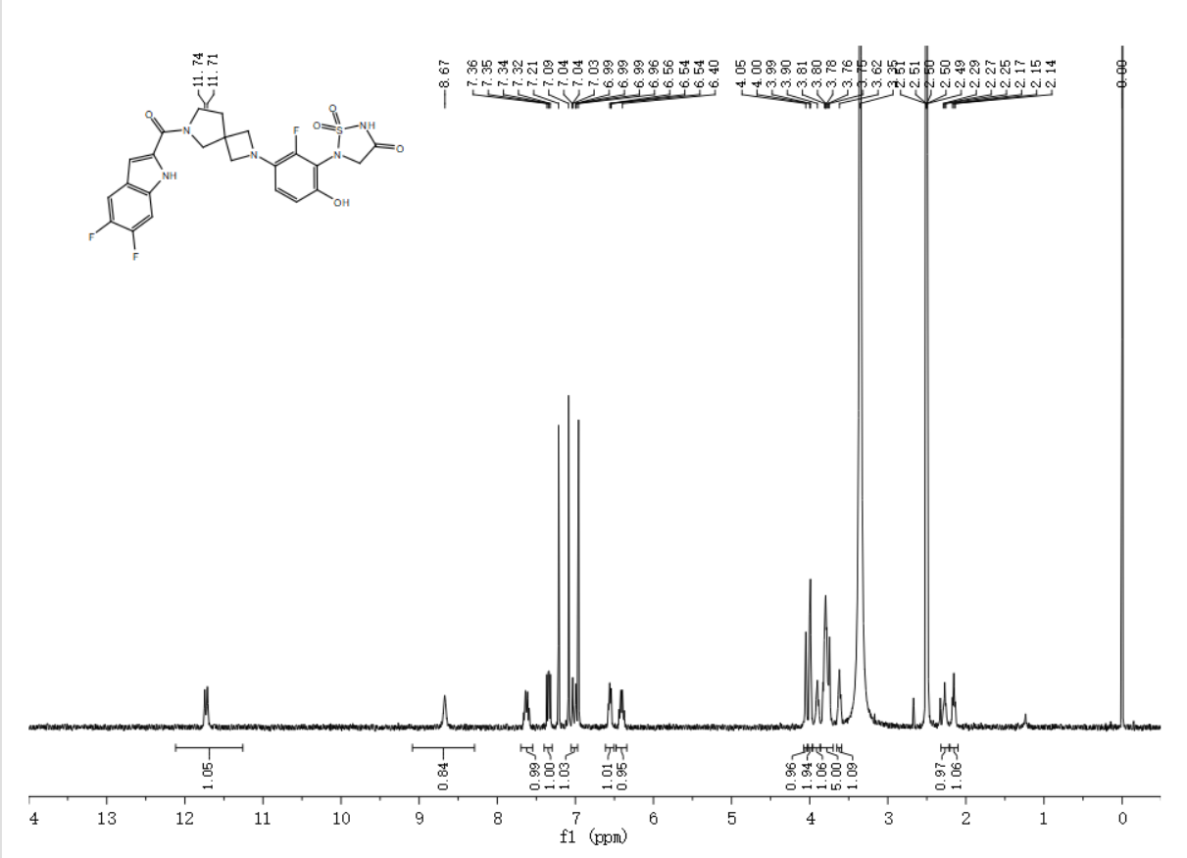5-(3-(6-(1H-benzo[d]imidazole-2-carbonyl)-2,6-diazaspiro[3.4]octan-2-yl)-2-fluoro-6-hydroxyphenyl)-1,2,5-thiadiazolidin-3-one 1,1-dioxide(XTN-C3-027) 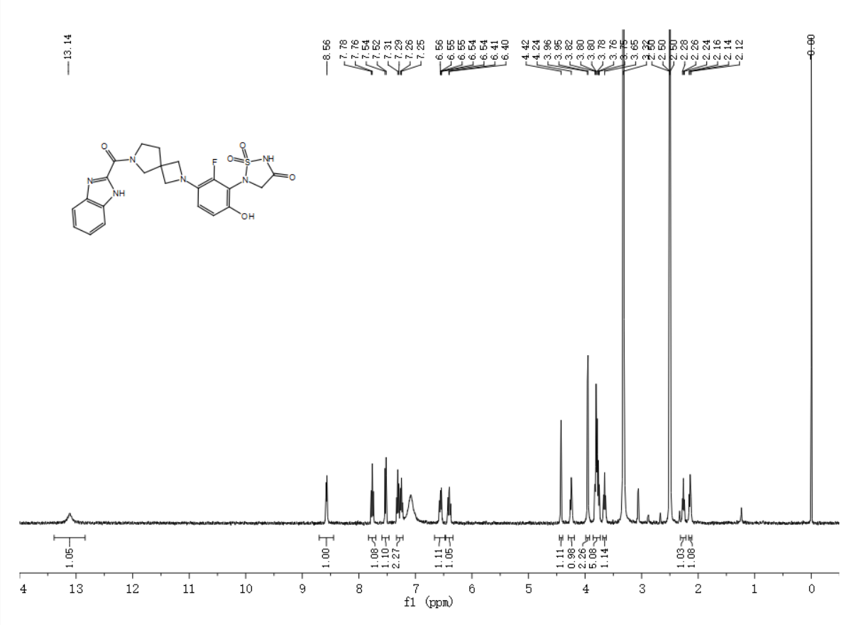5-(2-fluoro-6-hydroxy-3-(6-(5-methoxy-1H-indole-2-carbonyl)-2,6-diazaspiro[3.4]octan-2-yl)phenyl)-1,2,5-thiadiazolidin-3-one 1,1-dioxide（XTN-C3-034）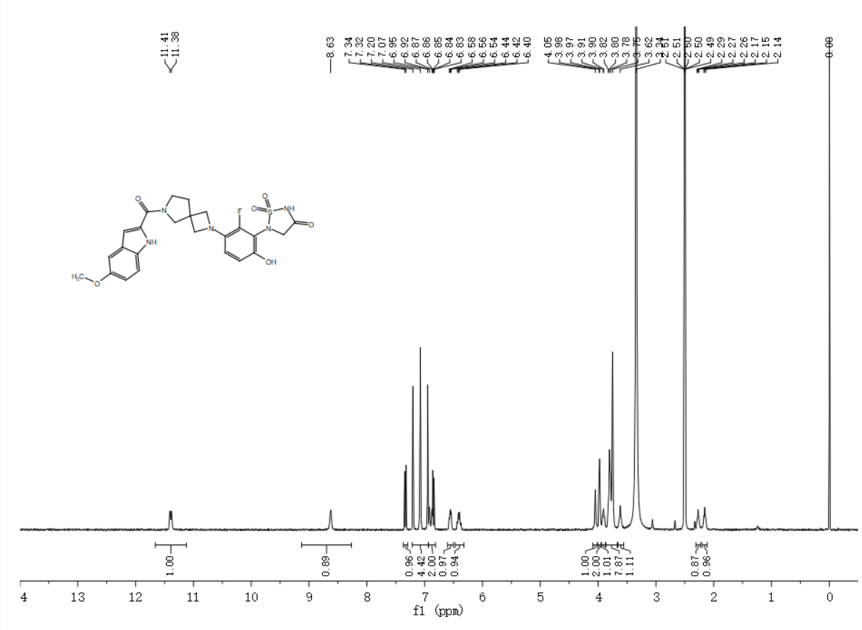5-(3-(6-(1H-pyrrolo[3,2-c]pyridine-3-carbonyl)-2,6-diazaspiro[3.4]octan-2-yl)-2-fluoro-6-hydroxyphenyl)-1,2,5-thiadiazolidin-3-one 1,1-dioxide（XTN-C3-037）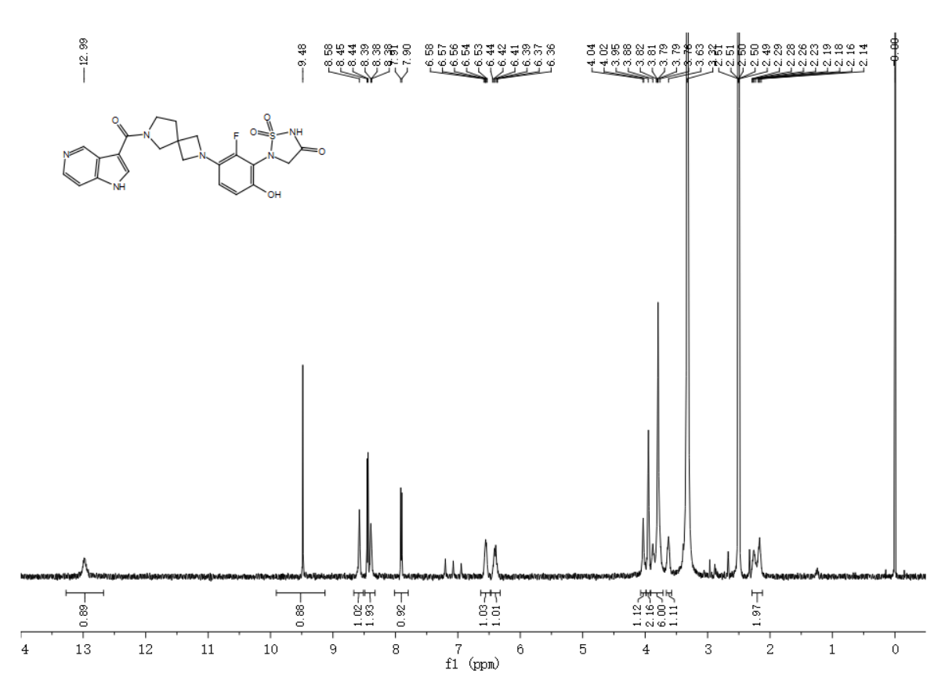5-(3-(6-(benzo[b]thiophene-3-carbonyl)-2,6-diazaspiro[3.4]octan-2-yl)-2-fluoro-6-hydroxyphenyl)-1,2,5-thiadiazolidin-3-one 1,1-dioxide（XTN-C3-039）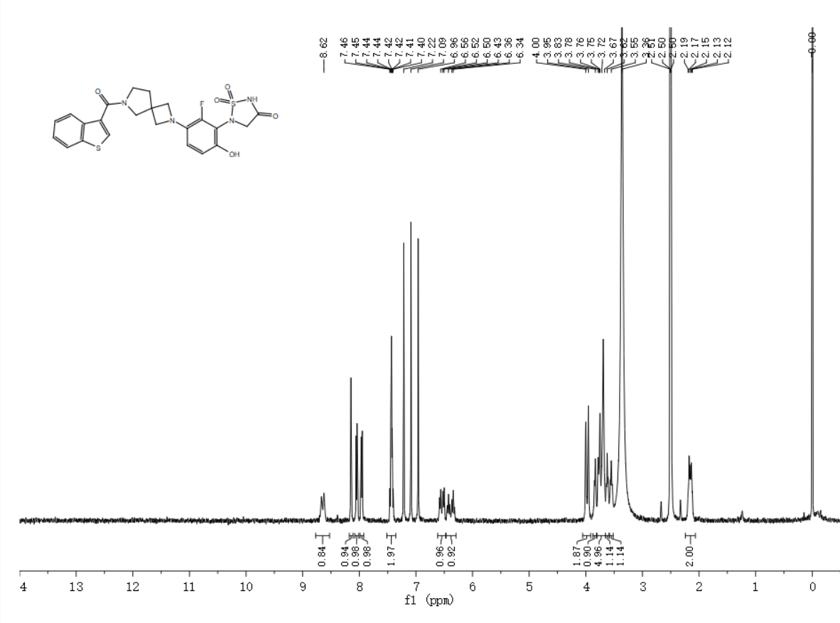5-(3-(6-(1H-indole-3-carbonyl)-2,6-diazaspiro[3.4]octan-2-yl)-2-fluoro-6-hydroxyphenyl)-1,2,5-thiadiazolidin-3-one 1,1-dioxide（XTN-C3-040）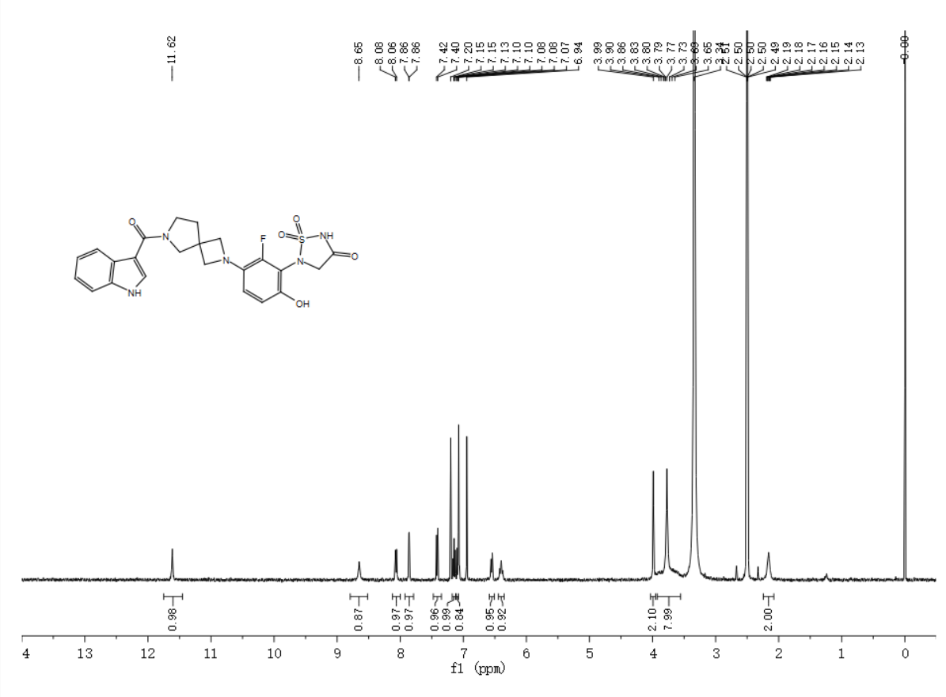3-(2-(3-(1,1-dioxido-4-oxo-1,2,5-thiadiazolidin-2-yl)-2-fluoro-4-hydroxyphenyl)-2,6-diazaspiro[3.4]octane-6-carbonyl)-1H-indole-6-carbonitrile （XTN-C3-041）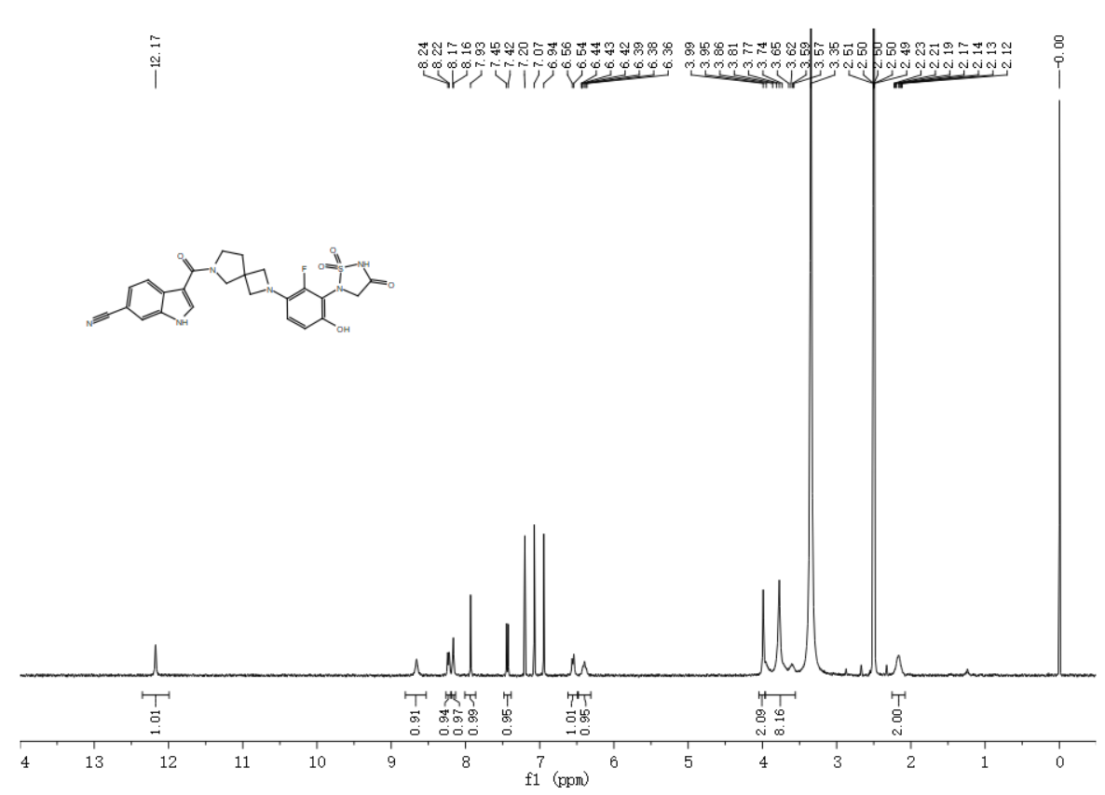5-(2-fluoro-6-hydroxy-3-(6-(5-methyl-1H-indole-3-carbonyl)-2,6-diazaspiro[3.4]octan-2-yl)phenyl)-1,2,5-thiadiazolidin-3-one 1,1-dioxide（XTN-C3-043）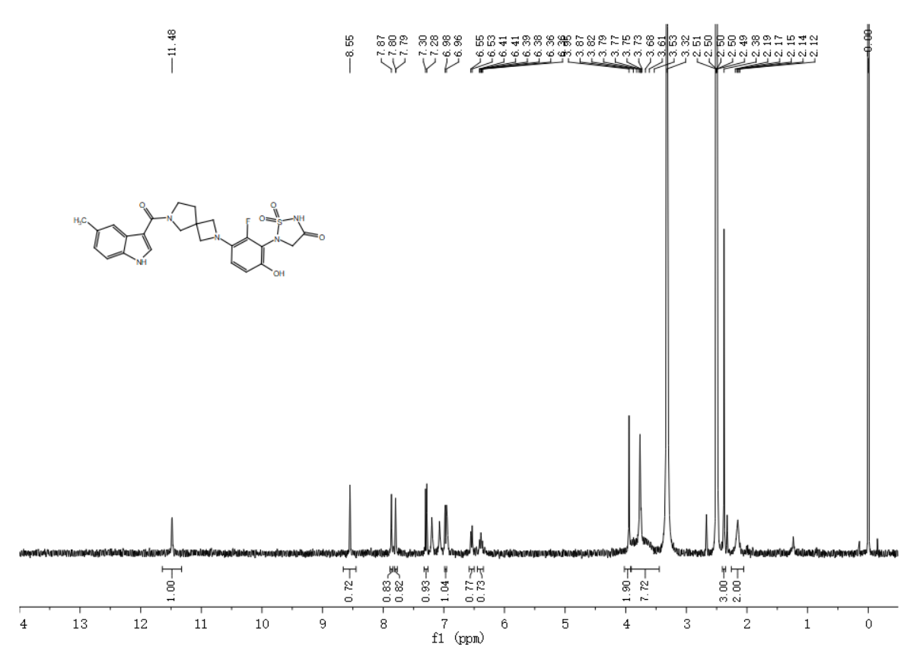5-(2-fluoro-6-hydroxy-3-(6-(6-methoxy-1H-indole-3-carbonyl)-2,6-diazaspiro[3.4]octan-2-yl)phenyl)-1,2,5-thiadiazolidin-3-one 1,1-dioxide（XTN-C3-044）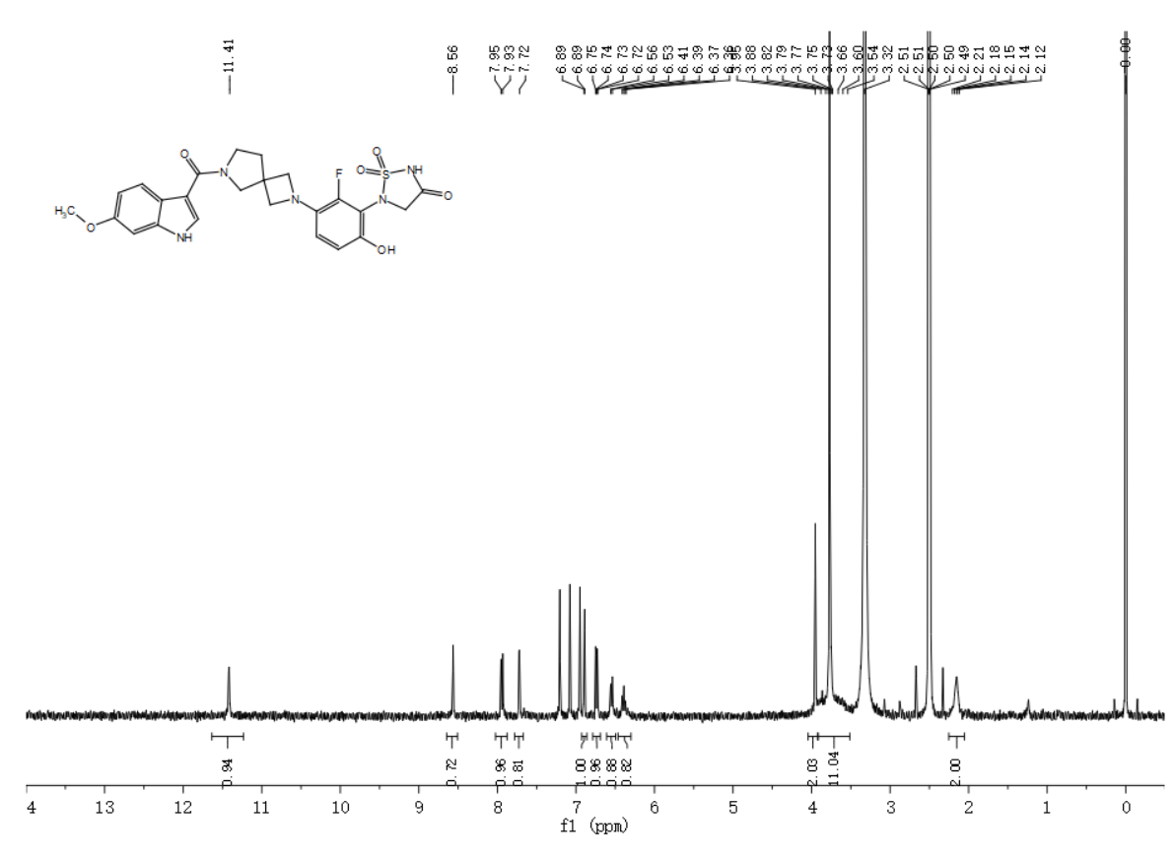5-(2-fluoro-6-hydroxy-3-(6-(5-methoxy-1H-indole-3-carbonyl)-2,6-diazaspiro[3.4]octan-2-yl)phenyl)-1,2,5-thiadiazolidin-3-one 1,1-dioxide（XTN-C3-045）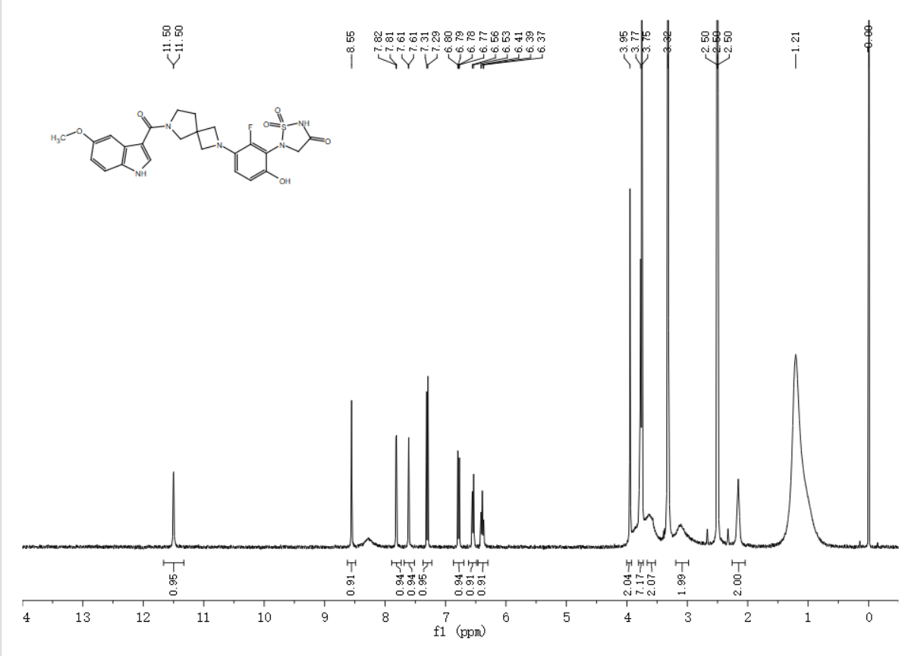5-(3-(6-(benzo[b]thiophene-2-carbonyl)-2,6-diazaspiro[3.4]octan-2-yl)-2-fluoro-6-hydroxyphenyl)-1,2,5-thiadiazolidin-3-one 1,1-dioxide（XTN-C3-048）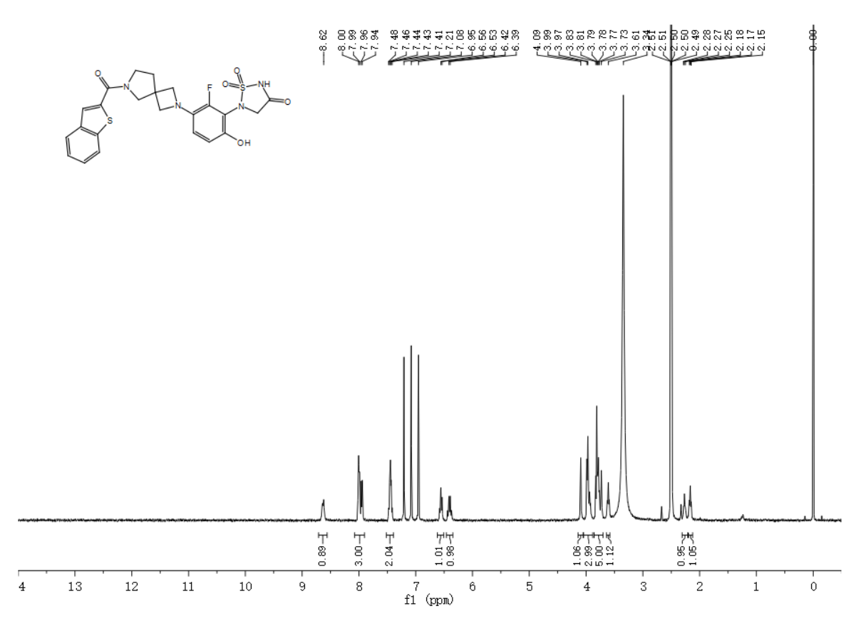5-(2-fluoro-6-hydroxy-3-(6-(2-methylthiazole-5-carbonyl)-2,6-diazaspiro[3.4]octan-2-yl)phenyl)-1,2,5-thiadiazolidin-3-one 1,1-dioxide（XTN-C3-050）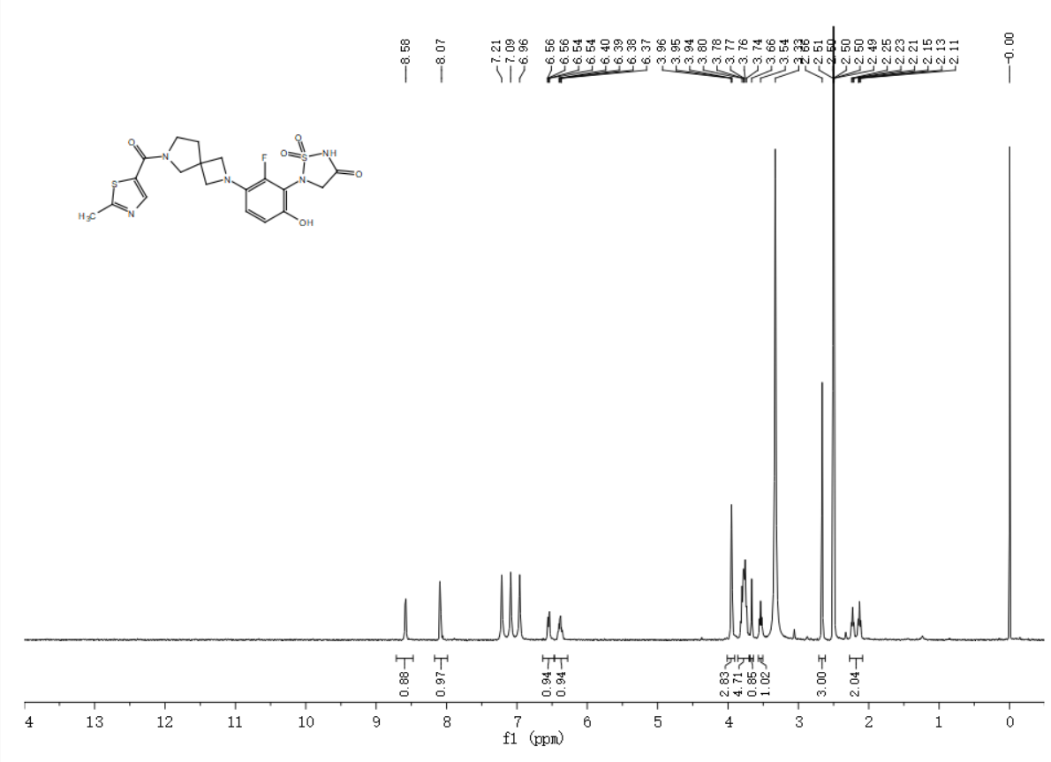5-(3-(6-(cyclopentanecarbonyl)-2,6-diazaspiro[3.4]octan-2-yl)-2-fluoro-6-hydroxyphenyl)-1,2,5-thiadiazolidin-3-one 1,1-dioxide（XTN-C3-052）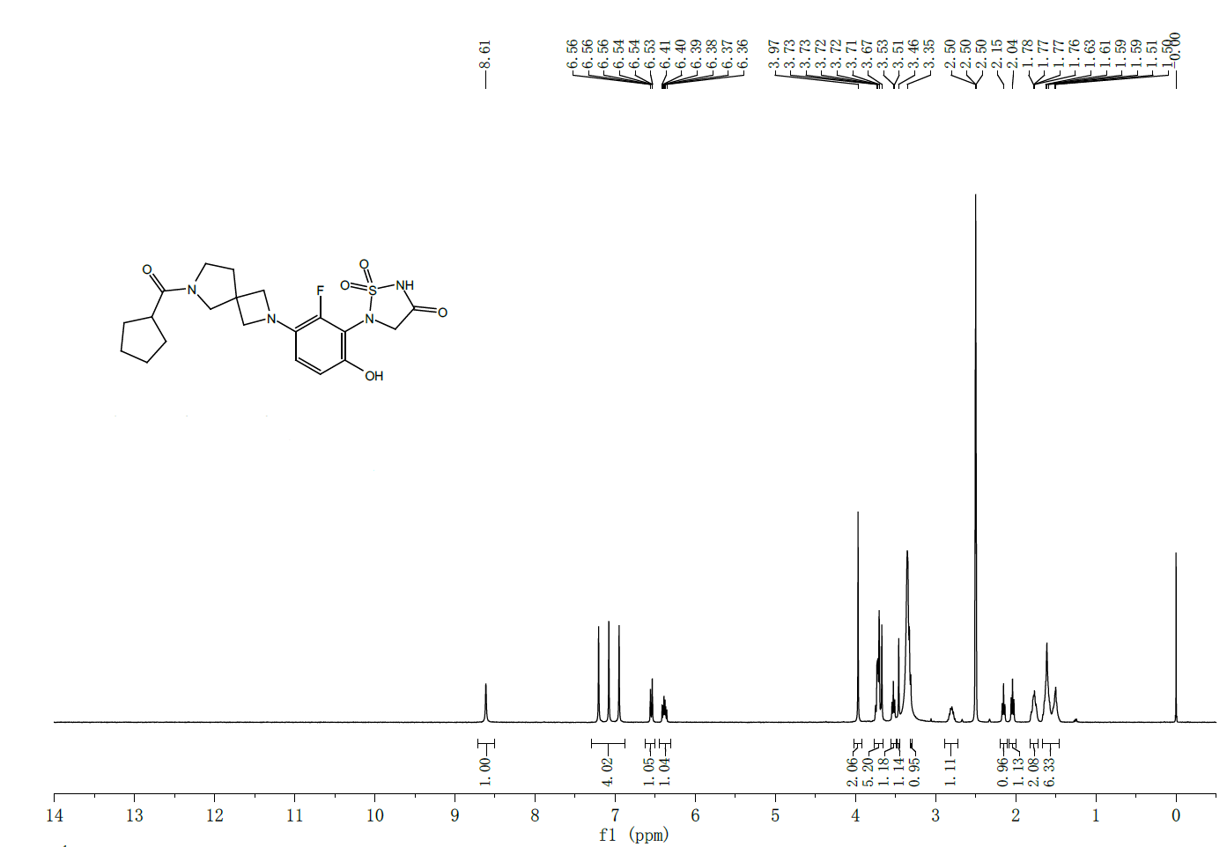5-(2-fluoro-6-hydroxy-3-(6-(5-methyl-1H-pyrazole-3-carbonyl)-2,6-diazaspiro[3.4]octan-2-yl)phenyl)-1,2,5-thiadiazolidin-3-one 1,1-dioxide（XTN-C3-059）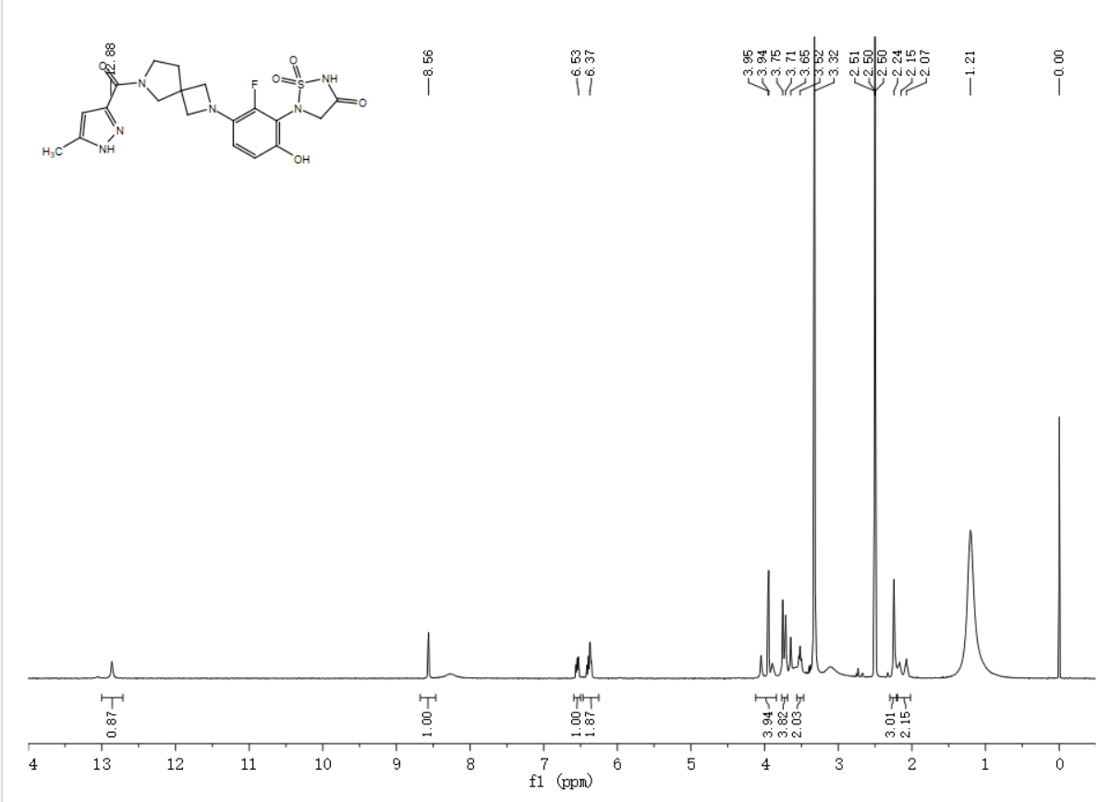5-(2-fluoro-6-hydroxy-3-(6-(1-methyl-1H-pyrazole-4-carbonyl)-2,6-diazaspiro[3.4]octan-2-yl)phenyl)-1,2,5-thiadiazolidin-3-one 1,1-dioxide（XTN-C3-062）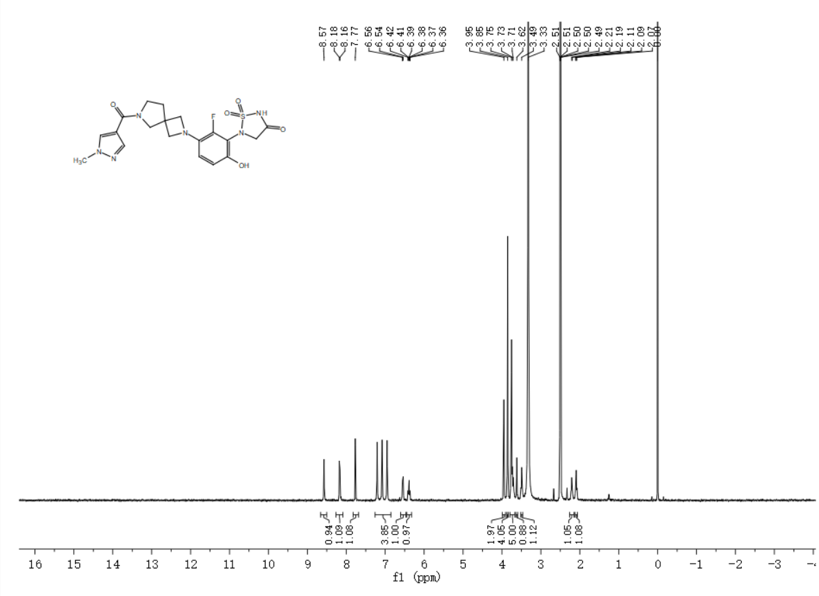5-(2-fluoro-6-hydroxy-3-(6-(pyrazolo[1,5-a]pyridine-3-carbonyl)-2,6-diazaspiro[3.4]octan-2-yl)phenyl)-1,2,5-thiadiazolidin-3-one 1,1-dioxide（XTN-C3-065）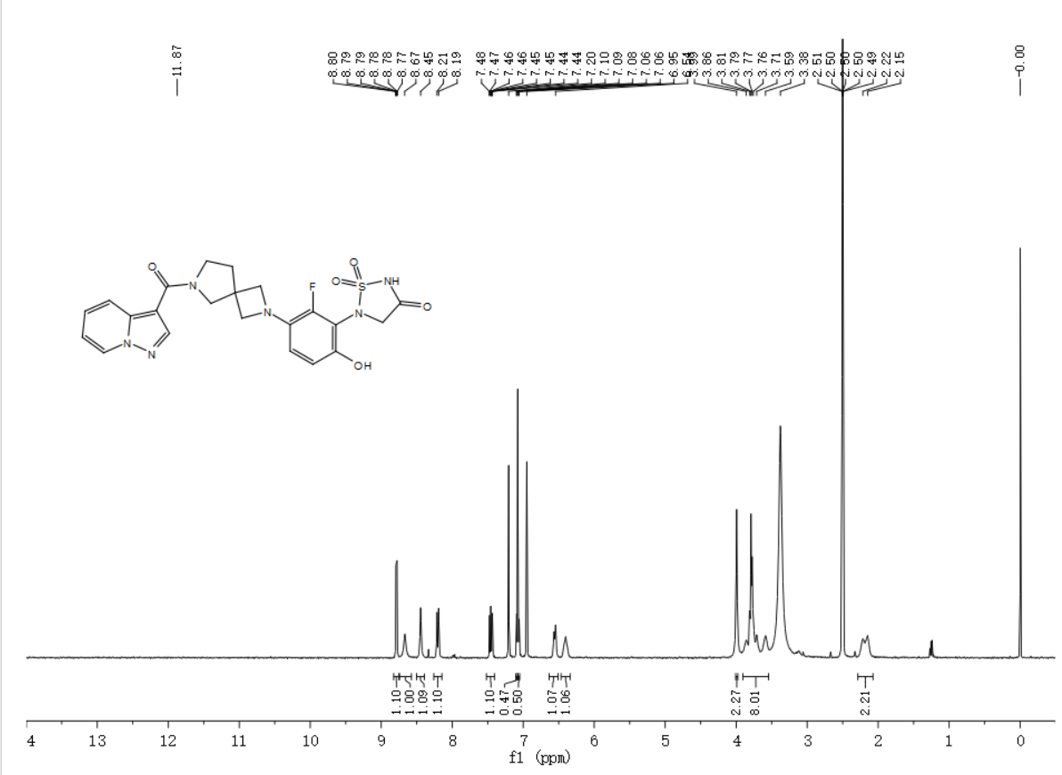5-(3-(6-(4H-thieno[3,2-b]pyrrole-5-carbonyl)-2,6-diazaspiro[3.4]octan-2-yl)-2-fluoro-6-hydroxyphenyl)-1,2,5-thiadiazolidin-3-one 1,1-dioxide（XTN-C3-073）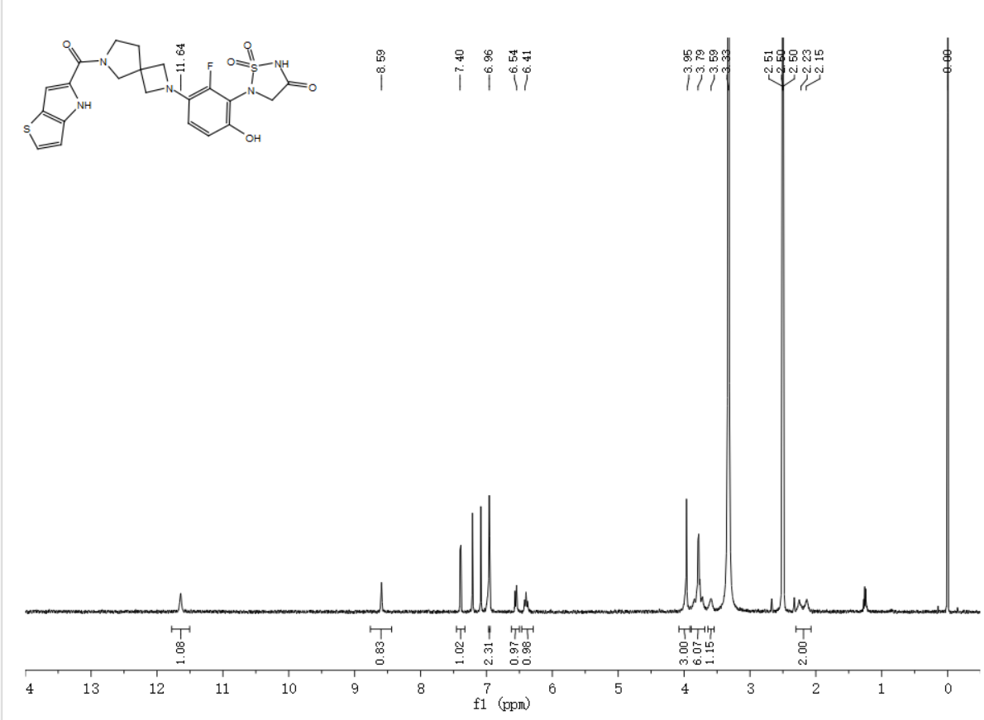5-(3-(6-(2,3-dihydro-1H-indene-1-carbonyl)-2,6-diazaspiro[3.4]octan-2-yl)-2-fluoro-6-hydroxyphenyl)-1,2,5-thiadiazolidin-3-one 1,1-dioxide（XTN-C3-075）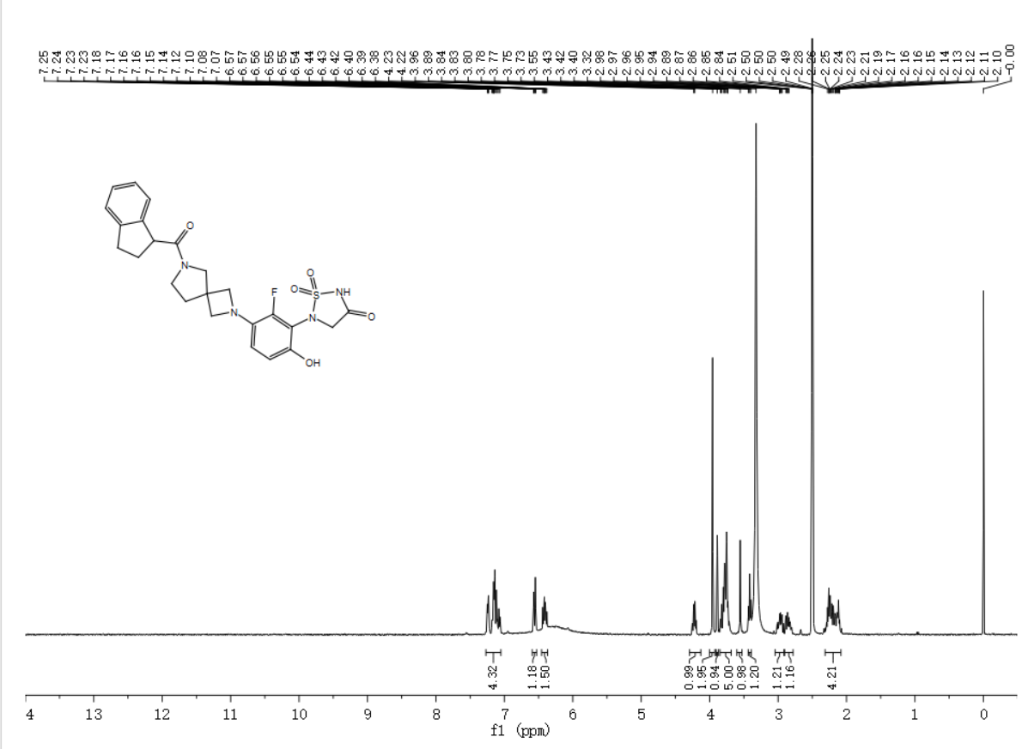5-(2-fluoro-6-hydroxy-3-(6-(2-methyloxazole-4-carbonyl)-2,6-diazaspiro[3.4]octan-2-yl)phenyl)-1,2,5-thiadiazolidin-3-one 1,1-dioxide（XTN-C3-091）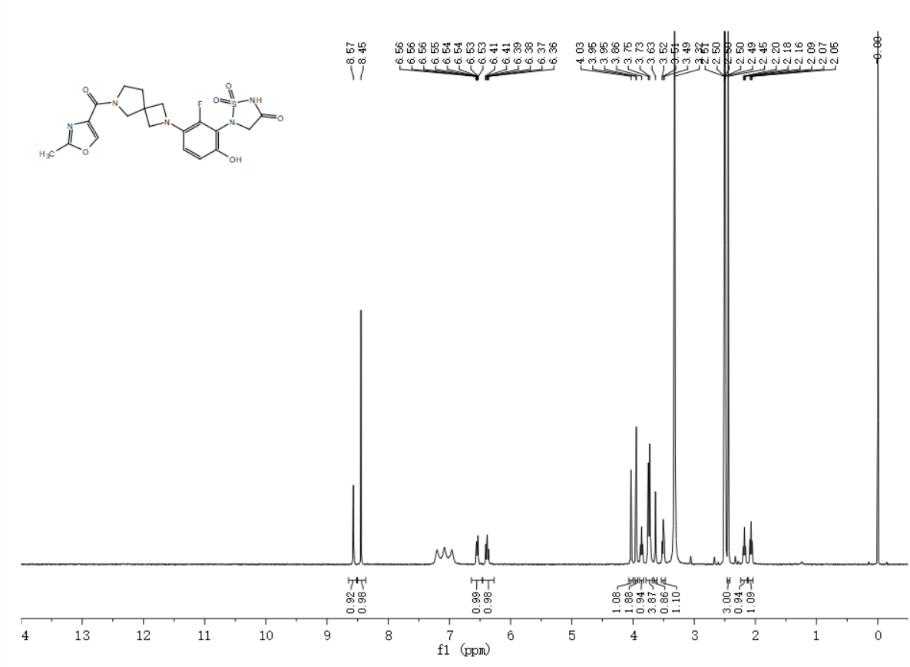5-(2-fluoro-6-hydroxy-3-(6-(1-phenyl-1H-pyrazole-4-carbonyl)-2,6-diazaspiro[3.4]octan-2-yl)phenyl)-1,2,5-thiadiazolidin-3-one 1,1-dioxide（XTN-C3-096）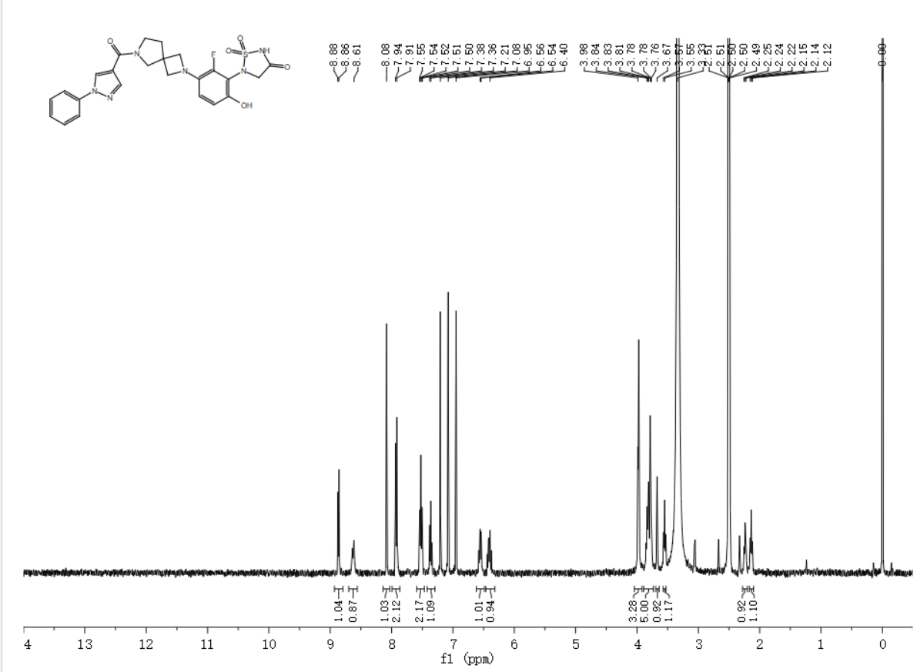5-(2-fluoro-6-hydroxy-3-(6-(1-methylcyclopropane-1-carbonyl)-2,6-diazaspiro[3.4]octan-2-yl)phenyl)-1,2,5-thiadiazolidin-3-one 1,1-dioxide（XTN-C3-103）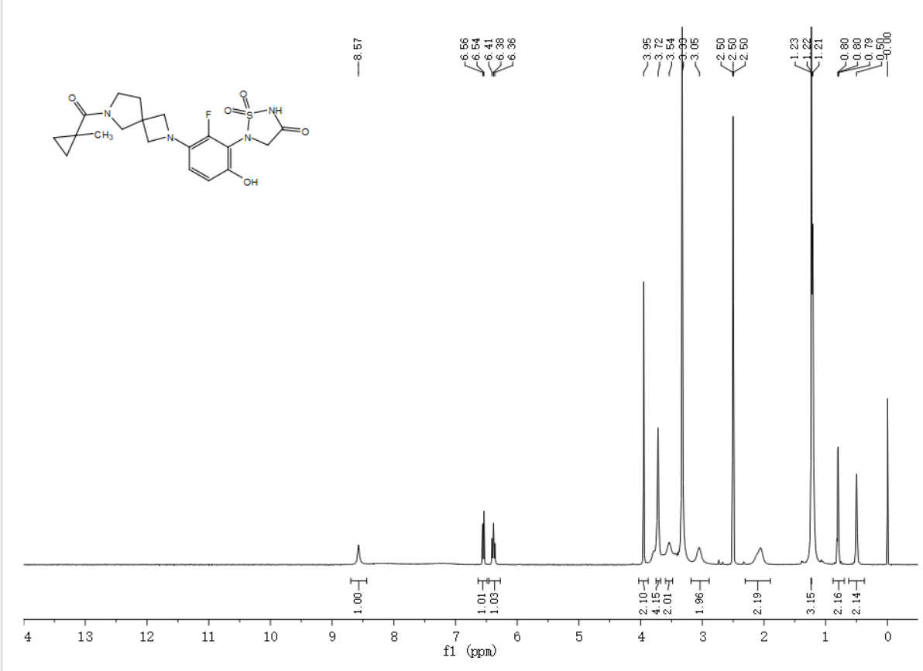5-(2-fluoro-6-hydroxy-3-(6-(1-methyl-1H-indole-3-carbonyl)-2,6-diazaspiro[3.4]octan-2-yl)phenyl)-1,2,5-thiadiazolidin-3-one 1,1-dioxide （XTN-C3-109）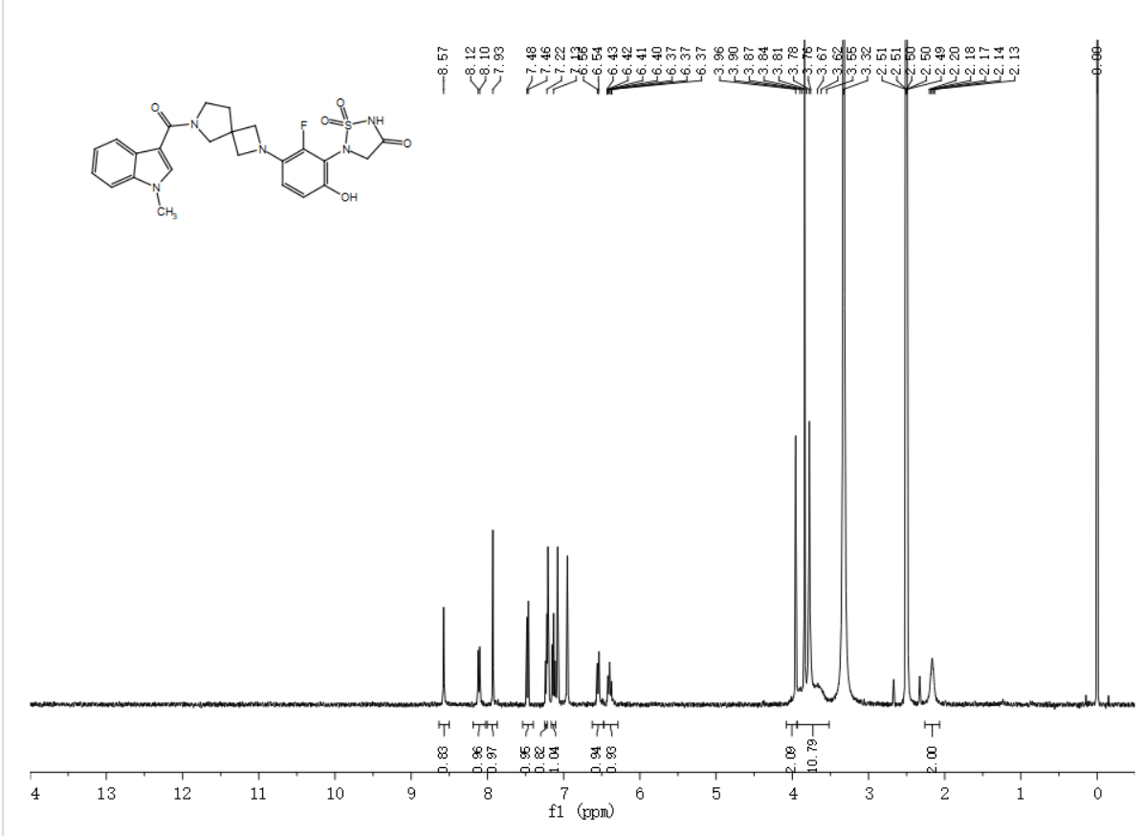5-(2-fluoro-6-hydroxy-3-(6-(3-phenylcyclobutane-1-carbonyl)-2,6-diazaspiro[3.4]octan-2-yl)phenyl)-1,2,5-thiadiazolidin-3-one 1,1-dioxide（XTN-C3-115）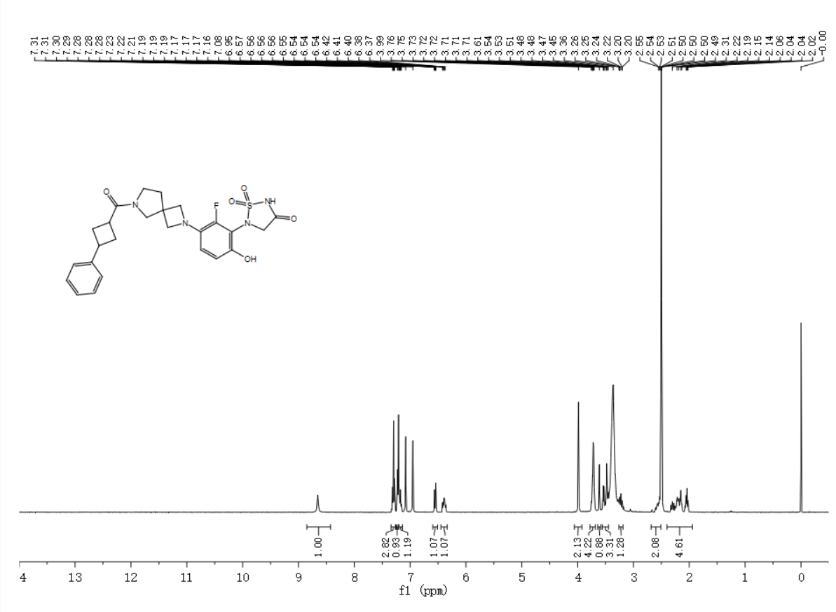5-(3-(2-(1H-indole-2-carbonyl)-2,6-diazaspiro[3.4]octan-6-yl)-2-fluoro-6-hydroxyphenyl)-1,2,5-thiadiazolidin-3-one 1,1-dioxide（XTN-D4-022）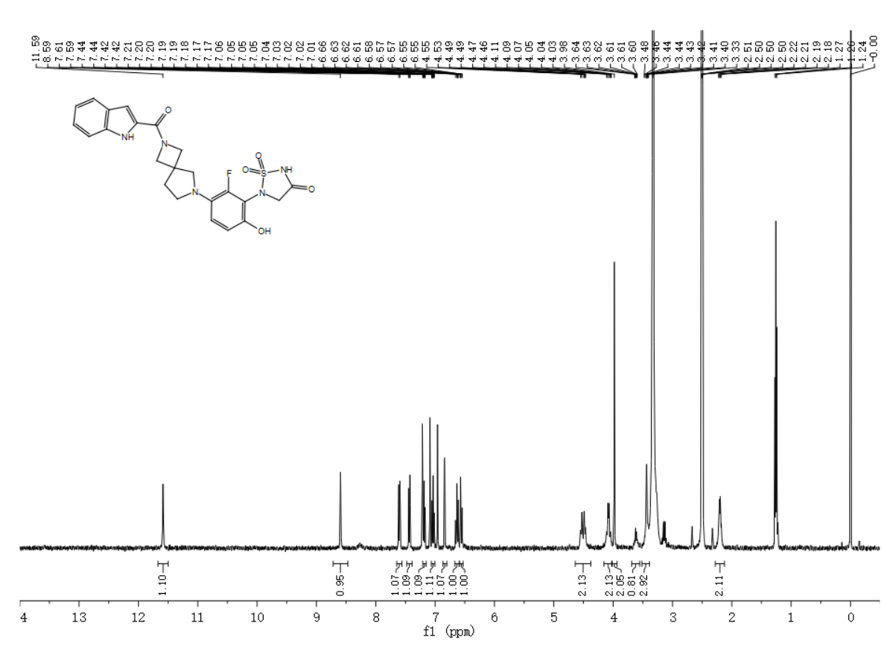5-(2-fluoro-6-hydroxy-3-(2-(7-methyl-1H-indole-2-carbonyl)-2,6-diazaspiro[3.4]octan-6-yl)phenyl)-1,2,5-thiadiazolidin-3-one 1,1-dioxide（XTN-D4-025）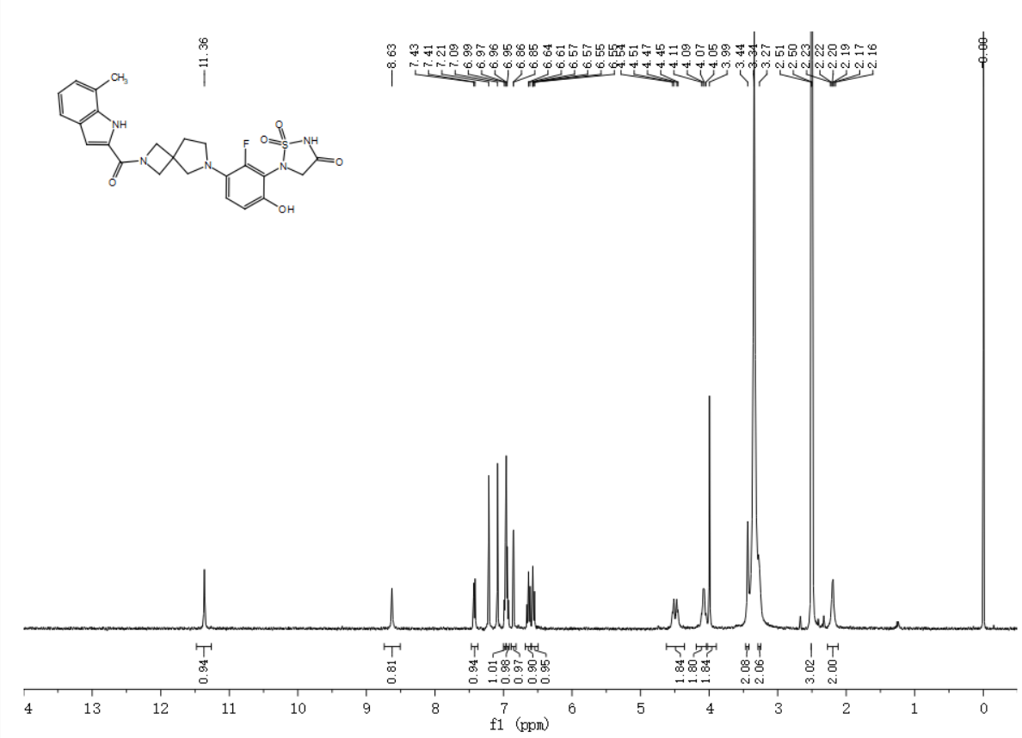5-(3-(2-(5,7-difluoro-1H-indole-2-carbonyl)-2,6-diazaspiro[3.4]octan-6-yl)-2-fluoro-6-hydroxyphenyl)-1,2,5-thiadiazolidin-3-one 1,1-dioxide（XTN-D4-032）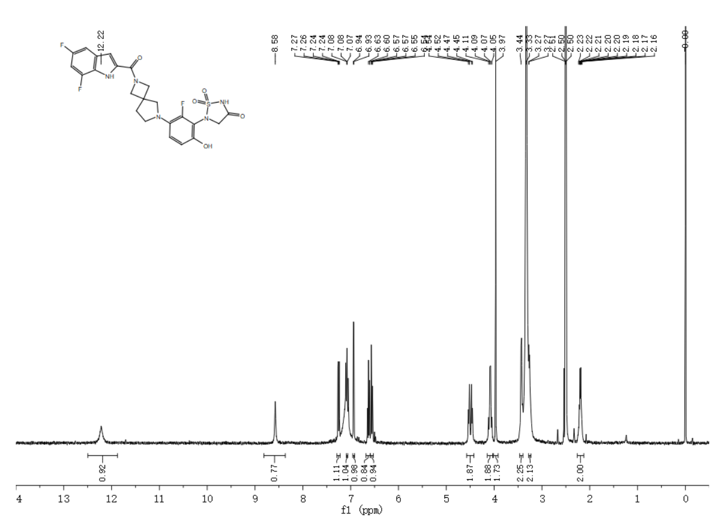5-(2-fluoro-6-hydroxy-3-(2-(5-methyl-1H-indole-2-carbonyl)-2,6-diazaspiro[3.4]octan-6-yl)phenyl)-1,2,5-thiadiazolidin-3-one 1,1-dioxide（XTN-D4-033）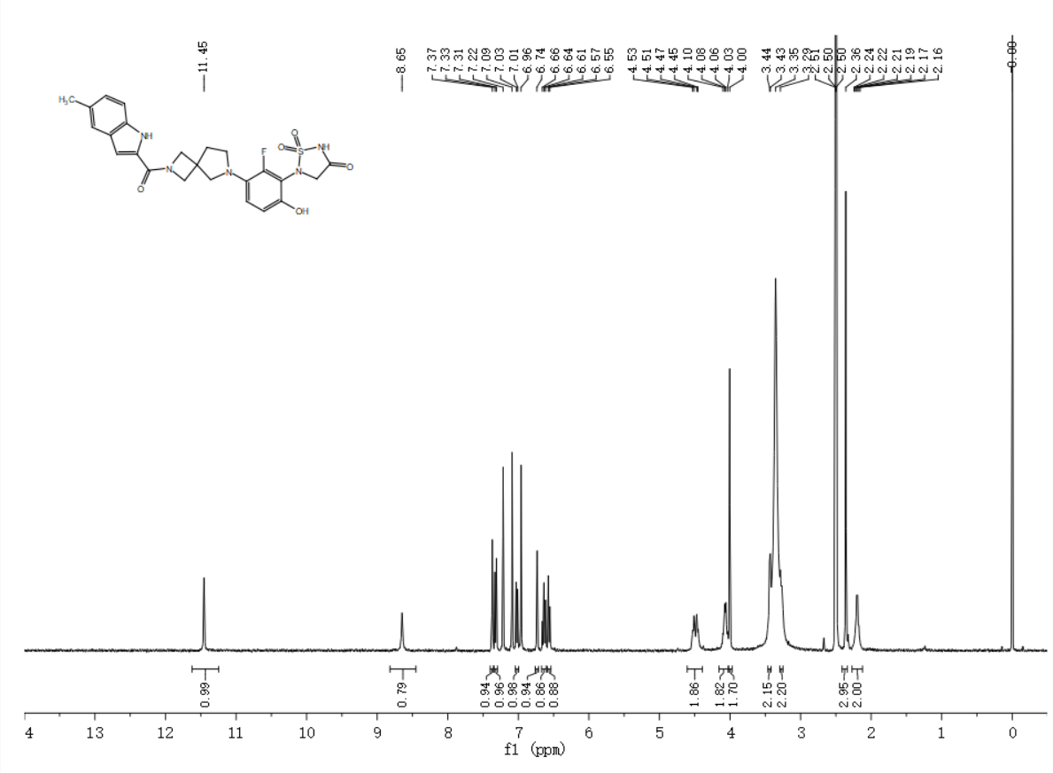5-(2-fluoro-6-hydroxy-3-(2-(5-methoxy-1H-indole-2-carbonyl)-2,6-diazaspiro[3.4]octan-6-yl)phenyl)-1,2,5-thiadiazolidin-3-one 1,1-dioxide（XTN-D4-034）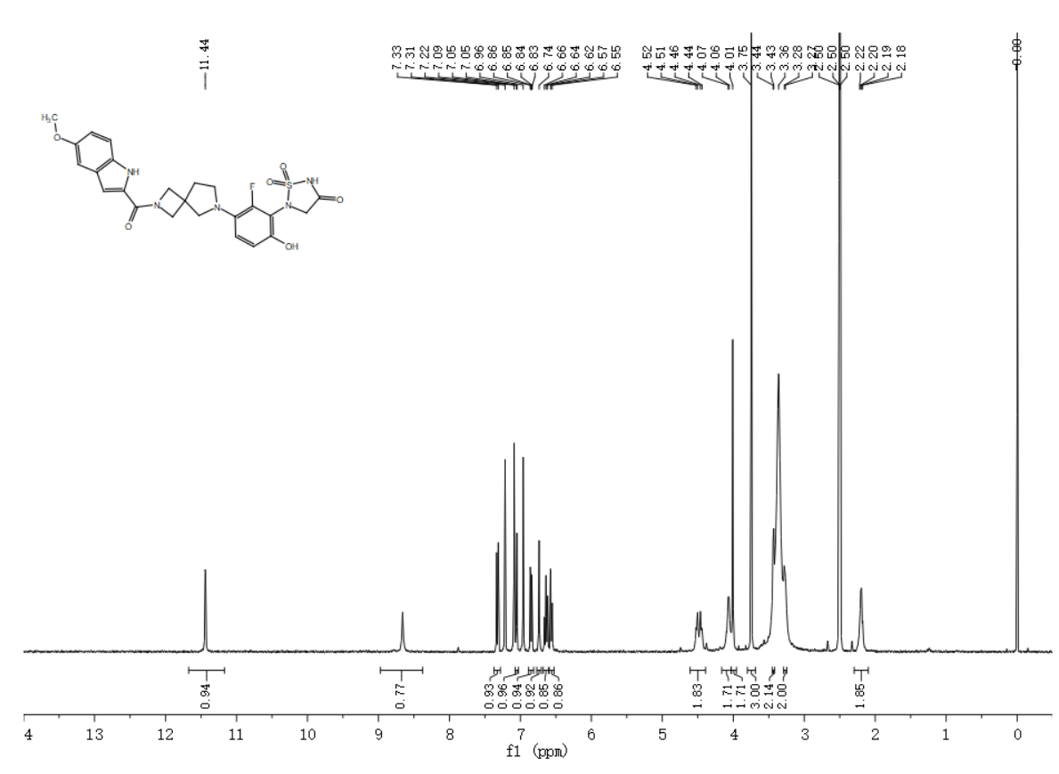5-(2-fluoro-6-hydroxy-3-(2-(6-methyl-1H-indole-3-carbonyl)-2,6-diazaspiro[3.4]octan-6-yl)phenyl)-1,2,5-thiadiazolidin-3-one 1,1-dioxide（XTN-D4-046）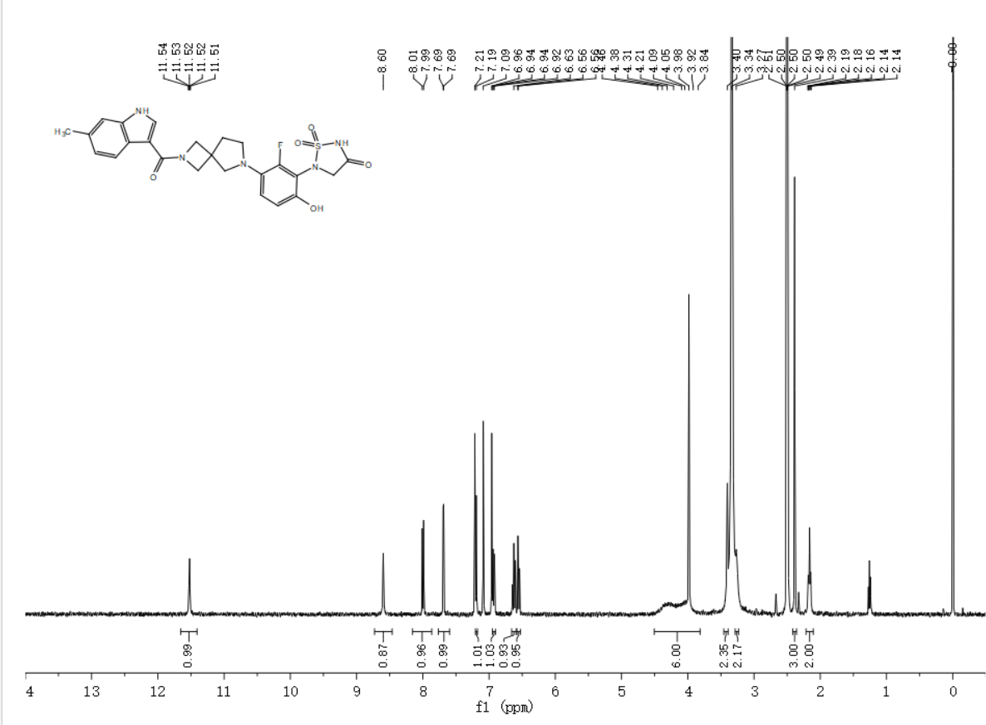5-(2-fluoro-6-hydroxy-3-(2-(4-methyl-2-(pyridin-3-yl)thiazole-5-carbonyl)-2,6-diazaspiro[3.4]octan-6-yl)phenyl)-1,2,5-thiadiazolidin-3-one 1,1-dioxide（XTN-D4-086）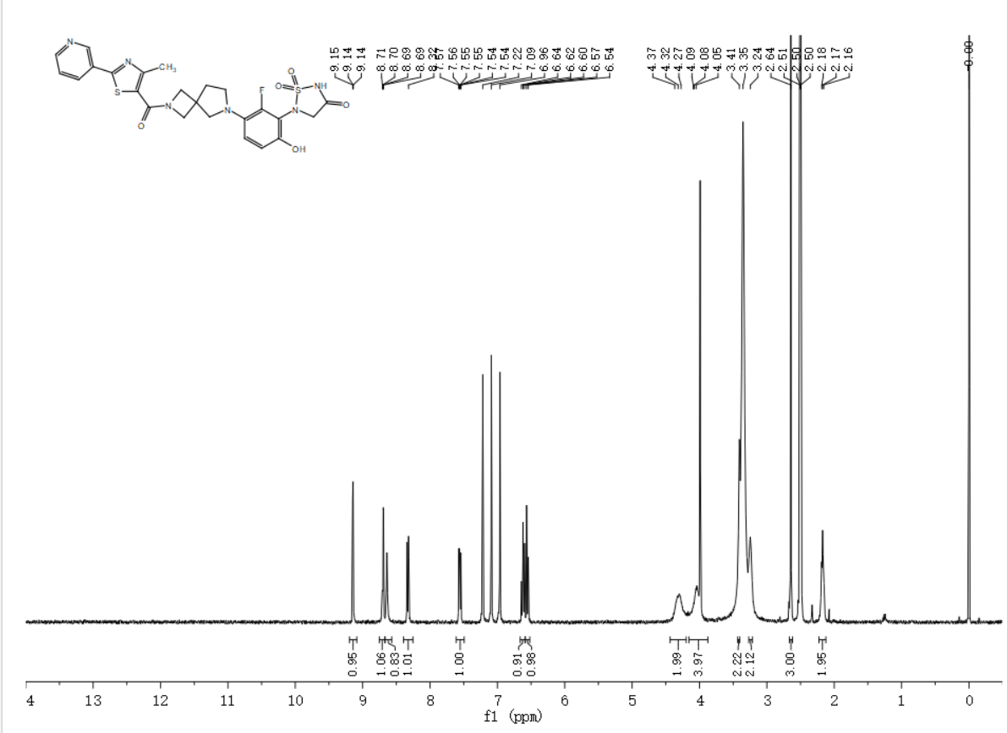5-(2-fluoro-6-hydroxy-3-(2-(1-methyl-1H-indole-3-carbonyl)-2,6-diazaspiro[3.4]octan-6-yl)phenyl)-1,2,5-thiadiazolidin-3-one 1,1-dioxide（XTN-D4-109）

methyl 4-((2-(3-(1,1-dioxido-4-oxo-1,2,5-thiadiazolidin-2-yl)-2-fluoro-4-hydroxyphenyl)-2-azaspiro[3.3]heptan-6-yl)carbamoyl)bicyclo[2.2.1]heptane-1-carboxylate（XTN-E5-012）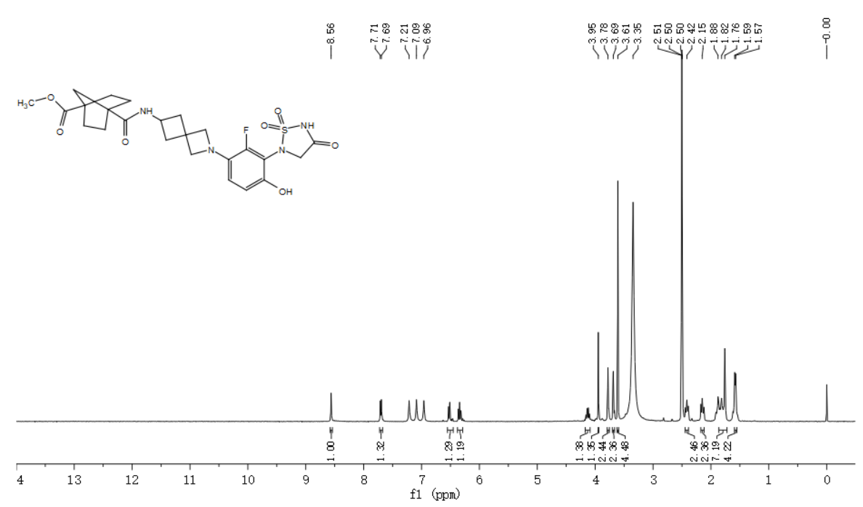
N-(2-(3-(1,1-dioxido-4-oxo-1,2,5-thiadiazolidin-2-yl)-2-fluoro-4-hydroxyphenyl)-2-azaspiro[3.3]heptan-6-yl)-1-(4-fluorophenyl)cyclopropane-1-carboxamide（XTN-E5-019）
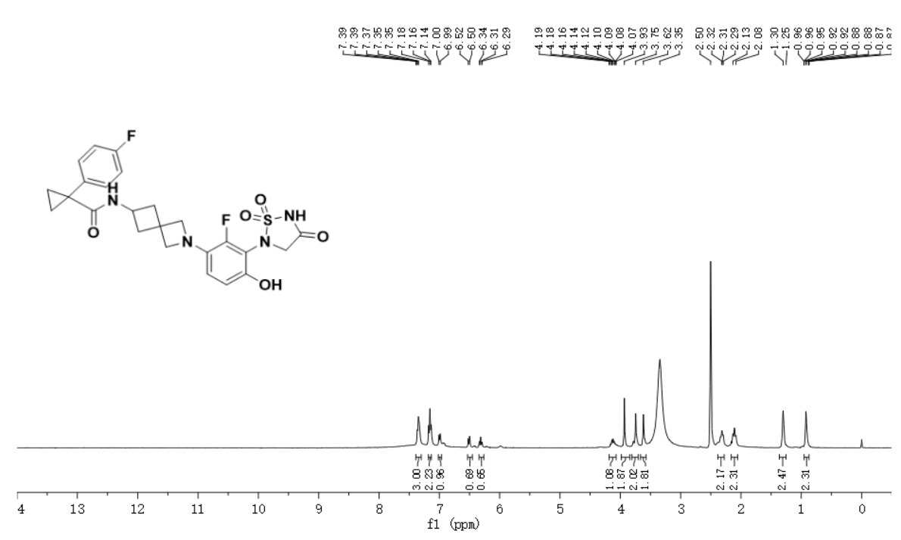N-(2-(3-(1,1-dioxido-4-oxo-1,2,5-thiadiazolidin-2-yl)-2-fluoro-4-hydroxyphenyl)-2-azaspiro[3.3]heptan-6-yl)-1-phenylcyclopentane-1-carboxamide（XTN-E5-021）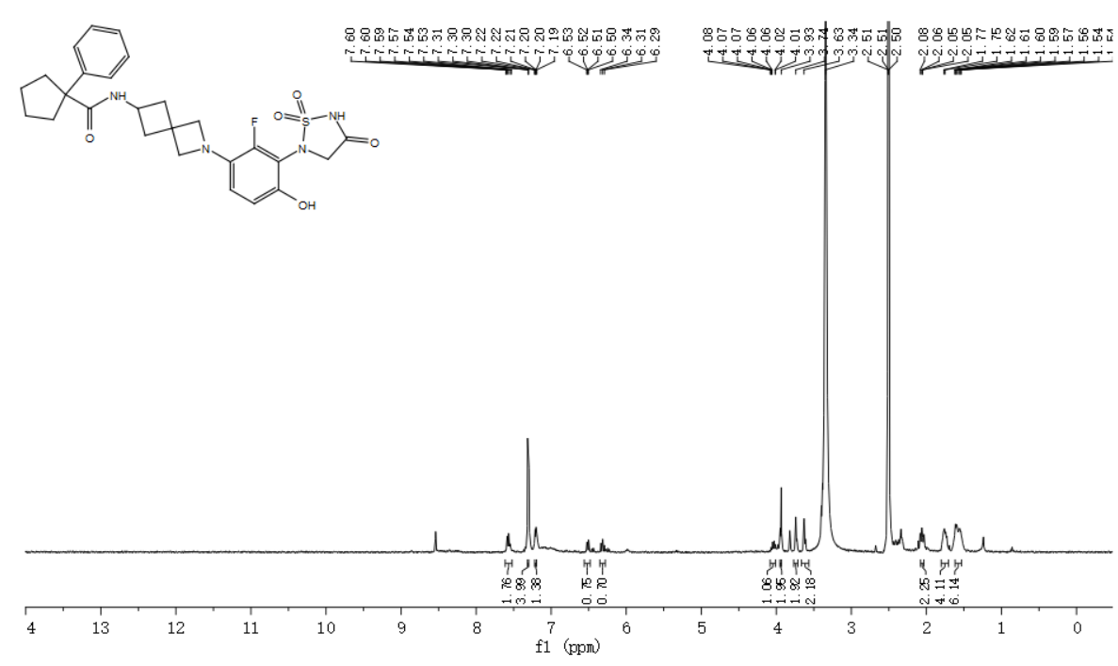 N-(2-(3-(1,1-dioxido-4-oxo-1,2,5-thiadiazolidin-2-yl)-2-fluoro-4-hydroxyphenyl)-2-azaspiro[3.3]heptan-6-yl)-1-methyl-1H-pyrazolo[3,4-b]pyridine-3-carboxamide（XTN-E5-108）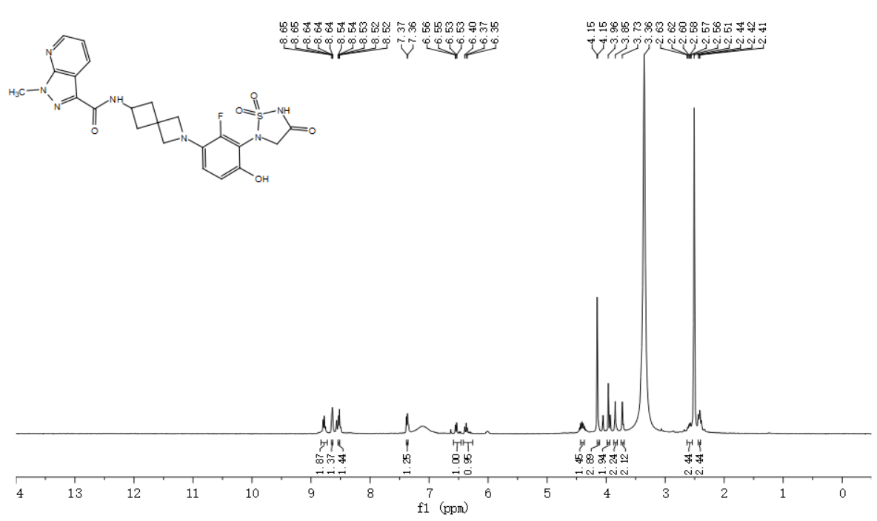N-(2-(3-(1,1-dioxido-4-oxo-1,2,5-thiadiazolidin-2-yl)-2-fluoro-4-hydroxyphenyl)-2-azaspiro[3.3]heptan-6-yl)spiro[3.3]heptane-2-carboxamide（XTN-E5-114）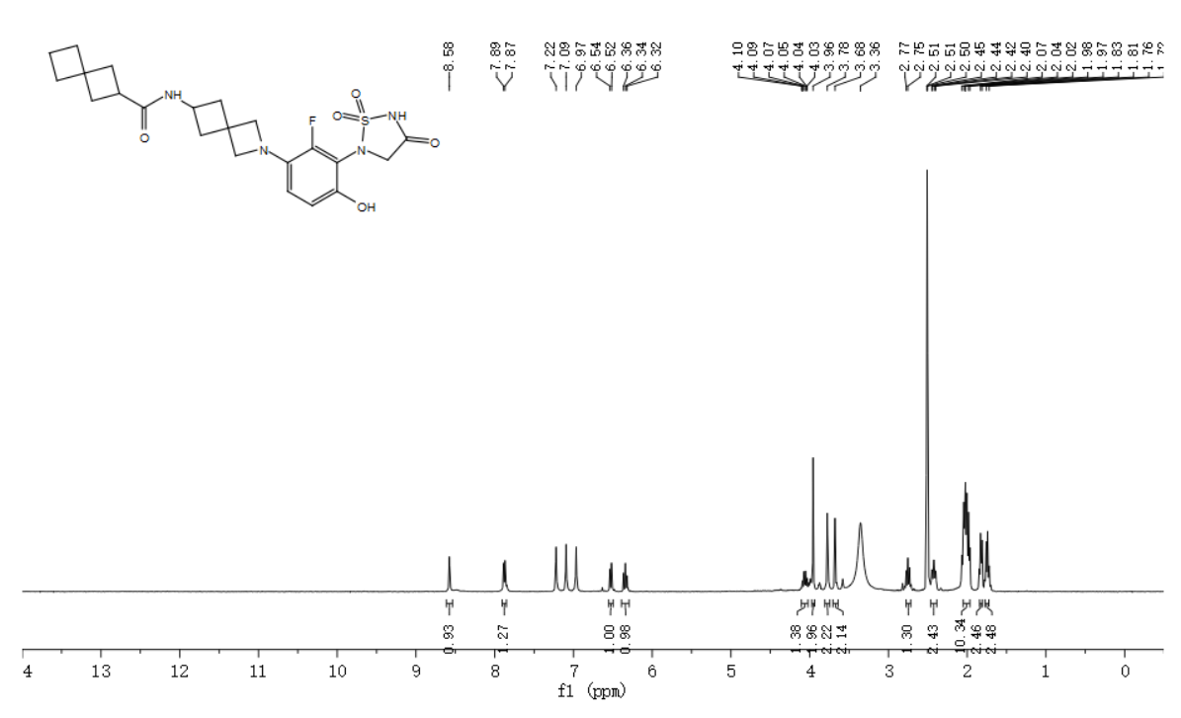
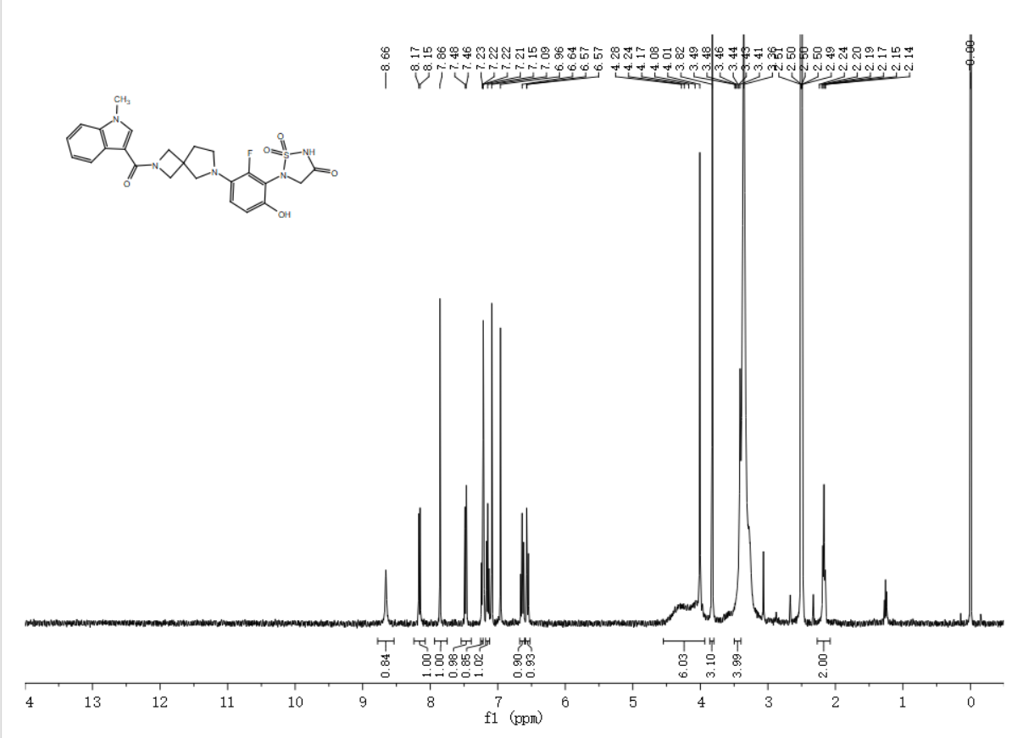

5-(2-fluoro-6-hydroxy-3-(5-(1-hydroxycyclobutane-1-carbonyl)hexahydropyrrolo[3,4-c]pyrrol-2(1H)-yl)phenyl)-1,2,5-thiadiazolidin-3-one 1,1-dioxide（XTN-F6-001）
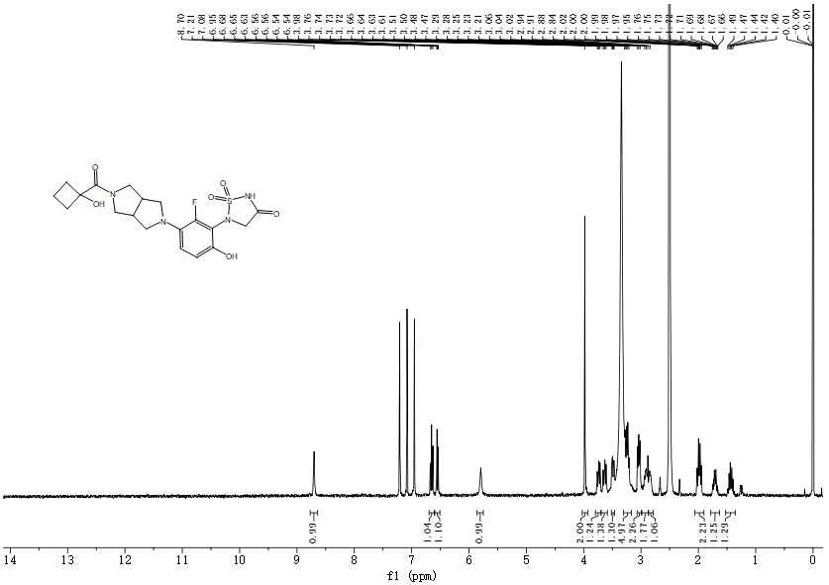

5-(2-fluoro-6-hydroxy-3-(5-(2-(4-methoxyphenyl)cyclopropane-1-carbonyl)hexahydropyrrolo[3,4-c]pyrrol-2(1H)-yl)phenyl)-1,2,5-thiadiazolidin-3-one 1,1-dioxide（XTN-F6-007）
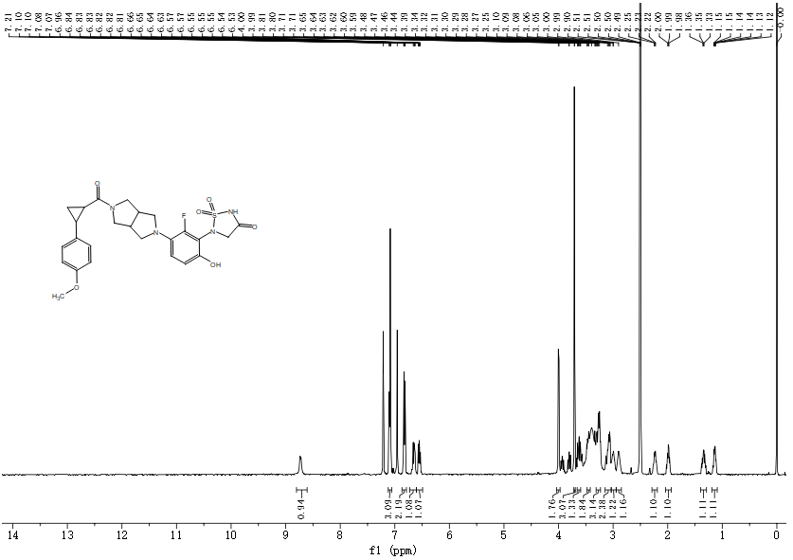

5-(2-fluoro-6-hydroxy-3-(5-(1-phenylcyclopentane-1-carbonyl)hexahydropyrrolo[3,4-c]pyrrol-2(1H)-yl)phenyl)-1,2,5-thiadiazolidin-3-one 1,1-dioxide（XTN-F6-021）
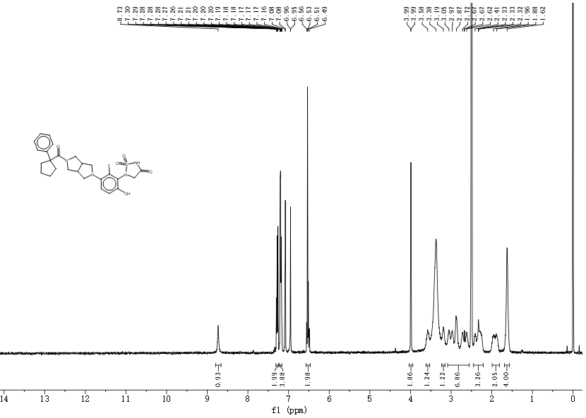

5-(3-(5-(1H-indole-2-carbonyl)hexahydropyrrolo[3,4-c]pyrrol-2(1H)-yl)-2-fluoro-6-hydroxyphenyl)-1,2,5-thiadiazolidin-3-one 1,1-dioxide（XTN-F6-022）
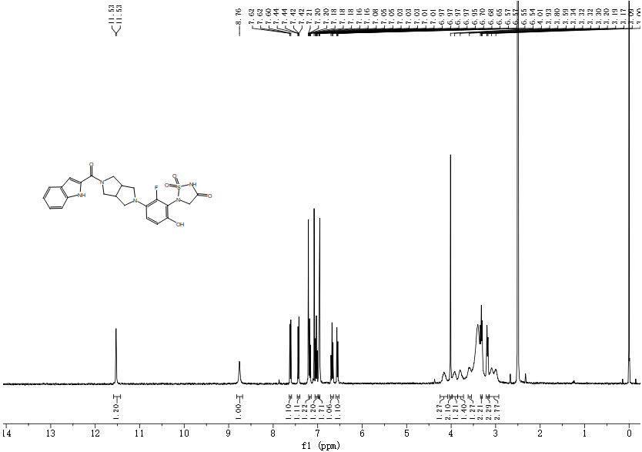

5-(3-(5-(1H-pyrrolo[3,2-b]pyridine-3-carbonyl)hexahydropyrrolo[3,4-c]pyrrol-2(1H)-yl)-2-fluoro-6-hydroxyphenyl)-1,2,5-thiadiazolidin-3-one 1,1-dioxide（XTN-F6-042）
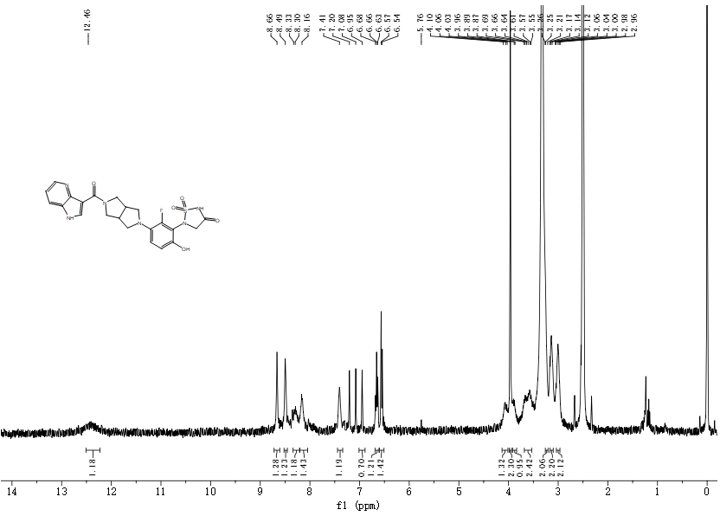

5-(3-(5-(benzo[b]thiophene-2-carbonyl)hexahydropyrrolo[3,4-c]pyrrol-2(1H)-yl)-2-fluoro-6-hydroxyphenyl)-1,2,5-thiadiazolidin-3-one 1,1-dioxide（XTN-F6-048）
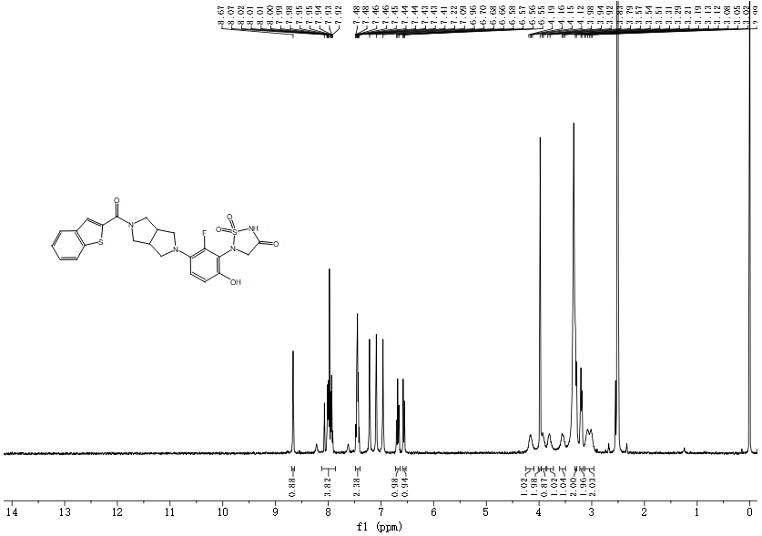

5-(2-fluoro-6-hydroxy-3-(5-(pyrazolo[1,5-a]pyrimidine-3-carbonyl)hexahydropyrrolo[3,4-c]pyrrol-2(1H)-yl)phenyl)-1,2,5-thiadiazolidin-3-one 1,1-dioxide（XTN-F6-063）
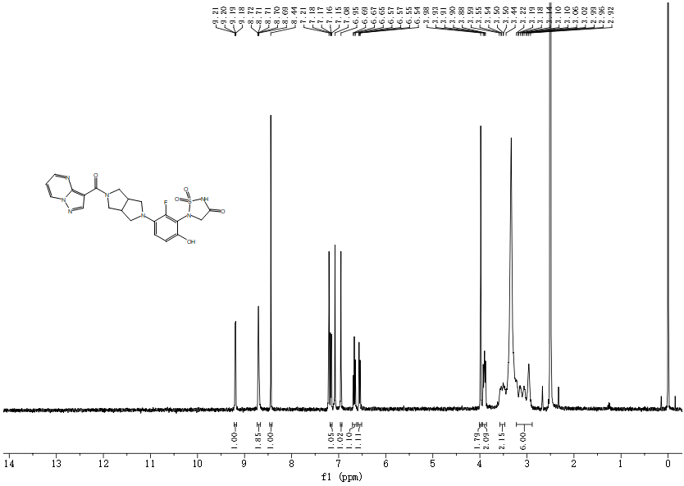

5-(2-fluoro-6-hydroxy-3-(5-(pyrazolo[1,5-a]pyridine-3-carbonyl)hexahydropyrrolo[3,4-c]pyrrol-2(1H)-yl)phenyl)-1,2,5-thiadiazolidin-3-one 1,1-dioxide（XTN-F6-065）
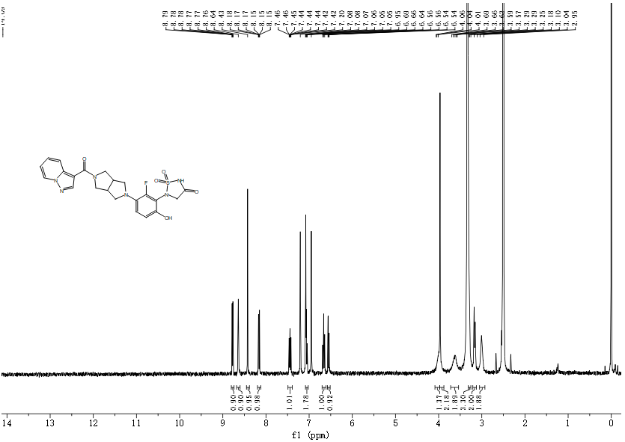

5-(2-fluoro-6-hydroxy-3-(5-(4-methyl-2-(pyridin-3-yl)thiazole-5-carbonyl)hexahydropyrrolo[3,4-c]pyrrol-2(1H)-yl)phenyl)-1,2,5-thiadiazolidin-3-one 1,1-dioxide（XTN-F6-086）
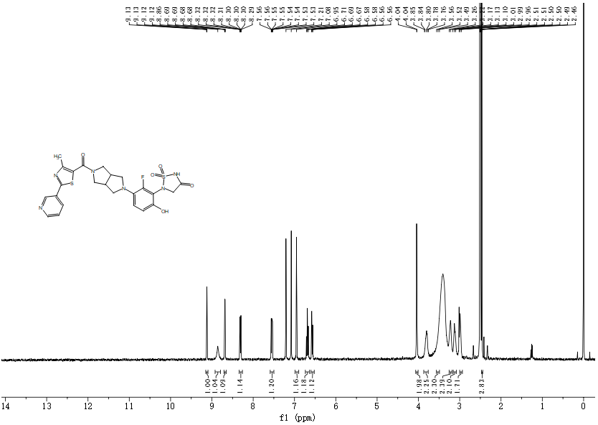

5-(2-fluoro-6-hydroxy-3-(5-(1-methyl-1H-indole-3-carbonyl)hexahydropyrrolo[3,4-c]pyrrol-2(1H)-yl)phenyl)-1,2,5-thiadiazolidin-3-one 1,1-dioxide（XTN-F6-109）
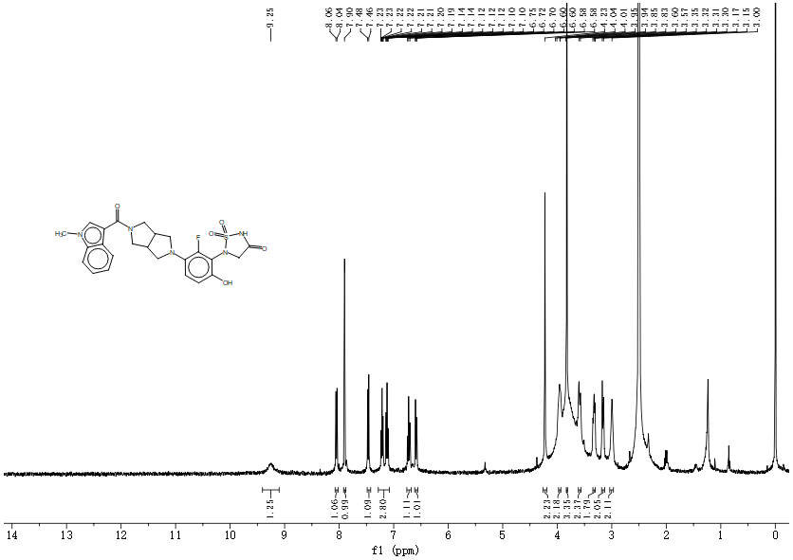

5-(2-fluoro-6-hydroxy-3-(5-(4,5,6,7-tetrahydrobenzo[b]thiophene-2-carbonyl)hexahydropyrrolo[3,4-c]pyrrol-2(1H)-yl)phenyl)-1,2,5-thiadiazolidin-3-one 1,1-dioxide（XTN-F6-110）
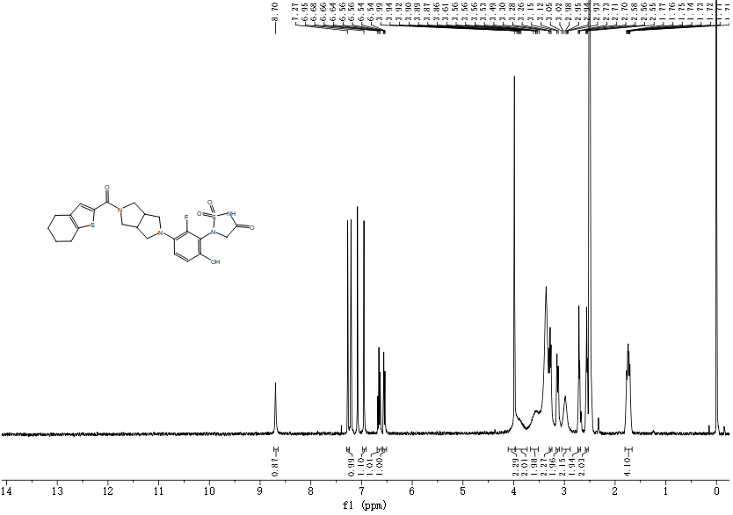

5. Invitrogen IC₅₀ Titration Curves
Reference compound：ABBV-CLS-484 (https://www.targetmol.cn/compound/abbv-cls-484)
ABBV-CLS-484

Compound ID | Structure | PTPN2 IC₅₀ (nM) | Titration Curve
XTN-C3-008 |  | 102.3
XTN-C3-010 |  | 131.1
XTN-C3-017 |  | 130.9
XTN-C3-021 |  | 113.1
XTN-C3-027 |  | 32.1
XTN-C3-034 |  | 165.1
XTN-C3-037 |  | 51.26
XTN-C3-039 |  | 83.38
XTN-C3-040 |  | 31.3
XTN-C3-041 |  | 59.53
XTN-C3-043 |  | 32.43
XTN-C3-044 |  | 15.72
XTN-C3-045 |  | 49.85
XTN-C3-048 |  | 122.3
XTN-C3-050 |  | 128.2
XTN-C3-052 |  | 16.76
XTN-C3-059 |  | 236.6
XTN-C3-062 |  | 148.8
XTN-C3-065 |  | 141.5
XTN-C3-073 |  | 175.7
XTN-C3-075 |  | 26.72
XTN-C3-091 |  | 108.6
XTN-C3-096 |  | 79.42
XTN-C3-103 |  | 20.45
XTN-C3-109 |  | 103.9
XTN-C3-115 |  | 36.92
XTN-D4-022 |  | 60.96
XTN-D4-025 |  | 60.12
XTN-D4-032 |  | 42.22
XTN-D4-033 |  | 80.85
XTN-D4-034 |  | 49.69
XTN-D4-046 |  | 26.9
XTN-D4-086 |  | 26.41
XTN-D4-109 |  | 57.8
XTN-E5-012 |  | 31.86
XTN-E5-019 |  | 22.59
XTN-E5-021 |  | 134.1
XTN-E5-108 |  | 16.33
XTN-E5-114 |  | 35.63
XTN-F6-001 |  | 121.7
XTN-F6-007 |  | 253.4
XTN-F6-021 |  | 105.4
XTN-F6-022 |  | 195.4
XTN-F6-042 |  | 139.7
XTN-F6-048 |  | 238.6
XTN-F6-063 |  | 214.5
XTN-F6-065 |  | 60.12
XTN-F6-086 |  | 63.58
XTN-F6-109 |  | 277.6
XTN-F6-110 |  | 229.8

