A universal strategy to induce oxidative stress-mediated cell death in biological systems
Karim Almahayni, Jana Bachir Salvador, Riccardo Conti, Anna Widera, Malte Spiekermann, Daniel Wehner, Hansjörg Grützmacher, and Leonhard Möckl

Table of contents

- SI Figure 1: Local BIOS activation in A549 cells.
- SI Figure 2: BAPO cleavage and chemical synthesis.
- SI Figure 3: Glutamine-BAPO characterization.
- SI Figure 4: Alanine-BAPO characterization.
- SI Figure 5: GABA-BAPO characterization.
- SI Figure 6: BSA-BAPO characterization.
- SI Figure 7: Irradiation device.
- SI Figure 8: Fiber-based irradiation device.
- SI Figure 9: Irradiation screens.
- SI Figure 10: Irradiation in the presence of tissue phantoms.
- SI Figure 11: BAPO conjugates screens.
- SI Figure 12: Changes in cell morphology over time following BIOS.
- SI Figure 13: Rescue upon ascorbate treatment.
- SI Figure 14: Systemic application in zebrafish larvae.

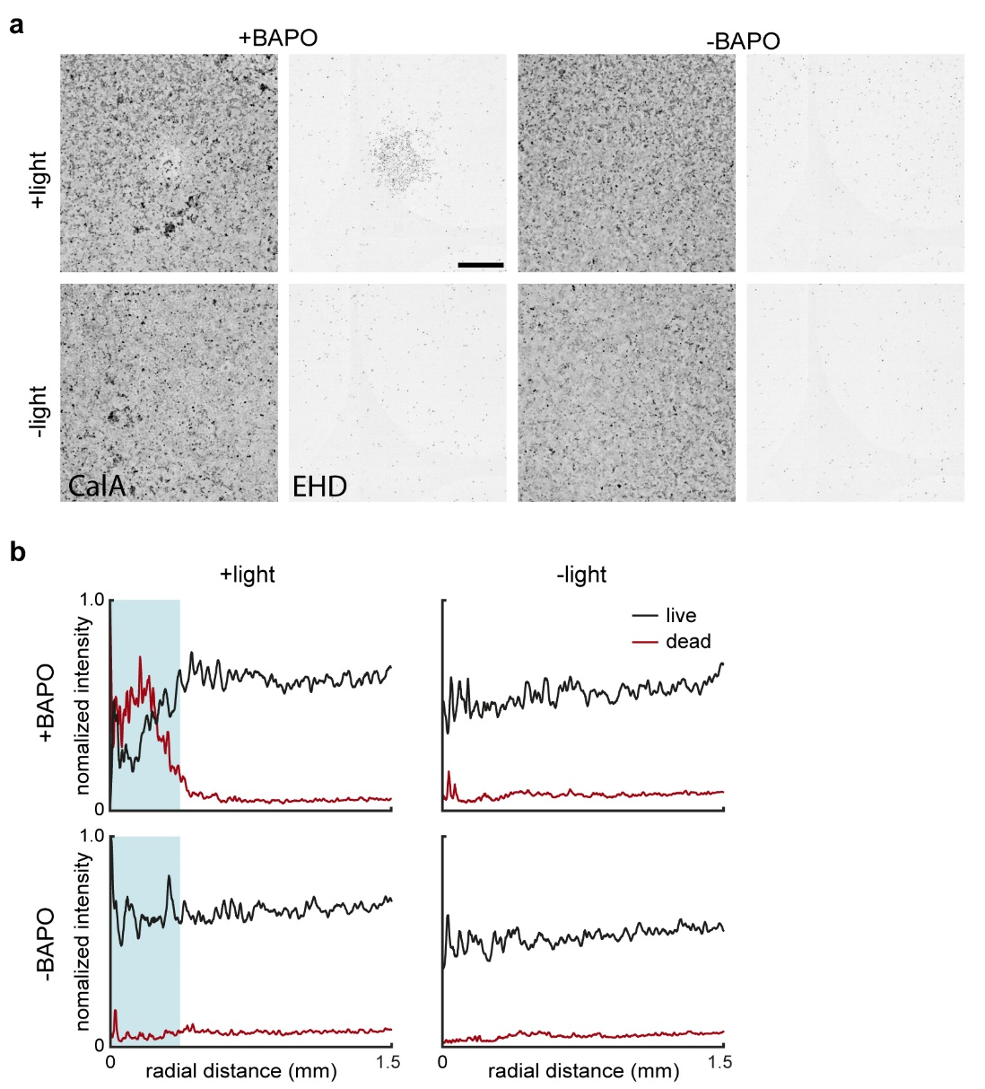

SI Fig. 1: Local BIOS activation in A549 cells. a, Local induction of cell death following BIOS (upper left). BIOS exhibits no dark toxicity (lower left) or light toxicity (upper right) compared to the untreated and unirradiated control (lower right). Scale bar: 500 μm. Left image: Calcein A stain, right image: ethidium homodimer stain. Inverted LUT (black corresponds to high signal). Light was delivered via a 40x Objective (see Methods). b, Radial profiles around the center of the irradiated area (blue) or around the center of the well for the non-irradiated conditions. Signal from live cells is shown in black, signal from dead cells is shown in red. All curves are normalized to the maximum signal across the different conditions for the live/dead signal, respectively. For the BAPO-treated and light-irradiated condition, the live signal decreases and the dead signal increases in the activation area. No effect is seen for the other conditions.

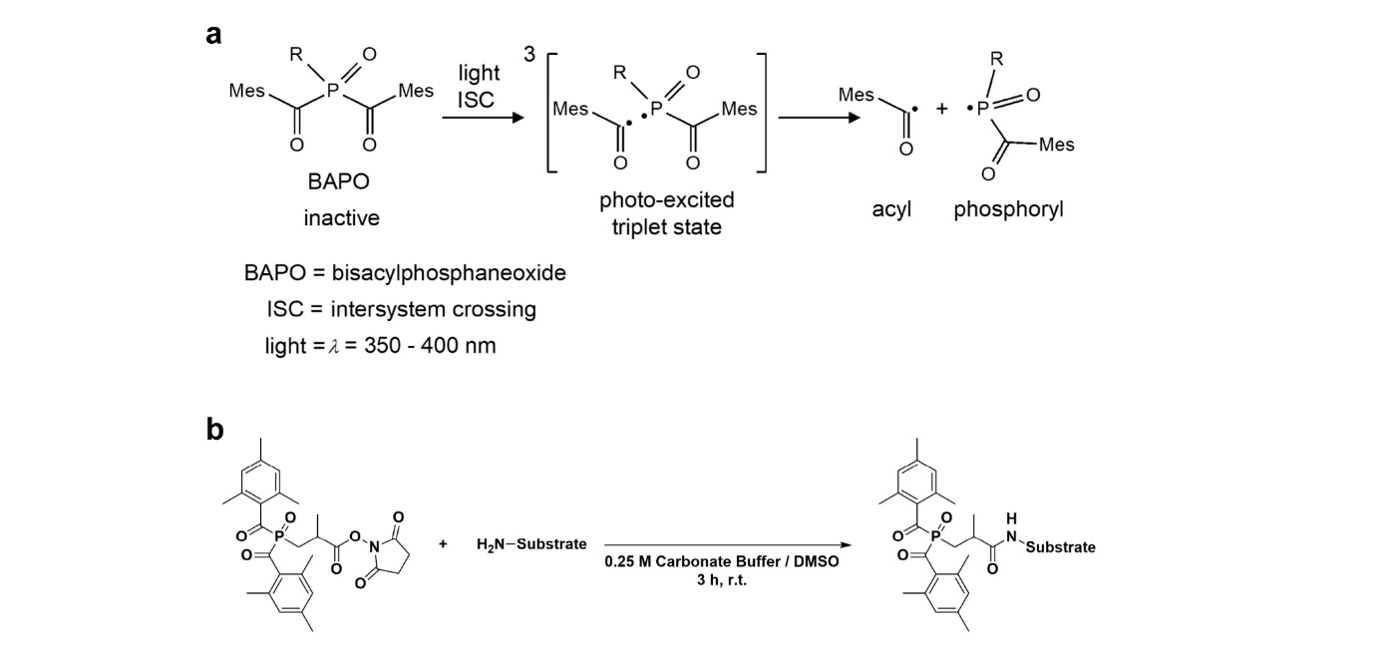
SI Fig. 2: BAPO cleavage and chemical synthesis. a, Detailed mechanism of BAPO cleavage. b, General ligation procedure in water/DMSO (see also reference 22 in main text). The target substrate (0.75 mmol, 1.3 eq.) is dissolved in 6 mL of 0.25 M sodium carbonate buffer (corresponding to 1.43 mmol, 2.5 eq. of base) in a 25 mL round bottomed flask. NHS-BAPO (300 mg, 0.57 mmol, 1 eq.) is dissolved in 2 ml of DMSO in a vial protected from light. The solution of NHS-BAPO is added dropwise to the aqueous solution under vigorous stirring. The mixture is stirred vigorously for 3 hours at room temperature protected from light, filtered, transferred to a separating funnel, and 15 mL of DCM are added followed by 15 mL of 2 M HCl. After the separation, the organic phase is washed 2 times with 15 mL of brine. The collected brine phases are washed with 15 mL of DCM. The collected organic phases are dried using Na₂CO₃. After filtering off the drying agent, the solvent is evaporated, and the product isolated.

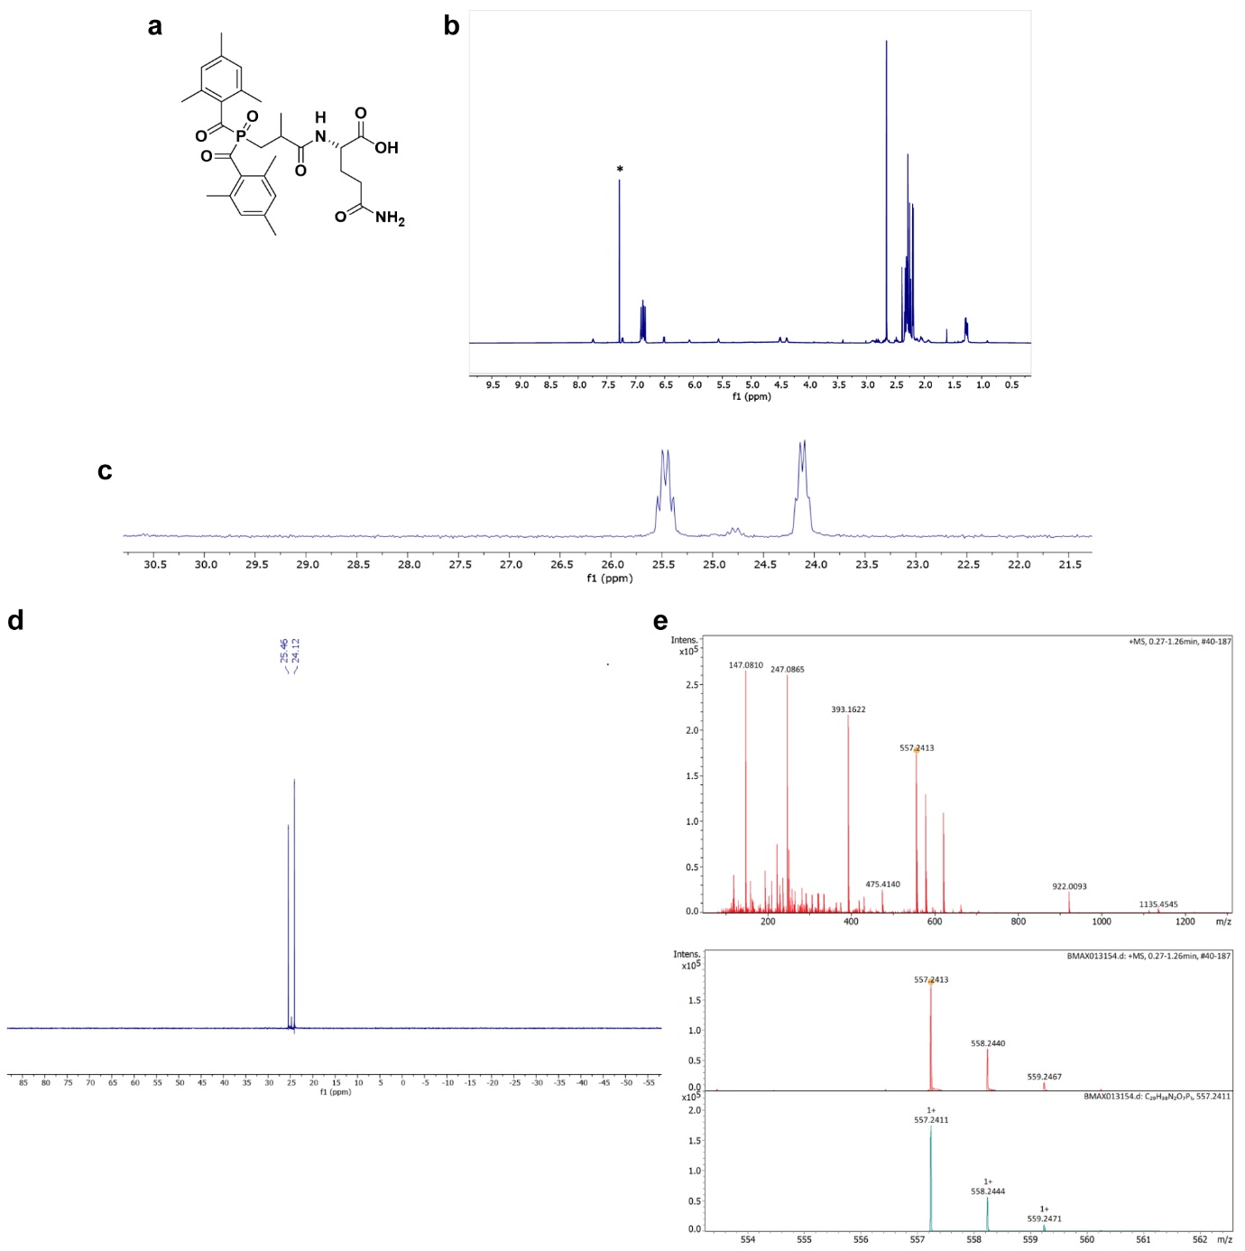

SI Fig. 3: Glutamine-BAPO characterization.
Prepared according to the general ligation procedure. Yield: 57% (180 mg). Yellow, hygroscopic solid.
a, Structure.
b, ¹H NMR (500 MHz, CDCl₃): δ (ppm): 7.23 (d, JHH = 6.8 Hz, 1H, NH), 6.91, 6.88, 6.86 and 6.84 (s, 4H, H_{arom} Mes), 6.51 (d, JHH = 4.3 Hz, 1H, NH), 4.50 (q, JHH = 5.5 Hz, 1H, N-CH), 4.38 (q, JHH = 6.2 Hz, 1H, N-CH), 2.38, 2.32, 2.31 and 2.30 (s, 6H, p-CH₃), 2.29, 2.25, 2.20 and 2.19 (s, 12H, o-CH₃), 1.28 and 1.25 (d, 3H, CH₃). CH and CH₂ signals not assigned, several multiplets are in the region 1.9-2.9 ppm, some signals are under the CH₃ of the mesitoyl substituent.
c, ³¹P NMR (203 MHz, CDCl₃): δ (ppm): 25.5 (m, 2,4JPH = 10.7 Hz, O=PR₃), 24.1 (m, 2,4JPH = 9.2 Hz, O=PR₃).
d, ³¹P{1H} NMR (203 MHz, CDCl₃): δ (ppm): 25.5 (s, O=PR₃), 24.1 (s, O=PR₃).
e, ESI-TOF (m/z) (+): 557.2411 (M+H)+.

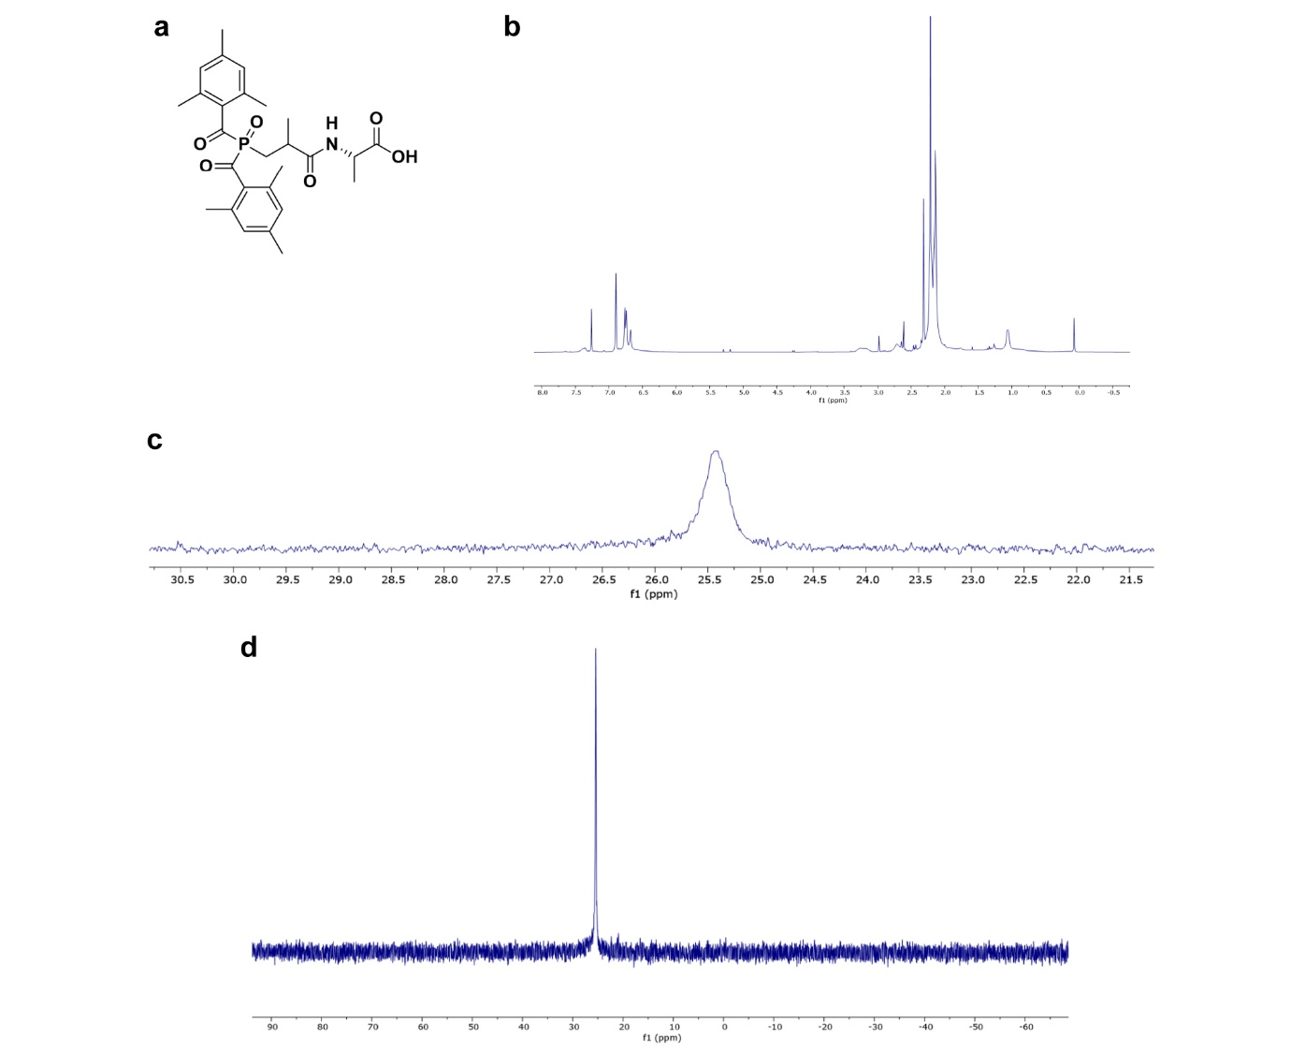
SI Fig. 4: Alanine-BAPO characterization.
Prepared according to the general ligation procedure. Yellow, hygroscopic solid.
a, Structure.
b, ¹H NMR (300 MHz, CDCl₃):
δ (ppm): 6.90, 6.76, 6.74 (s, 4H, H_{arom} Mes), 6.68 (s, 1H, NH), 3.21 (br, 1H, N-CH), 2,71 (br, 2H, CH₂), 2.31 (s, 3H, CH₃), 2.21, 2.14 (s, 6H, p-CH₃ and o-CH₃), 1.07 (br, 3H, CH₃). CH signal not assigned.
c, ³¹P{1H} NMR (121 MHz, CDCl₃): δ (ppm): 25.4 (s, O=PR₃).
d, ³¹P NMR (121 MHz, CDCl₃): δ (ppm): 25.4 (br, O=PR₃).

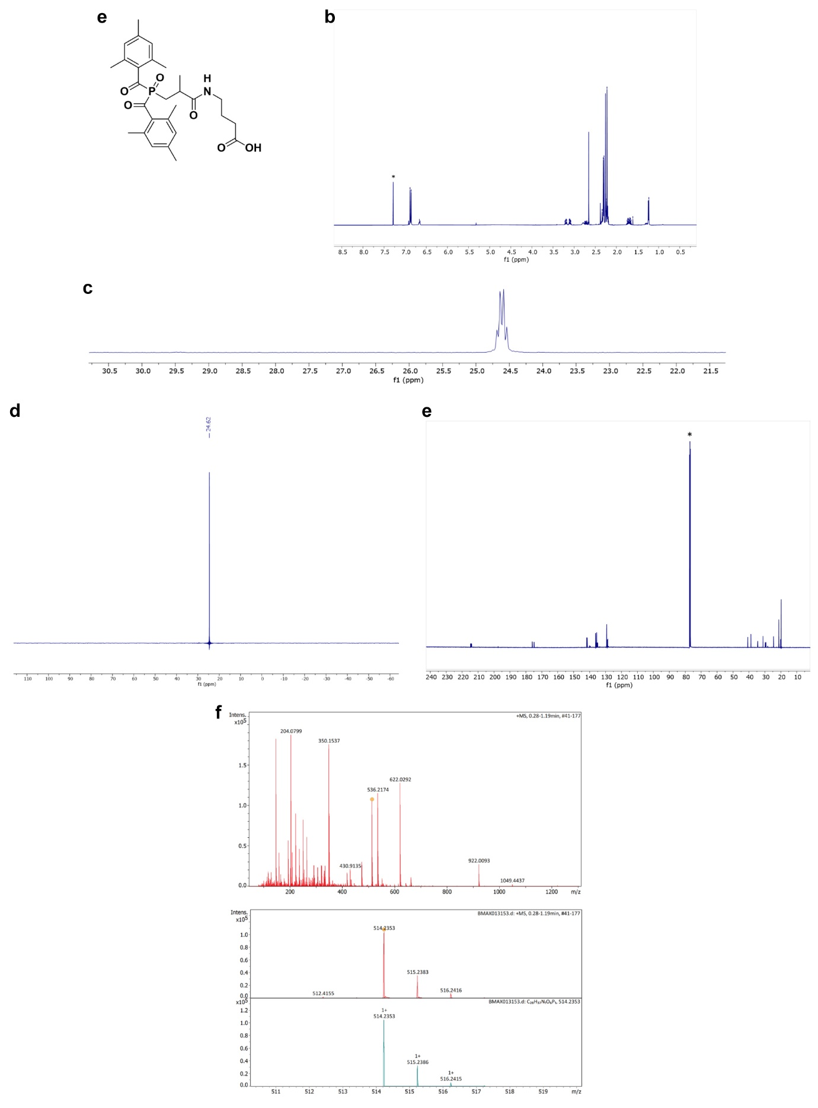

SI Fig. 5: GABA-BAPO characterization.
Prepared according to the general ligation procedure. Yield: 78% (230 mg). Yellow, hygroscopic solid.

a, Structure.
b, ¹H NMR (500 MHz, CDCl₃): δ (ppm): 6.88 and 6.86 (s, 4H, H_{arom} Mes), 6.66 (s, 1H, NH), 3.23-3.16 (m, 1H, CH₂), 3.13-3.07 (m, 1H, CH₂), 2.82-2.77 (m, 1H, CH₂), 2.76-2.69 (m, 1H, CH), 2.35-2.32 (m, 1H, CH₂), 2.31 and 2.29 (s, 6H, p-CH₃), 2.26 and 2.22 (s, 12H, o-CH₃), 2.23-2.19 (m, 2H, CH₂), 1.77-1.63 (m, 2H, CH₂), 1.24 (d, ³J_{HH} = 6.5 Hz, 3H, CH₃).
c, ³¹P NMR (203 MHz, CDCl₃): δ (ppm): 24.6 (m, ^{2,4}J_{PH} = 10.7 Hz, O=PR₃).
d, ³¹P{1H} NMR (203 MHz, CDCl₃): δ (ppm): 24.6 (s, O=PR₃).
e, ¹³C{1H} NMR (126 MHz, CDCl₃): δ ppm): 214.5 (d, ¹J_{CP} = 53.2 Hz, P-C=O), 214.2 (d, ¹J_{CP} = 52.2 Hz, P-C=O), 176.0 (s, COOH), 174.8 (d, ³J_{CP} = 5.0 Hz, N-C=O), 141.8 and 141.5 (d, C⁴ Mes), 136.3 and 135.6 (s, C^{2,6} Mes), 135.7 and 135.0 (d, ²J_{CP} = 42.2 and ²J_{CP} = 41.2 Hz, C¹ Mes), 129.3 and 129.3 (s, C^{3,5} Mes), 38.8 (s, CH₂), 34.5 (d, ²J_{CP} = 4.3 Hz, CH), 31.2 (s, CH₂), 29.6 (d, ¹J_{CP} = 52.2 Hz, CH₂-P), 24.6 (s, CH₂), 21.3 (s, p-CH₃), 20.2 (d, ³J_{CP} = 4.0 Hz, CH-CH₃), 19.8 (s, o-CH₃).
f, ESI-TOF (m/z) (+): 514.2353 (M+H)⁺.

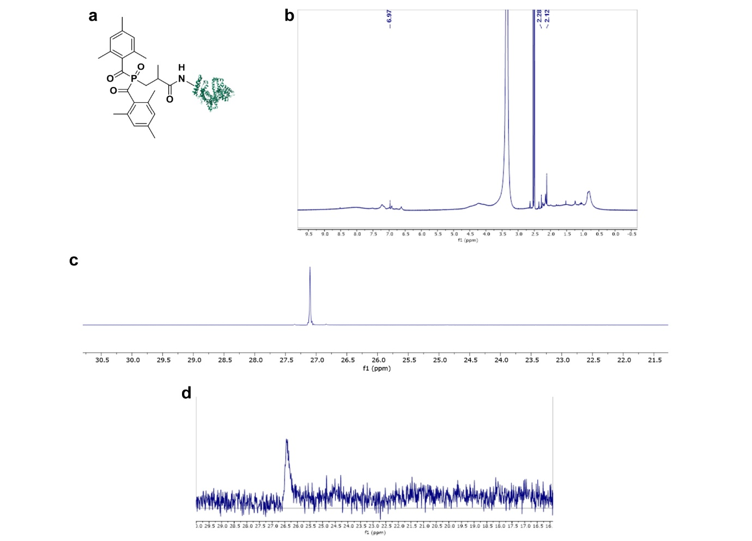

SI Fig. 6: BSA-BAPO characterization.
In a 50 ml round bottomed flask the BSA (2.529 g, 0.038 mmol, 1 eq.) is dissolved in 30 ml of 0.25 M carbonate buffer at room temperature. The NHS-BAPO (0.300 g, 0.57 mmol, 15 eq.) is dissolved in 2 ml of DMSO in a vial protected from light. The solution of NHS-BAPO is added dropwise to the water solution. The mixture is stirred vigorously for 1 hour at room temperature and protected from light. The mixture is diluted adding 30 ml of deionized water, then it is filtered and dialyzed. The product BSA-BAPO is recovered after lyophilization of the dialyzed solution, and the solid product is grinded to obtain a fine pale yellow powder (Yield: 2.3 g).
a, Structure.
b, ¹H-NMR (300.1 MHz, DMSO-d6, 298 K): δ (ppm): 6.97 (s, 4H, H_{arom} Mes), 2.28 (s, 6H, p-CH₃), 2.12 (s, 12H, o-CH₃).
c, ³¹P{¹H}-NMR (121.5 MHz, DMSO-d6, 298 K): δ (ppm): 26.43 (br, O=PR₃).
d, ³¹P-NMR (121.5 MHz, DMSO-d6, 298 K): δ (ppm): 26.44 (br, O=PR₃).

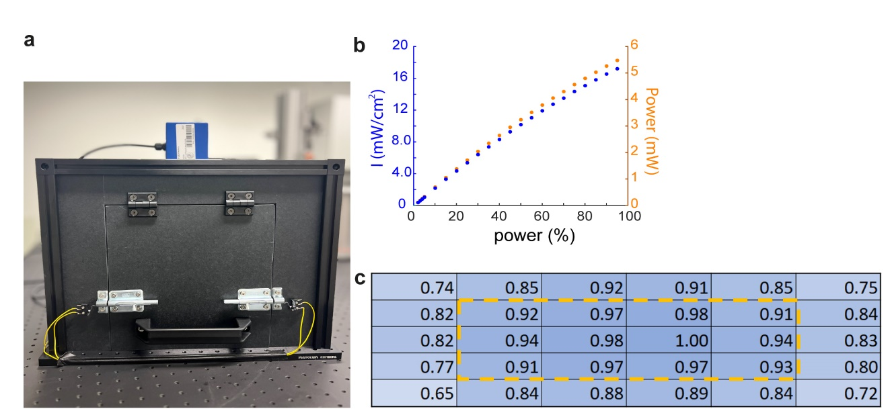
SI Fig. 7: Irradiation device. a, Photograph of the irradiation device. b, Measured intensity in dependence on the power setting. The sensor was placed in the location where cells are irradiated. c, Intensity variation over the irradiated area. Values are normalized, and measurement locations are spaced 2.5 cm horizontally and vertically from each other. The yellow rectangle denotes the area of the 96-well plates that contained cells in our experiments. Homogenous irradiation for all cells is ensured.

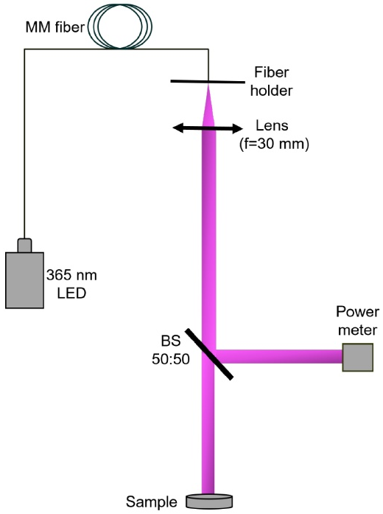
SI Fig. 8: Fiber-based irradiation device. A fiber-coupled light emitting diode (LED, Thorlabs M365FP1) was used. The LED was connected to a LED driver (Thorlabs LEDD1B) at continuous wave mode and coupled into a multi-mode (MM) 600 μm core diameter fiber, 0.22 NA (Thorlabs M143L01). Light emitted from the fiber was collected by a lens (f=30 mm, Thorlabs LA1805) placed 3 cm away from the fiber holder opening, and directed downwards. A 50/50 beam splitter (BSW19, Thorlabs) was placed 15 cm away from the lens, splitting the light into two arms. One arm was directed through the tissue phantom onto the sample, and one arm was directed to a power meter (Thorlabs PM100D) to precisely measure the delivered power.

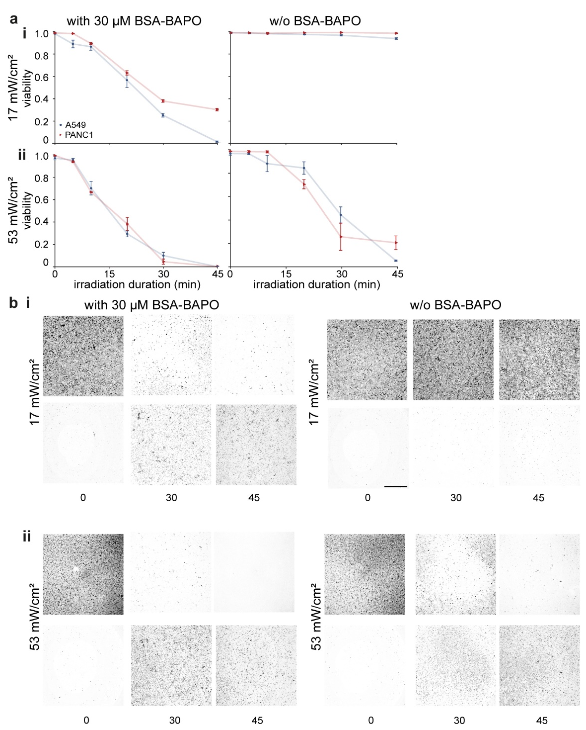
SI Fig. 9: Irradiation screens. a, Quantification of cell viability of A549 (blue) and PANC-1 (red) cells when treated with light doses of either (i) 17 mW/cm² or (ii) 53 mW/cm² for 45 minutes in presence of 30 μM BSA-BAPO or without (left and right panels, respectively). N=3. Error bars: SD. b, Representative images of A549 cells when treated with light doses of either (i) 17 mW/cm² or (ii) 53 mW/cm² for 45 minutes with 30 μM BSA-BAPO or without (left and right, respectively). Upper row: Calcein stain (live cells); bottom row: ethidium homodimer stain (dead cells). Inverted LUT. Scale bar: 1 mm

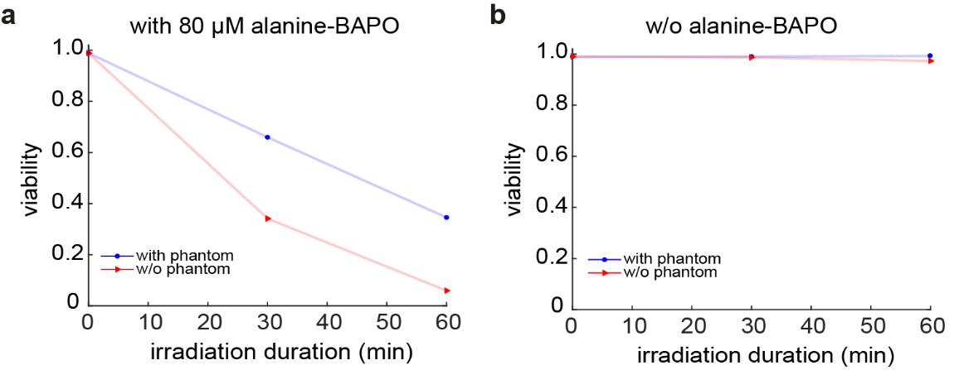
Fig. 10: Irradiation in the presence of tissue phantoms. Quantification of cell viability of A549 when treated with a light dose of 15 mW/cm² with a, 80 μM alanine-BAPO or b, without in the presence or absence of a tissue phantom (blue and red, respectively).

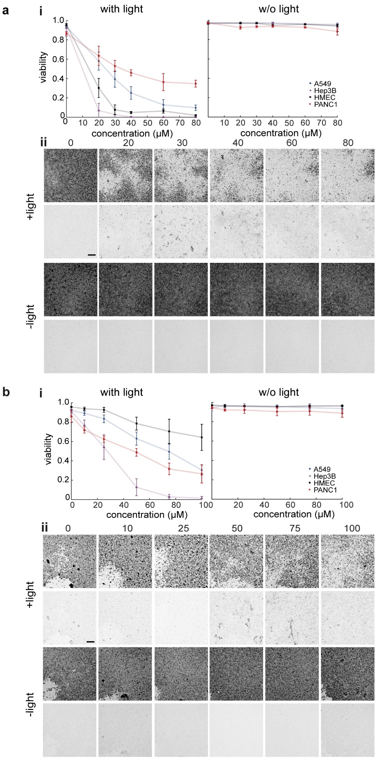

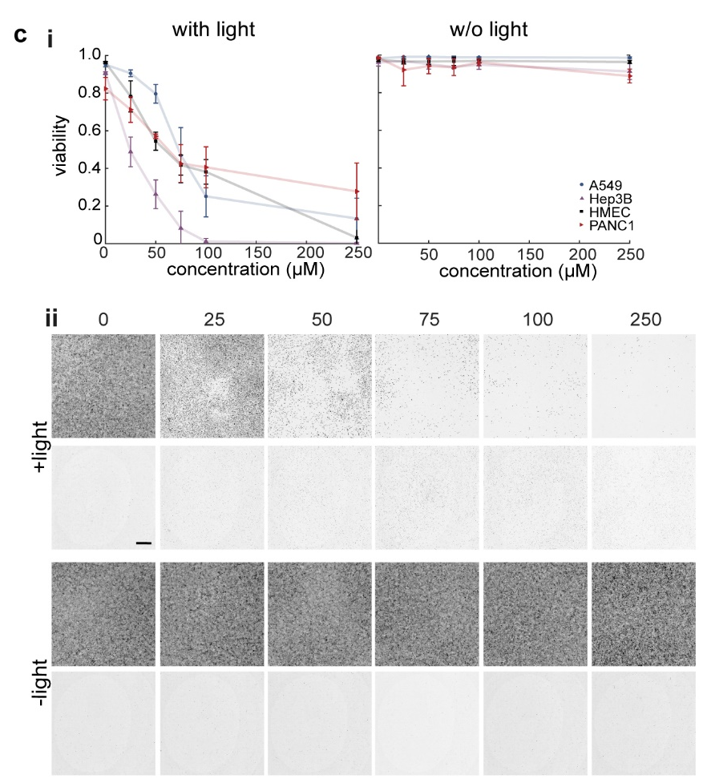
SI Fig. 11: BAPO conjugates screen. i Quantification of viability of cells treated with a alanine-BAPO, b glutamine-BAPO, or c GABA-BAPO and either subjected to light irradiation or not (left/right panel, respectively). N=3. Error bars: SD. ii Representative images of A549 cells, PANC-1 cells, HMECs, respectively. Upper row: CalA stain (live cells); bottom row: EHD stain (dead cells). Inverted LUT. Irradiation intensity: 15 mW/cm². Scale bar: 500 μm

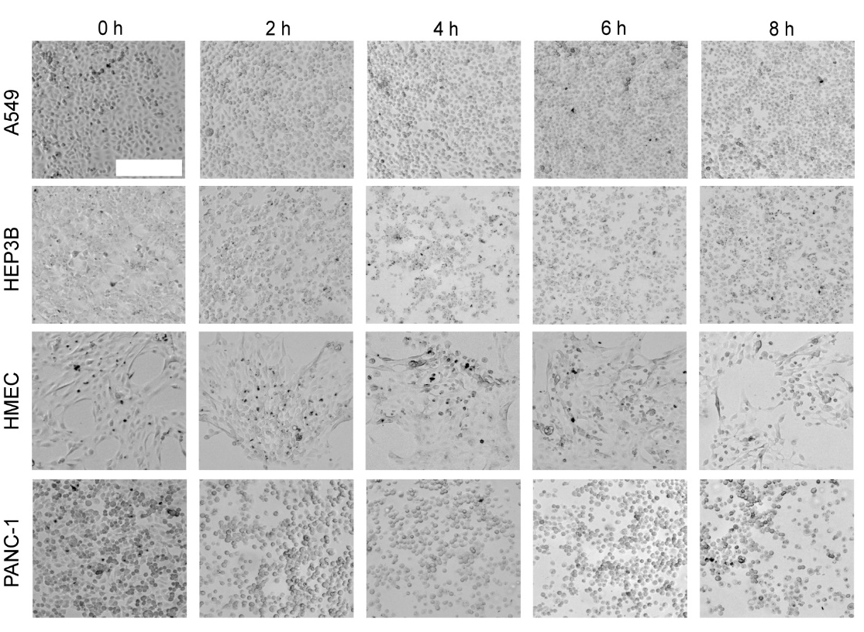
SI Fig. 12: Changes in cell morphology over time following BIOS. Representative images of A549 cells, Hep3B cells, HMECs, PANC-1 cells (top to bottom) 0 to 8 hours after BIOS induction (left to right). Scale bar: 500 μm.

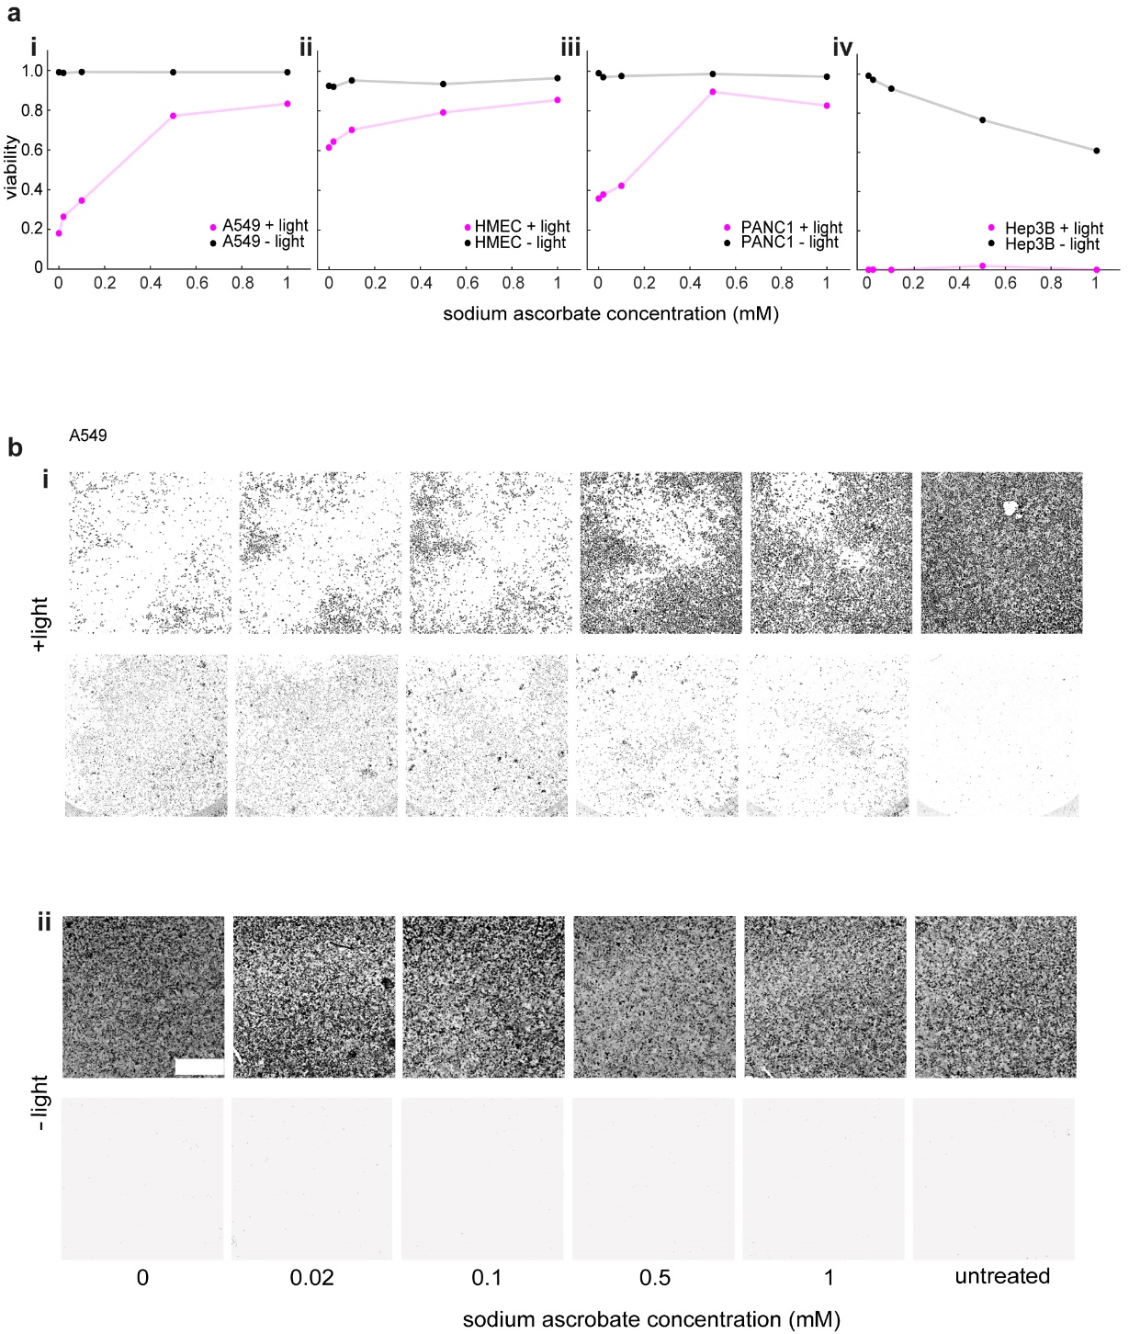
SI Fig. 13: Rescue upon ascorbate treatment. a, Quantification of cellular viability of (i) A549 cells, (ii) HMECs, (iii) PANC-1 cells, (iv) Hep3B cells when co-treated with 30 μM of BSA-BAPO and ascorbate at the indicated concentrations and either subjected to light irradiation or not (black, purple symbols, respectively). b, Representative images of A549 cells when co-treated with 30 μM of BSA-BAPO and different ascorbate concentration as indicated. i corresponds to light irradiation, ii to no light irradiation. Upper rows: CalA stain (live cells); bottom row: EHD stain (dead cells). Untreated refers to no treatment with neither BSA-BAPO nor ascorbate. Inverted LUT. Scale bar: 1 mm.

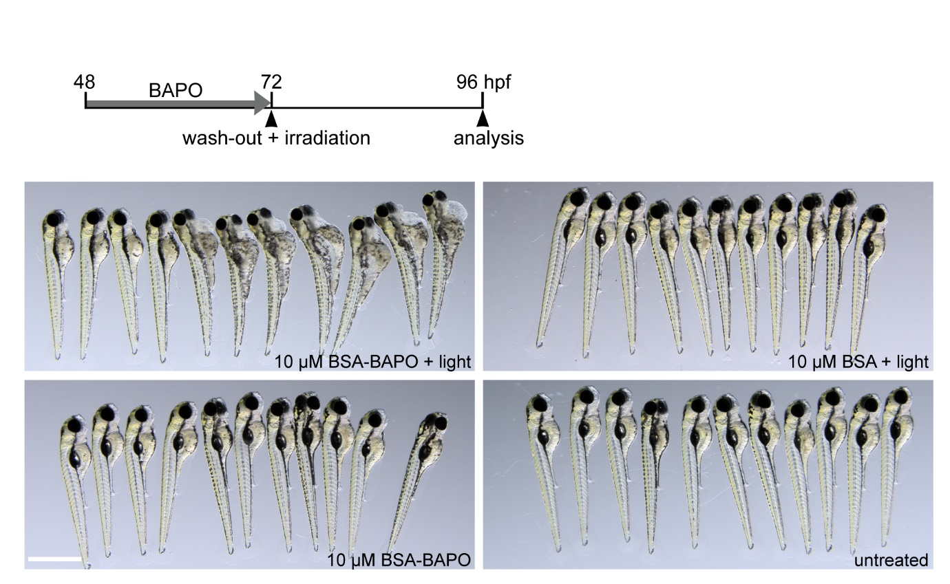

SI Fig. 14: Systemic application in zebrafish larvae. Depiction of all larvae investigated. Loss of tissue integrity and development of cardiac edema following BIOS (upper left) is clearly visible. Control conditions were unaffected (other panels). Scale bar: 1 mm.

