Table 6: The assessment of greenness values using Eco Analytical Scale, GAPI, AGREE, and NEMI tools
Tools For Assessment | TLC-densitometric | HPLC Method
Eco Analytical Scale | 77 | 86
  Reagents | Penalty points
  Methanol | 6
  Toluene | 2
  Ethyl Acetate | 8
  Triethyl Amine | 3
  Energy used for LC | 1
  Waste | 3
  Occupational hazard | 0
  Total penalty points | 23
  Analytical eco-scale | 77
  Reagents | Penalty points
  Acetonitrile | 4
  Ammonium Acetate | 4
  Energy used for LC | 1
  Waste | 5
  Occupational hazard | 0
  Total penalty points | 14
  Analytical eco-scale | 86
GAPI |  | 
AGREE | 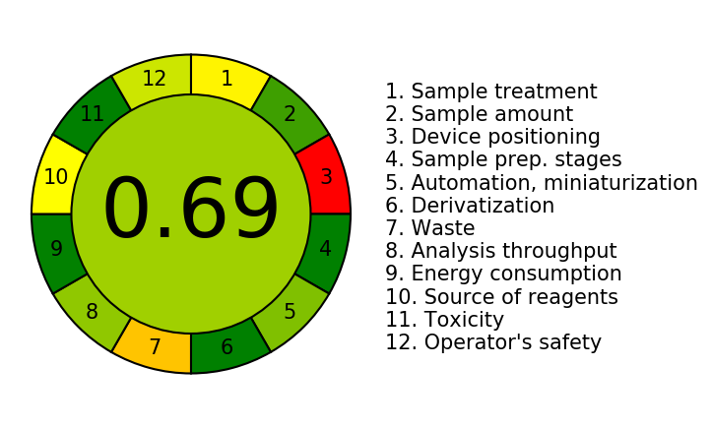 | 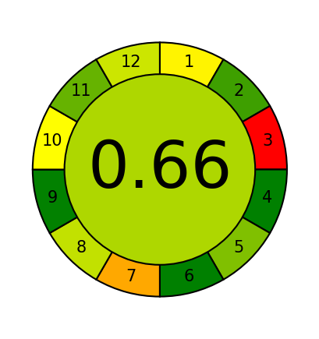
NEMI | 