Patient 1 Patient 2
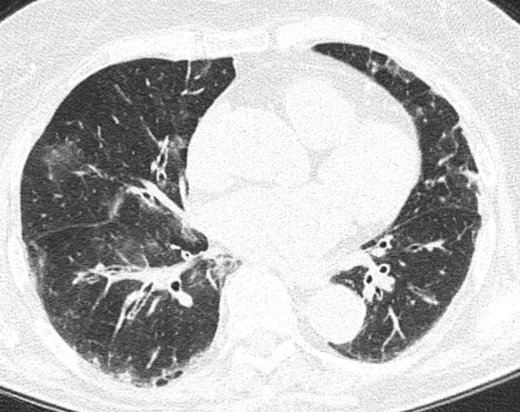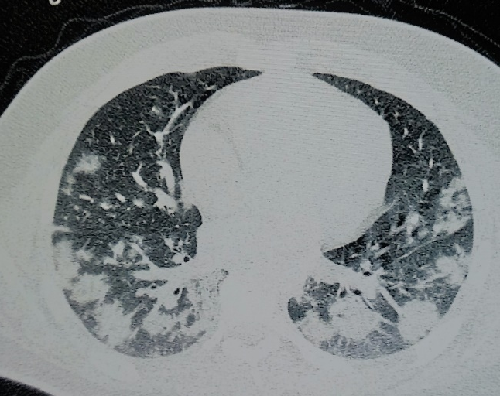

Patient 3 Patient 4
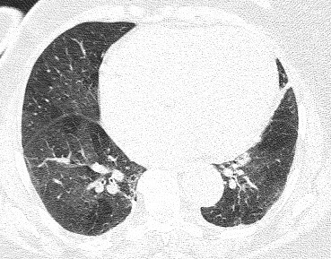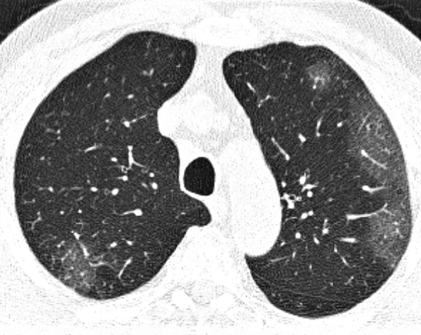

Patient 5 Patient 6
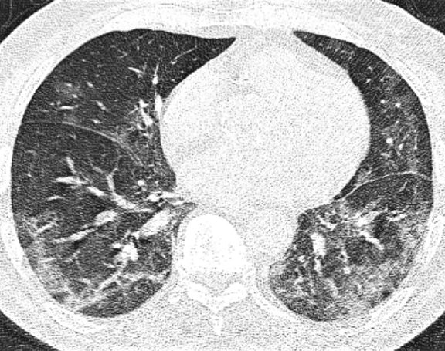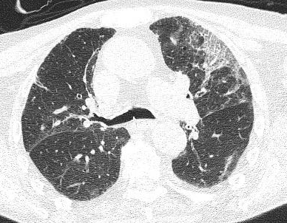

Patient 7
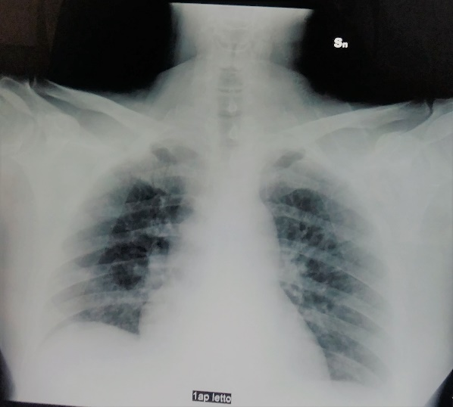

Supplementary Figure1. Radiological findings of patients with SARS-CoV-2 and Chlamydia pneumoniae (n=5) or Mycoplasma pneumoniae (n=2) co-infection.

