Supplementary Information (SI)

Preparation and characterization of novel Polyvinyl Alcohol-Alginate beads for Quorum Quenching application in MBRs

Ermias Mideksa^{1,2*}, Johanne Teychene^{1*}, Valerie Sartor³, Catherine Claparols⁴, Christelle Gugui¹, Audrey Tourrette²
*Corresponding author: Johanne Teychene (rumpala@insa-toulouse.fr) and Ermias Mideksa (mideksa@insa-toulouse.fr)

*ORCID ID: https://orcid.org/0000-0002-2997-4744 and https://orcid.org/0000-0002-6372-4319

- TBI, INSA CNRS UMR 5504, INRA UMR 792, Université de Toulouse, 31077 Toulouse, France
- CIRIMAT, CNRS UMR 5085, Université Toulouse III – Paul Sabatier, 31062 Toulouse, France

ESM_1 provides information on parameters for gradient elution UHPLC-MS/MS analysis, cumulative pore size and volume of SC-CO₂ dried beads formulated in different conditions, the possible chemical crosslinking process of PVA-ALG beads by the respective ions, the % transmittance of peaks of interest for PVA/SA beads and swelling kinetics of different PVA/SA beads.
Table S1 Parameter for the procedure of gradient elution UHPLC-MS/MS
Time (min) | Solvent A | Solvent B
0 | 40 | 60
1 | 40 | 60
2 | 50 | 50
5 | 100 | -
7 | 100 | -
7.2 | 40 | 60
9 | 40 | 60

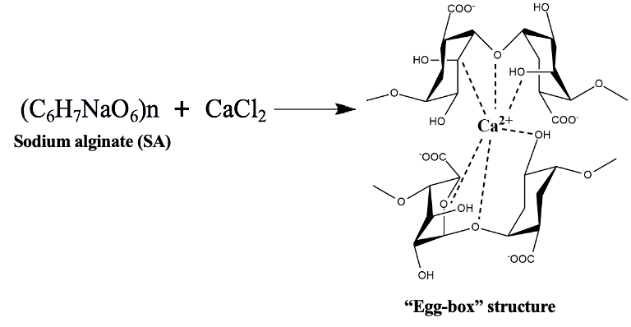
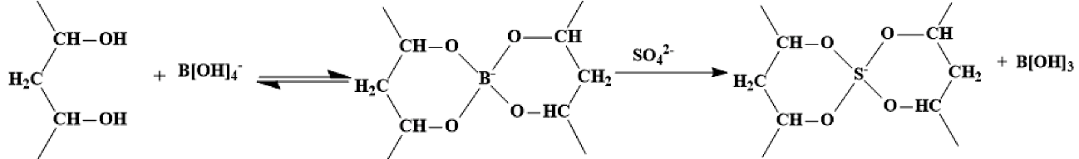
Fig. S1 Possible chemical crosslinking process of PVA and SA with B[OH]₄⁻, SO₄²⁻ and Ca²⁺ ions at pH = 4.
Fig. S2 Cumulative pore size distributions of dry SC-CO₂ beads using different preparation conditions
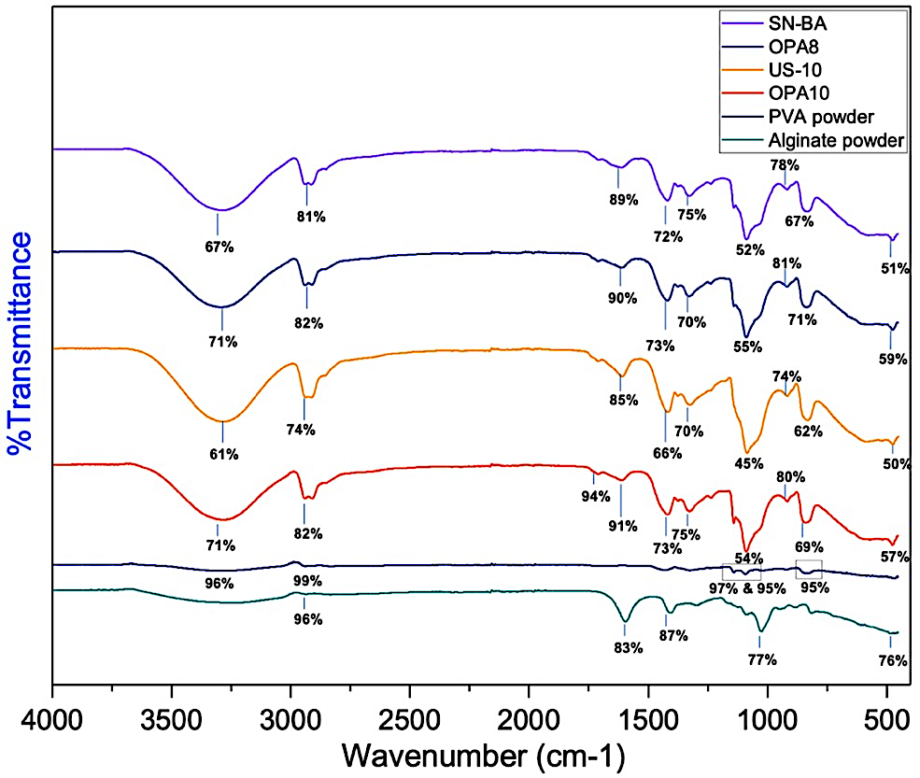

Fig. S3 % Transmittance of peaks of interest for PVA/SA beads

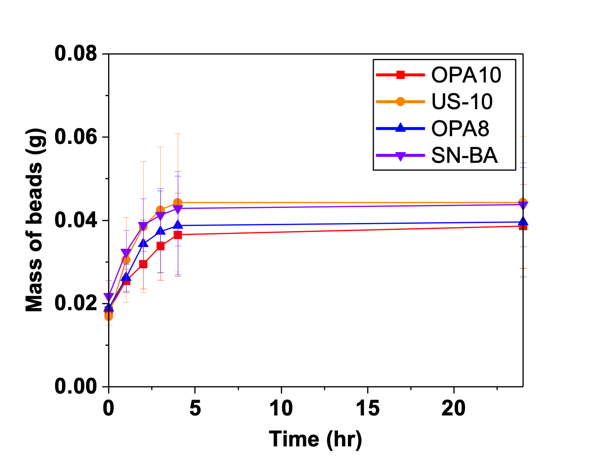

Fig. S4 Swelling kinetics of PVA/SA beads

