Supporting information for
Biotoxicity of paraquat to lung cells mediated by endoplasmic reticulum-mitochondria interaction
Mitochondrial dysfunction exposure mediates paraquat biotoxicity to lung tissue cells: The role of endoplasmic reticulum stress
Ping Xiao¹, Shaohua Wu¹, Zhiyong Wang², Guoqiang Shen², Xiaofeng Shi^{2*}
1 Clinical Laboratory, Tianjin First Central Hospital, Tianjin, 300192.
2 Department of Emergency, Tianjin First Central Hospital, Tianjin, 300192.
*Address correspondence to Xiaofeng Shi, E-mail: sxf74@sohu.com.

Number of pages: 12
Number of tables:3
Number of figures: 4

Text S1.Proteomic analysis
S1.1. Experimental method
1. Add appropriate amount of lysis buffer (8M urea, 2M thiourea, 0.1% CHAPS) to rat lung tissue samples and vortex to mix.
2. After homogenization, sonicate for 60s, 0.2s on, 2s off, amplitude 25%.
3. Extract for 10 min at room temperature.
4. 15000rpm at4℃ centrifugation for 10min, carefully remove the supernatant (repeat once).
5. Collect the supernatant, take an equal amount of protein and add 1μlof1M DTT, incubate at 37℃ for 1h.
6. Add 4μlof 1M IAA, avoid light and incubate at 37℃ for 1h.
7. Equilibrate 10kDa ultrafiltration tube 1 time (Sartorius 10 KDa, 400 ulof 50mM NH₄HCO₃, 14000g for10min), add reduced alkylated samples, centrifuge at 15℃ 14000g for 20 min, add 400 μl 50 mM NH₄HCO₃ to wash for 3 times, replace the collection tube, add 50 μlof50mM NH₄HCO₃ to the ultrafiltration tube, add 1μg trypsin (Promega sequencing grade), incubate at 37℃ for 12-16h.
8. Mix the sample in the ultrafiltration tube with a pipette gun, centrifuge at 14000g at 4℃ for 20min, add 50 μlof50 mM NH4HCO3 to rinse 3 times, add 1% (v/v) formic acid to the collection tube to terminate the enzyme digestion, and vacuum evaporate at 60℃.
9.12μl 0.1% formic acid water resuspension sample, nanodrop measurement, take the same amount of peptide for the detection of mass spectrometry.

S1.2. Liquid chromatography parameters
The liquid chromatography model used in this study was EASY-nLC1000 (thermofisher) The tandem mass spectrometer was Orbitrap Fusion (thermofisher). The digested peptides were loaded onto a homemade Trapcolumn (100μm×2cm, C18 packing size 3μm, 120A) with phase A (0.1% formic acid), and the Trapcolumn was eluted with different gradients of phase B (80% acetonitrile, 0.1% formic acid, 19.9% water), and the eluted peptides were passed through an analytical column (150um×150cm). The eluted peptides were separated on an analytical column (150um×15cm, C18 packing size 1.9um, 120A) to form a charged spray for mass spectrometry (MS) detection.The gradient of the B-phase was 0 min-6%, 2min-9%, 12min-13%, 58min-26%, 81min-38%, 82min-100%, 90min-100% at a flow rate of 600 nm. Mass spectrometry parameters: primary detector type was Orbitrap, resolution was 120,000, mass scan range was 300-1400 m/z, Max injection time was 100 ms, and automatic gain control target was 100 nl/min. The data-dependent scanning mode was adopted for the second stage, and the detector type was the same as ionTrap, the maximum injection time was 35ms, and the automatic gain control target was 5E3. include charge state: 2-6, exclusion duration: 18s, mass tolerance: ±7 ppm, separation window (Isolation window) for 1.6m/z, fragmentation mode (Activation type) HCD, normalized fragmentation energy (Collision energy) The normalized collision energy is 32%.

S1.3. Data analysis
The raw data collected by mass spectrometry were searched using Maxquant software (version 1.6.1.0). Enzymatic cleavage: trypsin/P, and a maximum of two missed cleavage sites were allowed. Variable modifications: Oxidation (M), Acetyl (protein N-term). Fixed modifications: Carbamidomethyl (C), and up to 5 variable modifications per peptide are allowed. Primary mass deviation 20 ppm, secondary mass deviation 20 ppm. the database is that of Uniprot rats (containing 36159 proteins, RELEASED 2020.06). The minimum peptide length was 7 amino acids, and the maximum peptide mass was 4800 Da. The FDR for spectra and protein matching was set to 1%, and the iBAQ algorithm was used to obtain protein quantification values.
The original quantitative values were median normalized and then log2 transformed to satisfy the normal distribution, and the distribution of the transformed quantitative values is shown in Figure 1, with each sample quantitative value satisfying the normal distribution. Screening for proteins that could be statistically analyzed (at least 9 out of 18 samples had quantitative values, or when lower than 9, at least 5 out of a group of 6 samples had quantitative values), in the use of the smallest quantitative value for the filling of vacancies, and TTEST analysis using the R software when comparing the two groups. Proteins with a p-value <0.05 and a fold change greater than 1.5-fold were screened as differential proteins, and the screening criteria for differential proteins for three-group comparisons, ONE WAY ANOVA p-value <0.05 and at least one of the three comparisons with a fold change of greater than 1.5-fold. Enrichment analyses of GO and KEGG pathway were performed for significant proteins using clusterProfiler package, respectively. The appropriate number of clusters was calculated using the R software vegan package when splitting clusters among the three comparisons, and the Mfuzz package was used for splitting clusters.

TableS1. Primers sequence used in real time-PCR.
Primers |  | Sequences (5’-3’) | Size(bp)
Bcl-2 | F | TGGAGAGCGTCAACAGGGAG | 169
Bcl-2 | R | AGCCAGGAGAAATCAAACAGAGG | 169
Caspase-3 | F | GTATGCTTACTCTACCGCACCCG | 186
Caspase-3 | R | AAAGTGGCGTCCAGGGAGAAG | 186
Bax | F | TGGTTGCCCTTTTCTACTTTG | 103
Bax | R | AGGAAGTCCAGTGTCCAGCCC | 103
Cytochrome C | F | CAGGCTGCTGGATTCTCTTACAC | 156
Cytochrome C | R | TCTGCCCTTTCTCCCTTCTTC | 156
CHOP | F | GCTGAGTCTCTGCCTTTCGCC | 142
CHOP | R | TTGATTCTTCCTCTTCGTTTCCTG | 142
Caspase-3 | F | AGCCACTGCTGATACAGATGAGG | 165
Caspase-3 | R | ATGAGTTTGGAAATGAAGAGAGAGC | 165
BIP | F | CTAAAATGAAGGAAACTGCCGAG | 205
BIP | R | TTCTTCTCTCCCTCTCTCTTATCCAG | 205
ACAA1 | F | GAGAATGTGGCTGAGCGGTTTG | 175
ACAA1 | R | GAGACACGGTGATGGTTTTCCTG | 175
ACADSB | F | AATGCCCTATGTTTCGCACCTC | 172
ACADSB | R | CCATCATCCCTTGTTGGAATAATC | 172
ACOX1 | F | ACCCCAAGACCCAAGAGTTCATTC | 80
ACOX1 | R | AGTTTTCCCAAGTCCCCCAGG | 80
ACOX3 | F | GGGAAGAAGTTGGGACAGAATGG | 125
ACOX3 | R | GGGGTGTTGTAAGTGCCCTCAG | 125
Adh5 | F | ATCATTGCCACTGCTGTTTGC | 133
Adh5 | R | GCTTAGTAACCCCTTCGCCAAC | 133
Echs1 | F | CGGCTGTCAATGGCTATGCTC | 143
Echs1 | R | GAGTCTCTGAGTGCCCCCTGC | 143
Mecr | F | AAGGATGCCCGAGACCAAAAAC | 74
Mecr | R | TCCCACCGACACAGTTGAGAGC | 74
Hsd17b4 | F | CGAATCCTTTACACATTGACCCG | 138
Hsd17b4 | R | TGAATCTTGACACATCATTATCCGC | 138
Hsd17b8 | F | AGTAGCATCGTTGGAAAGGTGGG | 137
Hsd17b8 | R | CCTGGGAGGACTGAGTTACATCG | 137
Tecr | F | CTACTACTGGGGCTTTGCTGCG | 78
Tecr | R | TGAACTCCATAGGTAGGGGGTGTG | 78
GK | F | TCAGCAACCAGAGGGAAACCACAGT | 88
GK | R | GTTCTTAGGTCAAGCCACACCACAGC | 88
Adipoq | F | CGGGGCTCTACTACTTTTCCTACC | 123
Adipoq | R | GGTCCACATTTTTTTCCTGATACTG | 123
Ilk | F | CTCCGAGAACGGGCAGAGAAGAT | 128
Ilk | R | AAGTCAATACCAGAGTGTTTGTTCAGGG | 128
Plin2 | F | ATGGCAGAGAAGGGAGTGAGGAC | 163
Plin2 | R | CAGATGTTGGCTGGTTCAGAATAGG | 163
GAPDH | F | TTCAGCTCTGGGATGACCTT | 129
GAPDH | R | TGCCACTCAGAAGACTGTGG | 129

Table S2. Primary antibodies used for Western blot.
Primary Antibody | Source | Manufacturer | Number | Dilution ratio
Bax | Rabbit | CST | #2772 | 1:1000
Bcl-2 | Rabbit | Abcam | ab196495 | 1:1000
Cyc-C | Rabbit | CST | #4272 | 1:500
Caspase9 | Rabbit | Abcam | ab2013 | 1:1000
Cleaved-Caspase9 | Rabbit | Affinity | AF5240 | 1:800
BIP | Rabbit | CST | #3183 | 1:1000
Caspase12 | Rabbit | Abcam | ab62484 | 1:1000
CHOP | Mouse | CST | #2895 | 1:1000
ACAA1 | Rabbit | Novus | NBP1-85786 | 1:1000
ACADSB | Rabbit | Novus | NBP2-48739 | 1:1000
ACOX1 | Rabbit | Abcam | ab184032 | 1:1000
ACOX3 | Rabbit | Novus | NBP1-85901 | 1:1000
ADH5 | Rabbit | Abcam | ab17793 | 1:1000
ADIPQ | Rabbit | Abcam | ab181281 | 1:1000
ECHS1 | Rabbit | Abcam | ab235835 | 1:1000
GK | Rabbit | Novus | NBP3-15687 | 1:800
HSD17B4 | Rabbit | Abcam | ab97975 | 1:1000
HSD17B8 | Rabbit | Novus | NBP1-84309 | 1:1000
ILK | Rabbit | Abcam | ab52480 | 1:1000
Mecr | Rabbit | Abcam | ab254707 | 1:1000
Plin2 | Rabbit | Abcam | ab108323 | 1:1000
Tecr | Rabbit | Novus | NBP2-49230 | 1:1000
GAPDH | Mouse | Youkang | UM4002 | 1:2000

Table S3. Secondary antibodies used in Western blot experiments.
Secondary Antibody | Source | Manufacturer | Number | Dilution ratio
Goat Anti-RabbitIgG-HRP | Goat | Bioss | bs-0295G-HRP | 1:3000
Goat Anti-Mouse gG-HRP | Goat | Bioss | bs-0296G-HRP | 1:3000

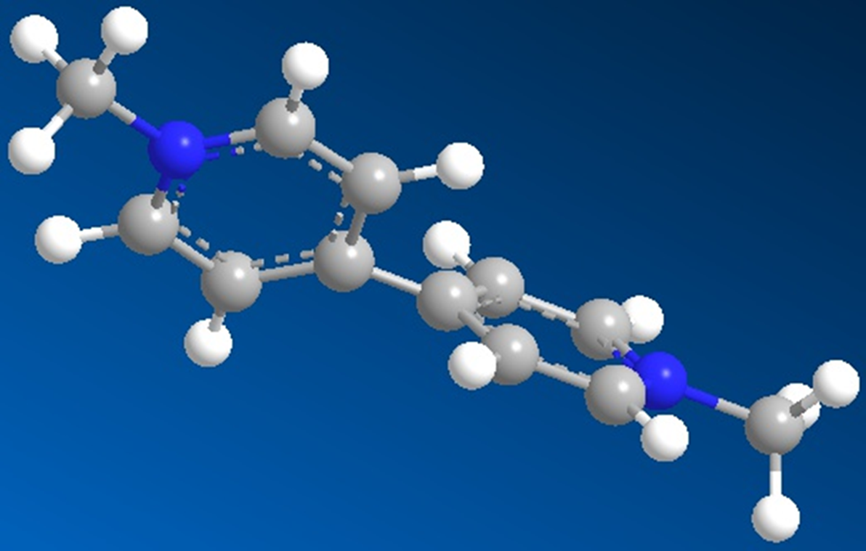
Figure S1.View of the ball-and-stick model for the paraquat molecule.

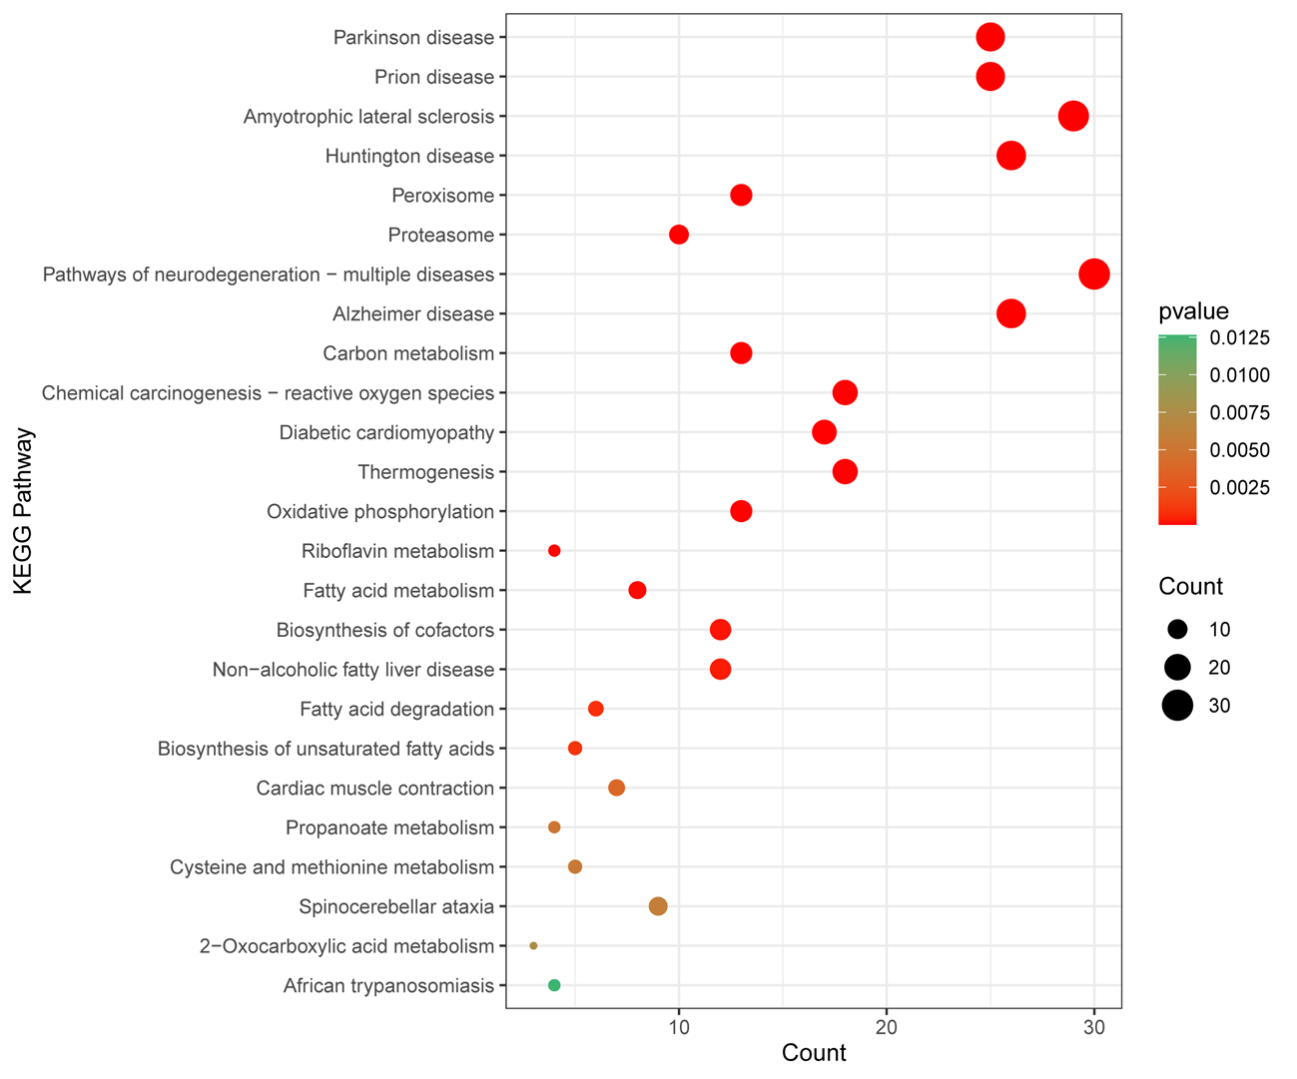
Figure S2.KEGG pathway analysis between the three groups.

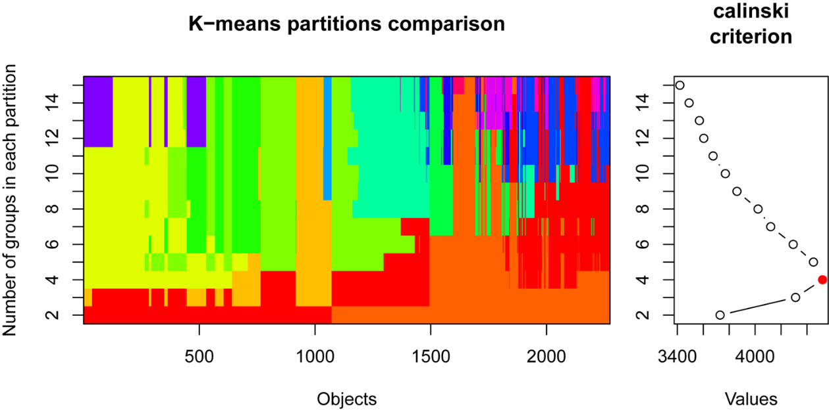
Figure S3. Calculation of the optimal cluster number.

FigureS4. Plot of protein expression trends in each cluster.

