Table 1:
Demographic Data of married Male Participants
Code | Socio economic status (SES) | Family income (Pakistani rupees) | Age | Educational level | Working status | Profession/ Employment status | Mother tongue | Type of family | Duration of marriage | Number, age, and sex of child(ren)
01 | Upper  middle | 70,000 | 33 years | Masters (MBA) | Working | Business man/ Self employed | Urdu | Nuclear | 4 years | 1 child  (Male: 2 years)
02 | Upper  middle | 100,000 | 29 years | Bachelors (B. com) | Working | Service Manager/ Private | Memoni | Extended | 7 years | 1 child  (Male: 5 years )
03 | Middle | 35,000 | 44 years | Bachelors (B.com) | Working | Business man/ Self-employed/  Owner | Gujrati | Nuclear | 20 years | 2 children (Female: 16 years; Male: 12 years)
04 | Middle | 40,000 | 33 years | Bachelors (B.A.) | Working | Service/ Employee | Punjabi | Extended | 5 years | 3 children (Male: 4, 2.5, and 1.2 years)
05 | Lower  middle | 8,000 | 36 years | Class 4 | Working | Driver /Employee | Punjabi | Nuclear | 10.5 years | 1 child (Female: 9.5 years; two children expired)
06 | Lower  middle | 1500 to  9,000 (wages) | 29 years | Illiterate | Working | Labour/  Works on wages/worker | Sindhi | Extended | 18 years | 4 children (Male:17 and12 years; Female: 9 and 7 years)

Table 2:
Demographic Data of married Female Participants
Code | SES | Family income (Pakistani rupees) | Age | Education level | Working status | Profession/ Employment status | Mother tongue | Type of family | Duration of marriage | Number, age, and sex of children
07 | Upper  middle | 80, 000 | 29 years | Diploma holder | Working | Designer and beautician/ Self employed | Gujrati | Nuclear | 6 years | 1 child  (Male: 5 years)
08 | Upper  middle | 100,000 | 40 years | Bachelors (B.A.) | Not working | Housewife/ Unemployed | Urdu | Nuclear | 16 years | 2 children  (Female:13 years; Male: 9 years)
09 | Middle | 22, 000 | 42 years | Bachelors (B.A.) | Working | Operator/ Employed | Urdu | Nuclear | 20 years | 2 children (Female: 19 and 12 years)
10 | Middle | 19,000 | 26 years | Bachelors (B.com) | Not working | Housewife/ Unemployed | Urdu | Extended | 3.5 years | 1 child  (Female: 2.5 years)
11 | Lower  middle | 8,000 | 28 years | Illiterate | Not working | Housewife/ Unemployed | Punjabi | Extended | 10.5 years | 3 children (Female: 9 years; Male: 8 years and 1 year)
12 | Lower  middle | 4,000 | 40 years | Illiterate | Not working | Housewife/ Unemployed | Sindhi | Nuclear | 20 years | 4 children  (Male: 15 and 5 years; Female 14 and 13 years)

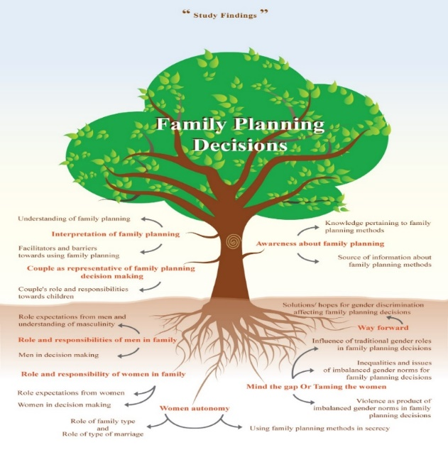
Figure 1. Study Findings
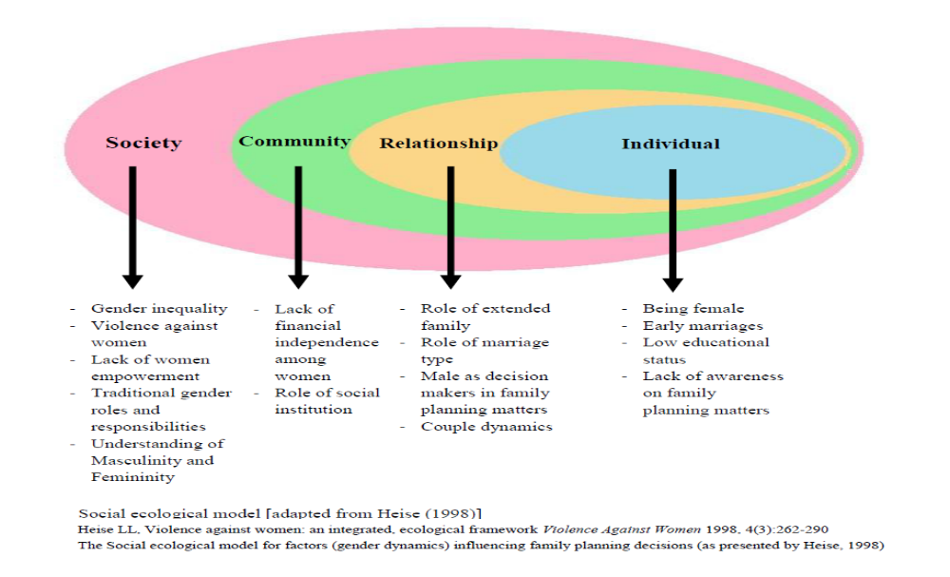
Figure 2. The Social ecological model for factor (gender dynamics) influencing FP decisions (as presented by Heise, 1998)
ERC Approval Letter
