Supplemetal Information for:

Chromosome-level genome assembly of a cliff plant Taihangia rupestris var. ciliata provides insights into its adaptation and demographic history

Wei-Guo Li¹*, Yuan-Yuan Li¹, Chuan-Kun Zheng¹, Zhi-Zhong Li²*
¹ School of Resource and Environment, Henan Polytechnic University, Jiaozuo, Henan 454000, China
² Wuhan Botanical Garden, Chinese Academy of Sciences, Wuhan, China

*Authors for correspondence:
Wei-Guo Li, E-mail: wgli@hpu.edu.cn
Zhi-Zhong Li, E-mail: lizhizhong@wbgcas.cn

- Supplementary Figures

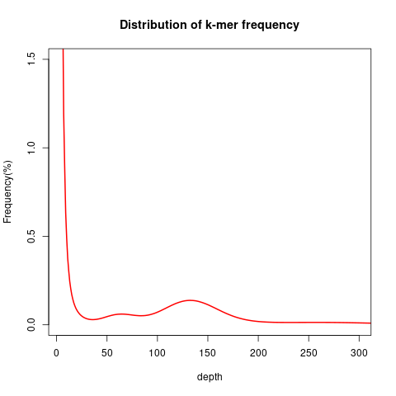

Fig S1. Distribution of 17-mer frequency for Taihangia rupestris var. ciliata
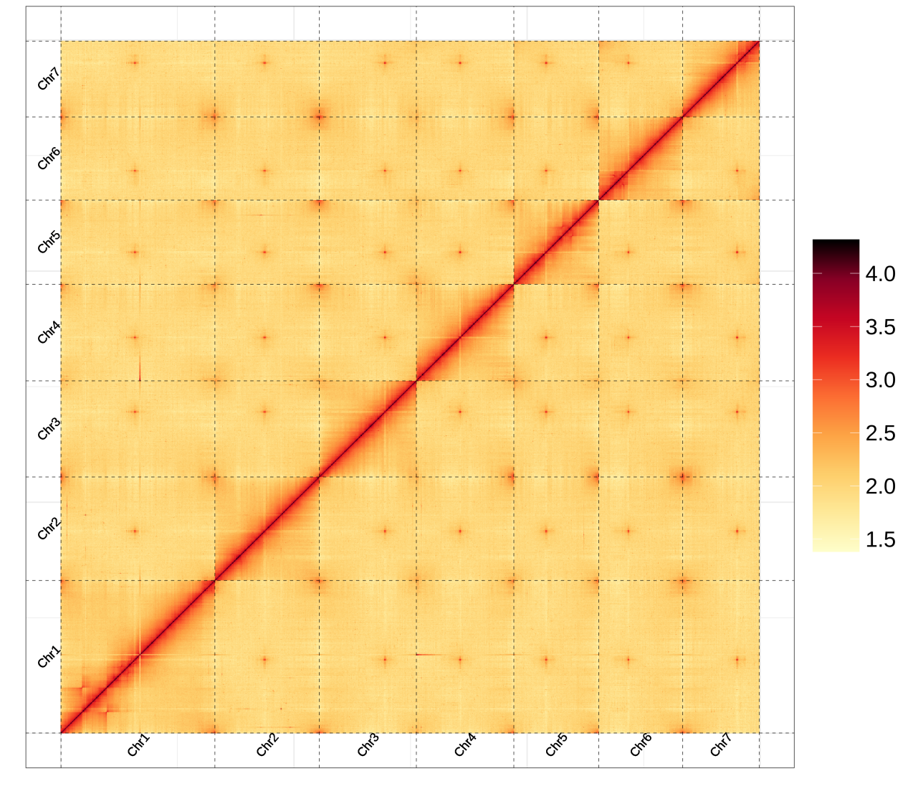
Fig S2. Heat map of the intensity for the Hi-C chromosome

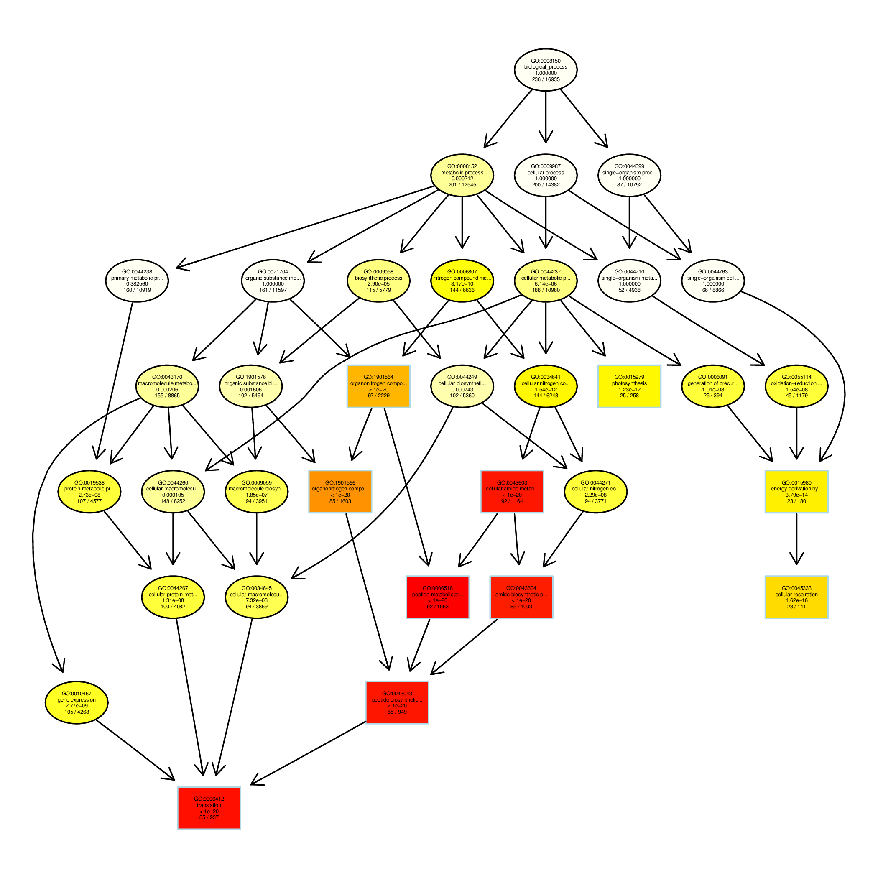
Fig S3. GO enrichment of T. rupestris var. ciliata-expanded genes

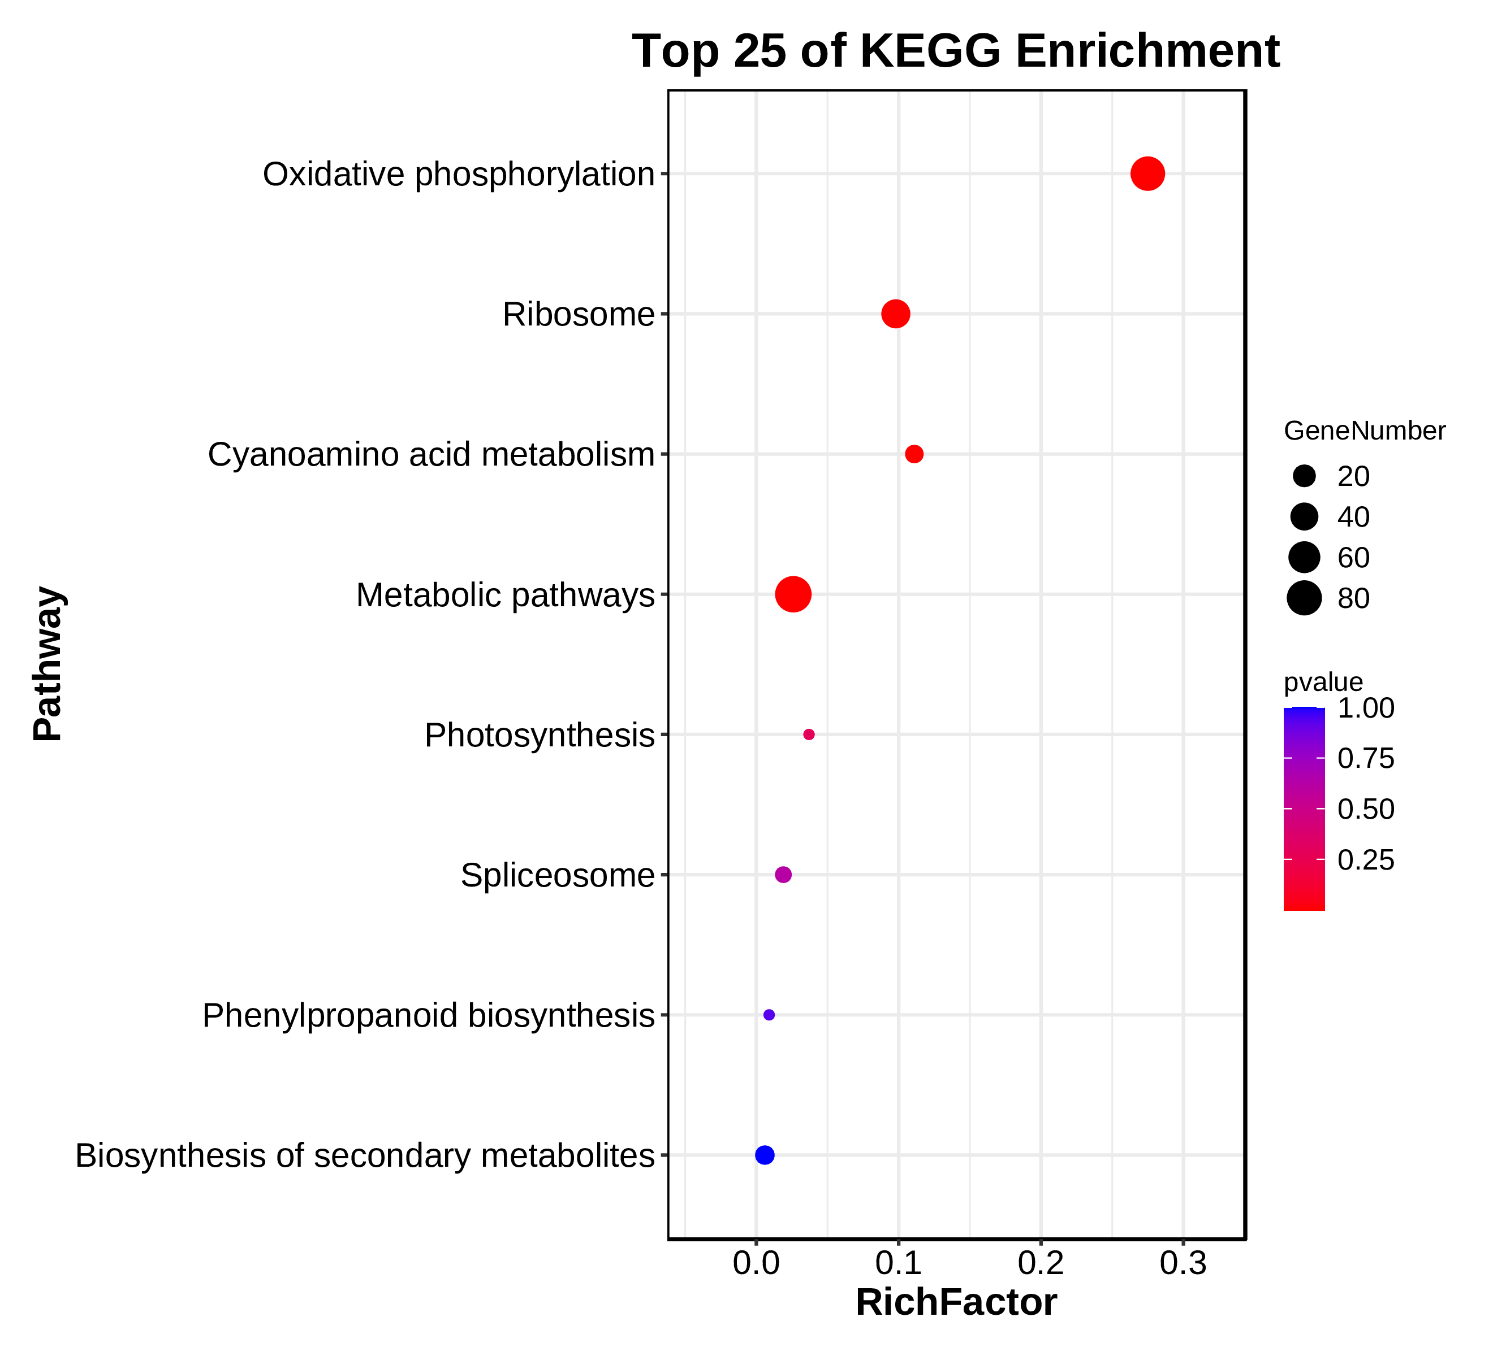

Fig S4. KEGG enrichment of T. rupestris var. ciliata-expanded genes

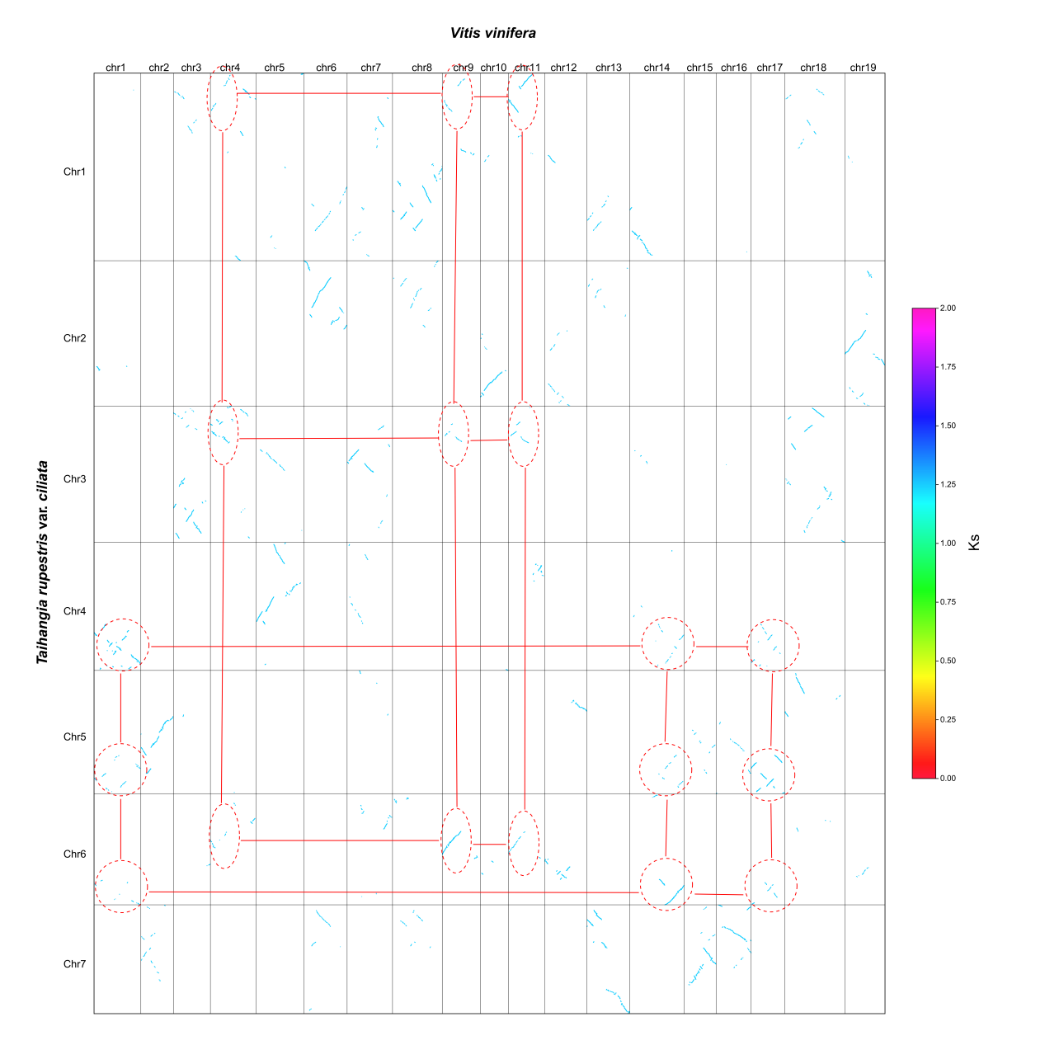

Fig S5. Syntenic analysis between T. rupestris var. ciliata and V. vinifera

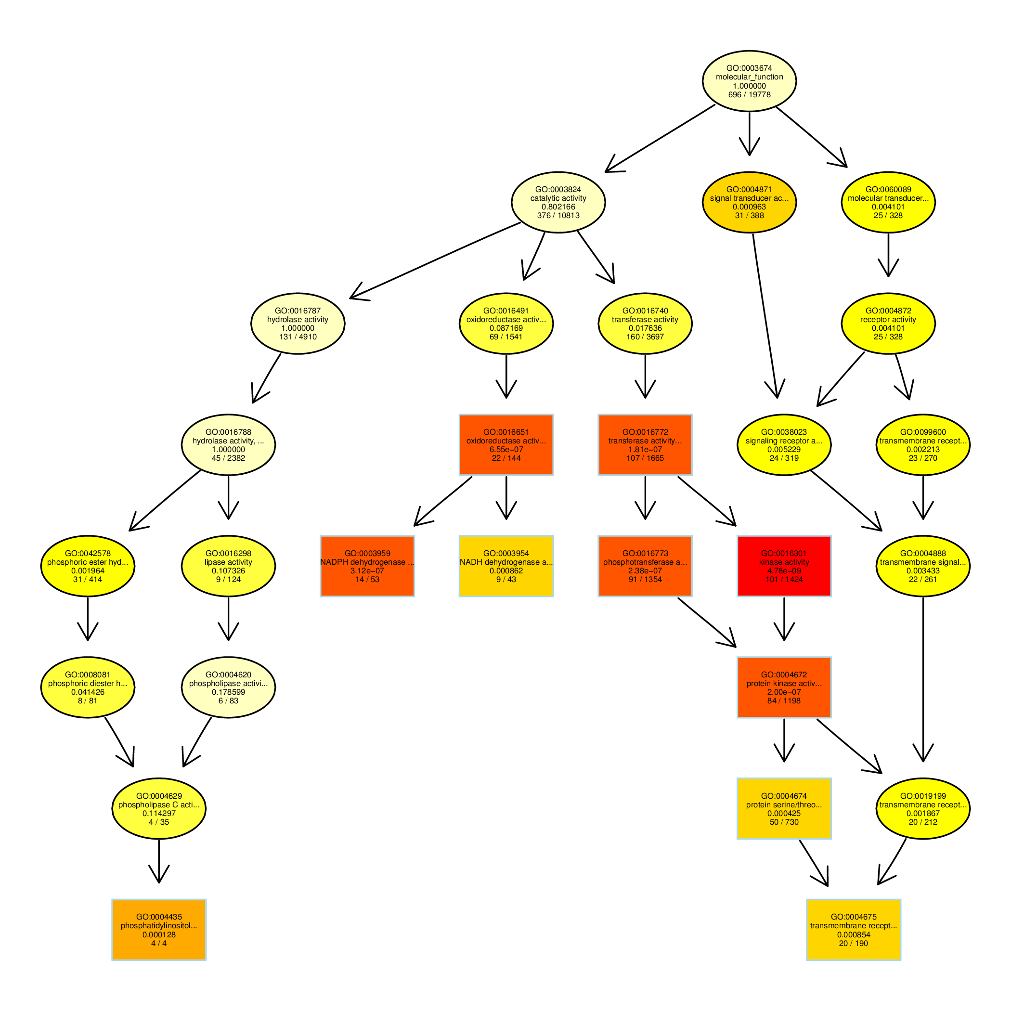

Fig S6. GO enrichment of WGT-related genes in T. rupestris var. ciliata

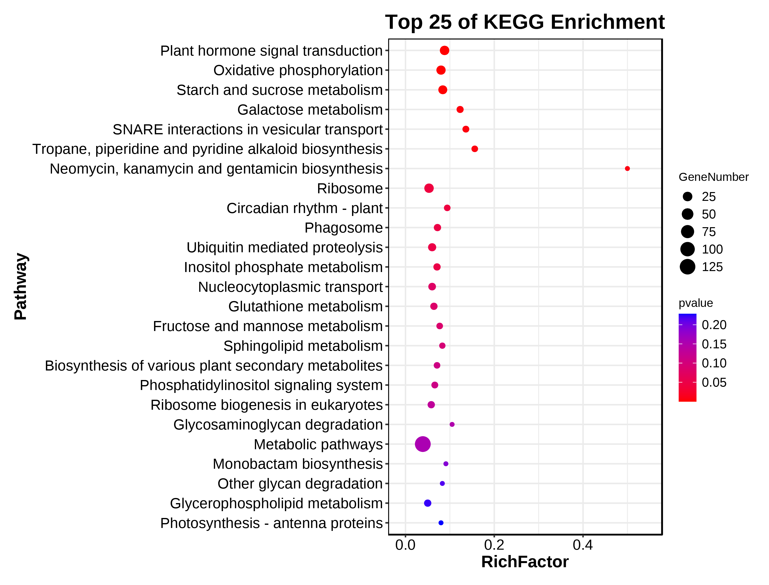

Fig S7. KEGG enrichment of WGT-related genes in T. rupestris var. ciliata

- Supplementary Tables
Table S1. Statistics of the T. rupestris var. ciliata genome assembly
 | Contig |  | Scaffold*
 | Contig length | Contig number | Scaffold length | Scaffold number
Total | 769,501,930 | 309 | 769,508,730 | 241
Longest | 49,193,729 | - | 165,965,130 | -
Number>=2000 | - | 309 | - | 241
N50 | 17,869,299 | 13 | 104,920,189 | 4
N60 | 15,829,046 | 18 | 104,920,189 | 4
N70 | 12,821,381 | 23 | 91,187,168 | 5
N80 | 10,112,734 | 30 | 90,489,742 | 6
N90 | 5,928,420 | 40 | 82,670,173 | 7

* Only scaffolds with more than 100 bp length were used in genome assembly.

Table S2. Evaluation of the T. rupestris var. ciliata genome assembly using core Eukaryotic genes mapping approach (CEGMA)
Category | Prot | Completeness (%)
Complete | 236 | 95.16
Complete + Partial | 241 | 97.18

Table S3. Evaluation of the T. rupestris var. ciliata genome assembly using Benchmarking Universal Single-Copy Orthologs (BUSCO)

BUSCO assessment results (embryophyta_odb10, n = 1614*) | Percentage(%)
Complete BUSCOs | 98.3
Complete and single-copy BUSCOs | 95.8
Complete and duplicated BUSCOs | 2.5
Fragmented BUSCOs | 0.2
Missing BUSCOs | 1.5

* n: Total BUSCO groups searched

Table S4. Evaluation of the T. rupestris var. ciliata genome assembly using remapping of Illumina reads

 |  | % of Percentage
Reads | Mapping rate (%) | 99.52
Genome | Average sequencing depth | 78.29
Genome | Coverage ≥ 1× (%) | 99.98
Genome | Coverage ≥ 4× (%) | 99.93
Genome | Coverage ≥ 10× (%) | 99.85
Genome | Coverage ≥ 20× (%) | 99.55

Table S5. Statistics of the T. rupestris var. ciliata and T. rupestris var. rupestris RNA-Seq data from different tissues

Taxa | Tissues | Accession No. | Sequence Platform | Read Length (bp) | Clean data (G) | Q20/Q30 | Mapping to genome (%)
var. ciliata | root | CNR0866267 | Novoseq6000 | PE150 | 6.55 | 96.42/90.47 | 94.87
var. ciliata | stem | CNR0866268 | Novoseq6000 | PE150 | 6.75 | 96.74/91.37 | 94.14
var. ciliata | leaf | CNR0866269 | Novoseq6000 | PE150 | 6.09 | 96.55/90.82 | 94.26
var. ciliata | male flower | CNR0866270 | Novoseq6000 | PE150 | 6.64 | 96.55/90.79 | 93.28
var. ciliata | bisexual flower | CNR0866271 | Novoseq6000 | PE150 | 6.06 | 95.89/89.41 | 92.69
var. ciliata | mature Leaf (Tci1)* | CNR0866272 | Novoseq6000 | PE150 | 6.30 | 96.88/91.80 | 95.43
var. ciliata | mature Leaf (Tci2)* | CNR0866273 | Novoseq6000 | PE150 | 6.40 | 97.12/92.22 | 96.47
var. ciliata | mature Leaf (Tci3)* | CNR0866274 | Novoseq6000 | PE150 | 6.42 | 97.63/93.52 | 97.13
var. rupestris | mature Leaf (Tru1)* | CNR0866275 | Novoseq6000 | PE150 | 6.20 | 96.75/91.52 | 93.65
var. rupestris | mature Leaf (Tru2)* | CNR0866276 | Novoseq6000 | PE150 | 6.00 | 96.92/91.70 | 94.07
var. rupestris | mature Leaf (Tru3)* | CNR0866277 | Novoseq6000 | PE150 | 6.48 | 97.68/93.59 | 94.61

* only used for comparative transcriptome analyses and other RNA-seq data was used for gene predict annotation in the T. rupestris var. ciliata genome assembly

Table S6. Summary of gene models in the T. rupestris var. ciliata genome assembly
Predict strategy | Gene set | Number | Average transcript length(bp) | Average CDS length(bp) | Average exons per gene | Average exon length(bp) | Average intron length(bp)
De novo | Augustus | 47,057 | 1,789.52 | 951.38 | 3.71 | 256.27 | 309
De novo | GlimmerHMM | 94,336 | 5,857.39 | 591.95 | 2.35 | 252.17 | 3,907.67
De novo | SNAP | 39,547 | 8,254.24 | 502.2 | 4.11 | 122.15 | 2,491.51
De novo | Geneid | 61,809 | 3,273.40 | 748.54 | 3.66 | 204.78 | 950.84
De novo | Genscan | 49,100 | 10,151.01 | 1,214.26 | 5.88 | 206.61 | 1,832.40
Homolog | Fragaria vesca | 30,719 | 2,293.03 | 1,024.20 | 4.04 | 253.68 | 417.74
Homolog | Rosa chinensis | 34,241 | 2,055.53 | 947.14 | 3.76 | 251.61 | 400.97
Homolog | Arabidopsis thaliana | 26,337 | 2,092.06 | 994.73 | 3.89 | 255.45 | 379.17
Homolog | Prunus persica | 28,431 | 2,328.89 | 1,060.77 | 4.17 | 254.67 | 400.64
Homolog | Vitis vinifera | 23,582 | 2,626.51 | 1,002.24 | 4.44 | 225.77 | 472.29
RNAseq | PASA | 33,106 | 2,120.93 | 1,050.88 | 4.54 | 231.41 | 302.18
RNAseq | Transcripts | 53,900 | 5,457.56 | 1,988.59 | 5.98 | 332.46 | 696.38
Final set |  | 36,300 | 2,563.92 | 1,058.99 | 4.37 | 242.48 | 446.91

Table S7. Summary of functional annotation for protein-coding genes in T. rupestris var. ciliata
Database | Number | Percentage (%)
Nr | 31,015 | 85.44
KOG | 10,115 | 27.87
Swissprot | 18,643 | 51.36
GO | 22,584 | 62.21
KEGG | 8,375 | 23.07
InterPro | 28,522 | 78.57
Total | 32,906 | 90.65

Table S8. Summary of non-coding RNA content in T. rupestris var. ciliata

Type |  | Copy number | Average length(bp) | Total length(bp) | % of genome
miRNA |  | 591 | 137.2 | 81,086 | 0.010539
tRNA |  | 1584 | 74.8 | 118,483 | 0.015399
rRNA | rRNA | 7513 | 372.52 | 2,798,727 | 0.36
rRNA | 18S | 1084 | 1736.49 | 1,882,360 | 0.24
rRNA | 28S | 4111 | 142.29 | 584,940 | 0.076023
rRNA | 5.8S | 1038 | 161.55 | 167,691 | 0.021794
rRNA | 5S | 1280 | 127.92 | 163,736 | 0.02128
snRNA | snRNA | 2292 | 111.97 | 256,625 | 0.033353
snRNA | CD-box | 863 | 105.77 | 91,282 | 0.011864
snRNA | HACA-box | 62 | 131.48 | 8,152 | 0.001059
snRNA | splicing | 1366 | 114.89 | 156,945 | 0.020398
snRNA | scaRNA | 1 | 246 | 246 | 0.000032
snRNA | Unknown | 0 | 0 | 0 | 0

Table S9. Summary of transposable elements in the T. rupestris var. ciliata genome assembly

Class |  | Count | Length(bp) | % in genome
LTR
 | Copia | 84,255 | 74,766,505 | 9.72
 | Gypsy | 115,441 | 172,639,711 | 22.44
 | unknown | 192,322 | 154,552,309 | 20.09
TIR
 | CACTA | 88,948 | 67,508,074 | 8.77
 | Mutator | 63,883 | 22,334,287 | 2.9
 | PIF_Harbinger | 33,992 | 14,487,289 | 1.88
 | Tc1_Mariner | 1646 | 645,578 | 0.08
 | hAT | 28,715 | 10,719,798 | 1.39
nonTIR
 | helitron | 57,012 | 25,352,507 | 3.3
Total |  | 666,214 | 543,006,058 | 70.57

Table S10. Comparison of transposon content in cliff and non-cliff plants in Rosaceae
 | T. rupestris var. ciliata | F. vesca | P. persica | R. chinensis | M. domestica | C. sativa
Habitat | cliff | non-cliff | non-cliff | non-cliff | non-cliff | non-cliff
Genome size (Mb) | 769 | 219 | 225 | 516 | 625 | 737
TE content  (% in genome) | 543 Mb (70.57%) | 72.59 Mb (33.08%) | 73.84 Mb (32.87%) | 290.37 Mb (56.32%) | 356.79 Mb (57.10%) | 504.52 Mb (68.50%)
Number of Intact LTR-RTs  (Copia/Gypsy) | 8558  (3729/4829) | 1098  (683/415) | 1132  (804/328) | 6033  (4265/1768) | 5421  (3251/2170) | 7226  (4698/2528)

Table S11. Summary of resequencing analysis
Taxa | Individuals | Localities | Latitude | Longitude | Resource type | Clean data (Gb) | Sequencing depth (×)* | Accession No.
var. ciliata | JG-1 | Jiaogou, Hebei | 36º30ʹ | 113°38ʹ | PE150 bp,  DNBSEQ-T7 | 24.91 | 28.86 | CNR0866279
var. ciliata | QQ-2 | Qingquan, Shanxi | 36º44ʹ | 113°32ʹ | PE150 bp,  DNBSEQ-T7 | 21.57 | 24.99 | CNR0866280
var. ciliata | DJC-2 | Dujiacun, Hebei | 36º53ʹ | 113°47ʹ | PE150 bp,  DNBSEQ-T7 | 21.6 | 25.02 | CNR0866281
var. ciliata | LJ-3 | Liejiang, Hebei | 36º54ʹ | 113°46ʹ | PE150 bp,  DNBSEQ-T7 | 26.18 | 30.33 | CNR0866282
var. rupestris | MZ-1 | Manzhanshan, Henan | 36°05ʹ | 113°42ʹ | PE150 bp,  DNBSEQ-T7 | 21.62 | 25.04 | CNR0866283
var. rupestris | XXT-1 | Xiaoxitian, Henan | 36°03ʹ | 113°40ʹ | PE150 bp,  DNBSEQ-T7 | 21 | 24.33 | CNR0866284
var. rupestris | QPG-1 | Qianpogou, Henan | 36°02ʹ | 113°39ʹ | PE150 bp,  DNBSEQ-T7 | 26.34 | 30.51 | CNR0866285
var. rupestris | YDS-1 | Yidoushui, Henan | 35°28ʹ | 113°23ʹ | PE150 bp,  DNBSEQ-T7 | 21.8 | 25.25 | CNR0866286
var. rupestris | ZYF-1 | Zhuyufeng, Henan | 35°27ʹ | 113°22ʹ | PE150 bp,  DNBSEQ-T7 | 19.37 | 22.44 | CNR0866287
var. rupestris | GS-1 | Hongshixia,Henan | 35°33ʹ | 113°30ʹ | PE150 bp,  DNBSEQ-T7 | 25.31 | 29.32 | CNR0866288
var. rupestris | TZF-1 | Tianzhufeng,Henan | 35°33ʹ | 113°31ʹ | PE150 bp,  DNBSEQ-T7 | 21.12 | 24.47 | CNR0866289

*Sequencing depth was estimated according to the estimated genome size of 863.27M

Table S12. Genome sequencing information for Taihangia rupestris var. ciliata

Library type | Clean data (Gb) | Read N50/ length (bp) | Sequencing depth (×)*
Illumina (Genome survey) | 70 | 150 | 81
Illumina (Hi-C) | 114.6 | 150 | 132
HiFi | 27.9 | 15,274 | 32
Total | 212.5 |  | 245

*Sequencing depth was estimated according to the estimated genome size of 863.27M

Table S13. Genomic resources used for comparative analyses in this study

Species name | Database link
Amborella trichopoda | https://www.ncbi.nlm.nih.gov/
Arabidopsis thaliana | https://bioinformatics.psb.ugent.be/plaza/
Populus trichocarpa | https://bioinformatics.psb.ugent.be/plaza/
Davidia involucrata | https://bioinformatics.psb.ugent.be/plaza/
Solanum lycopersicum | https://bioinformatics.psb.ugent.be/plaza/
Helianthus annuus | https://bioinformatics.psb.ugent.be/plaza/
Nelumbo nucifera | http://nelumbo.biocloud.net/nelumbo/home
Fragaria vesca | https://bioinformatics.psb.ugent.be/plaza/
Rosa chinensis | https://bioinformatics.psb.ugent.be/plaza/
Malus domestica | https://bioinformatics.psb.ugent.be/plaza/
Prunus persica | https://bioinformatics.psb.ugent.be/plaza/
Cannabis sativa | https://bioinformatics.psb.ugent.be/plaza/
Vitis vinifera | https://bioinformatics.psb.ugent.be/plaza/
Acer truncatum | https://bioinformatics.psb.ugent.be/plaza/
Musa acuminata | https://bioinformatics.psb.ugent.be/plaza/
Oryza sativa ssp. japonica | https://bioinformatics.psb.ugent.be/plaza/
Nymphaea colorata | https://www.ncbi.nlm.nih.gov/

