Supplementary material
An environmentally friendly multifunctional soy protein adhesive composed of rosin acid derivative inspired from organic-inorganic hybrid structure
Yinchun Hu ^{1, #} Limin Qu ^{1, #} Zhenyang Bao ¹ Zhaoshuang Li ^{1, *} Renzhong Wei ² Qin Huang ³ Yan Qing ¹ Xingong Li ¹ Yiqiang Wu ^{1, *}
¹ College of Materials Science and Engineering, Central South University of Forestry & Technology, Changsha 410004, China
² Treezo New Material Science & Technology Group Co., Ltd, Hangzhou 311107, China
³ Key Laboratory of Chemistry and Engineering of Forest Products, State Ethnic Affairs Commission, Guangxi Key Laboratory of Chemistry and Engineering of Forest Products, Guangxi Minzu University, Nanning 530006, China
# These authors contributed equally to this work
* Corresponding author: Zhaoshuang Li (lzs0829@csuft.edu.cn) & Yiqiang Wu (wuyq0506@126.com)
1.1 Preparation of RA modified functionalization compounds
50 g APA, 150 g EPC and 1.52g TEBA were added into a flask and stirred fully for 2 h at 117 ℃ under the protection of nitrogen atmosphere, and then cooled to 60 ℃. After that, 10.68 g sodium hydroxide and 14.98 g calcium oxide were added and continued for 3 h at 60 ℃. The obtained compound was filtered with kieselguhr and the filtrate was distilled in vacuum at 100 ℃. At last, the product after vacuum distillation was reacted with 7.9 g DOPA at 80 ℃ for 1 h to obtain the RA-DOPA modified functionalization compounds. The syntheses and Nuclear Magnetic Resonance (NMR) data of RA-DOPA modified functionalization compound was described in Figure S1 and Figure S2.
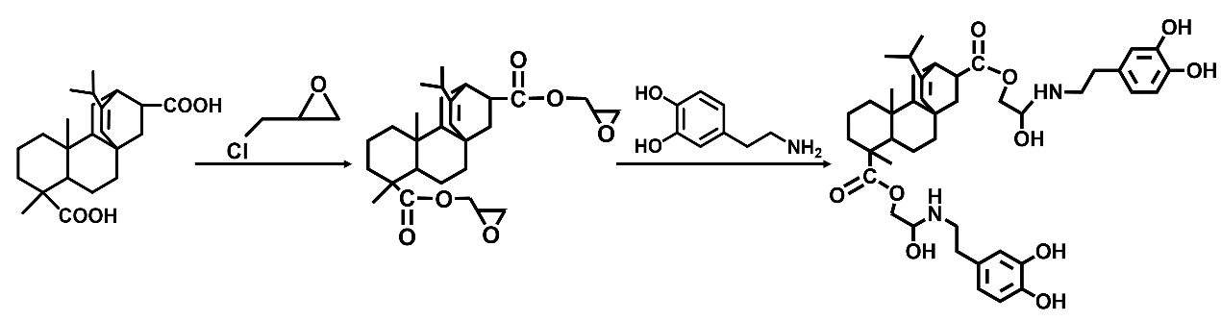
Figure. S1 Syntheses of the RA-DOPA modified functionalization compound
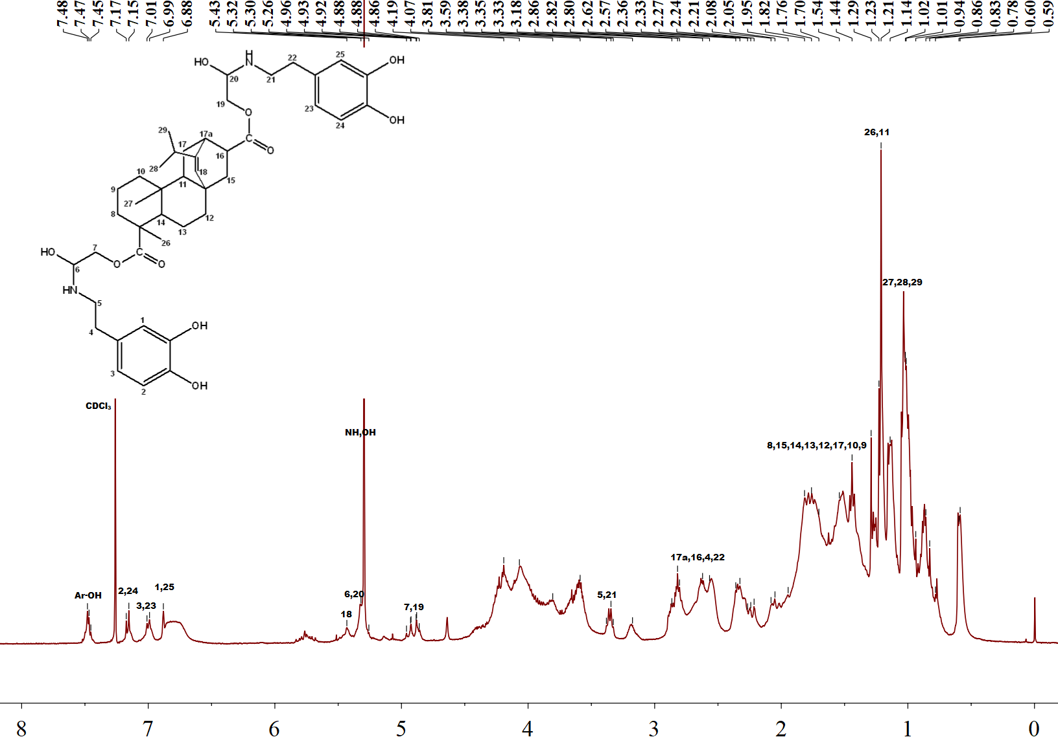
Figure. S2 ¹H-NMR spectra of the RA-DOPA modified functionalization compounds
1.2 Characterization
To ascertain the chemical make-up of the materials, XPS (Kratos, UK) was utilized. Additionally, SEM (Hitachi, Regulus 8100, Japan) was deployed to investigate the specimens’ morphology after bonding strength test. EDS (Hitachi, Regulus 8100, Japan) was used to prove that adhesive was evenly distributed on wood veneer. Design-expert (trial version 13, StatEase Inc., Minneapolis) was applied to find the best formulation for SPI-RA-CSA adhesive. The response surface optimization test design was carried out by using three-factor and three-level Box-Behnken Design model, and 17 groups of experiments were carried out. The environmental impact of melamine-formaldehyde resin, phenolic resin and SPI-RA6-CSA1 adhesive was evaluated by LCA analysis. The whole modeling process was calculated by Simapro 9 software and the Ecoinvent 3.9 database.

1.3 RSM analysis and results
Table S1 Levels of independent variables used in RSM design
Independent variables |  |  |  | Levels
Factors | -1 |  | 0 |  | 1
CSA (g) | 0.75 |  | 1 |  | 1.25
Compound (%) | 3 |  | 6 |  | 9
Hot-pressing temperature (°C) | 120 |  | 130 |  | 140

Table S2 Experimental parameters and results
Std | Run | A: CSA (g) | B: Compound (%) |  | C: Hot-pressing temperature (°C) | Y: Aged bonding strength (MPa)
1 | 11 | 0.75 |  | 3 | 130 | 1.07
2 | 9 | 1.25 |  | 3 | 130 | 1.35
3 | 15 | 0.75 |  | 9 | 130 | 1.28
4 | 5 | 1.25 |  | 9 | 130 | 1.32
5 | 7 | 0.75 |  | 6 | 120 | 1.01
6 | 12 | 1.25 |  | 6 | 120 | 1.08
7 | 8 | 0.75 |  | 6 | 140 | 1.22
8 | 2 | 1.25 |  | 6 | 140 | 1.20
9 | 10 | 1 |  | 3 | 120 | 1.04
10 | 13 | 1 |  | 9 | 120 | 1.04
11 | 16 | 1 |  | 3 | 140 | 1.24
12 | 4 | 1 |  | 9 | 140 | 1.21
13 | 1 | 1 |  | 6 | 130 | 1.48
14 | 6 | 1 |  | 6 | 130 | 1.43
15 | 14 | 1 |  | 6 | 130 | 1.52
16 | 3 | 1 |  | 6 | 130 | 1.37
17 | 17 | 1 |  | 6 | 130 | 1.39

Table S3 ANOVA results for response surface quadratic model of aged bonding strength
Sources | Sum of squares | df | Mean square | F value | P value | Effect
Model | 0.3899 | 9 | 0.0433 | 10.01 | 0.0031 | significant
A-CSA | 0.0171 | 1 | 0.0171 | 3.95 | 0.0871
B-Compound | 0.0028 | 1 | 0.0028 | 0.6496 | 0.4468
C-Hot pressing temperature | 0.0612 | 1 | 0.0612 | 14.15 | 0.0071
AB | 0.0144 | 1 | 0.0144 | 3.33 | 0.1110
AC | 0.0020 | 1 | 0.0020 | 0.4677 | 0.5160
BC | 0.0002 | 1 | 0.0002 | 0.0520 | 0.8262
A² | 0.0372 | 1 | 0.0372 | 8.59 | 0.0220
B² | 0.0334 | 1 | 0.0334 | 7.70 | 0.0275
C² | 0.1974 | 1 | 0.1974 | 45.59 | 0.0003
Residual | 0.0303 | 7 | 0.0043
Lack of fit | 0.0148 | 3 | 0.0049 | 1.28 | 0.3957 | not significant
Pure Error | 0.0155 | 4 | 0.0039
Cor Total | 0.4202 | 16

