Supporting Information

Direct observation of unidirectional exciton-polariton in layered van der Waals semiconductors

Section S1: Plane wave expansion of the field of circularly polarized dipole
Section S2: Simulation of AFM apex induced circularly polarized dipoles
Section S3: Experimental setup
Section S4: Calibration by TE₀ mode in ultra-thin MoS₂ layer
Section S5: Real-space imaging of unidirectional waveguide modes in MoS₂ layer
Section S6: Coupling efficiency of near-field waveguide modes with s-SNOM tip
Section S7: Characterization of TMD nanoflakes with Raman spectroscopy
Section S8: Strong coupling of unidirectional waveguide EP modes in WS₂ layer

Section S1: Plane wave expansion of the field of circularly polarized dipole
The wave equation of vector potential$\vec{A}$(x,y,z) in a homogeneous non-magnetic medium is:
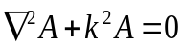 (S1.1)
where k is the wavevector of the free space. Considering the dipole and TMD nanoflakes are placed along z axis, we can expand the field distribution into plane waves propagate along xoy plane with in-plane wavevector (k_{x},k_{y}) as:
(S1.2)
To ensure this plane wave solution satisfies the wave equation Eq. S(1.1), the spatial frequency distribution $\tilde{A}$(k_{x},k_{y},z) satisfies the restriction equation in z direction:
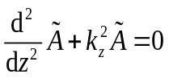 (S1.3)
where k_{z} = $\sqrt{k^{2}-k_{x}^{2}-k_{y}^{2}}$ and k_{z} reveals free space wave as k_{x}² + k_{y}² ≤ k², while it reveals evanesent wave as k_{x}² + k_{y}² > k², i.e. the waveguide exciton-polariton mode in our work.
In this case, we expanded the vector potential of an electric dipole as followes ⁽¹⁾:
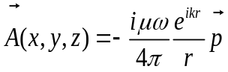 (S1.4)
where r = $\sqrt{x^{2} + y^{2} + z^{2}}$, into plane wave by using the Weyl identity:
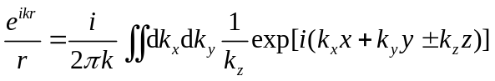 (S1.5)
where the + sign for field above the dipole (z > 0) and – sign for field below the dipole (z < 0), such that:
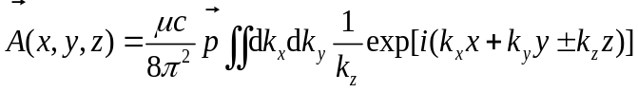 (S1.6)
With the definition of magnetic field and vector potential $\vec{H}$(x,y,z) = $∇$×$\vec{A}$(x,y,z) / μ , we can further expand the magnetic field of the dipole into a set of plane wave as:
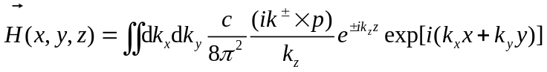 (S1.7)
Based on the Maxwell's equations in frequency domain that $\vec{E}$(x,y,z) = $∇$×$\vec{H}$(x,y,z) / (iωε), the electric field of the dipole can be expanded as:
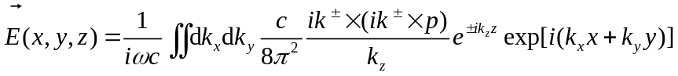 (S1.8)
where the spatial frequency distribution of dipole's electric field is shown as:
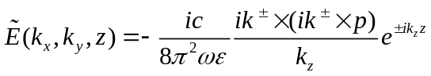 (S1.9)
Consider the plane wave components which propagate along x direction, i.e., the components with k_{y} = 0, we can derived the spatial frequency distribution of TE modes excited by horizontal dipole components (p_{x},p_{y},0) and of TM modes induced by vertical dipole components (p_{x},0,p_{z}) after considering the position of dipole z_{dipole} as followed:
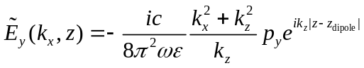 (S1.10)
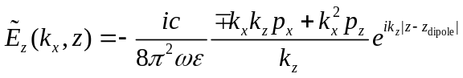 (S1.11)
As shown in Fig. S1, the elliptical polarization converts the positive correlation between unidirectionality R = |$\tilde{E}$_{z}(k_{x})/$\tilde{E}$_{z}(-k_{x})| and the in-plane momentum k_{x} of circularly polarized incidence into negative correlation, i.e. the unidirectionality of elliptically dipole is more significant when the coupled waveguide modes have smaller in-plane momentum.
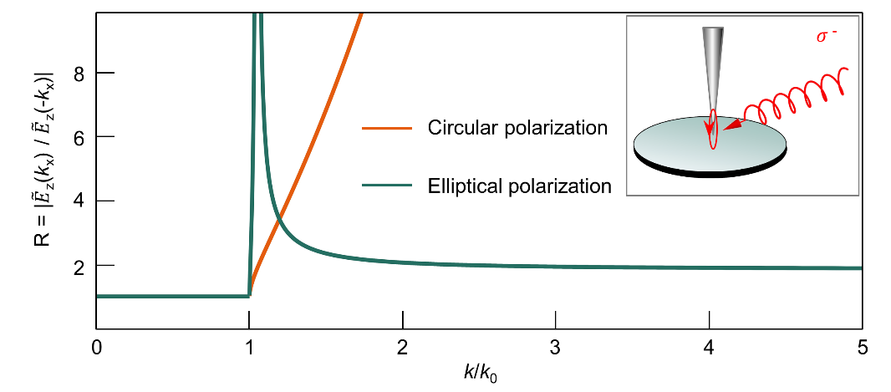

Fig. S1| Unidirectionality of a circularly polarized (orange line) dipole with (px, py, pz) = (1, 0, -i) and an elliptical polarized (cyan line) dipole with (px, py, pz) = (1, 0, -0.3i), where R = |$\tilde{E}$_{z}(k_{x})/$\tilde{E}$_{z}(-k_{x})|. Inset: illustration of the elliptic circularly polarized dipole at the AFM tip via oblique illumination. The wavelength of incident light is 632.8 nm.

Section S2: Simulation of AFM apex induced circularly polarized dipoles.
To model the atomic force microscope (AFM) apex induced transition from free-space chiral illumination to circularly polarized dipole, numerical simulations were performed with finite difference time domain method. As shown in Fig. S2, a circularly polarized plane wave is incident on the 3D simplified pyramid shaped tip. To estimate the polarization of the electric field near the AFM apex, we calculated the Stokes parameter S₃ = - 2Im(E_{y}E_{z}*) at the yoz cross section at x = 0 μm. We marked the areas where |S₃| > 0.98 which reveals significant circularly polarization in yoz plane. The results for LCP and RCP illuminations are shown in Fig. S1a and Fig. S1b, and these results illustrate that the AFM apex modulates the chiral illuminations into chiral electric field near it. More importantly, the calculations show that the chiral electric field localizes in a small area near the top of apex and forms a circularly polarized dipole.
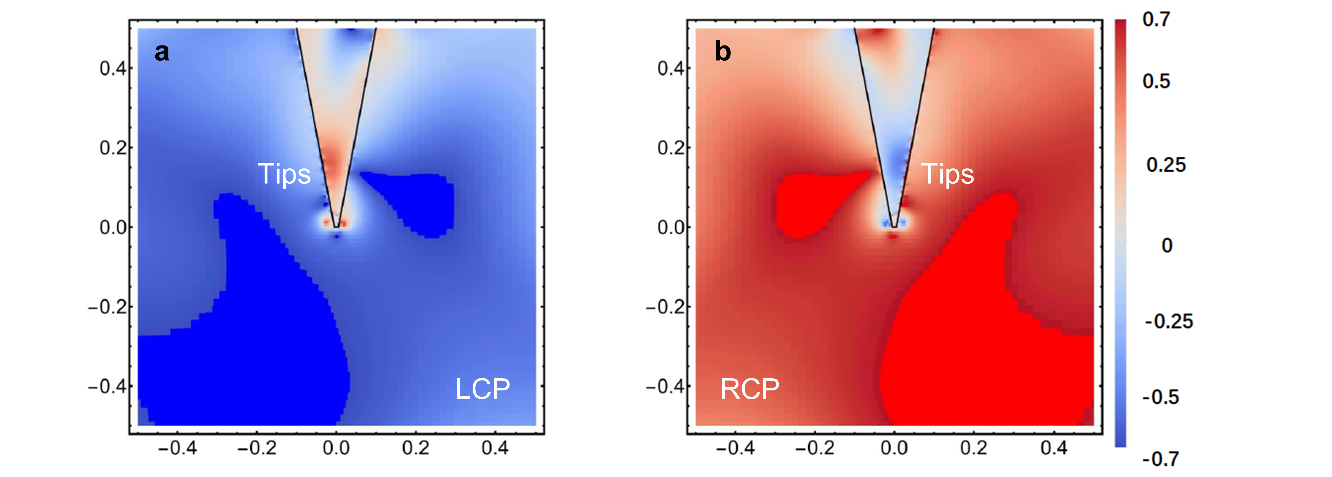

Fig. S2| Numerical simulation of the distribution of Stokes parameter S₃ near the AFM apex. The illumination is circularly polarized planewave and the apex of AFM is a simplified pyramid shaped tip. With LCP (a) and RCP (b) incident lasers, the distribution of S₃ shows the polarization states near the top of apex are consisted with the illumination.

Section S3: Experimental setup
Figure S3 shows the experimetal setup utilized to probe the TMD sample in the near field. A helium-neon laser in the visible spectram ($λ=$632.8 nm) is used as the light source. And a polarizer ensures the incident light is linearly polarized and a 1/4 waveplate is used to convert the linear polarization to circular polarization, which is further controlled by a 1/2 waveplate. The circularly polarized laser is then used to excite and to probe the EP through a typical s-SNOM based on a Michelson interferometer configuration. The detected signal is collected by a detector and modulated by the tapping frequency of the AFM tip through a lock-in amplifier to excluding the scattering far-field noise and filtering the near-field signals.
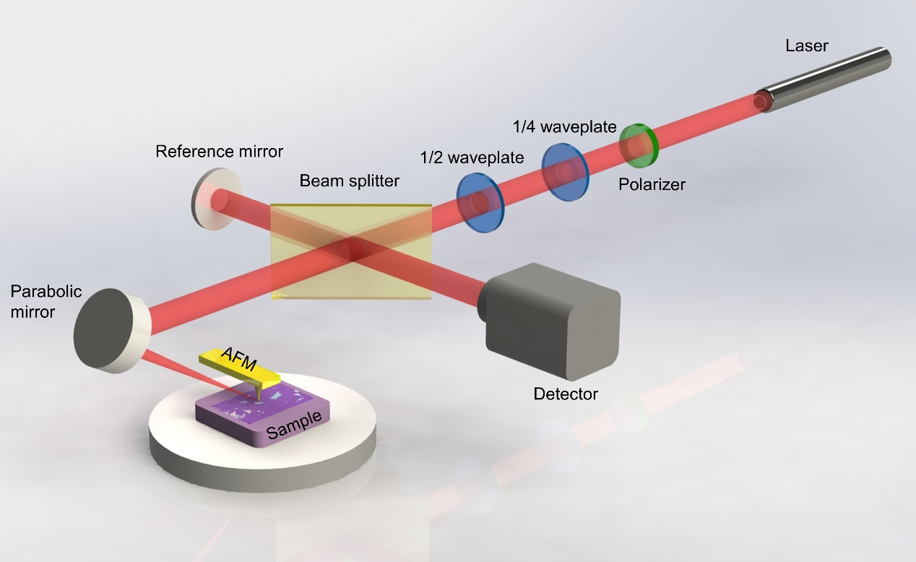

Fig. S3| Schematic illustration of the near-field measurement setup.

Figure S4 shows the formation of near-field EPs at the edge of TMD material. Under left circularly polarized illumination, unidirectional EPs are excited due to the asymmetric high-spatial-frequency components of the circularly polarized dipole radiation coupled into waveguide modes. As illustrated in Fig. S4, the amplitude of exponential-decay blue curve propagating to the left is larger than that of orange curve which propagates to the right. Tip-launched waveguide modes propagate and get scattered to the free space as edge scattering signal. With tip moving away from the edge, the amplitude of inference pattern between edge and tip scattering signals gradually decreases, leading to darker inteference fringes shown as Fig. 4S(d).
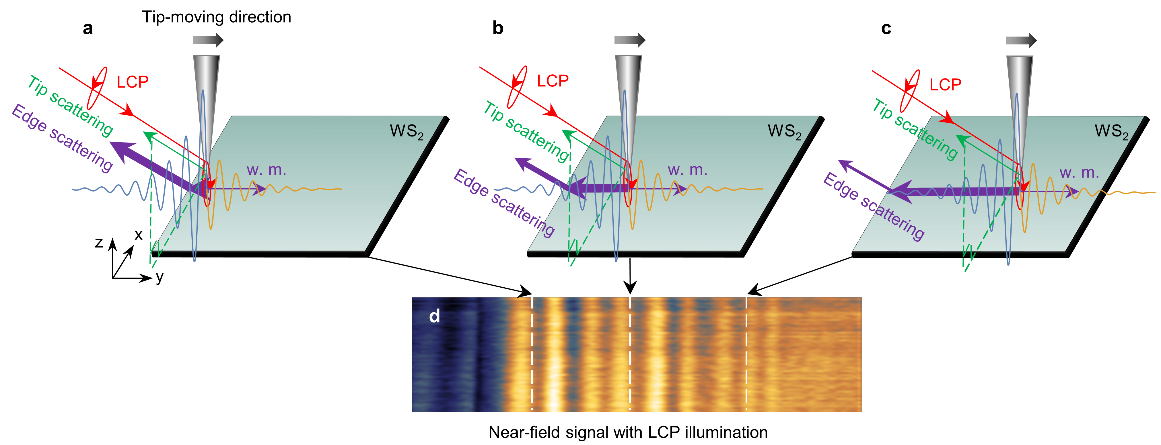
Fig. S4| Formation of the near-field EPs at the edge.

Section S4: Calibration by TE₀ mode in ultra-thin MoS₂ layer
In order to further verify our probing method, another van der Waals material, 12 nm-thick MoS₂, was used to first obtain the calibration value and normalized factor. Here, we used scattering-type scanning near-field optical microscopy (s-SNOM), which is bulit based on an AFM in tapping mode. The AFM tip used in experiments are PR-EX-SNM-A with the tapping frequency of 277 kHz.
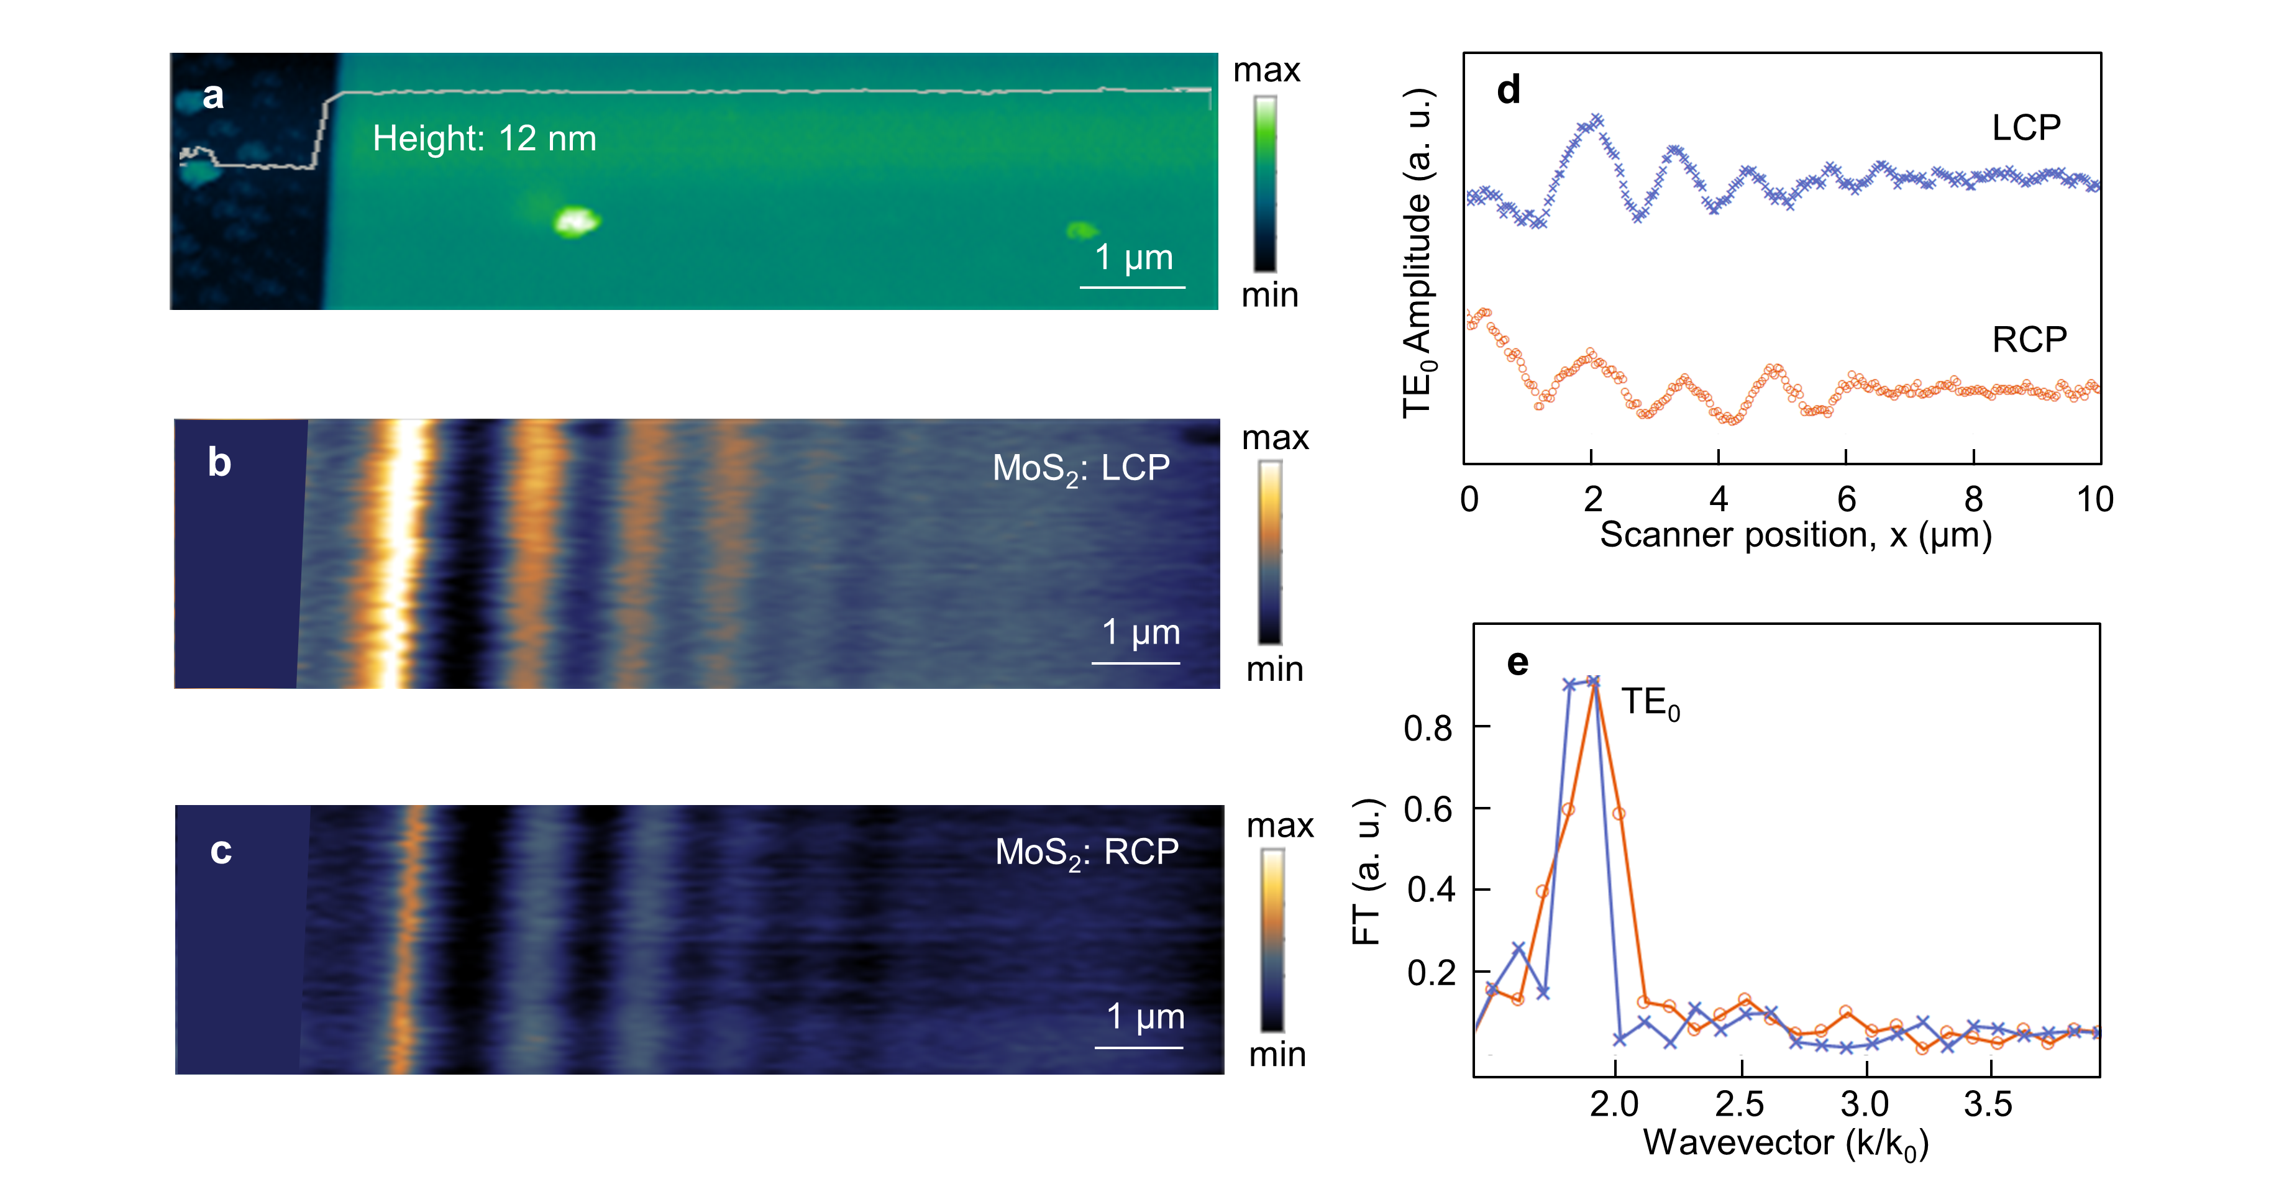

Fig. S5| Experimental observation of TE₀ mode on the MoS₂ flake. a, Topography image of a 12 nm-thick MoS₂ on the SiO₂ substrate. The inset white line denotes the height of MoS₂. Measured amplitude images of the TE₀ mode by illuminating right (b) and left (c) circularly polarized light at wavelength of 632.8 nm, respectively. d, Amplitude line profiles extracted from near-field images (b and c). e, Fourier transform of the experimental near-field signals after calibration.

Section S5: Real-space imaging of unidirectional waveguide modes in MoS₂ layer
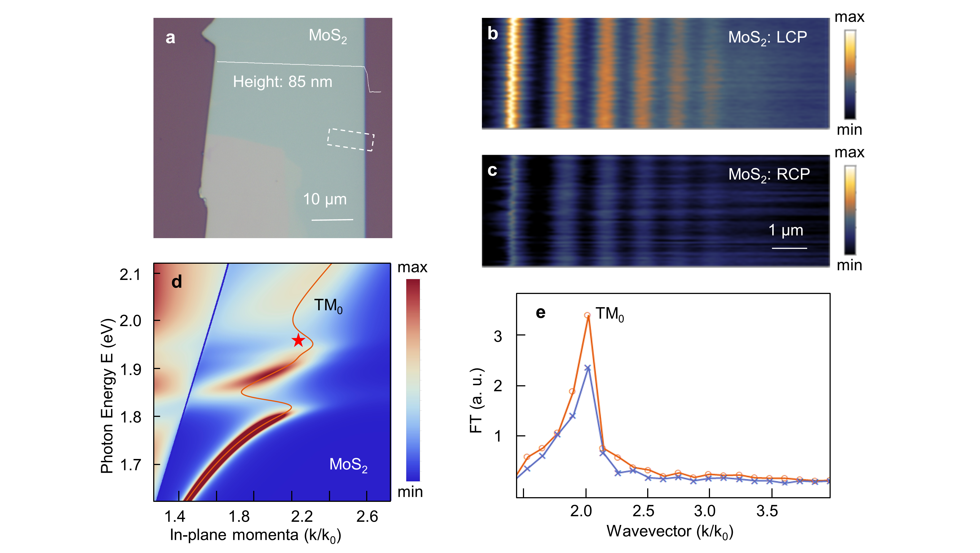

Fig. S6| Real-space imaging of unidirectional waveguide modes by s-SNOM. a, Optical microscope images of the 85 nm-thick MoS₂ flake. The measured areas are marked by white dashed circles. Profiles taken from the scanning regions are shown as white lines. (b and c) Polarization-dependent amplitudes of TM₀ mode. d, Dispersion colormap of an Air/MoS₂/SiO₂ waveguide calculated by transform matrix method. The experimental data points (red pentagrams) show good agreement with the calculated dispersion of TM₀ mode (red line). e, FT of the near-field images shown in (b and c). The frequency peak corresponds to TM₀ mode equals to 2.03k₀.

Section S6: Coupling efficiency of near-field waveguide modes and s-SNOM tip.

The propagating waveguide modes in the WS₂ flakes interfere with tip scattering of the illuminating laser, forming the interferometric patterns as shown in Fig. 3. It is worth mentioning that the Fourier transform of the near-field signals exhibits two peaks, one around 1.56k₀ is associated with TM₁ mode, while the other one (2.26k₀) denotes the TM₀ mode. The calculated coupling efficiency of the tip-induced hotspot and the former waveguide mode (0.045), $C_{eff}=\frac{\int_{0}^{z_{tip}}{\left|E_{z}\right|dz}}{\int_{-∞}^{∞}{\left|E_{z}\right|dz}}$, is predominant than that of TM₀ mode (0.021). The interval 0 nm < z < $z_{tip}$ denotes the efficient coupling region (green region), where $z_{tip}$ equals to 100 nm. The tip-sample coupling efficiency is shown in Fig. S7.
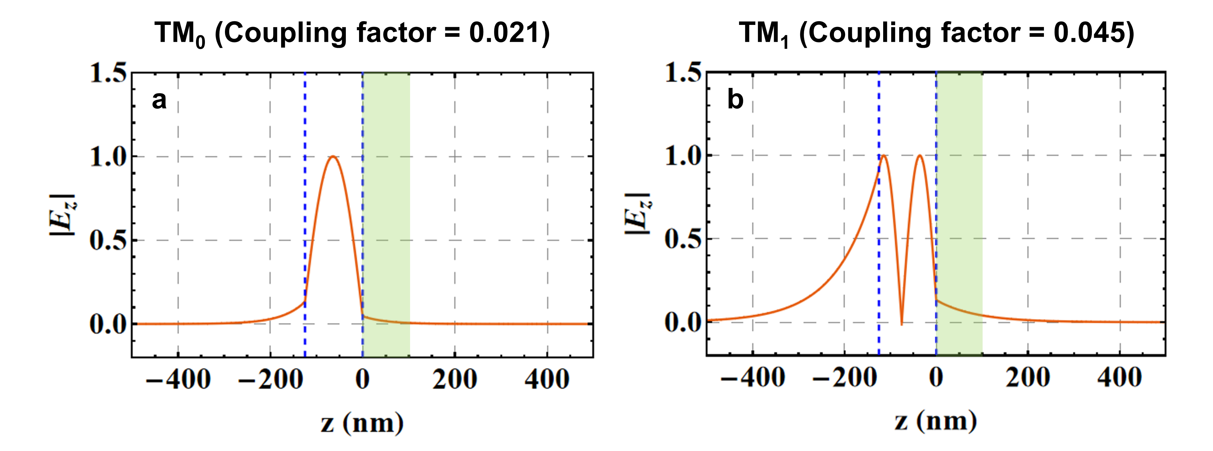

Fig. S7| Coupling efficiency of s-SNOM tip with (a) TM₀ and (b) TM₁ modes in 125 nm-thick WS₂ at incident wavelength of 632.8 nm. The blue dashed lines denote the region of the WS₂ layer (125 nm). The green region is the efficient coupling region. The coupling factor for TM₁ (0.045) mode is higher than that for TM₀ (0.021) mode, denoting the predominant position of TM₁ mode in the measured signal in Fig. 3k.

Section S7: Characterization of TMD nanoflakes with Raman spectroscopy
To confirm that the exfoliated nanoflakes we used to support the unidirectional waveguide EP modes are indeed MoS₂ and WS₂, we perform Raman spectroscopy of these flakes. Figure S8 shows Raman spectra signals, obtained with a homemade Raman microscope, of the MoS₂ and WS₂ sample illustrated in the insets, as well as in Fig. S6 and Fig. 3d. The typical first order in-plane phonon mode $E_{2g}^{1}$(Γ) (at 382 cm⁻¹) peak and out-plane phonon mode A_{1g}(Γ) (at 407 cm⁻¹) peak for MoS₂ flake are obtained as shown in Fig. S8a, while the first-order modes LA(M) (at 176 cm⁻¹), $E_{2g}^{1}$(Γ) (at 356 cm⁻¹) and A_{1g}(Γ) (at 418 cm⁻¹) Raman peaks and the significant second-order mode 2LA(M) (at 352 cm⁻¹) of WS₂ sample are revealed in Fig. S8b. The Raman spectra obtained from the samples we used to reveal the unidirectional EP modes are greatly consisted with previous works ^{(2, 3)}.
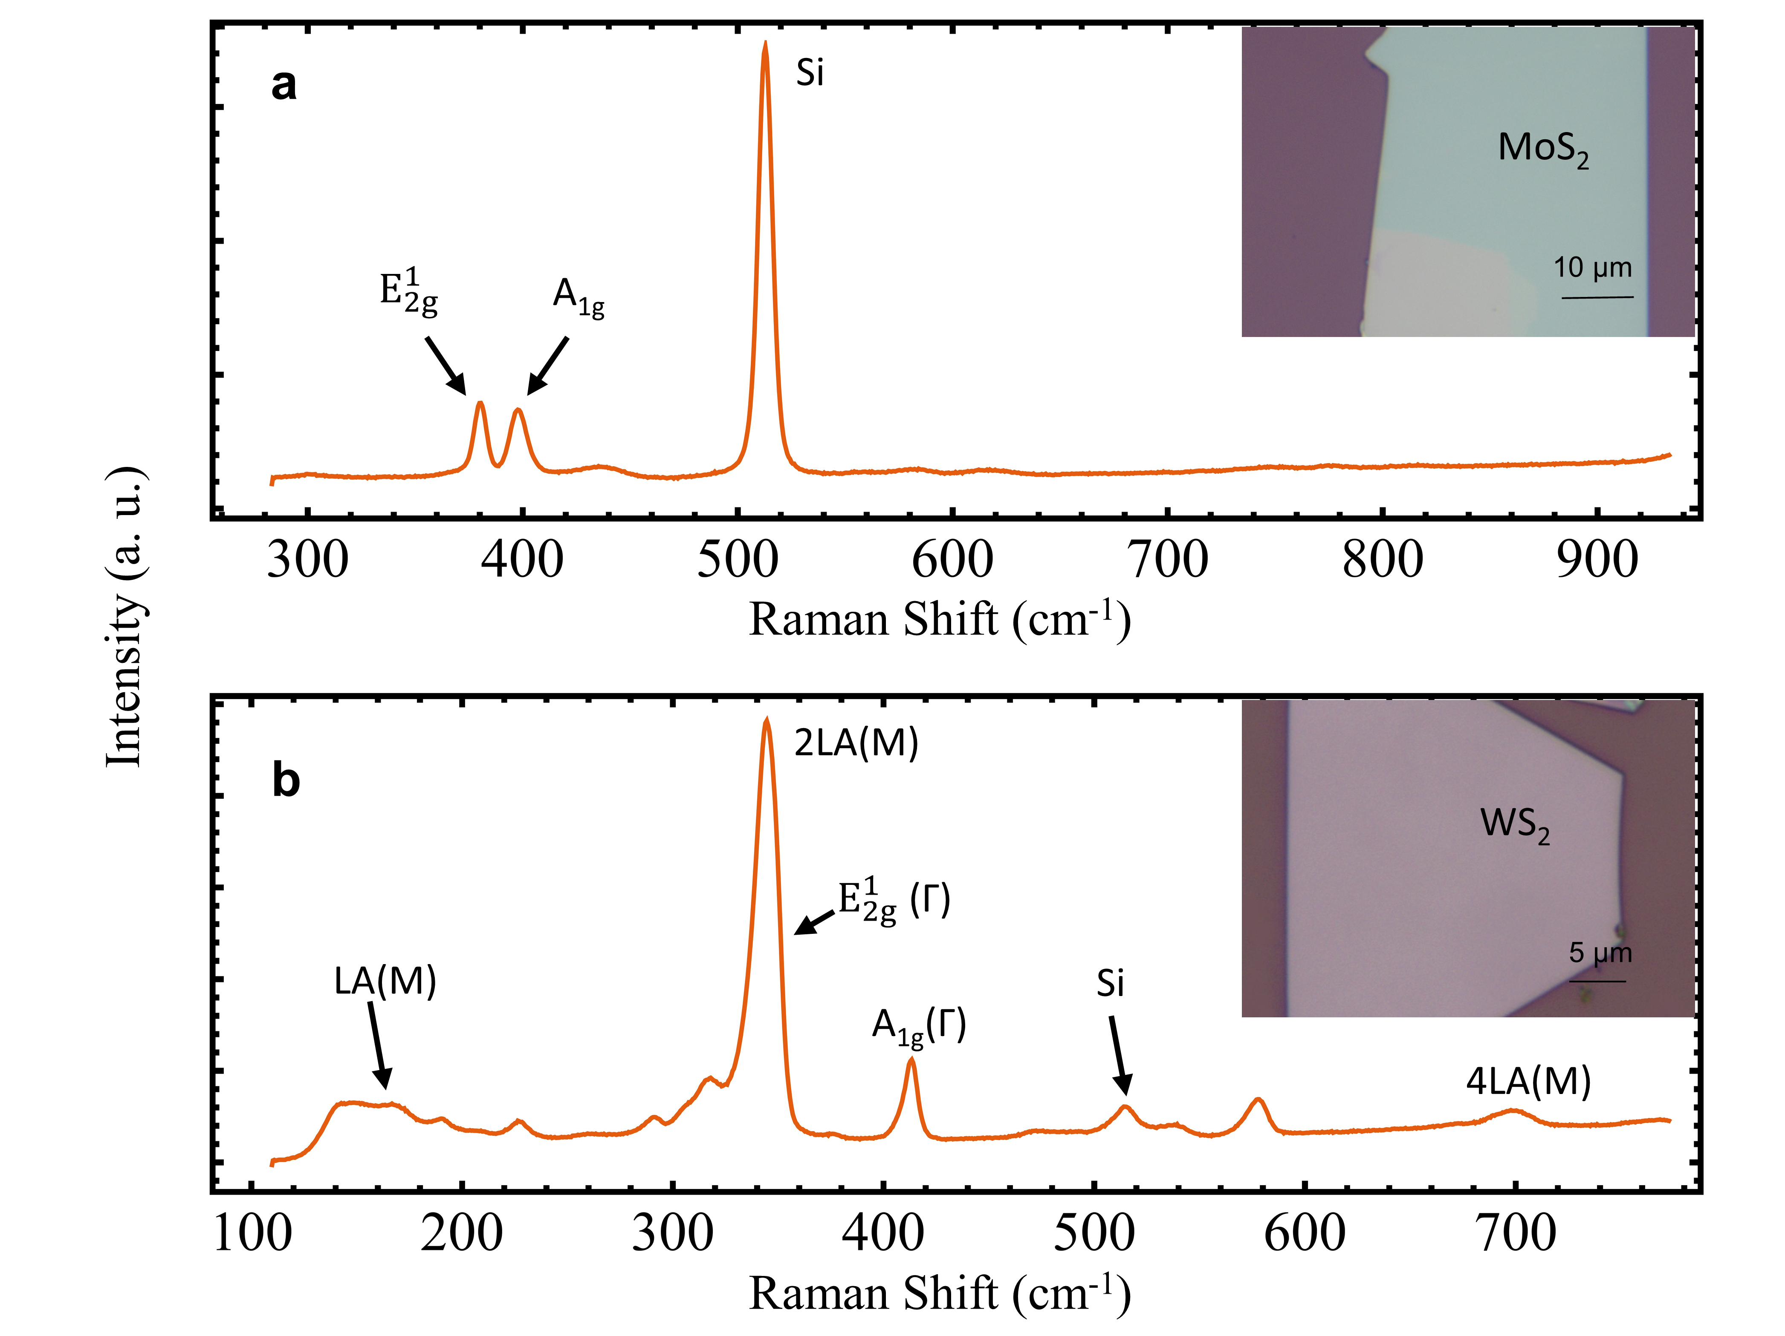
Fig. S8| Raman spectra of MoS₂ sample (a) and WS₂ sample (b). Insets: the corresponding optical microscope images.

Section S8: Strong coupling of unidirectional waveguide EP modes in WS₂ slab
Moreover, these self-hybridized EPs also work in the strong coupling regime, with Rabi splitting energies (ħΩ) of 100.7 meV at room temperature. For instance, Fig. S9 shows the dispersion color map of an Air/125 nm WS₂/SiO₂ waveguide, where energy-momentum relation of the waveguide modes is constructed. The obtained experimental data (pentagram points) coincide with the energy of exciton polaritons in the split position of calculated dispersion relation. In the dispersion color map, we plot the imaginary part of the p-polarized reflection coefficient, which illustrates the TM photonic density of states. The solid lines denote the theoretical dispersion relations revealed by pure modes analysis.
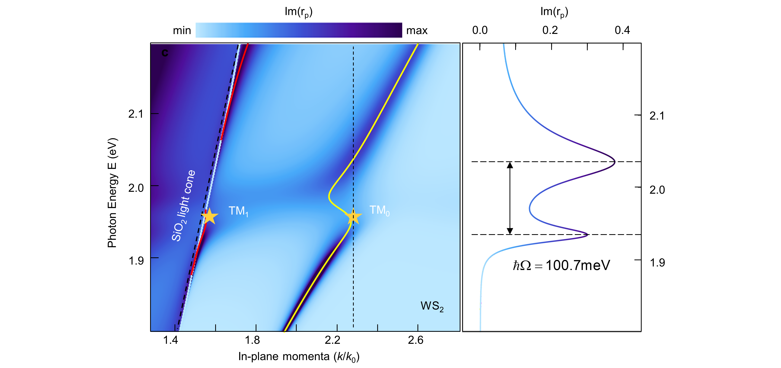
Fig. S9| Dispersion colormap of an Air/WS₂/SiO₂ waveguide calculated by transform matrix method. Dispersion of TM₀ mode (yellow line) and TM₁ mode (red line) are calculated by pure modes analysis. Experimental data points (yellow pentagrams) show good agreement with the calculated dispersion.

References
1. J. D. Jackson, Classical Electrodynamics. (ed. 3rd, 1925).
2. A. Berkdemir et al., Identification of individual and few layers of WS₂ using Raman Spectroscopy. Scientific Reports 3, 1755 (2013).
3. H. Li et al., From Bulk to Monolayer MoS₂: Evolution of Raman Scattering. Advanced Functional Materials 22, 1385-1390 (2012).

