Supplementary Information
Catalyst-free selective oxidation of C(sp³)-H bonds in toluene on-water

Kyoungmun Lee¹, Yumi Cho², Jin Chul Kim², Chiyoung Choi³, Jiwon Kim¹, Jae Kyoo Lee^{3,4}, Sheng Li^{1,5}, Sang Kyu Kwak^{6,*} & Siyoung Q. Choi^{1,5,*}

¹Department of Chemical and Biomolecular Engineering, Korea Advanced Institute of Science and Technology (KAIST), Daejeon 34141, Republic of Korea
²School of Energy and Chemical Engineering, Ulsan National Institute of Science and Technology (UNIST), UNIST-gil 50, Ulju-gun, Ulsan 44919, Republic of Korea
³Department of Applied Bioengineering, Graduate School of Convergence Science and Technology, Seoul National University, Seoul 08826, Republic of Korea
⁴Research Institute for Convergence Science, Seoul National University, Seoul 08826, Republic of Korea
⁵KAIST Institute for the Nanocentury, KAIST, Daejeon 34141, Republic of Korea.
⁶Department of Chemical and Biological Engineering, Korea University, Seoul 02841, Republic of Korea

*E-mail: skkwak@korea.ac.kr (Kwak, S. K.); sqchoi@kaist.ac.kr (Choi, S. Q.)

Table of Contents

Supplementary Figures
Supplementary Fig. 1: Size distribution of the generated emulsion droplets 1
Supplementary Fig. 2: UV-visible absorption intensity corresponding to the H₂O₂ concentration 2
Supplementary Fig. 3: Concentration of H₂O₂ generated by different oil-water interfaces 3
Supplementary Fig. 4: Additive- and initiator-free radical polymerization on-water 4
Supplementary Fig. 5: Size distribution of the created emulsion droplets with toluene 5
Supplementary Fig. 6: Effect of radical scavenger on toluene oxidation 6
Supplementary Fig. 7: GC-MS analysis of toluene oxidation on-water 7
Supplementary Fig. 8: Microdroplet mass spectrometry analysis 8
Supplementary Fig. 9: Influence of dissolved oxygen on H₂O₂ generation 9
Supplementary Fig. 10: The reaction state configurations of toluene in bulk oil 10
Supplementary Fig. 11: The reaction state configurations of toluene at the oil-water interfaces 11
Supplementary Fig. 12: DFT optimized structure and molecular electrostatic potential (MEP) map 12
Supplementary Fig. 13: Configurations of the H-abstraction reaction states of benzaldehyde 13
Supplementary Fig. 14: Evaluation of H₂O₂ production at various oil-water interfaces 14
Supplementary Fig. 15: GC-MS analysis of benzene oxidation on-water 15
Supplementary Fig. 16: GC-MS analysis of o-xylene oxidation on-water 16
Supplementary Fig. 17: GC-MS analysis of m-xylene oxidation on-water 17
Supplementary Fig. 18: GC-MS analysis of p-xylene oxidation on-water 18
Supplementary Fig. 19: GC-MS analysis of 1,2,4-trimethylbenzene oxidation on-water 19
Supplementary Fig. 20: Molecular dynamics system with toluene at the oil-water interface 20
Supplementary Fig. 21: Molecular dynamics system with benzaldehyde at the oil-water interface 21

Supplementary Tables
Supplementary Table 1: On-water activity for selective toluene oxidation 22
Supplementary Table 2: Comparison of on-water toluene oxidation with catalytic studies 23
Supplementary Table 3: Influence of dissolved oxygen concentration on toluene oxidation 24
Supplementary Table 4: Effect of the $π$-hydrogen bond strength on toluene oxidation 25
Supplementary Table 5: Impact of chain length of hydrocarbon oils on toluene oxidation 26
Supplementary Table 6: Selective activation of C(sp³)-H bonds in various aromatic compounds 27

Supplementary References 28

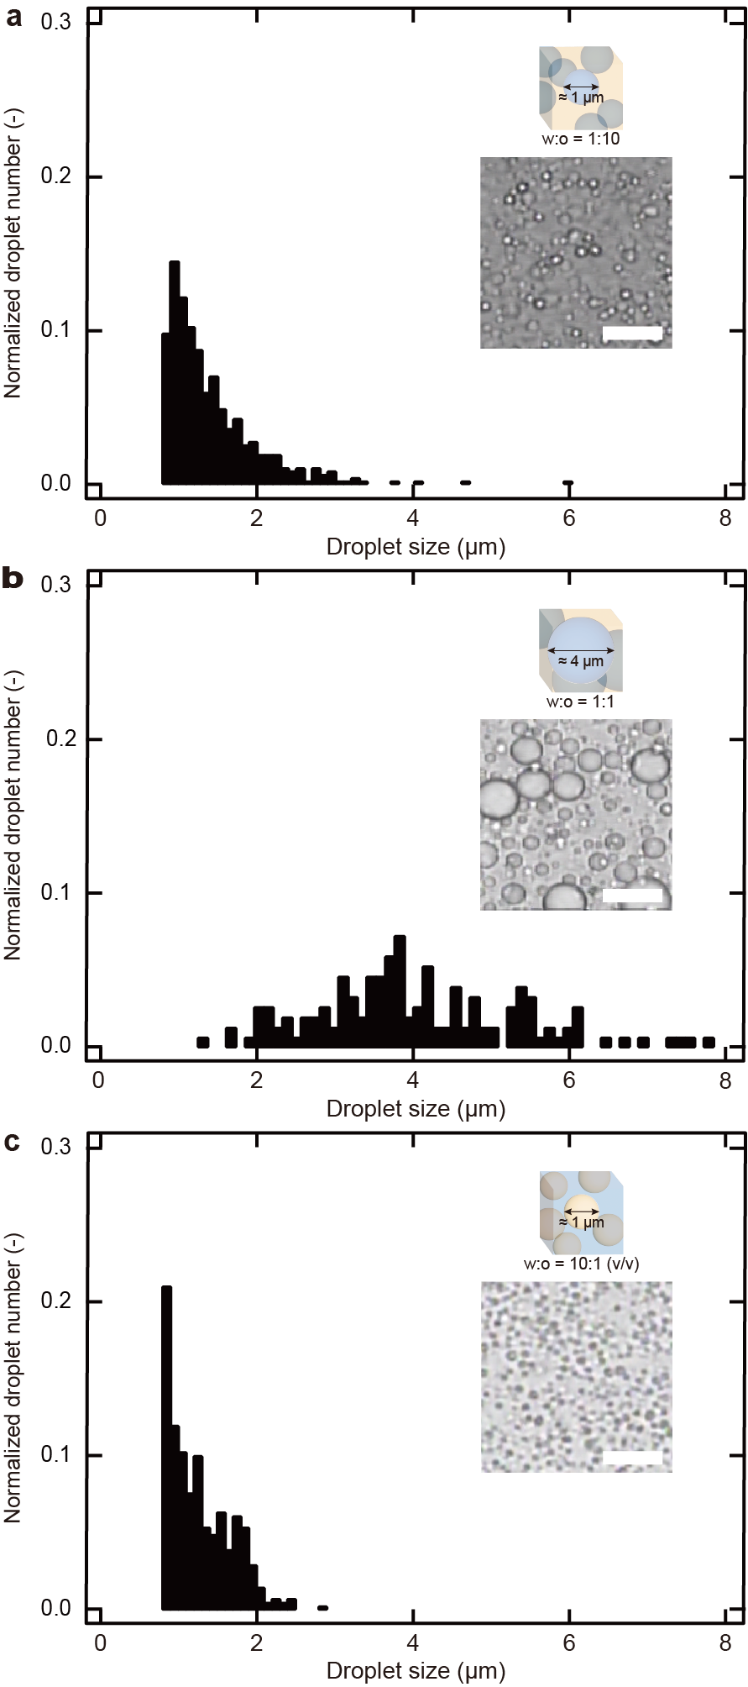
Supplementary Fig. 1. Size distribution of the generated emulsion droplets. Three different oil-water interfaces were created by emulsifying 1:10 (a), 1:1 (b), and 10:1 (c) (v/v) mixtures of water and hexadecane. The inset images depict the produced emulsion droplets at 30 min sonication time (scale bar: 10 μm).

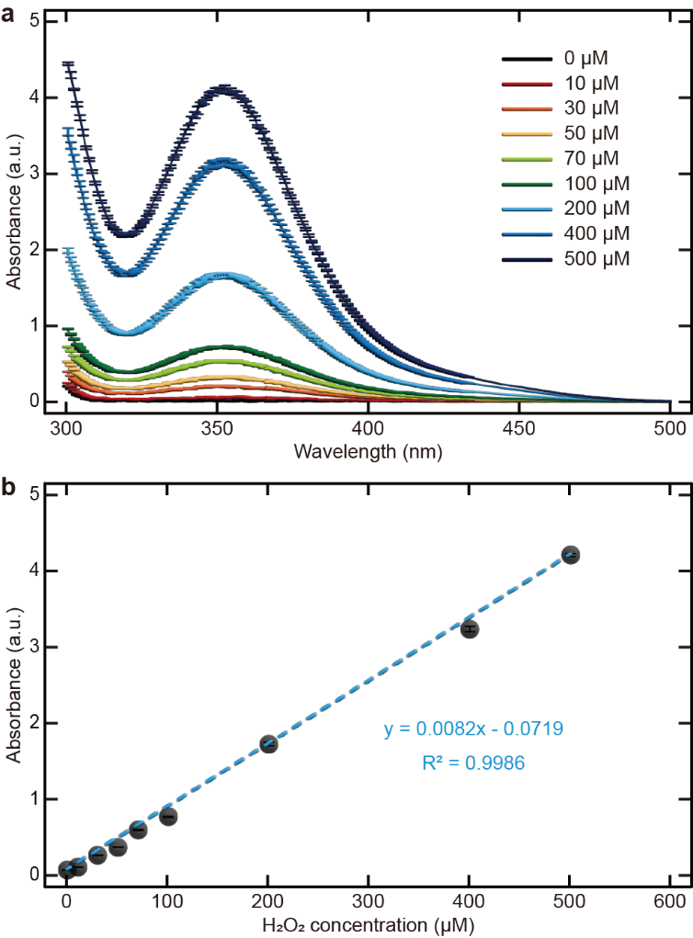
Supplementary Fig. 2. UV-visible absorption intensity corresponding to the H₂O₂ concentration. Absorption peak at 353 nm results from the oxidation of the I⁻ ion to the I₃⁻ ion by the catalytic activity of ammonium molybdite in the presence of H₂O₂. a, UV-visible spectra of aqueous solutions containing different concentrations of H₂O₂. b, Linear increase of absorption peak at 353 nm with increasing H₂O₂ concentration. Higher concentrations above 500 μM were measured after dilution.

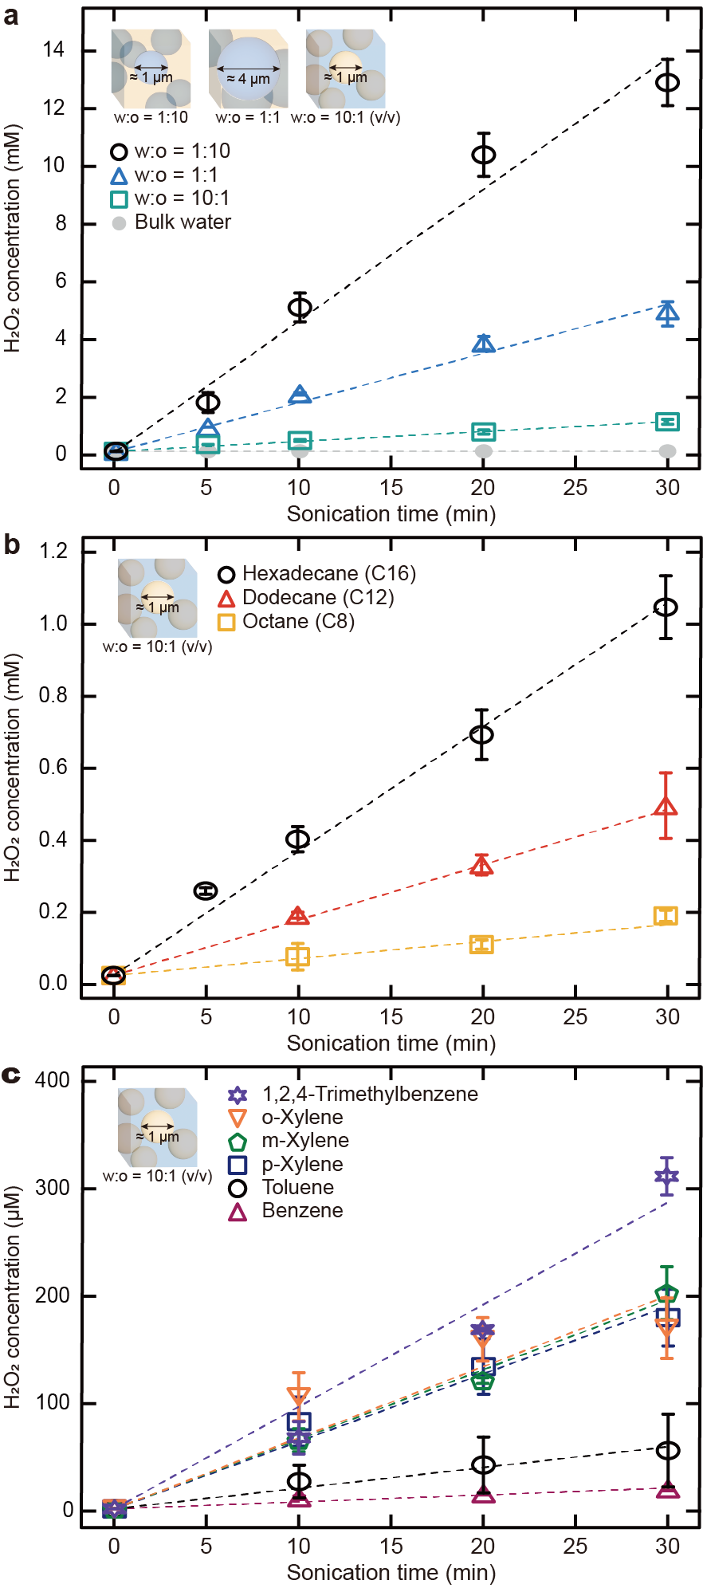
Supplementary Fig. 3. Concentration of H₂O₂ generated by different oil-water interfaces. a, Concentration of H₂O₂ generated by emulsifying 1:10, 1:1, and 10:1 (v/v) mixtures of water and hexadecane. In bulk water, the H₂O₂ concentration was below the detection threshold. b, c, The effect of chain length of hydrocarbon oils (b) and oil types (c) on the production of H₂O₂ in 10:1 (v/v) water and oil mixtures.
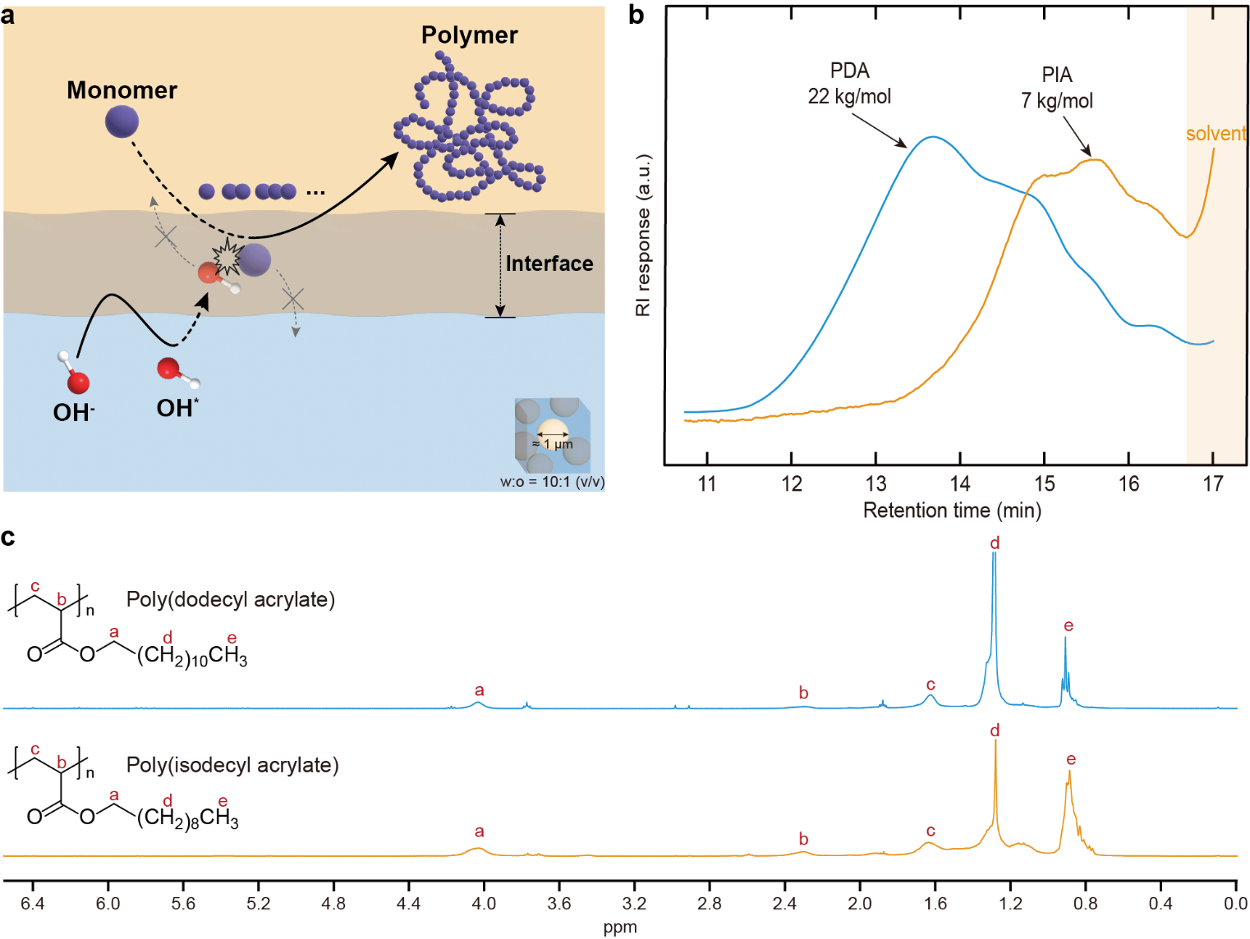
Supplementary Fig. 4. Additive- and initiator-free radical polymerization on-water. a, Schematic illustration of the free radical polymerization of oil-soluble monomers initiated by the transport of OH∙ across the interfaces. b, Representative tetrahydrofuran SEC traces of the synthesized poly(dodecyl acrylate) (PDA) and poly(isodecyl acrylate) (PIA). c, ¹H NMR spectra of PDA and PIA synthesized by oil-water interfaces.

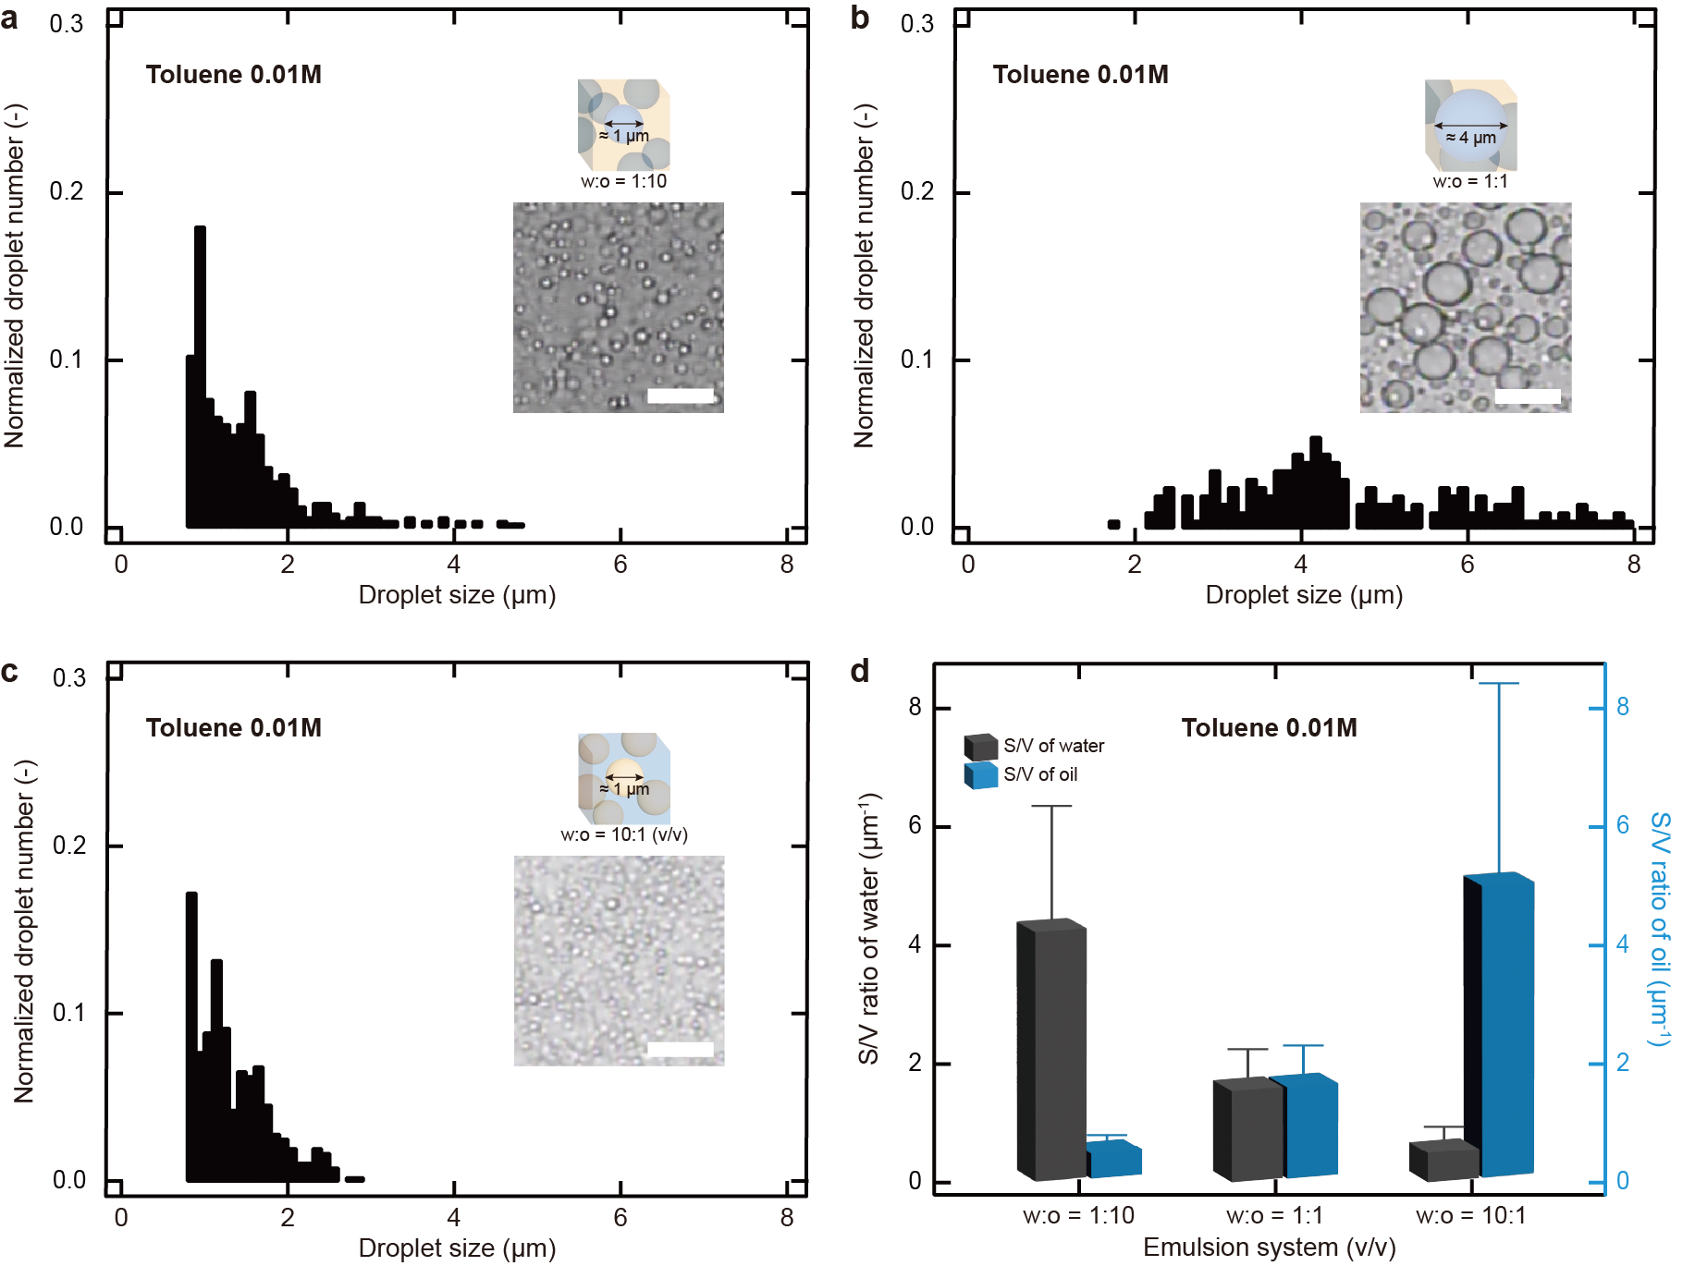
Supplementary Fig. 5. Size distribution of the created emulsion droplets with toluene. a-c, Three different oil-water interfaces were created by emulsifying 1:10 (a), 1:1 (b), and 10:1 (c) (v/v) mixtures of water and hexadecane solution (toluene 0.01 M). The inset images depict the produced emulsion droplets at 30 min sonication time (scale bar: 10 μm). d, S/V ratios of the water and oil phases (toluene 0.01 M) in three different emulsions.

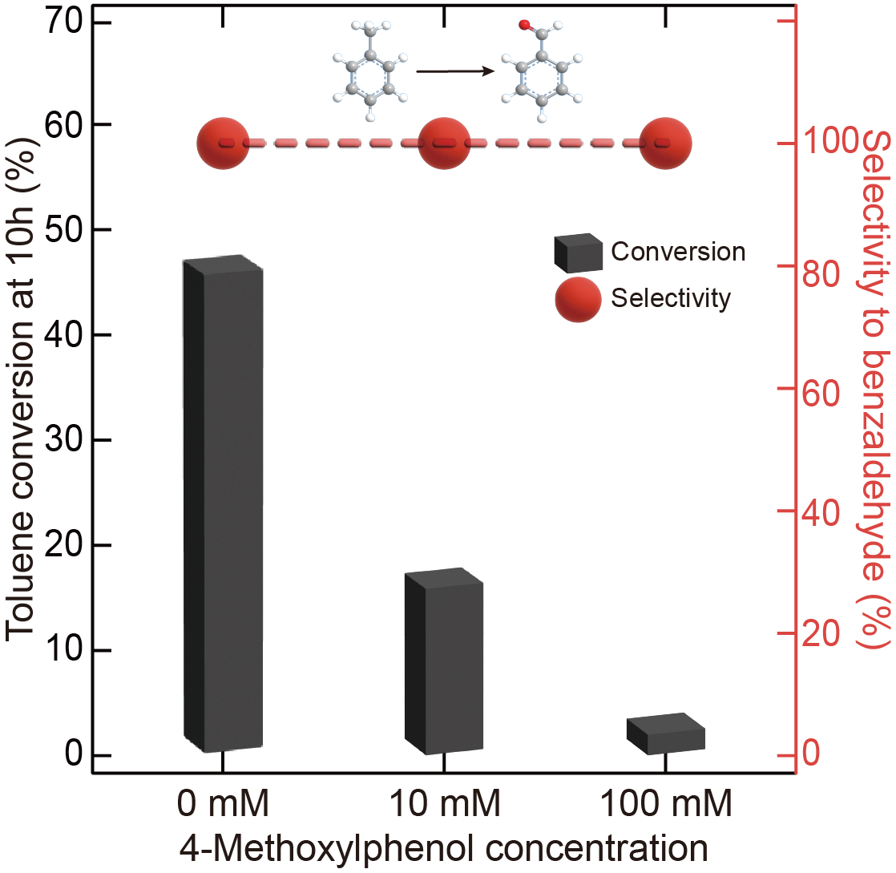
Supplementary Fig. 6. Effect of radical scavenger on toluene oxidation. Toluene conversion and benzaldehyde selectivity upon addition of varying concentrations of 4-methoxyphenol: [Toluene]₀ = 0.01 M, 1 atm oxygen, 25 ºC (298 K), water to oil ratio 10:1 (v/v).
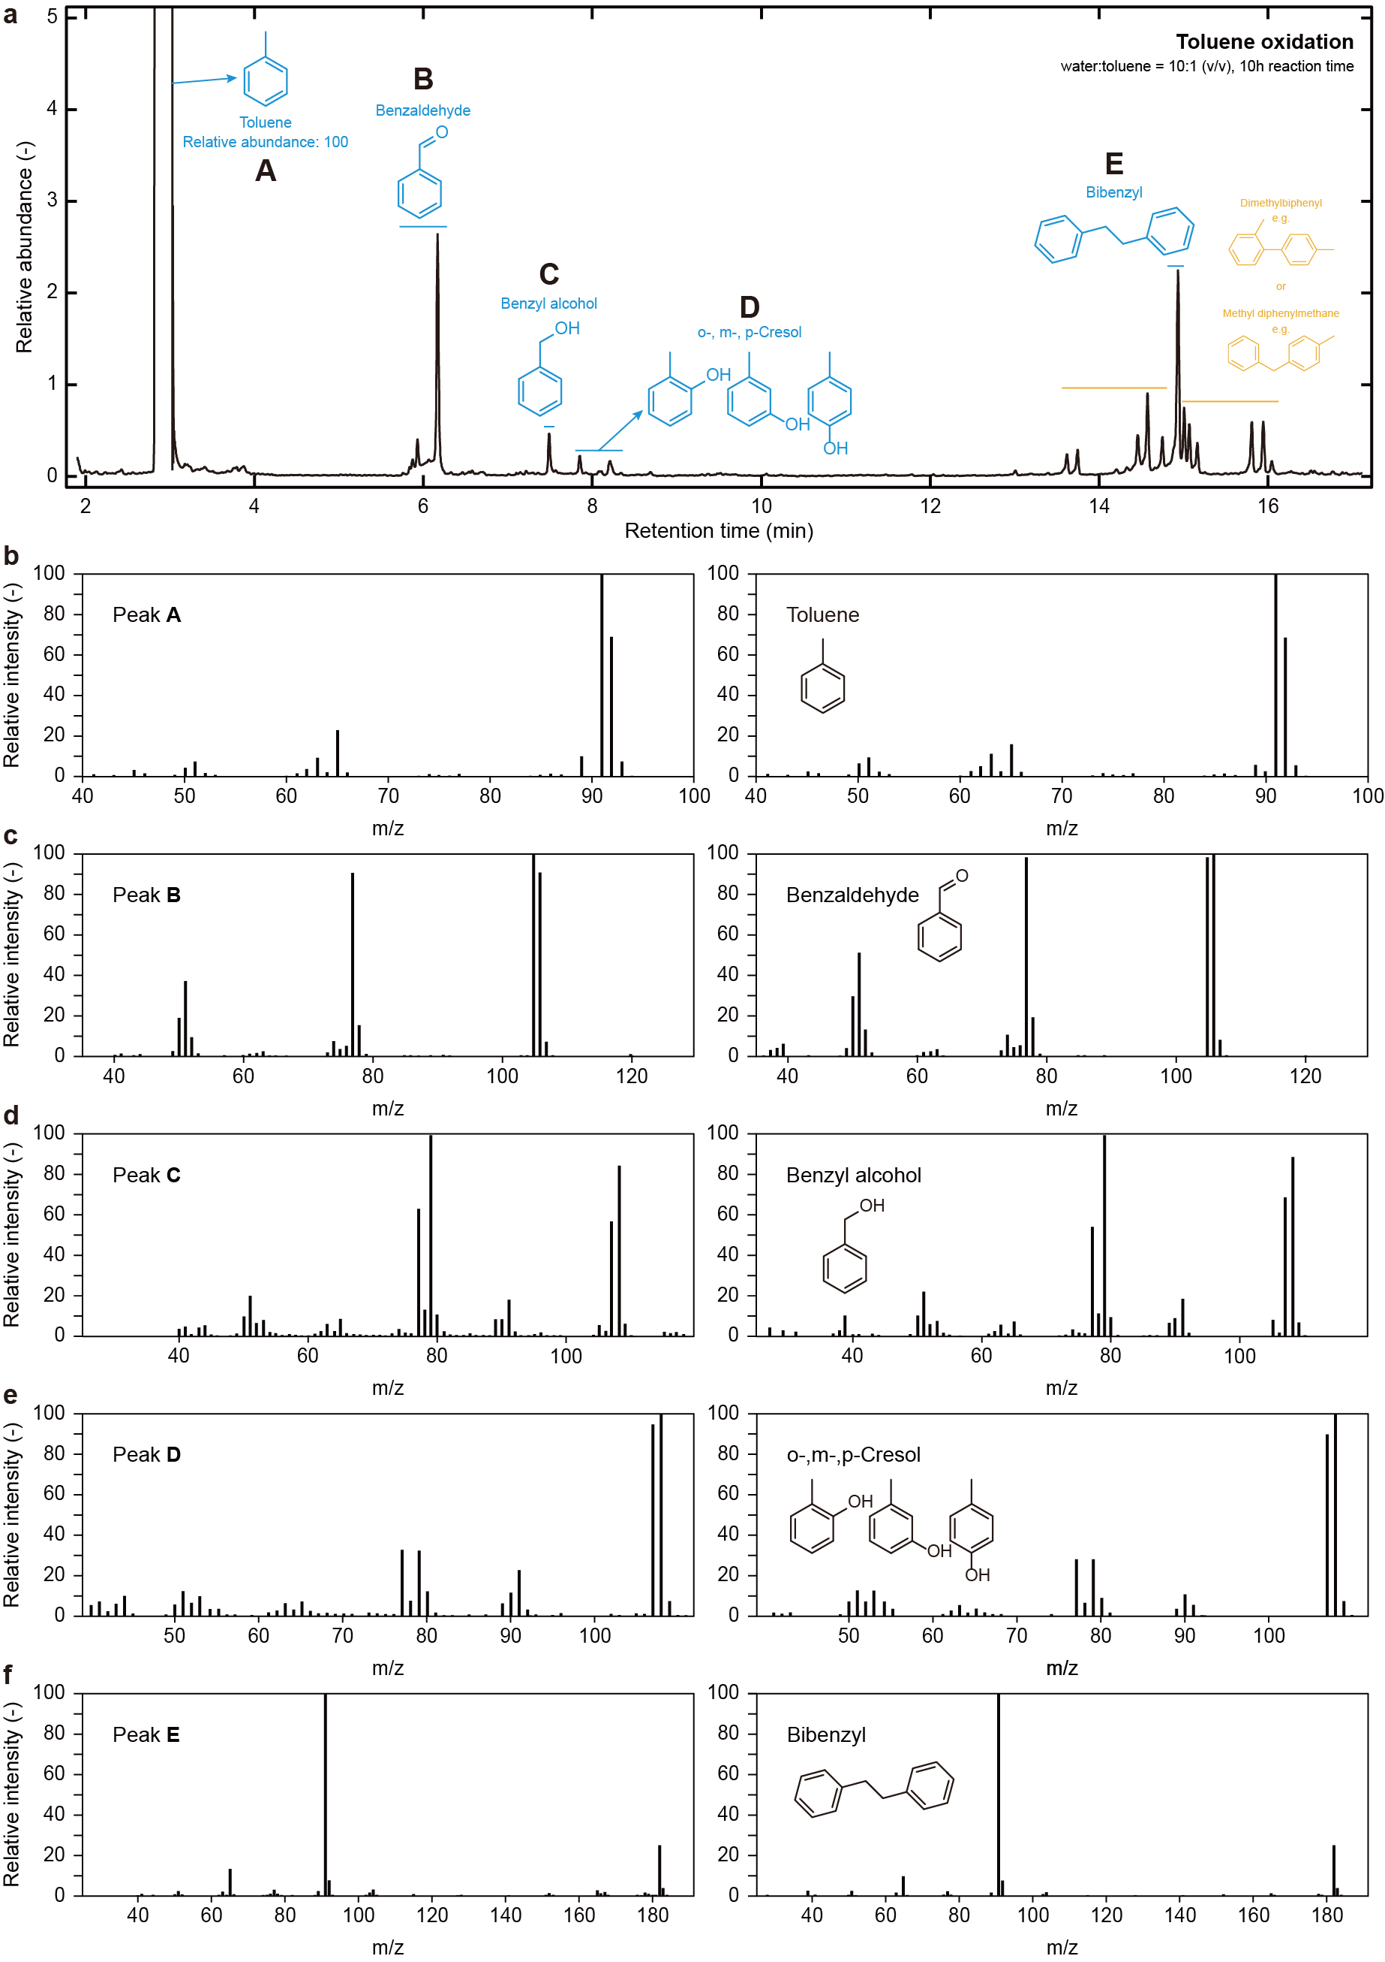
Supplementary Fig. 7. GC-MS analysis of toluene oxidation on-water. a, Elution profiles of GC measurements. b-f, Mass spectra of the oxidized products: 1 atm oxygen, 25 ºC (298 K), 10 M toluene, water to toluene ratio 10:1 (v/v), 10 h reaction.

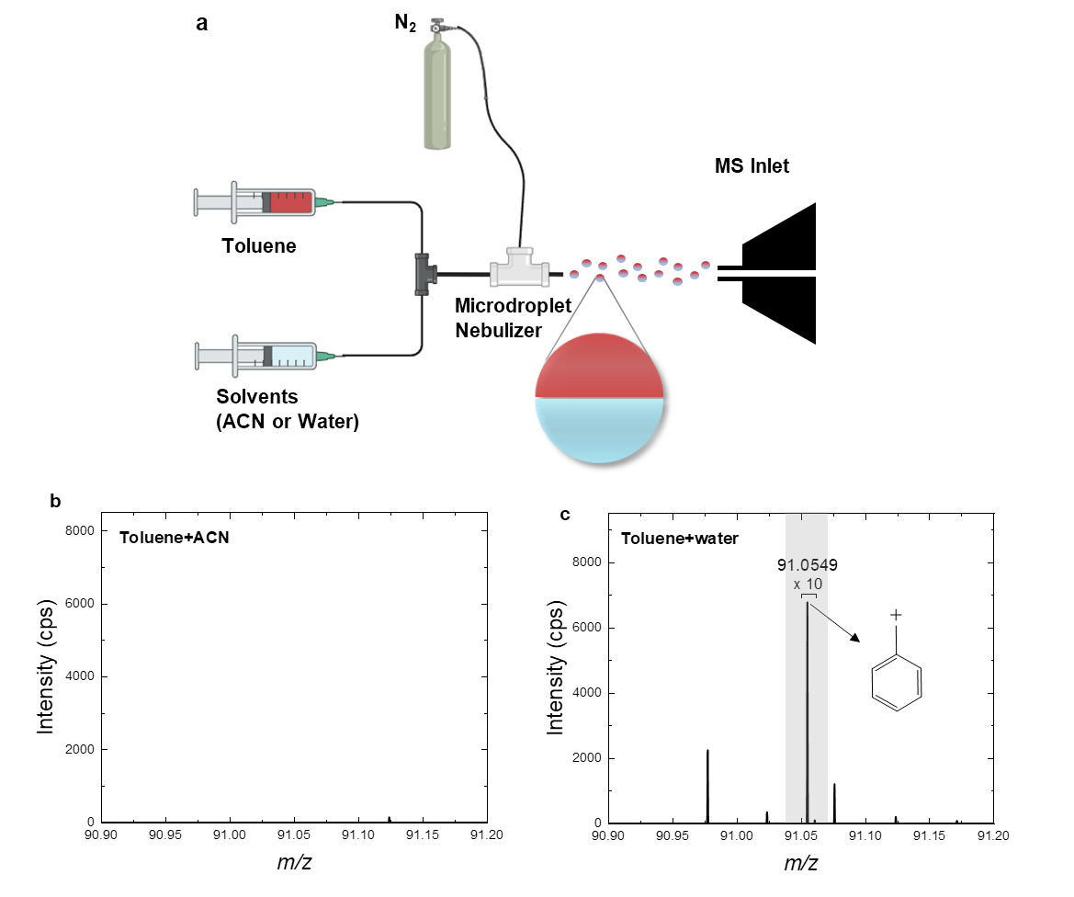
Supplementary Fig. 8. Microdroplet mass spectrometry analysis. a, Schematic diagram of the microdroplet spectrometry setup. Microdroplets, generated by nebulizing a mixture of toluene and either acetonitrile (ACN) or water with N₂ gas were directly injected into a mass spectrometer for the analysis of reaction intermediates. b, c, The mass spectra obtained using different solvents, ACN (b) and water (c). The MS peak at m/z 91.0529 corresponding to C₇H₇⁺ was observed in microdroplets only with toluene and water interfaces, not toluene and ACN interfaces.

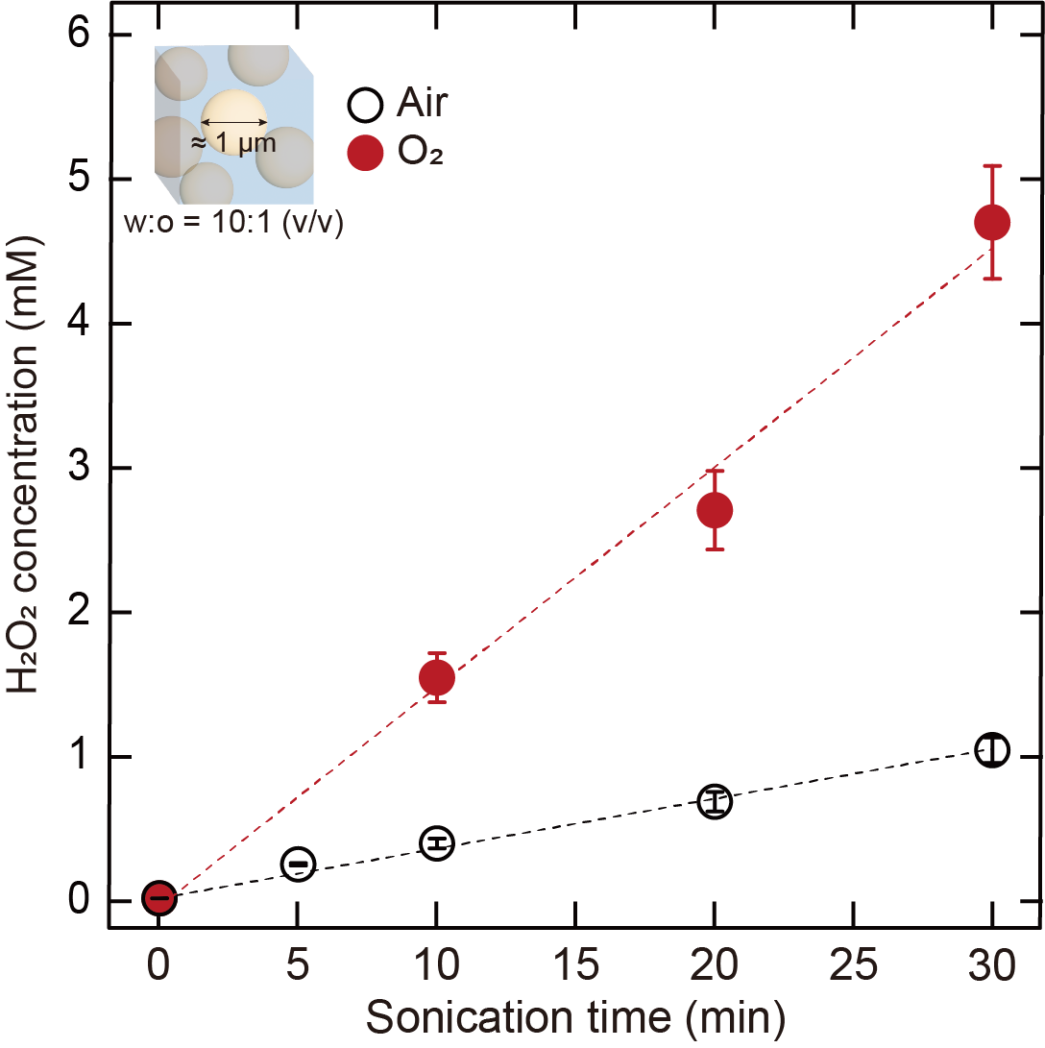
Supplementary Fig. 9. Influence of dissolved oxygen on H₂O₂ generation. Both water and oil were exposed to a 20-minute purging process with air or O₂ gas prior to emulsification.

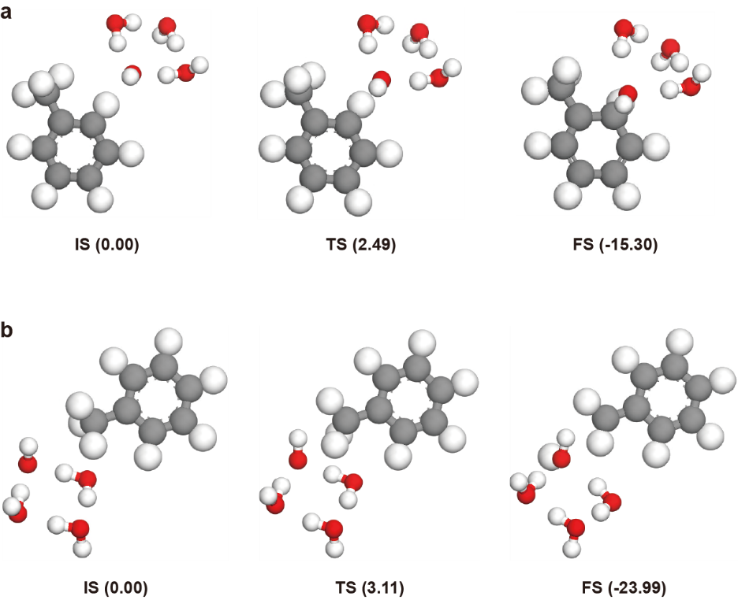
Supplementary Fig. 10. The reaction state configurations of toluene in bulk oil. a, OH-addition and b, H-abstraction. Toluene and water molecules are shown by ball-and stick model. In the color scheme, C, O, and H atoms are colored in gray, red, and white, respectively. The activation energy and heat of reaction are represented by the number in parenthesis below each snapshot in the unit of kcal/mol. IS, TS, and FS in each reaction mechanism represent initial state, transition state, and final state, respectively.
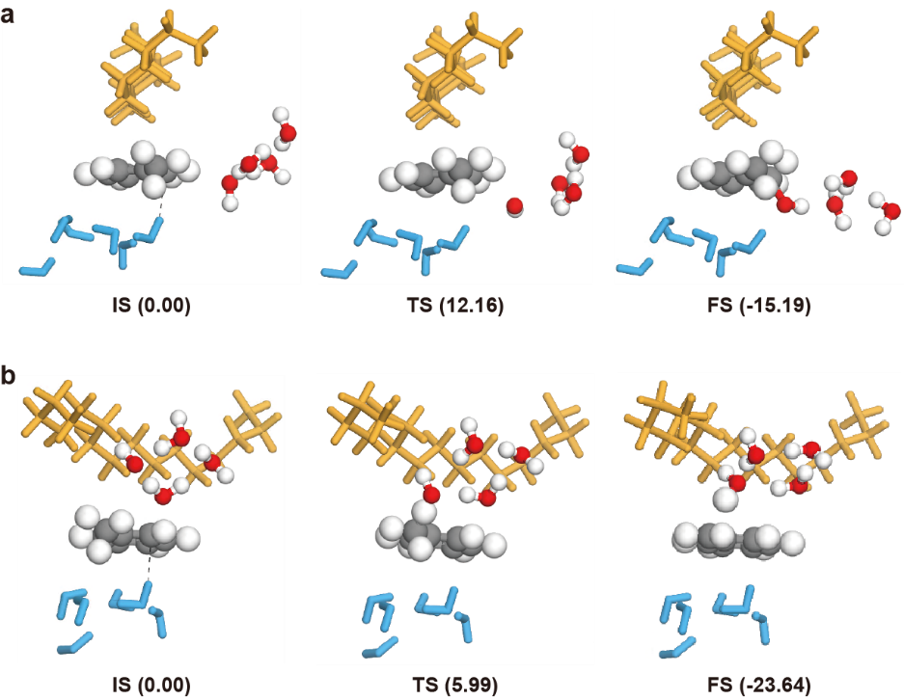
Supplementary Fig. 11. The reaction state configurations of toluene at the oil-water interfaces. a, OH-addition and b, H-abstraction. Toluene and OH∙ with three water molecules are shown by ball-and stick model, while the oil and water solvent molecules are described by stick model. In the color scheme, C, O, and H atoms of toluene and OH∙ with three water molecules are colored in gray, red and white, respectively. However, the oil and water solvent molecules are colored in orange and sky blue, respectively. The activation energy and heat of reaction are represented by the number in parenthesis below each snapshot in the unit of kcal/mol. IS, TS, and FS in each reaction mechanism represent initial state, transition state, and final state, respectively. Black dash line in the figures of IS represents the π-hydrogen interaction between the water and toluene molecules.
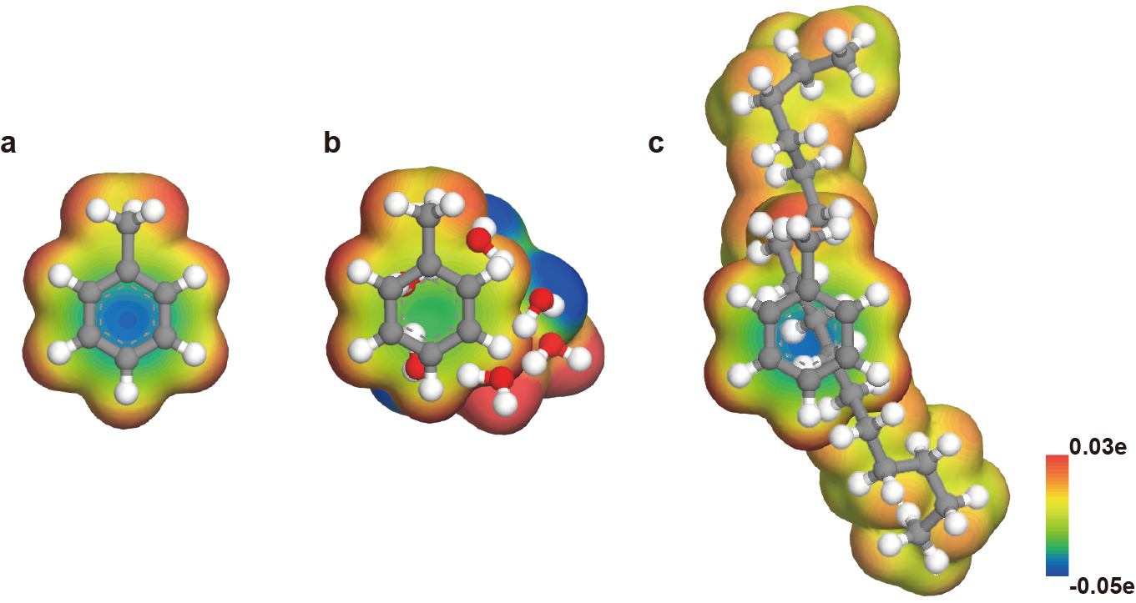
Supplementary Fig. 12. DFT optimized structure and molecular electrostatic potential (MEP) map. a, single toluene molecule. b, one toluene and six water molecules. c, one toluene and oil molecules. The MEP map provides the recognition of electron distribution in molecules. Blue color shows the negatively charged regions while red color presents the positively charged regions of MEP. For clear view, all atoms are represented by ball-and-stick model. The C, O, and H atoms are colored in gray, red, and white, respectively.
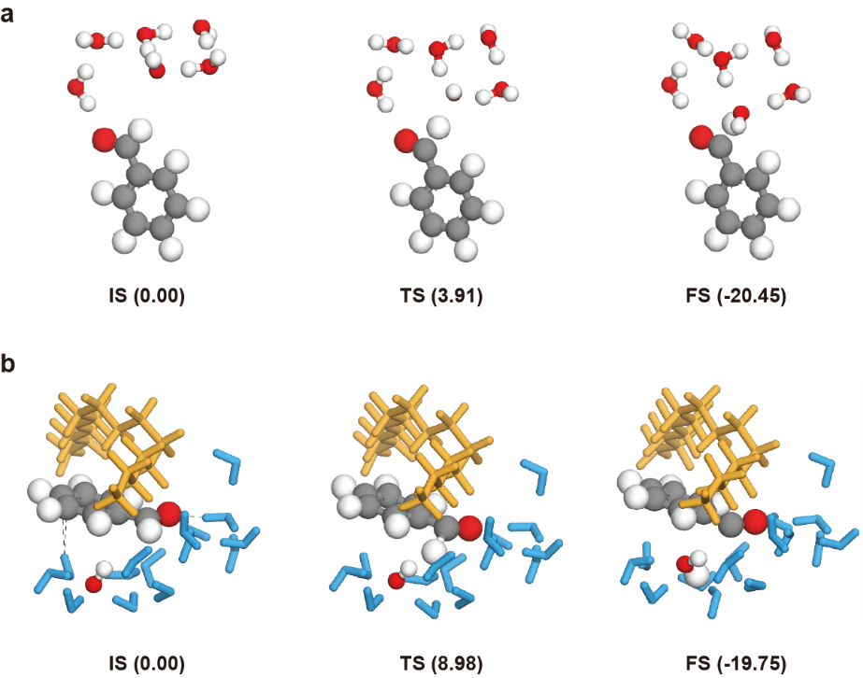
Supplementary Fig. 13. Configurations of the H-abstraction reaction states of benzaldehyde. a, the bulk oil and b, the oil-water interface. Benzaldehyde and OH∙ molecules are shown by ball-and stick model, and oil and water solvent molecules are described by stick model. In the color scheme, C, O, and H atoms of benzaldehyde and OH∙ molecules are colored in gray, red and white, respectively. However, the oil and water solvent molecules are colored in orange and sky blue, respectively. The activation energy and heat of reaction are represented by the number in parenthesis below each snapshot in the unit of kcal/mol. IS, TS, and FS in each reaction mechanism represent initial state, transition state, and final state, respectively. Black dash line in the IS figure in the oil-water interface represents the hydrogen bonding interactions between the water and benzaldehyde molecules.

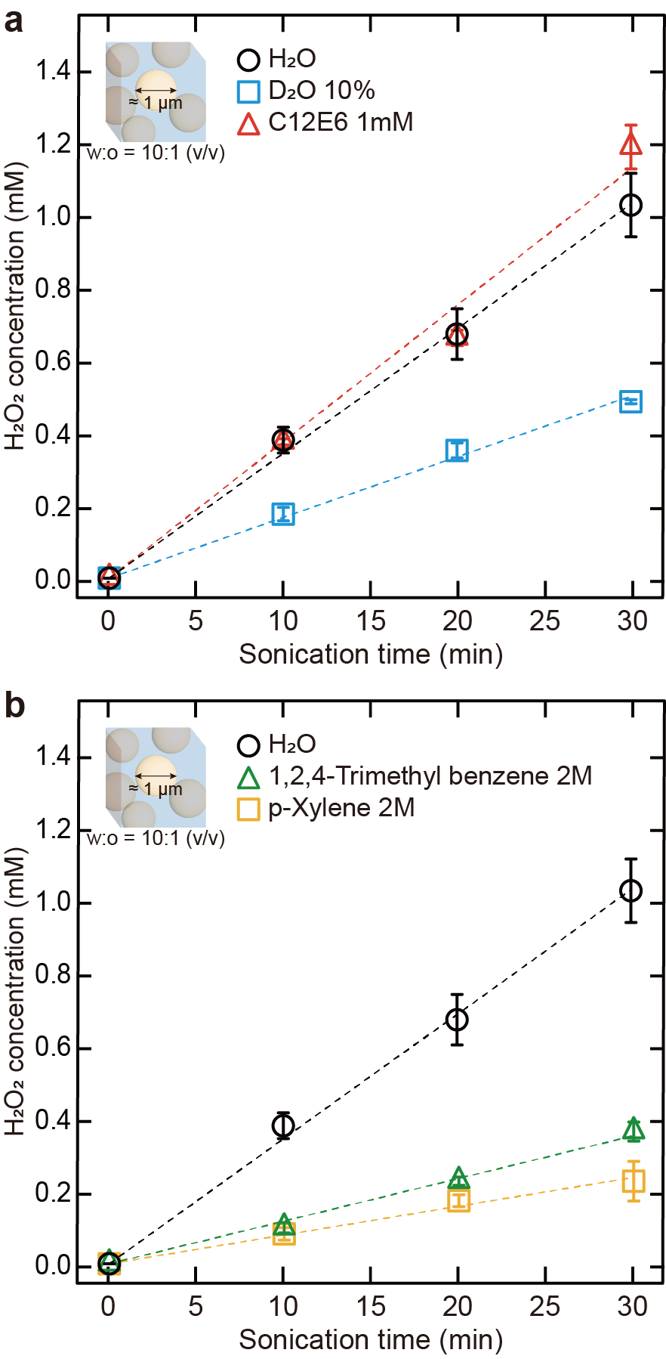
Supplementary Fig. 14. Evaluation of H₂O₂ production at various oil-water interfaces. a, b, Impact of interfacial properties (a) and dissolved aromatic compounds (b) on the formation of H₂O₂.

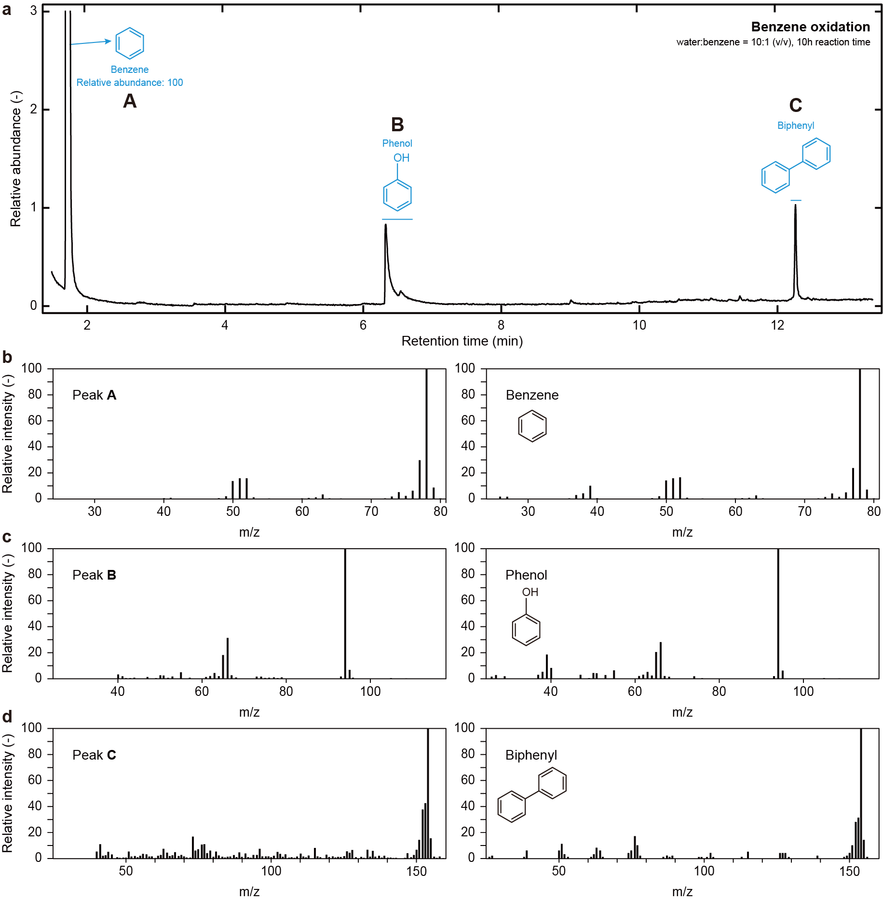
Supplementary Fig. 15. GC-MS analysis of benzene oxidation on-water. a, Elution profiles of GC measurements. b-f, Mass spectra of the oxidized products: 1 atm oxygen, 25 ºC (298 K), 10 M benzene, water to benzene ratio 10:1 (v/v), 10 h reaction.
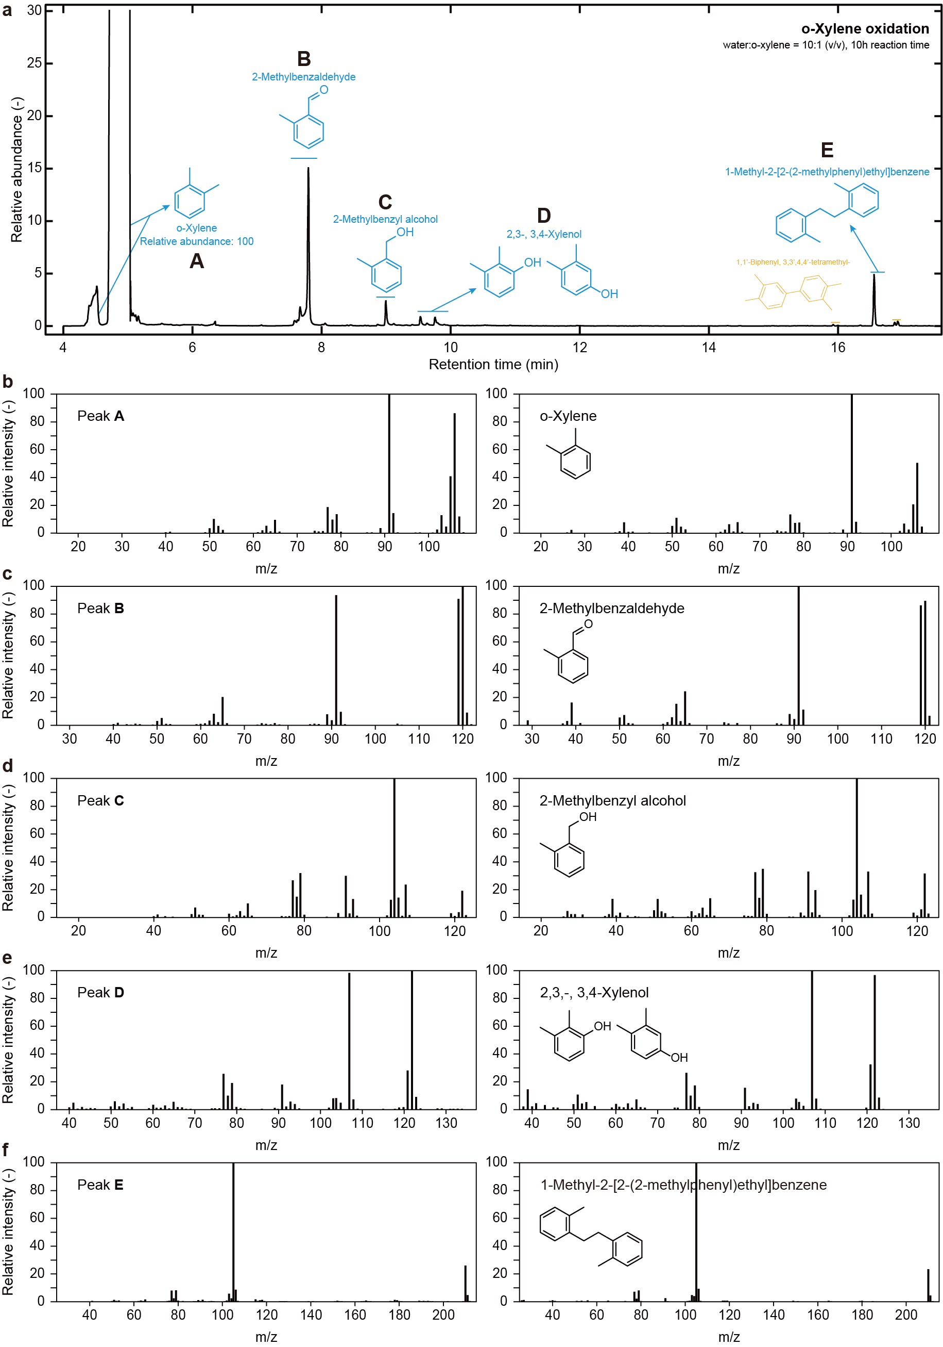
Supplementary Fig. 16. GC-MS analysis of o-xylene oxidation on-water. a, Elution profiles of GC measurements. b-f, Mass spectra of the oxidized products: 1 atm oxygen, 25 ºC (298 K), 10 M o-xylene, water to o-xylene ratio 10:1 (v/v), 10 h reaction.
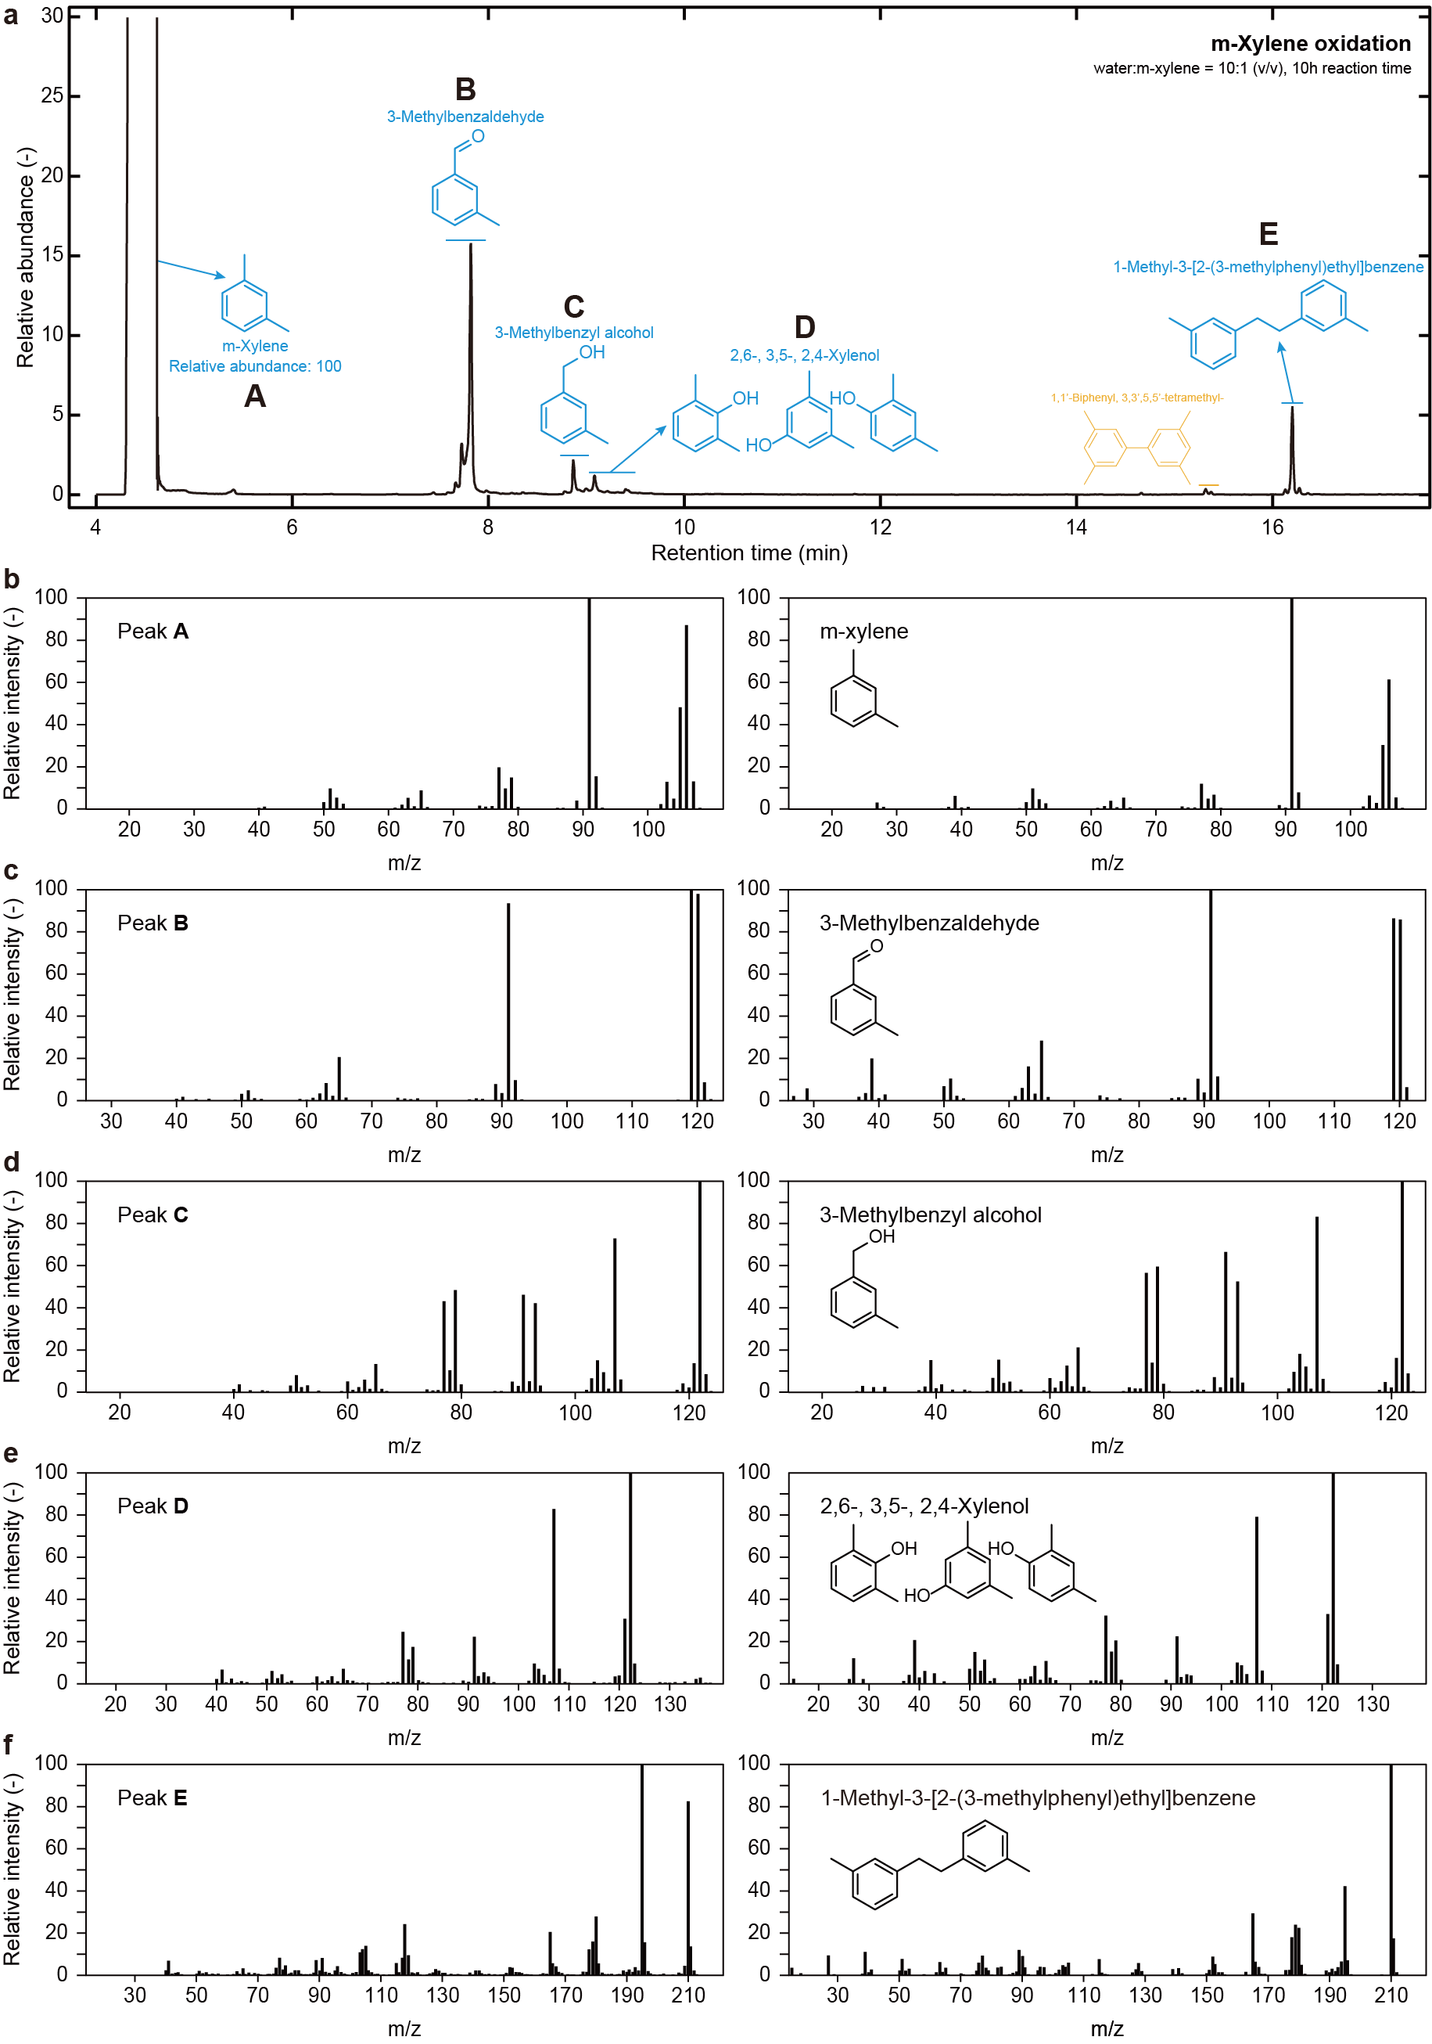
Supplementary Fig. 17. GC-MS analysis of m-xylene oxidation on-water. a, Elution profiles of GC measurements. b-f, Mass spectra of the oxidized products: 1 atm oxygen, 25 ºC (298 K), 10 M m-xylene, water to m-xylene ratio 10:1 (v/v), 10 h reaction.
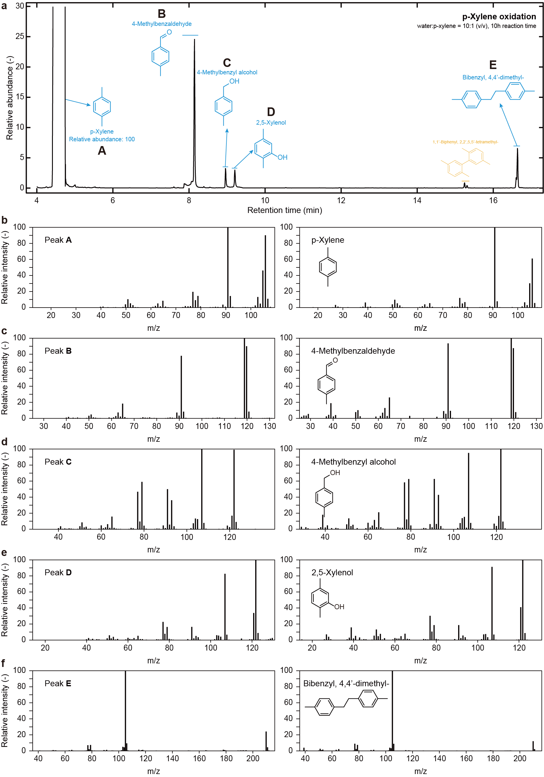
Supplementary Fig. 18. GC-MS analysis of p-xylene oxidation on-water. a, Elution profiles of GC measurements. b-f, Mass spectra of the oxidized products: 1 atm oxygen, 25 ºC (298 K), 10 M p-xylene, water to p-xylene ratio 10:1 (v/v), 10 h reaction.
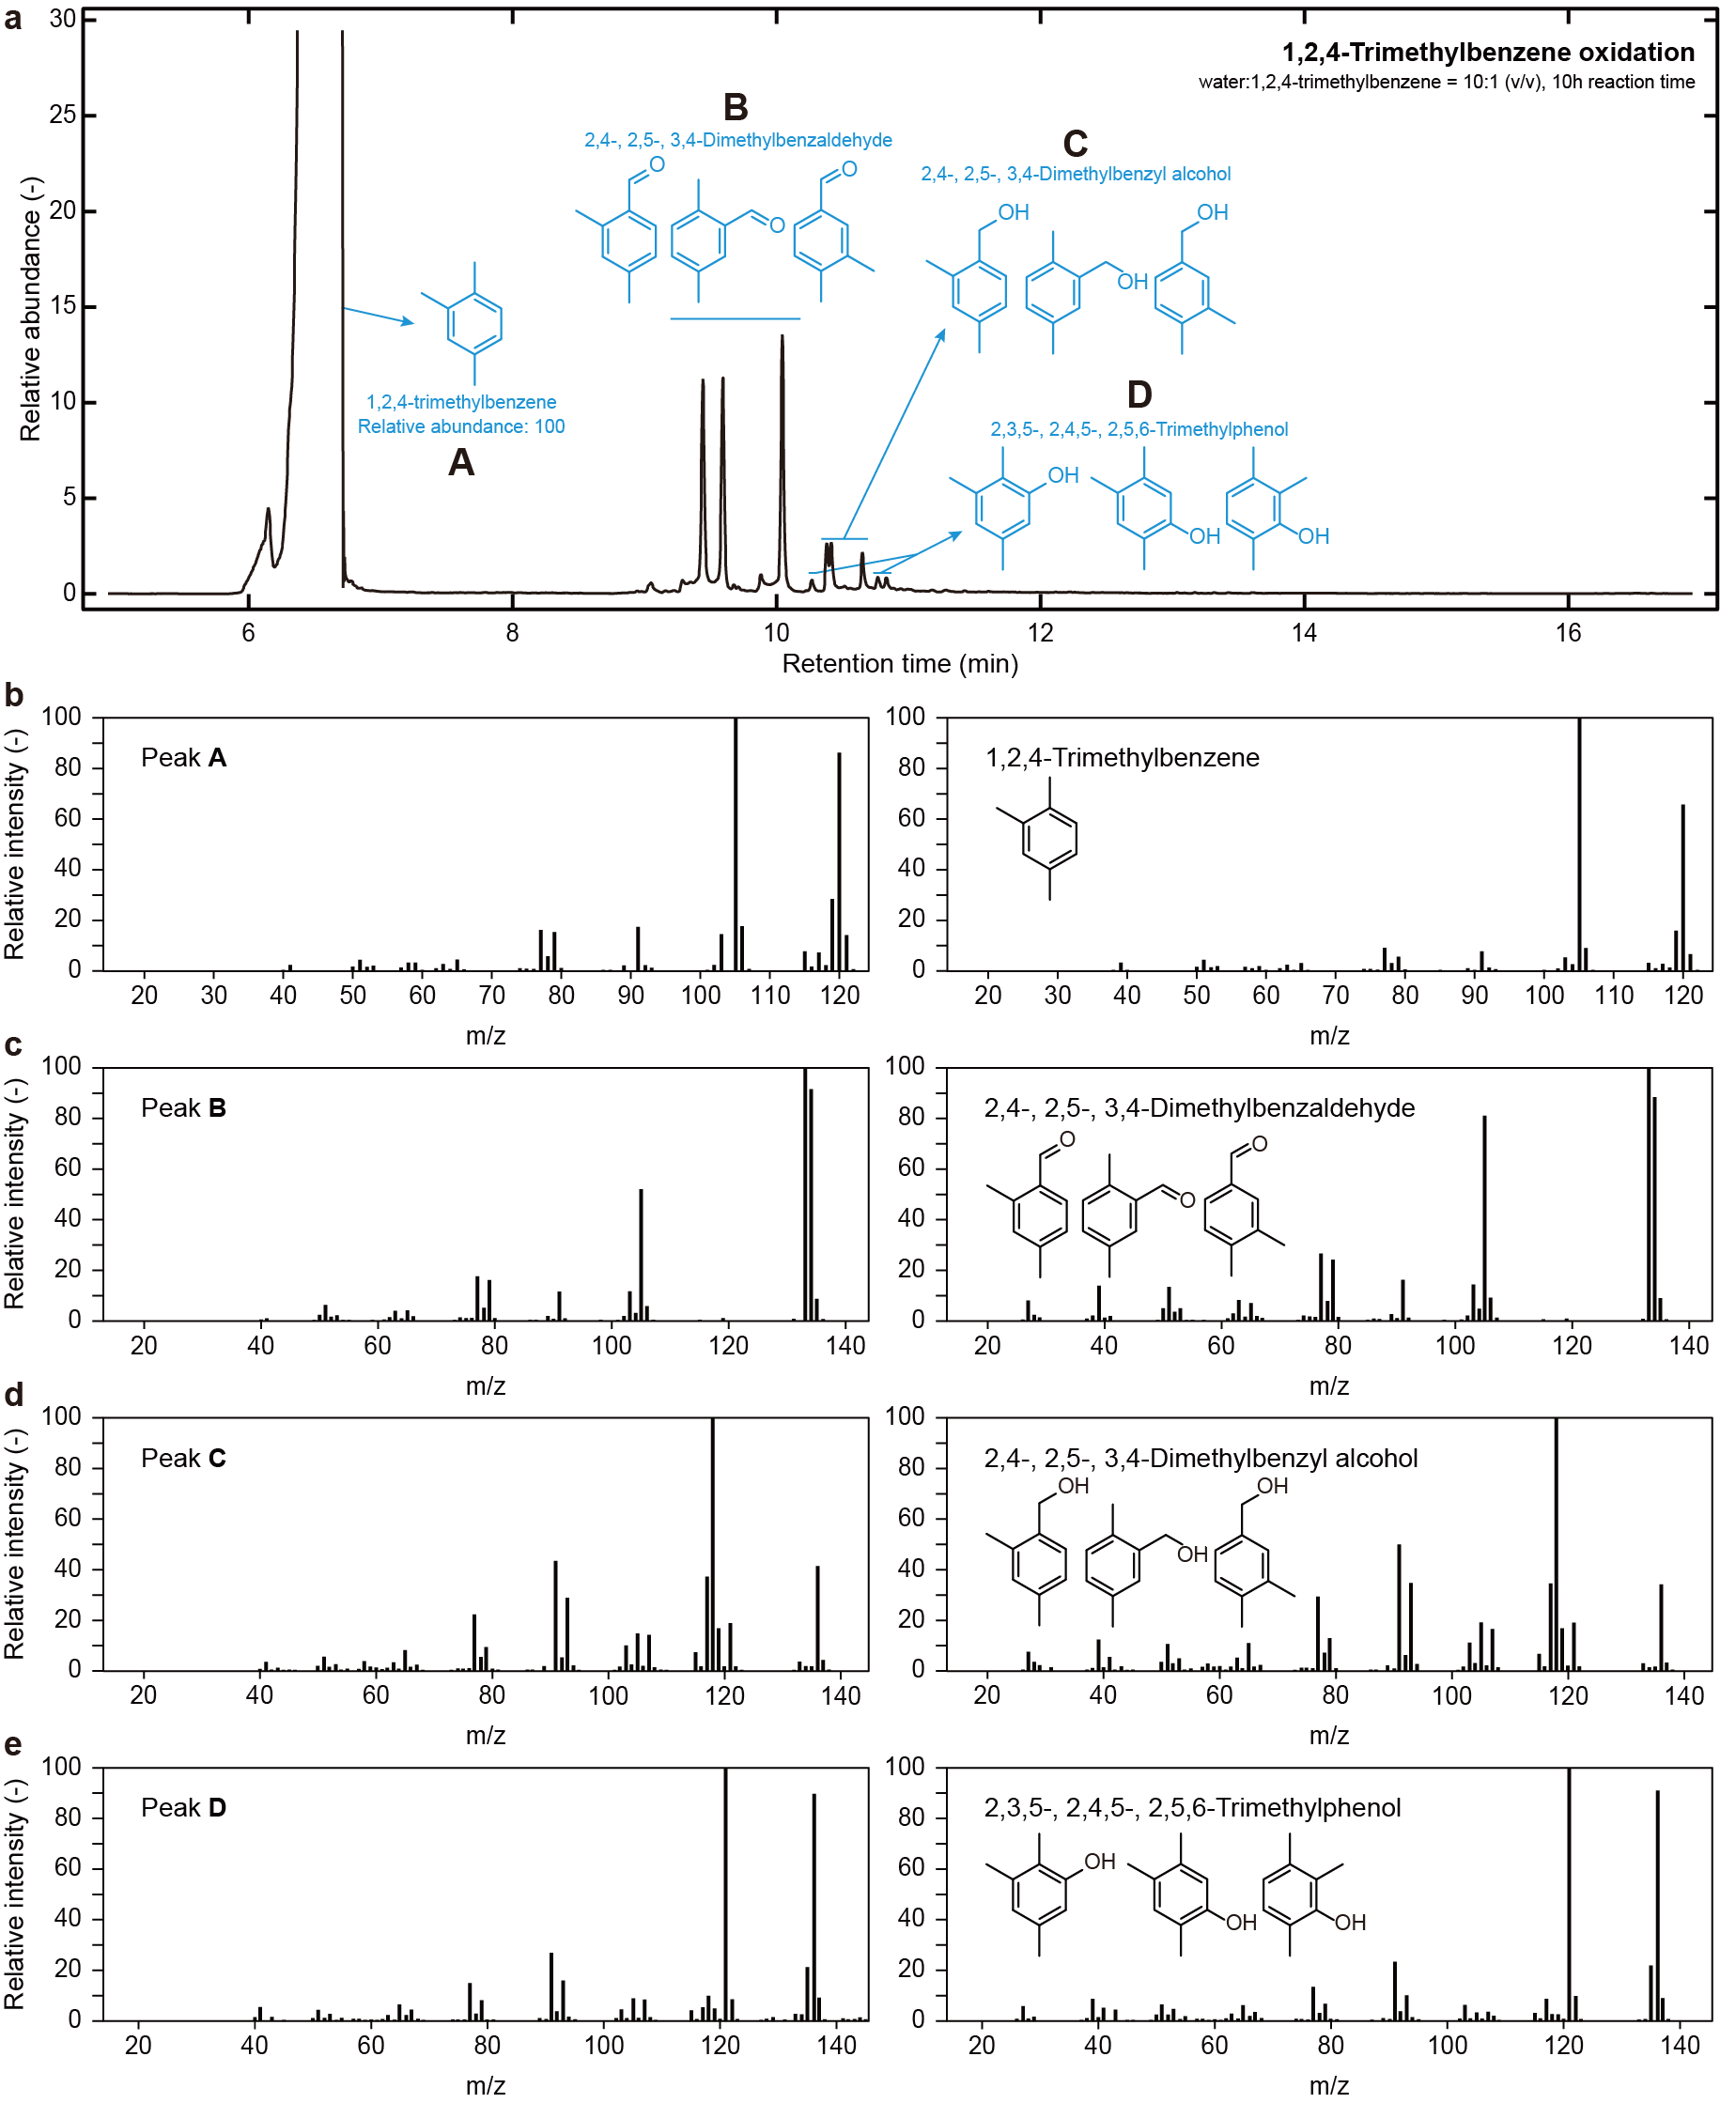
Supplementary Fig. 19. GC-MS analysis of 1,2,4-trimethylbenzene oxidation on-water. a, Elution profiles of GC measurements. b-f, Mass spectra of the oxidized products: 1 atm oxygen, 25 ºC (298 K), 10 M 1,2,4-trimethylbenzene, water to 1,2,4-trimethylbenzene ratio 10:1 (v/v), 10 h reaction.

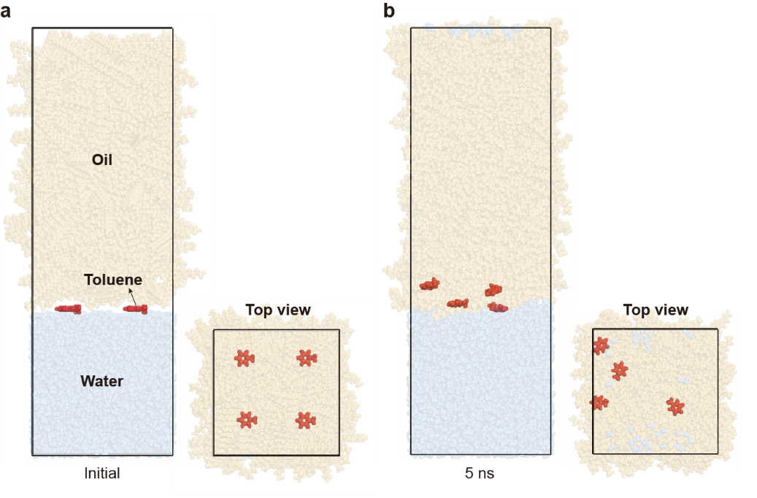
Supplementary Fig. 20. Molecular dynamics system with toluene at the oil-water interface. Snapshots of NVT-MD simulation of a, initial and b, after 5 ns with front and top views. For the clear view, the oil, toluene, and water molecules are assigned by the orange, red, and blue colored ball-and stick models, respectively.

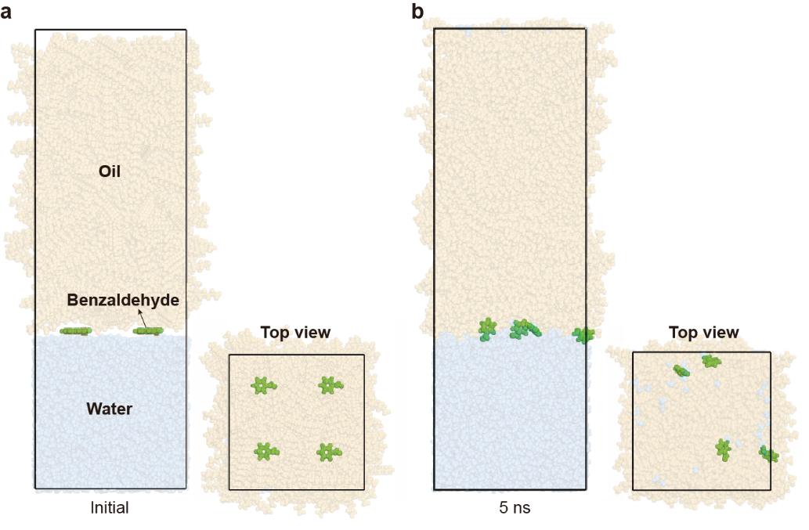
Supplementary Fig. 21. Molecular dynamics system with benzaldehyde at the oil-water interface. Snapshots of NVT-MD simulation of a, initial and b, after 5 ns with front and top views. For the clear view, the oil, benzaldehyde, and water molecules are assigned by the orange, green and blue colored ball-and stick models, respectively.

Supplementary Table 1. On-water activity for selective toluene oxidation
Entry | w:o (v/v) | [Toluene]₀ (M) | Time (h) | Conv. (%)ª | Selectivity (%)ª
 |  |  |  |  | Benzaldehyde | Benzyl alcohol | Cresol | Bibenzyl | Others
1 | 10:1 | 0.01 | 1 | 4.71 | > 99 | - | - | - | -
2 | 10:1 | 0.01 | 3 | 13.18 | > 99 | - | - | - | -
3 | 10:1 | 0.01 | 5 | 22.81 | > 99 | - | - | - | -
4 | 10:1 | 0.01 | 7 | 30.77 | > 99 | - | - | - | -
5 | 10:1 | 0.01 | 10 | 48.15 | > 99 | - | - | - | -
6 | 10:1 | 0.01 | 13 | 61.76 | > 99 | - | - | - | -
7 | 10:1 | 0.01 | 17 | 86.36 | > 99 | - | - | - | -
8 | 10:1 | 0.01 | 20 | > 99 | > 99 | - | - | - | -
9 | 10:1 | 0.01 | 30 | > 99 | > 99 | - | - | - | -
10 | 1:1 | 0.01 | 1 | 1.52 | > 99 | - | - | - | -
11 | 1:1 | 0.01 | 5 | 10.00 | > 99 | - | - | - | -
12 | 1:1 | 0.01 | 10 | 23.88 | > 99 | - | - | - | -
13 | 1:10 | 0.01 | 1 | 0.88 | > 99 | - | - | - | -
14 | 1:10 | 0.01 | 5 | 2.97 | > 99 | - | - | - | -
15 | 1:10 | 0.01 | 10 | 4.37 | > 99 | - | - | - | -
All reactions were conducted under 1 atm oxygen and 25 ºC (298 K). ªConversion and selectivity were analyzed by gas chromatography-mass spectrometry.

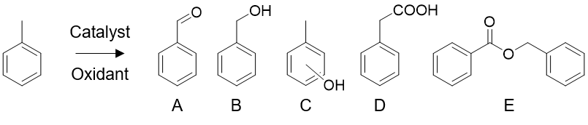
Supplementary Table 2. Comparison of on-water toluene oxidation with catalytic studies
Entry | Catalyst | Oxidant | Temp. (ºC) | P_{O2} (bar) | Time (h) | Yield (%) | Selectivity (%) |  |  |  |  |  | Ref.
 |  |  |  |  |  |  | A | B | C | D | E | Others | Ref.
1 | - | OH∙, O₂ | 25 | 1 | 20 | > 99 | > 99 | - | - | - | - | - | This work
2 | Au-Pd/C | O₂ | 160 | 10 | 27 | 80 | 1 | < 1 | - | 13 | 86 | - | Ref. 1
3 | Pt | O₂ | 160 | 10 | 5 | 2 | 20 | 17 | - | 62 | 1 | - | Ref. 2
4 | g-C₃N₄ | O₂ | 160 | 10 | 16 | 2 | > 99 | - | - | - | - | - | Ref. 3
5ª | p-BWO | O₂ | 25 | 1 | 6 | 44 | 81 | 4 | - | 15 | - | - | Ref. 4
6ª | TiO₂ | O₂ | 25 | 1 | 4 | < 1 | 25 | 3 | - | 72 | - | - | Ref. 5
7ª | Nb₂O₅-N | O₂ | 40 | 1 | 12 | 1 | 96 | - | - | 4 | - | - | Ref. 6
8^{b} | [Ni(tepa)]²⁺ | H₂O₂ | 60 | - | 24 | 1 | 10 | - | 90 | - | - | - | Ref. 7
9^{c} | [$γ$-PW₁₀O₃₈V₂($μ$-OH)₂]³⁻ | H₂O₂ | 60 | - | 1 | 1 | < 1 | 2 | 86 | - | - | 12^{d} | Ref. 8
10^{b} | MnWO₄ | H₂O₂ | 80 | - | 24 | 54 | 90 | 8 | 2 | - | - | - | Ref. 9
ªPhotocactalyst. ^{b}Reaction was performed under atmospheric pressure. ^{c}Reaction was conducted under 1 atm Ar. ^{d}Methyl-p-benzoquinone.

Supplementary Table 3. Influence of dissolved oxygen concentration on toluene oxidation
Entry | P_{gas}  (1 bar) | w:o (v/v) | [Toluene]₀ (M) | Time (h) | Conv. (%)^{c} | Selectivity (%)^{c}
 |  |  |  |  |  | Benzaldehyde | Benzyl alcohol | Cresol | Bibenzyl | Others
1ª | O₂ | 10:1 | 10.00 | 10 | 2.80 | 24.68 | 2.71 | 4.19 | 25.18 | 43.24
2^{b} | Air | 10:1 | 10.00 | 10 | 1.74 | 20.76 | 2.90 | 4.36 | 27.00 | 44.98
3ª | O₂ | 10:1 | 0.01 | 10 | 48.15 | > 99 | - | - | - | -
4^{b} | Air | 10:1 | 0.01 | 10 | 11.90 | 91.74 | 8.26 | - | - | -
ªPurged for 20 min with oxygen prior to emulsification. ^{b}Purged for 20 min with air before emulsification. ^{c}Conversion and selectivity were analyzed by gas chromatography-mass spectrometry.

Supplementary Table 4. Effect of the $π$-hydrogen bond strength on toluene oxidation
Entry | Reactant | [Reactant]₀ (M) | Time  (h) | Conv. (%)^{c} | Selectivity (%)^{c}
 |  |  |  |  | Aldehyde | Alcohol | Phenol | Bibenzyl | Others
1ª | Toluene | 2.00 | 10 | 6.59 | 44.23 | 0.49 | 0.48 | 32.69 | 22.11^{d}
2^{b} | Toluene | 2.00 | 10 | 4.65 | 45.63 | 1.51 | 4.56 | 27.36 | 20.52^{d}
3 | Toluene | 2.00 | 10 | 5.27 | 46.12 | 3.67 | 2.40 | 24.91 | 23.00^{d}
4 | p-Xylene | 2.00 | 10 | 4.96 | 66.67 | - | 1.33 | 32.00 | -
5 | 1,2,4-Trimethylbenzene | 2.00 | 10 | 2.42 | > 99 | - | - | - | -
All reactions were conducted under 1 atm oxygen, 25 ºC (298 K), and w:o = 10:1 (v/v). ªD₂O 10%. ^{b}C₁₂E₆ 1mM. ^{c}Conversion and selectivity were analyzed by gas chromatography-mass spectrometry. ^{d}Other products include dimetehylbiphenyl and methyl diphenylmethane.

Supplementary Table 5. Impact of chain length of hydrocarbon oils on toluene oxidation
Entry | w:o (v/v) | [Toluene]₀ (M) | Time (h) | Conv. (%)ª | Selectivity (%)ª
 |  |  |  |  | Benzaldehyde | Benzyl alcohol | Cresol | Bibenzyl | Others
C16 | 10:1 | 0.01 | 10 | 48.15 | > 99 | - | - | - | -
C12 | 10:1 | 0.01 | 10 | 7.42 | > 99 | - | - | - | -
C8 | 10:1 | 0.01 | 10 | 0.10 | > 99 | - | - | - | -
All reactions were conducted under 1 atm oxygen and 25 ºC (298 K). ªConversion and selectivity were analyzed by gas chromatography-mass spectrometry.

Supplementary Table 6. Selective activation of C(sp³)-H bonds in various aromatic compounds.
Entry | Reactant | [Reactant]₀ (M) | Time  (h) | Conv. (%)ª | Selectivity (%)ª
 |  |  |  |  | Aldehyde | Alcohol | Phenol | Bibenzyl | Others
1 | Benzene | 0.01 | 10 | - | - | - | - | - | -
2 | Benzene | 10.00 | 10 | 2.86 | - | 44.48 | - | - | 55.52^{b}
3 | o-Xylene | 0.01 | 10 | 16.92 | > 99 | - | - | - | -
4 | o-Xylene | 10.00 | 10 | 3.71 | 55.87 | 8.66 | 6.42 | 25.14 | 3.91^{c}
5 | m-Xylene | 0.01 | 10 | 12.50 | > 99 | - | - | - | -
6 | m-Xylene | 10.00 | 10 | 4.54 | 58.33 | 7.43 | 6.31 | 25.23 | 2.70^{d}
7 | p-Xylene | 0.01 | 10 | 15.54 | > 99 | - | - | - | -
8 | p-Xylene | 10.00 | 10 | 5.31 | 54.67 | 6.29 | 7.05 | 28.95 | 3.05e
9 | 1,2,4-Trimethylbenzene | 0.01 | 10 | 14.27 | > 99 | - | - | - | -
10 | 1,2,4-Trimethylbenzene | 10.00 | 10 | 5.09 | 78.43 | 16.33 | 5.24 | - | -
All reactions were conducted under 1 atm oxygen, 25 ºC (298 K), and w:o = 10:1 (v/v). ªConversion and selectivity were analyzed by gas chromatography-mass spectrometry. ^{b}Biphenyl. ^{c}3,3’,4,4’-Tetramethylbiphenyl. ^{d}3,3’,5,5’-Tetramethylbiphenyl. ^{e}2,2’,5,5’-Tetramethylbiphenyl.

Supplementary References
- Kesavan, L. et al. Solvent-free oxidation of primary carbon-hydrogen bonds in toluene using Au-Pd alloy nanoparticles. Science 331, 195-199 (2011).
- Huda, M., Minamisawa, K., Tsukamoto, T., Tanabe, M. & Yamamoto, K. Aerobic toluene oxidation catalyzed by subnano metal particles. Angew. Chem. Int. Ed. 58, 1002-1006 (2019).
- Li, X.-H., Wang X. & Antonietti M. Solvent-free and metal-free oxidation of toluene using O₂ and g-C₃N₄ with nanopores: nanostructure boosts the catalytic selectivity. ACS Catal. 2, 2082-2086 (2012).
- Cao, X. et al. A photochromic composite with enhanced carrier separation for the photocatalytic activation of benzylic C–H bonds in toluene. Nat. Catal. 1, 704-710 (2018).
- Tripathy, J., Lee, K. & Schmuki, P. Tuning the selectivity of photocatalytic synthetic reactions using modified TiO₂ nanotubes. Angew. Chem. Int. Ed. 53, 12605-12608 (2014).
- Su, K. et al. Visible-light-driven selective oxidation of toluene into benzaldehyde over nitrogen-modified Nb₂O₅ nanomeshes. ACS Catal. 10, 1324-1333 (2020).
- Morimoto, Y., Bunno, S., Fujieda, N., Sugimoto, H. & Itoh, S. Direct hydroxylation of benzene to phenol using hydrogen peroxide catalyzed by nickel complexes supported by pyridylalkylamine ligands. J. Am. Chem. Soc. 137, 5867–5870 (2015).
- Kamata, K., Yamaura, T. & Mizuno, N. Chemo- and regioselective direct hydroxylation of arenes with hydrogen peroxide catalyzed by a divanadium-substituted phosphotungstate. Angew. Chem. Int. Ed. 51, 7275-7278 (2012).
- Mal, D. D., Khilari, S. & Pradhan, D. Efficient and selective oxidation of toluene to benzaldehyde on manganese tungstate nanobars: a noble metal-free approach. Green Chem. 20, 2279-2289 (2018).

