Supporting Information for:

Overexpression of a novel microRNA IamiR-4-3p from water spinach (Ipomoea aquatica Forsk.) increased Cd toxicity and accumulation in Arabidopsis thaliana

Chuang Shenª, Ying-Ying Huangª, Jun-Liang Xinª, Chun-Tao He^{*b} and Zhong-Yi Yang^{*b}

a. Research Center for Environmental Pollution Control Technology, School of Safety and Environmental Engineering, Hunan Institute of Technology, Hengyang 421002, China
b. State Key Laboratory for Biocontrol, School of Life Sciences, Sun Yat-Sen University, Xingang Xi Road 135, Guangzhou, 510275, China

* Corresponding Author
Mail address: Xingang Xi Road 135, Guangzhou, 510275, China.
Email: hecht3@mail.sysu.edu.cn
Tel: +86 2084113220

* Corresponding Author
Mail address: Xingang Xi Road 135, Guangzhou, 510275, China.
Email: adsyzy@mail.sysu.edu.cn
Tel: +86 2084113220
Figure S1. Constitutive of IamiR-4-3p vector for generating transgenic Arabidopsis.

Figure S2. The PCR products electrophoresis of pre-IamiR-04m-3p and GFP gene in Arabidopsis. Note: the two bands near 750 bp stand for GFP and the band near 250bp stand for pre-IamiR-04m-3p.

Figure S3. Alignment of GST3 sequences between water spinach and Arabidopsis. Note: the * indicate the same base sequence between two plants.

Table S1. Primers for IamiR-4-3p precursor and GFP amplification

Table S2. The primers for qRT-PCR

Table S1. Primers for IamiR-4-3p precursor and GFP amplification
Primer | Sequence
Forward pre-IamiR-4-3p | NcoⅠ CATGCCATGGCTCGTGTTCATGTTTGGT
Reverse pre-IamiR-4-3p | SpeⅠ GGACTAGTTGAACAGATACTACATTG
Forward GFP | ATGGTAGATCTGACTAGTA
Reverse GFP | CTAG CTTTGTATAGTTCAT

Table S2. The primers for qRT-PCR
Primer | Sequence
IamiR-4-3p_F | GATCACAGTGTATTATGGTGTCC
IamiR-4-3p_R | Universal primer
U6_F | GATCACAATGTATTATGGTGTCC
U6_R | Universal primer
GST3_F | AGCAAGAGTGCCCAAAGCTA
GST3_R | TGCACCCCATACTAGCTGGA
actin_F | CAGCACACTCCAACAGGTTT
actin_R | GACCGGACTCATCATACTCTGC

Figure S1.

P35S
GFP
IamiR-4-3p

Figure S1. Constitutive of IamiR-4-3p vector for generating transgenic Arabidopsis.

Figure S2.
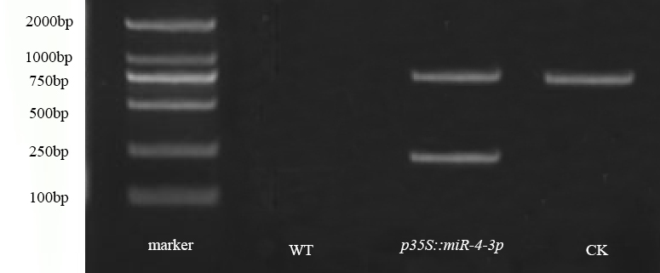
Figure S2. The PCR products electrophoresis of pre-IamiR-04m-3p and GFP gene in Arabidopsis. Note: the two bands near 750 bp stand for GFP and the band near 250bp stand for pre-IamiR-04m-3p.

Figure S3.
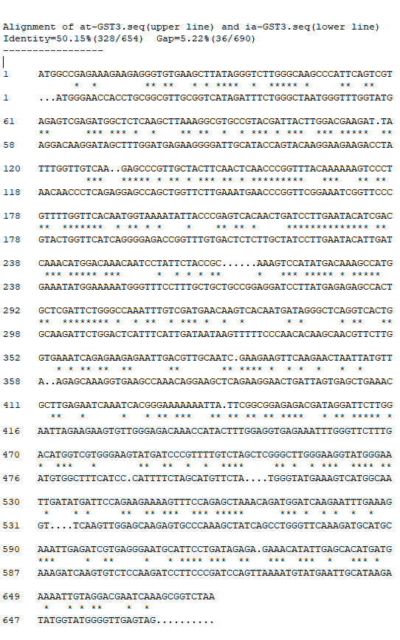
Figure S3. Alignment of GST3 sequences between water spinach and Arabidopsis. Note: the * indicate the same base sequence between two plants.

