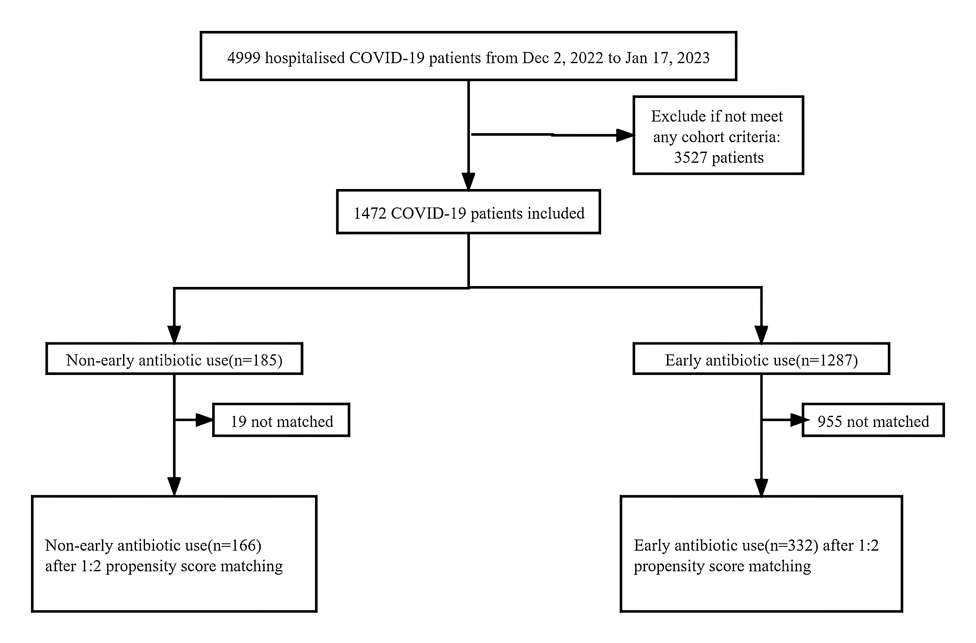
Figure1: Identification of patients hospitalized with COVID-19 with and without early antibiotic use during the study period.

Table1. Baseline characteristics and laboratory parameters of COVID-19 patients with and without early antibiotic use before and after propensity score matching.
 | Before 1:2 propensity-score matching |  |  | After 1:2 PSM
 | Non-Early antibiotic use (n=185) | Early antibiotic use (Controls(n=1287)） | p Value | p Value
Baseline covariates
Age(years) | 62.91±19.65 | 71.24±16.95 | <0.001 | 0.127
Sex: |  |  | 0.235 | 1.000
Female | 35.1%(65/185) | 30.6%(394/1287)
Male | 64.9(120/185) | 69.4%(893/1287)
BMI | 24.11±3.59 | 23.39±3.87 | 0.024 | 0.832
Former or current smoker | 16.2%(30/185) | 22.5%（290/1287) | 0.056 | 0.537
Comorbids:
Diabetes | 20.0%(37/185) | 27.8%(358/1287) | 0.026 | 0.643
Hypertension | 42.2%(78/185) | 46.1%(593/1287) | 0.344 | 1.000
Chronic kidney disease | 15.7%(29/185) | 26.4%(340/1287) | 0.002 | 0.700
Chronic hepatic disease | 4.3%(8/185) | 7.2%(93/1287) | 0.163 | 0.459
Chronic lung diseases | 8.1%(15/185) | 21.5%(277/1287) | <0.001 | 0.421
Cardiovascular disease | 13.0%(24/185) | 27.7%(356/1287) | <0.001 | 0.662
Immune system disease | 2.7%(5/185) | 4.1%(53/1287) | 0.425 | 0.800
Malignancy | 9.7%(18/185) | 13.8%(177/1287) | 0.134 | 0.751
≥ 2 types of Comorbids | 30.3%(56/185) | 55.7%(717/1287) | <0.001 | 0.409
Disease severity for COVID-19: |  |  | <0.001 | 0.524
Non-severe COVID-19 | 71.4%(132/185) | 37.1%(478/1287)
Severe COVID-19 | 25.9%(48/185) | 39.4%(507/1287)
Critical COVID-19 | 2.7%(5/185) | 23.5%(302/1287)
Laboratory parameters at admission
Lymphocytes, 109 /L | 0.96±0.46 | 0.83±0.92 | 0.072 | 0.471
PCT, ng/mL | 0.15±0.39 | 1.20±4.36 | <0.001 | 0.387
CRP, mg/L | 41.45±49.81 | 75.91±70.77 | <0.001 | 0.034
IL-6, μg/L | 23.61±42.97 | 60.50±105.44 | <0.001 | 0.335
D-Dimer, mg/L | 1.54±2.86 | 3.85±5.81 | <0.001 | 0.563
CD4+ T cells, cell/μL | 358.88±269.70 | 213.19±199.26 | 0.005 | 0.149
CD8+ T cells, cell/μL | 229.00±172.49 | 152.06±124.93 | 0.018 | 0.092
PSM: propensity-score matching, PCT: procalcitonin, CRP: C-reactive protein, IL-6: interleukin 6, NA: not applicated.

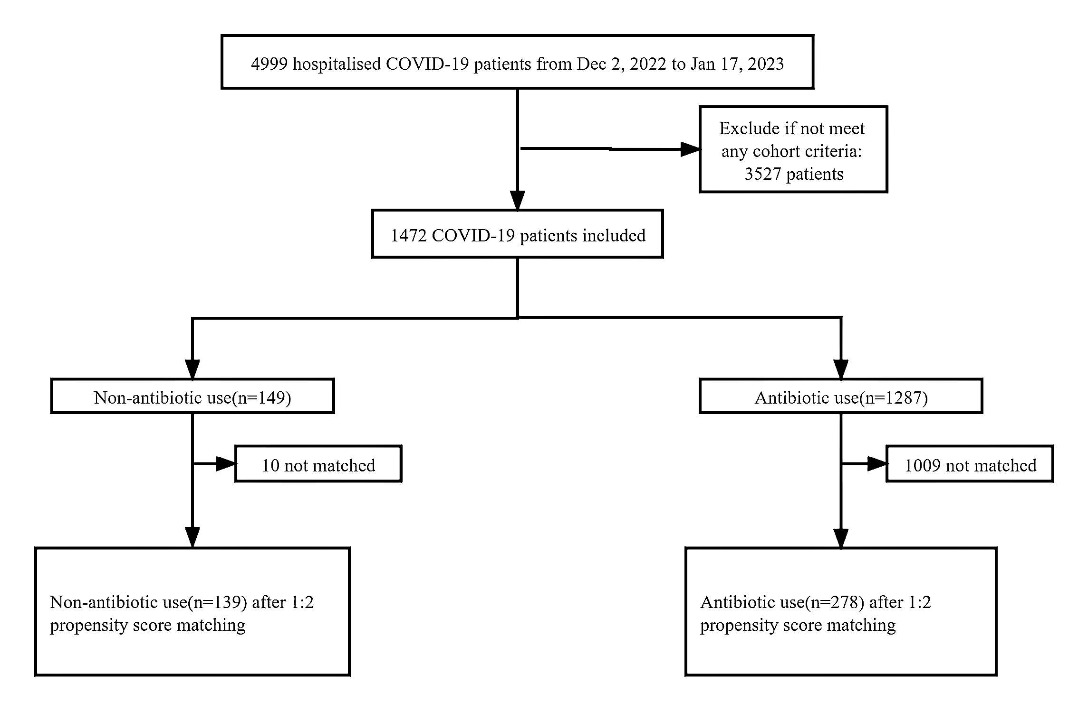
Figure2: Identification of patients hospitalized with COVID-19 with and without antibiotic use during the study period.
Table2. Baseline characteristics and laboratory parameters of COVID-19 patients with and without antibiotic use before and after propensity score matching.
 | Before 1:2 propensity-score matching |  |  | After 1:2 PSM
 | Non-antibiotic use (n=149) | Antibiotic use (n=1323) | p Value | p Value
Baseline covariates
Age(years) | 61.42±19.00 | 71.18±17.08 | <0.001 | 0.218
Sex: |  |  | 0.515 | 0.655
Female | 33.6%(50/149) | 30.9%(409/1323)
Male | 66.4%(99/149) | 69.1%(914/1323)
BMI | 23.82±3.60 | 23.45±3.86 | 0.292 | 0.814
Former or current smoker | 16.8%(25/149) | 22.3%（295/1323) | 0.142 | 0.893
Comorbids:
Diabetes | 18.8%(28/149) | 27.7%(367/1323) | 0.025 | 1.000
Hypertension | 40.9%(61/149) | 46.1%(610/1323) | 0.259 | 0.916
Chronic kidney disease | 16.1%(24/149) | 26.1%(345/1323) | 0.009 | 0.885
Chronic hepatic disease | 5.4%(8/149) | 7.0%(93/1323) | 0.500 | 0.834
Chronic lung diseases | 8.1%(12/149) | 21.2%(280/1323) | <0.001 | 0.848
Cardiovascular disease | 11.4%(17/149) | 27.4%(363/1323) | <0.001 | 1.000
Immune system disease | 3.4%(5/149) | 4.0%(53/1323) | 0.827 | 0.477
Malignancy | 8.7%(13/149) | 13.8%(182/1323) | 0.097 | 0.859
≥ 2 types of Comorbids | 28.2%(42/149) | 55.3%(731/1323) | <0.001 | 0.818
Disease severity for COVID-19: |  |  | <0.001 | 0.222
Non-severe COVID-19 | 73.2%(109/149) | 37.9%(501/1323)
Severe COVID-19 | 24.2%(36/149) | 39.2%(519/1323)
Critical COVID-19 | 2.6%(4/149) | 22.9%(303/1323)
Laboratory parameters at admission
Lymphocytes, 109 /L | 0.96±0.46 | 0.83±0.91 | 0.094 | 0.808
PCT, ng/mL | 0.17±0.44 | 1.17±4.31 | <0.001 | 0.302
CRP, mg/L | 40.49±49.76 | 75.05±70.45 | <0.001 | 0.043
IL-6, μg/L | 22.35±42.51 | 59.68±104.45 | <0.001 | 0.417
D-Dimer, mg/L | 1.22±1.70 | 3.81±5.79 | <0.001 | 0.346
CD4T cell | 389.50±279.86 | 214.01±199.59 | 0.005 | 0.070
CD8T cell | 251.54±183.97 | 152.20±124.71 | 0.015 | 0.067
PSM: propensity-score matching, PCT: procalcitonin, CRP: C-reactive protein, IL-6: interleukin 6, NA: not applicat
Table3. Comparison of outcomes parameters between patients with and without early antibiotic use before and after propensity score matching.
 | Before 1:2 propensity-score matching |  |  |  |  |  | After 1:2 propensity-score matching
 | Non-early antibiotic use (n=185) | Early antibiotic use (n=1287) | Crude  HR | 95%CI |  | P value | Non-early antibiotic use (n=166) | Early antibiotic use (n=332) | Crude  HR | 95%CI |  | P value
Mechanical ventilation | 7.0%(13/185) | 32.6%(420/1287) | 0.156 | 0.088 | 0.277 | <0.001 | 4.8%(8/166) | 9.3%(31/332) | 0.492 | 0.221 | 1.095 | 0.082
Tracheal intubation | 1.1%(2/185) | 9.3%(120/1287) | 0.106 | 0.026 | 0.434 | 0.002 | 1.2%(2/166) | 0.9%(3/332) | 1.337 | 0.221 | 8.083 | 0.751
ICU admission | 1.1%(2/185) | 13.1%(168/1287) | 0.073 | 0.018 | 0.296 | <0.001 | 1.2%(2/166) | 1.8%(6/332) | 0.663 | 0.132 | 3.319 | 0.617
Length of hospital stay(days) | 12.02±7.02 | 15.74±10.15 | NA | NA | NA | <0.001 | 11.77±6.83 | 13.94±8.12 | NA | NA | NA | 0.003
Mortality | 3.1%(6/185) | 14.8%(190/1287) | 0.194 | 0.085 | 0.443 | <0.001 | 3.0%(5/166) | 3.3%(11/332) | 0.906 | 0.310 | 2.653 | 0.857
NA: not applicated, ICU: Intensive Care Unit, HR: Hazard ratios, CI: Confidence interval.

Table4. Comparison of outcomes parameters between patients with and without antibiotic use before and after propensity score matching.
 | Before 1:2 propensity-score matching |  |  |  |  |  | After 1:2 propensity-score matching
 | Non-antibiotic use(n=149) | Antibiotic use (n=1287) | Crude  HR | 95%CI |  | P value | Non-antibiotic use (n=139) | Antibiotic use (n=278) | Crude  HR | 95%CI |  | P value
Mechanical ventilation | 6.7%(10/149) | 32.0%(423/1287) | 0.153 | 0.08 | 0.294 | <0.001 | 5.0%(7/139) | 9.0%(25/278) | 0.537 | 0.226 | 1.273 | 0.158
Tracheal intubation | 1.3%(2/149) | 9.1%(120/1287) | 0.136 | 0.033 | 0.557 | 0.006 | 1.4%(2/139) | 3.6%(10/278) | 0.391 | 0.085 | 1.811 | 0.230
ICU admission | 1.3%(2/149) | 12.7%(168/1287) | 0.094 | 0.023 | 0.381 | 0.001 | 1.4%(2/139) | 3.6%(10/278) | 0.391 | 0.085 | 1.811 | 0.230
Length of hospital stay(days) | 10.56±5.89 | 15.80±10.11 | NA | NA | NA | <0.001 | 10.55±5.81 | 14.10±8.27 | NA | NA | NA | ＜0.001
Mortality | 2.7%(4/149) | 14.5%（192/1287) | 0.163 | 0.059 | 0.444 | <0.001 | 2.2%(3/139) | 4.3%(12/278) | 0.489 | 0.136 | 1.762 | 0.274
NA: not applicated, ICU: Intensive Care Unit, HR: Hazard ratios, CI: Confidence interval.

