Supplemental Figures
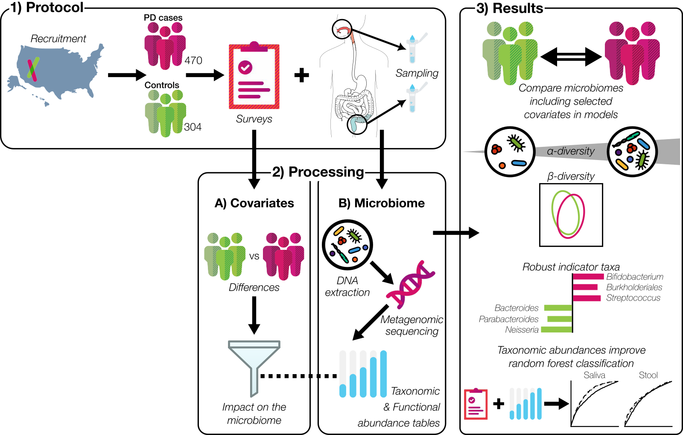

Supplemental figure 1. Study Design
1) We enrolled subjects from across the United States into a cross sectional study that involved home-based saliva and stool sampling and completion of a >100 item custom-designed PD microbiome survey. 2) To understand the impact of disease-status, survey questions were compared between PD cases and controls. We performed metagenomic sequencing, and after quality control, assigned taxonomic and functional group annotations to the sequences. 3) Regression analysis was performed with alpha- and beta-diversity metrics of the saliva or stool microbiomes. The diversity, composition, and abundances of individual features of the saliva and stool microbiomes were defined, accounting for clinical features. Lastly, we constructed random forest classification models to determine which microbiome metrics performed best at distinguishing between controls and PD cases.

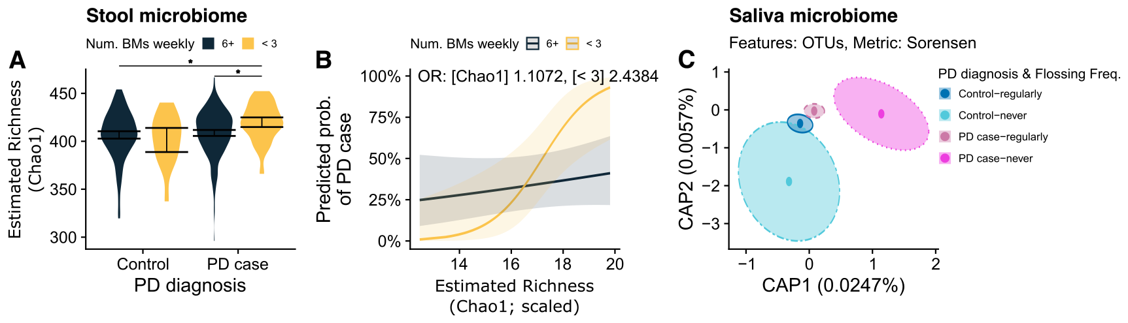

Supplemental figure 2. Covariate interactions.
(A) Violin plots show Chao1 scores for controls and PD cases who report regular weekly BMs (6+; navy) or few weekly BMs (< 3; yellow). Black error bars indicate bootstrapped 95% C.I.s. around the means, asterisks denote significant differences in means according to Tukey’s honest significant differences tests (adj. p < 0.05). (B) Estimated relationships between scaled Chao1 and probability of PD diagnosis from a logistic regression model that included the interaction terms as well as all other disease-relevant covariates. The navy line shows the relationship between scaled Chao1 and probability of PD diagnosis for participants reporting regular weekly BMs (OR 1.11), and the yellow line shows the relationship between scaled Chao1 and probability of PD diagnosis for participants reporting few weekly BMs (OR 2.44). (C) dbRDA ordination plot showing the shift in saliva beta-diversity at the OTU level in controls and PD cases by reported teeth flossing frequency. Dark blue indicates controls who floss regularly; light blue indicates controls who never floss. Dark pink indicates PD cases who floss regularly; light pink indicates PD cases who never floss. Points indicate centroids for each group, and ellipses denote the 95% C.I.s around the centroids.

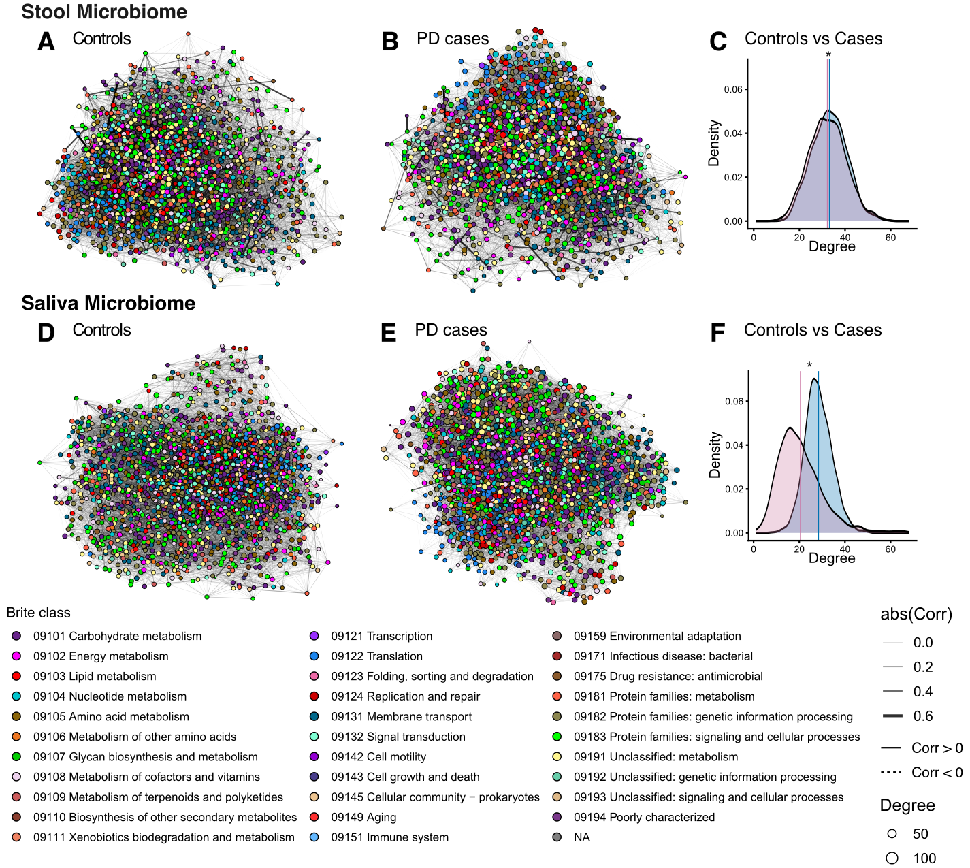

Supplemental figure 3. Functional networks
Function-function (KO level) abundance association networks for saliva and stool, and controls and PD cases. The networks in the top row are for stool KOs in controls (A) and PD cases (B). The networks on the bottom row are for saliva KOs in controls (D) and PD cases (E). Each point represents an individual KO, and the color within the point represents the KO’s BRITE class. The lines connecting points indicate statistically significant associations in their abundances as determined by the spiec-easi method. The lines are colored and scaled by the absolute value of their correlation coefficient with darker and wider indicating greater correlation magnitude. Solid lines indicate positive correlations, dashed lines indicate negative correlations. The density plots to the right of the networks, for stool (C) and saliva (F) show the distributions of degree centralities for each KO (node) in the networks. The lines indicate the mean degree for controls (blue) and cases (pink). An asterisk indicates a significant difference in degree between controls and cases, and an “n.s.” indicates no significant difference.

