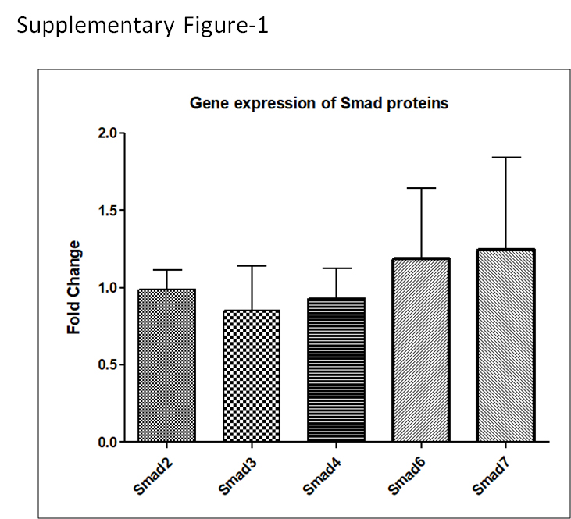

Supplementary Fig. 1: Gene expression of Smad2, Smad3, Smad4, Smad6 and Smad7 proteins.
Bar diagram representing relative expression of Smad2, Smad3, Smad4, Smad6 and Smad7 genes in DENV infected HEK-293T cells calculated by using ddct method. Mock infected cells were used as controls and GAPDH was used as internal controls.

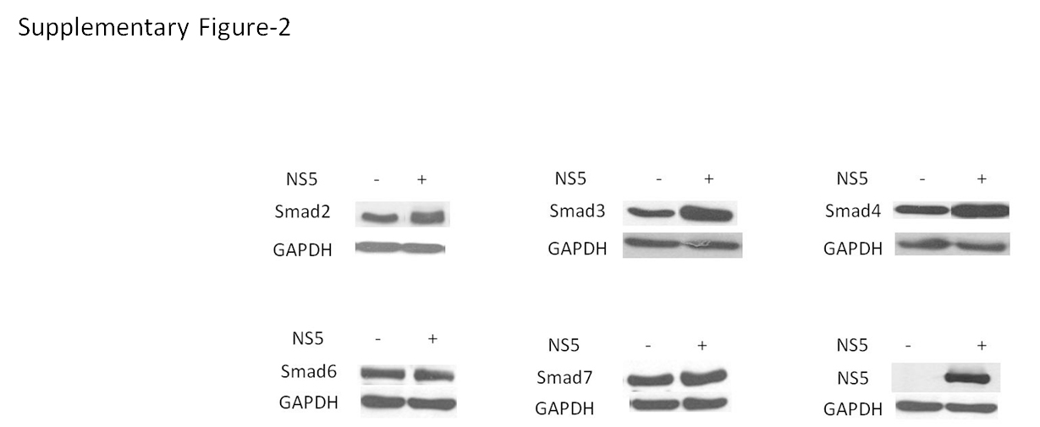

Supplementary Fig. 2: DENV-NS5 has no effect on the expression of Smad2, Smad3, Smad4, Smad6 and Smad7 in HEK-293T cells. HEK-293T cells were co-transfected with DENV NS5 and Smad2/3/4/6/7 construct. No difference was observed with co-expression of NS5 as shown by western blot.

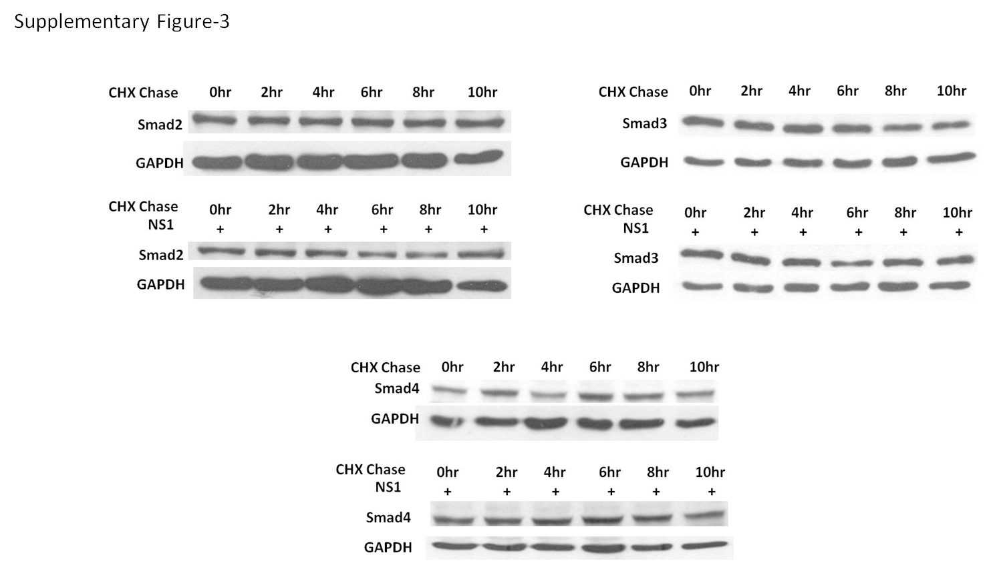

Supplementary Fig. 3: HEK-293T cells were transfected with Smad2/3/4 alone or with DENV NS1; at 24h post-transfection, cells were treated with 100ug CHX for different time points (2,4,6,8 and 10h) followed by western blotting.

Supplementary Table S1: sgRNA gene sequence details
S.N. | Oligonucleotides | Sequence (5’-3’)
1 | CHIP sgRNA 1 Forward | CACCGAGGAGCTCGCTGCTGCAGCT
2 | CHIP sgRNA 1 Reverse | AAACAGCTGCAGCAGCGAGCTCCTC
3 | CHIP sgRNA 2 Forward | CACCGGACACCTTCACTGGCCTGGT
4 | CHIP sgRNA 2 Reverse | AAACACCAGGCCAGTGAAGGTGTCC
5 | Scrambled sgRNA 1 Forward | CACCGGAAAGGCCCGGCGCCATTCT
6 | Scrambled sgRNA 1 Reverse | AAACAGAATGGCGCCGGGCCTTTCC

Supplementary Table S2: Detail of primers used for gene expression analysis.

Target gene | Forward primer (5’-3’) | Reverse Primer (5’-3’)
Smad2 | ACCGAAATGCCACGGTAGAA | TGGGGCTCTGCACAAAGAT
Smad3 | GCCTGTGCTGGAACATCATC | TTGCCCTCATGTGTGCTCTT
Smad4 | CATCCTGCTCCTGAGTATTGG | GGGTCCACGTATCCATCAAC
Smad6 | CTGCAACCCCTACCACTTCA | TTGGTAGCCTCCGTTTCAGT
Smad7 | AGAGGCTGTGTTGCTGTGAA | AAATCCATCGGGTATCTGGA
GAPDH | CGGAGTCAACGGATTTGGTCGTATTGG | GCTCCTGGAAGATGGTGATGGGATTTCC

