Supplementary Data:

Figure 1: Critical Appraisal Skills Programme (CASP) checklist for clinical trials.
Questions correspondence as follows:
- Did the study address a clearly focused research question?
- Was the assignment of participants to interventions randomized?
- Were all participants who entered the study accounted for at its conclusion?
- Were the participants ‘blind’ to intervention they were given? Were the investigators ‘blind’ to the intervention they were giving to participants? Were the people assessing/analysing outcome/s ‘blinded’?
- Were the study groups similar at the start of the randomized controlled trial?
- Apart from the experimental intervention, did each study group receive the same level of care (that is, were they treated equally)?
- Were the effects of intervention reported comprehensively?
- Was the precision of the estimate of the intervention or treatment effect reported?
- Do the benefits of the experimental intervention outweigh the harms and costs?
- Can the results be applied to your local population/in your context?
- Would the experimental intervention provide greater value to the people in your care than any of the existing interventions?

Figure 2: Funnel plots illustrating the meta-analysis results for the included studies in the pooled analysis for all (autologous and allogeneic) patients treated with HSCT and the subgroup analysis with ones treated with allogeneic HSCT.

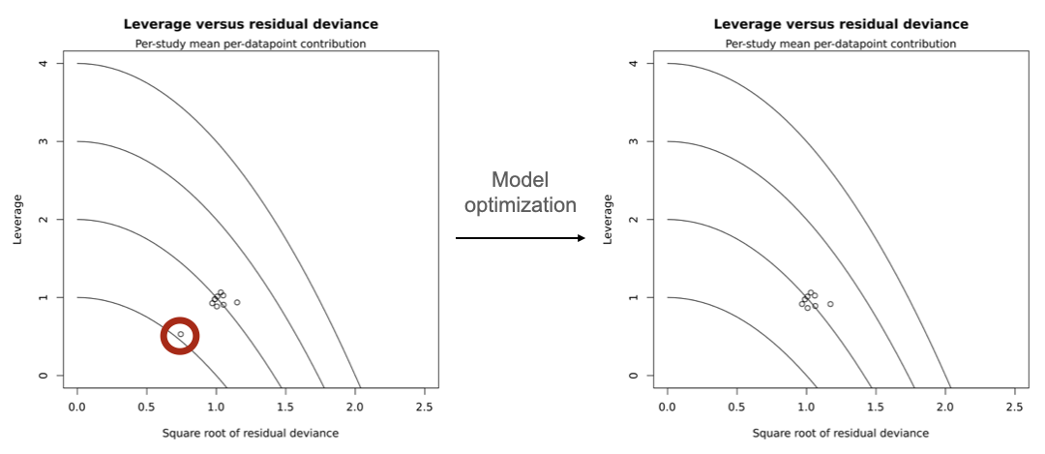

Figure 3: Leverage versus square root of residual deviance plot of the studies included in the network meta-analysis. The outlier pattern of FFP (fresh frozen plasma) on the graph on the left (red circle), further prompted its exclusion from the pooled analysis.

Figure 4: Direct and indirect evidence proportions of network estimates according to a random effects model in all patients submitted to hematopoietic stem cells transplantation.

Figure 5: Direct and indirect evidence proportions of network estimates according to a random effects model in patients who underwent allogeneic hematopoietic stem cells transplantation (subgroup analysis).

