Supplementary Material

Hormonal dynamics shape brain structural plasticity across the menstrual cycle: Insights from dense-sampling structural brain imaging of females with and without endometriosis

Carina Heller, Christian Gaser, Lejla Colic, Nooshin Javaheripour, Feliberto de la Cruz, Philine Rojczyk, Carina J. Koeppel, Habib Ganjgahi, Frederik J. Lange, Ann-Christine Buck, Michael Kiehntopf, Laura Pritschet, Emily G. Jacobs, Zora Kikinis, Martin Walter, Ilona Croy, Daniel Güllmar

Supplementary Figure 1. Hormone concentrations for each participant plotted across all test days, covering the entire menstrual cycle.
Supplementary Figure 2. Timeline of data collection for the control analyses involving a male and a female on oral contraceptives across the time course of five weeks (25 test sessions).
Supplementary Figure 3. Hormone concentrations of estradiol, progesterone, and the ratio of progesterone to estradiol for the male participant and the female participant on oral contraceptives across the time course of five weeks (25 test sessions).
Supplementary Figure 4. Linear regression analyses with hormonal values as predictors of brain spatiotemporal pattern1 (STP1) in the male and the female on oral contraceptives.
Supplementary Figure 5. Spatiotemporal brain pattern in the male and the female using oral contraceptives.
Supplementary Figure 6. All four spatiotemporal brain patterns in the endometriosis cycle, the typical cycle, and the 28andMe (typical) cycle.
Supplementary Figure 7. Behavioral variations across the 25 test days in the endometriosis and the typical cycle.
Supplementary Description 1. Behavioral assessment.

Supplementary References

Supplementary Figure 1. Hormone concentrations for each participant plotted across all test days, covering the entire menstrual cycle. Hormone levels suggest a healthy hormonal balance in the typical cycle, while hormone levels suggest an estradiol dominance in the luteal phase of the endometriosis cycle. LH = luteinizing hormone. FSH = follicle-stimulating hormone.

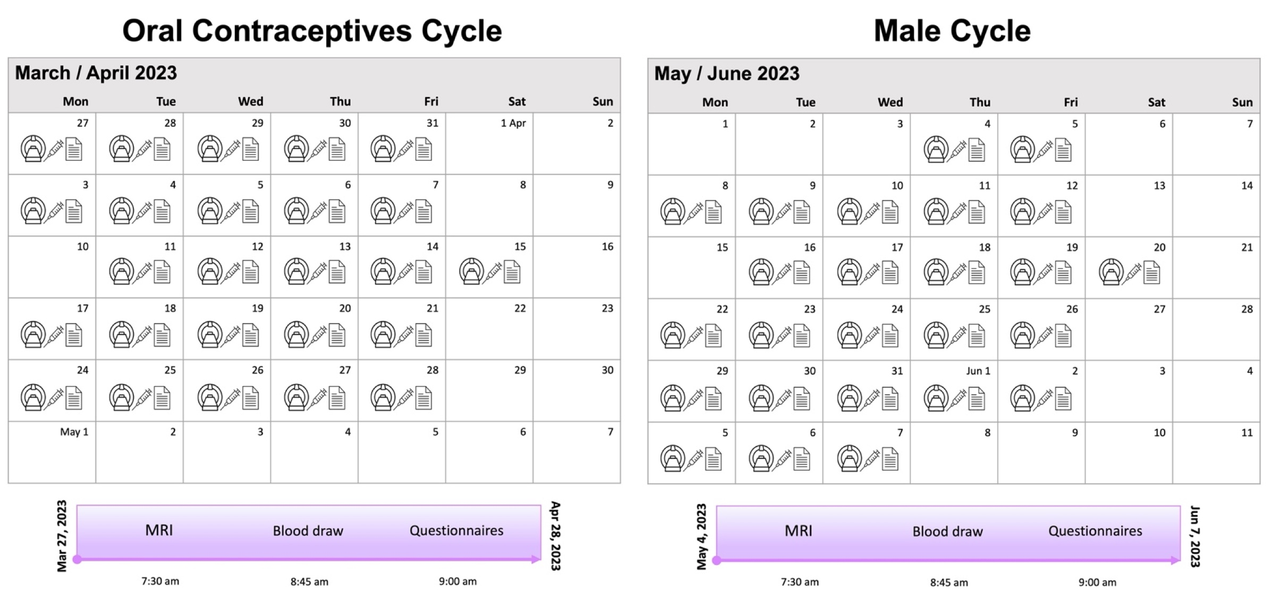
Supplementary Figure 2. Timeline of data collection for the control analyses involving a male (26 years of age, Caucasian) and a female on oral contraceptives (31 years of age, Caucasian) across the time course of five weeks (25 test sessions). MRI and endocrine assessments were acquired simultaneously on each test day for each participant. The female was placed on a daily regimen of 0.03 mg ethinyl-estradiol and 2 mg dienogest (Maxim, Jenapharm) for at least three months before the assessment. Participants gave written informed consent, and the Friedrich Schiller University Jena Ethics Committee approved the study.
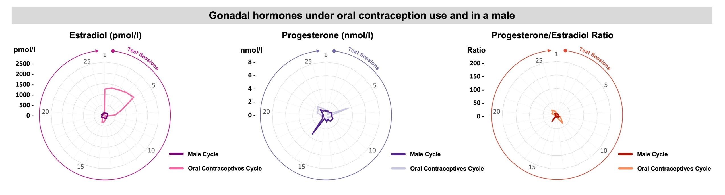

Supplementary Figure 3. Hormone concentrations of estradiol, progesterone, and the ratio of progesterone to estradiol for the male participant and the female participant on oral contraceptives across the time course of five weeks (25 test sessions). The male participant presented with low hormonal concentrations of estradiol, progesterone, and progesterone/estradiol ratio. In the female on oral contraceptives, a daily regimen of 0.03 mg ethinyl-estradiol and 2 mg dienogest selectively suppressed circulating progesterone. The concentration and dynamic range of estradiol during oral contraception intake was similar to a typical cycle.
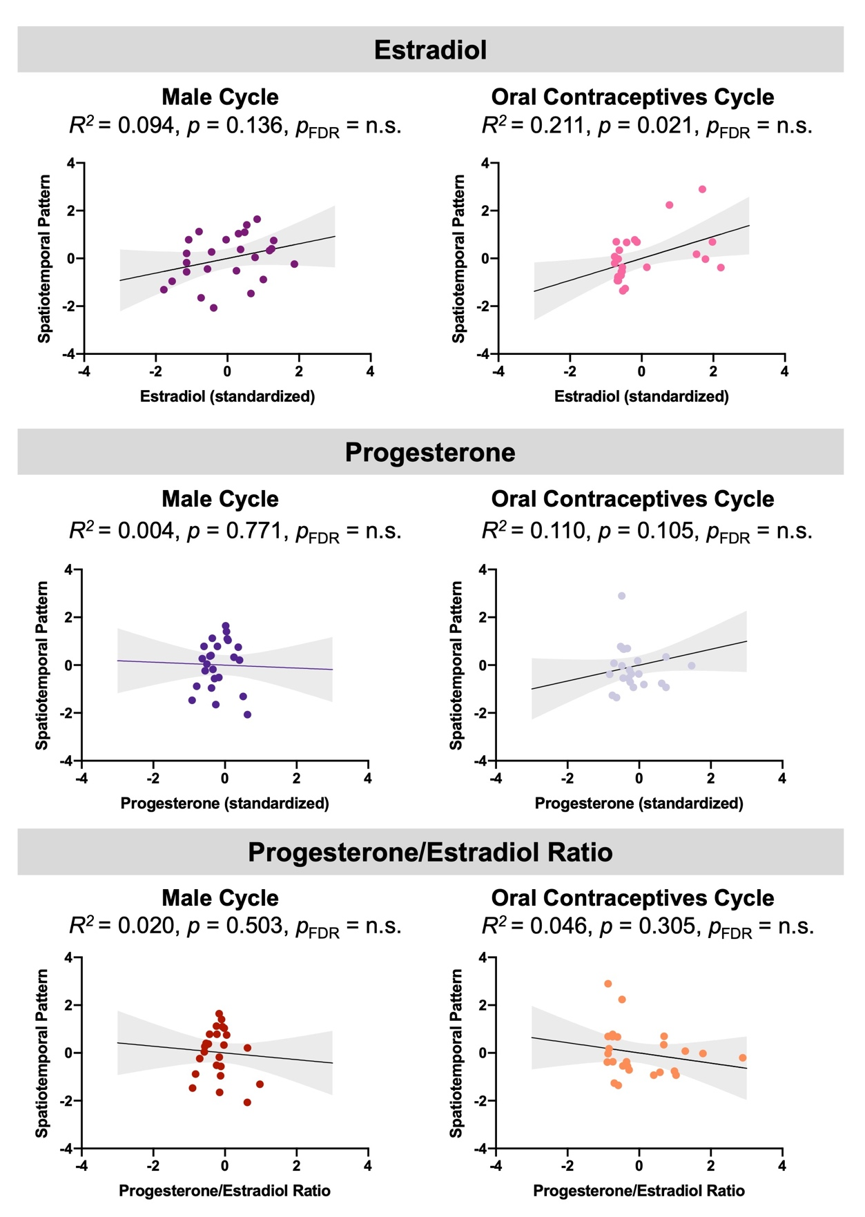
Supplementary Figure 4. Linear regression analyses with hormonal values as predictors of brain spatiotemporal pattern1 (STP1) in the male and the female on oral contraceptives. AutoRegressive Integrated Moving Average (ARIMA) models were employed to investigate the relationship between spatiotemporal patterns in brain structure and gonadal hormones of estradiol, and progesterone, as well as the progesterone/estradiol ratio. Models were initially specified as ARIMA(0,0,0). This specification implies the deliberate exclusion of autoregressive (p), differencing (d), or moving average (q) terms, simplifying the models into basic linear regression without inherent time series complexities. Data are displayed in standardized units. p = p-value. p_{FDR} = p-value after false discovery rate correction for multiple comparisons. n.s. = non-significant. The black lines represent the best-linear-fit for the data with 95% confidence bands in gray.

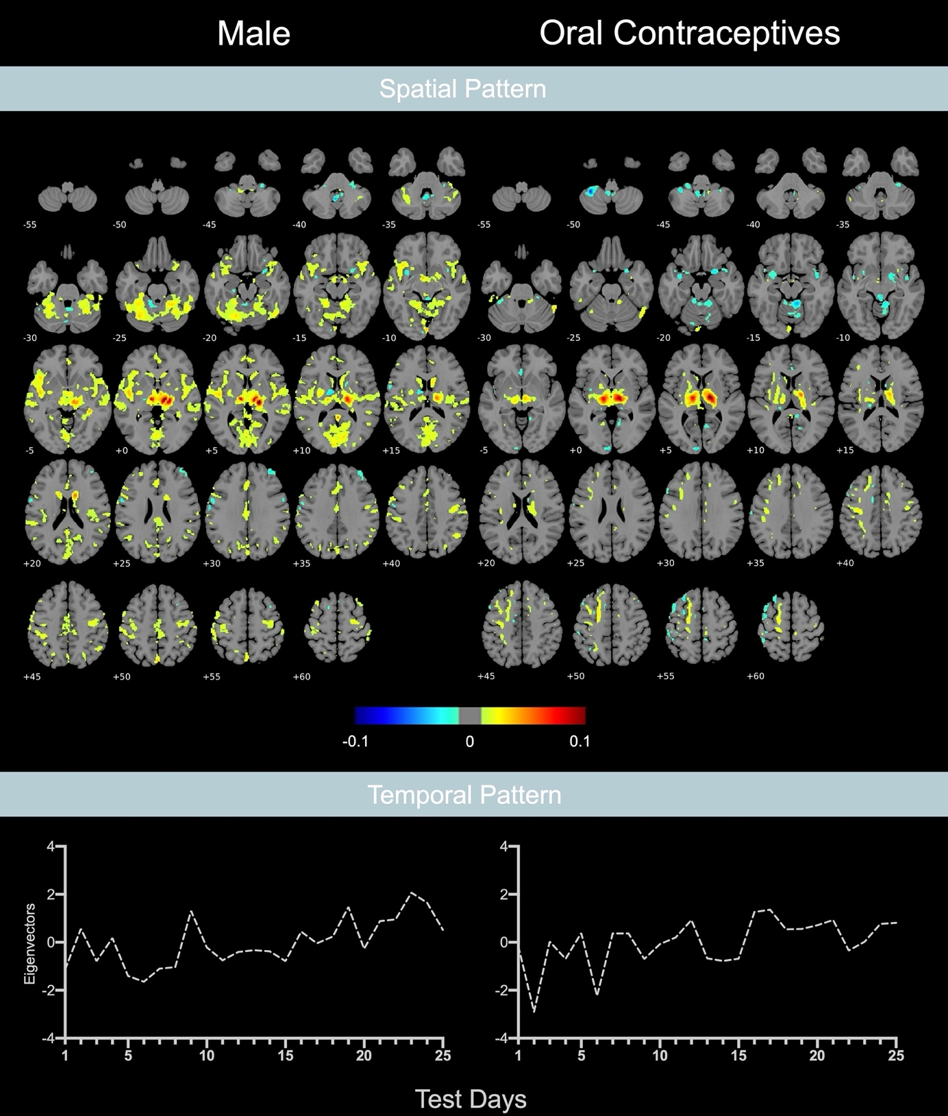
Supplementary Figure 5. Spatiotemporal brain pattern in the male and the female using oral contraceptives. Displayed is spatiotemporal pattern1 (STP1), which represents the dominant pattern explaining the most variance. The top shows the spatial maps that represent brain regions that share a similar structural pattern (spatial pattern). Warm colors indicate positive associations, while cool colors represent negative associations of the spatial pattern with the temporal pattern across the measurement. The bottom shows the associated time course of each spatial map (temporal pattern). Individual eigenvectors of each test day associated to the spatial map are displayed.
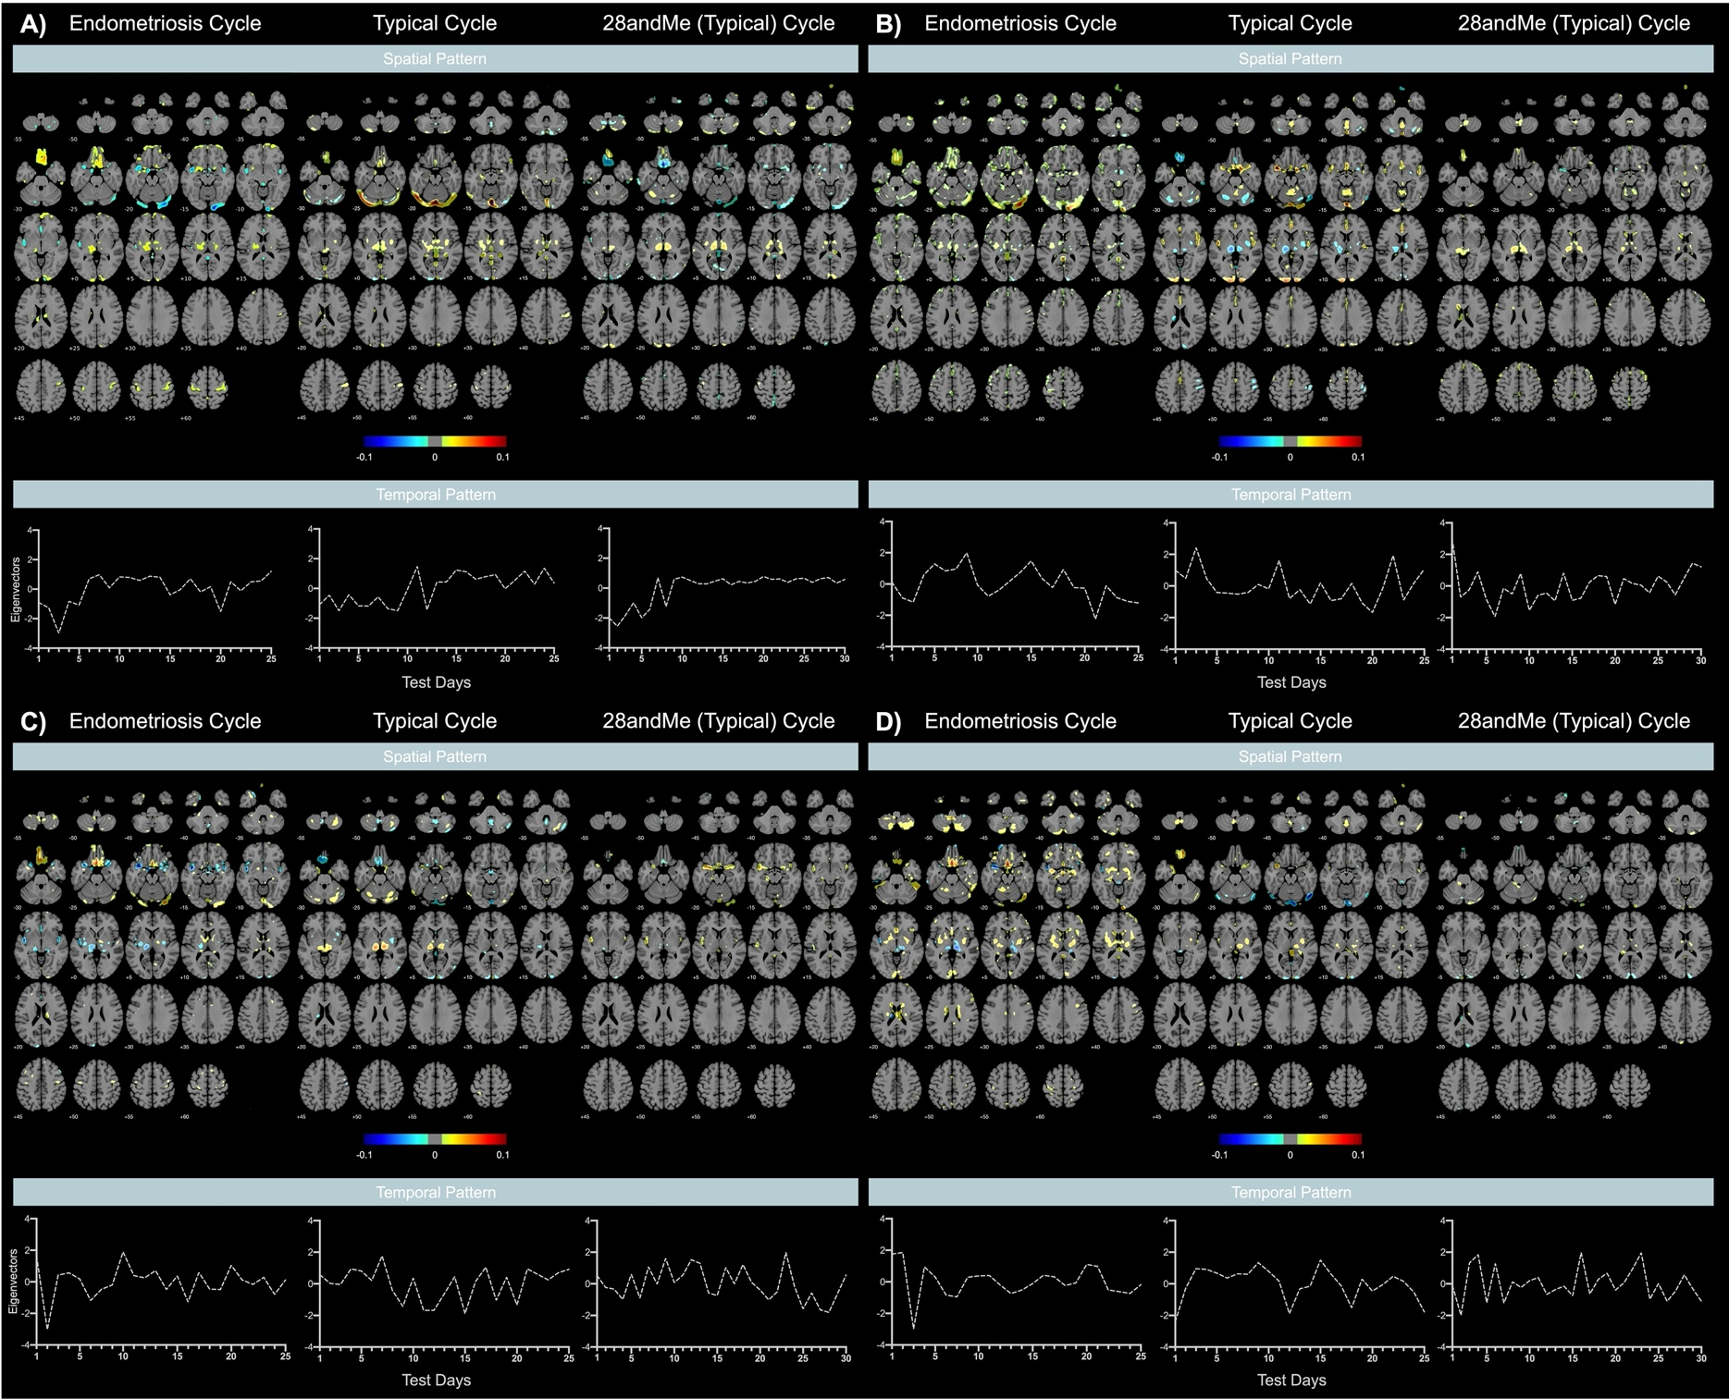
Supplementary Figure 6. All four spatiotemporal brain patterns in the endometriosis cycle, the typical cycle, and the 28andMe (typical) cycle. Brain regions exhibiting a consistent spatial pattern throughout the menstrual cycle are visualized. The top of each panel shows the spatial maps that represent brain regions that share a similar spatial pattern across the menstrual cycle (spatial pattern). Warm colors indicate positive associations, while cool colors represent negative associations of the spatial pattern with the temporal pattern across the cycle. The bottom of each panel shows the associated time course of each spatial map (temporal pattern). Individual eigenvectors of each test day associated to the spatial map are displayed. Panel A) Spatiotemporal pattern1 (STP1). Panel B) Spatiotemporal pattern2 (STP2). Panel C) Spatiotemporal pattern3 (STP3). Panel D) Spatiotemporal pattern4 (STP4).

Supplementary Description 1. Behavioral assessment.
In the endometriosis cycle and typical cycle, positive and negative affect was assessed for each test session separately using the Positive and Negative Affect Schedule (PANAS) ¹. The PANAS is a 20 item self-reporting questionnaire assessing positive emotions such as joy, interest, and alertness, and negative emotions such as sadness, distress, and irritability. Each item on the PANAS is rated on a 5-point Likert scale, ranging between 1 and 5, with 1 indicating low agreement to the specific item (not at all) and 5 indicating a high agreement (very much). The positive affect score was calculated as the average of the 10 positive items. The negative affect score was calculated as the average of the 10 negative items. Hence, positive and negative affect scores can range from 1 to 5. Lower scores represent lower levels of positive and negative affect, whereas higher scores represent higher levels of positive and negative affect, respectively.
State anxiety was assessed with the State-Trait Anxiety Inventory (STAI) ², which measures a person's temporary or situational anxiety level. It assesses how an individual feels "right now" or in a specific situation. State anxiety can fluctuate in response to stressors or environmental factors. Each statement on the STAI is rated on a 4-point Likert-type scale, ranging from 1 (not at all) to 4 (very much). Higher values indicate higher anxiety levels.
During the 28andMe (typical) cycle, different psychological measures were assessed. Details regarding these assessments are published elsewhere ³.
Overall, positive and negative affect were low in both the endometriosis cycle and the typical cycle. The participant with a typical menstrual cycle exhibited higher levels of anxiety (M = 48.93, SD = 9.26), while the participant with endometriosis presented moderate levels (M = 35.80, SD = 4.19). Notably, state-dependent behavioral measures did not correlate with estradiol and progesterone levels in the endometriosis cycle or in the typical cycle. This suggests that state-dependent mood does not exert any discernible association with these sex steroid hormones. Psychological assessments for the 28andMe (typical) cycle are reported elsewhere ³.
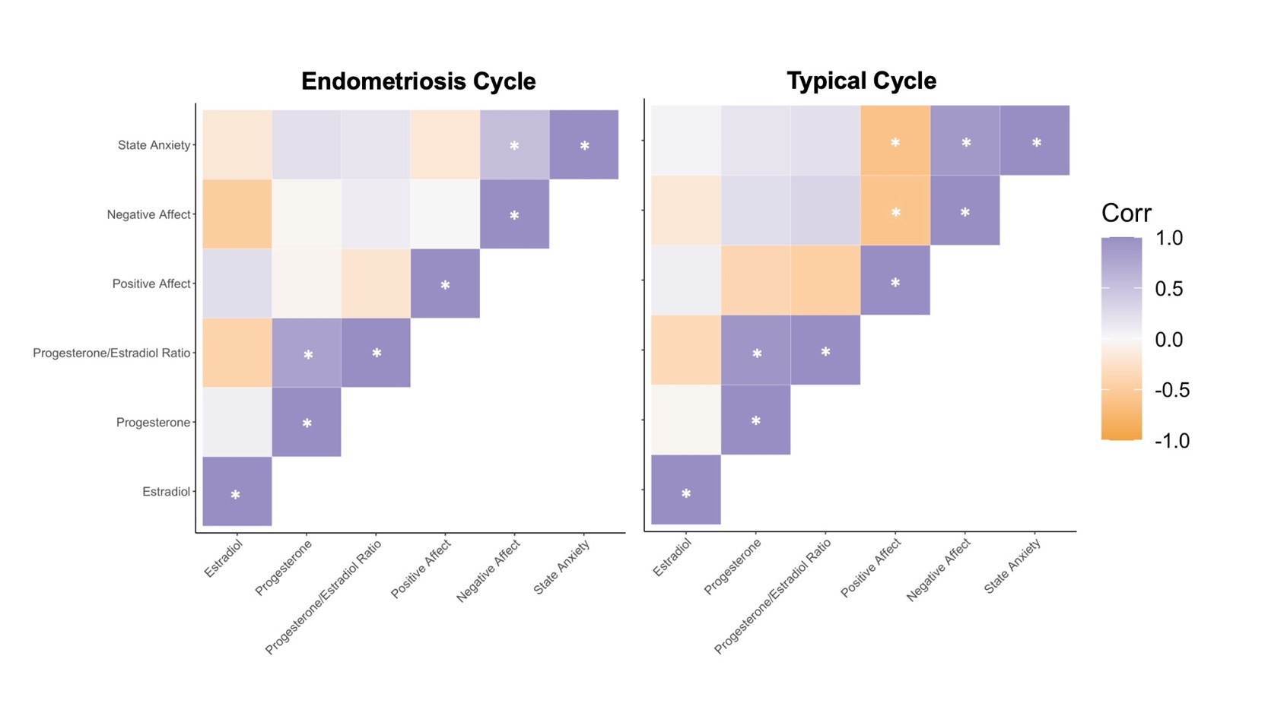
Supplementary Figure 7. Behavioral variations across the 25 test days in the endometriosis and the typical cycle. Plots show Spearman correlations between positive affect, negative affect, state anxiety, and sex steroid hormones. Purple-colored cells indicate positive correlations, orange-colored cells indicate negative correlations, white cells indicate no correlation. White asterisks indicate significant correlations after FDR-correction (p < 0.05). Corr = correlation coefficient.

Supplementary References

1. Watson D, Clark LA, Tellegen A. Development and validation of brief measures of positive and negative affect: the PANAS scales. J Pers Soc Psychol. 1988;54(6):1063-1070. doi:10.1037//0022-3514.54.6.1063
2. Spielberger CD. State-trait anxiety inventory: Bibliography, 2nd edn. Paolo Alto. 1989.
3. Pritschet L, Santander T, Taylor CM, et al. Functional reorganization of brain networks across the human menstrual cycle. Neuroimage. 2020;220:117091. doi:10.1016/j.neuroimage.2020.117091

